|  |
| --- |
| Special Variation Application Form – Part B  Council application for 2015/16 |
| Ballina Shire Council:  Date Submitted to IPART:  Council Contact Person: Peter Morgan  Council Contact Phone: 66861288  Council Contact Email: peterm@ballina.nsw.gov.au |

© Independent Pricing and Regulatory Tribunal of New South Wales 2014

This work is copyright. The *Copyright Act 1968* permits fair dealing for study, research, news reporting, criticism and review. Selected passages, tables or diagrams may be reproduced for such purposes provided acknowledgement of the source is included.

ISBN

The Tribunal members for this review are:

Dr Peter J. Boxall AO, Chairman

Ms Catherine Jones

Inquiries regarding this document should be directed to a staff member:

Michael Seery (02) 9290 8421

Tony Camenzuli (02) 9113 7706

Kumi Cuthbertson (02) 9290 8479

Independent Pricing and Regulatory Tribunal of New South Wales

PO Box Q290, QVB Post Office NSW 1230

Level 8, 1 Market Street, Sydney NSW 2000

T (02) 9290 8400 F (02) 9290 2061

[www.ipart.nsw.gov.au](http://www.ipart.nsw.gov.au/)

Contents

1 Introduction 1

1.1 Completing the application form 1

1.2 Using the Council Portal to submit the application 2

2 Preliminaries 3

2.1 Focus on Integrated Planning and Reporting 3

2.2 Key purpose of special variation 3

2.3 Capital expenditure review 7

3 Assessment Criterion 1: Need for the variation 8

3.1 Case for special variation - community need 8

3.2 Financial sustainability 17

3.3 Financial indicators 19

3.4 Contribution plan costs above the cap 21

4 Assessment criterion 2: Community awareness and engagement 22

4.1 The consultation strategy 23

4.2 Feedback from the community consultations 26

5 Assessment criterion 3: Impact on ratepayers 29

5.1 Impact on rates 30

5.2 Consideration of affordability and the community’s capacity and willingness to pay 32

5.3 Addressing hardship 34

6 Assessment criterion 4: Public exhibition of relevant IP&R documents 35

7 Assessment criterion 5: Productivity improvements and cost containment strategies 44

8 List of attachments 54

9 Certification 56

# Introduction

IPART will assess each application against the criteria set out in the Office of Local Government’s (OLG) *Guidelines for the preparation of an application for a special variation to general income for 2015/2016* (the Guidelines). Councils should refer to these guidelines before completing this application form.[1]

Each council must complete this Part B application form when applying for a special variation to general income either under section 508A or under section 508(2) of the *Local Government Act 1993*.

The Part B form must be completed together with the Part A (spreadsheet) form for both s508(2) and s508A applications. The Guidelines also require the council to have resolved to apply for a special variation. You must attach a copy of the council’s resolution to make a special variation application. IPART’s assessment of the application cannot commence without it.

## Completing the application form

This form is structured to provide guidance on the information we consider necessary to assess a special variation application. To complete the form, the council will need to respond to questions and insert text in the boxed area following each section or sub-section.

The amount of information that a council provides will be a matter of judgement for the council, but it should be sufficient for us to make an evidence-based assessment of the application. Generally, the extent of the evidence should reflect the size of the variation sought. More complex applications or requests for a high cumulative percentage increase should be supported by stronger, more extensive evidence.

Councils may submit additional supporting documents as attachments to the application (refer to section 8). These should be clearly identified in Part B and cross-referenced. We prefer to receive relevant extracts rather than complete publications, unless the complete publication is relevant to the criteria. You should provide details of how we can access the complete publication should this be necessary.

We publish Fact Sheets on how IPART assesses special variations and on the nature of community engagement for special variation applications. These will assist in preparing the application. The latest Fact Sheets on these topics are dated October 2014 and are available on IPART’s website.[2]

We may ask for additional information to assist us in making our assessment. If this is necessary, we will contact the nominated council officer.

This application form consists of:

* Section 2 – Preliminaries
* Section 3 – Assessment criterion 1
* Section 4 – Assessment criterion 2
* Section 5 – Assessment criterion 3
* Section 6 – Assessment criterion 4
* Section 7 – Assessment criterion 5
* Section 8 – List of attachments
* Section 9 – Certification.

## Using the Council Portal to submit the application

All councils intending to apply for a special variation must use the Council Portal on IPART’s website to register as an applicant council and to submit an application.

The Portal is at <http://www.ipart.nsw.gov.au/Home/Industries/Local_Govt>. The [User Guide](http://www.ipart.nsw.gov.au/files/948b8fb1-2e6e-4647-b9d3-a10000a2552a/Local_Government_-_Council_Portal_User_Guide_-_November_2012.pdf) for the Portal will assist you with the registration and online submission process. If you experience difficulties please contact Himali Ranasinghe on (02) 9113 7710 or by email [himali_ranasinghe@ipart.nsw.gov.au](mailto:himali_ranasinghe@ipart.nsw.gov.au)

Councils intending to submit an application under either section 508(2) or section 508A must notify us of their intention to apply by **COB Friday, 12 December 2014.**

Councils should submit their applications via the Portal. File size limits apply to each part of the application. For Part B the limit is 10MB. The limit for supporting documents is 70MB for public documents and 50MB for confidential documents. These file limits should be sufficient for your application. Please contact us if they are not.

We ask that councils also submit one hard copy of their application to us (with a table of contents and appropriate cross referencing of attachments). Note, early in 2015 IPART will be relocating to the following address:

Local Government Team  
Independent Pricing and Regulatory Tribunal  
PO Box K35,   
Haymarket Post Shop NSW 1230

2-24 Rawson Place, Sydney NSW 2000

We must receive your application via the Council Portal no later than **COB Monday, 16 February 2015.**

We will post all applications (excluding confidential content) on the IPART website. Confidential content may include part of a document that discloses the personal identity or other personal information pertaining to a member of the public or whole documents such as a council working document and/or a document that includes commercial-in-confidence content. Councils should ensure that documents provided to IPART do not expose confidential content.

Councils should also post their application on their own website for the community to access.

# Preliminaries

## Focus on Integrated Planning and Reporting

Councils must identify the need for a special variation to their General Fund’s rates revenue as part of their Integrated Planning and Reporting (IP&R) process.[3] The IP&R documents will need to be publicly exhibited and adopted by the council prior to it submitting its application to us. Also refer to section 6 for a more detailed explanation.

The key IP&R documents are the Community Strategic Plan, Delivery Program, Long Term Financial Plan and, where applicable, the Asset Management Plan. A council’s application may also include supplementary and/or background publications used within its IP&R processes. You should refer to these documents to support your application for a special variation where appropriate.

## Key purpose of special variation

At the highest level, indicate the key purpose(s) of the special variation by marking one or more of the boxes below with an “x”.

|  |  |
| --- | --- |
| Maintain existing services |  |
| Enhance financial sustainability |  |
| Environmental services or works |  |
| Infrastructure maintenance / renewal | **X** |
| Reduce infrastructure backlogs |  |
| New infrastructure investment |  |
| Other (specify) |  |

You should summarise below the key aspects of the council’s application, including the purpose and the steps undertaken in reaching a decision to make an application.

***Council Submission***

**Purpose**

Council’s application is for a permanent increase to our rate yield of 5.41% in 2015/16 and 5.34% in 2016/17, to raise additional funds to finance the refurbishment of the Ballina and Alstonville swimming pool complexes. The additional revenue raised from the special rate variation will fund the repayment of loans that are needed to finance the refurbishment works.

**Steps Undertaken**

The Ballina and Alstonville swimming pool complexes were opened in 1975 with largely identical facilities. The facilities are well utilised, with the last two years showing aggregate attendance numbers in excess of 150,000.

Council has undertaken regular maintenance on both facilities however the infrastructure is now reaching a stage in its asset life where major refurbishment works are needed to replace ageing infrastructure and to ensure that the complexes reflect community standards for the next twenty to forty years.

Council has acknowledged the need to refurbish the swimming pools since 2003/04 when a safety audit identified potential safety issues relating to multiple trip hazards, risk of structure collapse, lack of emergency lighting and fire equipment, presence of poor landscape design and fall hazards.

For the period from 2004 to 2006 actions were taken to improve the facilities based on this safety report and in 2005 Council engaged a consultancy firm, Pool Link Pty. Ltd., to provide a “Aquatic Facility Review and Capital Upgrade Works Report” for both pools. That report, copy attached as per Attachment 13.1, identified a range of recommended improvements.

Minimal works were then completed as a result of this report, largely due to funding limitations.

In 2007, another independent report, prepared by Mr Geoff Leaver, Swimming Pool Consultant, copy also attached at Attachment 13.2, again identified the need for essential and improvement works.

Minimal works were again completed as a result of this report due to funding limitations.

In 2011 Council completed an Aquatic Facilities Strategic Financial Plan Discussion Paper that provided an overview of the current state of the swimming complexes, identified current maintenance issues, along with confirming a program of essential and desirable works (copy attached at Attachment 13.3).

During 2011 Council received a number of approaches from the community in respect to upgrading the pools, including a petition with approximately 600 signatures.

Media articles were also published at that time supporting an upgrade to the Ballina swimming pool (copy attached at Attachment 13.4). This campaign was partially driven by the potential closure of a private indoor 25 metre pool, in Ballina, which to date has not been closed.

Since 2011 Council has continued to review the preferred scope of works and also examined options for funding the pool improvements. Council has now reached the stage where we consider an essential program of works is approximately $4m per swimming complex ($8m in total). The works program is focused on refurbishments with some upgrades also included. The preliminary scope of works is as follows:

**Item Estimate ($)**

**(per complex)**

50 metre pools – Coping, relining, concourse 1,100,000

50 metre pools – Lane widening, access, heating, misc 500,000

Grandstands, shade structures, fencing, BBQs etc 300,000

Children’s wet play areas etc 250,000

Plant and equipment 300,000

Training pools – Expansion, relining, concourse etc 1,100,000

Amenities, kiosk, contingencies 450,000

**Total 4,000,000**

In order to finance this program we have examined asset sales, operating expenditure savings and program reviews, however the one-off magnitude of this expenditure is of such a scale that loan funds are the only viable option to finance the works. Therefore to ensure that the loan repayments do not materially impact on Council’s available cash funding, a permanent increase to our operating revenue is now sought.

In summary, for over a decade Council has been examining the scope of works needed to maintain and improve the swimming pools, along with assessing funding options.

Council has now identified a program of works, that is considered minimalist, but at the same time will rectify existing infrastructure concerns and provide improved facilities for future generations.

The difficulty with managing capital upgrades for swimming pools for any council is that they require a major capital investment and generally this investment is not offset by any significant increase in revenues, albeit that some revenue increase is anticipated through higher use of the upgraded facilities.

Any capital investment should also aim to reduce operating expenses, or at least minimising any on-going increases in operating expenses that may be occurring due to escalating maintenance costs.

In respect to funding, the options canvassed include:

a) Asset Sales

b) Increased User Fees and Charges

c) Expense Reductions

d) Loan Funds

e) Combinations of all of the above

**a) Asset Sales -** In respect to asset sales Council has residential and industrial land that it develops and sells, with the current forecast sale proceeds being applied to other priority infrastructure projects including a replacement Ballina Marine Rescue Tower, the construction of a coastal pathway between Lennox Head and Ballina and expanded sports fields at Skennars Head.

Asset sales were considered as one option for this project however the scale of the expenditure required would have led to asset stripping of a number of major assets and impacted on the longer term financial sustainability of Council.

As swimming pools and associated upgrades are an integral part of the community infrastructure for many councils, one off asset sales do not provide a viable long term solution for managing assets of this nature, as this type of expenditure will need to be incurred again in the medium to long term. This means it is essential for Council to have a financially sustainable rate base to fund these works.

**b) User Fees and Charges –** Currently the total annual income from swimming pool fees is approximately $340,000 with existing operating costs, excluding depreciation, at approximately $792,000 per annum. The estimated loan repayments required for a refurbishment of $8m range from $800,000 to $900,000 dependent on interest rates, based on a 15 year repayment term.

Even with significant increases in existing fees any additional funds raised will be well short of the repayments needed. Further reviews of the existing fees for the swimming pools will take place as part of the refurbishment, if it proceeds. Council continues to examine all our other fees and charges however certainty is required for loan repayments of the magnitude estimated.

**c) Expense Reductions** – Similar to the previous item expenditure reductions are being pursued across the organisation however the magnitude of the funding required and the associated loan repayments is of a scale that needs greater certainty.

**d) Loan Funds** – Loan funds are an ideal funding source for infrastructure such as swimming pools. Loans allow the cost of the asset to be distributed over future generations, with those generations also being the beneficiaries of the works.

Similarly the asset upgrades will have a significant life span, ranging from 20 years for items such as plant and equipment to possibly 30 to 50 years for items such as the swimming pool decks.

**e) Combinations -** Combinations of the above items were also considered and even though there are on-going improvements through increased revenues and expense reductions, along with asset sales, the nature of this project lends itself to the certainty of having loan funds readily available, with Council then having the ability to finance the loan repayments.

Council has identified the swimming pool upgrades as essential refurbishment works, including improvements and having canvassed all the funding options available, due to the magnitude and scale of the works needed, a special rate variation is considered to be the preferred option to finance these works.

## Capital expenditure review

You should complete this section if council is undertaking major capital projects that are required to comply with the OLG’s Capital Expenditure Guidelines, as outlined in OLG Circular 10-34. A capital expenditure review is required for projects that are not exempt and cost in excess of 10% of council’s annual ordinary rates revenue or $1 million (GST exclusive), whichever is the greater.

A capital expenditure review is a necessary part of a council’s capital budgeting process and should have been undertaken as part of the Integrated Planning and Reporting requirements in the preparation of the Community Strategic Plan and Resourcing Strategy.

|  |  |  |
| --- | --- | --- |
| Does the proposed special variation require council to do a capital expenditure review in accordance with OLG Circular to Councils, Circular No 10-34 dated 20 December 2010 | Yes X | No |
| If *Yes*, has a review been done and submitted to OLG? | Yes X | No |

# Assessment Criterion 1: Need for the variation

Criterion 1 within the OLG Guidelines is:

*The need for and purpose of a different revenue path for the council’s General Fund (as requested through the special variation) is clearly articulated and identified in the council’s IP&R documents, including its Delivery Program, Long Term Financial Plan and Asset Management Plan where appropriate. In establishing need for the special variation, the relevant IP&R documents should canvass alternatives to the rate rise. In demonstrating this need councils must indicate the financial impact in their Long Term Financial Plan applying the following two scenarios:*

* *Baseline scenario – General Fund revenue and expenditure forecasts which reflect the business as usual model, and exclude the special variation, and*
* *Special variation scenario – the result of approving the special variation in full is shown and reflected in the General Fund revenue forecast with the additional expenditure levels intended to be funded by the special variation.*

*Evidence to establish this criterion could include evidence of community need /desire for service levels/projects and limited council resourcing alternatives.*

*Evidence could also include the assessment of the council’s financial sustainability conducted by the NSW Treasury Corporation.*

The response to this criterion should summarise the council’s case for the proposed special variation. It is necessary to show how the council has identified and considered its community’s needs, alternative funding options (to a rates rise) and the assessment of its financial sustainability as conducted by the NSW Treasury Corporation (TCorp).

The criterion states that the need for the special variation must be identified and clearly articulated in the council’s IP&R documents especially the Long Term Financial Plan (LTFP) and the Delivery Program, and, where appropriate, the Asset Management Plan (AMP). The purpose of the special variation should also be consistent with the priorities of the Community Strategic Plan (CSP).

## Case for special variation - community need

Summarise and explain below:

* How the council identified and considered the community’s needs and desires in relation to matters such as levels of service delivery and asset maintenance and provision.
* How the decision to seek higher revenues above the rate peg was made and which other options were examined, such as changing expenditure priorities or using alternative modes of service delivery.
* Why the special variation is the most appropriate option. For example, typically other options would include introducing new or higher user charges and/or an increase in council loan borrowings, or private public partnerships or joint ventures.
* How the proposed special variation impacts the LTFP forecasts and how this relates to the need the council identified. Our assessment will also consider the assumptions which underpin the council’s LTFP forecasts.

In addressing this criterion, you should include extracts from, or references to, the IP&R document(s) that demonstrate how the council meets this criterion.

***Council Submission***

**Needs and Desires**

As outlined in section 2 the need to refurbish and upgrade the swimming pools has been identified since 2003. Council has now had three reports completed that confirm the need for these works as per Attachments 13.1, 13.2 and 13.3.

Council has accepted that both swimming pools are an essential Council service. The importance of swimming pools to the community has also been statistically measured by Council through three surveys undertaken by an independent research firm, being Micromex Pty. Ltd. The Micromex research surveys a random sample of 500 residents, providing a confidence level of plus or minus 4.4%.

These surveys, undertaken in 2008, 2012 and 2014 measure the level of importance and satisfaction that the community attaches to a wide range of Council services.

For the three survey periods the swimming pools have been identified as having an importance level of 3.54 (2014), 3.56 (2012) and 3.53 (2008) using the Unipolar scale applied by Micromex. Under this scale 3.00 to 3.59 identifies a service as having a moderate level of importance and 3.60 – 3.89 as a moderately high level of importance. As per these results the swimming pools rank just under the moderately high level of importance threshold.

In the 2012 community survey Council also sought feedback on the priorities for specified community infrastructure. The results from that survey identified that there was moderately high levels of support for the refurbishment of the Ballina and Alstonville swimming pools, with the Ballina pool rating particularly high, based on the Unipolar scale. A copy of the extracts relating to the importance levels from the 2008, 2012 and 2014 surveys are included as Attachments 13.5, 13.6 and 13.7, along with the community infrastructure ranking from the 2012 Micromex Report, which is included in Attachment 13.8.

Council’s 2014 community survey also sought feedback on the need for the refurbishment of the swimming pools. The survey results identified 83% of the survey sample of 500 were supportive, or somewhat supportive, of the need for the upgrade of the Ballina and Alstonville swimming pools. A copy of the final 2014 report from Micromex is attached at Attachment 13.9.

The overall mean rating for this survey for the swimming pool upgrades was 3.79, which represents a “Moderately high” level of importance based on the Unipolar scale applied by Micromex.

Council’s community consultation process for the special rate proposal also sought feedback from the community on priority elements of the refurbishment with over 1,400 responses received to that element of our consultation. The highest rated elements for the refurbishment were, in priority order:

1. Improved disabled access
2. Covered spectator seating and shade
3. Children’s Wet Play Areas
4. Heating – Ballina Pool (Alstonville is currently heated albeit that it needs upgrading

The works program has focused on these elements.

Also from a needs perspective, operating costs, particularly with respect to water usage, water loss and maintenance costs are now escalating rapidly, as per the following table, which outlines actual cash operating expenses for the past three financial years.

**Ballina and Alstonville Swimming Pools**

**Cash Operating Expenses (2011/12 to 2013/14) ($’000)**

**Item 2011/12 2012/13 2013/14**

Contractor Charges 369 395 398

Council Rates and Water Charges 72 114 152

Chemicals, Electricity 109 117 122

Maintenance 106 105 137

Other 7 24 9

**Total Operating Expenses 663 755 818**

**% Increase Per Annum 14% 8%**

From an asset management perspective it is important that Council addresses this rapid increase in operating costs.

Council’s Asset Management Plan for swimming pools has also identified the need for items such as plant and equipment to be replaced in the short to medium term. There is a risk of failure of this equipment unless works are undertaken in the near future. Extracts from the Swimming Pool Asset Management Plan are included in Attachment 10.

Council has also engaged an external consultancy firm, Ridgemill Pty. Ltd, to assist in confirming the final works program for the pools. Ridgemill is a specialist swimming pool consultancy firm based in Brisbane.

Ridgemill has an exceptional track record in the development and delivery of aquatic facility projects including the Waterway Gardens Leisure Centre with Townsville City Council, Bundamba Aquatic Centre for Ipswich City Council, Bribie Island Aquatic Centre and Caboolture Regional Aquatic Leisure Centre for Caboolture Shore Council, South Burnet Aquatic Centre for Nanango Shire Council and Gould Adams Aquatic Centre with Logan City Council and with Logan City Council. Many of these facilities are located in areas with a similar climate to Ballina.

As part of the refinement of the works program Ridgemill will undertake further consultation with key stakeholders, along with considering whole of life costs.

Ridgemill has provided a brief status report on the swimming pools and that report has again confirmed the importance of these works. A copy of that report, dated 20 January 2015, is included in Attachment 13.10.

It is important to acknowledge that $4m per swimming pool is a relatively limited amount of funding, with many desirable elements not included in the program of works. The Aquatic Facilities Strategic Financial Plan Discussion Paper, as included in Attachment 13.3, identified works that are seen as desirable, such as fully enclosed facilities, which are not funded in the preliminary works program.

Council has recognised that these types of enhancements are not affordable and therefore the works program has focused on essential refurbishment works and improvements considered to reflect minimum contemporary standards (i.e. children’s wet play areas).

Finally Council’s Community Strategic Plan (CSP) Delivery Program (DP) and Operational Plan (OP) emphasise the importance of these services.

The CSP has identified a Connected Community as one of its four key Directions, with one outcome we are striving to achieve in relation to that direction being “We feel connected to the community”.

One of the strategies our DP then identifies to achieve that outcome is that Council will ensure that:

*There are services and facilities that suit our needs (CC3)*

This is then supported by Delivery Program Strategies and Operational Plan Activities to achieve that outcome.

To support this comment, the following image is an extract from pages 13 and 14 of the Council’s adopted Delivery Program and Operational Plan for 2014/15 outlining the strategy and actions being followed in respect to the swimming pool refurbishments.

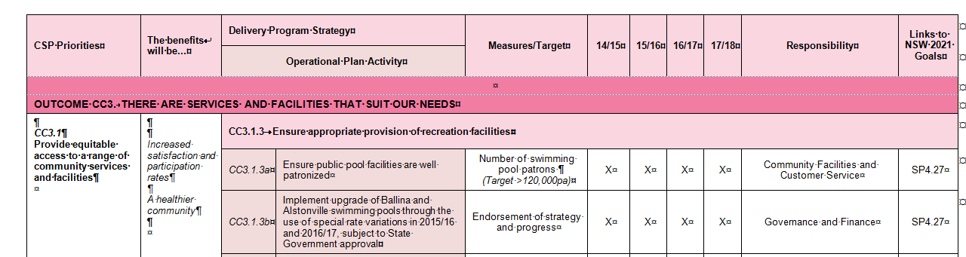

**Decision to Seek Higher Rate Income**

An increase in rate income is typically the last option for Council to consider when examining funding sources as our preference is to minimise rate impacts on residents.

The standard process followed by Council is to initially identify the preferred funding source for the proposed works. With this works program totalling approximately $8m it is impractical for Council to readily source these funds from the operating budget, therefore capital income is needed through either asset sales, loan income or grants.

In respect to asset sales one of the strengths of Ballina Shire Council over many decades has been its entrepreneurial land development activities. Council has a portfolio of commercial, residential and industrial land that helps to supplement our income streams.

Council has an on-going program of residential and industrial land sales with our LTFP already having a number of sales, in the short to medium term supporting projects such as:

* $1m to assist with the construction of a replacement Ballina Marine Rescue Tower – this facility is long overdue for replacement and there are a number of safety and structural issues with the current building
* $1m to assist with the expansion of sports fields in Skennars Head – There is currently an under supply of sports fields for this location (Lennox Head / Skennars Head)
* $850,000 to assist with the construction of a shared pathway between Lennox Head and Ballina, with this project typically attracting 50% grant monies. The $850,000 represents Council’s contribution.

Generally asset sales are funding works of a smaller scale than the $8m identified in this refurbishment program.

To date Council has not been able to identify any grants to assist with these works as the major Federal and State Government grants are focused on new infrastructure.

This leaves loan funds as the preferred capital income source, particularly as the works relate to long term infrastructure assets. The issue then facing Council is financing the interest and principal repayments. In order to finance the repayments Council examined its existing operating revenues and expenses to determine if there is capacity for the repayments to be financed either through surplus funds or through the reallocation of existing funding streams.

The Office of Local Government comparative data reports highlight that many of our comparative benchmarks are below the Group Average, which reflects the limitations we have in respect to savings in existing operating revenues and expenses. Examples from the latest 2012/13 reports, as sourced from the Office of Local Government website, are as follows:

**Item Ballina Group**

**Finances**

Average ordinary residential rate 757 878

Average ordinary business rate 2,437 3,168

Average ordinary farmland rate 1,216 1,834

**Leadership**

Population Per EFT Staff 155 125

**Services (General Fund related items)**

Governance and Admin Expend Per Capita 114 266

Community Services etc Expend Per Capita 105 178

Recreation and Culture Expend Per Capita 179 252

Public Order Expend Per Capita 57 63

These figures help to highlight how Council is operating at a relatively lean level.

In recent years Council has also gained the benefit of Local Infrastructure Renewal Scheme (LIRS) loans to finance road reconstruction works and airport upgrades. This has now placed our General Fund debt ratios at relatively tight margins with the external audit report for our 2013/14 annual financial statements identifying that our General Fund Debt Service Cover Ratio is 1.82 for 2013/14.

The preferred benchmark for this ratio is greater than 2, highlighting that Council is not in a position to take on new debt, without a readily available funding source. An extract from the External Audit report is included in Attachment 13.11.

With limited opportunities to finance additional debt through either savings in operating expenses, or existing surplus revenues, the final option is to increase revenues, through a secure revenue source, being additional rate income.

**Why the Special Rate Variation is the Most Appropriate**

Council is mindful of its overall level of rate income and as per the Office of Local Government comparative reports we benchmark our income against similar councils, particularly from a regional perspective. For the 2014/15 financial year this provided the following information.

**Benchmarking – Average Ordinary Rates for 2014/15 ($)**

**Council Ballina Byron Coffs Lismore Rich Val Tweed**

Residential 859 1,077 1,006 1,134 785 1,290

Business 2,869 2,668 3,585 4,588 2,219 3,087

Farmland 1,314 1,787 1,846 2,180 1,270 2,122

These figures are sourced directly from the rating staff at each of the councils listed.

When Council applies the average ordinary rates for similar or adjoining councils to our existing number of rateable assessments it reinforces the large discrepancy in total rate yields as per the following summary.

**Ballina – Estimated Number of Rateable Assessments (November 2014)**

Residential 15,355

Business 1,271

Farmland 1,057

**Revised Total Rate Yield for 2014/15 ($’000)**

**Council Ballina Byron Coffs Lismore Rich Val Tweed**

Total Income 18,225 21,817 21,955 25,548 16,217 25,974

**Extra Income to Ballina 3,592 3,730 7,323 (2,008) 7,749**

These figures highlight that councils with similar characteristics, demographics and socio economic conditions as Ballina Shire, are generating millions of dollars extra in rate income each year.

The only exception to this is Richmond Valley, which has received IPART approval for a 12.5% rate increase in 2014/15 and 5.5% for the next four years.

The magnitude of these variances indicates to Council that there is an opportunity for a special rate variation to finance the proposed refurbishment program.

Council is also very mindful of the views enunciated by the Independent Local Government Review Panel where they stated as follows:



*"As indicated in Case for Sustainable Change, 'fiscal responsibility' does not mean simply keeping rates and expenditure as low as possible and remaining debt fee. On the contrary, in so many cases the more responsible approach is to face up to the need to increase rates and charges in order to achieve and operating surplus and undertake essential asset maintenance; and then where necessary to borrow additional funds to tackle infrastructure backlogs."*

Council has an existing asset, with a need for major maintenance and refurbishment works, which supports the proposal for a special rate variation.

**How the Special Rate Variation Impacts the LTFP**

The additional rate income is being applied to additional interest and principal repayments and importantly there is a relatively significant improvement in the General Fund LTFP operating result as outlined in the following two tables.

**General Fund – Operating Statement – Special Rate Variation Included ($’000)**

|  |  |  |  |  |  |  |  |  |  |  |
| --- | --- | --- | --- | --- | --- | --- | --- | --- | --- | --- |
| **Year** | **2014/15** | **2015/16** | **2016/17** | **2017/18** | **2018/19** | **2019/20** | **2020/21** | **2021/22** | **2022/23** | **2023/24** |
| **Operating Revs** |  |  |  |  |  |  |  |  |  |  |
| Rates and Charges | 24,065 | 25,364 | 26,687 | 27,631 | 28,618 | 29,632 | 30,678 | 31,768 | 32,891 | 34,047 |
| User Charges/Fees | 9,632 | 9,759 | 10,009 | 10,292 | 10,524 | 10,788 | 11,033 | 11,312 | 11,571 | 11,838 |
| Investment Revs | 1,213 | 1,037 | 1,058 | 1,181 | 1,328 | 1,268 | 1,319 | 1,386 | 1,427 | 1,527 |
| Operating Grants | 6,730 | 6,430 | 6,430 | 7,026 | 7,585 | 7,653 | 7,774 | 7,900 | 8,037 | 8,204 |
| Other Revenues | 5,643 | 5,603 | 5,872 | 5,998 | 6,178 | 6,343 | 6,534 | 6,707 | 6,908 | 7,091 |
| **Sub Total** | **47,283** | **48,193** | **50,056** | **52,129** | **54,234** | **55,683** | **57,337** | **59,073** | **60,832** | **62,706** |
|  |  |  |  |  |  |  |  |  |  |  |
| **Operating Exps** |  |  |  |  |  |  |  |  |  |  |
| Employee Costs | 15,230 | 15,703 | 16,191 | 16,694 | 17,212 | 17,747 | 18,298 | 18,866 | 19,452 | 20,056 |
| Materials/Contracts | 19,993 | 16,033 | 14,769 | 15,529 | 15,652 | 16,092 | 16,570 | 17,069 | 17,588 | 17,999 |
| Borrowing Costs | 1,808 | 1,912 | 1,953 | 1,730 | 2,094 | 2,262 | 2,058 | 1,841 | 1,648 | 1,502 |
| Depreciation | 14,668 | 13,516 | 13,940 | 14,338 | 14,764 | 15,203 | 15,655 | 16,120 | 16,600 | 17,094 |
| Other Expenses | 5,519 | 5,575 | 5,982 | 5,865 | 6,045 | 6,231 | 6,683 | 6,619 | 6,822 | 7,031 |
| **Sub Total** | **57,218** | **52,739** | **52,835** | **54,155** | **55,768** | **57,534** | **59,263** | **60,516** | **62,110** | **63,682** |
|  |  |  |  |  |  |  |  |  |  |  |
| **Result (Deficit)** | **(9,936)** | **(4,547)** | **(2,779)** | **(2,026)** | **(1,534)** | **(1,851)** | **(1,926)** | **(1,443)** | **(1,277)** | **(975)** |

**General Fund – Operating Statement – Special Rate Variation Excluded ($’000)**

|  |  |  |  |  |  |  |  |  |  |  |
| --- | --- | --- | --- | --- | --- | --- | --- | --- | --- | --- |
| **Year** | **2014/15** | **2015/16** | **2016/17** | **2017/18** | **2018/19** | **2019/20** | **2020/21** | **2021/22** | **2022/23** | **2023/24** |
| **Operating Revs** |  |  |  |  |  |  |  |  |  |  |
| Rates and Charges | 24,065 | 24,813 | 25,664 | 26,573 | 27,523 | 28,498 | 29,505 | 30,553 | 31,634 | 32,746 |
| User Charges/Fees | 9,632 | 9,759 | 9,971 | 10,221 | 10,450 | 10,712 | 10,955 | 11,232 | 11,488 | 11,752 |
| Investment Revs | 1,213 | 1,037 | 1,058 | 1,181 | 1,329 | 1,270 | 1,322 | 1,392 | 1,436 | 1,541 |
| Operating Grants | 6,730 | 6,430 | 6,430 | 7,026 | 7,585 | 7,653 | 7,774 | 7,900 | 8,037 | 8,204 |
| Other Revenues | 5,643 | 5,603 | 5,872 | 5,998 | 6,178 | 6,342 | 6,534 | 6,707 | 6,907 | 7,090 |
| **Sub Total** | **47,283** | **47,642** | **48,995** | **50,999** | **53,066** | **54,475** | **56,088** | **57,784** | **59,501** | **61,333** |
|  |  |  |  |  |  |  |  |  |  |  |
| **Operating Exps** |  |  |  |  |  |  |  |  |  |  |
| Employee Costs | 15,230 | 15,703 | 16,191 | 16,694 | 17,212 | 17,747 | 18,298 | 18,866 | 19,452 | 20,056 |
| Materials/Contracts | 19,993 | 16,033 | 14,749 | 15,508 | 15,631 | 16,070 | 16,547 | 17,046 | 17,564 | 17,974 |
| Borrowing Costs | 1,808 | 1,912 | 1,397 | 1,197 | 1,587 | 1,781 | 1,606 | 1,420 | 1,259 | 1,148 |
| Depreciation | 14,668 | 13,516 | 13,940 | 14,338 | 14,764 | 15,203 | 15,655 | 16,120 | 16,600 | 17,094 |
| Other Expenses | 5,519 | 5,575 | 5,982 | 5,865 | 6,045 | 6,231 | 6,683 | 6,619 | 6,822 | 7,031 |
| **Sub Total** | **57,218** | **52,739** | **52,259** | **53,602** | **55,239** | **57,031** | **58,789** | **60,071** | **61,697** | **63,303** |
|  |  |  |  |  |  |  |  |  |  |  |
| **Result (Deficit)** | **(9,936)** | **(5,097)** | **(3,264)** | **(2,603)** | **(2,174)** | **(2,556)** | **(2,700)** | **(2,287)** | **(2,195)** | **(1,969)** |

As per these tables the estimated operating deficit improves significantly through this variation which helps to strengthen Council’s long term financial sustainability.

The majority of the additional cash funds being generated in the improved operating result are then applied to the repayment of the loan principal, which means there is marginal improvement in Council’s overall cash position.

It is also important to highlight that Council’s consultation was based on an assumed rate pegging limit of 3% for 2015/16. With IPART now confirming a rate pegging increase of 2.4% this has resulted in a variance in income for 2015/16 of $111,000, compounding, when matching additional rate income raised as compared to direct increased expenses, both operating and capital for the swimming pool refurbishments.

This variance has been highlighted in the Part A through the allocation of part of the funding to recurrent operating expenses, and the balance to a higher than CPI increase in funding to recurrent capital works programs, such as roads, open spaces, sports fields, footpaths and buildings.

For capital works, if the special rate variation is approved the forward funding is increased by 1% above CPI on an on-going basis.

These additional funds, which highlight the benefit of compounding over time, are assisting Council’s operating result, while at the same time improving our asset renewal ratios.

Finally one of the key asset management and financial issues is that if Council does not receive the additional funding and the refurbishment works become critical in nature, then this would result in a significant deterioration in the Council’s current financial position.

## Financial sustainability

The special variation may be intended to improve the council’s underlying financial position, or to fund specific projects or programs of expenditure, or a combination of the two. We will consider evidence about the council’s current and future financial sustainability and the assumptions it has made in coming to a view on its financial sustainability.

You should explain below:

* The council’s understanding of its current state of financial sustainability, its long-term projections based on alternative scenarios and assumptions about revenue and expenditure.
* Any external assessment of the council’s financial sustainability, eg, by auditors or TCorp. Indicate how such assessments of the council’s financial sustainability is relevant to supporting the decision to apply for a special variation.
* The council’s view of the impact of the special variation on its financial sustainability.

***Council Submission***

Council was one of the first NSW councils to undertake the Tcorp Financial Sustainability Assessment, primarily as we applied for loans under rounds one and two of the State Government’s Local Infrastructure Renewal Scheme (LIRS).

Under the Tcorp assessment we were rated as follows:

* *Financial Sustainability Rating – Moderate*
* *Outlook – Neutral*

Council is accepting of this rating for a number of reasons; i.e.

1. our asset condition assessments are comparatively satisfactory and we have a relatively low asset backlog, therefore we are in a sound position moving forward
2. the majority of our financial ratios such as the unrestricted current ratio, asset maintenance ratio, asset renewal ratio, capital expenditure ratio and own source income ratio are above agreed benchmarks or close to agreed benchmarks, which again means we are in in a sound base position
3. our debt service cover ratio is slightly under the OLG benchmark of 2, which limits our potential to take on new debt
4. Our outlook is neutral, as additional funds are not being freed up in the near future to further improve our investment into asset renewal and improve our current operating deficit. Therefore it is a paramount that Council does not undertake any new projects without a well thought out funding strategy.
5. The moderate and neutral ratings reflect that we are in a tight financial position with the advantage of being able to improve our financial position through increased revenue opportunities and continued control of expenses, however there is also the risk of our financial position deteriorating through poor management of revenues and expenses.

Council is now in the process of examining our financial position for the Fit for the Future Program and our initial evaluation in respect to the seven financial indicators in that program is as follows:

**Benchmark Result Benchmark**

Infrastructure Backlog Ratio 0.27 Yes

Asset Maintenance Ratio 103.33 Yes

Debt Service Ratio 8.05 Yes

Decrease in Real Operating Expenditure No No

Own Source Revenue Ratio 54.43 No

Building and Infrastructure Renewal Ratio 77.39 No

Operating Performance Ratio -12.3% No

In respect to the areas not meeting the benchmark, preliminary comments for each ratio are as follows.

* Decrease in real operating expenditure – Council acknowledges the State Government’s objective to reduce costs in real terms therefore all programs are being examined to determine more cost effective delivery methods or reductions in service levels. Our latest LTFP reflects these improvements.
* Own source revenue ratio – Council’s result is marginally below the benchmark and the difficulty with this ratio is that it includes capital contributions, including non-cash developer contributions. During 2012/13 Council received significant contributions largely due to the handover of the former RMS highway and we anticipate that the result moving forward will constantly meet the agreed benchmark.
* Building and Infrastructure Ratio – Council has a twofold strategy to address this through the improved accounting treatment of items that have traditionally been expensed that are actually capital, along with the capital funding allocation being increased by a percentage higher than CPI in our LTFP.
* Operating Performance Ratio – This is the one area where Council has not yet identified that we can reach the agreed target of at least a break even result.

The latest review of our LTFP has identified that for the General Fund we will be facing an operating deficit of around $1m to $2m per annum. The only way this deficit can be addressed is through further increases in revenue, reductions in services or a combination of both. Council will be debating the preferred options as part of our Fit for the Future Program response.

Even though Council is meeting the Debt Service Ratio under the Fit for the Future Program, as demonstrated by our Debt Service Cover Ratio result for 2013/14, we are struggling to allocate revenue to any additional debt.

An excel copy of our latest update of the LTFP is included as Attachments 3.1 (inclusive of SRV) and 3.2 (exclusive of SRV).

In conclusion Council is not treating this current special rate variation application as the solution to the operating deficit, albeit that it provides assistance by achieving a reduced operating deficit. The primary strategy with this proposal is to ensure that Council retains its current financial sustainability rating of moderate, with a neutral outlook, as the major concern is that if additional funding is not identified for these refurbishment works, we will be placed in a position where urgent unfunded works will be needed for the swimming pools, that will then impact negatively on other areas of Council’s operations and our overall financial position.

## Financial indicators

How will the special variation affect the council’s key financial indicators (General Fund) over the 10-year planning period? Please provide an analysis of council’s performance based on key indicators (current and forecast) which may include:

* Operating balance ratio excluding capital items (i.e. net operating result before capital grants and contributions as percentage of operating revenue before capital grants and contributions).
* Unrestricted current ratio (the unrestricted current assets divided by unrestricted current liabilities).
* Rates and annual charges ratio (rates and annual charges divided by operating revenue).
* Debt service ratio (principal and interest debt service costs divided by operating revenue excluding capital grants and contributions).
* Broad liabilities ratio (total debt plus cost to clear infrastructure backlogs as per Special Schedule 7 divided by operating revenue).
* Asset renewal ratio (asset renewals expenditure divided by depreciation, amortisation and impairment expenses).

***Council Submission***

Council has updated its adopted 2014/15 LTFP to incorporate a number of adjustments and improvements to the modelling, including:

1. revised 2015/16 operating budgets to reflect the latest available information for revenues and expenses
2. updated depreciation estimates resulting in recurrent savings of approximately $3m per annum
3. further reviews of salary positions with some essential positions not being replaced, or remaining on hold
4. improvements to items traditionally treated as operating expenses, where the cost is now being treated as capital expenditure
5. for 2015/16 limited indexation of major revenue funded programs such as roads and open spaces
6. improved balance sheet information and ratio analysis.

The updated LTFP (excel spreadsheet version) is included as Attachments 3.1 (inclusive of SRV) and 3.2 (exclusive of SRV) to this application. Key ratio forecasts in the supporting spreadsheets are as follows:

**General Fund Ratios**

**LTFP – Special Rate Variation Included ($’000)**

|  |  |  |  |  |  |  |  |  |  |  |
| --- | --- | --- | --- | --- | --- | --- | --- | --- | --- | --- |
| **Indicator** | **14/15** | **15/16** | **16/17** | **17/18** | **18/19** | **19/20** | **20/21** | **21/22** | **22/23** | **23/24** |
| Infrastructure Backlog | 0.27% | 0.26% | 0.26% | 0.26% | 0.26% | 0.25% | 0.25% | 0.25% | 0.25% | 0.24% |
| Asset Maintenance | 103.06% | 93.43% | 97.38% | 100.37% | 103.54% | 106.81% | 110.17% | 113.63% | 117.20% | 120.87% |
| Debt Service | 10.99% | 12.35% | 12.03% | 9.59% | 9.84% | 10.05% | 8.99% | 8.57% | 7.30% | 5.90% |
| Own Source Operating Rev | 74.62% | 75.30% | 80.27% | 75.73% | 74.20% | 76.73% | 78.03% | 82.13% | 82.29% | 82.41% |
| Asset Renewal | 111.37% | 127.73% | 109.79% | 123.67% | 93.88% | 85.38% | 103.36% | 115.90% | 77.11% | 77.57% |
| Operating Expenditure | 1.14 | 1.02 | 0.98 | 0.96 | 0.96 | 0.95 | 0.94 | 0.92 | 0.91 | 0.90 |
| Operating Performance | -0.210 | -0.094 | -0.056 | -0.039 | -0.028 | -0.033 | -0.034 | -0.024 | -0.021 | -0.016 |

**LTFP – Special Rate Variation Excluded ($’000)**

|  |  |  |  |  |  |  |  |  |  |  |
| --- | --- | --- | --- | --- | --- | --- | --- | --- | --- | --- |
| **Indicator** | **14/15** | **15/16** | **16/17** | **17/18** | **18/19** | **19/20** | **20/21** | **21/22** | **22/23** | **23/24** |
| Infrastructure Backlog | 0.27% | 0.26% | 0.26% | 0.26% | 0.26% | 0.25% | 0.25% | 0.25% | 0.25% | 0.24% |
| Asset Maintenance | 103.06% | 93.43% | 97.38% | 100.37% | 103.54% | 106.81% | 110.17% | 113.63% | 117.20% | 120.87% |
| Debt Service | 10.99% | 12.15% | 10.48% | 8.06% | 8.38% | 8.64% | 7.61% | 7.23% | 5.97% | 4.58% |
| Own Source Operating Rev | 74.62% | 75.06% | 79.87% | 75.26% | 73.71% | 76.27% | 77.59% | 81.76% | 81.91% | 82.04% |
| Asset Renewal | 111.37% | 92.56% | 74.44% | 123.21% | 93.15% | 84.39% | 101.94% | 114.02% | 74.82% | 74.87% |
| Operating Expenditure | 1.14 | 1.02 | 0.97 | 0.95 | 0.95 | 0.94 | 0.93 | 0.92 | 0.90 | 0.89 |
| Operating Performance | -0.210 | -0.107 | -0.067 | -0.051 | -0.041 | -0.047 | -0.048 | -0.040 | -0.037 | -0.032 |

As per these figures, based on the assumptions included in the LTFP, the Debt Service, Asset Renewal and Operating Performance Ratios are the ratios with material variations.

The additional rate revenue does provide some assistance to address Council’s operating performance ratio deficit, the Asset Renewal Ratio improves for the years the works are taking place and the Debt Service Ratio is slightly lower without the special rate variation due to Council not taking out additional loans for the project.

What is not reflected in these figures is the continuing delay in undertaking these refurbishment works. From an asset management perspective the current asset condition is not being reflected as backlog, as the asset is still operating, however the underlying concern is the risk of a material failure, that then results in a large part of the works being identified as backlog and requiring urgent funding.

## Contribution plan costs above the cap

You should complete this section if the special variation seeks funding for contributions plan costs above the development contributions cap. Otherwise, leave this section blank.

Please explain how the council has established the need for a special variation to meet the shortfall in development contributions.

For costs above the cap in contributions plans, a council must provide:[4]

* a copy of the council’s section 94 contributions plan
* a copy of the Minister for Planning’s response to IPART’s review and details of how the council has subsequently amended the contributions plan
* details of any other funding sources that the council is proposing to use
* any reference to the proposed contributions (which were previously to be funded by developers) in the council’s planning documents (eg, LTFP and Asset Management Plan (AMP).

|  |
| --- |
| N/A |

# Assessment criterion 2: Community awareness and engagement

Criterion 2 within the OLG Guidelines is:

*Evidence that the community is aware of the need for and extent of a rate rise. The IP&R documentation should clearly set out the extent of the General Fund rate rise under the special variation. The council’s community engagement strategy for the special variation must demonstrate an appropriate variety of engagement methods to ensure an opportunity for community awareness and input to occur.*

In responding to this criterion, the council must provide evidence that:

* it has consulted and engaged the community about the special variation using a variety of engagement methods and that the community is aware of the need for, and extent of, the requested rate increases
* it provided opportunities for input and gathered input/feedback from the community about the proposal
* the IP&R documents clearly set out the extent of the requested rate increases.

In assessing the evidence, we will consider how transparent the engagement with the community has been, especially in relation to explaining:

* the proposed cumulative special variation rate increases including the rate peg for each rating category (in both percentage and dollar terms)
* the annual increase in rates that will result if the special variation is approved in full (and not just the increase in daily or weekly terms)
* the size and impact of any expiring special variation (see Box 4.1 below for further detail)
* the rate levels that would apply without the special variation
* proposed increases in any other council charges (eg, waste management, water and sewer), especially if these are likely to exceed the increase in the CPI.

More information about how the council may engage the community is to be found in the OLG *Guidelines*, the IP&R manual, and IPART’s Fact Sheet *Community Awareness and Engagement for special variation applications*, October 2014.

|  |
| --- |
| Where a council is renewing or replacing an expiring special variation |
| The council’s application should show how you have explained to its community:  There is a special variation due to expire at the end of the current financial year or during the period covered by the proposed special variation. This needs to include when the expiring special variation was originally approved, for what purpose and the percentage of (General Fund) general income originally approved.  The corresponding percentage of general income that the expiring special variation represents for the relevant year.  Whether the temporary expiring special variation is being replaced with another temporary or a permanent increase to the rate base.  The percentage value of any additional variation amount, above the rate peg, for which the council is applying for through a special variation.  If the proposed special variation was not approved ie, only the rate peg applies, the year-on-year change in rates would be lower, or that rates may fall.  The council also must attach, to its application to IPART, a copy of the Instrument of Approval that has been signed by the Minister or IPART Chairman. |
|  |

## The consultation strategy

The council is required to provide details of the consultation strategy undertaken, including the range of methods used to inform and engage with the community about the proposed special variation and to obtain community input and feedback. The engagement activities could include media releases, mail outs, focus groups, statistically valid random or opt-in surveys, online discussions, public meetings, newspaper advertisements and public exhibition of documents.

The council is to provide relevant extracts of the IP&R documents that explain the proposed rate rises under the special variation and attach relevant samples of the council’s consultation material.

***Council Submission***

There was two distinct phases to Council’s consultation in respect to this proposal. Details of those phases are as follows.

**Phase One – Review of Delivery Program and Operational Plan for 2014/15**

With Council formally resolving in April 2014 to consider a special rate variation of 5.5% in 2015/16 and 2016/17 to finance the swimming pool upgrades, the exhibition of Council’s Delivery Program and Operational Plan during May / June 2014 included the following:

* Commentary in the exhibited and subsequently adopted 2014/15 Delivery Program and Operational Plan as included in Attachment 2 – Delivery Program.
* Public meeting presentation including specific slide on this proposal – copy attached – Public meetings were held in Wardell and Lennox Head as part of this exhibition process as follows:

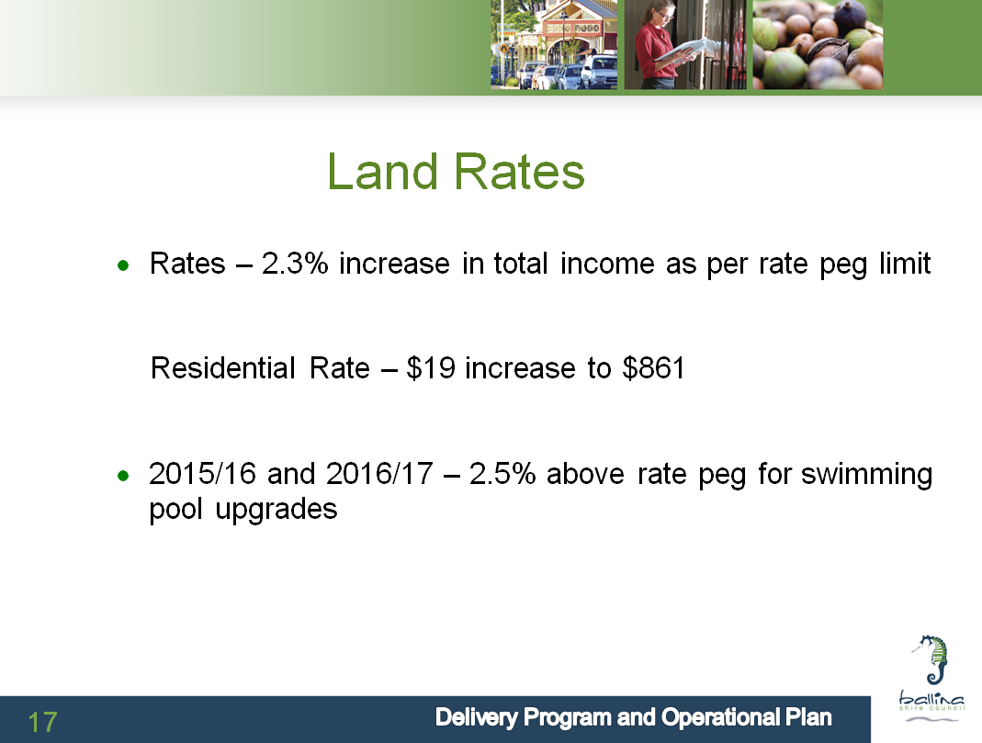

Council did not place a heavy focus on this proposal in adopting the 2014/15 Delivery Program and Operational Plan as the strategy was to undertake a specific and comprehensive consultation process during September to November 2014.

This ensured that the proposal did not become confused with other Council works and services exhibited in the adoption of our 2014/15 documents.

**Phase Two – Specific Consultation Process during September to November 2014**

Council resolved at the 24 July 2014 Ordinary meeting to undertake a focused consultation process, inclusive of the following elements, as a minimum:

1. Fact Sheets
2. Use of Council website
3. Letters to all residents
4. Community Connect advertising
5. Community Survey – Including the Micromex community satisfaction survey and an on-line survey on the Council website
6. Ward Committees
7. Public Meetings at Ballina, Lennox Head and Alstonville
8. Direct Consultation with key interest groups such as the local swimming clubs.

Included as attachments to this application in Attachment 5 are:

1. Media releases and advertisements, including an extract from Council’s Community Connect newsletter for September 2014, a copy of which is distributed to all households in the Shire
2. Consultation summary information sheet
3. Copy of information provided on Council website
4. Council on-line survey
5. Powerpoint presentation delivered to public meetings
6. Initial letter mailed direct to all ratepayers
7. Second letter delivered to all ratepayers either by second rate instalment notice or through direct mail
8. Extract of questionnaire from Micromex community survey which randomly sampled 500 residents on community satisfaction and levels of importance. The special rate variation proposal was also included as part of this survey.

Importantly, as per points f) and g), Council wrote to all ratepayers (property owners) twice during the consultation process.

The first correspondence was written directly to all property owners as per Council’s rating records. This correspondence provided an overview of the proposal.

The second correspondence was written following some limited feedback that the initial correspondence was not adequately clear in respect to the proposed increase being a permanent increase to Council’s rate income. Following discussions with IPART staff a second letter was sent highlighting that the increase was intended to be permanent.

This second correspondence was sent with the second rate instalment notice to all property owners to reduce mailing costs, and direct mail was also sent to any owners who had paid their rates in full prior to the second instalment.

From Council’s perspective there was and remains a high level of awareness of this proposal in the community as demonstrated in the level of submissions received as per section 4.2, as follows.

## Feedback from the community consultations

Summarise the outcomes and feedback from the council’s community engagement activities. Outcomes could include the number of attendees at events and participants in online forums, as well as evidence of media reports and other indicators of public awareness of the council’s special variation intentions. Where applicable, provide evidence of responses to surveys, particularly the level of support for specific programs or projects, levels and types of services, investment in assets, as well as the options proposed for funding them by rate increases.

Where the council has received submissions from the community relevant to the special variation, the application should set out the views expressed in those submissions. Please refer to Section 1.2 concerning how the council should handle confidential content in feedback received from the community. The council should also identify and document any action that it has taken, or will take, to address issues of common concern within the community.

***Council Submission***

The feedback from the community consultation was reported to the Council meeting held 27 November 2014. A copy of that report is included in Attachment 13.12.

In summary Council received a significant amount of feedback with the level of response summarised as follows:

**Public Meetings**

Attendance numbers were Lennox Head (17), Alstonville (52) and Ballina (51). These meetings were for information only with no vote taken.

**Written submissions**

A total of 367 submissions received with the level of support as follows:

**Preference Number Percentage**

No 300 84

Conditional Support 12 3

Yes 45 13

In addition to the 357 who provided their level of support or otherwise, another 10 respondents just provided a general commentary.

**On-line submissions**

A total of 1,750 online survey responses completed with the level of support as follows:

**Preference Number Percentage**

No 1,214 70

Conditional 189 11

Yes 336 19

The number of preferences is less than the 1,750 as not every respondent completed this question in the on-line survey.

**Micromex Survey**

A total of 500 residents were surveyed by Micromex as part of our community satisfaction surveys.

**Support Levels Supportive of Upgrade Supportive with Rate Increase**

Very Supportive 36 20

Supportive 32 21

Somewhat Supportive 15 19

Not very Supportive 9 15

Not at all Supportive 8 25

**Ward Committees**

Council has established Ward Committees (Council is divided into A, B and C Wards for the local government elections) with each of the Committees consisting of approximately 15 to 20 community groups, with one representative from each group able to attend meetings.

The proposal was considered by each of the Ward Committees, with A Ward noting the proposal, B Ward considered the proposal “prudent and appropriate” and C Ward only discussed the matter with the minutes not showing any agreed position.

**Media Articles and Letters to the Editor**

There were a number of media articles and letters to the Editor. Copies are included in Attachment 5.

**Summary of Feedback**

As outlined in the attached Council report the majority of written and on-line responses to the proposed special variation were not supportive, with the only anomaly being the Micromex survey that resulted in 60% of respondents being supportive or somewhat supportive.

The opposition to the proposal consisted of five main themes with Council’s response to those comments as follows.

1. Council’s rates are unaffordable – Council is very mindful of this and as per Section 3.1 of this application our general rates remain comparatively low compared to similar councils
2. Council should have been putting money away for these works – Council shares those sentiments and unfortunately the reality of our financial position is that we are unable to set aside funding approaching $8m due to the need for other essential works and services across the Shire.
3. The pools should be user pays – The fees for the swimming pools will be reviewed as part of any redevelopment however with total income for the pools currently at approximately $350,000 and current cash operating expenses at $818,000, along with loan repayments then estimated at $800,000 to $900,000 per annum, any increase in fees will have negligible impact on the overall financial position of the swimming pools.
4. It is unfair to charge all ratepayers for these works – This was one of the major issues coming through the consultation with many people not supportive of the proposal as they are not direct users of the swimming pools.

The Council position on this is if the works proceed without the special rate variation, then major revenue funded services such as roads and open spaces will need to have their service levels reduced to finance the works. This would then have a direct impact on many or all ratepayers.

1. Council does not have a firm program of works – Council has confirmed a preliminary program of works as per this submission and as per the reports included in Attachment 13, with that program having been researched over many years. If Council receives approval for this special variation we will then be in a position to expend monies on obtaining more detailed estimates and actual costs for the works.

The Mayor also provided a detailed response to all people who provided a submission with a copy of that response included in Attachment 5.

**Council Actions in Response to Submissions**

The key actions Council is taking in response to the submissions are:

1. undertaking a realistic and essential works program to minimise the funds needed for the works
2. Council slightly reduced the proposed increase from 5.5% for 2015/16 and 5.5% for 2016/17 to 5.41% and 5.34% respectively to help reduce the impact of the increase. These percentages reflect the latest available rating revenue information.
3. reviewing the proposed increases in our water, wastewater and waste charges to ensure the overall impact on ratepayers is minimised. The latest review of our LTFP includes far lower increases in these charges for 2015/16 onwards as compared to the LTFP adopted for 2014/15.
4. committing to a review of the swimming pool fees to maximise the revenue from the facilities, thus reducing the overall impact on the General Fund budget
5. continuing to communicate and inform the community in respect to the overall fees and charges levied by Ballina Shire Council. Included in Attachment 13.13 is an extract from the December 2014 edition of the Council’s Community Connect magazine that outlines our rates and charges along with providing comparisons to similar councils.

# Assessment criterion 3: Impact on ratepayers

Criterion 3 within the OLG Guidelines is:

*The impact on affected ratepayers must be reasonable, having regard to both the current rate levels, existing ratepayer base and the proposed purpose of the variation. The IP&R processes should:*

* *clearly show the impact of any rises upon the community*
* *include the council’s consideration of the community’s capacity and willingness to pay rates and*
* *establish that the proposed rate increases are affordable having regard to the local community’s capacity to pay.*

The impact of the council’s proposed special variation on ratepayers must be reasonable. To do this, we take into account current rate levels, the existing ratepayer base and the purpose of the special variation. We also review how the council’s IP&R processes have assessed whether that the proposed rate rises are affordable having regard to the community’s capacity and willingness to pay.

## Impact on rates

Much of the quantitative information we need on the impact of the special variation on (General Fund) rate levels will already be contained in Worksheet 5a and 5b of Part A of the application.

To assist us further, the application should set out the rating structure under the proposed special variation, and how this may differ from the current rating structure, or that which would apply if the special variation is not approved.

We recognise that a council may choose to apply an increase differentially among categories of ratepayers. If so, you should explain the rationale for applying the increase differentially among different categories and/or subcategories of ratepayers. This will be relevant to our assessment of the reasonableness of the impact on ratepayers.

Councils should also indicate the impact of any other anticipated changes in the rating structure.

***Council Submission***

Council is not proposing any other changes to the rating structure through this special variation. The only change will be the higher base charge and higher rate in the dollar if the special variation is approved. Council has received new land values for the 2015/16 financial year and variations in land values will typically result in some fluctuations through the Shire.

Council’s existing rating structure can be summarised as follows:

* Residential Rate – Approximately 50% of the rate income from base charges to minimise the impact of variances in land values
* Business Rate – Council policy is to levy approximately 20% of the total rate yield from business rates. Prior to this policy being introduced the Ballina Shire average business rate was the lowest in the State for Group 4 councils
* Farmland Rate – The rate in the dollar is typically approximately 80% of the residential rate with this calculation determined following the calculation of the business rate
* Mining Rate – Council does not have any properties categorised as mining. The mining rate is set at the same as the business rate for the purposes of adopting the rates each year.
* Base Charge – The same base charge is applied to business and farmland properties as calculated for the residential properties; i.e. all properties pay the same base charge.

In respect to the direct impact on ratepayers the average variances were included in the two items of direct correspondence forwarded to all ratepayers as included in Attachment 5.

A summary of the information used in the consultation process is as follows.

**Estimated Variation to Average Rates Per Category of Property**

**(as per consultation process)**

|  |  |  |  |  |
| --- | --- | --- | --- | --- |
| **Item** | **2014/15** | **2015/16** | **2016/17** | **2017/18** |
| **Estimated Rate Pegging** |  | **3%** | **3%** | **3%** |
| Average Residential Rate | 859 | 885 | 911 | 938 |
| Average Business Rate | 2,869 | 2,955 | 3,044 | 3,135 |
| Average Farmland Rate | 1,314 | 1,353 | 1,394 | 1,436 |
|  |  |  |  |  |
| **Additional Percentage** |  | **2.5%** | **2.5%** | **0%** |
| Average Residential Rate | 859 | 906 | 956 | 985 |
| Average Business Rate | 2,869 | 3,027 | 3,193 | 3,289 |
| Average Farmland Rate | 1,314 | 1,386 | 1,463 | 1,507 |
|  |  |  |  |  |
| Average Extra Rates Each Year |  |  |  |  |
| Residential Extra | 0 | 21 | 45 | 46 |
| Business Extra | 0 | 72 | 149 | 153 |
| Farmland Extra | 0 | 33 | 69 | 71 |

The actual increases will now be slightly less based on the revised percentage increases of 5.41% and 5.34%.

### Minimum Rates

The special variation may affect ordinary rates, special rates and/or minimum rates.

|  |  |  |
| --- | --- | --- |
| Does the council have residential minimum rates? | Yes | No X |

If *Yes*, Does the council propose to increase the minimum residential rate by:

The rate peg percentage

The special variation percentage

Another amount  Indicate this amount _____________

What will the residential minimum rate be after the increase? _________

The council must explain how the proposed special variation will apply to the minimum rate of any ordinary and special rate, and any change to the proportion of ratepayers on the minimum rate for all relevant rating categories that will occur as a result.

You should also explain the types of ratepayers or properties currently paying minimum rates, and the rationale for the application of the special variation to minimum rate levels.

## Consideration of affordability and the community’s capacity and willingness to pay

The council is required to provide evidence through its IP&R processes, and in its application, of how it assessed the community’s capacity and willingness to pay the proposed rate increases. This is to include an explanation of how the council established that the proposed rate rises are affordable for the community.

Evidence about capacity to pay could include a discussion of such indicators as SEIFA rankings, land values, average rates, disposable incomes, the outstanding rates ratio and rates as a proportion of household/business/farmland income and expenditure, and how these measures relate to those in comparable or neighbouring council areas.

As many of these measures are highly aggregated, it may also be useful to discuss other factors that could better explain the impact on ratepayers affected by the proposed rate increases, particularly if the impact varies across different categories of ratepayers.

We may also consider how the council’s hardship policy (see Section 5.3 below) might reduce the impact on socio-economically disadvantaged ratepayers.

***Council Submission***

A key consideration for Council has been our overall level of rates and charges and how they compare with similar councils. Section 3.1 identified the current average ordinary rates for the councils listed as per the following table.

**Benchmarking – Average Ordinary Rates for 2014/15 ($)**

**Council Ballina Byron Coffs Lismore Rich Val Tweed**

Residential 859 1,077 1,006 1,134 785 1,290

Business 2,869 2,668 3,585 4,588 2,219 3,087

Farmland 1,314 1,787 1,846 2,180 1,270 2,122

Also the total rates and charges account for these councils was examined, with a copy of the extract from Council’s Community Connect magazine identifying the following total rates and charges accounts for 2014/15, for the councils listed (copy included in Attachment 13.13).

**Extract from December 2014 Community Connect Magazine**

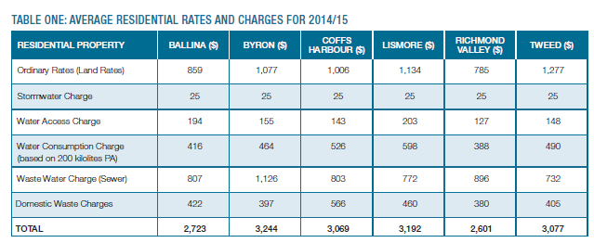

As per this information Ballina Shire Council has a comparatively low ordinary rate to all the councils listed, excluding Richmond Valley, which has IPART approval for 5.5% increases for the next four years, after a 12.5% increase in 2014/15.

Similarly our total rates and charges account is also comparatively affordable.

In respect to the ability of the community to pay some of the key indicators for Ballina Shire Council, along with other councils in the Northern Rivers are as follows.

**Socio-Economic Factors for Northern Rivers**

**Council Ballina Byron Lismore Rich Val Tweed**

SEIFA Score (#) 980 979 946 888 949

SEIFA Index NSW (#) 99 98 66 7 68

SEIFA Index Australia (#) 343 340 216 56 227

Unemployment Rate (%) 4.8 8.5 6.2 6.8 6.4

Employment Participation Rate (%) 61.9 60.8 65.7 57.0 51.3

Per Capita Income ($) 22,565 21,780 20,251 16,097 19,581

Average Wage / Salary Income ($) 41,275 36,242 40,062 38,719 41,876

Property Median Sale Price ($’000) 415 538 342 278 398

Median Weekly Rental – 3 bed house ($) 410 480 320 270 400

Average Age – Years (#) 43 40 39 41 43

Dependency Ratio (%) 66 48 52 69 69

1. *SEIFA – Sourced from ABS website*
2. *Balance of indicators sourced from Ballina Shire Council – Economic Profile – October 2014 – Prepared by Lawrence Consulting – Copy included in Attachment 13.15*

These figures identify that on a comparative basis Ballina Shire has a stronger economy through higher income levels and lower unemployment rates, although house prices and rentals are higher than some of our immediate neighbours.

Our SEIFA ranking is the highest in the region.

Tweed Council is one of the more interesting comparisons in this table as many of the indicators for Ballina and Tweed Shire are similar, however the current average residential rate for Tweed as compared to Ballina is almost 48% higher (i.e. $1,277 compared to $859).

In respect to outstanding rates and charges the percentage outstanding for all rates and charges for the last five financial years is follows:

* 2013/14 – 5.63%
* 2012/13 – 7.05%
* 2011/12 – 7.59%
* 2010/11 – 9.81%
* 2009/10 – 12.17%

Council is not anticipating that this trend of improvement will change due to the proposed special rate variation.

## Addressing hardship

In addition to the statutory requirement for pensioner rebates, most councils have a policy, formal or otherwise to address issues of hardship.

|  |  |  |
| --- | --- | --- |
| Does the council have a Hardship Policy? | Yes X | No |
| If Yes, is an interest charge applied to late rate payments? | Yes X | No |
| Does the council propose to introduce any measures to limit the impact of the proposed special variation on specific groups in the community? | Yes | No X |

You should attach a copy of the Hardship Policy and explain below who the potential beneficiaries are and how they are assisted.

Please provide details of any other measures addressing hardship to be adopted, or alternatively, explain why no measures are proposed.

The council is also to indicate whether the policy or other measures are referenced in the council’s IP&R documents (with relevant page reference or extract provided).

***Council Submission***

Council’s Financial Assistance for Rates, Annual Charges and Fees Policy is included as Attachment 7. This policy was previously titled the “Financial Hardship – Rates and Charges” policy however at its last review in 2011 the policy was renamed to reflect a wider coverage of matters.

The policy provides broad authority for the General Manager to manage applications for financial support. The policy is purposely written this way as it is extremely difficult to cover every scenario in a policy document.

The policy does provide for the option of deferral of rates and charges against the property estate for eligible aged pensioners and self-funded retirees. This was written to assist in managing situations where pensioners may be residing in a prime beachfront location and due to increases in land value the rates on the property may have become unaffordable. Even though this option is now available Council has not actually reached formal agreement with a property owner in respect to this scenario.

Council also has a policy titled “Pensioner Concessions – Rates and Charges” (copy also attached at Attachment 13.14) which outlines how applications for pensioner concessions are to be managed. Importantly this policy, as per clause seven, states that pensioners will not be exempt from interest charges on overdue rates.

At this point in time Council has not identified any additional strategies for the management of personal hardship, primarily as our rates still remain affordable on a comparative basis to a number of other councils in this region. Any applications for hardship will be dealt with on a case by case basis.

# Assessment criterion 4: Public exhibition of relevant IP&R documents

Criterion 4 within the OLG Guidelines is:

*The relevant IP&R documents[5] must be exhibited (where required), approved and adopted by the council before the council applies to IPART for a special variation to its general revenue.*

Briefly outline the significant IP&R processes the council has undertaken to reach the decision to apply for a special variation. Include the details of and dates for key document revisions, public exhibition period(s) and the date(s) that the council adopted the relevant IP&R documents.

You should also include extracts from council minutes as evidence that the documents were adopted.

The council is reminded that amendments to the Community Strategic Plan and Delivery Program require public exhibition for at least 28 days prior to adoption, while amendments to the Long Term Financial Plan and Asset Management Plan/s do not require public exhibition.

***Council Submission***

The Community Strategic Plan (CSP) was adopted by Council following the 2012 local government elections and prior to 30 June 2013.

The consultation for the CSP resulted in Council adopting four key directions, or community aspirations, for the Council to follow, with a “Connected Community” being the direction relevant to this application.

A summary of the outcomes and benefits identified for a Connected Community, as per page 22 of the adopted CSP, is as follows. (Refer Attachment 1)

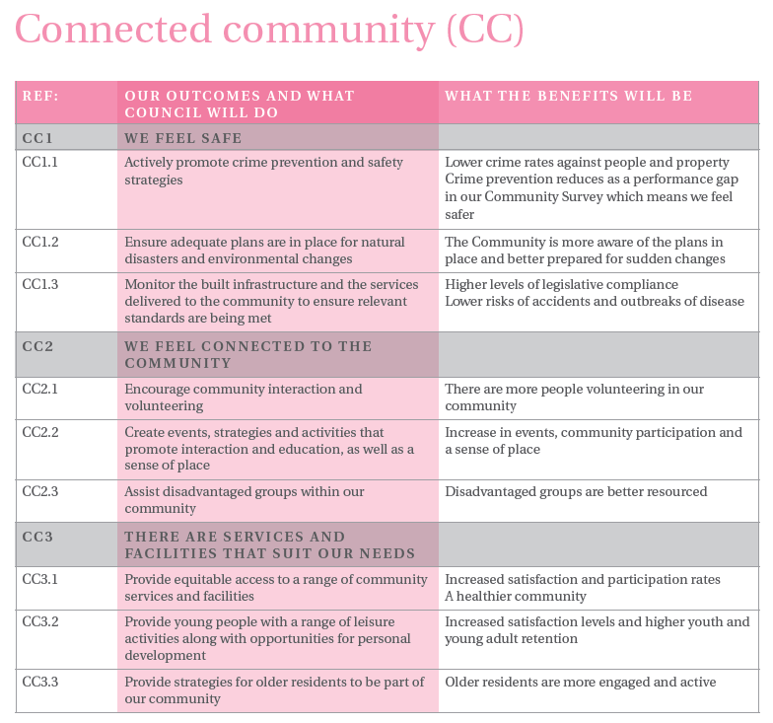

References CC3.1, CC3.2 and CC3.3 identify outcomes that have a direct linkage to improved recreational facilities such as swimming pools.

Council adopted the CSP on 28 March 2013 as per the following resolution:

*That Council adopts the Community Strategic Plan, as exhibited and attached, subject to the changes identified within this report.*

In respect to the Delivery Program (DP) and Operational Plan (OP) both documents were reviewed by Council during 2013/14 for adoption for the 2014/15 financial year.

Items of particular relevance for this application are as follows:

1. 18 March 2014 Finance Committee meeting - Council reviewed its forward capital works program and funding options and based on the contents of that report adopted the following recommendation:

*That Council support a redevelopment of the Ballina and Alstonville pools as soon as practicable seeking Federal and State Government Grants, along with receiving a report on the use of special rate variations to assist in funding this work.*

1. 8 April 2014 Finance Committee meeting - Council reviews special rate options for the swimming pools and recommends as follows:

*1. That Council provides in principle support for a proposal to seek a special rate variation to finance the refurbishment and redevelopment of the Ballina and Alstonville swimming pools.*

*2. That based on Council’s current information the special variation would need to be a 5.5% increase in the rate pegging limit for 2015/16 and 2016/17, assuming a base rate pegging increase of 3% (i.e. 2.5% special variations).*

*3. That Council include points one and two in the draft 2014/15 Delivery Program, Operational Plan and Long Term Financial Plan for exhibition purposes.*

*4. That Council receive a further report on how these actions are to be implemented following the completion of the exhibition period for the draft 2014/15 Delivery Program and Operational Plan.*

1. Council’s draft Integrated Planning and Reporting documents include references to this proposal. Extracts from the draft documents, along with the presentation material used for the public meetings are as follows:

***Draft Delivery Program***

Page 14 of the Draft Delivery Program, as exhibited and then subsequently adopted, had particular reference to the proposed upgrades of the swimming pools, as per the following extract.

This extract provides linkages to the CSP, along with the links to the NSW State Plan (NSW 2021).

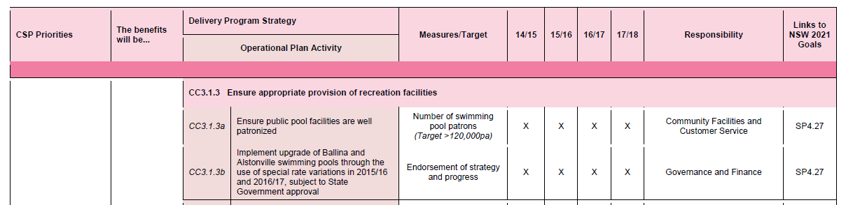

***Draft Operational Plan***

The draft Operational Plan, which formed a sub-set of the draft Delivery Program, then included the following references to this proposal as outlined below

***Capital Expenditure – extract from page 33 of Draft Operational Plan***

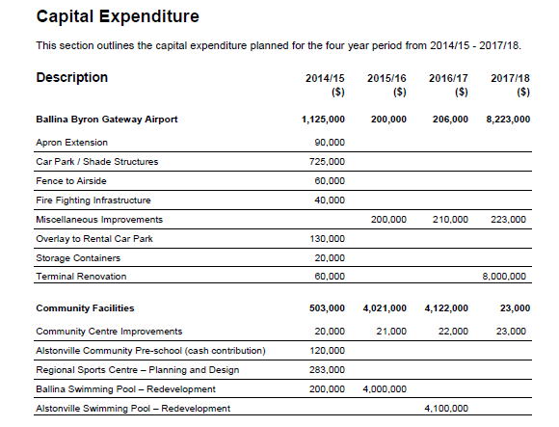

***Revenue Policy – extract from page 44 of the draft Operational Plan***

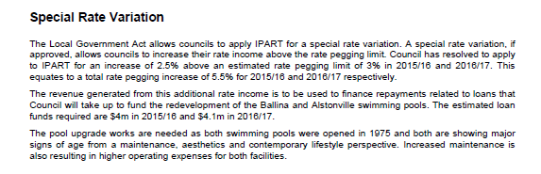

***Revenue Policy – extract from page 45 of the draft Operational Plan***

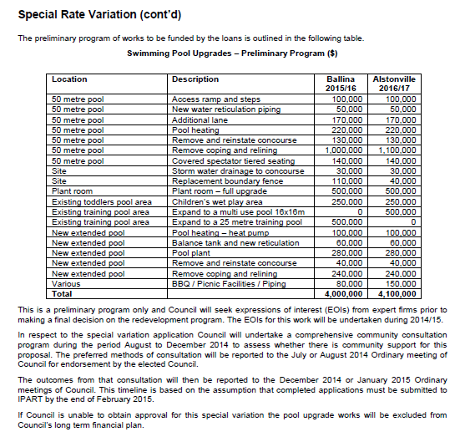

***Public Meetings***

***Copy of slide from public meetings held at Wardell and Lennox Head***



***Draft LTFP for 2014/15***

***Swimming Pools Program – extract from page 21 of the draft LTFP***

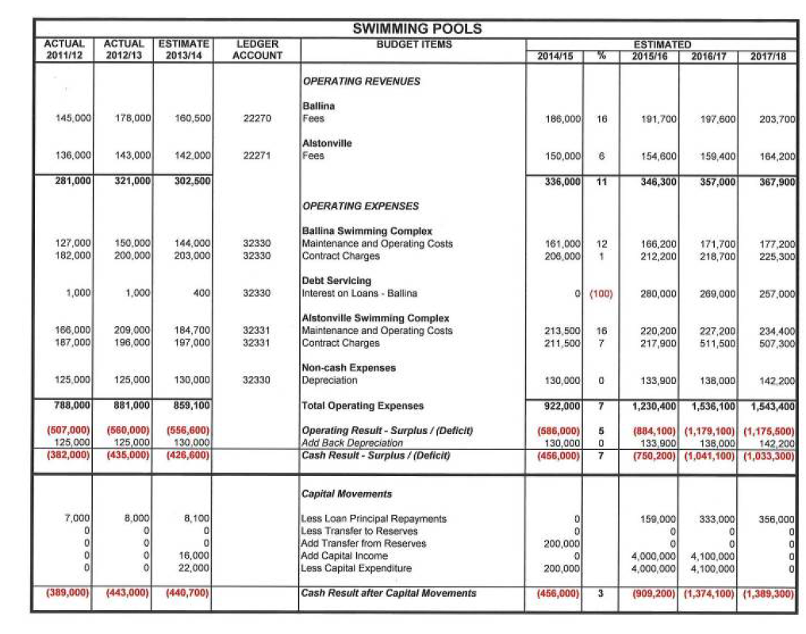

1. Council’s draft Delivery Program, Operational Plan and Long Term Financial Plan were then adopted at the 26 June 2014 Ordinary meeting with that comprehensive resolution as follows: (Refer also Attachment 12).

***260614/1 Resolved***

*(Cr Sharon Cadwallader/Cr Robyn Hordern)*

*1. That Council adopts the 2014/15 to 2017/18 Draft Delivery Program and 2014/15 Operational Plan, and associated documents, as exhibited, inclusive of any amendments determined at this meeting or at the May Ordinary meeting, whilst the documents were on exhibition.*

*2. That Council approves the formation of a Committee comprising all Councillors, to consider the applications for general and hall donations for 2014/15.*

*3. That in respect to the various submissions for fees and charges and works and services Council endorses the following actions, subject to any further changes at this meeting:*

*a) Leona Ross – Noted with a reduction in the water charges recommended (reduction in water charges approved later in meeting)*

*b) Max Moffitt – Noted with no change.*

*a) Far North Coast Lifesaving – Lifesaver patrols – Defer until tender completed*

*b) Far North Coast Lifesaving – Shelly Beach Surf Club – No action as priorities already determined (funding approved later in meeting)*

*c) South Ballina Residents Association – Actions noted as per contents of this report.*

*d) Richmond River County Council – Include additional funding of $35,000 in 2014/15 funded from General Revenue, with this funding only available if all constituent councils contribute.*

*e) Alstonville Plateau Historical Society – Noted with no change.*

*f) Ballina Environment Society – Noted with no change.*

*g) Womensport NSW – Inclusion of an additional Operational Plan action to improve our measurement of women and girls participation in sport*

*h) Lennox Head Residents Association – Actions noted as per contents of this report.*

*i) David Felsch – noted with no change.*

*4. That Council based on the feedback from the public meeting held at Wardell Hall include the following additional action in the 2014/15 Operational Plan:*

*Analyse options for the delivery of affordable housing in Wardell.*

*5. That Council notes the overview provided of the changes to the Long Term Financial Plan, with the General Fund now predicting a working capital deficit of $95,300 for 2014/15, subject to any further changes resolved as part of this report.*

*6. That Council approves the gate fees at the waste centre for 100% sorted reusable waste (clean topsoil and fill) to be increased from $53/tonne to $66/tonne.*

*7. That Council approves the gate fees at the waste centre for 100% recyclable inert (clean bricks, tiles rock) to be increased from $64/tonne to $86/tonne.*

*8. That Council approves the gate fees at the waste centre for excavated material (clean excavated natural material) to be increased from $49/tonne to $66/tonne.*

*9. That Council approves the introduction of a new fee titled ‘missed collection charge’ for instances when the customer has not presented their bin for collection and subsequently ask for the bin to be collected. The fee will be based on a ‘price on application’ calculation.*

*10. That Council approves amendments to the gate fees at the waste management centre such that any pricing referencing a sedan or station wagon is amended to include the words ‘minimum fee’.*

*11. That Council based on the information contained in this report and the latest water consumption figures approves an amendment to the 2014/15 water annual and consumption charges as per the following table:*

|  |  |  |
| --- | --- | --- |
| ***Charge Type*** | ***2013/14*** | ***2014/15 (6%)*** |
| *Water Access Charge - 20mm meter* | *178* | *189* |
| *Water Consumption under 350kl* | *1.91* | *2.02* |
| *Water Consumption over 350kl* | *2.87* | *3.04* |
| *Vacant Land Charge* | *178* | *189* |

*12. That Council notes the comments in this report in respect to the application of the Hoarding Fee.*

*13. That Council resolves to make a base rating structure for the levy of the 2014/15 Ordinary Rate as per the following structure.*

|  |  |  |  |
| --- | --- | --- | --- |
| ***Rate Category*** | ***Rate in Dollar (cents in $)*** | ***Base Amount***  ***($)*** | ***% Income from Base Amount*** |
| *Residential* | *0.165306* | *429* | *49.85* |
| *Business* | *0.604521* | *429* | *14.74* |
| *Farmland* | *0.133971* | *429* | *32.64* |
| *Mining* | *0.604521* | *429* | *00.00* |

*14. That Council resolves to make the 2014/15 rates and charges as per the advertised Operational Plan and Delivery Program, inclusive of any amendments adopted at this meeting.*

*15. That Council approves the addition of the following measurement in the 2014/15 Operational Plan as identified within this report:*

|  |  |  |
| --- | --- | --- |
| *Customer requests are dealt with effectively and promptly* | *% completed within allocated timeframe*  *(Target > 85%)* | *Governance and Finance* |

*FOR VOTE - Cr David Wright, Cr Sharon Cadwallader, Cr Keith Williams, Cr Keith Johnson, Cr Susan Meehan, Cr Ken Johnston, Cr Paul Worth, Cr Robyn Hordern and Cr Ben Smith*

*AGAINST VOTE - Cr Jeff Johnson*

1. Council then received another report on the special rate variation proposal at the 24 July 2014 Ordinary meeting with Council resolving to undertake a more specific and comprehensive consultation process for the special rate variation proposal. A copy of that resolution is as follows:

*1. That Council confirms that its community engagement strategy for the proposed special rate variation of 5.5% in 2015/16 and 2016/17 to finance the redevelopment of the Alstonville and Ballina swimming pools will include as a minimum the following actions:*

*a) Fact Sheets*

*b) Use of Council website*

*c) Letters to all residents*

*d) Community Connect advertising*

*e) Community Survey – Including the Micromex community satisfaction survey and on-line survey on the Council website*

*f) Ward Committees*

*g) Public Meetings at Ballina, Lennox Head and Alstonville*

*h) Direct Consultation with key interest groups such as the local swimming clubs.*

*2. That Council authorises the General Manager to conduct a tender process to select the preferred consultant to assist Council with the redevelopment of Alstonville and Ballina Swimming Pools.*

*FOR VOTE - All Councillors voted unanimously.*

1. The outcomes from this consultation process were then reported to the 27 November 2014 Ordinary meeting where Council resolved as follows:

*1. That Council acknowledges the feedback from the community consultation process undertaken for the special rate variation application for upgrades to the Ballina and Alstonville swimming pools.*

*2. In acknowledging this consultation Council remains of the opinion that additional funds are needed to upgrade these pools for the following reasons:*

*a) the ever growing need for refurbishment of the pools due to the condition of the existing infrastructure*

*b) the increasing operating costs*

*c) the potential operating efficiencies to be gained through pool upgrades and the use of modern technologies*

*d) the push by the Office of Local Government for councils to concentrate on asset renewal*

*e) the Council’s comparatively low rate base and*

*f) the additional funds help to improve Council’s overall financial position in respect to our operating result.*

*3. That based on points one and two Council authorises the General Manager to submit an application to IPART for a special rate variation, however the application is to be varied from that proposed in the community consultation, with the amended percentages being 5.41% for 2015/16 and 5.34% for 2016/17, based on the latest available rating information as per Table Six.*

A copy of this report is included in Attachment 13.12, and copies of all other reports are available on our website – refer to Quick Links – Minutes and Agendas.

# Assessment criterion 5: Productivity improvements and cost containment strategies

Criterion 5 within the OLG Guidelines is:

*The IP&R document or the council’s application must explain the productivity improvements and cost containment strategies the council has realised in past years, and plans to realise over the proposed special variation period.*

In this section, you must provide details of any productivity improvements and cost containment strategies that you have implemented in the last two years (or longer) and any plans for productivity improvements and cost containment during the period of the special variation.

These strategies, which may be capital or recurrent in nature, must be aimed at reducing costs and/or improving efficiency. Indicate if any initiatives are to increase revenue eg, user charges. Identify if the proposed initiatives (ie, cost savings), have been factored into the council’s resourcing strategy (eg, LTFP and AMP).

Where possible, the council is to quantify in dollar terms the past and future productivity improvements and cost savings.

The council may also provide indicators of efficiency, either over time or in comparison to other relevant councils. We will make similar comparisons using various indicators and OLG data provided to us.

***Council Submission***

Items of relevance to this application are as follows.

**Road Resurfacing Strategy**

At the December 2014 Ordinary meeting Council adopted a resurfacing strategy in respect to the management of resealing the existing road network. This issue arose as new subdivisions in the Shire have traditionally had their road network constructed with an asphaltic concrete (AC) surface. As many of these roads are now becoming due for resealing Council debated whether the roads should be resurfaced with AC or bitumen, with bitumen having a lower cost and a lesser life.

From a whole of life cost perspective bitumen is the most cost effective option, however it does represent a lower level of service (surface not as smooth and slight increase in noise).

Council subsequently adopted a strategy of converting AC to bitumen with the exception of some higher order (increased traffic volumes) roads.

The estimated benefits to Council from this process were identified in the report as follows:

Model 10 year total cost 10 year average cost

Scenario 1 – Like for Like $12,868,160 $1,286,816

Scenario 2 - Bitumen $7,580,157 $758,016

Scenario 2, being the adopted approach, means that Council is now able to stretch its road funding over a significantly greater amount of road resealing projects, than what would be the case if the like for like, scenario one approach, was adopted.

This process will result in better asset management outcomes as more assets (roads) will be resealed within the funding available. There is no change to the LTFP as existing funding allocation is being used more cost effectively.

**Solar Power and Energy Efficiency**

Council has recently installed a 1,200 panel solar power system at the West Ballina Waste Water Treatment Plant. The system has been designed to produce (conservatively) 466,000 kilowatt hours per annum. This is expected to provide approximately $9,500 a month in savings on current electricity consumption. The system is understood to be the largest bank of solar panels in NSW.

Even though this is a Sewer Fund activity, it helps to highlight Council’s commitment to expense reduction.

Other General Fund related energy efficiency programs undertaken include:

1. Council entered a street lighting upgrade program in 2012 which involved the replacement of all Mercury Vapour street lighting in the minor public road network with more energy efficient 46 watt PL fluorescent streetlight fittings. This has resulted in approximately 30 percent reduction in energy consumption, resulting in savings of approximately $40,000 per annum.
2. During 2013 Council installed solar tube water heating at the Alstonville Leisure and Community Centre with an estimated saving of approximately $5,000 per annum.
3. The Council Administration building has been retrofitted with energy efficient T5 lighting. This is estimated to reduce energy consumption in the building by up to 20 percent with estimated savings of $10,000 per annum.

Savings are included in the LTFP.

**Information Technology**

Council continues to pursue operating efficiencies through a range of information technology improvements with recent actions including:

1. Electronic Forms (eforms) – Council has introduced a large number of electronic forms to reduce paperwork and improve efficiency in data collection and processing. Time savings when completing eforms are substantial.

For example, playground inspections previously took around three to four hours in completing paper forms on site, taking photos, going back to the office, downloading photos, compressing them, typing up the inspection results, printing, signing, scanning and then putting into Council’s electronic data management system (EDMS). This process now takes 20 to 30 minutes, as everything is captured in the eform on site and when staff click on submit, the information goes straight into the EDMS, with no return to the office required. The estimated efficiency gains across the organisation are in the tens of thousands of dollars, if not more.

1. DigSafe Pro Software Implementation – This system now provides automatic responses to Dial Before You Dig requests, resulting in a significant reduction in time taken by staff looking for information and sending manual responses. The business case for this process identified cost efficiencies between the ongoing manual processing and an automated software response, based on an average processing of 1,230 enquiries per year, with manual processing costing us $112,000, whereas using DigSafe Pro, the estimated cost is $25,000.
2. Online Recruitment – Council has implemented an on-line recruitment process resulting in significant reduction in paperwork and manual processing. Estimated efficiency gains $20,000 plus per annum.
3. Human Resources (HR) Software Integration – Council is integrating standalone HR software into our core corporate system, which will result in improved business processes and a significant reduction in paperwork. For example, the annual staff appraisals will be conducted online this year, which will save numerous hours in copying appraisals, filing etc.
4. Asset Management – Existing standalone spreadsheets and software systems have been integrated into Council’s core corporate system. This was identified as the major weakness in Council’s Asset Management practices, as per the Office of Local Government State wide audit. This has and will continue to result in significant savings through improved modelling and processing, along with major savings in the depreciation expense, based on a review of useful life calculations and condition assessments.
5. Australia Post Digital Mailbox – Introduction of the electronic delivery of rates and charges notices has resulting in savings in paper and postage. Estimated saving to date $5,000pa with savings to grow over time.
6. Integration of Council’s EDMS into our Web Content Management System - This facilitates the publishing of web documents directly from the EDMS and reduces duplication and staff effort maintaining currency of documents available to the public resulting in efficiency gains.
7. GPS Monitoring in Vehicles - This has assisted in the measurement and management of production, and the setting of service levels, in areas such as open space mowing, waste service collection, and hydrant maintenance.

Based on the use of this technology, along with other operational adjustments, the open space operating expense budget, as at 31 December 2014, is trending in excess of $50,000 better than budget, with any surplus funds to be transferred to capital to increase our investment in the renewal of assets for open spaces.

Further activities, for example street sweeping and pothole maintenance will be included in this program in 2015.

These actions represent efficiency gains within existing budgets. There may be a change to the LTFP once confirmed savings to open spaces is known, with the savings being transferred to capital works for open spaces.

**Community Facilities**

Actions implemented to reduce operating costs, or to generate efficiencies, for our community facilities program include:

1. Establishment and operation of the fully integrated on line booking system for all of Council’s community facilities. These can all now be managed from the one place delivering significant staff efficiencies – Estimated productivity gain is $10,000 to $20,000 per annum
2. Leasing out floor space at the Kentwell Community Centre to On-Track Community Programs. On-Track, a private company, receive an affordable work space (which is critical to their business model) and then manage all the casual hirers of that community facility eg setting up, cleaning up - Estimated saving in employee costs of $20,000 per annum recurrent – Included in LTFP.
3. Improving the focus on shop stock/sales at Council’s Northern Rivers Community Galley (NRCG) to increase revenue. In early 2015 we will be establishing retail space for the NRCG at the Ballina/Byron Gateway Airport (direct access to about 440,000 airport users every year) to further increase revenues. Council has also achieved Gift Recipient Status for NRCG to encourage giving by miscellaneous donors. There is no substantial change to the LTFP, with income anticipated to grow over time.

**Procurement**

Following a review of Council’s procurement practices by ArcBlue Pty. Ltd., who provide procurement advice to numerous NSW and Victorian councils, Council has adopted a centre led procurement model to improve efficiencies. The centre led model places an emphasis on a centralised procurement service and improved stock management.

Benefits gained from this process during the past six months include:

1. A number of stock inventory supply arrangements have been rationalised consequent to improved reporting data and inherent staff skills, bringing purchase efficiencies and lower costs. One such example has occurred with a number of single product/single supplier items (c.10-15) now being sourced and consolidated via Blackwoods Pty Ltd, usually at more competitive prices.
2. All inward and outward freight movements have been consolidated via the Council Store for preparation, electronic booking; documentation; costing and traceability. This allows us to effectively monitor and enact our Standard Purchasing Condition that quote/invoice amounts for all purchased goods be delivered to Council “Free into Store”. This allows more effective comparisons of quoted prices from multiple suppliers.
3. In conjunction with relevant Water and Wastewater staff, dialogue has commenced with offshore suppliers of high value; high turnover consumable items (i.e. water filter membranes, electric ballast, etc) with a view to gaining significant cost efficiencies, subject to satisfactory testing of sample consumables.
4. The Store warehouse has been redesigned to provide a more effective workflow and rack and shelf designation enhanced to assist with quicker identification/locating of stock.
5. After successful testing in a demonstration environment, “satellite” warehouses at critical off depot sites such as the Waste Water Treatment Plants will be created, monitored and maintained by Stores/Procurement Officers allowing purchase and stock maintenance processes to take effect to ensure stringent management of critical item stock levels and holdings. The predominant stock will continue to be held by Depot Store, however smaller quantities of critical items will be monitored, maintained, supplied from Depot Store and constantly accounted for at these “satellite” warehouses.
6. A regular and improved reporting structure around slow moving stock will aid in excess/slow stock being either returned to suppliers for credit or disposed of at auction or tender according to Council guidelines.
7. The success of 22 December 2014 stocktake (total stock adjustment <$90) has confirmed that the operation of the Store has now reached the stage where current practices and minor continuing enhancements to processes will ensure continuous improvement. Further technology refinements in terms of barcode utilisation to track inward and outward stock is an ongoing project but is constrained by current software limitations.
8. As part of the management of Stores and Stock processes, major and minor group categorisation has been assigned to each current stock item. In order to maintain consistency, the categories allocated are those which have been supplied by Local Government Procurement (LGP). This Major and Minor group categorisation will be extended to services and non-stock goods in order to be able to present and review a consolidated overview of supplier/commodity spend.
9. Discussions have taken place with a number of local trades suppliers with a view to rationalising the high volume of small value invoices raised for ad-hoc purchases by trades staff. Close co-ordination is taking place with Accounts Payable and Finance staff to develop solutions along the lines of standing orders; settlement of monthly accounts via Corporate Credit Card.

Significant price efficiencies are anticipated from this process of improvement with no financial change yet included in the LTFP.

**Non-replacement of staff positions and management of salaries**

For the 2014/15 financial year Council resolved to suspend the replacement of five positions within the organisation structure. In current preparations for the 2015/16 budget, similar savings are being sought with the 2014/15 and 2015/16 budget savings as follows.

**Description Days Per Week 2014/15 ($) 2015/16 ($)**

GIS Officer Five 62,000 0

Building Surveyor 2.5 days 52,000 0

Strategic Planner Three 47,000 50,000

Debtors Officer Two 26,000 29,000

Depot Assistant 2.5 days 31,000 36,000

Health Officer 2.5 days 0 54,000

**Total Annual Saving 218,000 169,000**

The affordability of all staff positions will continue to be monitored throughout the organisation.

These savings are factored into the LTFP.

Council’s containment of salaries was also clearly enunciated in a benchmarking project that has been undertaken with a number of other councils and coordinated by LG Professionals NSW and PwC (PricewaterhouseCoopers) titled *NSW Local Government Operational and Management Effectiveness.* It is understood 72 councils participated in this survey, including 43 regional councils.

The report for the financial year ending 2013, which is currently the latest report, identified that Ballina Shire Council had a 1.4% decline in headcount and a 1.0% decline in employee costs, with our management of employee costs identified as being in an austerity phase, as per the following extracts from pages 10 and 27 of the report.

***Extract from page 10***

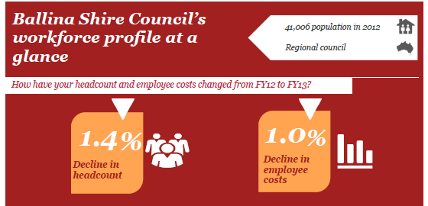

***Extract from page 27***

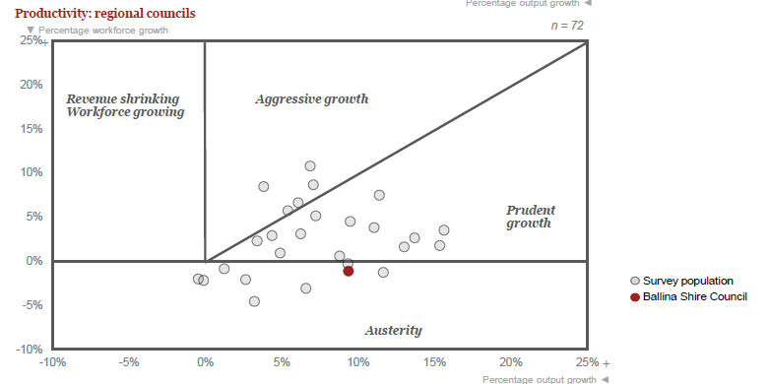

Council has also proactively been pursuing reductions in long service liabilities and sick leave.

The results of these actions are also highlighted in the PwC report, as per the following extracts.

***Extract from page 23***

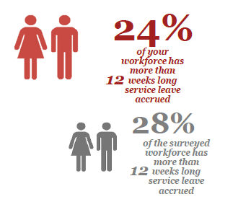

***Extract from page 24***

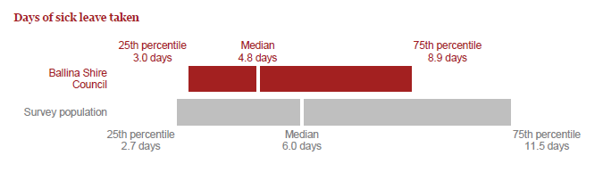

By having reduced LSL liabilities and lower than average sick leave figures Council is producing efficiencies in the hundreds of thousands of dollars, considering total employee costs for the 2013/14 financial year were slightly under $20 million.

**Work Health and Safety (WHS)**

Council has undertaken a comprehensive whole of organisation approach to WHS through partnerships with Workcover and on-going training and information sessions. The PwC report confirmed our performance as per the following extract.

***Extract from page 28***

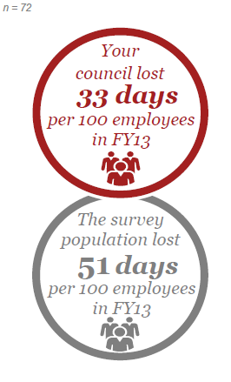

**Increased Revenues**

In addition to expenditure and efficiency savings Council has been pursuing increased revenue opportunities with some of the major projects being:

1. Council is currently seeking an expansion of our existing quarry operations, with the quarries currently paying a dividend to the General Fund of $210,000 per annum.
2. Council has obtained approval from NSW Trade and Investment to seek planning approvals and the dredging licence for the commercial removal of sand from North Creek, Ballina. This sand will assist Council in its own land development activities and will also provide an opportunity for sale on the open market.
3. Council is currently investigating the long term (30 years plus) lease of the Ballina Byron Gateway Airport. The aim of this lease will be to provide an on-going dividend to Council, with those funds being invested into core infrastructure renewal, if the lease proceeds.

The revenues from these three items have not been included in the LTFP as the actual revenues are still to be quantified.

On a smaller scale, other revenue generating activities, include:

1. Strategic land use planning – Substantial increases in fees for rezoning proponents to reflect the “betterment” achieved through increased land values
2. On Site Sewage Management Charge – Increased by approximately 50% to reflect the importance of this service and the need for increased resources to undertake essential inspections.
3. Building Services Fees – A number of fees were increased by 20% to 30% for 2014/15 to better reflect the services provided.

These changes represent increased revenues of approximately $100,000 per annum and they have been incorporated into Council’s LTFP.

**Comparative Benchmarks**

Finally it is also important to again reinforce Council’s existing efficiencies as supported by our comparatively low rate base. The following are extracts from the latest Office of Local Government comparative data report (2012/13):

**Item Ballina Group Four**

Equivalent Full Time Staff 265 staff 312 staff

Population Per Staff Number 155 residents 125 residents

Average residential rate $757 $878

Average business rate $2,437 $3,168

Average farmland rate $1,217 $1,835

Governance / Admin Expend Per Capita $114 $266

Community Services Expend Per Capita $105 $178

Recreation and Culture Expend Per Capita $179 $253

Roads and Bridges Expend Per Capita $495 $350

Building and Infrastructure Renewal Ratio 119% 76%

Infrastructure Backlog Ratio 1.5% 10.65%

Asset Maintenance Ratio 1.1 0.8

What these figures emphasise is that Council is a comparatively low rating, low staffed and low spending Council with a strong focus on asset maintenance and renewal as demonstrated by our positive asset ratios.

# List of attachments

The following is a list of the supporting documents to include with your application. Some of these attachments will be mandatory to all special variation applications eg, Attachment 1, extracts from the Community Strategic Plan. Other attachments will be required from some, but not all, councils. For example, Attachment 10, extracts from the Asset Management Plan, would be required from a council seeking approval of a special variation to fund infrastructure. Councils should submit their application forms and attachments online through the Council Portal in the following order.

|  |  |
| --- | --- |
| Item | Included? |
| **Mandatory forms and Attachments** |  |
| Part A Section 508A and Section 508(2) Application form (Excel spreadsheet) | X |
| Part B Application form (Word document) – this document | X |
| Attachment 1: Relevant extracts from the Community Strategic Plan | X |
| Attachment 2: Delivery Program | X |
| Attachment 3.1: Long Term Financial Plan with projected (General Fund) financial statements (Income, Cash Flow and Financial Position) in Excel format (inclusive of special rate variation) | X |
| Attachment 3.2: Long Term Financial Plan with projected (General Fund) financial statements (Income, Cash Flow and Financial Position) in Excel format (exclusive of special rate variation) | X |
|  |  |
| Attachment 4: TCorp report on financial sustainability | X |
| Attachment 5: Media releases, public meeting notices, newspaper articles, fact sheets relating to the rate increase and special variation | X |
| Attachment 6: Community feedback (including surveys and results if applicable)  Attachment 6.1 – Results of on line survey  Attachment 6.2 – Community Feedback Submissions – Conditional  Attachment 6.3 – Community Feedback Submissions – Other  Attachment 6.4 – Community Feedback Submissions – In Favour  Attachment 6.5 – Community Feedback Submissions – In Opposition – File 1  Attachment 6.6 – Community Feedback Submissions – In Opposition – File 2  Attachment 6.7 – Community Feedback Submissions – In Opposition – File 3  Attachment 6.8 – Community Feedback Submissions – In Opposition – File 4  Attachment 6.9 – Community Feedback Submissions – In Opposition – File 5  Attachment 6.10 – Community Feedback Submissions – In Opposition – File 6 | X |
| Attachment 7: Hardship Policy | X |
| Attachment 8: Resolution to apply for the special variation | X |
| Attachment 9: Certification | X |
| **Other Attachments** |  |
| Attachment 10: Relevant extracts from the Asset Management Plan | X |
| Attachment 11: Past Instruments of Approval (if applicable) | N/A |
| Attachment 12: Resolution to adopt the revised Community Strategic Plan (if necessary) and/or Delivery Program | X |
| Attachment 13: Other (please specify) | X |

**Attachments – Other**

13.1 Pool Link Report – Aquatic Facility Review and Capital Works Report

13.2 Geoff Leaver Report – Planning Options Ballina War Memorial Swimming Pool

13.3 Ballina Shire Aquatic Facilities Strategic Financial Plan Discussion Paper

13.4 Swimming Pools – petition and articles

13.5 Importance Level – 2008 Micromex report

13.6 Importance level – 2012 Micromex report

13.7 Importance level – 2014 Micromex report

13.8 Community Infrastructure Planning Ranking – 2012 Micromex report

13.9 Community Survey Feedback – 2014 Micromex report

13.10 Ridgemill – Brief Status report 20 January 2015

13.11 Extract from External Auditor report re debt ratio

13.12 Report to Ordinary Council meeting 27 November 2014

13.13 Extract from Community Connect newsletter December 2014

13.14 Policy Pensioner Concessions – Rates and Charges

13.15 Economic Profile – October 2014 – Prepared by Lawrence Consulting

# Certification

**APPLICATION FOR A SPECIAL RATE VARIATION**

**To be completed by General Manager and Responsible Accounting Officer**

Name of council: Ballina Shire

We certify that to the best of our knowledge the information provided in this application is correct and complete.

General Manager (name): Paul Hickey

Signature and Date: 12 February 2015

Responsible Accounting Officer (name): Peter Morgan

Signature and Date: 12 February 2015

Once completed, please scan the signed certification and attach it as a public supporting document online via the Council Portal on IPART’s website.

1. The Guidelines are available at [www.olg.nsw.gov.au](http://www.olg.nsw.gov.au)
2. See [www.ipart.nsw.gov.au](http://www.ipart.nsw.gov.au).
3. The OLG’s October 2014 *Guidelines* and the IP&R Manual outline this link between the special variation and the IP&R process.
4. See Planning Circular 10-025 dated 24 November 2010 at [www.planning.nsw.gov.au](http://www.planning.nsw.gov.au) and for the most recent Direction issued under section 94E of the *Environmental Planning and Assessment Act 1979*. See also Planning Circular PS 10-022 dated 16 September 2010.
5. Relevant documents are the Community Strategic Plan, Delivery Program, Long Term Financial Plan and where applicable, the Asset Management Plan.