|  |
| --- |
| Special Variation Application Form – Part B  For 2016-17  Issued January 2016 |
| Insert Name of Council: Lachlan Shire Council  Date Submitted to IPART: 15 February 2016  Council Contact Person: John Chapman  Council Contact Phone: (02) 6895 1910  Council Contact Email: john.chapman@lachlan.nsw.gov.au |
|  |

© Independent Pricing and Regulatory Tribunal of New South Wales 2016

This work is copyright. The *Copyright Act 1968* permits fair dealing for study, research, news reporting, criticism and review. Selected passages, tables or diagrams may be reproduced for such purposes provided acknowledgement of the source is included.

The Tribunal members for this review are:

Dr Peter J. Boxall AO, Chairman

Ms Catherine Jones

Mr Ed Willett

Inquiries regarding this document should be directed to a staff member:

Dennis Mahoney (02) 9290 8494

Tony Camenzuli (02) 9113 7706

Independent Pricing and Regulatory Tribunal of New South Wales

PO Box K35, Haymarket Post Shop NSW 1240

Level 16, 2-24 Rawson Place, Sydney NSW 2000

T (02) 9290 8400 F (02) 9290 2061

[www.ipart.nsw.gov.au](http://www.ipart.nsw.gov.au/)

Contents

1 Introduction 1

1.1 Completing the application form 1

1.2 Notification and submission of the special variation application 2

2 Preliminaries 4

2.1 Focus on Integrated Planning and Reporting 4

2.2 Key purpose of special variation 4

2.3 Capital expenditure review 6

3 Assessment Criterion 1: Need for the variation 6

3.1 Case for special variation - community need 7

3.2 Financial sustainability 12

3.3 Financial indicators 14

3.4 Contribution plan costs above the cap 18

4 Assessment criterion 2: Community awareness and engagement 18

4.1 The consultation strategy 20

4.2 Feedback from the community consultations 22

5 Assessment criterion 3: Impact on ratepayers 25

5.1 Impact on rates 25

5.2 Consideration of affordability and the community’s capacity and willingness to pay 29

5.3 Addressing hardship 31

6 Assessment criterion 4: Public exhibition of relevant IP&R documents 32

7 Assessment criterion 5: Productivity improvements and cost containment strategies 33

8 List of attachments 35

9 Certification 37

# Introduction

IPART will assess each application against the criteria set out in the Office of Local Government’s (OLG) *Guidelines for the preparation of an application for a special variation to general income for 2016/2017* (the Guidelines). Councils should refer to these guidelines before completing this application form.[1]

Each council must complete this Part B application form when applying for a special variation to general income either under section 508A or under section 508(2) of the *Local Government Act 1993*.

In addition, councils must complete the Part B form with the Part A (spreadsheet) form for both s508(2) and s508A applications. The Guidelines also require the council to have resolved to apply for a special variation. You must attach a copy of the council’s resolution. IPART’s assessment of the application cannot commence without it.

If the proposed special variation includes increasing minimum rates above the statutory limit, or is to apply a higher rate of increase to an existing minimum rate than to its other rates, it is not necessary for the council to also complete the separate Minimum Rates Application form. However, this must be clearly identified and addressed in the special variation application. In such circumstances, councils are encouraged to discuss their proposed application with IPART as soon as possible.

As outlined in the OLG’s Guidelines, councils that are the subject of merger proposals will not be eligible for a special variation for the 2016-17 rating year.

## Completing the application form

This form is structured to provide guidance on the information we consider is necessary for us to assess a special variation application. To complete the form, the council will need to respond to questions and insert text in the boxed area following each section or sub-section.

The amount of information that a council provides will be a matter of judgement for the council, but it should be sufficient for us to make an evidence-based assessment of the application. Generally, the extent of the evidence should reflect the size of the variation sought. More complex applications or requests for a high cumulative percentage increase should be supported by stronger, more extensive evidence.

Councils may submit additional supporting documents as attachments to the application (refer to section 8). These attachments should be clearly cross-referenced in Part B. We prefer to receive relevant extracts rather than complete publications, unless the complete publication is relevant to the criteria. If you provide complete documents when only an extract is relevant, we may ask you to resubmit the extract only. (You should provide details of how we can access the complete publication should this be necessary.)

We publish videos and Fact Sheets on how IPART assesses special variations and on the nature of community engagement for special variation applications. These will assist in preparing the application. The latest videos and Fact Sheets on these topics are available on IPART’s website.[2]

We may ask for additional information to assist us in making our assessment. If this is necessary, we will contact the nominated council officer.

This application form consists of:

* Section 2 – Preliminaries
* Section 3 – Assessment criterion 1
* Section 4 – Assessment criterion 2
* Section 5 – Assessment criterion 3
* Section 6 – Assessment criterion 4
* Section 7 – Assessment criterion 5
* Section 8 – List of attachments
* Section 9 – Certification.

## Notification and submission of the special variation application

Notification of intention to apply

Councils intending to submit an application under either section 508(2) or section 508A should have notified us of their intention to apply, via the Council Portal, by Friday, 11 December 2015.

**Any councils that did not notify but intend to apply for a special variation for 2016-17 should contact us as soon as possible.**

On-line submission of applications

All councils intending to apply for a special variation must use the Council Portal on IPART’s website to register as an applicant council and to submit an application.

The Portal is at <http://www.ipart.nsw.gov.au/Home/Industries/Local_Govt>. The [User Guide](http://www.ipart.nsw.gov.au/files/948b8fb1-2e6e-4647-b9d3-a10000a2552a/Local_Government_-_Council_Portal_User_Guide_-_November_2012.pdf) for the Portal will assist you with the registration and online submission process. If you experience difficulties please contact Himali Ranasinghe on (02) 9113 7710 or by email [himali_ranasinghe@ipart.nsw.gov.au](mailto:himali_ranasinghe@ipart.nsw.gov.au)

File size limits apply on the Council Portal to each part of the application. For this Part B application form the limit is 10MB. The limit for supporting documents is 50MB for public documents and 50MB for confidential documents. These file limits should be sufficient for your application. Please contact us if they are not.

We will post all applications (excluding confidential content) on the IPART website. Confidential content may include part of a document that discloses the personal identity or other personal information pertaining to a member of the public or whole documents such as a council working document and/or a document that includes commercial-in-confidence content. Councils should ensure that documents provided to IPART are redacted so that they do not expose confidential content.

Councils should also post their application on their own website for the community to access.

Hardcopy of application

We ask that councils also submit one hardcopy of their application to us (with a table of contents and appropriate cross-referencing of attachments) at the following address:

**Local Government Team**Independent Pricing and Regulatory Tribunal  
PO Box K35  
Haymarket Post Shop NSW 1240

or

Level 15, 2-24 Rawson Place, Sydney NSW 2000.

We must receive your application via the Council Portal no later than **COB Monday, 15 February 2016.**

# Preliminaries

## Focus on Integrated Planning and Reporting

Councils must identify the need for a proposed special variation to their General Fund’s rates revenue as part of their Integrated Planning and Reporting (IP&R) process. The IP&R documents will need to be publicly exhibited and adopted by the council prior to it submitting its application to us. Also refer to section 6 for a more detailed explanation.

The key IP&R documents are the Community Strategic Plan, Delivery Program, Long Term Financial Plan and, where applicable, the Asset Management Plan. A council’s application may also include supplementary and/or background publications used within its IP&R processes. You should refer to these documents to support your application for a special variation where appropriate.

## Key purpose of special variation

At the highest level, indicate the key purpose(s) of the proposed special variation by marking one or more of the boxes below with an “x”.

|  |  |
| --- | --- |
| Maintain existing services |  |
| Enhance financial sustainability |  |
| Environmental services or works |  |
| Infrastructure maintenance / renewal |  |
| Reduce infrastructure backlogs |  |
| New infrastructure investment |  |
| Other (specify) |  |

You should summarise below the key aspects of the council’s application, including the purpose and the steps undertaken in reaching a decision to make an application.

During the development of the 2015/16 – 2018/19 Delivery Program it was recognised that Council did not have sufficient funding to meet the financial, infrastructure and efficiency targets outlined in the Office of Local Government’s “Fit for the Future” criteria.

Consequently, the development of the Delivery Program and Long Term Financial Plan included a proposal for a SRV increase of 5% plus rate pegging each year over 4 years across all categories.

During the period of development of the Delivery Program and Long Term Financial Plan, particular emphasis was placed upon Council’s 2013-2014 Financial Reports, principally in relation to the depreciation expense for roads and stormwater infrastructure, and the required annual maintenance cost and estimated cost to bring Council’s roads infrastructure up to a satisfactory standard (Special Schedule 7).

In this regard, Jeff Roorda and Associates (Infrastructure Assets Management Consultants) were engaged to undertake a comprehensive review of Council’s roads infrastructure valuations and depreciation expenses, together with a re-calculation of the required annual maintenance cost and estimated cost to bring Council’s roads infrastructure up to a satisfactory standard. The review was carried out with the aim of ensuring that sufficient funds were allocated so that Council would meet the “Fit for the Future” financial targets.

Additionally, a comprehensive (internal) review of the estimated annual maintenance costs and estimated costs to bring Council’s buildings up to a satisfactory standard has been undertaken.

The Delivery Program and Long Term Financial Plan were prepared with a view to addressing previous shortfalls in funding for roads infrastructure and buildings maintenance and to ensure necessary capital upgrades are undertaken to bring all assets up to a satisfactory standard.

In order to ensure that the Community was aware of the proposed special rate variations being considered, Council held community meetings as part of the Community Strategic Plan process in June 2015 and was able to involve over 80 people in face-to-face sessions.

Meetings were held at:

* Condobolin
* Lake Cargelligo
* Tottenham

At each of the meetings, a presentation was given to residents outlining Council’s financial situation, the range and cost of services and facilities that Council provides and a discussion was had with participants on the need for a SRV.

In these meetings, residents were advised that:

* The Independent Local Gov’t Review Panel Report to the NSW Government has recommended that Lachlan Shire Council be a stand-alone Council in a Central West Joint Organisation or merge with Parkes Shire Council.
* To stand alone LSC must become “Fit for the Future” (FFTF) and meet several financial, infrastructure and efficiency targets. Currently we do not meet any of the targets.
* Our Operating Profit before Capital Grants and contributions as at June 2014 was a loss of $7.4m – we have to find this to be FFTF.

and that measures required to become sustainable are:

* Reduce Expenditure
* Increase Fees and Charges
* Review Service Levels (staff)
* Increase Rates
* Borrow
* Combination of the Above

Residents were advised that Council’s 2015/16 – 2018/19 Delivery Program included a combination of the measures required.

In relation to rates increases it was noted that:

* Rates are proposed to be increased by 5% per annum each year for 4 years in addition to the rate peg increase of 2.4% p.a. giving a total increase of 33% over the 4 year period.
* The estimated standard rate pegging increase each year for the next 4 years is expected to be 2.4% and this makes up 10% of the estimated 33% rate increase.
* The special rate increase if approved will apply in the year after next year (2016/17)

## Capital expenditure review

You should complete this section if the council intends to undertake major capital projects that are required to comply with the OLG’s Capital Expenditure Guidelines, as outlined in OLG Circular 10-34. A capital expenditure review is required for projects that are not exempt and cost in excess of 10% of council’s annual ordinary rates revenue or $1 million (GST exclusive), whichever is the greater.

A capital expenditure review is a necessary part of a council’s capital budgeting process and should have been undertaken as part of the Integrated Planning and Reporting requirements in the preparation of the Community Strategic Plan and Resourcing Strategy.

|  |  |  |
| --- | --- | --- |
| Does the proposed special variation require council to do a capital expenditure review in accordance with OLG Circular to Councils, Circular No 10-34 dated 20 December 2010 | No |  |
| If *Yes*, has a review been done and submitted to OLG? |  |  |

# Assessment Criterion 1: Need for the variation

Criterion 1 within the OLG Guidelines is:

*The need for, and purpose of, a different revenue path for the council’s General Fund (as requested through the special variation) is clearly articulated and identified in the council’s IP&R documents, in particular its Delivery Program, Long Term Financial Plan and Asset Management Plan where appropriate. In establishing need for the special variation, the relevant IP&R documents should canvass alternatives to the rate rise. In demonstrating this need councils must indicate the financial impact in their Long Term Financial Plan applying the following two scenarios:*

*Baseline scenario – General Fund revenue and expenditure forecasts which reflect the business as usual model, and exclude the special variation, and*

*Special variation scenario – the result of implementing the special variation in full is shown and reflected in the General Fund revenue forecast with the additional expenditure levels intended to be funded by the special variation.*

*Evidence to establish this criterion could include evidence of community need /desire for service levels/projects and limited council resourcing alternatives.*

*Evidence could also include the assessment of the council’s financial sustainability conducted by the NSW Treasury Corporation.*

The response to this criterion should summarise the council’s case for the proposed special variation. It is necessary to show how the council has identified and considered its community’s needs, alternative funding options (to a rates rise).

The criterion states that the need for the proposed special variation must be identified and clearly articulated in the council’s IP&R documents especially the Long Term Financial Plan (LTFP) and the Delivery Program, and, where appropriate, the Asset Management Plan (AMP). The purpose of the proposed special variation should also be consistent with the priorities of the Community Strategic Plan (CSP).

## Case for special variation - community need

Summarise and explain below:

* How the council identified and considered the community’s needs and desires in relation to matters such as levels of service delivery and asset maintenance and provision.
* How the decision to seek higher revenues above the rate peg was made and which other options were examined, such as changing expenditure priorities or using alternative modes of service delivery.
* Why the proposed special variation is the most appropriate option: for example, typically other options would include introducing new or higher user charges and/or an increase in council loan borrowings, or private public partnerships or joint ventures.
* How the proposed special variation impacts the LTFP forecasts for the General Fund and how this relates to the need the council identified. Our assessment will also consider the assumptions which underpin the council’s LTFP forecasts.

In addressing this criterion, you should include extracts from, or references to, the IP&R document(s) that demonstrate how the council meets this criterion.

**Identification and consideration of the community’s needs and desires in relation to levels of service delivery and asset maintenance and provision**

The need for significant additional funding to address a deteriorating condition in roads infrastructure and buildings asset has been known and evidenced for some time. The deteriorating condition has been anecdotal and complaint based but recently identified through the Special Schedule 7 review and update of Assets Management Plans.

Council receives feedback on the condition of its roads and bridges from professional road users such as school bus operations, emergency services, local state agencies, truck operations as well as ratepayers.

Through the community’s involvement in the development of the Community Strategic Plan it was evident that there is concern about the state of the shire’s roads and bridges with a key theme that they want to see core infrastructure maintained and improved.

While most residents agree that Council is “doing a good job” with what funding it has, there is an understanding that we are consistently underspending on the roads infrastructure due to lack of financial resources. A significant gap has opened between Council’s capacity and community expectations.

In a community survey commissioned by Council and undertaken by Micromex Research in June 2015 revealed that, in response to the question “In your opinion, what are the main priorities for the Shire over the next 10 years?”, 56% of those surveyed indicated that the priority is road maintenance, improvement, grading, sealing and safety. The overall results of the survey are summarised in the following chart.

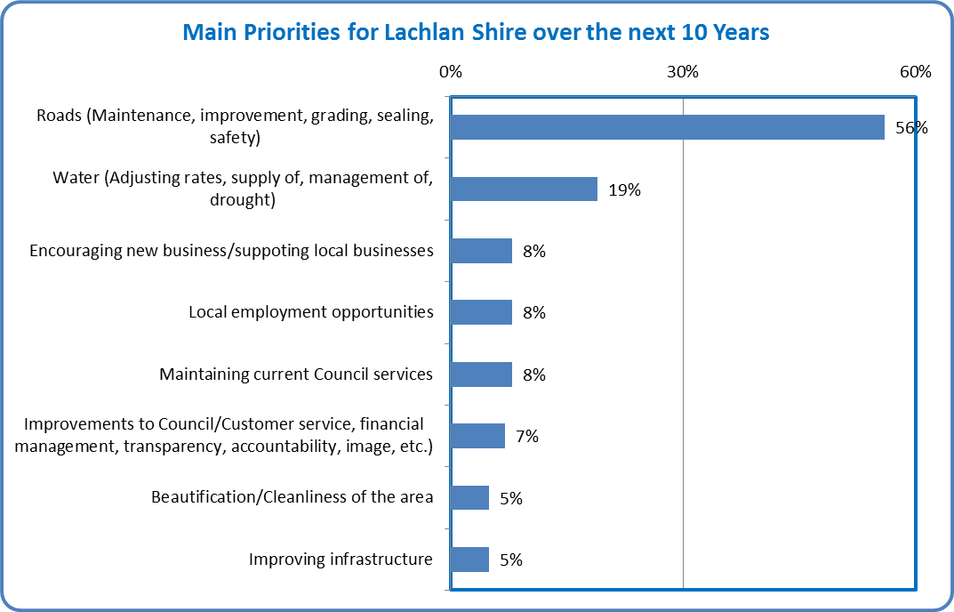

Council manages the largest road network of any council in the State, responsible for maintaining 4,460 kilometres of roads, with over 1,000km of these sealed. Roads infrastructure assets have a replacement value of $277m. The projected maintenance, renewal and upgrade cost in the Long Term Financial Plan 2015-2016 to 2024-2025 is $149m, partly offset by income of $94m from grants and contributions (including Roads to Recovery grants, Regional Roads funding and the untied roads component of the Financial Assistance Grant). The balance of $55m leaves a significant funding shortfall, part of which is intended to be met from the additional income generated by the proposed Special Rate Variation.

Taking into consideration the majority support from the community for the Special Rate Variation option and resultant increase in expenditure on the road network, Council is confident that the community’s desires for an improved road network are being addressed through the proposed Special Rate Variation.

While the community survey conducted in June 2015 reveals that only 5% of those surveyed indicated that “Improving Infrastructure” is a priority, Council undertook in 2015 a detailed review of the condition of all buildings assets. The projected maintenance, renewal and upgrade cost in the Long Term Financial Plan 2015-2016 to 2024-2025 is $9.8m. Provision is made for funding from grants ($1.6m) and loans ($1.9m), leaving a balance of $6.3m to be funded from general revenue, part of which is intended to be met from the additional income generated by the proposed Special Rate Variation.

The purpose of this Special Rates Variation application is to enable Council to increase rates above the rate pegging limit to permit the implementation of an asset renewal and maintenance program for roads infrastructure, buildings and other community facilities.

**The decision to seek higher revenues above the rate peg and other options examined.**

Council understands and appreciates that rate increases of any kind are never welcomed; however it is Council’s firm belief that a sustainable and affordable increase in rates is essential if Council is to meet the needs and expectations of the community across a range of services.

Like most councils, Lachlan has felt the escalating costs of providing services over recent years as well as an expectation to provide a broader range of services. At the same time income levels to fund services have not kept pace; not only have Councils’ rates been pegged, but State and Federal Governments have shifted costs to local government and decreased the funding disbursements that are crucial to the ongoing viability of local government. This continued decline in other sources of funding is almost certainly going to continue into the foreseeable future and is an integral part of a council’s sustainability.

Lachlan Shire Council has recognised the need to undergo a significant transformation in relation to organisational reform and implemented a number of initiatives to reform the organisation and improve its long term sustainability.

These initiatives have included (but not limited to):

• Withdrawal in 2010 from the operation of the residential aged care facility

• Removal, in conjunction with the review of the Community Strategic Plan in 2015, a number of positions from the organisation structure. Those positions were:

* + Economic Development Officer
  + Grants/Events Officer
  + Tourism Officer from full time to part time
  + 3 Operation/Works Staff (Parks/gardens & town maintenance)
* Development and adoption of a Section 94A Contribution Plan, implemented from 1 July 2015
* Closure of some village waste management disposal facilities, upgrading remaining facilities, restricting access by setting formal operating hours, and implementation of collection of user fees for access to waste facilities.

Examination of assets not required for operations such as housing, plant, commercial premises, land, etc. and utilise sale income. 3 residential properties currently on the market, medical centre sold and rents increased for General Practitioner houses supplied by Council.

Reduction, in conjunction with the review of the Community Strategic Plan in 2015, generous donations budget for community groups

Other reform initiatives currently in progress or planned, and incorporated in Council’s Improvement Plan (Attachment 11), include:

* Preparation and implementation of an Economic Development Plan to increase investment, employment and population
* Introduce Zero Based Budgeting (ZBB)
* Revision of current work practices to reduce costs and improve efficiencies
* Negotiation of a new Enterprise Agreement and eliminate payment of untaken sick leave on termination and introduce fortnightly pays
* Strengthening of the Friendship Alliance with Penrith City Council and utilise their staff and expertise to improve governance processes
* Development of a formal MOU with the Mid Lachlan Alliance (Forbes, Parkes and Lachlan) setting out opportunities for Resource Sharing.

Council’s Long Term Financial Plan (refer Attachment 3) reflects the above reform initiatives and which addresses Council’s Financial Sustainability. The Improvement Plan includes actions which see a continuation of efficiency gains, improving revenue streams where feasible and consideration of services and service levels. Rates increases are part of the picture and are one measure amongst a range of other actions to improve the long term viability of the Council

**Why the proposed special variation is the most appropriate option**

Being a relatively small rural council, options for Lachlan Shire Council to access higher or alternate forms of revenue other than rates and government grants, are limited.

Council has incorporated loan borrowings into its Long Term Financial Plan, however a prudent approach has been taken to ensure such borrowing commitments can be serviced in future operating budgets.

Whilst it is acknowledged that Council currently has a “zero” Debt Service Ratio, the projected operating position does not have the capacity to service significant debt. However, Council has sought to better utilise debt servicing to fund a major project and $1.9m in loan borrowings has been budgeted in the 2015/2016 financial year. These borrowings will assist to fund the replacement of Condobolin’s SRA Hall, the town’s community hall.

The long term financial plan provides for revenue from Grants and Contributions. Council has explored alternative options and opportunities, however where no knowledge or evidence of other programs exist it has adopted a prudent approach in its forecasts. Other user fees and revenues were also given consideration and a review of these is an ongoing task. However, the impact of those reviews is considered immaterial to deliver the funding levels required to assist Council to sustain service delivery long term.

**Impacts on the LTFP forecasts for the General Fund and how this relates to the need the council identified**

The LTFP achieves the following objectives over the ten year time frame:

• maintain and improve the existing service levels to the community;

• strive to provide adequate funding to support Council’s asset management plans;

• improve its cash position;

• maintain a surplus annual budget (before and after capital grants & contributions);

• maintain an adequate Employee Leave Entitlements Reserve based on the age and entitlements of all staff in accordance with Council’s Workforce Strategy; and

• ensure that all Reserves are cash backed.

Council is committed to the delivery of strategies outlined in the Community Strategic Plan. The development of the LTFP alongside the Strategic Plan assists Council to assess the financial impact of the strategic directions. Council is projecting that it will operate with a surplus budget (before capital grants and contributions) from 2015/2016, however it will continue to examine a number of strategies to improve efficiencies, access future revenue opportunities and contain costs. The impact of these strategies will be incorporated into future LTFP’s.

Council’s current LTFP includes three scenarios:

* **Scenario 1 – a 2.4% rate peg increase per annum for ten years. No Special rate Variation applied for**.

The Budget Summary shows an annual operating surplus before capital grants and contributions. The cash flow trend suggests that while reserves will be maintained, working funds will be reduced in real terms.

This is an unsustainable situation where infrastructure will deteriorate as it is not being adequately maintained to a satisfactory level while Council’s financial situation will deteriorate further. This would suggest that there needs to be an adjustment to the level of services provided, and/or substantial efficiencies made and/or additional revenue raised.

* **Scenario 2 – a 2.4% rate peg increase in Year 1 – 2015/16. A permanent 7.4% Special Rate Variation (inclusive of the 2.4% rate peg) is proposed each year from 2016/17 for four years then annual rate pegging increases of 2.4% per annum thereafter. This is equivalent to a 33.05% rate increase over the four year period from 2016/17 to 2019/20.**

In comparison to Scenario 1 the trend of the Income Statement shows increasing surpluses, before capital revenue, and surpluses after capital expenditure. The positive cash flow balance trend remains over the ten years, unlike Scenario 1. Scenario 2 provides for additional funds for much needed infrastructure and maintenance works with some of the funding being sourced from the Special Rate Variation.

* **Scenario 3 – 2.4% Rate Pegging Increase in Year 1. A permanent Special Rate Variation of 12.4% (inclusive of the 2.4% rate peg) is being sought each year from 2016/17 to 2019/20 then annual rate pegging increases of 2.4% per annum thereafter. This is equivalent to a 59.61% rate increase over the four year period from 2016/17 to 2019/20.**

In comparison to Scenario 1 the trend of the Income Statement shows increasing surpluses before capital grants and contributions with increased capital expenditure on infrastructure. The cash flow balance and reserve trend remains similar to Scenario 2.

This scenario has been based upon the premise of bringing all Council assets up to a satisfactory condition, funding depreciation expenses and ensuring Council’s long term financial sustainability. This is only possible by cumulatively increasing rates levied over a period of 4 years by a permanent 59.61%, placing a significant burden on ratepayers and adversely affecting their “capacity to pay”.

Council adopted Scenario 2 which provides for a Special Rate Variation of 5% plus rate peg of 2.4% per annum in each year from 2016/17 to 2019/20. Scenario 2 provides better long term cash retention, increases funds available for essential infrastructure works and in the medium to long-term assists in meeting Council’s financial objectives of a surplus budget and ensuring financial sustainability.

The additional income raised from the proposed special rate increase will be committed to priority areas of Council’s road network and will enable a continuation of needed infrastructure improvements.

## Financial sustainability

The proposed special variation may be intended to improve the council’s underlying financial position for the General Fund, or to fund specific projects or programs of expenditure, or a combination of the two. We will consider evidence about the council’s current and future financial sustainability and the assumptions it has made in coming to a view on its financial sustainability.

You should explain below:

* The council’s understanding of its current state of financial sustainability, its long-term projections based on alternative scenarios and assumptions about revenue and expenditure.
* Any external assessment of the council’s financial sustainability, eg, by auditors, Treasury Corporation. Indicate how such assessments of the council’s financial sustainability is relevant to supporting the decision to apply for a special variation.
* The council’s view of the impact of the proposed special variation on its financial sustainability.

**Current state of financial sustainability, long-term projections based on alternative scenarios and assumptions about revenue and expenditure.**

Council is of the view that to sustain assets and deliver services into the future to the expectations of the community it requires a special variation. This special variation is part of a long term strategy toward this outcome.

With an extensive network of infrastructure and a low level of projected population growth, many rural councils face a number of long term financial challenges.

The Long Term Financial Plan has been prepared to ensure that Council lives within its means while stating the need to develop actions in consultation with its community to move towards sufficient infrastructure works (maintenance and renewal) to ensure that service levels do not diminish and intergenerational equity is maintained. The strategy also seeks to ensure that Council has sufficient cash flows to remain financially sustainable, which is a key focus for the local government reform process.

A summary of the three scenarios considered by Council, together with relevant comments, is provided above (item 3.1 Case for special variation - community need).

The assumptions relating to revenue and expenditure in preparation of the Long Term Financial Plan were:

* + the 2014-2015 revised budget (as per the March Quarterly Review) was used as the basis for developing the Long Term Financial Plan 2015/2016-2024/25.
  + A consumer price index of 2.5% p.a.
  + 3.25% for salaries and wages
  + Superannuation contributions in accordance with legislated minimum contribution levels
  + depreciation calculated on an asset condition assessment basis using asset cost data, periodic inspections of assets, revaluated asset data and standard depreciation periods for major asset groups.
  + Interest on Investments at 3.1% for the first two years, 3.4% for the third year and 3.5% thereafter
  + Interest on loans at 4% p.a.

**External assessments of the council’s financial sustainability**

TCorp’s Financial Assessment, Sustainability and Benchmarking Report of 19 March 2013 noted that “…*we consider Council to be moderately Sustainable in the short term but Council faces increasing pressures in the medium to long term in relation to their infrastructure*” and recommended that “…*the following points be considered:*

* *Council is heavily reliant on grants and contributions to boost their revenues, with 75% of total revenues being received in 2011 and 2012*
* *Council’s Infrastructure Backlog has been above $81m in the last four years and the projected $9.6m shortfall in asset maintenance and renewals funding is only going to increase this figure*
* *Council remains in the process of finalising their Asset Revaluations, this may negatively impact on the forecast operating results if depreciation expenses increase above the levels within the current LTFP*
* *A revised focus on asset renewals as opposed to upgrades or new assets is advised to assist with improving the quality of the asset base and reducing the maintenance and renewals funding gap*
* *Council should investigate all revenue raising options including the possibility of an SRV and the option of applying for LIRS funding in order to assist with their outstanding infrastructure renewals and therefore reducing the infrastructure backlog”*

Council has taken heed of the TCorp’s observations and adopted a Special Rate Variation model which will address the current level of under-expenditure on infrastructure assets. The LTFP confirms that the additional revenue raised from the Special Rate Variation will give Council the capacity to increase expenditure on infrastructure and make operating profits both before and after capital grants and contributions, enabling financial sustainability in the long term.

The Long Term Financial Plan was adopted also with the view to ensuring that Council meets the criteria to become financially “Fit for the Future”.

## Financial indicators

How will the proposed special variation affect the council’s key financial indicators (General Fund) over the 10-year planning period? Please provide, as an addendum to the LTFP, an analysis of council’s performance based on key indicators (current and forecast) which may include:

* Operating balance ratio excluding capital items (ie, net operating result before capital grants and contributions as percentage of operating revenue before capital grants and contributions).
* Unrestricted current ratio (the unrestricted current assets divided by unrestricted current liabilities).
* Rates and annual charges ratio (rates and annual charges divided by operating revenue).
* Debt service ratio (principal and interest debt service costs divided by operating revenue excluding capital grants and contributions).
* Broad liabilities ratio (total debt plus cost to clear infrastructure backlogs as per Special Schedule 7 divided by operating revenue).
* Asset renewal ratio (asset renewals expenditure divided by depreciation, amortisation and impairment expenses).

**Operating balance ratio excluding capital items**:

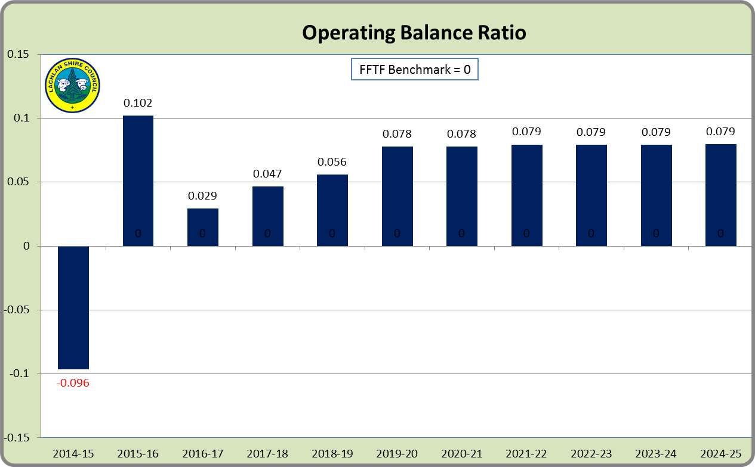

**Unrestricted current ratio:**

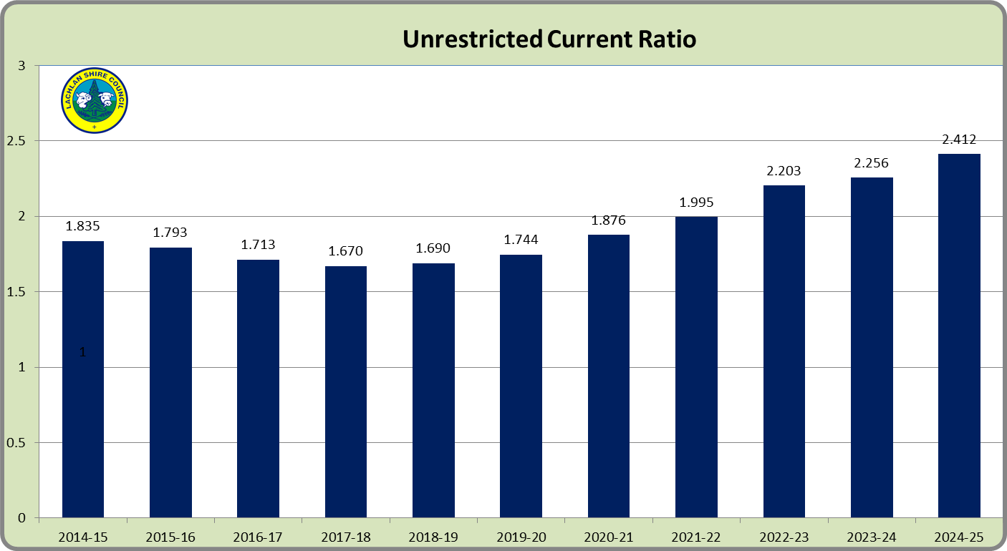

**Rates and annual charges ratio:**

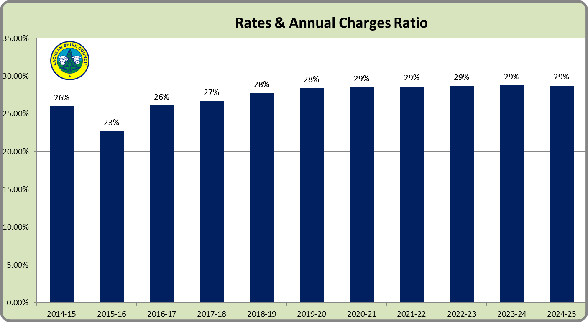

**Debt service ratio:**

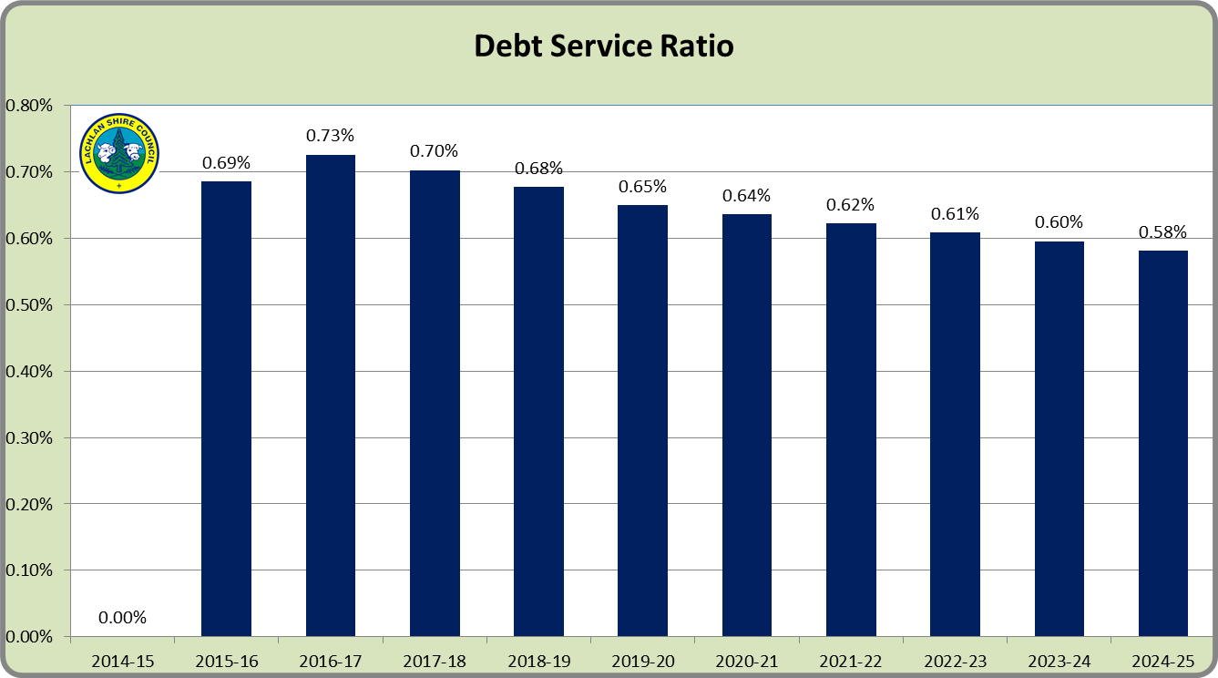

**Broad liabilities ratio:**

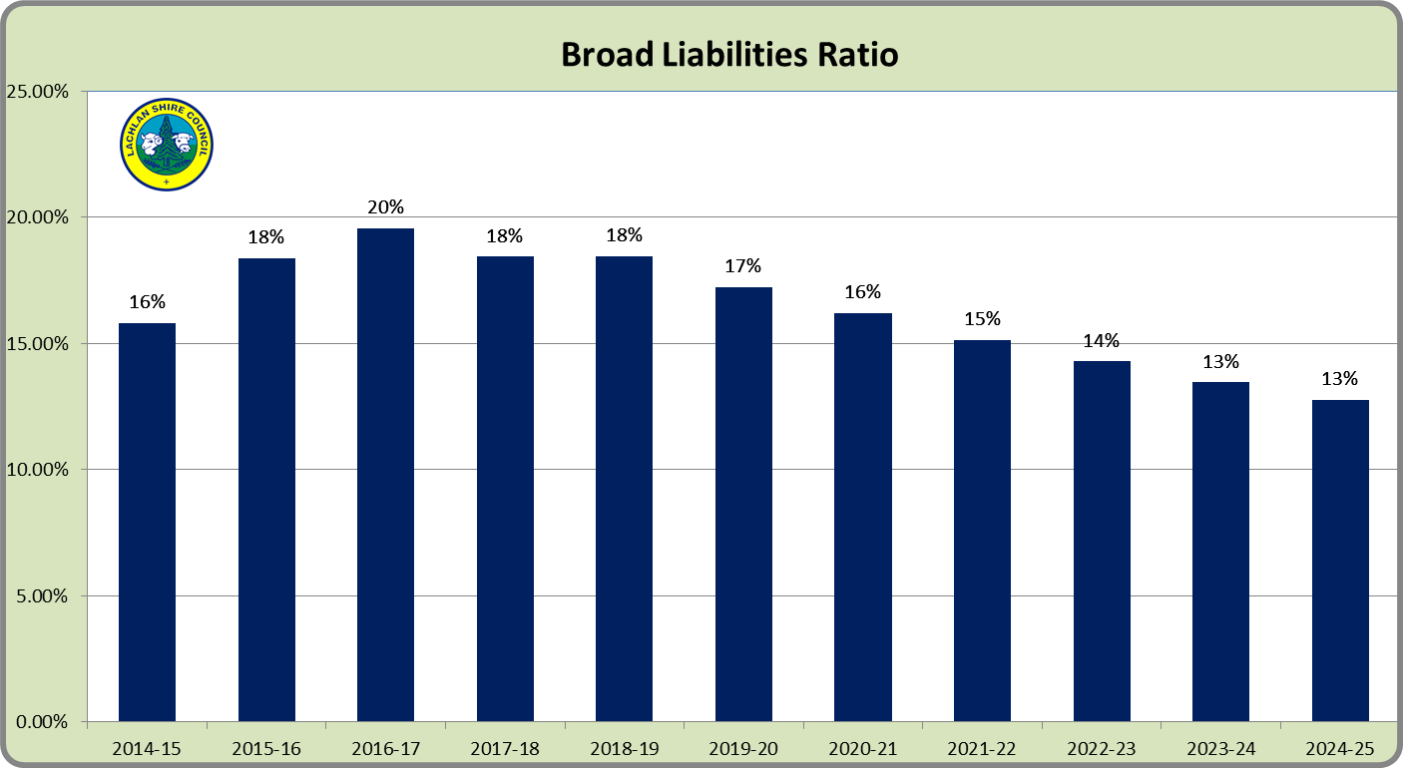

**Asset renewal ratio:**

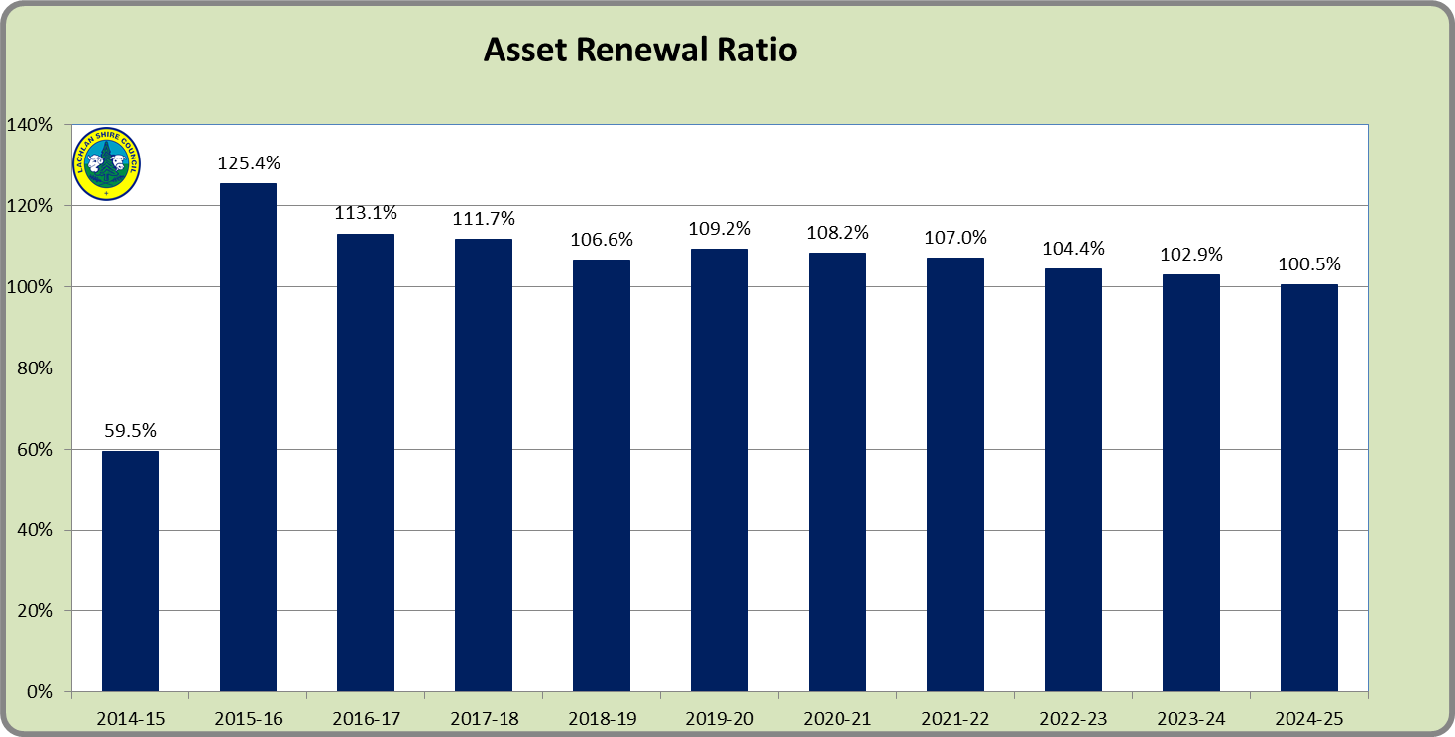

# Contribution plan costs above the cap

You should complete this section if the proposed special variation seeks funding for contributions plan costs above the development contributions cap. Otherwise, leave this section blank.

Please explain how the council has established the need for a special variation to meet the shortfall in development contributions.

For costs above the cap in contributions plans, a council must provide:[3]

* a copy of the council’s section 94 contributions plan
* a copy of the Minister for Planning’s response to IPART’s review and details of how the council has subsequently amended the contributions plan
* details of any other funding sources that the council is proposing to use, and
* any reference to the proposed contributions (which were previously to be funded by developers) in the council’s planning documents (eg, LTFP and Asset Management Plan (AMP).

|  |
| --- |
|  |

# Assessment criterion 2: Community awareness and engagement

Criterion 2 within the OLG Guidelines is:

*Evidence that the community is aware of the need for and extent of a rate rise. The Delivery Program and Long Term Financial Plan should clearly set out the extent of the General Fund rate rise under the special variation. The council’s community engagement strategy for the special variation must demonstrate an appropriate variety of engagement methods to ensure community awareness and input occur. IPART’s fact sheet includes guidance to councils on the community awareness and engagement criterion for special variations.*

Our fact sheet on the requirements for community awareness and engagement are available on the IPART website.[4]

In responding to this criterion, the council must provide evidence that:

* it has consulted and engaged the community about the proposed special variation using a variety of engagement methods and that the community is aware of the need for, and extent of, the requested rate increases
* it provided opportunities for input and gathered input/feedback from the community about the proposal, and
* the IP&R documents clearly set out the extent of the requested rate increases.

In assessing the evidence, we will consider how transparent the engagement with the community has been, especially in relation to explaining:

* the proposed cumulative special variation rate increases including the rate peg for each major rating category (in both percentage and dollar terms)
* the annual increase in rates that will result if the proposed special variation is approved in full (and not just the increase in daily or weekly terms)
* the size and impact of any expiring special variation (see Box 4.1 below for further detail), and
* the rate levels that would apply without the proposed special variation.

More information about how the council may engage the community is to be found in the OLG *Guidelines*, the IP&R manual, and IPART’s Fact Sheet *Community Awareness and Engagement for special variation applications*, January 2016.

|  |
| --- |
| Box 5.1 Where a council is renewing or replacing an expiring special variation |
| The council’s application should show how you have explained to its community:  There is a special variation due to expire at the end of the current financial year or during the period covered by the proposed special variation. This needs to include when the expiring special variation was originally approved, for what purpose and the percentage of (General Fund) general income originally approved.  The corresponding percentage of general income that the expiring special variation represents for the relevant year.  Whether the temporary expiring special variation is being replaced with another temporary or a permanent increase to the rate base.  The percentage value of any additional variation amount, above the rate peg, for which the council is applying through a special variation.  If the proposed special variation was not approved ie, only the rate peg applies, the year-on-year change in rates would be lower, or that rates may fall.  The council also must attach, to its application to IPART, a copy of the Instrument of Approval that has been signed by the Minister or IPART Chairman. |
|  |

## The consultation strategy

The council is required to provide details of the consultation strategy undertaken, including the range of methods used to inform and engage with the community about the proposed special variation and to obtain community input and feedback. The engagement activities could include media releases, mail outs, focus groups, statistically valid random or opt-in surveys, online discussions, public meetings, newspaper advertisements and public exhibition of documents.

The council is to provide relevant extracts of the IP&R documents that explain the rate rises under the proposed special variation and attach relevant samples of the council’s consultation material.

Council’s Community Engagement Policy is committed to strengthening and coordinating its community engagement activities, in order to improve its decision making processes for corporate planning, services and major projects. The intention of this policy is to broadly define Lachlan Shire Council’s approach to the engagement of our community. It has application across the full range of policy, program and service issues in local government and is integral to Council’s integrated planning framework. It is intended this policy will clearly outline Council’s commitment to community engagement, including the values that underpin our work with our community. Council anticipates more informed decision making as a consequence of the application of this policy and commitment to achieving the vision outlined in Council’s Strategic Plan.

In relation to the proposed Special Rate Variation, Council recognised the need to educate the community on all aspects of the proposal and to provide opportunities for all ratepayers to participate in discussion and debate and to influence Council’s decision making.

**Community Surveys**

Micromex Research was engaged to undertake a community survey by telephone, initially in June 2015, to gauge the community’s views on Council’s Community Strategic Plan including specific questions regarding the proposal to apply for a special rate variation.

A second telephone survey, again undertaken by Micromex Research, was carried out in October 2015 following the release of IPARTS’s findings in relation to Fit for the Future criteria and its recommendation that Lachlan Shire Council would be best served by merging with Parkes Shire Council. The aim of the survey was to measure community support for standing alone or merging with Parkes Shire Council once made aware of the financial implications, i.e. rates will need to rise by 33% (5% plus rate pegging per annum over 4 years)

**Council’s Website and Social Media**

The effective use of Council’s website and social media tools is critical to the success of any community engagement process. Particular attention was paid to effective utilisation of the website and Facebook to publicise the proposed Special Rate Variation.

**Direct Engagement with the Community**

Council held community meetings which were publicised in the following local newspapers:

* Lake News (Lake Cargelligo)
* The Lachlander (Condobolin)
* The Condobolin Argus

and on Council’s website and Facebook site.

At these meetings information was provided via a Powerpoint presentation (Attachment 5a & 5b) by staff, inviting questions and encouraging discussion with community members in attendance.

Community meetings were held as follows:

* Tottenham Community Hall – Monday 15 June 2015
* Condobolin Council Chambers – Wednesday 17 June 2015
* Lake Cargelligo Memorial Hall – Friday 19 June 2015
* Lake Cargelligo Memorial Hall – Wednesday 3 February 2016
* Condobolin Council Chambers – Thursday 4 February 2016
* Tottenham Community Hall – Monday 8 February 2016

**Media Reports**

Council’s proposal to apply for a Special Rate Variation received significant attention in the local media with thirteen articles appearing in local print media. Copies of the specific articles are included as Attachment 5c. The Mayor was also interviewed on ABC radio regarding the proposed rate rise.

**Exhibition of IP&R Documents**

Council adopted the current version of its current Community Strategic Plan (CSP) *’Living Lachlan Style 2025’* in June 2015 (at Attachment 1)

The development of the current CSP, incorporating the 2016/2019 Delivery Program and 2015/2016 Operational Plan clearly articulated Council’s proposal to apply for a Special Rate Variation. Adopted by Council on 25 June 2014, the Delivery Program and Operational Plan included extensive commentary on the Special Rate Variation as follows:

* Mayor introduction (refer page 4)
* Delivery Program Outcome 5.7 – Strong Effective Council (refer page 26)
* Statement of Revenue Policy (refer pages 34 to 107.)

The 2016/2019 Delivery Program and 2015/2016 Operational Plan were placed on public exhibition on 21 May 2015 with submissions closing 19 June 2015. The community was informed of the public consultation period by way of advertisements placed in the three local newspapers.

The Delivery Program and Operational Plan were also placed on the front page of Council’s website throughout the consultation period.

Council formally adopted the Community Strategic Plan, Delivery Program and Operational Plan on 24 June 2015.

## Feedback from the community consultations

Summarise the outcomes and feedback from the council’s community engagement activities. Outcomes could include the number of attendees at events and participants in online forums, as well as evidence of media reports and other indicators of public awareness of the council’s special variation intentions. Where applicable, provide evidence of responses to surveys, particularly the level of support for specific programs or projects, levels and types of services, investment in assets, as well as the options proposed for funding them by rate increases.

Where the council has received submissions from the community relevant to the proposed special variation, the application should set out the views expressed in those submissions. Please refer to Section 1.2 concerning how the council should handle confidential content in feedback received from the community. The council should also identify and document any action that it has taken, or will take, to address issues of common concern within the community.

Overall, Council was very pleased with the level of community feedback during the engagement period and the views expressed by all participants assisted Council greatly in the decision making process.

Following is a summary of the outcomes from the various communication activities undertaken.

**Community Surveys**

Copies of the final reports on the two community surveys undertaken by Micromex Research are included as Attachments 6a & 6b. The following extracts from the Micromex reports confirm that the majority of ratepayers that took part in the survey support the Special Rate Variation proposal.

The Micromex Research report on the June 2015 telephone survey revealed that, in answer to the following:

*Concept Statement: “…Council is proposing to increase rates in 2016/17 by an additional 5% per annum plus the estimated rate peg increase of 2.4%. This would be applied each year for a period of 4 years coming to a total 33% increase, inclusive of the 10% increase that would have come with the current rate peg increases”.*

*Question 5b: “Council has proposed to reduce its operating costs by $1.8 million over the next 4 years however, this will not be enough to address the Council’s financial shortfall. Would you support Council increasing rates as indicated above to reduce the remaining shortfall for it to become financially sustainable?”*

61% of residents indicated they would support an increase in rates to reduce the remaining shortfall in order for Council to become financially sustainable. Residents aged 65+ were significantly more likely to support the rates increase.

The Micromex Research report on the October 2015 telephone survey revealed that, in answer to the following:

*Concept Statement: “If Lachlan Shire Council were to stand alone, it would be required to find additional revenue/cost savings each year to meet the Government’s criteria by 2020.*

*In May the community supported a 33% rate rise over 4 years to allow Council to stand alone. In the submission to IPART, Lachlan Council indicated that the rate rise be implemented from next July to make it financially sustainable.*

*If the Lachlan Shire community continues to wish to stand alone, rates will need to rise by 33% (5% plus rate pegging per annum over 4 years) and the Lachlan Shire Local Government area will miss out on a share of the State Government offer of $10m for each new merged entity.”*

*Question 4b: How supportive are you of Lachlan Shire Council standing alone and not merging with Parkes Shire Council?*

*Question 6a: “Thinking about the options we have just discussed, which is your preferred option?”*

68% of residents indicated that ‘Lachlan Shire Council standing alone’ was their preferred option.

**Direct Engagement with the Community**

As mentioned above, Council convened a number of community meetings in June 2015 and in February 2016 to engage with the community.

The June 2015 meetings were held as part of the consultation process leading to adoption of the Community Strategic Plan, Delivery Program and Operational Plan. The Powerpoint presentation at those meetings included the following slide: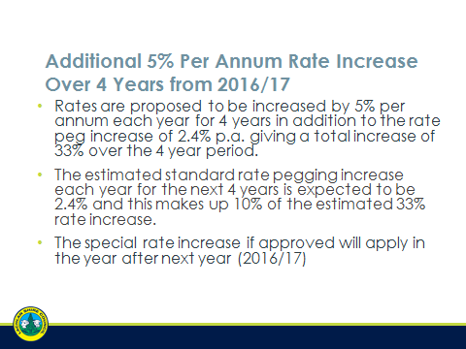

Over 80 residents attended these meetings. Feedback at those meetings indicated that the vast majority of those in attendance supported the proposed rate increases.

The February 2016 meetings were held specifically to again inform the community of Council’s proposal to make application for a Special Rate Variation and to highlight the effect the variation would have on rates levied within each category. The Powerpoint presentation at those meetings included the following slide: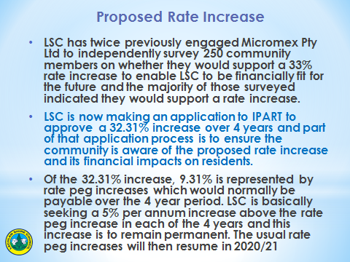

Over 90 residents attended these meetings. Again, feedback at those meetings indicated that the vast majority of those in attendance supported the proposed rate increases.

**Media Reports**

Council’s proposal to apply for a Special Rate Variation received significant attention in the local media with thirteen articles appearing in local print media. Copies of the specific articles and advertisements placed by Council are included as Attachment 5c.

# Assessment criterion 3: Impact on ratepayers

Criterion 3 within the OLG Guidelines is:

*The impact on affected ratepayers must be reasonable, having regard to both the current rate levels, existing ratepayer base and the proposed purpose of the variation. The Delivery Program and Long Term Financial Plan should:*

*clearly show the impact of any rises upon the community*

*include the council’s consideration of the community’s capacity and willingness to pay rates and*

*establish that the proposed rate increases are affordable having regard to the community’s capacity to pay.*

The impact of the council’s proposed special variation on ratepayers must be reasonable. To do this, we take into account current rate levels, the existing ratepayer base and the purpose of the proposed special variation. We also review how the council has assessed whether that the proposed rate rises are affordable having regard to the community’s capacity and willingness to pay.

## Impact on rates

Much of the quantitative information we need on the impact of the proposed special variation on rate levels will already be contained in Worksheet 5a and 5b of Part A of the application.

To assist us further, the application should set out the rating structure under the proposed special variation, and how this may differ from the current rating structure, or that which would apply if the special variation is not approved.

We recognise that a council may choose to apply an increase differentially among categories of ratepayers. If so, you should explain the rationale for applying the increase differentially among different categories and/or subcategories of ratepayers, and how this was communicated to the community. This will be relevant to our assessment of the reasonableness of the impact on ratepayers.

Councils should also indicate the impact of any other anticipated changes in the rating structure.

The overall structure of the rate model applied to the Special Rate Variation does not vary from Council’s current rate model. The proposed Special Rate Variation will not result in any new or additional rate categories.

The current rating structure (based upon the actual income derived from the 2014-2015 rates levy) consists of:



Key elements of the Special Rate Variation model are as follows:

* Additional revenue commencing with approximately $256,260 in year 1 distributed evenly across existing rating categories.
* Percentage of total yield within each rating category to remain consistent with the current rating structure.
* Properties with the average annual levy within each rating category will pay an additional sum above rate pegging per annum in accordance with the following summaries presented at the community meetings held in February 2016 and reported in local print media:

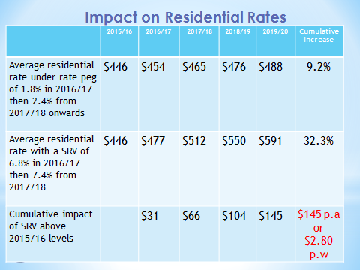

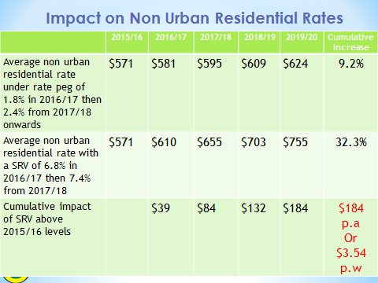

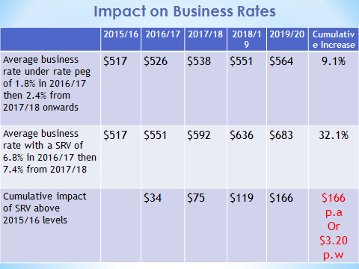

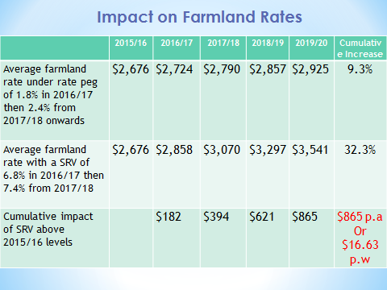

The proposed rate model has been developed so as to achieve a consistent average increase in dollar terms above rate pegging across all rating categories. In order to achieve a consistent average increase in dollar terms across each rating category, the percentage movement in rates varies across each rating category based on the relative average valuations.

### Minimum Rates

The proposed special variation may affect ordinary rates, special rates and/or minimum rates.

As previously discussed, if the proposed special variation includes increasing minimum rates above the statutory limit, or is to apply a higher rate of increase to an existing minimum rate than to its other rates, it is not necessary for the council to also complete the separate Minimum Rates Application form. However, this must be clearly identified and addressed in the special variation application.

|  |  |  |
| --- | --- | --- |
| Does the council have minimum Ordinary rates? |  | **No** |

If *Yes*, does the council propose to increase minimum Ordinary rates by:

The rate peg percentage

The special variation percentage

Another amount  Indicate this amount _____________

What will minimum Ordinary rates be after the proposed increase? _________

The council must explain how the proposed special variation will apply to the minimum rate of any ordinary and special rate, and any change to the proportion of ratepayers on the minimum rate for all relevant rating categories that will occur as a result.

You should also explain the types of ratepayers or properties currently paying minimum rates, and the rationale for the application of the special variation to minimum rate levels.

## Consideration of affordability and the community’s capacity and willingness to pay

The council is required to provide evidence through its IP&R processes, and in its application, of how it assessed the community’s capacity and willingness to pay the proposed rate increases. This is to include an explanation of how the council established that the proposed rate rises are affordable for the community.

Evidence about capacity to pay could include a discussion of such indicators as SEIFA rankings, land values, average rates, disposable incomes, the outstanding rates ratio and rates as a proportion of household/business/farmland income and expenditure, and how these measures relate to those in comparable or neighbouring council areas.

As many of these measures are highly aggregated, it may also be useful to discuss other factors that could better explain the impact on ratepayers affected by the proposed rate increases, particularly if the impact varies across different categories of ratepayers.

We may also consider how the council’s hardship policy (see Section 5.3 below) might reduce the impact on socio-economically disadvantaged ratepayers.

The impact is considered reasonable as:

* Average residential rates will rise by only an estimated 6.8% in 2016/17, then 7.4% from 2017/2018
* In dollar terms, residential rates are to rise on average by around $145 ($2.80 per week) cumulatively over the four years as a result of the proposed variation.
* While the LGA has a very low SEIFA ranking of 39/152 and high outstanding rates ratio (8.7%), average residential rates are below that of neighbouring LGAs (refer chart below).
* Average residential rates are equivalent to 1.1% of household incomes ie, below the average for neighbouring councils (e.g. Parkes 1.9%, Forbes 2.0%)
* No community submissions were received in relation to council’s decision to seek approval for a special rates variation
* The council has a reasonable financial hardship policy to assist ratepayers having difficulties paying their rates.

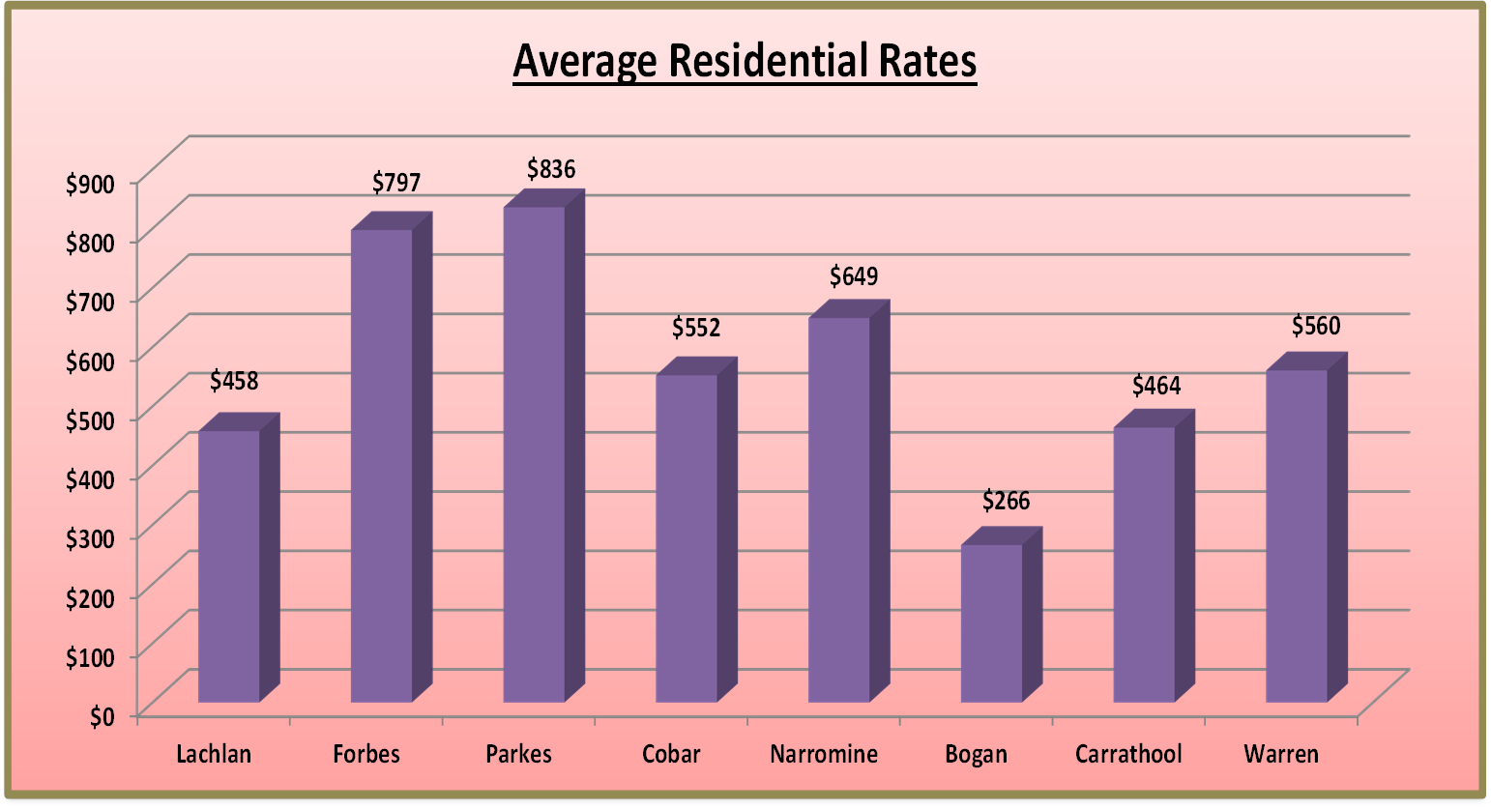

## Addressing hardship

In addition to the statutory requirement for pensioner rebates, most councils have a policy, formal or otherwise to address issues of hardship.

|  |  |  |
| --- | --- | --- |
| Does the council have a Hardship Policy? | **Yes** |  |
| If Yes, is an interest charge applied to late rate payments? | **Yes** |  |
| Does the council propose to introduce any measures to reduce the impact of the proposed special variation on specific groups in the community? |  | **No** |

You should attach a copy of the Hardship Policy and explain below who the potential beneficiaries are and how they are assisted.

Please provide details of any other measures addressing hardship to be adopted, or alternatively, explain why no measures are proposed.

The council is also to indicate whether the hardship policy or other measures are referenced in the council’s IP&R documents (with relevant page reference or extract provided).

Copies of Council’s Debt Recovery Policy and Hardship Policy are attached as Attachment 7.

Council’s Hardship Policy provides as follows:

* *Council recognises there are cases of genuine financial hardship requiring*

*respect and compassion in special circumstances*

* *…applies to all applications for waiving, alternative payment arrangements or writing off rates, annual charges and interest accrued on such debts.*
* *Council may enter into a formal agreement with a ratepayer eligible for alternative periodic payments for due and payable rates and charges*
* *Pensioner ratepayers will be assisted in keeping their rate accounts current by waiving any interest charges raised during the year provided their account has no arrears of rates and charges owing as at the first day of the rating year*

The Policy applies to all ratepayers, however specific assistance may be provided to eligible age pensioners as provided above.

The hardship policy is mentioned on page 4 of the Delivery and Operational Plan within the Mayor’s introduction.

Council will continue to encourage ratepayers to contact Council directly in relation to any financial hardship issues that may result in late or non-payment of rates. Each case will be treated fairly and in accordance with Council’s policy. At present, Council provides a number of payment options to ratepayers and is openly accepting of individual payment plans that are consistent with the principles outlined in the Hardship Policy.

# Assessment criterion 4: Public exhibition of relevant IP&R documents

Criterion 4 within the OLG Guidelines is:

*The relevant IP&R documents must be exhibited (where required), approved and adopted by the council before the council applies to IPART for a special variation to its general revenue.*

Briefly outline the significant IP&R processes the council has undertaken to reach the decision to apply for a special variation. Include the details of and dates for key document revisions, public exhibition period(s) and the date(s) that the council adopted the relevant IP&R documents.[5]

You should also include extracts from council minutes as evidence that the documents were adopted.

The council is reminded that the Community Strategic Plan and Delivery Program (if amended), require public exhibition for at least 28 days prior to adoption. Amendments to the Long Term Financial Plan and Asset Management Plan do not require public exhibition.[6] However, it would be expected that the Long Term Financial Plan would be posted, in a prominent location, on the council’s website.

Council adopted the current version of its current Community Strategic Plan *’Living Lachlan Style 2025’* in June 2015 (Attachment 1).

Council adopted the revised Community Strategic Plan at the Ordinary Meeting held on 24 June 2015 as follows:

*7.1.7 COMMUNITY STRATEGIC PLAN*

*RESOLVED that subject to the attached recommended variations to the draft Operational Plan and Delivery Plan budgets and Schedule of Fees and Charges, Council adopt the:*

*• Community Strategic Plan for the ten year period from 2015/2016 – 2024/2025,*

*• Delivery Program for the period from 2015/2016 to 2018/2019, and*

*• Operational Plan for 2015/2016*

*• Resourcing Strategy*

*(Phillips/Frankel)*

Strategic Outcome 5.7 of the CSP aims to provide a “Strong effective Council.” Drilling down to the Delivery Program and Operational Plan level, Action 5.7.1 of the 2015/2019 Delivery Program and 2015/2016 Operational Plan aims to ensure that *“Council is financially sustainable and provides services at a level expected by the community*”.

The development of the 2015/2019 Delivery Program and 2015/2016 Operational Plan clearly articulated Council’s proposal to apply for a Special Rate Variation. The Delivery Program and Operational Plan (Attachment 10) included commentary on the Special Rate Variation as follows:

* Introduction: Council “…*has reviewed its operational expenditure and reduced staffing levels and other costs, increased fees and charges such as water and sewer and introduced new ones such as S94A development contributions, proposes to sell assets such as houses and it proposes to submit a Special Rate Variation application to IPART effective 2016/17 to increase rates by 5% per annum plus the rate pegging allowance each year for four years”*.
* Operational Plan Action 5.7.1: Consult with the community and prepare an

application for a Special Rate Variation

* Statement of Revenue Policy: Council will apply the full rate peg each year as announced by IPART. Special Rate Variations may be applied for in the future and this will impact on the overall general income percentage increase. Council is proposing to apply for a Special Rate Variation for the 2016/2017 rating year

Council’s Long Term Financial Plan (LTFP) was updated to incorporate increases in income and expenditure under the proposed Special Rate Variation model.

Council’s LTFP confirms that the additional revenue raised from the Special Rate Variation will provide the capacity to increase expenditure on infrastructure and buildings maintenance and renewal. Over the next decade, in cumulative terms this will amount to an additional $7.9 million spent on maintaining and renewing Council’s infrastructure and buildings assets.

# Assessment criterion 5: Productivity improvements and cost containment strategies

Criterion 5 within the OLG Guidelines is:

*The IP&R documents or the council’s application must explain the productivity improvements and cost containment strategies the council has realised in past years, and plans to realise over the proposed special variation period.*

In this section, you must provide details of any productivity improvements and cost containment strategies that you have implemented during the last two years (or longer) and any plans for productivity improvements and cost containment over the duration of the proposed special variation.

These strategies, which may be capital or operational in nature, must be aimed at reducing costs and/or improving efficiency. Indicate if any initiatives are to increase revenue eg, user charges. Please include below whether the proposed initiatives (ie, cost savings) have been factored into the council’s LTFP.

Where possible, the council is to quantify in dollar terms the past and future productivity improvements and cost savings.

The council may also provide indicators of efficiency, either over time or in comparison to other relevant councils. We will make similar comparisons using various indicators and OLG data provided to us.

A summary of past and proposed productivity improvements and cost containment strategies are included in Item 3.1 under the heading “The decision to seek higher revenues above the rate peg and other options examined” and is restated below:

Lachlan Shire Council has recognised the need to undergo a significant transformation in relation to organisational reform and implemented a number of initiatives to reform the organisation and improve its long term sustainability.

These initiatives have included (but not limited to):

• Withdrawal in 2010 from the operation of the residential aged care facility

• Removal, in conjunction with the review of the Community Strategic Plan in 2015, a number of positions from the organisation structure. Those positions were:

* + Economic Development Officer
  + Grants/Events Officer
  + Tourism Officer from full time to part time
  + 3 Operation/Works Staff (Parks/gardens & town maintenance)
* Development and adoption of a Section 94A Contribution Plan, implemented from 1 July 2015
* Closure of some village waste management disposal facilities, upgrading remaining facilities, restricting access by setting formal operating hours, and implementation of collection of user fees for access to waste facilities.

Examination of assets not required for operations such as housing, plant, commercial premises, land, etc. and utilise sale income. 3 residential properties currently on the market, medical centre sold and rents increased for General Practitioner houses supplied by Council.

Reduction, in conjunction with the review of the Community Strategic Plan in 2015, donations budget for community groups

Other reform initiatives currently in progress or planned, and incorporated in Council’s Improvement Plan, include:

* Preparation and implementation of an Economic Development Plan to increase investment, employment and population
* Introduce Zero Based Budgeting (ZBB)
* Revision of current work practices to reduce costs and improve efficiencies
* Negotiation of a new Enterprise Agreement and eliminate payment of untaken sick leave on termination and introduce fortnightly pays
* Strengthening of the Friendship Alliance with Penrith City Council and utilise their staff and expertise to improve governance processes
* Development of a formal MOU with the Mid Lachlan Alliance (Forbes, Parkes and Lachlan) setting out opportunities for Resource Sharing.

Council’s Long Term Financial Plan (Attachment 3) reflects the above reform initiatives and which addresses Council’s Financial Sustainability. The Improvement Plan includes actions which see a continuation of efficiency gains, improving revenue streams where feasible and consideration of services and service levels. Rates increases are part of the picture and are one measure amongst a range of other actions to improve the long term viability of the Council

# List of attachments

The following is a list of the supporting documents to include with your application.

Some of these attachments will be mandatory to all special variation applications eg, extracts from the Community Strategic Plan.

Other attachments will be required from some, but not all, councils. For example, extracts from the Asset Management Plan would be required from a council seeking approval of a special variation to fund infrastructure.

Councils should submit their application forms and attachments online through the Council Portal in the following order. Councils may number the attachments as they see fit.

|  |  |
| --- | --- |
| Item | Included? |
| **Mandatory forms and Attachments** |  |
| Part A Section 508A and Section 508(2) Application form (Excel spreadsheet) |  |
| Part B Application form (Word document) – this document |  |
| Attachment 1: Community Strategic Plan |  |
| Attachment 2: Delivery Program and Operational Plan |  |
| Attachment 3: Long Term Financial Plan with projected (General Fund) financial statements (Income, Cash Flow and Financial Position) in Excel format |  |
| Attachment 4: NSW Treasury Corporation report on financial sustainability |  |
| Attachment 5: Media releases, public meeting notices, newspaper articles, fact sheets relating to the rate increase and proposed special variation |  |
| Attachment 6: Community feedback (including surveys and results if applicable) |  |
| Attachment 7: Hardship Policy |  |
| Attachment 8: Resolution to apply for the proposed special variation |  |
| Certification (see Section 10) |  |
| **Other Attachments** |  |
| Attachment 9: Roads Asset Management Plan |  |
| Other (please specify) |  |
| Attachment 10: Letter of Intention to make application for a special rate variation |  |
| Attachment 11: Council Improvement Plan |  |

# Certification

**APPLICATION FOR A SPECIAL RATE VARIATION**

**To be completed by General Manager and Responsible Accounting Officer**

Name of council: Lachlan Shire Council

We certify that to the best of our knowledge the information provided in this application is correct and complete.

General Manager (name): Robert Hunt

Signature and Date: 15 February 2016

Responsible Accounting Officer (name): John Chapman

Signature and Date: 15 February 2016

Once completed, please scan the signed certification and attach it as a public supporting document online via the Council Portal on IPART’s website.

1. The Guidelines are available at [www.olg.nsw.gov.au](http://www.olg.nsw.gov.au)
2. See [www.ipart.nsw.gov.au](http://www.ipart.nsw.gov.au).
3. See Planning Circular 10-025 dated 24 November 2010 at [www.planning.nsw.gov.au](http://www.planning.nsw.gov.au) and for the most recent Direction issued under section 94E of the *Environmental Planning and Assessment Act 1979*. See also Planning Circular PS 10-022 dated 16 September 2010.
4. [http://www.ipart.nsw.gov.au/Home/Industries/Local_Govt/Special_Variations_and_  
   Minimum_Rates](http://www.ipart.nsw.gov.au/Home/Industries/Local_Govt/Special_Variations_and_Minimum_Rates)
5. The IP&R documents are the Community Strategic Plan, Delivery Program, Long Term Financial Plan and where applicable, the Asset Management Plan.
6. Office of Local Government (then Division of Local Government), *Integrated Planning and Reporting Manual for local government in NSW*, March 2013, pp 5-6.