|  |
| --- |
| Special Variation Application Form – Part B  For 2017-18  Issued December 2016 |
| Insert Name of Council: Shoalhaven City Council  Date Submitted to IPART: 13 February 2017  Council Contact Person: Craig Milburn  Council Contact Phone: XXXXXXXXXXX  Council Contact Email: XXXXXXXXXXX |

© Independent Pricing and Regulatory Tribunal of New South Wales 2016

This work is copyright. The *Copyright Act 1968* permits fair dealing for study, research, news reporting, criticism and review. Selected passages, tables or diagrams may be reproduced for such purposes provided acknowledgement of the source is included.

The Tribunal members for this review are:

Dr Peter J. Boxall AO, Chairman

Ms Catherine Jones

Mr Ed Willett

Inquiries regarding this document should be directed to a staff member:

Derek Francis (02) 9290 8421

Letitia Watson-Ley (02) 9290 8402

Independent Pricing and Regulatory Tribunal of New South Wales

PO Box K35, Haymarket Post Shop NSW 1240

Level 16, 2-24 Rawson Place, Sydney NSW 2000

T (02) 9290 8400 F (02) 9290 2061

[www.ipart.nsw.gov.au](http://www.ipart.nsw.gov.au/)

Contents

1 Introduction 1

1.1 Completing the application form 1

1.2 Notification and submission of the special variation application 2

2 Preliminaries 3

2.1 Focus on Integrated Planning and Reporting 3

2.2 Key purpose of special variation 4

2.2.1 Purpose 4

2.2.2 Steps Taken 8

2.3 Capital expenditure review 16

3 Assessment Criterion 1: Need for the variation 16

3.1 Case for special variation - community need 17

3.1.1 Community Surveys 17

3.1.2 Information to Council 24

3.1.3 Special Schedule 7 24

3.1.4 Other Actions 25

3.1.5 Assumptions. 29

3.2 Financial sustainability 30

3.2.1 Background 30

3.2.2 The TCorp Review 31

3.2.3 Council oversight - Incoming Council information 2012 32

3.2.4 Fit for the Future Report on Financial Sustainability 34

3.3 Financial indicators 35

3.4 Contribution plan costs above the cap 36

4 Assessment criterion 2: Community awareness and engagement 37

4.1 The consultation strategy 38

4.1.1 Community Engagement 39

4.1.2 Community Consultative Bodies 39

4.1.3 Community Engagement Process 40

4.2 Feedback from the community consultations 41

4.2.1 Community Infrastructure Survey 41

4.2.2 2016/17 SRV Proposal 44

4.2.3 Written Submissions 49

4.2.4 EHQ - Get Involved Shoalhaven- Online Engagement 49

4.2.5 Listening Posts 50

4.2.6 Media 50

4.2.7 Other feedback 51

4.2.8 Summary of Engagement 51

4.2.9 Verons Estate 51

5 Assessment criterion 3: Impact on ratepayers 52

5.1 Impact on rates 52

5.1.1 Minimum Rates 53

5.2 Consideration of affordability and the community’s capacity and willingness to pay 54

5.2.1 Capacity to pay 55

5.3 Addressing hardship 61

6 Assessment criterion 4: Public exhibition of relevant IP&R documents 65

6.1.1 Development of the Community Strategic Plan 66

7 Assessment criterion 5: Productivity improvements and cost containment strategies 74

7.1.1 Expenditure Actions 74

7.1.2 Continuous Improvement 75

7.1.3 Cost Base 76

8 List of attachments 77

9 Certification 79

# Introduction

IPART will assess each application against the criteria set out in the Office of Local Government’s (OLG) *Guidelines for the preparation of an application for a special variation to general income for 2017/2018* (the [Guidelines](http://www.olg.nsw.gov.au/sites/default/files/Guidelines%20for%20the%20Preparation%20of%20an%20Application%20for%20a%20Special%20Variation%20to%20General%20Income%20for%202017-2018.pdf)). Councils should refer to these Guidelines before completing this application form.

Each council must complete this Part B application form when applying for a special variation to general income either under section 508(2) or section 508A of the *Local Government Act 1993* (NSW).

In addition, councils must complete the Part B form with the Part A (spreadsheet) form for both section 508(2) or section 508A applications. The Guidelines also require the council to have resolved to apply for a special variation. You must attach a copy of the council’s resolution. IPART’s assessment of the application cannot commence without it.

If the proposed special variation includes increasing minimum rates above the statutory limit, or is to apply a higher rate of increase to an existing minimum rate than to its other rates, it is not necessary for the council to also complete the separate Minimum Rates application form. However, this must be clearly identified and addressed in the special variation application. In such circumstances, councils are encouraged to discuss their proposed application with IPART as soon as possible.

As outlined in the Guidelines, new councils created in 2016, or councils whose merger proposals are pending due to legal proceedings, will be ineligible for special variations for the 2017-18 rating year.

## Completing the application form

This form is structured to provide guidance on the information we consider is necessary for us to assess a special variation application. To complete the form, the council will need to respond to questions and insert text in the boxed area following each section or sub-section.

The amount of information that a council provides will be a matter of judgement for the council, but it should be sufficient for us to make an evidence-based assessment of the application. Generally, the extent of the evidence should reflect the size of the variation sought. More complex applications or requests for a high cumulative percentage increase should be supported by stronger, more extensive evidence.

Councils may submit additional supporting documents as attachments to the application (refer to section 8). These attachments should be clearly cross-referenced in Part B. We prefer to receive relevant extracts rather than complete publications, unless the complete publication is relevant to the criteria. If you provide complete documents when only an extract is relevant, we may ask you to resubmit the extract only. (You should provide details of how we can access the complete publication should this be necessary.)

We publish videos and fact sheets on how IPART assesses special variations and on the nature of community engagement for special variation applications. These will assist in preparing the application. The latest videos and fact sheets on these topics are available on [IPART’s website](https://www.ipart.nsw.gov.au/Home/Industries/Local-Government/For-Councils/Apply-for-a-special-variation-or-minimum-rate-increase).

We may ask for additional information to assist us in making our assessment. If this is necessary, we will contact the nominated council officer.

This application form consists of:

* Section 2 – Preliminaries
* Section 3 – Assessment criterion 1
* Section 4 – Assessment criterion 2
* Section 5 – Assessment criterion 3
* Section 6 – Assessment criterion 4
* Section 7 – Assessment criterion 5
* Section 8 – List of attachments
* Section 9 – Certification.

## Notification and submission of the special variation application

Notification of intention to apply

Councils intending to submit an application under either section 508(2) or section 508A should have notified us of their intention to apply, via the Council Portal, by Friday 16 December 2016.

**Any councils that did not notify but intend to apply for a special variation for 2017-18 should contact us as soon as possible.**

Online submission of applications

All councils intending to apply for a minimum rate increase must use the [Council Portal](https://www.ipart.nsw.gov.au/Home/Industries/Local-Government/For-Councils/Council-portal) on IPART’s website to register as an applicant council and to submit an application.

You are required to submit the application, via the Council Portal, by **Monday 13 February 2017.**

The [User Guide](http://www.ipart.nsw.gov.au/files/948b8fb1-2e6e-4647-b9d3-a10000a2552a/Local_Government_-_Council_Portal_User_Guide_-_November_2012.pdf) for the Portal will assist you with the registration and online submission process. If you experience difficulties please contact:

* Arsh Suri - [Arsh_Suri@ipart.nsw.gov.au](mailto:Arsh_Suri@ipart.nsw.gov.au) or 02 9113 7730
* Himali Ardestani - [Himali_Ardestani@ipart.nsw.gov.au](mailto:Himali_Ardestani@ipart.nsw.gov.au) or 02 9113 7710.

File size limits apply on the Council Portal to each part of the application. For this Part B application form the limit is 10MB. The limit for supporting documents is 50MB for public documents and 50MB for confidential documents. These file limits should be sufficient for your application. Please contact us if they are not.

We will post all applications (excluding confidential content) on the IPART website. Confidential content may include part of a document that discloses the personal identity or other personal information pertaining to a member of the public or whole documents such as a council working document and/or a document that includes commercial-in-confidence content. Councils should ensure that documents provided to IPART are redacted so that they do not expose confidential content.

Councils should also post their application on their own website for the community to access.

Hardcopy of application

We ask that councils also submit their application to us in hard copy (with a table of contents and appropriate cross referencing to supporting documents) to the following address by **Monday 13 February 2017**:

**Local Government Team**  
The Independent Pricing and Regulatory Tribunal  
PO Box K35

Haymarket Post Shop NSW 1240

or

Level 15, 2-24 Rawson Place, Sydney NSW 2000.

# Preliminaries

## Focus on Integrated Planning and Reporting

Councils must identify the need for a proposed special variation to their General Fund’s rates revenue as part of their Integrated Planning and Reporting (IP&R) process. The IP&R documents will need to be publicly exhibited and adopted by the council prior to it submitting its application to us. Also refer to section 6 for a more detailed explanation.

The key IP&R documents are the Community Strategic Plan, Delivery Program, Long Term Financial Plan and, where applicable, the Asset Management Plan. A council’s application may also include supplementary and/or background publications used within its IP&R processes. You should refer to these documents to support your application for a special variation where appropriate.

## Key purpose of special variation

At the highest level, indicate the key purpose(s) of the proposed special variation by marking one or more of the boxes below with an “x”.

|  |  |
| --- | --- |
| Maintain existing services |  |
| Enhance financial sustainability |  |
| Environmental services or works |  |
| Infrastructure maintenance / renewal |  |
| Reduce infrastructure backlogs |  |
| New infrastructure investment |  |
| Other (specify) |  |

You should summarise below the key aspects of the council’s application, including the purpose and the steps undertaken in reaching a decision to make an application.

### Purpose

**General Rate Increase**

Council is seeking a Special Rate Variation (SRV) of 13.2% in 2017/18 (11.7% plus the rate peg of 1.5%) and 14% in 2018/19 (11.5% plus the rate peg of 2.5%). This special rate application seeks to gain approval for the Introduction of a Special Rate under Section 508A of the Local Government Act 1993 for a general rate increase to cover infrastructure maintenance and renewal, maintenance of services and financial sustainability and address the Verons Estate infrastructure requirements. This special rate will be a permanent increase to the rating base.

Council has been under increasing pressure for a number of years to provide the level of and extent of services expected by the community. A further impact on the provision of these services is Council’s aging infrastructure as there are insufficient funds to support the service expectations as well as renew and maintain the existing asset base to the required level.

The additional revenue will fund the shortfall in the renewals and maintenance program and the resource base that will improve Council’s long term financial sustainability. The program will deliver increased annual funding to help address the gap in infrastructure renewal particularly for roads and fund a capital renewal program for existing infrastructure in very poor condition. The program will also significantly improve Council’s long term financial sustainability as required by the State Governments Fit for the Future criteria. Over the last 4 years Council has implemented a number of initiatives to make operational savings.

Council is looking for a substantial increase in rates to support the following tasks:



Over the past 18 months Council has also increased service levels and introduce new services that also impact on the operating result of the organisation. Council also received contributed assets through new subdivisions and new buildings as constructed.

Outlined below are some of these increases in service levels and new assets:

* RFS buildings at West Nowra & SES shed - increases in contributions
* Additional staff - Development Planners, Compliance Officer, Swimming Pool Compliance Officer, communications unit, Shoalhaven Entertainment Centre, GIPA, Assets and Data management to meet work loads and community demands.
* Peak period additional street bin servicing
* Peak period additional Ranger patrols - Hyams Beach
* Flood Damage restoration for non-essential assets not funded by NDRRA (Walking tracks, recreation areas)
* Roads, footpaths, drains, parks and playground equipment from new subdivisions - Bayswood, Green Orchid and Ulladulla
* Other enhanaced or new Assets constructed and are now being maintained and depreciated
  + Ulladulla Civic Centre enhancements
  + Nowra Pool enhancements
  + New Amenities at Burrill Lake
  + ½ court Basketball court - Mollymook
  + Skate park, Manyana and Sanctuary Point
  + 59 Owen Street Huskisson - Sealed Car Park
  + Learn to Ride facility Clifton Park
  + Learn to Ride facility Shoalhaven Heads
  + New Pontoons, Shoalhaven River, Nowra and Huskisson, Currambene Creek
  + New and enhanced boat launching ramps and upgrades to access:
    - Currarong
    - Sanctuary Point
    - Sussex Inlet
  + New shared pathways
    - Callala
    - Milton to Frogs Holla
    - Ulladulla to Burrill
    - Princes Highway, south Nowra

There will also be large contributed assets in future financial years from RMS with the hand-over of new paths, old bridges and roads after the opening of the Berry bypass and Burrill Lake bridge. All of these result in additional whole of life costs and impact expenditure with a flow on effect to levels of service, impacting the bottom line of the financial result.

The table (Table 1) below contains the first 4 years of the forecast works being proposed as part of the SRV.

Table 1 – first 4 years of the forecast works being proposed as part of the SRV



**Verons Estate**

To enable Council to take out a loan of $2,130,000 to enable the estate to be safely and appropriately developed 0.2% has been included in the first year of the application. Details of the process are included in the **Community Engagement Report attachment.**

### Steps Taken

**2007 - Increased focus on Assets**

In 2007 as the Independent Inquiry into Financial Sustainability of Local Government was published Council adopted Asset Management Plans that concluded Council had a substantial infrastructure renewal backlog and the successive updates continue to identify that this would continue to deteriorate if nothing changed. Since this time, Council has implemented a number of operational improvements to enable more funds to be made available for renewals and maintenance. Council has been very successful in seeking grant funds for renewing and upgrading assets. These improvements, while increasing the amount of funds available for asset renewal are not sufficient in the long term.

**2012 - TCorp Review**

Since TCorp presented Council with its Financial Assessment and Benchmarking report in October 2012, council has been on a pathway to improved financial sustainability. The TCorp report provided Council with an external review of its financial outlook. The Financial Sustainability Rating (FSR) was strong but the Outlook was rated Negative. “A negative outlook indicates that the Councils FSR is more likely to deteriorate and is a sign of a general weakness in performance and sustainability. (P6 TCorp “Financial Sustainability of the NSW Local Government Sector” April2013) (More of the TCorp report is provided in section 3.2 below)

**2012 - Report for new Council**

When the new Council was elected in September 2012 the Director of Finance at the time presented the Council with clear information that demonstrated the unsustainable position of the organisation. (More of this report is provided in section 3.2 below)

**2012 – 2016 - Elected Council Actions**

There was a significant change of councillors in the September 2012 election with 10 new councillors (out of 13) being elected. The newly elected Council made a number of decisions to address the long term financial situation of Council. The key imperative at that time was an efficiency review, carried out by Blackadder and Associates Pty Ltd in February 2013. This review included an organisational restructure along with associated reviews of cost structures and services provided. This review and actions (known as the Transformation Program) resulted significant savings as outlined in Section 7 of this submission.

Another aspect of this term was the decision in 2013 to seek a SRV of 4.5% above the rate peg. The funds raised from this has been directed to the maintenance and renewal programs.

**2012 - 2013 - Community Infrastructure Survey**

A community infrastructure survey was undertaken in Dec 2012 and Jan 2013 to determine priorities and willingness to pay to improve the condition of assets.

A report to Council and subsequent resolution on 23 June 2013 to exhibit a wide range of Asset Management Plans (AMPs) led to extensive consultation with the community in relation to the communities understanding of the current assets of the city, the need to undertake further maintenance and renewals and the accepted standard the assets should be kept in.

Actual meetings with the Community Consultative Bodies (CCBs) occurred between July 2013 and October 2013.   Community consultation meetings were held on this matter at the following villages

|  |  |
| --- | --- |
| * Berry | * St Georges Basin |
| * Shoalhaven Heads | * Tomerong |
| * Cambewarra | * Sussex Inlet |
| * Greenwell Pt | * Bendalong |
| * Culburra beach | * Ulladulla |
| * Callala Bay | * Lake Tabourie |
| * Currarong | * Kioloa |

Staff presented asset related information at these CCB meetings and sought feedback from these groups in relation to the levels of service they desired for the city’s assets. As a result of this consultation program levels of service were adjusted in Asset management Plans (AMPs), where necessary, to match those indicated by CCBs.  The infrastructure survey results were also considered for any Level of Service (LOS).

Results of the survey are included in Section 4 of this application.

**2013 – 2014 - Financial Sustainability Report**

In August 2013 a new Director of Corporate and Community Services was appointed to Council with a new Chief Financial Officer (CFO) appointed later that year. This allowed for new eyes to review the financial position of the organisation. A Financial Sustainability Report was commenced in the second quarter of 2014 to present to Council and highlight the issues around the financial position and the need to either significantly cut/reduce services or increase revenue/rates. A briefing was booked for September 2014. 2 Days prior to the conduct of this briefing the State Government announce the Fit for the Future Program.

The material in the briefing was in line with the State Governments direction and the briefing proceeded under the heading of Fit for the Future. Following this briefing a report was presented to Council in October 2014.

At the 28 October 2014 Ordinary Meeting of Council the following recommendation was adopted following consideration of the Financial Sustainability Report **(Attachment 1)**

**Financial Sustainability Report File 39801E Index**

RECOMMENDED that Council adopts the following recommendations from the Report of the General Manager (Corporate and Community Services Group) on the Financial Sustainability of Council:

a) Council notes the current long term financial position of the organisation and begins Community Engagement with regard to ways to address Councils Financial position

b) The General Manager and Staff commence to prepare the necessary documentation in relation to the State Governments “Fit for the Future” Program.

c) The General Manager introduce formalised continuous improvement principles and processes to the organisation

d) The General Manager continues to drive cultural changes throughout the organisation in order to address Councils long term financial sustainability.

e) Council adopt the key principles with regard to future Loan borrowings, Asset Rationalisation and Revotes as covered in the Financial Sustainability report attached.

f) That a further report be presented to Council on recommended principles and opportunities for asset and service rationalisation and their relationship to the Long Term Financial Plan.

g) That staff undertake a review and report to Council on opportunities for increased income generation from Council’s assets and services.

**2014 – 15 - Fit for the Future Submission**

At the 23 June 2015 Council meeting Council made the following resolution:

That Council adopts the attached submission (including template) which meets, or shows improvements to meet all Fit for the Future assessment criteria by 2020 and resolve for the proposal to be uploaded to the Independent Pricing and Regulatory (IPART) website by 30th June 2015. This includes rate rises of 7.5% over 2 years above any IPART rate peg amount (2017/18 and 2018/19).

The submission clearly outlined the unsustainable financial position of council and provided recommendations in relation to action that needed to be taken to become financially sustainable and also Fit for the Future.

Council’s Fit for the Future submission was independently assessed by IPART which resulted in IPART determining that Council would be financially sustainable based on implementing the detailed information and strategies provided.

The predominate driver for the need to increase rates is the continued shortfall in the maintenance and renewal programs in the General Fund that Council needs to undertake on the assets it holds on behalf of the community in particular those with poor condition and low community satisfaction such as roads and facilities such as toilets. As the custodian of over $2 billion (SS7 General Fund replacement costs) in assets Council has the responsibility to maintain these to ensure the community gets maximum value from the assets. It is noted that during this time additional and upgraded facilities and assets have also come on line. These include Pyree Lane and Bolong road upgrades, Turpentine Road, RFS and SES buildings, Nowra Aquatic Park, Ulladulla Civic Centre, and contributed assets of Bayswood, Twin Waters and Green Orchid estates.

**2015 – ongoing - Continuous Improvement**

Fundamental to cost reductions for Council is the introduction to the concept of Lean or continuous improvement. This is a philosophy which is being driven by the senior executive team of the organisation and filtered out to all levels within the organisation. This takes commitment and resources in terms of training and allowing time for teams to hold meetings to review processes and look for efficiencies. Council has established an internal Business Improvement Unit which has the mandate to drive the continuous improvement of the organisation using the Lean philosophy.

To date the unit has assisted with numerous areas as outlined in Section 7 of this submission

**2013 – ongoing - Revenue Measures**

Council has been continually reviewing all user pay fees and charges over the last 3 years, staff have developed training in pricing, marketing and costing methodologies and between 2014 and 2016 the income from user fees and charges has increased by 15% over the 2 year period (approximately $2 million annually). Over two thirds of this revenue has a restricted use within Crown Land reserves and with the same increase again over the next 2 years from the remaining fees and charges, revenue would only increase by $2.2m over the 2 years leaving a shortfall. Council have forecast increases of 4% annually for fees and charges into the long term plan, which is the limit that the community would accept and is able to pay. Further details provided in Section 3 of this submission.

**2016 – 2017 - Rerun LTFP**

The Long Term Financial Plan and Financial Sustainability Report are regularly updated. Following in large part are the key reasons for this proposed higher rate compared to the June 2015 submission:

* Increase overall in the emergency services contributions to the State up by $817,000
* A reduction of $448,000 from the model to the actual rate peg of 1.8% in 2016/17
* A reduction of $600,000 from the model to the actual rate peg of 1.5% in 2017/18
* Increase in general operating expenditure of $434,000

**2015 – ongoing - Recent Decisions**

More recently the Office of Local Government introduced the Stronger, Smarter Councils imperative, with the main outcome being “Fit for the Future” Councils. Council recognised as part of this process that the key lever to ensure financial sustainability was a substantial rate increase to ensure a breakeven Three (3) Year Average Operating Performance Ratio by 2020.

This special rate application seeks to gain approval for the Introduction of a Special Rate under Section 508A of the Local Government Act 1993 for a general rate increase of 11.5% above the rate peg for two years to cover infrastructure maintenance and renewal, maintenance of services and financial sustainability. This special rate will be a permanent increase to the rating base.

**2016 – Special Rate Variation Options**

At the 25 October 2016, Council Ordinary Meeting, following several years of considering and acting to address its financial position Council resolved to move forward with a Special Rate Variation. The resolution of that meeting was:–

**MIN 16.792** That Council:

Authorise staff to notify the IPART of its intention to apply for a Special Rate Variation Application for the following three (3) models of rate increase:

1. 11.5% over 2 years (plus the rate peg)
2. 6.27% over 4 years (plus the rate peg)
3. 5% over 7 years (plus the rate peg)
4. 2. Work on any anomalies within the rating categories that would possibly produce additional rate income
5. Receive a report modelling the community’s capacity to pay for rate increases.
6. Council undertake an extensive community engagement program explaining the reason for the rate increase and seek the community’s comments.

FOR: Clr Findley, Clr Gash, Clr Wells, Clr Levett, Clr Cheyne, Clr Alldrick and Clr Gartner

AGAINST: Clr Guile, Clr Pakes, Clr Watson, Clr Kitchener and Clr Proudfoot

CARRIED

Council subsequently notified IPART of this intention and undertook a community engagement program as outlined in Section 4 of this submission.

**2017 – Special Rate Variation Decision**

At the 1 February 2017, Extraordinary meeting, Council considered an extensive report **(Attachment 2)** following the community engagement and resolved to proceed with a Special Rate Variation. The resolution reads:-

**RESOLVED**MIN17.71

That:

1.    Council receive the feedback and results of the community engagement

2.    Council endorse a financial sustainability approach that includes continued improvement in our procurement and asset management practices and improving productivity and implementing a Special Rate Variation

3.    Council authorise staff to make formal application to the Independent Pricing and Regulatory Tribunal (IPART) and lodge a Section 508A Special Rate Variation (SRV) on general income for an increase of 11.5% in 2017/18 and 11.5% in 2018/19, above rate peg for each of the 2 years in order for Council to financially support the ongoing provision of service levels to the community and increase levels of asset maintenance and renewal.

4.    Staff provide a report to the next Ordinary Council Meeting on the establishment of a Citizen’s Panel to provide recommendations to Council on priority areas for expenditure related to the Special Rate Variation

5. Council accept the submission from The Shoalhaven Independents on behalf of the ratepayers and residents who attended protest meetings at St Georges Basin, Bomaderry, Huskisson and Nowra as part of the overall submissions and the submission also be reported to IPART.

6.    The General Manager report back to Council on how Council could capture any business that is operating from residential premises and re-categorise to business and if there are any legislative hurdles should Council wish to pursue this as an ongoing part of revenue review. This should include the cost for resourcing such a project- this suggestion was put to Council by concerned ratepayers.

7.    The General Manager report back if any other Councils apply a levy or any other mechanism to increase rates on those properties that are known to supply accommodation to the tourism industry and are essentially a business- these properties would be those listed by real estate agents and online mechanisms such as Air BnB and Stayz –this suggestion has been raised by concerned business operators.

8.    The General Manager also report back on any measures that can be used to essentially pass some of the financial burden of maintaining assets onto the many tourist that come to the Shoalhaven, suggestions that have come through include parking meters for peak tourist times and places and bed taxes. The report should also include any legislative or resourcing issues for such matters.

9.    In reporting back could the General Manager please comment on any timing issues that could be foreseen if such mechanisms were to be adopted by Council.

10. Council refer the matters raised by an Independent Auditor in a recent confidential meeting with councillors to Council’s Risk & Audit committee for consideration and any further advice.

**1985 – 2017 - Verons Estate**

Verons Estate, which comprises a subdivision of 32 lots was registered in 1920, but remains undeveloped.

The first planning scheme was gazetted on 28th February 1964 and replaced by the SLEP in 1985. The zoning generally prevented the erection of dwellings on individual allotments under 40 ha in size. Council resolved to investigate rezoning Verons Estate in 1993 on the basis that landowners would meet all costs. **(See Attachment 3)**

In 1994 there was a State Government rezoning moratorium for the Sussex Inlet Area. This moratorium was lifted in 2007 and Council adopted the Sussex Inlet Settlement Strategy which included a “neutral or beneficial effect” requirement for land draining to “sensitive coastal waterbodies”, this had implications for Lots 20 – 32 (Swan Lake)

In 2009-2010 Council sought and obtained clarification from State agencies on the “neutral or beneficial effect requirement.”

After a series of reports and landowner consultation from 2010 – 2011 in April 2011 Council resolved to:

1. “Accept that land within the Swan Lake catchment is unable to be rezoned for rural residential development, until a neutral or beneficial effect study (NorBE) is undertaken and demonstrated…”

In June 2012 Council resolved to prepare and submit a draft Planning Proposal, which was submitted to the DP&I in May 2013, with a Gateway determination issued on 7th June 2013.

On 30 July 2013 Council resolved to a) exhibit the Verons Estate PP and b) remove the road design and construction special rates from Lots 20 to 32 (MIN13.715).

Verons Estate Planning Proposal was exhibited in August and September 2013 and finalised in September 2014. Properties were rezoned with a mix of E2, E3 and E4, with dwelling entitlements on Lots 1 to 19. Lots 20, 28 and 29 are “1964 holdings” and can also potentially have dwellings approved. Other lots used to varying extents.

The estate has long dead-end roads potentially dangerous in a bushfire emergency. The Planning Proposal was finalised on the basis that the roads will be upgraded. Unless upgraded, the Estate as a whole cannot be safely developed.

Landowners and Council now have a clear direction in terms of the land’s rezoning and development potential. However, the Estate cannot be properly and safely developed until roadworks are completed.

The estimated cost for providing these works is $2.13m. Council has considered a range of cost recovery options and a special rate funded loan is the most viable option. This is consistent with the approach taken for the Special Rate application for Jerberra Estate in 2015.

On 10th November 2016, Council resolved as per MIN16.794 SA16.13:

That

1. Council authorise staff to notify IPART of its intention to prepare a Special Variation application for a $2.13m loan-funded special rate levy (‘Special Rate Variation’) so that Council can provide essential road infrastructure in Verons Estate;

2. 17% of the total cost be met by the broader rate base based in recognition of the potential benefit of the road upgrades to the broader community including properties fronting Sussex Inlet Road which have rear access onto Mokau Road.

3. Further details of the proposed funding arrangement be refined in consultation with the affected landowners; and

4. Unless there are substantial changes to the details provided in this report, the Special Rate Variation application to IPART be submitted before the February 2017 deadline.

5. During the notification to IPART Council hold a Public meeting with the land owners and the community.

For: Clr Findley, Clr Gash, Clr White, Clr Wells, Clr Levett, Clr Cheyne, Clr Guile, Clr Pakes, Clr Watson, Clr Proudfoot and Russ Pigg

Against: Nil

CARRIED

## Capital expenditure review

You should complete this section if the council intends to undertake major capital projects that are required to comply with the OLG’s Capital Expenditure Guidelines, as outlined in OLG Circular 10-34. A capital expenditure review is required for projects that are not exempt and cost in excess of 10% of council’s annual ordinary rates revenue or $1 million (GST exclusive), whichever is the greater.

A capital expenditure review is a necessary part of a council’s capital budgeting process and should have been undertaken as part of the Integrated Planning and Reporting requirements in the preparation of the Community Strategic Plan and Resourcing Strategy.

|  |  |  |
| --- | --- | --- |
| Does the proposed special variation require council to do a capital expenditure review in accordance with OLG Circular to Councils, Circular No 10-34 dated 20 December 2010 | Yes | No |
| If *Yes*, has a review been done and submitted to OLG? | Yes | No |

# Assessment Criterion 1: Need for the variation

Criterion 1 in the OLG Guidelines is:

*The need for, and purpose of, a different revenue path for the council’s General Fund (as requested through the special variation) is clearly articulated and identified in the council’s IP&R documents, in particular its Delivery Program, Long Term Financial Plan and Asset Management Plan where appropriate. In establishing need for the special variation, the relevant IP&R documents should canvass alternatives to the rate rise. In demonstrating this need councils must indicate the financial impact in their Long Term Financial Plan applying the following two scenarios:*

* *Baseline scenario – General Fund revenue and expenditure forecasts which reflect the business as usual model, and exclude the special variation, and*
* *Special variation scenario – the result of implementing the special variation in full is shown and reflected in the General Fund revenue forecast with the additional expenditure levels intended to be funded by the special variation.*

*Evidence to establish this criterion could include evidence of community need /desire for service levels/projects and limited council resourcing alternatives.*

*Evidence could also include the assessment of the council’s financial sustainability conducted by the NSW Treasury Corporation.*

The response to this criterion should summarise the council’s case for the proposed special variation. It is necessary to show how the council has identified and considered its community’s needs, as well as alternative funding options (to a rates rise).

The criterion states that the need for the proposed special variation must be identified and clearly articulated in the council’s IP&R documents especially the Long Term Financial Plan and the Delivery Program, and, where appropriate, the Asset Management Plan. The purpose of the proposed special variation should also be consistent with the priorities of the Community Strategic Plan.

## Case for special variation - community need

Summarise and explain below:

* How the council identified and considered the community’s needs and desires in relation to matters such as levels of service delivery and asset maintenance and provision.
* How the decision to seek higher revenues above the rate peg was made and which other options were examined, such as changing expenditure priorities or using alternative modes of service delivery.
* Why the proposed special variation is the most appropriate option: for example, typically other options would include introducing new or higher user charges and/or an increase in council loan borrowings, or private public partnerships or joint ventures.
* How the proposed special variation impacts the Long Term Financial Plan forecasts for the General Fund and how this relates to the need the council identified. Our assessment will also consider the assumptions which underpin the council’s Long Term Financial Plan forecasts.

In addressing this criterion, you should include extracts from, or references to, the IP&R document(s) that demonstrate how the council meets this criterion.

* How the council identified and considered the community’s needs and desires in relation to matters such as levels of service delivery and asset maintenance and provision.

### Community Surveys

Council has measured the community’s level of satisfaction with the provision of services and facilities and Council’s performance over the period of 2014, 2015, 2016. The survey is conducted as a random telephone interview by an independent provider (IRIS) of a demographically representative sample of the Shoalhaven Community.

This survey shows a clear dissatisfaction with the current state of Shoalhaven’s roads and infrastructure over the survey period. A comparison of the years has shown that community satisfaction has increased in these areas with a correlating increase in expenditure. A summary of results is provided below:

**2014**

* Building new road and footpath connections- Mean satisfaction scores ranged from 2.51 to 2.82 out of 5 which are both considered ‘low’.
* Provision of footpaths and walking paths is the item that residents are most satisfied with in this key service area with one third of residents (33.9%) giving a high satisfaction rating.
* Maintain our infrastructure - All services in this category received ‘medium’ mean satisfaction scores with the exception of public toilets.
* The provision of sporting fields received a mean satisfaction score of 3.62, making it the item that residents are most satisfied with within this key service area.
* 50% or more of residents recorded mean scores in the high range for sporting fields, community buildings and halls and parks, playgrounds and reserves.
* 36.4% of residents scored a ‘low’ satisfaction rating for public toilets which caused a ‘low’ mean score of 2.83.

**2015**

* Several service areas registered low satisfaction ratings: Unsealed rural roads (mean score 2.44 out of 5), Sealed rural roads (2.48), Car parks (2.63), Provision of footpaths and walking paths (2.82) and Making the most of waterways (2.98).

**Graph 1 – Sealed Roads**

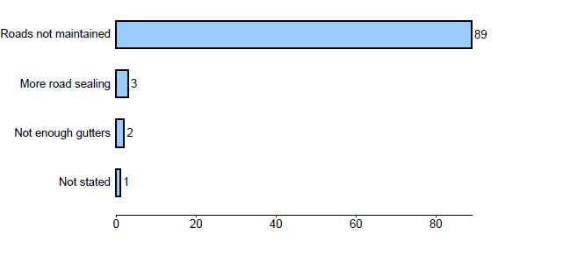

**Graph 2 – Unsealed Roads**

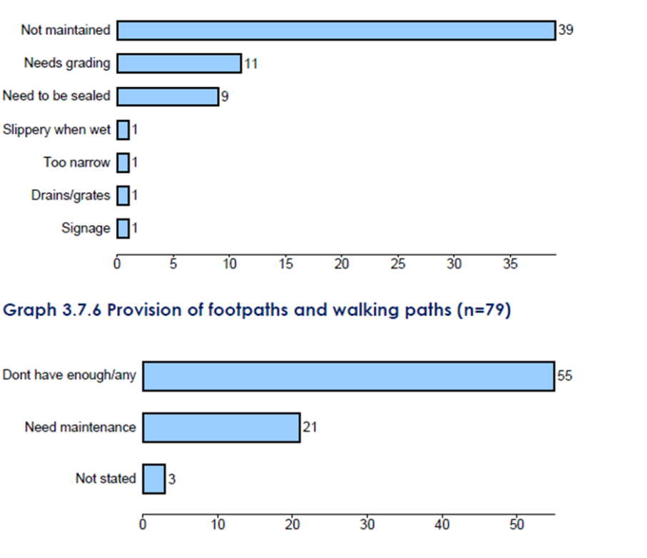

**Graph 3 – Provision of footpaths and walking paths**

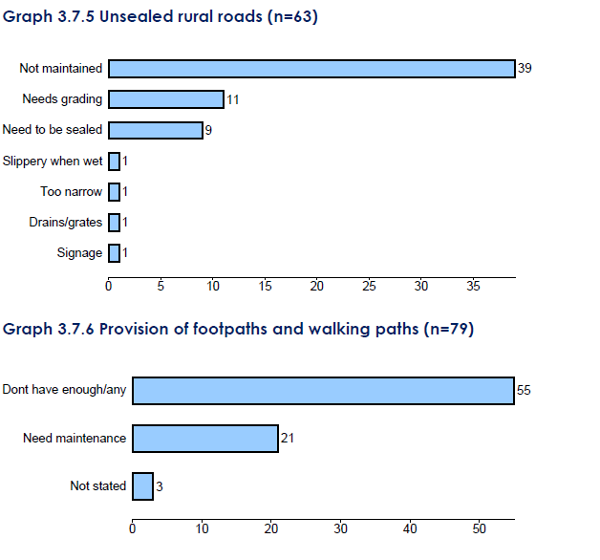

**2016**

* Several service areas registered low satisfaction ratings: Sealed rural roads (mean score 2.62 out of 5), Unsealed rural roads (2.72), Making the most of waterways (2.85), Car parks (2.87) and Managing commercial development (2.94).
* Provision of footpaths and walking paths (3.10) recorded a medium level satisfaction score (mean score between 3.0 and 3.74) while the other three services in this category fell into the low satisfaction category with mean scores below 3.0 out of 5.
* Unsealed rural roads have showed a statistically significant improvements on their 2015 mean. Roads and footpaths stillremain at unsatisfactory levels for the community. The extract below from the survey provides the 2016 results

**Graph 4 – Extract of 2016 Survey –Sealed Roads, Unsealed Roads and Footpaths and Walking Paths**

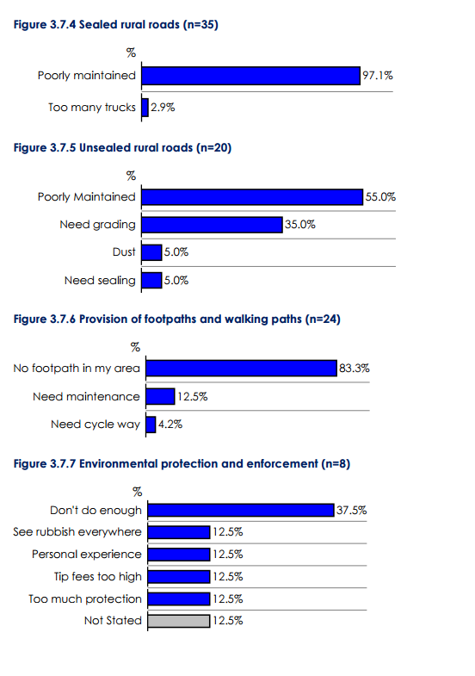

**Quadrant Analysis**

A key deliverable of the community survey is the quadrant analysis. This tool provides information on community satisfaction levels for Council’s services and facilities. In addition it also indicates the importance each service has and the overall satisfaction the community has for Council as a whole.

What is clearly shown through each of the survey years is that roads and maintenance of assets are of a high importance to the community but they are currently dissatisfied with the level of service that is provided in these areas. The derived importance for the survey years is shown below.

**Figure 1 – 2014 Quadrant Analysis**

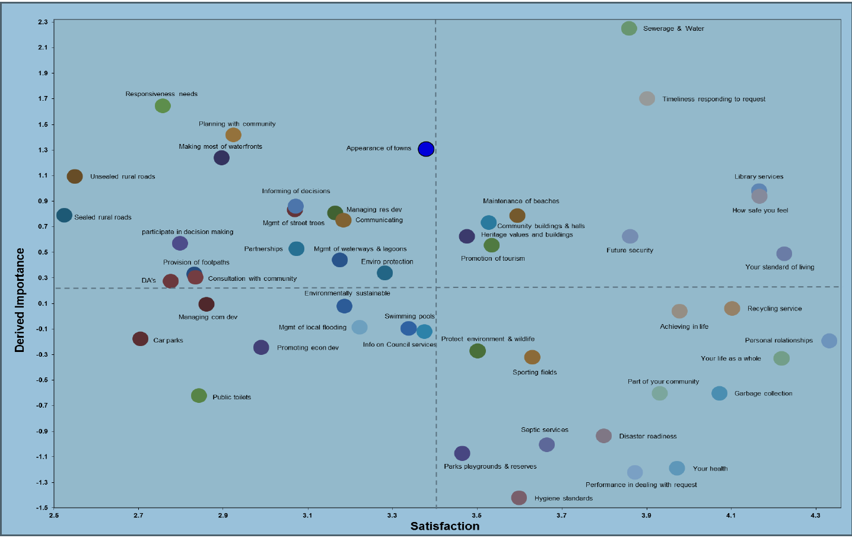

**Figure 2 – 2015 Quadrant Analysis**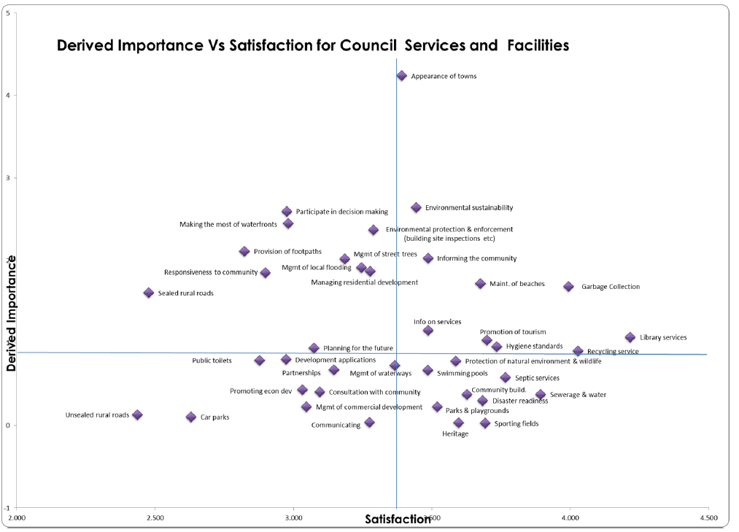

**Figure 3 – 2016 Quadrant Analysis**

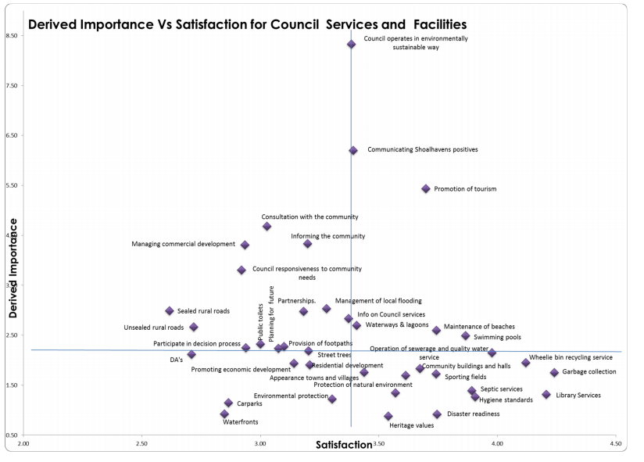

**Comparison between years**

Residents in the survey have continued to provide their reasons for dissatisfaction with services, these are provided in the tables below. The scale of measuring is explained at Table 2.

**Table 2 - Scale of Measuring**

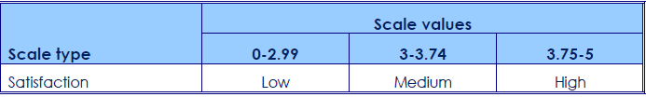

Figure 4 provides the percentage of dissatisfaction of respondents across various areas.

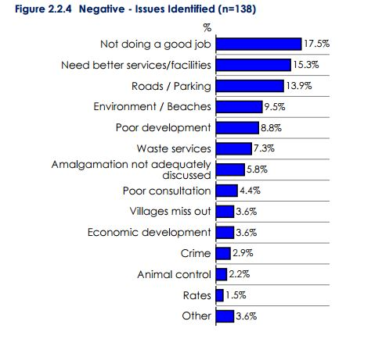**Figure 4 – Reasons for Dissatisfaction**

Figure 5 provides an indication of the satisfaction levels across roads and footpaths.

**Figure 5 - Satisfaction levels across roads and footpaths.**

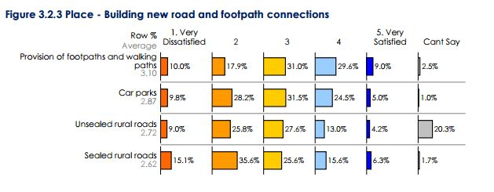

The 2014 – 2016 comparison of mean satisfaction levels across a range of services is provided in the table below. The majority of areas are showing small increases in satisfaction.

**Table 3 - 2014 – 2016 comparison of mean satisfaction**

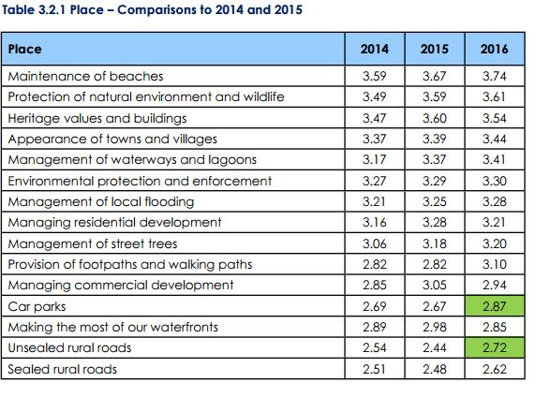

**Also please note the information provided below in 4.2 - Community Infrastructure Survey.** This information has also been used by Council to consider the community’s needs and desires in relation to the levels of service and asset maintenance and renewal.

How the decision to seek higher revenues above the rate peg was made and which other options were examined, such as changing expenditure priorities or using alternative modes of service delivery.

### Information to Council

As outlined in Section 2 above, Council staff have continually highlighted Councils financial position, to the Community, to the OLG and to IPART. The TCorp review in 2012 highlighted the need for greater focus on the 10 year forecast. Since that time Council has prepared a Financial Sustainability Report which showed that a significant increase in rates was required to bridge the gap. Subsequent to this the Fit for the Future Submission was completed which highlighted the need for a rate increase of 7.5% over 2 years above rate peg.

This rate increase was conveyed at community meetings and also to discuss merger proposals. Details of this are contained in Section 4 of this submission. There was a strong level of support from the community in favour of Council standing alone and supportive of the need for a rate increase to fund current levels of service and asset maintenance and renewal.

Subsequent to Council being deemed “Fit” based upon the proposed rate increase a second edition of the financial sustainability report was put to Council in September 2016. This further highlighted the need for a rate increase, albeit slightly higher than the original forecasts, due to cost shifting of emergency services levies, along with a reduced rate peg and increases in assets/services.

These changes have resulted in a proposed increase of 13.2% for 2017/18 and 14% for 2018.

### Special Schedule 7

The extract below (Figure 6) from the 2015/16 general Purpose Financial Statements highlights the low levels of infrastructure renewals and asset maintenance that the General Fund is facing. These ratios have been historically low and are similar to the issues identified by TCorp in 2012.

**Figure 6 – Extract from Special Schedule 7 2015/16 GPFS**



### Other Actions

Part of the decision of Council was that a rate increase need to also be supported by other revenue and expenditure measures. **The Financial Sustainability Report** identifies ongoing areas for improvement, engagement with the community and reduction in expenditure. These targets include:

1. Increases in User Pays fees and charges above CPI *- $4M increase in past 2 years, targeting $500K in next 2 years*
2. Increases in DA fees and introduction of value added services *- $470K increase in past 2 years (included in $4M above), targeting $400K in next 2 years*
3. Introduction of Parking fees *- Potential to introduce in some holiday locations to cover costs of additional services requested by the community eg Hyams Beach/Huskisson*
4. Reduction in Cost structure through efficiency initiatives *- $2.376M reduction in past 4 years, targeting $250K in next 2 years*
5. Service reviews and outsourcing where practical and cost effective *- $1.2 Saved in past 2 years, targeting $250K in next 2 years*
6. The Use of Technology to drive efficiencies *- Savings have been delayed in this area due to termination of the contract with the Vendor. This is a high priority focus for the next 1 - 2 years. Savings will be addressed once the system is implemented.*
7. Procurement initiatives locally and through the Joint Organisation *- $110,000 Saved in past 2 years, target $100,000 Over the next 2 years*
8. Energy Management *- $365,000 saved in past 4 years, targeting $150,000 in next 2 years*
9. Better Management of Fringe Benefits *- $173,000 saved in past 4 years targeting $80,000 in next 2 years*
10. Improved management of Leave Liabilities *- targeting $200,000 in next 2 years*
11. Reductions in service levels if agreement could be reached with the community *- targeting $100,000 in next 2 years*
12. Fuel efficiencies *- $348,000 Saved in past 4 years, targeting $75,000 in next 2 years*
13. Utilisation of Assets and Rationalisation of underutilised assets *- targeting $200,000 in next 2 years*

Although a number of these initiatives have been achieved and others are in the process of being carried out ($2.3M in next 2 years) they do not have the level of financial impact to improve the operating performance ratio to the level required. The only option of the magnitude required was an above rate peg increase.

Council continually looks at ways it can change its expenditure priorities. Below (Figure 7) is a graphic representation of what services would need to be discontinued completely to bridge the required gap. As can be seen from this chart this is the majority of discretionary services which Council operates and to reduce these services completely would be totally unacceptable from a community perspective. It should be made clear that no decision has been made to take steps of this magnitude and impact. The graphs simply try and put into some perspective the extent of the issue facing the community and Council.

**Figure 7 – Graphic Representation of Extent of Issue**

Council also uses a range of delivery methods for its services and market tests these through tendering/EOI processes where appropriate. Over the past 3 years council has continued to use external contractors for much of its construction work, many community services such as the management of its facilities are run by volunteer community committees. Council has recently let the management of its Ulladulla Civic Centre to an external service provider.

The cleaning of the CBD and catering at the Shoalhaven Entertainment Centre have also been out to tender. International Tourism marketing is done in a joint partnership with the State Government (DNSW) and a private business.

Council is also an active member Illawarra Joint Organisation and have actively pursued more effective purchases through participating in a range of tenders and EOI’s via this process. These have included:-

* Light Vehicles
* Trade Services Panel Tender
* Tree Services Panel Tender
* Legal Services Panel

Planned or in Progress

* Sanitary Services (open now)
* Print Services (includes rates notices)
* Office Supplies (Regional basket of goods – against existing Panel on LGP)
* Plant (Heavy Plant)
* Temporary Labour Hire
* Chemicals (Water and Pools)
* Road Line Marking
* Building/Hardware
* Computer Software (consolidation of systems e.g. regional Project Management software – one licence sharing)

Council has also set up long term panel contracts for asphalt, bitumen resealing and concrete supply.

Even with all the actions above there remains a significant funding gap that needs to be addressed via a special rate variation.

* Why the proposed special variation is the most appropriate option: for example, typically other options would include introducing new or higher user charges and/or an increase in council loan borrowings, or private public partnerships or joint ventures.

Council has been continually reviewing all user pay fees and charges over the last 3 years, staff have been trained in pricing, marketing and costing methodologies and between 2014 and 2016 the income from fees and charges has increased by 15% over the 2 year period. Over two thirds of this revenue has a restricted use within Crown Lands reserves and even with the same increase again over the next 2 years from the remaining fees and charges, revenue would only increase by $2.2m over the 2 years. Council have forecast increases of 4% annually for fees and charges into the long term plan, which is probably the maximum that the community can bear. Table 4 below presents the last 3 years income from fees and charges showing the increases achieved.

**Table 4 – Fees and Charges Revenue Increase 2014 - 2016**



Council has already been through a transformation program in the last couple of years which resulted in savings of $6m to the cost structure as outlined above

The one project that could make significant efficiency savings for Council is the implementation of a new Council wide software/computer system. Council had been going down the path with a LG software vendor, however after 4 years of perseverance the contract had to be terminated. Council is now fast tracking the selection and implementation of a computer system, which will achieve the efficiency savings Council so needs. The current platform is non-integrated, aged technologies, which require significant manual input and duplication of efforts, with very little visibility to be able to plan into the future. Unfortunately this project will take a number of years to see benefits and may not see staff reductions but will have a focus on improved efficiencies and customer service.

In the last few years Council has implemented some key principles with regards to borrowing of funds, with one of the main criteria being that the works need to relate to new or growth assets and will not be used to finance operational needs or operating deficits. This limits the potential to utilise loan funds, given that Council is not spending significant funds on New or Growth Assets. The other impact from borrowing more funds is the additional expense incurred from borrowings, which further impacts the operating deficit currently forecast for the next 10 years, without a rate increase.

At the time of preparing the latest Financial Sustainability document Council was looking at a 10 year forecast operating result before Capital Grants and Contributions of $116m loss. The only way to make the significant change required to bring this back to a break even result and to fund the maintenance and renewal of aging infrastructure was to introduce a significant rate increase over the rate peg.

* How the proposed special variation impacts the Long Term Financial Plan forecasts for the General Fund and how this relates to the need the council identified. Our assessment will also consider the assumptions which underpin the council’s Long Term Financial Plan forecasts.

For several years the LTFP has identified the need to rate increases. This was clearly documented as part of Council’s Fit for the Future submission. The table below (Table 5) provides the performance against each of the Fit for the Future measures with the proposed rate increase.

**Table 5 – Fit for the Future Measures**



### Assumptions.

The assumptions that underpin the LTFP are outlined below (Table 6). The change in the other revenue in 2020/21 is due to changes to the payment of the dividend from the Sewer fund.

**Table 6 - Assumptions**



## Financial sustainability

The proposed special variation may be intended to improve the council’s underlying financial position for the General Fund, or to fund specific projects or programs of expenditure, or a combination of the two. We will consider evidence about the council’s current and future financial sustainability and the assumptions it has made in coming to a view on its financial sustainability.

You should explain below:

* The council’s understanding of its current state of financial sustainability, its long-term projections based on alternative scenarios and assumptions about revenue and expenditure.
* Any external assessment of the council’s financial sustainability (eg, by auditors, NSW Treasury Corporation). Indicate how such assessments of the council’s financial sustainability are relevant to supporting the decision to apply for a special variation.
* The council’s view of the impact of the proposed special variation on its financial sustainability.
* The council’s understanding of its current state of financial sustainability, its long-term projections based on alternative scenarios and assumptions about revenue and expenditure.

### Background

Servicing such a large area with a widespread population and a huge seasonal influx of visitors Council is not able to meet all of the service demands. The issues with the sustainability of the financial position of Council as a result of these demands have been highlighted for a number of years and in Annual reports as early as 2001/2002. This has been exacerbated by the increasing unfunded responsibilities transferred to Local Government and the cost of implementing many legislative requirements. This historic and current information highlights Council needs to significantly increase revenue, or target a reduction in service costs, or a combination of both by approximately $11M per year.

In 2007 as the Independent Inquiry into Financial Sustainability of Local Government was published Council adopted Asset Management Plans that concluded Council had a substantial infrastructure renewal backlog and the successive updates continue to identify that this would continue to deteriorate if nothing changed. Since this time, Council has implemented a number of operational improvements to enable more funds to be made available for renewals and maintenance. Council has been very successful in seeking grant funds for upgrading assets. These improvements, while increasing the amount of funds available for asset renewal are not sufficient in the long term.

The predominate driver for the need to increase rates is the continued shortfall in the maintenance and renewal programs in the General Fund that Council needs to undertake on the assets it holds on behalf of the community in particular those with poor condition and low community satisfaction such as roads and facilities such as toilets. As the custodian of over $2 billion (SS7 General Fund replacement costs) in assets Council has the responsibility to maintain these to ensure the community gets maximum value from the assets.

It is noted that over the past few years additional and upgraded facilities and assets have also come on line. These include Pyree Lane and Bolong road upgrades, Turpentine Road, RFS and SES buildings, Nowra Aquatic Park, Ulladulla Civic Centre, and contributed assets of Bayswood, Twin Waters and Green Orchid estates.

* Any external assessment of the council’s financial sustainability (eg, by auditors, NSW Treasury Corporation). Indicate how such assessments of the council’s financial sustainability are relevant to supporting the decision to apply for a special variation.

### The TCorp Review

In 2012 the NSW Treasury Corporation (TCorp) undertook an analysis of the Financial Sustainability of each of the Councils in NSW, The Financial Assessment and Benchmark Report reviewed the previous three years of Council operations (2009/10 - 2011/12) and conducted a detailed review of the 10 year financial forecasts. The report made the following comments in their assessment of the Council financial position:

Council reported $43.1m of Infrastructure Backlog in 2011 which represents 2.3% of its infrastructure asset value of $1,873m. Other observations include:

* The Backlog is on an upward trend particularly in the roads asset category
* A significant portion of the Backlog (77.9%) is related to roads assets

The key observations from our review of the Council’s 10 year forecasts for its General Fund are:

* The forecast shows deficit positions excluding capital grants and contributions in all forecast years
* The Council’s forecast liquidity position is particularly weak, particularly from 2015 when the Unrestricted Current Ratio falls to negative levels which indicate that Council will have difficulty meeting its day to day expenses

The Council has posted declining operating results when grants and contributions for capital purposes are excluded.

This trend of declining operating results is not financially sustainable in the long term.

The Council has a maintenance shortfall of around $7m each year which can impact on the condition of the infrastructures. This is reflected in an Asset Maintenance Ratio of below 1.0x in all three years.

Asset renewal spending decreased by nearly 40% ($5.5m) over the last three years.

Operating deficits are forecast in the current 10 year model and Council is reliant on meeting its expenditure savings and productivity improvements to reach the forecast results. **The declining result is not a sustainable trend.**

The TCorp report presented to Council a very clear assessment of its current performance and its long term outlook. This has been instrumental in Council considering what actions it needs to take to address the long term sustainability of the organisation.

### Council oversight - Incoming Council information 2012

The information provided for the incoming Council in September 2012 by the Director of Financial and Corporate Services stated the following:

The over-riding key issue faced by Council over the next term is the financial sustainability of the organisation.

Council has infrastructure assets valued at over $2.3 billion which are ageing and require considerable expenditure on renewal & maintenance to ensure they are presented to the community in a satisfactory condition.

*Roads, Bridges & Footpaths $978 million*

*Earthworks $63 million*

*Drainage $204 million*

*Water Supply $482 million*

*Sewerage Network $589 million*

Presently, it is estimated that an amount of **$42.5 million** is required to be spent on this infrastructure to bring it up to a satisfactory condition. Once this is achieved, **$23.85 million** per annum is required in maintenance to keep it in a satisfactory condition. At present, Council is able to allocate **$16.48 million** per annum in maintenance which leaves an **annual shortfall of $7.37 million**.

It is not simply a case of dealing with this shortfall through allocating more funding for this purpose.

Council’s Resourcing Strategy (which includes a 10 year Financial Plan) has identified major shortfalls in funding that will occur over the next 10 year period due to the need to allocate additional funding for infrastructure renewal.

The shortfalls in funding begin immediately as can be evidenced from the cash flow as follows:

*2012/13 2013/14 2014/15 2015/16 2016/17 2017/18 2018/19*

*($14.2m) ($9.35m) ($8.68m) $0.001m $0.001m ($4.29m) ($3.29m)*

These shortfalls occur due to Council continuing with a large capital works program to construct new & enhanced assets while also allocating increased funding each year to infrastructure renewal & maintenance.

Like all levels of government, Council’s have limited funding available to provide the wide array of services required by the community. If Council wished to address this shortfall, it would have to either:

*1 Increase its revenue; or*

*2 Decrease operating expenses; or*

*3 Decrease its new capital works; or*

*4 Borrow more money; or*

*5 Commence a combination of all of these.*

These comments are very significant and assisted the newly elected Council to make decisions around expenditure reductions etc.

The Resourcing Strategy presented to Council in 2012/13 provided the Council with a very clear picture of the financial position at that time. The graph below (Figure 8) clearly presents the significant deficit operating result the Council was facing.

**Figure 8 – Operating Result before Capital Grants and Contributions**

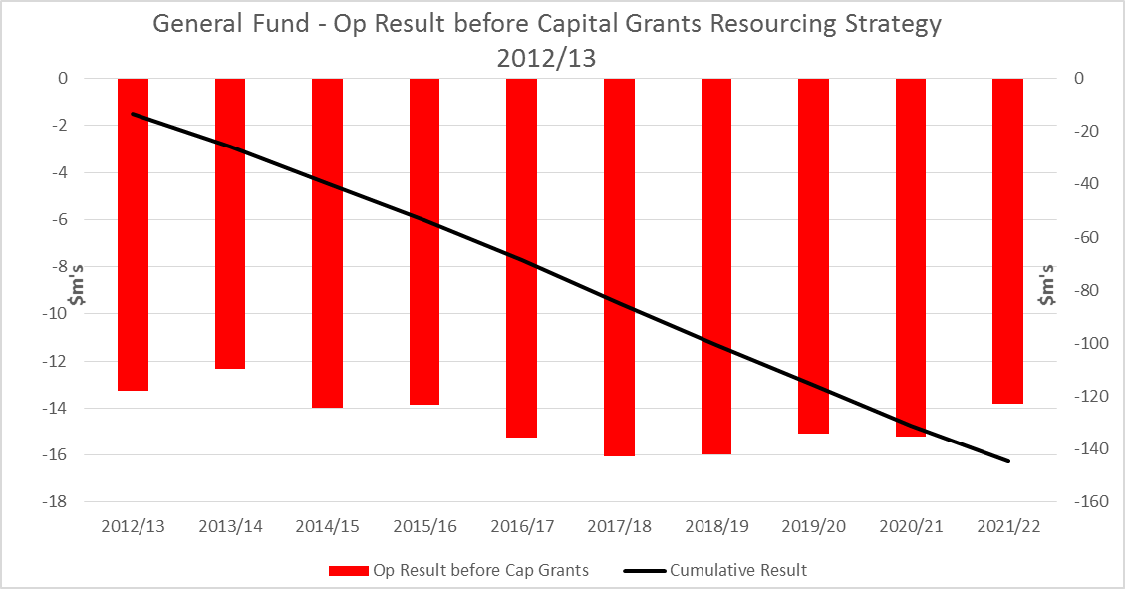

Source 2012/13 SCC Resourcing Strategy

The Resourcing Strategy was also a call to action for the Council. As outlined in 2.2 above Blackadder and Associates were contracted to assist Council in looking at ways to restructure and reduce costs. It was also apparent that these actions alone would not bridge the entire funding gap.

### Fit for the Future Report on Financial Sustainability

The “Report on Financial Sustainability - Shoalhaven City Council, General Fund” provides details of the issues facing Council at that stage. In Oct 2014 in response to this report the Council adopted the following resolution:-

**Financial Sustainability Report File 39801E**

That Council adopts the following recommendations from the Report of the General Manager (Corporate and Community Services Group) on the Financial Sustainability of Council:

a) Council notes the current long term financial position of the organisation and begins Community Engagement with regard to ways to address Councils Financial position

b) The General Manager and Staff commence to prepare the necessary documentation in relation to the State Governments “Fit for the Future” Program.

c) The General Manager introduce formalised continuous improvement principles and processes to the organisation

d) The General Manager continues to drive cultural changes throughout the organisation in order to address Councils long term financial sustainability.

e) Council adopt the key principles with regard to future Loan borrowings, Asset Rationalisation and Revotes as covered in the Financial Sustainability report attached.

f) That a further report be presented to Council on recommended principles and opportunities for asset and service rationalisation and their relationship to the Long Term Financial Plan.

g) That staff undertake a review and report to Council on opportunities for increased income generation from Council’s assets and services.

Council’s Fit for the Future submission also highlighted the need for rate increases to address the long term renewal and maintenance issues facing the community.

Graph 5 below is taken from the submission and highlights the existing LTFP at the time and the improvements gained with the rate increases and strategies proposed at that time.

**Graph 5 – OPR as per the 2015 Fit for the Future Submission**

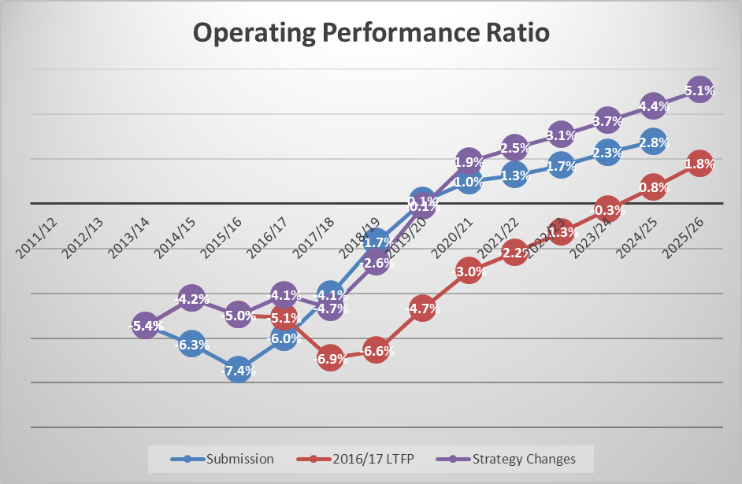

* The council’s view of the impact of the proposed special variation on its financial sustainability.

The Council understands that the Special Rate Variation is required to address its long term financial sustainability. It also understands that other measures must be equally pursued including other revenue measures as outlined earlier in the report and ongoing business process improvement and expenditure measures.

It is acknowledged that that the financial gap is too large to address without the SRV as cost and service reductions can only provide a proportion of this gap.

This position has been consistent since 2015 when Council made its Fit for the Future submission and apart from updating the LTFP and the SRV amount Councils position has remained unchanged as reflected by the fact that Council has continues to resolve to proceed with the application. The indicators provided in section 3 above also demonstrate the impact that the SRV has on financial sustainability of the organisation.

## Financial indicators

How will the proposed special variation affect the council’s key financial indicators (General Fund) over the 10-year planning period? Please provide, as an addendum to the Long Term Financial Plan, an analysis of council’s performance based on key indicators (current and forecast) which may include:

* Operating balance ratio excluding capital items (ie, net operating result before capital grants and contributions as percentage of operating revenue before capital grants and contributions).
* Unrestricted current ratio (the unrestricted current assets divided by unrestricted current liabilities).
* Rates and annual charges ratio (rates and annual charges divided by operating revenue).
* Debt service ratio (principal and interest debt service costs divided by operating revenue excluding capital grants and contributions).
* Broad liabilities ratio (total debt plus cost to clear infrastructure backlogs as per Special Schedule 7 divided by operating revenue).
* Asset renewal ratio (asset renewals expenditure divided by depreciation, amortisation and impairment expenses).

The Fit for the Future ratios/indicators are provided in the table below (Table 7). In general there is improvement across the indicators with the most significant improvement being in the Operating Performance Result. There is improvement in the Building and Infrastructure Asset Renewal result but Council still has more to do the bring this indicator to the target required. Likewise the Infrastructure Backlog Result does not meet the target over the 10 years.

**Table 7 - The Fit for the Future ratios/indicators**

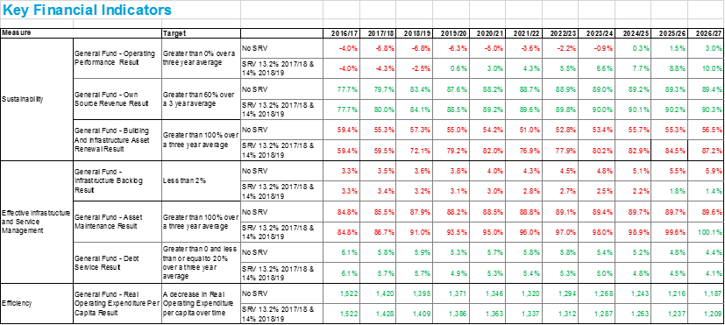

**See** **Attachment 4 for the Financial Indicators Addendum**

## Contribution plan costs above the cap

You should complete this section if the proposed special variation seeks funding for contributions plan costs above the development contributions cap. Otherwise, leave this section blank.

Please explain how the council has established the need for a special variation to meet the shortfall in development contributions.

For costs above the cap in contributions plans, a council must provide:[1]

* a copy of the council’s section 94 contributions plan
* a copy of the Minister for Planning’s response to IPART’s review and details of how the council has subsequently amended the contributions plan
* details of any other funding sources that the council is proposing to use, and
* any reference to the proposed contributions (which were previously to be funded by developers) in the council’s planning documents (eg, Long Term Financial Plan and Asset Management Plan AMP.

|  |
| --- |
| Not Applicable |

# Assessment criterion 2: Community awareness and engagement

Criterion 2 in the Guidelines is:

*Evidence that the community is aware of the need for and extent of a rate rise. The Delivery Program and Long Term Financial Plan should clearly set out the extent of the General Fund rate rise under the special variation. The council’s community engagement strategy for the special variation must demonstrate an appropriate variety of engagement methods to ensure community awareness and input occur. IPART’s fact sheet includes guidance to councils on the community awareness and engagement criterion for special variations.*

Our fact sheet on the requirements for community awareness and engagement is available on the IPART website.[2]

In responding to this criterion, the council must provide evidence that:

* it has consulted and engaged the community about the proposed special variation using a variety of engagement methods and that the community is aware of the need for, and extent of, the requested rate increases
* it provided opportunities for input and gathered input/feedback from the community about the proposal, and
* the IP&R documents clearly set out the extent of the requested rate increases.

In assessing the evidence, we will consider how transparent the engagement with the community has been, especially in relation to explaining:

* the proposed cumulative special variation rate increases including the rate peg for each major rating category (in both percentage and dollar terms)
* the annual increase in rates that will result if the proposed special variation is approved in full (and not just the increase in daily or weekly terms)
* the size and impact of any expiring special variation (see Box 4.1 below for further detail), and
* the rate levels that would apply without the proposed special variation.

More information about how the council may engage the community is to be found in the Guidelines, the IP&R manual and our fact sheet.

|  |
| --- |
| Box 4.1 Where a council is renewing or replacing an expiring special variation |
| The council’s application should show how you have explained to its community:  There is a special variation due to expire at the end of the current financial year or during the period covered by the proposed special variation. This needs to include when the expiring special variation was originally approved, for what purpose and the percentage of (General Fund) general income originally approved.  The corresponding percentage of general income that the expiring special variation represents for the relevant year.  Whether the temporary expiring special variation is being replaced with another temporary or a permanent increase to the rate base.  The percentage value of any additional variation amount, above the rate peg, for which the council is applying through a special variation.  If the proposed special variation was not approved (ie, only the rate peg applies), the year-on-year change in rates would be lower, or that rates may fall.  The council also must attach, to its application to IPART, a copy of the Instrument of Approval that has been signed by the Minister or IPART Chairman. |
|  |

## The consultation strategy

The council is required to provide details of the consultation strategy undertaken, including the range of methods used to inform and engage with the community about the proposed special variation and to obtain community input and feedback. The engagement activities could include media releases, mail outs, focus groups, statistically valid random or opt-in surveys, online discussions, public meetings, newspaper advertisements and public exhibition of documents.

The council is to provide relevant extracts of the IP&R documents that explain the rate rises under the proposed special variation and attach relevant samples of the council’s consultation material.

### Community Engagement

Community engagement in relation to Council’s financial sustainability position started in October 2014 when Council first considered the Financial Sustainability Report. There was extensive media coverage at the time and debate in the community. Since this time Council has continued to work alongside the community and CCBs to understand the community’s priorities and visions via the strategic planning and Delivery Program process.

At this time Council’s CCBs were provided with a presentation at the CCB Executive meeting and access to the information. This continued when the State Government introduced the Fit for the Future requirements. Council updated its information in line with these requirements and again made this information available to the community. The Fit for the Future submission clearly outlined the need for two x 7.5% above rate peg increases.

During the public consultation process for the proposed forced merger of Shoalhaven City Council and Kiama Council, Council again outlined its financial position and the Fit for the Future measures. In a number of submissions received, as part of this process, members of the public made it clear that there was a good understanding of the Council’s financial strategy and proposal and support for this.

With the election of the new Council and changes in the rate peg and additional costs impacting the financial position of the organisation, the Financial Sustainability report was updated and presented to Council for consideration. That report outlined the recommended rate rises required to meet the Fit for the Future benchmarks and to improve infrastructure. Council resolved to undertake further community engagement and present to the community three rate increase options for their feedback.

### Community Consultative Bodies

Council has a network of 24 Community Consultative bodies which it regularly uses to communicate important information such as its financial position etc.

**Table 9 – CCB Representation**

| **Area** | **Community Consultative Body** |
| --- | --- |
| Northern Area | [Berry Forum](http://shoalhaven.nsw.gov.au/My-Community/Residents-groups/Berry-Forum) |
| [Pride of Bomaderry](http://shoalhaven.nsw.gov.au/My-Community/Residents-groups/Pride-of-Bomaderry) |
| [Budgong Community Group](http://shoalhaven.nsw.gov.au/MyCommunity/Residentsgroups/BudgongCommunityGroup.aspx) |
| [Cambewarra Residents and Ratepayers Association](http://shoalhaven.nsw.gov.au/MyCommunity/Residentsgroups/CambewarraResidentsandRatepayers.aspx) |
| [Shoalhaven Heads Community Forum](http://shoalhaven.nsw.gov.au/MyCommunity/Residentsgroups/ShoalhavenHeadsCommunityForum.aspx) |
| Central Area 1 | [Callala Bay Community Association](http://shoalhaven.nsw.gov.au/MyCommunity/Residentsgroups/CallalaBayCommunityAssociation.aspx) |
| [Callala Beach Progress Association](http://shoalhaven.nsw.gov.au/MyCommunity/Residentsgroups/CallalaBeachProgressAssociation.aspx) |
| [Culburra Beach Progress Association](http://shoalhaven.nsw.gov.au/MyCommunity/Residentsgroups/CulburraBeachProgressAssociation.aspx) |
| [Currarong Community Association Incorporated](https://shoalhaven.nsw.gov.au/MyCommunity/Residentsgroups/CurrarongProgressAssociation.aspx) |
| [Greenwell Point Community Association](https://www.shoalhaven.nsw.gov.au/My-Community/Residents-groups/Greenwell-Point-Get-to-the-Point) |
| [Orient Point Progress Association](http://shoalhaven.nsw.gov.au/MyCommunity/Residentsgroups/OrientPointProgressAssociation.aspx) |
| Central Area 2 | [Basin Villages Forum](http://shoalhaven.nsw.gov.au/MyCommunity/Residentsgroups/BasinVillagesForum.aspx) |
| [Huskisson Woollamia Community Voice](http://shoalhaven.nsw.gov.au/MyCommunity/Residentsgroups/HuskissonWoollamiaCommunityVoice.aspx) |
| [Hyams Beach Villagers Association](http://shoalhaven.nsw.gov.au/My-Community/Residents-groups/Hyams-Beach-Villagers-Association) |
| [Tomerong Community Forum](http://shoalhaven.nsw.gov.au/MyCommunity/Residentsgroups/TomerongCommunityForum.aspx) |
| [Vincentia Ratepayers & Residents Association](http://shoalhaven.nsw.gov.au/MyCommunity/Residentsgroups/VincentiaRatepayersandResidents.aspx) |
| [Wandandian Progress Association](http://shoalhaven.nsw.gov.au/MyCommunity/Residentsgroups/WandandianProgressAssociation.aspx) |
| Southern Area | [Bawley Point/Kioloa Community Association](https://www.shoalhaven.nsw.gov.au/MyCommunity/Residentsgroups/BawleyPointKioloaProgressAssociation.aspx) |
| [Milton 2538 CCB](http://shoalhaven.nsw.gov.au/My-Community/Residents-groups/Friends-of-2538) |
| [Conjola Community Association](http://shoalhaven.nsw.gov.au/My-Community/Residents-groups/Conjola-Community-Association) |
| [Red Head Villages Association](http://shoalhaven.nsw.gov.au/MyCommunity/Residentsgroups/RedHeadVillagesAssociation.aspx) |
| [Sussex Inlet and Districts Community Forum](https://www.shoalhaven.nsw.gov.au/MyCommunity/Residentsgroups/SussexInletCommunityForum.aspx) |
| [Tabourie Lake Ratepayers & Residents Association](http://shoalhaven.nsw.gov.au/MyCommunity/Residentsgroups/TabourieLakeRatepayersandResidents.aspx) |
| [Ulladulla & Districts Community Forum](http://shoalhaven.nsw.gov.au/MyCommunity/Residentsgroups/UlladullaandDistrictsCommunityForum.aspx) |
|  |

Following the Financial Sustainability Report above and the Fit for the Future announcement, Council met with the executives of all the CCB’s in April 2015 and provided them with a presentation of the financial position and the proposed 20% rate rise over the next 2 years (As proposed at that time based on 2 x 7.5% rate increases above 2.5% rate peg).

The CCB’s are provided with all Council business papers and minutes and are kept abreast of all discussions Council is having in relation to its financial situation.

In Nov 2016 another CCB Executive meeting was held to provide them with information on the new proposal (2 x 13.5% rate increases above a 1.5% and a 2.5% rate peg).

Another CCB Executive meeting was held in January 2017 to discuss the proposal and answer questions from the groups.

### Community Engagement Process

The community engagement process for this SRV has been extensive and has used a variety of methods to inform the community about the proposal and to provide opportunities for Council to receive feedback. From November 2016 to January 2017 the engagement included:

* Direct engagement with CCBs including presentations and direct emails
* Direct mail out to all residents and ratepayers outlining the proposal and the opportunity to provide feedback to Council
* Online survey
* Online poll
* Online Engagement portal with FAQs and details about the proposal
* Hard copy information pack at all Council facilities
* Hard copy information pack to mailout for those without internet access
* On the ground listening posts and random surveys at shopping centres
* IRIS commissions random telephone survey
* Media releases, radio items, advertising and other publicity
* Features in Council’ s Neighbourhood News EDM

## Feedback from the community consultations

Summarise the outcomes and feedback from the council’s community engagement activities. Outcomes could include the number of attendees at events and participants in online forums, as well as evidence of media reports and other indicators of public awareness of the council’s special variation intentions. Where applicable, provide evidence of responses to surveys, particularly the level of support for specific programs or projects, levels and types of services, investment in assets, as well as the options proposed for funding them by rate increases.

Where the council has received submissions from the community relevant to the proposed special variation, the application should set out the views expressed in those submissions. Please refer to Section 1.2 concerning how the council should handle confidential content in feedback received from the community. The council should also identify and document any action that it has taken, or will take, to address issues of common concern within the community.

### Community Infrastructure Survey

Feedback in 2012/13 from the Community Infrastructure Survey provided the following information for the consideration of Council.

Graph 6 highlights the very high percentage of respondents that saw maintenance and renewal of various asset categories as critical or important both locally and citywide.

**Graph 6 – Responses to Critical and Importance of Maintenance and Replacement**

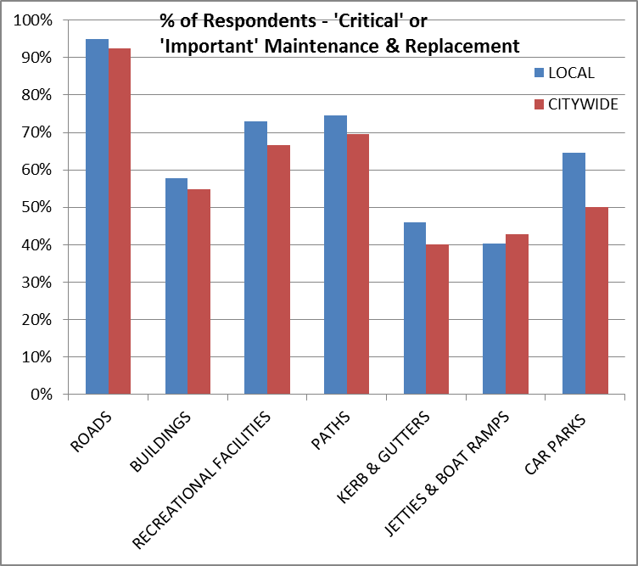

The following graph (Graph 7) shows the high levels of dissatisfaction with the current levels of service being provided across these asset categories.

**Graph 7 – Level of Satisfaction**

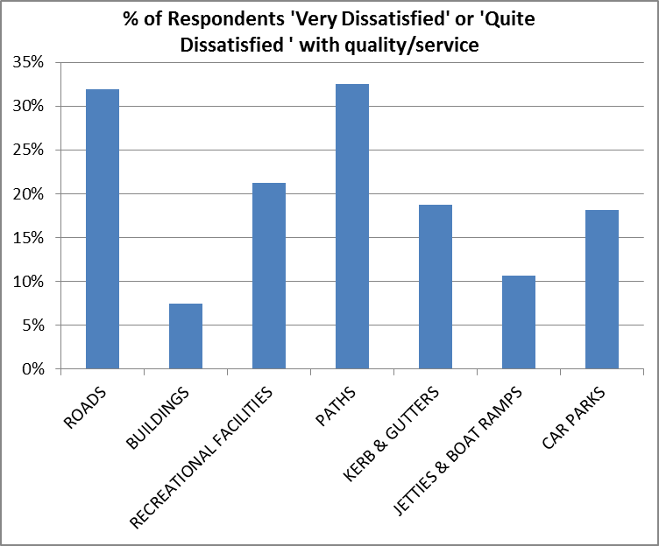

In relation to the community’s expressed priority area the results were very clear as indicated below in Graph 8.

**Graph 8 – Priority Areas**

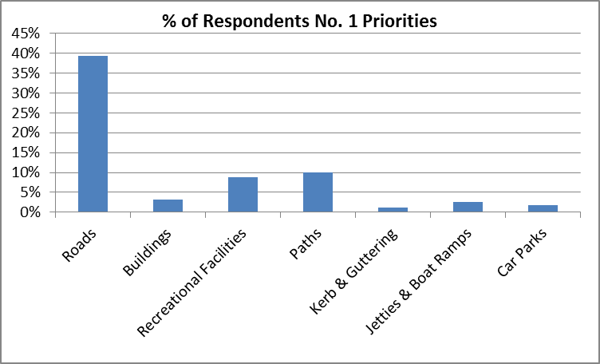

Survey respondents were also asked if a ‘fair condition’ was acceptable. The graph below (Graph 9) provides the results of these questions. It is very clear that the respondents did not think that a ‘fair condition’ was acceptable in a number of the asset categories.

**Graph 9 – Fair Condition Acceptable?**

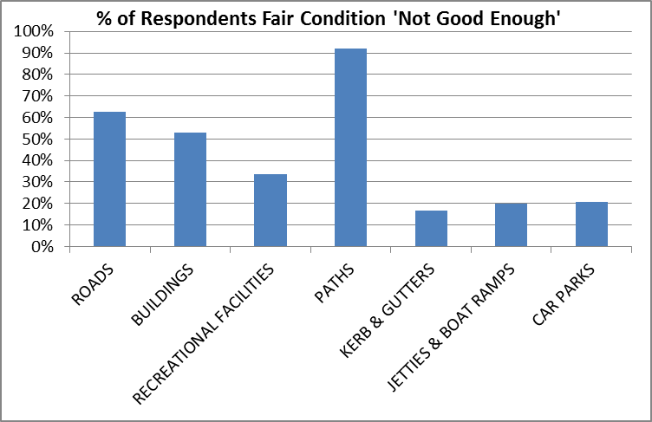

When asked “Do you agree that Council should increase rates to improve the quality and/or condition from 'fair' to 'good'” of the various infrastructure types, the respondents were supportive in some areas such as paths and roads.

**Graph 10 – Agree/Disagree to Increase Rates**

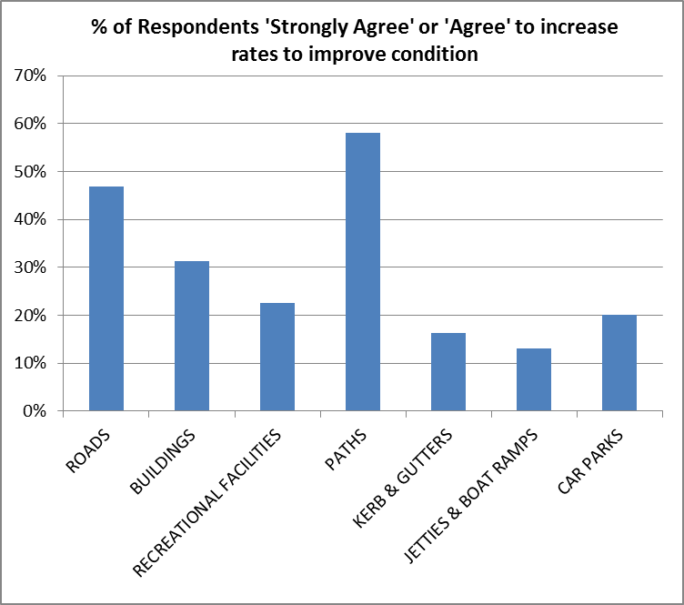

### 2016/17 SRV Proposal

The proposed rates increases attracted significant media attention and was well publicised.

In a survey, one week after the Council’s announcement, 60% of respondents had directly heard about the Council’s new rates proposal. Offline sources, especially radio (39%) and local newspaper (20%), were the main source of information.

The key issues raised by the CCBs were how the different scenarios would impact on rates; the management of assets; and the opportunities of a citizens panel.

The results of the phone survey are as follows:

**IRIS (Illawarra Regional Information Service) Phone Survey (See Community Engagement Report)**

A telephone survey was conducted to seek random and demographically representative feedback on the rates increase. A sample size of 405 people was selected. This provides a representative sample, a larger size would not have shown different results.

Respondents were also asked whether they pay rates to Shoalhaven City Council. Results showed that, the majority of the respondents pay rates (86%) and almost all of those who pay rates to Shoalhaven City Council pay it for their own residence (96%). Some respondents have rental properties for which they also pay rates (8%)

The questions were reviewed and critically analysed by IRIS to ensure that they would allow for a representative sample to be obtained.

A copy of the survey questions is provided in the **Community Engagement Report**

* **Perception of Council’s financial position**

Results showed that respondents did not agree that the council’s financial situation was particularly negative. The average score (4.9 out of 10) showed that the respondents mainly had a neutral perception towards the Council’s financial situation

**Figure 10 – View of Council’s Financial Position**

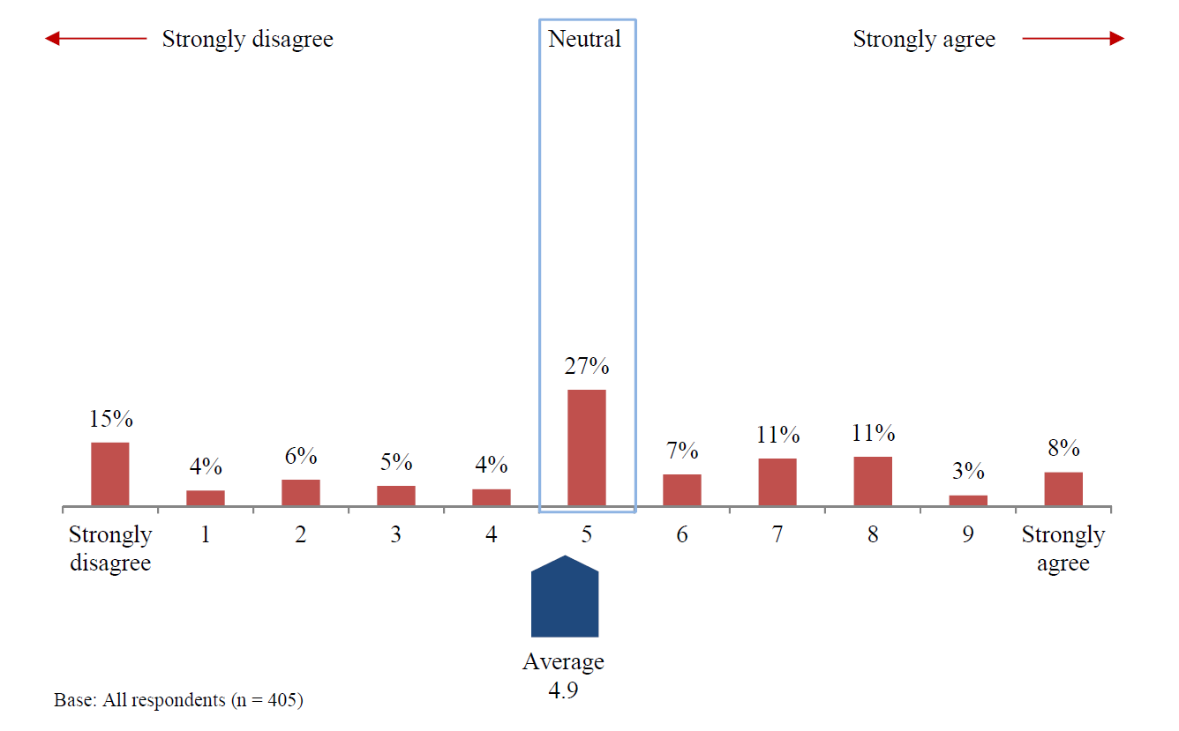

* **Support for the rates proposal**

Two in five residents (40%) indicated that they were not at all supportive’ of paying higher rates. 16% of respondents had neutral support for paying higher rates. Average respondent support was 3.0 out of 10.

**Figure 11 – Supportive of Paying Higher Rates**

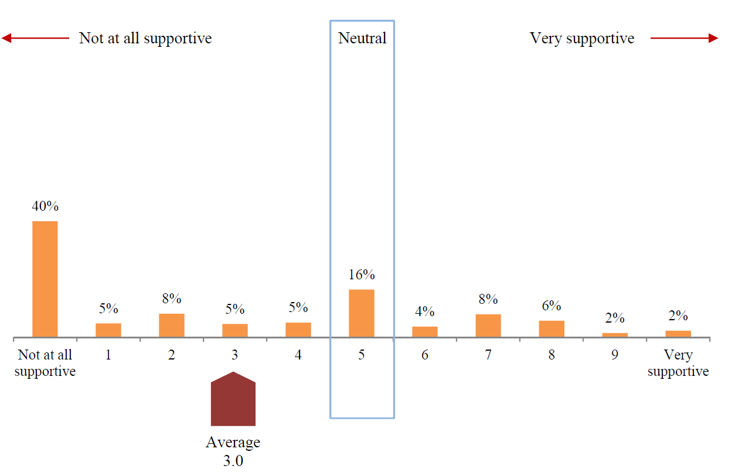

The results showed that 62% of respondents do not support the idea of having to pay higher rates. This result is the same among rate-payers. Non-rate payers seem to be less supportive, however the significance tests show that the differences are not statistically significant.

* **Motivations to pay higher rates, usage fees and charges**

The results showed that some residents would consider paying higher rates, usage fees and charges, if the community has a say in the way the money is spent. Some residents also advised that they would consider paying higher rates, if the extra money is spent on the community priorities, management of Shoalhaven’s natural environment and the operations of Council in a more sustainable way.

The Council’s financial sustainability, implementation of strategic objectives and provision of inclusive facilities were not stated as strong motivators. Some respondents agreed that they would be willing to pay higher rates, usage fees and charges, if it makes Shoalhaven City a more liveable and attractive place, more prosperous and inviting.

**Figure 12 – Willingness to Pay Higher Rates**

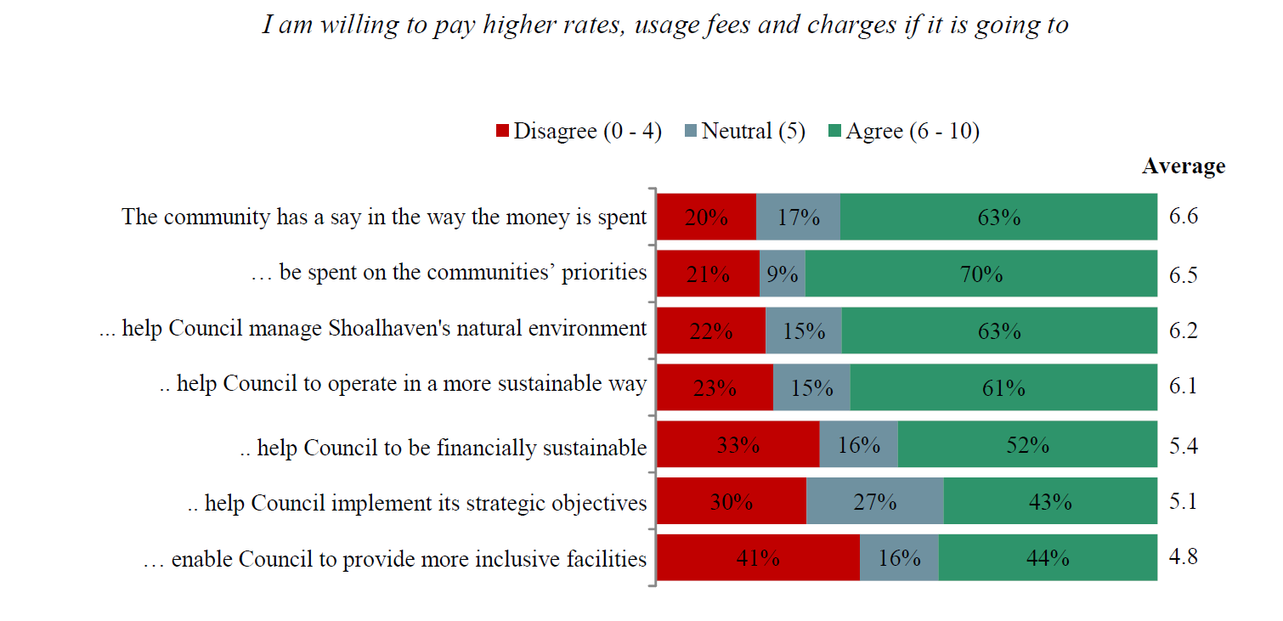

Respondents recommended that to create an overall motivationfor paying higher rates among residents, Council should create opportunities for community to be involved in decision-making processes. Council should clearly show that it understands the community’s priorities correctly and build strategies to make the money is spent effectively to meet their priorities.

To create support for having to pay higher rates, Council should communicate its management methods more effectively. Residents should be aware how the higher rates would provide Council with opportunities to build more inclusive community facilities.

Council should ensure that the residents are aware that the higher rates generate financial sustainability for the Council and opportunities for management to implement its strategic objectives.

In both cases, some residents are motivated to pay higher rates and support having to pay higher rates if the money is used to improve Shoalhaven City’s future prospects.

* **Rates Options**

When the rate-payers were asked their preferred options for the future rates increases, almost half of them (47%) stated that they are not prepared to pay additional rates. They do not indicate a clear preference among the proposed options but an ‘increase rates by 11.5% every year for 2 years (plus the rate peg): Lowest increase over a seven year period’ was the most identified option (37%).

**Figure 13 – Rate Increase Preferred Option**

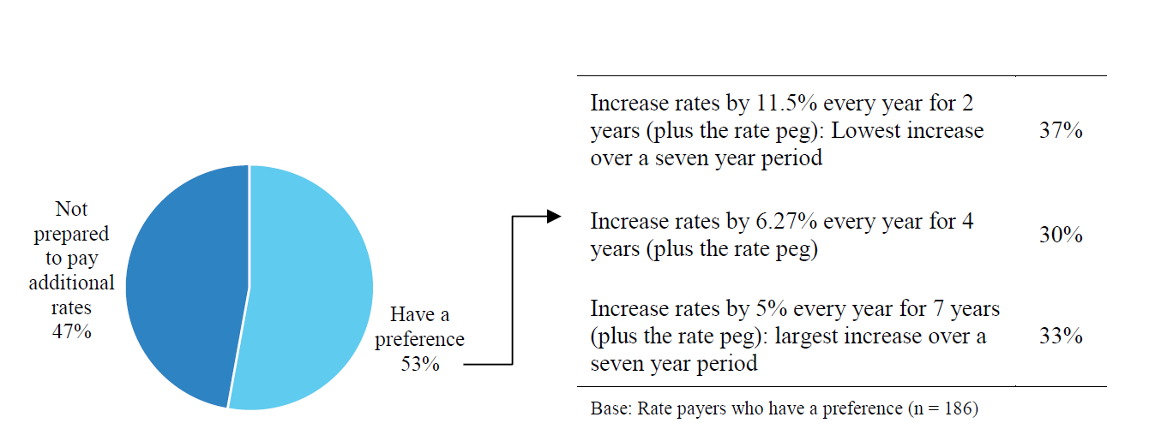

* **Spending of additional funds**

According to respondents, the extra income that is generated from the increased rates should be spent on roads (58%).The significance tests showed that the roads are clearly the main priority for the Council’s future investments for all subgroups of the sample.

**Table 10 – Areas for SRV Funds to be Directed**

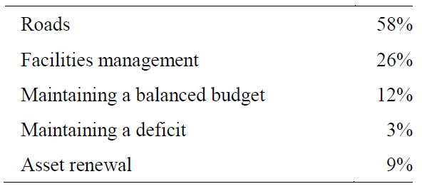

* **Services to be reduced**

Respondents did not clearly identify particular services or facilities to be reduced to help to maintain the rates, fees, and charges at their current level. Some respondents suggest some unused services and facilitiesbe closed, namely entertainment, art, information centres and take away facilities in Nowra and Milton. Respondents suggest roads cleaning and street sweeping could be reduced to help keep fees at their current level.

Numbers of parks and reserves can be reduced by closing some located in isolated irrelevant areas. Similarly, some respondents suggest reducing the number of waste collection bins.

A reduction in wages paid to Councillors and Councillors expenses, including water bottles/ food at council meetings as well as staff salaries was also suggested.

Respondents listed some unused services and facilities such as Roundabout at south Nowra, new plan for Bomaderry sporting complex, misting bubblers in the Nowra CBD and library services. Some respondents suggested community events could be reduced to keep the rates at their current level.

There were some comments made about the contractors who currently work for the Council while some suggested that having contractors is more efficient. Respondents stated that if the tip feesare eliminated council could save money for cleaning illegal dumping. Finally, it was suggested that the red tape and some internal Council expenses could be reduced.

Council is continually evaluating its services and looking at ways to reduce expenditure and long term liabilities. Some of these suggestions may be viable while others may not be acceptable to the majority of the community. These suggestions will be considered in that ongoing process and will involve the necessary community consultation.

* **Recommended ways to raise revenue**

When the respondents were asked to recommend ways for the Council to raise revenue, the most common recommendations were related to better managementmethods.

Residents understand that the rates, fees and charges are the main sources of the Council’s income thus they recommend rate increasesas a way of raising revenue.

Residents mentioned that Council should apply for funding from the State and Commonwealth governments as a way of raising revenue.

Residents suggested that user paysfor the services and facilities could be a source for additional revenue. Residents suggested that users might start to pay or pay more for the services and facilities they use such as, library computers, development applications, and boat ramps. Similarly, parking fees and finesare suggested as a potential source for revenue raise. Residents suggest user pays for car parking in the CBD or in caravan parks is another way of raising revenue.

Residents recommend conducting events and activitiesfor the council to raise revenue. They suggested that more community events, festivals, fairs, concerts, and annual shows would not only raise funds for the Council but also bring the Shoalhaven community together.

Tourismwas suggested as a way to raise income. Visitors could have ‘user pays’ for the existing tourist attractions and also for the activities that are held by the Council. Furthermore, if the tourism is improved, the facilities that are mainly used by tourists would generate more revenue.

Residents suggested that the Council management should work more efficiently and be more productive. They recommended that council review their investment strategy. They claimed that cutting some internal expense would be helpful to reduce expenditure. They also suggested a reduction in the number of staff.

A number of these suggestions are already being explored. Some are not necessarily revenue raisers but may in fact increase costs. These suggestions will be considered in an ongoing review process and will involve the necessary community consultation.

### Written Submissions

A total of 62 written submissions were received as part of the engagement process.

These submissions have been summarised in to a table and provided as part of the **Community Engagement Report**

* 34 did not support the proposed rate rise in any form many provided reasons such as Council should live within its means or cut services and it should be a user pays system
* 13 submissions did not support the proposed rate rise in its current form but proposed alternative options or proposed a delay for further engagement
* 15 submissions proposed which option they preferred ( some specifically said they supported the rise other said if it had to happen then the option they preferred would be 1,2 or 3)
  + 9 Option 1
  + 5 Option 2
  + 1 Option 3

### EHQ - Get Involved Shoalhaven- Online Engagement

As part of the engagement process the new online engagement portal was used to capture online submissions. As of 10 February 2017, the EHQ page “Your Rates, Everybody's Future” has had:

•         1,393 page views

•         974 visits

•         42 Quick Poll responses

•         35 Survey responses

•         16 Guestbook responses

•         974 participants were “aware”

•         349 participants were “informed”; and

•         70 participants were “engaged”.

35 responses to the online survey were received as part of the online engagement. The results from this survey included:

* 14 were not at all supportive of the proposal (0 out of 10)
* 2 had a support level of 2 out of 10
* 5 had a support level of 3 out of 10
* 2 had a support level of 5 out of 10
* 3 had a support level of 7 out of 10
* 2 had a support level of 8 out of 10: and
* 7 were very supportive of the proposal (10 out of 10).

Suggestions for saving money:

* Reduce services such as libraries and swimming pools
* User pays system
* Administrative improvements
* Asset maintenance system to ensure best use of funds.

A copy of each individual survey response is provided as part of the **Community Engagement Report.**

16 individual online submissions were also received this allowed for specific comments to be made. This also allowed for those that did not want to select any of the three options to provide comment about the proposal and to outline that they did not support any rise if they so choose. A copy of each of the guestbook comments in provided as part of the **Community Engagement Report.**

A quick poll was also included on the site where participants were able to select from the following three options:

Option 1: Rates to increase by 11.5% every year for 2 years (plus the rate peg)

Option 2: Rates to increase by 6.27% every year for 4 years (plus the rate peg)

Option 3: Rates to increase by 5% every year for 7 years (plus the rate peg)

The results were from 42 respondents.  45% selected the option 1, 24% selected option 2, and 31% option 3.

### Listening Posts

Two listening posts were conducted at Nowra Shopping centre and Ulladulla Civic Centre on December 21 and 22. These included Council staff attending and provided brochures and an opportunity for the community to provide feedback on rates. In Nowra 30 people were contacted and in Ulladulla 15 people were contacted*.*

The feedback from these listening posts was that the community were aware of the proposal and many had already received a rate brochure in the mail. Most did not provide a strong opinion about the rates proposal.

### Media

There were 16 unique articles that featured in South Coast Register, 2st and Milton Ulladulla Times. Articles also appeared in a number of CCB newsletters. There were also a number of radio features and the rates proposal also featured on Councils Facebook site and Shoalhaven news site. The community are aware of the proposal and there are mixed comments on each of these sites. This feedback has not been captured for this report as not official submissions to the Council engagement process.

### Other feedback

Another issue raised during the consultation process was the value Council allocated to its assets such as Kerb and Gutter replacement costs and the annual depreciation. It was suggested that Council should use a lower value to estimate rates. Council is using rates that have been calculated by using costs that also include demolition, disposal of concrete, compaction of base and new pavement, concrete supply and installation based on actual costs in 2013 - 2015. To use the lower rate would not be an accurate replacement cost for an isolated section of replacement of kerb and gutter.

### Summary of Engagement

The outcomes of the community consultation indicates that the proposed rate increase was generally not supported, there was some members of the community who would pay higher rates to maintain services.   The feedback is also clear that if a SRV is determined the community does want to have a say in how the funds raised from a Special Rate Variation are allocated.  In response to this feedback staff are to provide a report to the next Ordinary Council Meeting on the establishment of a Citizen’s Panel to provide recommendations to Council on priority areas for expenditure related to the Special Rate. The report will outline the possible structure and terms of reference for the Citizen’s Panel.

A key theme in the submissions and engagement was the impact of rates on low income earners and pensioners. Council acknowledges that any rate increase may be difficult for some community members.

There has been little comment from Farmers and Business property owners. In a recent meeting with the General Manager and the President of the Shoalhaven Chamber of Commerce, the Chamber expressed support for the rate rise. Council undertook a review of the business rates last year which had strong support from the business community.

Council has also maintained a positive working relationship with the farmers of the area. As part of the rates review last year discussion were held in relation to making the two farmers rates the same. The resultant consultation and discussion saw the split remain in place with Dairy Farmers being charged a lower rate than other farmers.

### Verons Estate

There has also been an extensive consultation process in relation to Verons Estate. The details of this are contained in the Verons information attachment (**Attachment 3**).

# Assessment criterion 3: Impact on ratepayers

Criterion 3 in the Guidelines is:

*The impact on affected ratepayers must be reasonable, having regard to both the current rate levels, existing ratepayer base and the proposed purpose of the variation. The Delivery Program and Long Term Financial Plan should:*

* *clearly show the impact of any rises upon the community*
* *include the council’s consideration of the community’s capacity and willingness to pay rates and*
* *establish that the proposed rate increases are affordable having regard to the community’s capacity to pay.*

The impact of the council’s proposed special variation on ratepayers must be reasonable. To do this, we take into account current rate levels, the existing ratepayer base and the purpose of the proposed special variation. We also review how the council has assessed whether that the proposed rate rises are affordable having regard to the community’s capacity and willingness to pay.

## Impact on rates

Much of the quantitative information we need on the impact of the proposed special variation on rate levels will already be contained in Worksheet 5a and 5b of Part A of the application.

To assist us further, the application should set out the rating structure under the proposed special variation, and how this may differ from the current rating structure, or that which would apply if the special variation is not approved.

We recognise that a council may choose to apply an increase differentially among categories of ratepayers. If so, you should explain the rationale for applying the increase differentially among different categories and/or subcategories of ratepayers, and how this was communicated to the community. This will be relevant to our assessment of the reasonableness of the impact on ratepayers.

Councils should also indicate the impact of any other anticipated changes in the rating structure.

Council recognises that any increase in costs including increases in rates will have a negative impact on some members of the local community. Council has taken very seriously its responsibility in trying to balance the needs of individual’s financial needs with the greater issues facing the entire community. The increase being requested tries to find the right balance while addressing the long term and intergenerational issues that the Council is responsible for.

The below graph (Graph 11) shows the ranking of Shoalhaven with regards to rates from 2014/15. This shows that Shoalhaven (Red) is ranked at No. 64 in residential rates charged. Other Councils in the Group 5 category are marked in Yellow and all have higher rates than SCC.

**Graph 11 – Rates Ranking**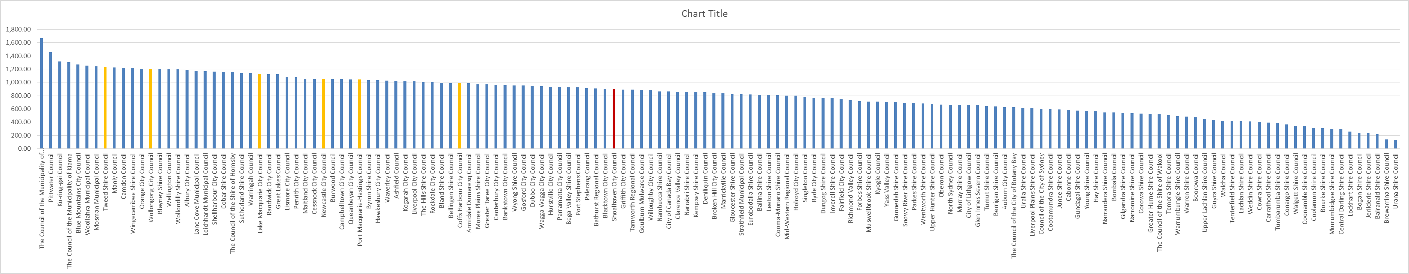

The new rating structure compared to the current is outlined in the table below (Table 11). There are no plans to change the rating structure. The SRV will be applied equally across all rating categories.

**Table 11 – Rating Structure**



### Minimum Rates

The proposed special variation may affect ordinary rates, special rates and/or minimum rates.

As previously discussed, if the proposed special variation includes increasing minimum rates above the statutory limit, or is to apply a higher rate of increase to an existing minimum rate than to its other rates, it is not necessary for the council to also complete the separate Minimum Rates application form. However, this must be clearly identified and addressed in the special variation application.

|  |  |  |
| --- | --- | --- |
| Does the council have minimum Ordinary rates? | Yes | No X |

If *Yes*, does the council propose to increase minimum Ordinary rates by:

The rate peg percentage

The special variation percentage

Another amount  Indicate this amount _____________

What will minimum Ordinary rates be after the proposed increase? _________

The council must explain how the proposed special variation will apply to the minimum rate of any ordinary and special rate, and any change to the proportion of ratepayers on the minimum rate for all relevant rating categories that will occur as a result.

You should also explain the types of ratepayers or properties currently paying minimum rates, and the rationale for the application of the special variation to minimum rate levels.

## Consideration of affordability and the community’s capacity and willingness to pay

The council is required to provide evidence through its IP&R processes, and in its application, of how it assessed the community’s capacity and willingness to pay the proposed rate increases. This is to include an explanation of how the council established that the proposed rate rises are affordable for the community.

Evidence about capacity to pay could include a discussion of such indicators as SEIFA rankings, land values, average rates, disposable incomes, the outstanding rates ratio and rates as a proportion of household/business/farmland income and expenditure, and how these measures relate to those in comparable or neighbouring council areas.

As many of these measures are highly aggregated, it may also be useful to discuss other factors that could better explain the impact on ratepayers affected by the proposed rate increases, particularly if the impact varies across different categories of ratepayers.

We may also consider how the council’s hardship policy (see Section 5.3 below) might reduce the impact on socio-economically disadvantaged ratepayers.

### Capacity to pay

One of the issues for Council to consider is the ability of the local community to pay for the proposed rate increases. A number of graphs are provided below that highlight the various areas that could be considered in this matter such as income, rates paid, Council area, etc.

Graph 12 is the Socio-economic Index rating. This shows that the Shoalhaven has the lowest rating of the group with Coffs Harbour, Tweed and Port Macquarie within 13 points of the Shoalhaven.

**Graph 12 - Socio-economic Index rating**

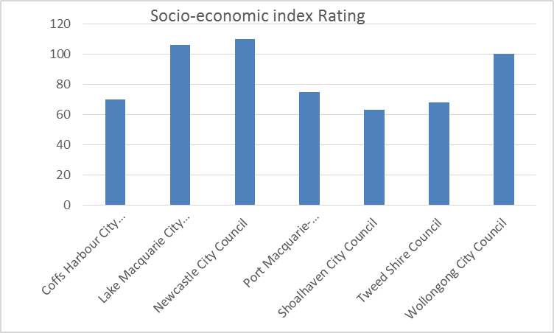

*Source-, NSW 2014/15 Local Government Comparative Data*

The SEFIA index below (Graph 13) has SCC rated the lowest with 954.6. Coffs harbour and Tweed rate 958.4 and 958.5 and Port Macquarie 968.9. All three of these areas having higher rates that SCC.

**Graph 13 - SEFIA Index**

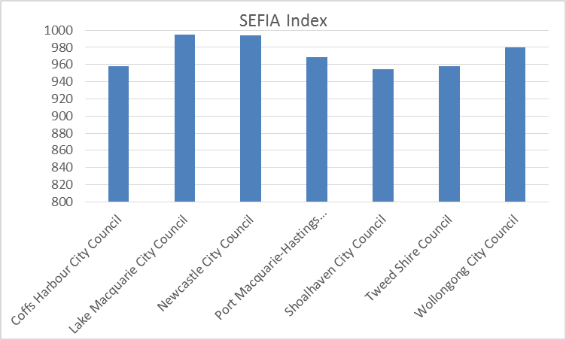

*Source-, NSW 2014/15 Local Government Comparative Data*

Graph 14 below includes the proposed SRV for SCC and this demonstrates that even with the SRV, Council is still only in the middle of the group in terms of average residential rates.

**Graph 14 - Average Residential Rates 2014/15 to 2018/19 with SRV for SCC**

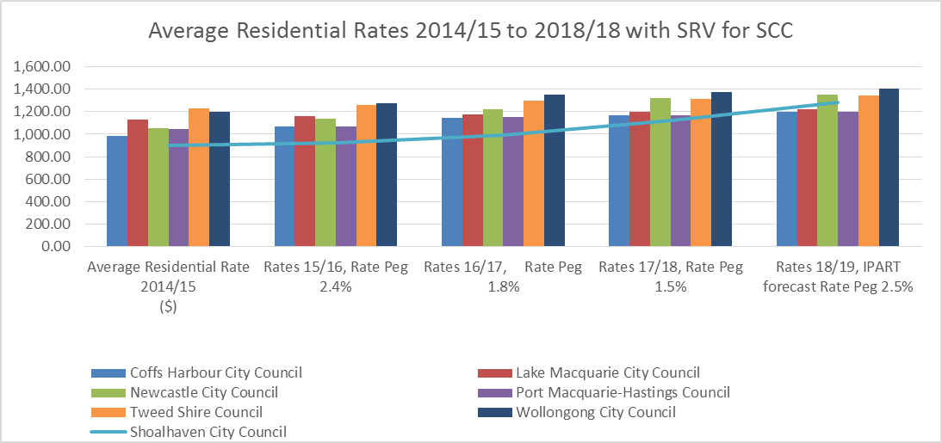

*Source-, NSW 2014/15 Local Government Comparative Data and IPART determinations*

Graph 15 below presents information on the average weekly taxable income compared to the Average Residential rate for Councils in the SCC Group. This graph shows for the purpose of comparison that the gap between one week’s taxable income (bar) and the average residential rate (line) is the second smallest of the comparative Councils. This would imply that relative to other areas with similar levels of taxable income such as Tweed, Port Macquarie or Coffs Harbour there is some capacity to increase rates.

Graph 15 - Average Weekly Income to Average Residential rate

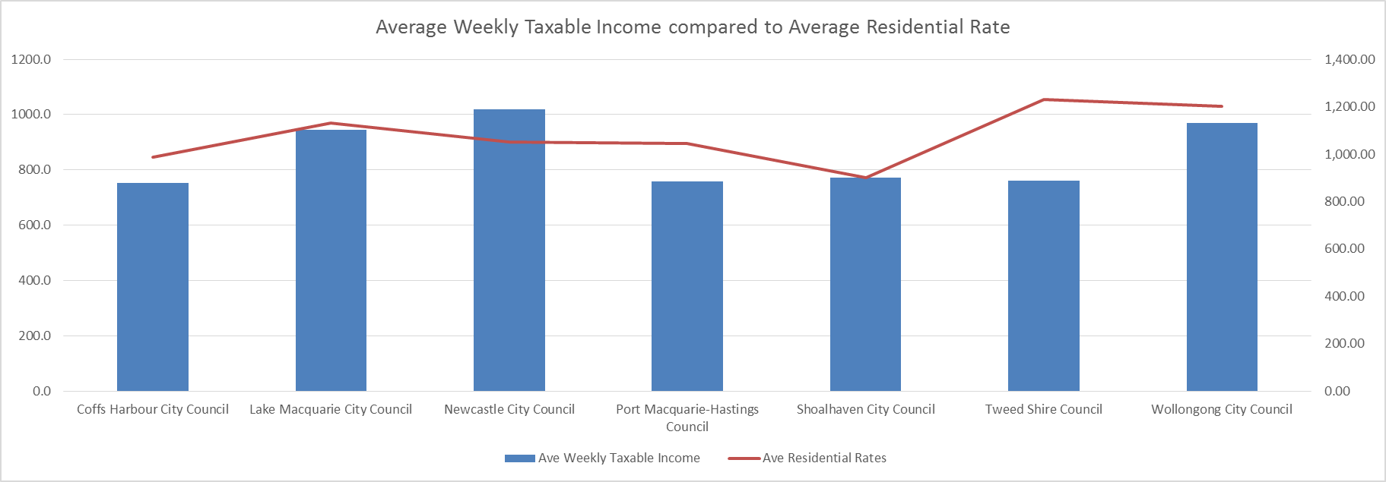

*Source NSW 2014/15 Local Government Comparative Data*

The Graph16below shows the comparison of average annual wage and salary income (bar) for Group 5 Councils compared to the average residential rate (line). The figure highlights that the SCC average wage and salary earner in the Shoalhaven is paying a slightly smaller proportion of their income in residential rates than other centres with higher rates such as Coffs Harbour, Port Macquarie and the Tweed.

**Graph 16 - Average Annual Wage and Salary Income Compared to the Average Residential Rate**

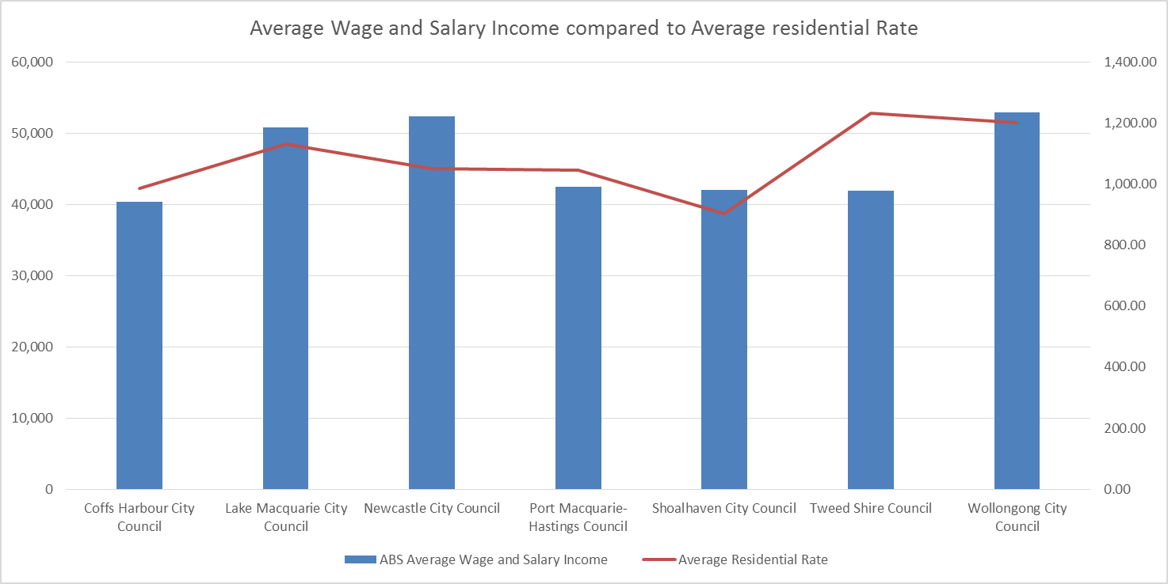

Source - ABS Wage and Salary Earner Statistics for Small Areas, Time Series, 2005-06 to 2010-11 and *NSW 2014/15 Local Government Comparative Data*

The Shoalhaven City Council has the third highest percentage of pensioners at 23.7% paying rates after Port Macquarie (30%) and Tweed (24%), however both Port Macquarie and Tweed have higher rates than Shoalhaven (see line), with the Tweed being 36% higher than the Shoalhaven’s. (Graph 17 below.)

**Graph 17- Average Residential Rates Compared to % Pensioners Residential rates**

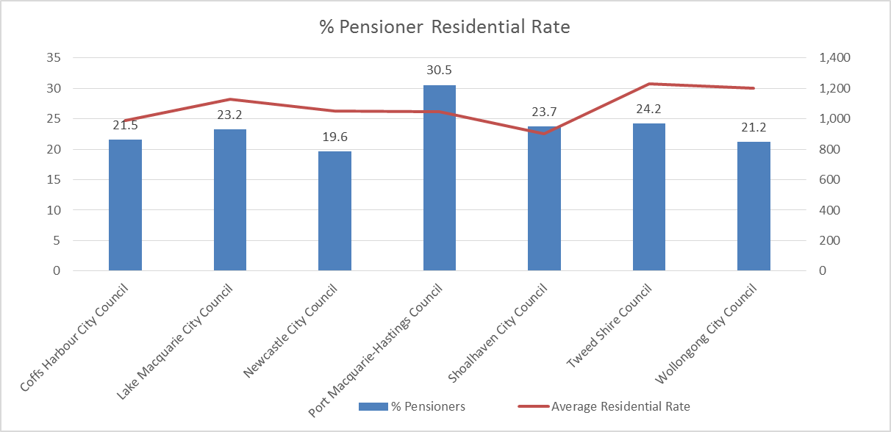

Source - *NSW 2014/15 Local Government Comparative Data*

The next graph 18 shows a comparison of average rates to the rates as a % of taxable income. This shows the percentage for Shoalhaven at 2.24% of taxable income, the second lowest in the group

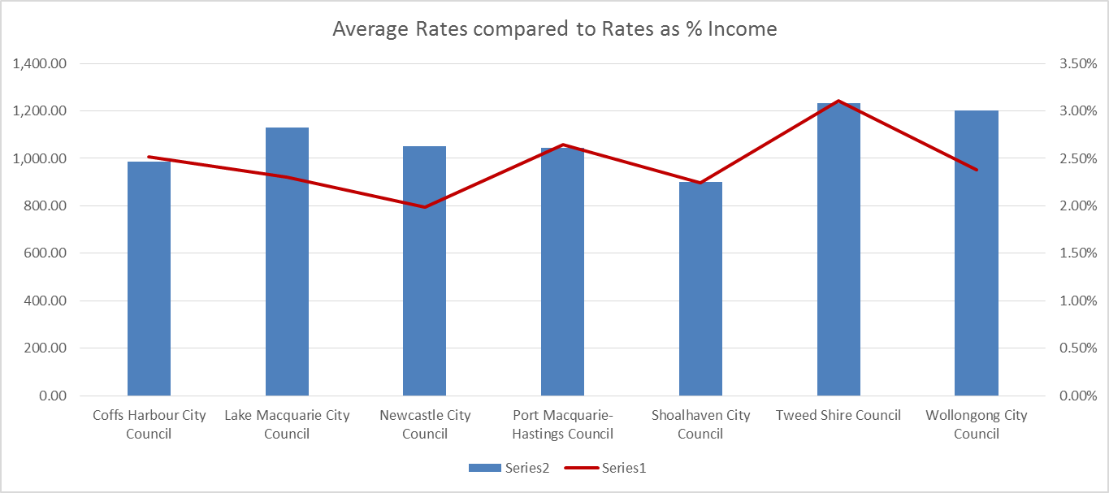Graph 18 Council Area to Taxable Income

*Source NSW 2014/15 Local Government Comparative Data*

**Average Rates compared to Rates as a % of Taxable Income**

Further analysis was carried out on comparatives of Area of Council, income levels within Council and the rates being charged. Graph 19 below shows the relationship for Area Size and taxable income, which shows the bigger the council area the lower average taxable income.

**Graph 19 – Council Area to Taxable Income**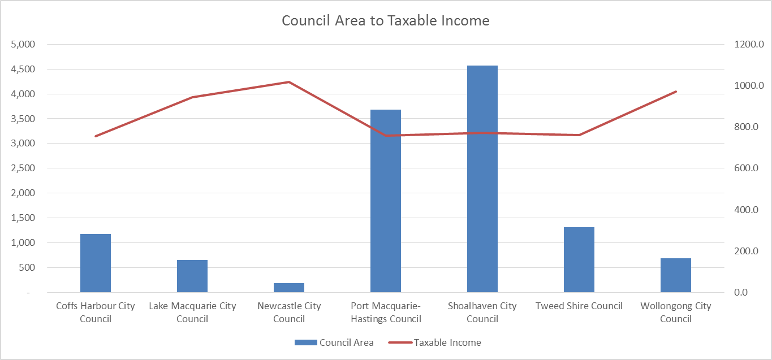

*Source NSW 2014/15 Local Government Comparative Data*

Graph 20 below highlights the difference between the Councils in relation to average rates compared to the total length of road that each Council has to maintain. This graph highlights the significant difference between the majority of the Councils and SCC.

**Graph 20 – Average Residential Rate Compared to Total Road Length**

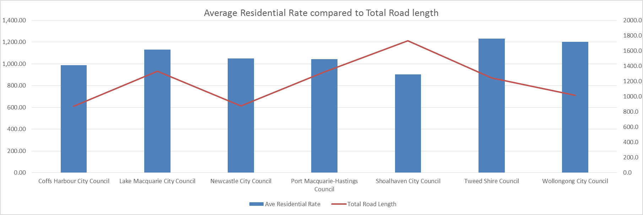

*Source NSW 2014/15 Local Government Comparative Data*

**Average Rates compared to Total Length of Road**

Graph 21 below provides the level of outstanding rates for the past 3 years. This is on a slightly decreasing trend and would indicate that Council currently has not seen an increase in the number of rate payers unable to pay their rates.

Graph 22 provides the number of rate payers who are accessing the Hardship Policy. This is very low and would indicate that very few people are experiencing hardship to the point where they need to access this assistance from Council.

**Graph 21 - Percentage Total Rates Outstanding**

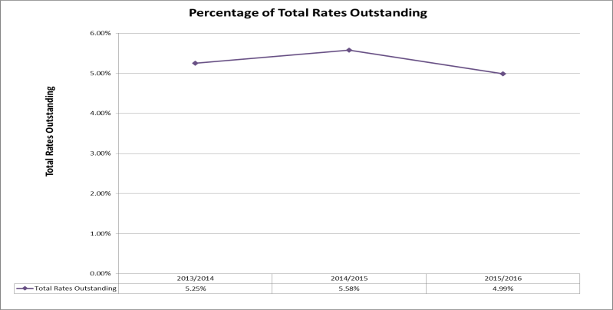

**Graph 22 - Number of Rate Payers Accessing the Hardship Policy**

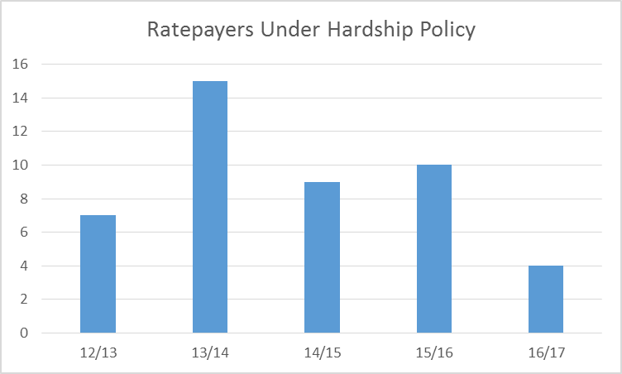

Graph 23 below has the unemployment figures for the Group 5 Councils from June 2015 to Sept 2016. Shoalhaven does have the highest unemployment rate of the comparison Councils. This is an indication that council does need to carefully consider the areas capacity to pay for any rate increase.

**Graph 23 - Unemployment Figures for the Group 5 Councils from June 2015 to Sept 2016**

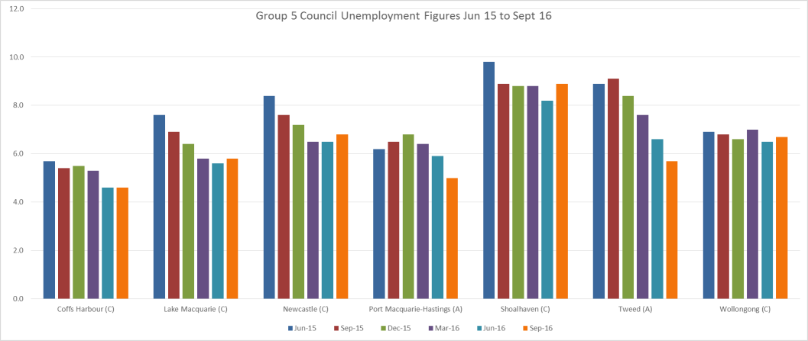

Graph 24 below has the percentage of pensioners who are paying rates across the Group 5 Councils. The Shoalhaven has 23.7%. The highest is Port Macquarie with over 30%. The average across the group is 23.4% which sees the Shoalhaven just above the average.

**Graph 24 - % Pensioners paying residential rates for the Group 5 Councils**

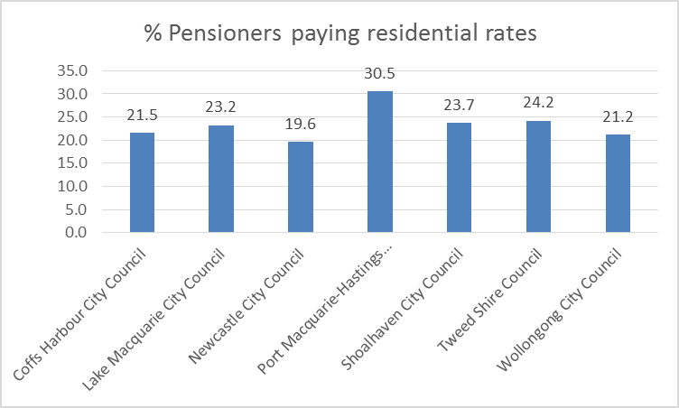

*Source NSW 2014/15 Local Government Comparative Data*

The information above would indicate that there is a large proportion of pensioners in other areas where higher rates apply, if this is considered there appears to be an ability to increase rates in the Shoalhaven, but acknowledging it may be difficult for some community members.

When all this information is combined there appears to be an ability for the community to pay the increase in rates being proposed.

While there needs to be continued discussion in relation to the ability of the residents to pay the rate increase there also needs to be an awareness and discussion of the consequences of delaying a rate increase and deferring infrastructure renewals. The facts set out in this submission, the Financial Sustainability Document, the Council Fit for the Future Submission and various other internal and external reports all indicate that Council needs to target a reduction in services or increase rates above the rate peg.

If a rates increase is delayed and significant reduction in service costs are not delivered then the community will be impacted by poor condition assets and more assets deteriorate at a faster rate due to a lack of funds for the necessary maintenance and renewal works. This is a risk across Local Governments in Australia and was highlighted in the National State of the assets report in 2015 for Roads and Community Infrastructure.

## Addressing hardship

In addition to the statutory requirement for pensioner rebates, most councils have a policy, formal or otherwise to address issues of hardship.

|  |  |  |
| --- | --- | --- |
| Does the council have a Hardship Policy? | Yes X | No |
| If Yes, is an interest charge applied to late rate payments? | Yes X | No |
| Does the council propose to introduce any measures to reduce the impact of the proposed special variation on specific groups in the community? | Yes | No X |

You should attach a copy of the Hardship Policy and explain below who the potential beneficiaries are and how they are assisted.

Please provide details of any other measures addressing hardship to be adopted, or alternatively, explain why no measures are proposed.

The council is also to indicate whether the hardship policy or other measures are referenced in the council’s IP&R documents (with relevant page reference or extract provided).

**Figure 14 – Extract of DPOP re Hardship Policy**

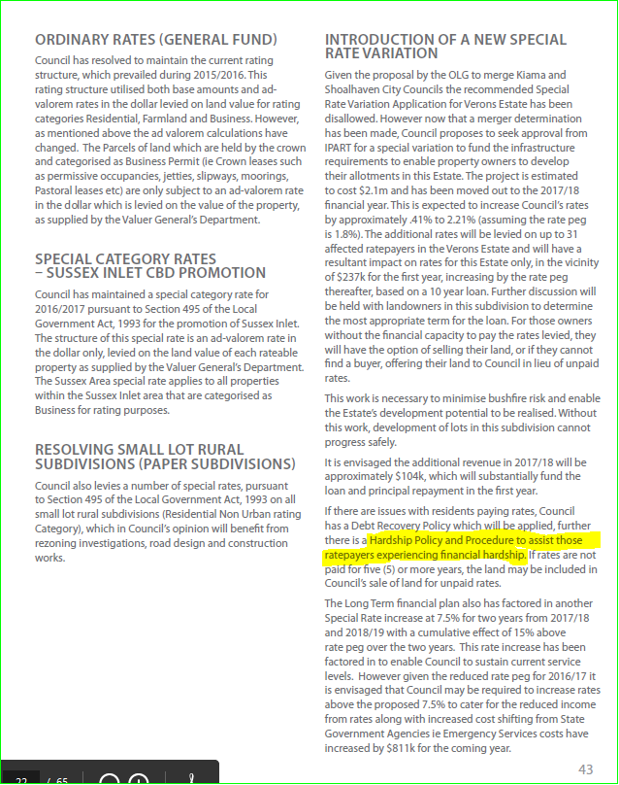

**Figure 15 – Extract of Annual Report 2015/16**

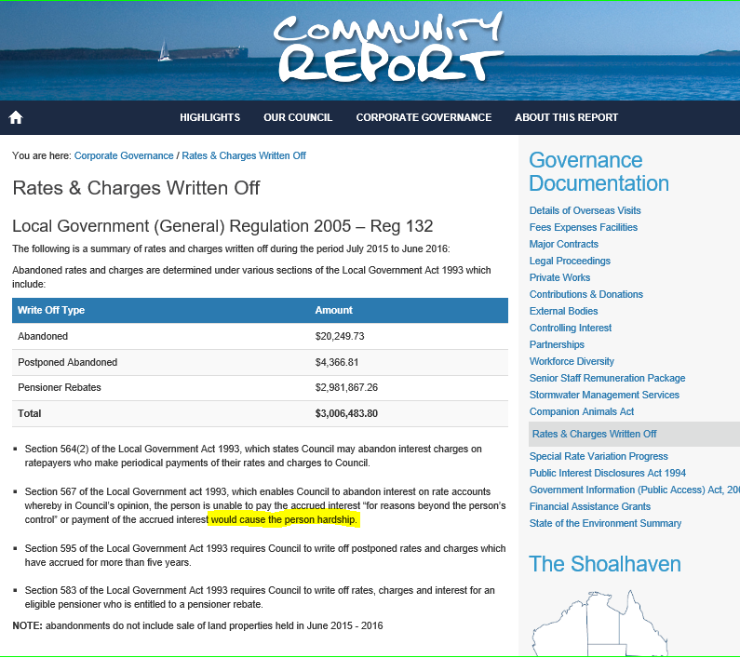

**Figure 16 – Extract of CSP 2023**

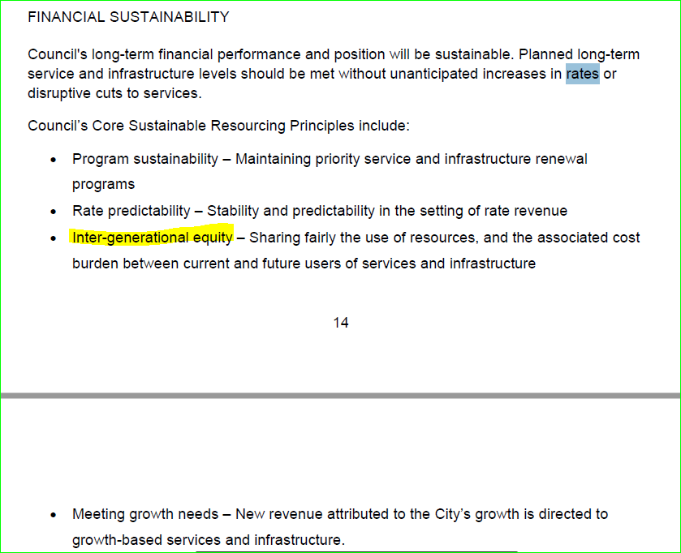

# Assessment criterion 4: Public exhibition of relevant IP&R documents

Criterion 4 in the Guidelines is:

*The relevant IP&R documents must be exhibited (where required), approved and adopted by the council before the council applies to IPART for a special variation to its general revenue.*

Briefly outline the significant IP&R processes the council has undertaken to reach the decision to apply for a special variation. Include the details of and dates for key document revisions, public exhibition period(s) and the date(s) that the council adopted the relevant IP&R documents.[3]

You should also include extracts from council minutes as evidence that the documents were adopted.

The council is reminded that the Community Strategic Plan and Delivery Program (if amended), require public exhibition for at least 28 days prior to adoption. Amendments to the Long Term Financial Plan and Asset Management Plan do not require public exhibition.[4] However, it would be expected that the Long Term Financial Plan would be posted, in a prominent location, on the council’s website.

Council has met all requirements under IP&R legislation to ensure that a Council has in place a Community Strategic Plan and Delivery Plan/Operational Plan. Council has also ensured that the long term financial plan including the proposal for the SRV has been provided to the community for comment and adopted by Council. As part of the development of both the CSP and the DPOP Council has sought feedback from the community on and outlined the plan for:

* Financial sustainability
* Fit for the Future benchmarks
* Managing the infrastructure backlog
* Community expectations about infrastructure and asset maintenance
* Special Rates Variation Proposal

### Development of the Community Strategic Plan

1. **Community Engagement and Project Scope**

On the 25 September 2012 (Min12.1099) Council resolved that:

a) The Project Scope and Engagement Strategy for the Community Strategic Plan Review 2013 – 2023 be adopted

b) The General Manager confirms the Project Team staff members;

c) A Reference Panel be formed consisting of the Mayor, Clr Gash, Deputy Mayor, Clr Wells, Clr Baptist and Clr Findley. CARRIED

Minute: <http://yoda.scc.shoalhaven.nsw.gov.au/hprmwebdrawer/record/2939798>)

Report: [http://doc.shoalhaven.nsw.gov.au/displaydoc.aspx?record=D12/228529 - Item 13](http://doc.shoalhaven.nsw.gov.au/displaydoc.aspx?record=D12/228529%20-%20Item%2013)

As part of the development of the Community strategic plan Council developed an Issues Paper for consideration and comment by the community. Within this issues paper it was clearly outlined that consideration needed to be given to the financial sustainability of Council the need for additional funding for asset management. Some exerts from this issues paper include:

“Council is required to respond to many competing demands on its resources, and long term sustainability is a key goal in ensuring that all Council assets are responsibly managed. Sustainability is the driving force behind many organisational strategies.” (Page 21)

“Council’s 2008/2009 budget provided for total capital asset expenditures of over $30 million on maintenance, renewal, upgrades and new infrastructure. Based on the scope of work identified in Council’s asset management plans, this investment remains some $5 million (or 15%) short of what is required.” (Page 23)

“As a scenario, if the core areas of maintenance and renewal were fully funded (based on the AMPs), then the more discretionary area of new and upgrade works would see its funding reduced to some $6 million (or 52% of the planned $11.5 million).” (Page 23)

As part of this process council also sought specific feedback on the expectations of the community in relation to the provision of assets and infrastructure which comprised of an Infrastructure Survey. Details of the engagement undertaken for this is provided in the Community Engagement Report

The CSP involved a significant community engagement process and included engagement on Council’s financial plan and also infrastructure needs.

A specific infrastructure survey was also conducted as part of this process to seek an understanding of the community expectations as related to the provision of infrastructure and councils assets.

This survey was the first step in the engagement process for the Special Rate variation.

Further information on the engagement processes undertaken to determine the decision to apply for a SRV are contained within the Community Engagement Report SRV.

1. **Development of Draft CSP for Exhibition**

Following the first phase of engagement a draft plan was developed incorporating strategies to ensure the long term financial sustainability of Council’s finances was provided and that increase expenditure on infrastructure and assets occurred.

**Draft Plan endorsement for Community Engagement**

On the 26 February 2013 (Min13.199)   Council resolved that:

a) Council endorse the Draft Community Strategic Plan (CSP) – Shoalhaven 2023 for the purposes of community engagement.

b) Staff proceed with community engagement on the Draft CSP – Shoalhaven 2023 in accordance with the adopted CSP Review Engagement Strategy.

c) The Engagement Phase 1 Report and Directions Paper from to the CSP Review be publicly released as part of the engagement process. CARRIED (<http://yoda.scc.shoalhaven.nsw.gov.au/hprmwebdrawer/record/3076890>)

As part of this report it was outlined that the rate variation proposal was an important consideration of the review process

Report - <http://doc.shoalhaven.nsw.gov.au/displaydoc.aspx?record=D13/41882>  - Item 87

Exert from report (Page 40)

“ Council’s rate variation proposal, closely linked to future financial sustainability and services and works delivery capacity, requires the early adoption of the revised CSP, to which the 2013/14 Delivery Program and 2013/14 Operational Plan will be aligned. Adoption of the Draft CSP 2023 and further community engagement will provide the basis for business planning towards the new Delivery Program and Operational Plan that reflects the current Council’s priorities.”

On the **21st May 2013 (Min 13.503)** Council resolved that:

a) The CSP Review Community Engagement Phase 2 Summary Report be received and noted.

b) **The Community Strategic Plan – Shoalhaven 2023 included as Attachment 1 to the business papers be adopted in accordance with the Integrated Planning and Reporting requirements of the Local Government Act 1993.**

c) The General Manager undertake all necessary steps to inform the community, stakeholders and Division of Local Government, and to implement the CSP 2023 through Council’s deliberations and operations.

d)   People and organisations that made submissions on the draft CSP be thanked for their contributions, advised of Council’s resolutions and invited to review the Community Engagement Phase 2 Summary Report for further information on submissions received and Council’s consideration of those submissions. CARRIED (<http://yoda.scc.shoalhaven.nsw.gov.au/hprmwebdrawer/record/3158118>)

Specific strategies included within the CSP both within the draft exhibited and the final adopted document relating to the SRV proposal include:

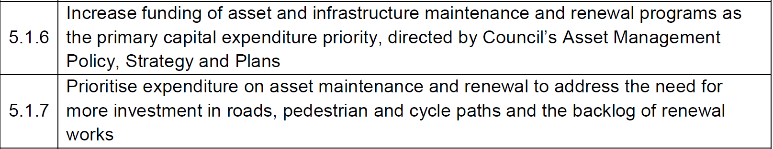



Source: <http://doc.shoalhaven.nsw.gov.au/Displaydoc.aspx?Record=D13/123349> Page 28

On the 24 September 2013 (Min13.968 ) resolved that:

The Community Strategic Plan Review – Evaluation Report and follow up community survey be:

a) Received for information and accepted as the final report on the CSP Review project 2023;

b) Made available to the community through publication on Council’s website; and

c) Provided to staff for information and to note ‘lessons learnt” and survey results and to use as a reference example in support of the community engagement handbook that has been developed.

(<http://yoda.scc.shoalhaven.nsw.gov.au/hprmwebdrawer/record/3288800>)

Additional details about the community strategic plan and the process undertaken to develop the plan are contained on Council’s website:

<http://www.shoalhaven.nsw.gov.au/My-Council/Community-strategic-plan>

**Delivery Plan 2014-2017 and Operational Plan 2016-17**

Shoalhaven City Council’s Delivery Program and Operational Plan 2016 – 2017 details Council’s response to the Community Strategic Plan: ***Shoalhaven 2023.***

It sets out how Council will work with the community to achieve its priorities over the remaining life of this elected council and describes the key actions that will help achieve these priorities.

The Draft DP/OP was put on public exhibition from Wednesday 20 April 2016 to Wednesday 18 May 2016 inclusive, in accordance with the provisions of the Local Government Act, 1993.

ADOPTED AT COUNCIL MEETING HELD ON TUESDAY 19 APRIL 2016

305. Public Exhibition - Draft Delivery Program & Operational Plan 2016 - 2017 File 52309E

MOTION: Moved: Wells / Second: Baptist

That the draft Delivery Program and Operational Plan (DP/OP) 2016 - 2017 be:

a) Endorsed for the purposes of community consultation; and

b) Considered further by Council following the community consultation program and receipt of community responses, prior to adoption of the final Delivery Program and Operational Plan 2016 - 2017.

CARRIED

FOR: Tribe, Robertson, Kearney, Anstiss, White, Wells, Baptist, Findley, Watson, Kitchener, McCrudden, Gash

AGAINST: Guile

Public notices were placed in local newspapers the South Coast Register and the Ulladulla Times over a range of dates. Community announcements were placed on the community radio station, Shoalhaven FM 2UUU and the Bay & Basin 92.7 FM advising of the details of the public exhibition and the dates and times of public meetings.

Exhibition locations included Council’s Nowra and Ulladulla offices as well as the City’s libraries in Nowra, Sanctuary Point, Ulladulla and the Bookmobile. The exhibition material was also placed on Council’s website with the provision for members of the public to make an online submission. Further to this CCBs and Business Chambers were notified of these meetings via email and a copy of the Executive Summary was forwarded to same.

There was rolling media coverage of the draft plans across all platforms and social media posts on Council’s Facebook and Twitter sites.

Three public meetings were also held to explain the proposals in the Draft Delivery Program and Operational Plan. Presentations were given by the General Manager and Group Directors and other senior staff on the proposed works program, financial analysis and the water and wastewater capital works and pricing.

|  |  |  |
| --- | --- | --- |
| LOCATION | DATE | ATTENDEES |
| Jervis Bay Maritime Museum | Wednesday 27th April 2016 | Approximately 40 people |
| Nowra School of Arts | Thursday 28th April 2016 | Around 10 people |
| Ulladulla Civic Centre | Wednesday 4th May 2016 | Around 25 people |

Exert from Council Exhibition Page [http://www.shoalhaven.nsw.gov.au/My-Council/Draft-](http://www.shoalhaven.nsw.gov.au/My-Council/Draft-Delivery-Program-Operational-Plan-2016)

**Fit for the Future**

*Council has commenced to show its plan for how it intends to meet the State Government's mandated 'Fit for the Future' process as part of the DPOP exhibition. The full list of strategies will form the basis of a report to go to Council in May.*

*The State Government has set 7 benchmarks which councils across the state have to meet to ensure they are classified by an independent panel as being 'fit for the future' and able to continue to deliver the services expected from communities in NSW.*

*Councils that are not considered to meet these criteria are already being slated for mergers with other councils.*

*Plans show that there is a long term strategy to meet the benchmarks placing the Shoalhaven in a good position to continue into the future. Currently Council meets 3 of the 7 benchmarks but there is a lot more work to be done towards ticking off all the criteria including a $13.5M gap in operating result.*

*To do this Council is looking at both the revenue and expenditure sides of the table. There has been a lot achieved over the past 2 years with reductions in expenditure totalling $4.4M and the targeted operational savings for 2015/16 increases to $5.5 million. There is a continued push for further productivity and efficiency savings across the organisation.*

*What is also being proposed is a 7.5% rate rise (above rate pegging) for three years from 2017 to 2019. Without that the $13.5M gap will need to be filled by cutting services.*

*To paint the picture of what that means Council would need to close some or all of our pools, tennis courts, community halls, sporting fields, centralise our library and drop other community services like the immunisation program - and we still may not even reach the $13.5M mark.*

*Whilst this will form part of the 'Fit for the Future' application it will be the next term of council that will make a final decision on rating levels needed in the future years.*

*Council is required to submit its final submission about how it intends to be 'Fit for the Future' to the State Government in June this year.*

**Changes** in the Budget

* *Forecast Rate increase above rate peg from 2017/18 to 2019/20 at 5% per annum for the 3 years – ie 15% cumulative*
* *Some new fees and charges and increases on others above CPI*
* *Transformation and operational savings of almost $6m*
* *Reduction in interest on investments and borrowings*
* *Increased focus on renewal of existing assets*

Following the exhibition of the DPOP all community submissions were considered and provided to Council. The adoption of Council’s current DPOP occurred on the 22nd June 2016

MIN:472 Public Exhibition - Draft Delivery Program & Operational Plan 2016 - 2017 File 52309E/1

MOTION: Moved: Wells / Second: Baptist

That Council adopts the Draft Delivery Program 2014 – 2017 and Operational Plan 2016 – 2017 with the changes as detailed below:

Note: A Rescission Motion was received on this item. The rescission motion was lost at the Extra Ordinary Meeting 22 June 2016.

A copy of the minute can be found at: <http://www.shoalhaven.nsw.gov.au/LinkClick.aspx?fileticket=NOytE0W-4OY%3d&portalid>=3

Specific changes relating to the SRV were proposed within this minute and were included in the adoption of the document as shown below:

*12. Fit for the Future – continue works to determine the required rate increase to enable Council to meet the Fit for the Future ratios by 2020.*

7. *Recommend to make the following changes to the DPOP document in relation to the Special Rate Variation for Veron’s Estate:*

1. The following changes are suggested to the paragraphs under the heading “INTRODUCTION OF A NEW SPECIAL RATE VARIATION” (page 43 of the draft DPOP). *Given the proposal by the OLG to merge Kiama and Shoalhaven City Councils the recommended Special Rate Variation Application for Verons Estate has been disallowed. However now that a merger determination has been made, Council proposes to seek approval from IPART for a special variation to fund the infrastructure requirements to enable property owners to develop their allotments in this Estate. The project is estimated to cost $2.1m and has been moved out to the 2017/18 financial year. This is expected to increase Council’s rates by approximately .41% to 2.21% (assuming the rate peg is 1.8%). The additional rates will be levied on up to 31 affected ratepayers in the Verons Estate and will have a resultant impact on rates for this Estate only, in the vicinity of $237k for the first year, increasing by the rate peg thereafter, based on a 10 year loan. Further discussion will be held with landowners in this subdivision to determine the most appropriate term for the loan. For those owners without the financial capacity to pay the rates levied, they will have the option of selling their land, or if they cannot find a buyer, offering their land to Council in lieu of unpaid rates.This work is necessary to minimise bushfire risk and enable the Estate’s development potential to be realised. Without this work, development of lots in this subdivision cannot progress safely.*

b) Update the financials in relation to Verons Estate to reflect the above changes.

**Long Term Financial Plan**

ADOPTED AT COUNCIL MEETING HELD ON TUESDAY 30 JULY 2013

780. (Item 24, Page 6) Resourcing Strategy 2013 to 2017 File 45907E

MOTION: Moved: Wells / Second: White

That Council adopts the Resourcing Strategy for 2013 to 2017 including the Long Term Financial Plan for 2013 to 2023.

CARRIED

FOR: Tribe, Robertson, Anstiss, White, Wells, Baptist, Findley, Watson, Gash

AGAINST: Kearney, Guile, Kitchener

# Assessment criterion 5: Productivity improvements and cost containment strategies

Criterion 5 in the Guidelines is:

*The IP&R documents or the council’s application must explain the productivity improvements and cost containment strategies the council has realised in past years, and plans to realise over the proposed special variation period.*

In this section, you must provide details of any productivity improvements and cost containment strategies that you have implemented during the last two years (or longer) and any plans for productivity improvements and cost containment over the duration of the proposed special variation.

These strategies, which may be capital or operational in nature, must be aimed at reducing costs and/or improving efficiency. Indicate if any initiatives are to increase revenue eg, user charges. Please include below whether the proposed initiatives (ie, cost savings) have been factored into the council’s Long Term Financial Plan.

Where possible, the council is to quantify in dollar terms the past and future productivity improvements and cost savings.

The council may also provide indicators of efficiency, either over time or in comparison to other relevant councils. We will make similar comparisons using various indicators and OLG data provided to us.

     

### Expenditure Actions

The SRV will also be supported by a range of measures including continuing to reduce expenditure through improved efficiency. Council will also ensure careful consideration of the impacts of new development on infrastructure needs, pro-actively encouraging growth and giving a greater population that can pay for use of our facilities. Driving efficiencies and cost reduction is critical to ensuring rate payers are getting value for money. Council over the past 4 years has undertaken an extensive review of its services and programs. This has resulted in significant reductions to expenditure of over $6 million annually as outlined in the Table 12 below, note there have been recent staff changes to meet demands such as increased development applications;

**Table 12: Savings from restructure, service reviews and other areas**



A savings target is built into Councils financial strategy and achievement however does not achieve the required change needed to match the deficit.

### Continuous Improvement

Fundamental to cost reductions is the introduction to the concept of Lean or continuous improvement. This is a philosophy which needs to be driven from the top of the organisation and filtered out to all levels within the organisation. This takes commitment and dollars in terms of training and allowing time for teams to hold meetings to review processes and look for efficiencies. Council has established an internal Business Improvement Unit which has the mandate to drive the continuous improvement of the organisation using the Lean philosophy.

To date the unit has assisted the following areas for process improvements:-

1. Project Management methodology was formalised and a Project Management Framework developed and adopted
   1. Set of Templates created and supported
2. ICT Control Group formed to provide formal support process for CBI Project/s Review
3. InfoCouncil solution implemented
4. Mobility solution for Shoalhaven Water – pilot group implemented
5. Merit system upgraded
6. Enhancements implemented for internal Financial Inquiry and Business Intelligence reporting
7. HP ERM implemented / upgraded from TRIM
8. Tenders / Quotations created for IPR Software, Facilities booking software, Credit Card management system, Plant & Fleet system & Water Billing software
9. Supporting Council business’ with Business Process Mapping:
   1. Human Resources
   2. On Boarding process
   3. Finance
   4. Procurement / Tendering
   5. Section 94
10. Data Cleansing for Rating / Property / Waste database synchronicity

### Cost Base

The strategy identifies ongoing areas for improvement, engagement with the community and reduction in expenditure. These targets include:

1. Increases in User Pays fees and charges above CPI *- $4M increase in past 2 years, targeting $500K in next 2 years*
2. Increases in DA fees and introduction of value added services *- $470K increase in past 2 years (included in $4M above), targeting $400K in next 2 years*
3. Introduction of Parking fees *- Potential to introduce in some holiday locations to cover costs of additional services requested by the community eg Hyams Beach/Huskisson*
4. Reduction in Cost structure through efficiency initiatives *- $2.376M reduction in past 4 years, targeting $250K in next 2 years*
5. Service reviews and outsourcing where practical and cost effective *- $1.2 Saved in past 2 years, targeting $250K in next 2 years*
6. The Use of Technology to drive efficiencies *- Savings have been delayed in this area due to termination of the contract with the Vendor. This is a high priority focus for the next 1 - 2 years. Savings will be addressed once the system is implemented.*
7. Procurement initiatives locally and through the Joint Organisation *- $110,000 Saved in past 2 years, target $100,000 Over the next 2 years*
8. Energy Management *- $365,000 saved in past 4 years, targeting $150,000 in next 2 years*
9. Better Management of Fringe Benefits *- $173,000 saved in past 4 years targeting $80,000 in next 2 years*
10. Improved management of Leave Liabilities *- targeting $200,000 in next 2 years*
11. Reductions in service levels if agreement could be reached with the community *- targeting $100,000 in next 2 years*
12. Fuel efficiencies *- $348,000 Saved in past 4 years, targeting $75,000 in next 2 years*
13. Utilisation of Assets and Rationalisation of underutilised assets *- targeting $200,000 in next 2 years*

Although a number of these initiatives have been achieved and others are in the process of being carried out ($2.3M in next 2 years) they do not have the level of financial impact to improve the operating performance ratio to the level required. The only option of the magnitude required was an above rate peg increase.

# List of attachments

The following is a list of the supporting documents to include with your application.

Some of these attachments will be mandatory to all special variation applications (eg, extracts from the Community Strategic Plan).

Other attachments will be required from some, but not all, councils. For example, extracts from the Asset Management Plan would be required from a council seeking approval of a special variation to fund infrastructure.

Councils should submit their application forms and attachments online through the Council Portal in the following order. Councils may number the attachments as they see fit.

|  |  |  |
| --- | --- | --- |
|  | Item | Included? |
|  | **Mandatory forms and Attachments** |  |
| A | Part A Section 508A and Section 508(2) Application form (Excel spreadsheet) |  |
| B | Part B Application form (Word document) – this document |  |
| C | Relevant extracts from the Community Strategic Plan |  |
| D | Delivery Program |  |
| E | Long Term Financial Plan with projected (General Fund) financial statements (Income, Cash Flow and Financial Position) in Excel format |  |
| F | NSW Treasury Corporation report on financial sustainability |  |
| G | Media releases, public meeting notices, newspaper articles, fact sheets relating to the rate increase and proposed special variation |  |
| G | Community feedback (including surveys and results if applicable) |  |
| H | Hardship Policy |  |
| I | Resolution to apply for the proposed special variation |  |
| J | Certification (see Section 9) |  |
|  | **Other Attachments** |  |
|  | Relevant extracts from the Asset Management Plan |  |
|  | Past Instruments of Approval (if applicable) |  |
|  | Resolution to adopt the revised Community Strategic Plan (if necessary) and/or Delivery Program |  |
|  | Other (please specify) |  |
|  | Attachment 1 - Oct 2014 Financial Sustainability Document |  |
|  | Attachment 2 - SRV Report - Final Feb 1 |  |
|  | Attachment 3 - Verons information |  |
|  | Attachment 4 - Financial Indicators Addendum |  |
|  | Attachment 5 - Submissions Summary SRV |  |

# Certification

**APPLICATION FOR A SPECIAL RATE VARIATION**

**To be completed by General Manager and Responsible Accounting Officer**

Name of council: Shoalhaven City Council

We certify that to the best of our knowledge the information provided in this application is correct and complete.

General Manager (name): Russ Pigg

Signature and Date: XXXXXXX 13 February 2017

Responsible Accounting Officer (name): Craig Milburn

Signature and Date: XXXXXX 13 February 2017

Once completed, please scan the signed certification and attach it as a public supporting document online via the Council Portal on IPART’s website.

1. See Planning Circular 10-025 dated 24 November 2010 at [www.planning.nsw.gov.au](http://www.planning.nsw.gov.au) and for the most recent Direction issued under section 94E of the *Environmental Planning and Assessment Act 1979*. See also Planning Circular PS 10-022 dated 16 September 2010.
2. <https://www.ipart.nsw.gov.au/Home/Industries/Local-Government/For-Councils/Apply-for-a-special-variation-or-minimum-rate-increase>
3. The relevant IP&R documents are the Community Strategic Plan, Delivery Program, Long Term Financial Plan and where applicable, the Asset Management Plan.
4. Office of Local Government (then Division of Local Government), *Integrated Planning and Reporting Manual for local government in NSW*, March 2013, pp 5-6.