|  |
| --- |
| Special Variation Application Form – Part B  For 2017-18  Issued December 2016 |
| PORT MACQUARIE-HASTINGS COUNCIL  Date Submitted to IPART: 16 February 2017  Council Contact Person: Craig Swift-McNair  Contact Phone: XXXXXXXXXXX  Council Contact Email: XXXXXXXXXXX |

© Independent Pricing and Regulatory Tribunal of New South Wales 2016

This work is copyright. The *Copyright Act 1968* permits fair dealing for study, research, news reporting, criticism and review. Selected passages, tables or diagrams may be reproduced for such purposes provided acknowledgement of the source is included.

The Tribunal members for this review are:

Dr Peter J. Boxall AO, Chairman

Ms Catherine Jones

Mr Ed Willett

Inquiries regarding this document should be directed to a staff member:

Derek Francis (02) 9290 8421

Letitia Watson-Ley (02) 9290 8402

Independent Pricing and Regulatory Tribunal of New South Wales

PO Box K35, Haymarket Post Shop NSW 1240

Level 16, 2-24 Rawson Place, Sydney NSW 2000

T (02) 9290 8400 F (02) 9290 2061

[www.ipart.nsw.gov.au](http://www.ipart.nsw.gov.au/)

Contents

1 Introduction 4

1.1 Completing the application form 4

1.2 Notification and submission of the special variation application 5

2 Preliminaries 8

2.1 Focus on Integrated Planning and Reporting 8

2.2 Key purpose of special variation 9

2.3 Capital expenditure review 16

3 Assessment Criterion 1: Need for the variation 16

3.1 Case for special variation - community need 17

3.2 Financial sustainability 24

3.3 Financial indicators 29

3.4 Contribution plan costs above the cap 29

4 Assessment criterion 2: Community awareness and engagement 31

4.1 The consultation strategy 33

4.2 Feedback from the community consultations 34

5 Assessment criterion 3: Impact on ratepayers 44

5.1 Impact on rates 44

5.2 Consideration of affordability and the community’s capacity and willingness to pay 47

5.3 Addressing hardship 50

6 Assessment criterion 4: Public exhibition of relevant IP&R documents 51

7 Assessment criterion 5: Productivity improvements and cost containment strategies 54

8 List of attachments 62

9 Certification 64

# Introduction

IPART will assess each application against the criteria set out in the Office of Local Government’s (OLG) *Guidelines for the preparation of an application for a special variation to general income for 2017/2018* (the [Guidelines](http://www.olg.nsw.gov.au/sites/default/files/Guidelines%20for%20the%20Preparation%20of%20an%20Application%20for%20a%20Special%20Variation%20to%20General%20Income%20for%202017-2018.pdf)). Councils should refer to these Guidelines before completing this application form.

Each council must complete this Part B application form when applying for a special variation to general income either under section 508(2) or section 508A of the *Local Government Act 1993* (NSW).

In addition, councils must complete the Part B form with the Part A (spreadsheet) form for both section 508(2) or section 508A applications. The Guidelines also require the council to have resolved to apply for a special variation. You must attach a copy of the council’s resolution. IPART’s assessment of the application cannot commence without it.

If the proposed special variation includes increasing minimum rates above the statutory limit, or is to apply a higher rate of increase to an existing minimum rate than to its other rates, it is not necessary for the council to also complete the separate Minimum Rates application form. However, this must be clearly identified and addressed in the special variation application. In such circumstances, councils are encouraged to discuss their proposed application with IPART as soon as possible.

As outlined in the Guidelines, new councils created in 2016, or councils whose merger proposals are pending due to legal proceedings, will be ineligible for special variations for the 2017-18 rating year.

## Completing the application form

This form is structured to provide guidance on the information we consider is necessary for us to assess a special variation application. To complete the form, the council will need to respond to questions and insert text in the boxed area following each section or sub-section.

The amount of information that a council provides will be a matter of judgement for the council, but it should be sufficient for us to make an evidence-based assessment of the application. Generally, the extent of the evidence should reflect the size of the variation sought. More complex applications or requests for a high cumulative percentage increase should be supported by stronger, more extensive evidence.

Councils may submit additional supporting documents as attachments to the application (refer to section 8). These attachments should be clearly cross-referenced in Part B. We prefer to receive relevant extracts rather than complete publications, unless the complete publication is relevant to the criteria. If you provide complete documents when only an extract is relevant, we may ask you to resubmit the extract only. (You should provide details of how we can access the complete publication should this be necessary.)

We publish videos and fact sheets on how IPART assesses special variations and on the nature of community engagement for special variation applications. These will assist in preparing the application. The latest videos and fact sheets on these topics are available on [IPART’s website](https://www.ipart.nsw.gov.au/Home/Industries/Local-Government/For-Councils/Apply-for-a-special-variation-or-minimum-rate-increase).

We may ask for additional information to assist us in making our assessment. If this is necessary, we will contact the nominated council officer.

This application form consists of:

* Section 2 – Preliminaries
* Section 3 – Assessment criterion 1
* Section 4 – Assessment criterion 2
* Section 5 – Assessment criterion 3
* Section 6 – Assessment criterion 4
* Section 7 – Assessment criterion 5
* Section 8 – List of attachments
* Section 9 – Certification.

## Notification and submission of the special variation application

Notification of intention to apply

Councils intending to submit an application under either section 508(2) or section 508A should have notified us of their intention to apply, via the Council Portal, by Friday 16 December 2016.

**Any councils that did not notify but intend to apply for a special variation for 2017-18 should contact us as soon as possible.**

Council notified IPART of its intent to apply for a Special Rate Variation on 9 December 2016 via the Council Portal. A copy of the letter submitted to IPART is provided on the next page.

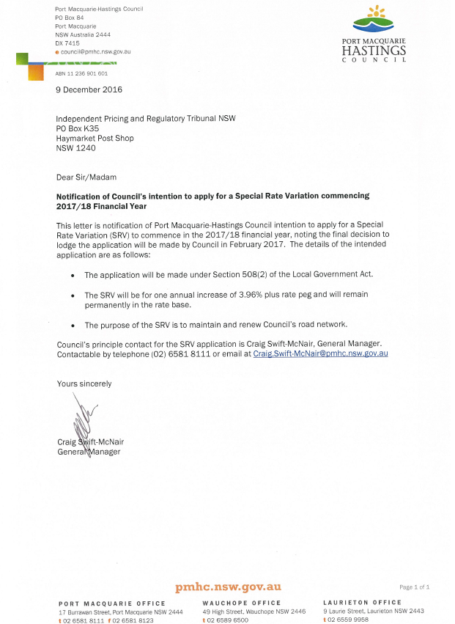

Online submission of applications

All councils intending to apply for a minimum rate increase must use the [Council Portal](https://www.ipart.nsw.gov.au/Home/Industries/Local-Government/For-Councils/Council-portal) on IPART’s website to register as an applicant council and to submit an application.

You are required to submit the application, via the Council Portal, by **Monday 13 February 2017.**

The [User Guide](http://www.ipart.nsw.gov.au/files/948b8fb1-2e6e-4647-b9d3-a10000a2552a/Local_Government_-_Council_Portal_User_Guide_-_November_2012.pdf) for the Portal will assist you with the registration and online submission process. If you experience difficulties please contact:

* Arsh Suri - [Arsh_Suri@ipart.nsw.gov.au](mailto:Arsh_Suri@ipart.nsw.gov.au) or 02 9113 7730
* Himali Ardestani - [Himali_Ardestani@ipart.nsw.gov.au](mailto:Himali_Ardestani@ipart.nsw.gov.au) or 02 9113 7710.

File size limits apply on the Council Portal to each part of the application. For this Part B application form the limit is 10MB. The limit for supporting documents is 50MB for public documents and 50MB for confidential documents. These file limits should be sufficient for your application. Please contact us if they are not.

We will post all applications (excluding confidential content) on the IPART website. Confidential content may include part of a document that discloses the personal identity or other personal information pertaining to a member of the public or whole documents such as a council working document and/or a document that includes commercial-in-confidence content. Councils should ensure that documents provided to IPART are redacted so that they do not expose confidential content.

Councils should also post their application on their own website for the community to access.

Permission was granted by IPART on 21 December 2016 for Port Macquarie-Hastings Council to lodge its application by 16 February 2017 to allow for the 15 February 2016 Ordinary Council meeting.

***From:*** *Letitia Watson-Ley [mailto:Letitia_Watson-Ley@ipart.nsw.gov.au]****Sent:*** *Wednesday, 21 December 2016 5:12 PM****To:*** *Holly McBride****Subject:*** *RE: SRV application 2017/18*

*Hi Holly,*

*I can confirm that we can accept an application from council by 16 February 2017.*

*Kind regards*

*Letitia*

Hardcopy of application

We ask that councils also submit their application to us in hard copy (with a table of contents and appropriate cross referencing to supporting documents) to the following address by **Monday 13 February 2017**:

**Local Government Team**  
The Independent Pricing and Regulatory Tribunal  
PO Box K35

Haymarket Post Shop NSW 1240

or

Level 15, 2-24 Rawson Place, Sydney NSW 2000.

# Preliminaries

## Focus on Integrated Planning and Reporting

Councils must identify the need for a proposed special variation to their General Fund’s rates revenue as part of their Integrated Planning and Reporting (IP&R) process. The IP&R documents will need to be publicly exhibited and adopted by the council prior to it submitting its application to us. Also refer to section 6 for a more detailed explanation.

The key IP&R documents are the Community Strategic Plan, Delivery Program, Long Term Financial Plan and, where applicable, the Asset Management Plan. A council’s application may also include supplementary and/or background publications used within its IP&R processes. You should refer to these documents to support your application for a special variation where appropriate.

**Supporting Attachments:**

* Attachment 1 Community Strategic Plan Extract;
* Attachment 2 Delivery Program; and
* Attachment 3 Long Term Financial Plan.

Council’s Community Strategic Plan (attachment 1) demonstrates community focus towards Roads and Infrastructure.

Council placed the amended 2013-2017 Delivery Program (attachment 2) and amended Long Term Financial Plan 2016-2016 (attachment 3) on public exhibition for 28 days from 21 November to 18 December 2016.

The amended documents include information that identifies Council’s need for the proposed Special Rate Variation (SRV).

## Key purpose of special variation

*At the highest level, indicate the key purpose(s) of the proposed special variation by marking one or more of the boxes below with an “x”.*

|  |  |
| --- | --- |
| *Maintain existing services* |  |
| *Enhance financial sustainability* |  |
| *Environmental services or works* |  |
| *Infrastructure maintenance / renewal* |  |
| *Reduce infrastructure backlogs* |  |
| *New infrastructure investment* |  |
| *Other (specify)* |  |

*You should summarise below the key aspects of the council’s application, including the purpose and the steps undertaken in reaching a decision to make an application.*

**Supporting Attachments:**

* Attachment 8 Asset Management Plan Extract; and
* Attachment 9 Past Instrument of Approval.

This application relates to continuing the funding provided by the current expiring Special Rate Variation (SRV) that expires June 2017 (attachment 9). The purpose of the new Special Rate Variation is to maintain and renew Council’s road network.

**Summary**

Council is applying for a SRV of 5.39% consisting of:

* 3.89% permanent single year SRV and;
* 1.5% rate peg.

This is for the purposes of maintaining and renewing Council’s road network.

**Background**

The sealed road network condition in 2012 was the result of a progressive and significant decline in condition since 1996. This was due to insufficient annual budget and resource allocations toward sealed road maintenance. The graph below shows the percentage of our road network in each condition from 1996 to 2016:

**Table 1**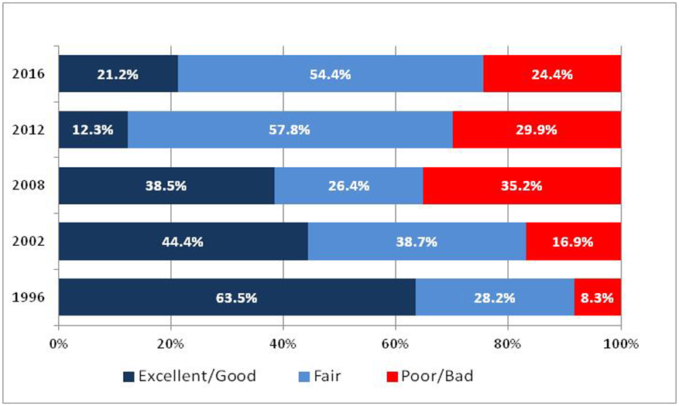

The service level experienced by residents up to 2012 was reactionary maintenance only, and was characterised by significant complaints to Council during wet weather events, when the condition of the sealed road network would rapidly deteriorate and cause issues for residents. As the graph demonstrates, this resulted in a significant decline in the condition of our road network over time.

Available resources up to 2012 were only able to be applied to short-term reactive maintenance activities, such as jet patching. Jet patching is viewed as a reactionary holding treatment only, temporary in nature, effective only in postponing the requirement for a more expensive and higher level of maintenance intervention in the future.

Due to budget constraints, up to 2012 only minimal road resealing activities were able to be undertaken. In comparison to jet patching, resealing of bitumen and asphaltic surfaces is considered a preventative maintenance activity. Resealing activities extend the service life of the road and reduces the instance of pavement failures and the subsequent requirement for reactive maintenance. Further, resealing is around one tenth the cost of full reconstruction or asphalt overlays, and when done at the right time can extend the life of a road by 10 to 15 years.

While the 2012 position indicates a conscious application of scarce funding aimed at containing the backlog of ‘poor’ roads and retaining as many roads as possible in at least ‘fair’ condition, it can be seen that this was at the cost of less roads remaining in the ‘good’ category. As a result, in 2012, while the rapid increase in the proportion of ‘poor’ roads in prior years had been arrested, it was still very high, at about one-third of the network, and represented a large backlog of work. In comparison, the improvement in the condition of the sealed road network in 2016 is the result of combining existing scarce maintenance funding with the first four years of clearly identified SRV funding, and applying these funds to specifically targeted long-term road maintenance activities.

In 2012, in recognition that the general condition of the sealed road network across the local government area was deteriorating faster than current resources could address, Council resolved to take a proactive approach to manage this network.

In line with this and following an application by Council, Council received approval from IPART to apply an SRV from the commencement of the 2012/13 financial year. This SRV allowed for the funding from the 4.43% increase to apply for each of the next five years.

The SRV meant that Council could transition from utilising a short-term reactive approach to its road maintenance activities, into the development and implementation of a roads maintenance and resealing program plus invest into heavy patching and unsealed road maintenance.

These were the priorities that were identified by the community in the extensive engagement that supported the 2012 rate rise application process, and these were the areas that Council needed to focus on to halt the consistent annual decline in the condition of the road network.

**Current Status**

Council currently provides and maintains 875km of sealed and 465km unsealed road network across the local government area. 261km are classified as high traffic roads, consisting of 68km arterial sealed roads (e.g. Ocean Drive, Hastings River drive, Lake Road) and 193km collector sealed roads (e.g. Beechwood Rd, William St, Kennedy Dr). 465km of the network are unsealed roads (e.g. Lorne Road, Maria River Road, Pappinbarra Road). As at 30 June 2016, Council’s sealed road assets are valued at $610.2M and unsealed road assets $94.3M, current replacement cost.

The service level currently experienced by residents is a combination of proactive and reactive roads maintenance, with Council steadily addressing the previous decline in condition of the sealed road network, through targeted and specific programs of work. In addition, more efficient work practices and ongoing resealing programmes have led to an increase in road condition and overall decrease of complaints from the public. As table 1 demonstrates since 2012 the additional funding has allowed for a reduction in our road network classed as poor/bad condition and a proactive shift towards increasing the volume classed as excellent/good condition.

The current SRV funding supports the overall maintenance of the sealed network at an average condition and the unsealed network at an average yet deteriorating condition.

Whilst it is clear the 2012 SRV has gone a long way toward improving the high traffic and unsealed road network across the local government network, with a current infrastructure backlog of $81.4M for sealed roads and $1.45M for unsealed roads, as reported in Special Schedule 7 as at 30 June 2016, there is still considerable work to be done to reduce our infrastructure backlog and continue our ability to maintain the progress made on the condition of our road network into the future. If Council are unable to maintain the current level of SRV funding, then the loss of the current SRV funding would create a significant estimated shortfall in the amount Council is able to allocate each year to road maintenance and would have a significant impact on the progress made and reduce the service levels received by the community.

*High Traffic Sealed Roads (arterial and collector)*

Council’s current asset management practice is focused on increasing the lifespan of high traffic sealed roads. Council’s current target, made possible by the 2012 4.43% SRV funding, is that sealed roads in the local government area will be resealed or rehabilitated every 12-14 years, in line with state wide programs.

The level of progress made since 2012/13 has been dependent on the existing SRV funding which has supported the maintenance of the network to an average condition. Should the current funding level cease there would be a significant increase in the percentage of high traffic sealed roads that fall into the poor/bad condition within the next eight years, see diagram 1.

**Diagram 1 High Traffic Sealed Roads**



*Unsealed Roads*

Current asset management practice for the unsealed road network requires application of new gravel material on average every eight years. For Council’s network of 456km of unsealed roads this equates to 58km of new gravel each year. Current operations are providing approximately 21km of new gravel per annum.

Continued loss of gravel and infrequent grading results in continuing deterioration of the network, that in turn results in compromised connectivity and loss of all weather access across parts of the network, as well as a reduction in vehicle travel speed on poor condition roads.

The existing SRV funding is supporting the maintenance of the network at an average yet deteriorating condition, with additional funding required to halt the deterioration of this asset class. Diagram 2 highlights the immediate impact the removal of additional funding would have upon the unsealed network, removing completely Council’s ability to provide a proactive 6 monthly grading program, resulting in the immediate increase of unscheduled works in reaction to network issues.

**Diagram 2 Unsealed Roads**



Over the past five years the SRV funding has allowed us to achieve significant results including but not limited to the following.

**2012 - 2013 - Yr 1 of 4.43% SRV Funding:**

Council was able to undertake the following proactive works, in 2012-2013, specifically utilising the **$1,577,600** allocated in the first year of SRV funding:

* Completion of **$800,000** of high traffic road resurfacing work, including resealing works on Randall and Cameron Street in Wauchope, on Pacific Drive and Gordon Street in Port Macquarie, on Ocean Drive in Lake Cathie and on Panorama Drive and Beach Street in Bonny Hills;
* Completion of **$398,000** of high priority unsealed road grading, under which all high priority unsealed roads were graded twice within the financial year, due to the addition of a fourth fulltime maintenance grading crew; and
* Completion of **$200,000** in pavement rejuvenation across the region based on priority rankings, and investment of **$180,000** to support design requirements for new road construction.

This was in addition to the ongoing reactive maintenance activities required to be undertaken in 2012/2013 to maintain the overall road network.

**2013-2014 - Yr 2 of 4.43% SRV Funding:**

Council was able to undertake the following proactive works, in 2013-2014, utilising the second year of SRV funding:

* Completion of **$827,000** of high traffic road resurfacing work, including rehabilitation works on Bago Rd South of King Creek near Wauchope, Koala St (Kennedy to Shearer St), Lake Rd (Lake Road and Jindalee Rd), and Pacific Dr (Pacific Dr and Flynn St, and Waterview to Bangalay) in Port Macquarie, and resealing works on Livingstone Rd (entire length) and Pacific Dr (Livingstone Rd to bus bay) in Port Macquarie;
* Completion of **$411,000** of unsealed road grading work, including allocation of two additional grading crews to continue the grading program; and
* Completion of **$207,000** in pavement rejuvenation across the region based on priority rankings, and investment of **$186,000** to support design requirements for new road construction.

This was in addition to the ongoing reactive maintenance activities required to be undertaken in 2013-2014 to maintain the overall road network.

**2014-2015 - Yr 3 of 4.43% SRV Funding:**

Council was able to undertake the following proactive works, in 2014-2015, utilising the third year of SRV funding:

* Completion of **$846,000** of high traffic road resurfacing work, including foam bitumen and asphalt rehabilitation works on Cameron St (High St to Bridge St) in Wauchope, Hastings River Drive (Tuffins Ln to Boundary St) and William St (Munster St to Grant St) in Port Macquarie;
* Completion of **$421,000** of unsealed road grading work, including allocation of two additional grading crews to continue the rural grading program; and
* Completion of **$212,000** in pavement rejuvenation across the region based on priority rankings, and investment of **$190,000** to support design requirements for new road construction.

**2015-2016 - Yr 4 of 4.43% SRV Funding:**

Council was able to undertake the following proactive works, in 2015-2016, utilising the fourth year of SRV funding:

* Completion of **$867,000** of high traffic road resurfacing work, including foam bitumen and asphalt rehabilitation works on Lord St (Gordon St to Yaranbee Rd) and Kennedy Drive (Yaranbee Rd to Coral St) in Port Macquarie, and Ocean Drive (near Waterview Cr) in West Haven;
* Completion of **$431,000** of unsealed road grading work, through allocation of two additional grading crews to continue the rural grading program, including 1km of works at each of Ballengarra Bransdon Rd in Telegraph Point and Pappinbarra Rd in Pappinbarra; and
* Completion of **$217,000** in pavement rejuvenation across the region based on priority rankings, and investment of **$195,000** to support design requirements for new road construction.

**2016-2017 - Year 5 (current financial year) of 4.43% SRV Funding:**

In 2016-2017, in accordance with the Council adopted Operational Plan, Council will undertake the following proactive works, utilising the fifth year of SRV funding:

* Completion of **$882,000** of high traffic road resurfacing work;
* Completion of **$438,000** of unsealed road grading work, through allocation of two additional grading crews to continue the rural grading program; and
* Completion of **$221,000** in pavement rejuvenation across the region based on priority rankings, and investment of **$198,000** to support design requirements for new road construction.

During the same year, Council will again continue to focus on addressing lower priority local roads, to continue to build on the positive impacts made to the condition of the road network from the previous four years of SRV funding.

**Expiry of the current SRV**

The current SRV funding will expire as of 30 June 2017. It is important to consider through the following points, the impact the loss of this funding would have on the progress made to date:

* Council would no longer be in a financial position to strategically manage its road assets to the current level, and the condition of the network would deteriorate year on year;
* Council would be forced to revert to a reactive approach to roads maintenance;
* Resealing and rejuvenation works would once again be predominantly replaced by reactive jet patching works;
* Sealed roads in the local government area would only be able to be resealed or rehabilitated every 25 years; and
* There would be a significant decrease in the level of service provided to residents by these assets.

It is also important to note that this SRV application is to maintain the current level of funding plus rate peg. It will not provide adequate funding to increase the service level for roads. However, it will allow for the level of progress made to continue, preventing our road network from going back towards the 2012 condition for sealed roads, and for unsealed roads preventing Council from going back to a reactive approach by allowing continuation of a proactive six monthly grading program.

As part of its process leading up to the application, Council undertook the following steps:

* Assessment of road condition and future needs (attachment 8);
* Review of Council’s planning documentation, amending the Delivery Program and Long Term Financial Plan (attachment 2 & 3);
* Extensive community engagement regarding Council services, including consideration of community willingness and capacity to pay (attachment 5);
* Financial modelling including productivity and cost efficiencies (attachment 3); and
* Obtained Council approval (attachment 7).

## Capital expenditure review

*You should complete this section if the council intends to undertake major capital projects that are required to comply with the OLG’s Capital Expenditure Guidelines, as outlined in OLG Circular 10-34. A capital expenditure review is required for projects that are not exempt and cost in excess of 10% of council’s annual ordinary rates revenue or $1 million (GST exclusive), whichever is the greater.*

*A capital expenditure review is a necessary part of a council’s capital budgeting process and should have been undertaken as part of the Integrated Planning and Reporting requirements in the preparation of the Community Strategic Plan and Resourcing Strategy.*

|  |  |  |
| --- | --- | --- |
| Does the proposed special variation require council to do a capital expenditure review in accordance with OLG Circular to Councils, Circular No 10-34 dated 20 December 2010 | Yes | No |
| If *Yes*, has a review been done and submitted to OLG? | Yes | No |

# Assessment Criterion 1: Need for the variation

*Criterion 1 in the OLG Guidelines is:*

*The need for, and purpose of, a different revenue path for the council’s General Fund (as requested through the special variation) is clearly articulated and identified in the council’s IP&R documents, in particular its Delivery Program, Long Term Financial Plan and Asset Management Plan where appropriate. In establishing need for the special variation, the relevant IP&R documents should canvass alternatives to the rate rise. In demonstrating this need councils must indicate the financial impact in their Long Term Financial Plan applying the following two scenarios:*

* *Baseline scenario – General Fund revenue and expenditure forecasts which reflect the business as usual model, and exclude the special variation, and*
* *Special variation scenario – the result of implementing the special variation in full is shown and reflected in the General Fund revenue forecast with the additional expenditure levels intended to be funded by the special variation.*

*Evidence to establish this criterion could include evidence of community need /desire for service levels/projects and limited council resourcing alternatives.*

*Evidence could also include the assessment of the council’s financial sustainability conducted by the NSW Treasury Corporation.*

*The response to this criterion should summarise the council’s case for the proposed special variation. It is necessary to show how the council has identified and considered its community’s needs, as well as alternative funding options (to a rates rise).*

*The criterion states that the need for the proposed special variation must be identified and clearly articulated in the council’s IP&R documents especially the Long Term Financial Plan and the Delivery Program, and, where appropriate, the Asset Management Plan. The purpose of the proposed special variation should also be consistent with the priorities of the Community Strategic Plan.*

Council’s need for an SRV to continue the maintenance of its sealed and unsealed road network is evidenced in the following attachments and described in section 2.2:

* Attachment 1 Community Strategic Plan;
* Attachment 2 Delivery Program;
* Attachment 3 Long Term Financial Plan;
* Attachment 4 NSW Treasury Corporation report on financial sustainability; and
* Attachment 9 Asset Management Plan Extract.

## Case for special variation - community need

*Summarise and explain below:*

* *How the council identified and considered the community’s needs and desires in relation to matters such as levels of service delivery and asset maintenance and provision.*
* *How the decision to seek higher revenues above the rate peg was made and which other options were examined, such as changing expenditure priorities or using alternative modes of service delivery.*
* *Why the proposed special variation is the most appropriate option: for example, typically other options would include introducing new or higher user charges and/or an increase in council loan borrowings, or private public partnerships or joint ventures.*
* *How the proposed special variation impacts the Long Term Financial Plan forecasts for the General Fund and how this relates to the need the council identified. Our assessment will also consider the assumptions which underpin the council’s Long Term Financial Plan forecasts.*

*In addressing this criterion, you should include extracts from, or references to, the IP&R document(s) that demonstrate how the council meets this criterion.*

**Supporting Attachments:**

* Attachment 3 Long Term Financial Plan;
* Attachment 4 NSW Treasury Corporation report on financial sustainability;
* Attachment 5 Media & Community Feedback; and
* Attachment 11 PMHC Engagement Strategy.

**Community Engagement**

Council undertakes regular community consultation regarding services and community expectation. For the past two years this engagement has shown the community would like to see Council continue and ‘do more’ in delivering roads and infrastructure.

Engagement over the past two years has focused on Council service levels. These activities include the Your Voice Our Community face-to-face and online engagement, and the July 2016 region-wide telephone survey (sample 800 people). These interactions have highlighted the community’s continuing desire to do more when it comes to roads. Council has listened to the priority the community place on continuing to build on the progress made over the last five years by prioritising funding to maintain and renew Council’s road network.

**Council Services**

*Your Voice our Community:*

* The Your Voice our Community engagement talked to the community about Council Services categorised into four themes:
  + Supporting your home life;
  + Supporting you in getting around;
  + Supporting community life; and
  + Supporting business and industry.
* Supporting you in getting around focused on roads and infrastructure services;
* The voting exercise (274 participants) results below show services in this theme are evenly split between ‘keep doing’ and ‘do more’ for sealed and unsealed roads; and
* The voting demonstrates a community desire to keep doing/increase the current service level for sealed and unsealed roads.

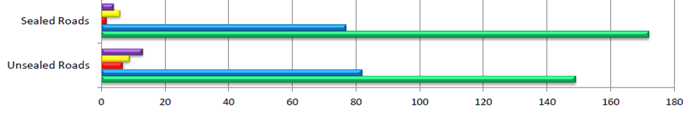

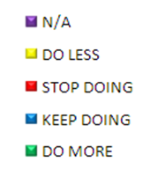

* Focus Groups were held for roads and transport, attended by 14 community members who were presented with Roads Service Level information;
* The focus groups asked community members to say what level they thought the current service was delivered and then what level of service they wanted delivered;
* For sealed and unsealed roads community feedback was to increase the current service levels;
* In July 2016 community forums were held to talk to the community about Council’s priority services, including Roads;
* The community was presented with service level information and again asked their view on the current service level. Council staff then presented detailed service information and the community were asked to vote again to show their desired service level;
* Results indicated a community desire to maintain/increase the service level provided for sealed and unsealed roads; and
* The feedback comments received throughout the Your Voice our Community engagement have been collated and entered into analytical software to produce a word cloud below. This analysis ‘counts’ the number of times a particular word or phrase appears and, based on the frequency of that word or phrase, a font size is generated. The larger the font, the more frequently the word or sentiment is mentioned. Below is the word cloud generated from feedback received relating to the theme: Supporting you in getting around.



**LGA wide telephone survey**

* In May 2016 Council engaged University of Technology Sydney Institute of Public Policy and Governance (UTS:IPPG) to conduct a random telephone survey of a minimum 800 residents within the Port Macquarie-Hastings Local Government Area (LGA);
* The survey was conducted in July 2016 and investigated community attitudes, values and perceptions of services, facilities, and infrastructure provided by Council;
* Results that demonstrate community continued focus to maintain and/or increase the service level for roads include:
* Over the past two years, residents perceive a positive change in Council’s performance (43% believed Council’s performance has improved and 43% believe it has stayed the same);
* The survey demonstrated an overall desire to increase the current service level of sealed and unsealed roads;
* A high percentage of residents (63%) believed that local government should spend ‘a little more’ or ‘a lot more’ on services in the local area, with 30% of residents feeling that the level of spending was ‘about the right amount’;
* The majority of residents believed that Council should invest more in roads (79%);
* 93 % placed creating and maintaining sealed roads as the local government function and activity of greatest importance; and
* Between 2013-2015 the importance remained mostly unchanged for:
  + Maintenance of sealed roads: 95% vs. 96%; and
  + Maintenance of unsealed roads: 79% vs. 78%.

**Specific SRV Engagement**

During October - December 2016, Council continued its engagement by talking with the community about the proposed SRV impact, affordability and determining the community’s willingness to pay. Engagement activities included the public exhibition of the amended Delivery Program 2013-2017 and Long Term Financial Plan 2016-2026, face to face (community events, pop up stands, community forum), online survey (PMHC Listening) and information factsheets.

The results of the 426 survey responses received overall supported the proposed SRV with 65% believing the current level of rates is a reasonable price to pay and 66.3% agreeing that the current rate level is affordable.

* **Do you think maintaining the current level of rates is a reasonable price to pay?**
  + 65% - strongly agree, agree or neither agree/disagree;
  + 33.4% - disagree or strongly disagree; and
  + 1.6% - don’t have an opinion/don’t want to answer.
* **Do you believe that maintaining the current rate level is affordable?**
  + 66.3% - strongly agree, agree or neither agree/disagree;
  + 32.5% - disagree or strongly disagree; and
  + 1.2% - don’t have an opinion/don’t want to answer.

**Council’s financial capacity and the most appropriate funding option**

The expenditure required to address the deteriorating condition of Council’s infrastructure is required on an ongoing basis. As such, it is necessary for any revenue stream to also be ongoing.

To date, this expenditure has been funded by the special rate variation of 4.43% plus rate peg which was approved in 2012. This is due to expire at the end of June 2017.

In determining the most appropriate funding option Council has considered alternative mechanisms and also rating principles.

Council has taken into account the rating benefits principle i.e. PMHC considers that it is appropriate to fund infrastructure which is for public use, or has characteristics of “public goods” from rates. Roads are viewed by Council as being a public good.

**Council has considered alternative revenue streams including:**

1. User fees and charges - this was not considered feasible as it would not be practical to implement a user fee for roads and the infrastructure is seen as having the characteristics of a public good, and hence use of rates is a more appropriate funding source.
2. Borrowing – Borrowing was not considered feasible as this is recurrent expenditure and is required on an ongoing basis. Continual borrowing to fund this expenditure would not be sustainable. Council is constantly assessing its borrowings and the most appropriate source of funding.

1. Reserves - The Port Macquarie-Hastings area is a high growth regional centre of the North Coast of NSW, has recently been identified as a Regional City by the NSW Government and is expected to accommodate a significant proportion of regional growth over the next two decades. The population will grow from 79,114 in 2016 to 102,926 in 2036. As a consequence of this growth, Council must not only provide services to the existing community and maintain existing assets, but Council must also plan for future maintenance and capital expenditure on the infrastructure that will be needed to support the community, business and visitors to the area into the future. The value of approved Development Assessments was far greater in 2015/16 than any previous year. In 2015/16 the value was $361m compared to $283m in 2014/15 and $199m in 2013/14.

To this end, Council holds cash reserves. As at June 2016, Council held $214 million in cash and reserves. Predominantly, these reserves are all allocated for specific purposes, with 70% of these reserves legally only being able to be used for the purpose for which they were collected (for example for water and sewer). The remaining reserves are also predominantly held for specific purposes (for example, for the development of the Airport, or to fund projects which have already commenced). The balances of these reserves are audited annually and published in Council’s financial statements.

1. The level of reserves held by Port Macquarie-Hastings Council is not disproportionate to other similar Councils, noting that different Councils provide different services. Not all Councils provide Water and Sewer services for example which require significant capital investment.

Productivity Improvements – Council has considered and included a number of productivity improvements as described in section 7 and referred to in the long term financial plan. The revenue proposed from the SRV is required in addition to these productivity enhancements.

**Impact of SRV on Council’s Long Term Financial Plan forecast**

The SRV is being sought to fund specific programs of expenditure. The primary purpose of the SRV are:

* Maintain existing services;
* Infrastructure maintenance/renewal; and
* Reduce infrastructure backlogs.

As part of Council’s Long Term Financial Plan, PMHC has modelled two (2) scenarios. These are:

Scenario 1 – Reduce (rate peg only, current SRV expires) – this scenario excludes both the special rate variation and the expenditure associated with it. This scenario results in a net reduction in rates due to the impact of the expiring special rate variation. Under this scenario the funding for roads reduces which impacts the service level provided to the community.

Scenario 2- Maintain (rate peg + SRV to replace expiring SRV)- the expiring special rate variation is replaced by a new permanent single year special rate variation maintaining the current level of funding. Under scenario 2, the expiring SRV is replaced with a new SRV.

At the time of preparing the amended Long Term Financial Plan an assumed rate peg of 2.5% was used as this was the rate anticipated by IPART. This resulted in scenario 2 including additional rating income of $1.78m in 2017/18 compared to scenario 1. This was assumed to continue with rate peg into the outer years. This income is fully expended in scenario 2. The amounts included in the long term financial plan during 17/18 are shown in the table below:

*$ expenditure of expiring and new SRV in Long Term Financial Plan*



Expenditure is a combination of capital and maintenance.

As a consequence of income being fully expended the shortfall /surplus is the same in both scenarios. In scenario 2 both expenditure and income increase by an equal amount compared to scenario 1.

In late 2016 the rate peg for 2017/18 was confirmed as 1.5%. This results in a lower SRV than included in the Long Term Financial Plan. The value of the SRV now being applied for as part of this application is $1.76m in 2017/18 compared to the previously anticipated $1.78m. The expenditure on maintenance has been reduced to compensate for this overall reduction. This has resulted in the application including the following in 2017/18.

*$ expenditure of expiring and new SRV following confirmed rate peg (1.5%)*



***Impact on shortfall/(surplus)***

The net result of the SRV on the Long Term Financial Plan general fund is that both Scenario 1 and 2 have the same shortfall/(surplus) funding position.

The projected shortfall/(surplus) funding position is shown below. As discussed previously the shortfall position is constant between the two scenarios. This is because expenditure and income change by the same amount (noting that the Long Term Financial Plan modelling was based on a 2.5% rate peg in 17/18. All other things being equal, the actual shortfall will now be higher.

*Predicted shortfall/(surplus)*



A shortfall exists until 2020. The General Fund position demonstrates a shortfall in available funds, indicating the need for the rate increase based on current expenditure levels. Similarly the income statement projects a loss before grants and contributions.

***Impact on operating performance***

Whilst the SRV does not impact the funding shortfall or surplus, it does impact the operating performance due to the portion of the expenditure on capital which is a cash outlay but non profit item. The improvement in Scenario 2 is shown below.

*Operating result before grants and contributions* 

Additionally the SRV results in an improvement in asset ratios as described in section 3.2.

## Financial sustainability

*The proposed special variation may be intended to improve the council’s underlying financial position for the General Fund, or to fund specific projects or programs of expenditure, or a combination of the two. We will consider evidence about the council’s current and future financial sustainability and the assumptions it has made in coming to a view on its financial sustainability.*

*You should explain below:*

*The council’s understanding of its current state of financial sustainability, its long-term projections based on alternative scenarios and assumptions about revenue and expenditure.*

* *Any external assessment of the council’s financial sustainability (eg, by auditors, NSW Treasury Corporation). Indicate how such assessments of the council’s financial sustainability are relevant to supporting the decision to apply for a special variation.*
* *The council’s view of the impact of the proposed special variation on its financial sustainability.*

**Supporting Attachments:**

* Attachment 2 Delivery Program;
* Attachment 3 Long Term Financial Plan; and
* Attachment 4 NSW Treasury Corporation report on financial sustainability.

The SRV is being sought to fund specific programs of expenditure. The primary purposes of the SRV are:

* Maintain existing services;
* Infrastructure maintenance/renewal; and
* Reduce infrastructure backlogs.

Council has assessed its long term financial position in its long term financial plan. It is important to note that these scenarios were premised on a rate peg of 2.5% in 2017/18 and outer years. As the published rate peg was only 1.5% for 2017/18 this will mean that the projections may be optimistic.

At the time of community engagement IPART had indicated an expected rate peg of 2.5%. The scenarios presented to the community for feedback were premised on this 2.5%, the number of rate payers as at 1 July 2016, and the latest land valuations at that time. Subsequent to the community engagement, IPART have confirmed the 17/18 rate peg is 1.5% as opposed to the expected 2.5%. Additionally the number of rate payers has grown since July. This results in a lower SRV % application being sought.

To ensure the average increase to rates for the community is equal to the rate peg increase only (1.5%), Council is applying to continue the current SRV funding plus rate peg amount. This involves an application of 5.39% (3.89% plus 1.5% rate peg). This is lower than the previously anticipated 6.46% (3.96% plus 2.5% rate peg) due to the lower rate peg and growth since community engagement.

Using the current data, the approval of the SRV will result in the total average residential rate increasing by approximately $17, which is a 1.5% increase in 17/18. Following this, the annual increase would be rate peg only unless future SRVs are considered by Council.

**Long Term Financial Plan**

Two scenarios have been included:

* Scenario 1 – Reduce (rate peg only, current SRV expires); and
* Scenario 2- Maintain (rate peg + SRV to replace expiring SRV).

As described in section 3.1 as a consequence of income being fully expended the shortfall /surplus is the same in both scenarios. In Scenario 2 both expenditure and income increase by an equal amount compared to Scenario 1. The net result of the SRV on the Long Term Financial Plan general fund is that both Scenario 1 and 2 have the same shortfall/(surplus) funding position.

In both scenarios Council has a shortfall until 2020. This shortfall is considered manageable, however without the special rate variation the expenditure available to be spent on roads reduces. The impact the loss of this funding would have is as follows:

* Council would no longer be in a financial position to strategically manage its road assets, and the condition of the network would deteriorate year on year;
* Council would be forced to revert to a reactive approach to roads maintenance;
* Resealing and rejuvenation works would once again be predominantly replaced by reactive jet patching works; and
* Sealed roads in the local government area would only be able to be resealed or rehabilitated every 25 years.

There would be a significant decrease in the level of service provided to residents by these assets.

***External Assessment of Council Financial Sustainability***

Although dated 2012, the NSW Treasury Corporation Report ‘Financial Assessment and Benchmarking’ supports the view that there is a need to invest in infrastructure e.g. Page 5 quotes ‘Council has not invested adequately in infrastructure asset maintenance or renewals over the period’. This report also suggests that Council has been managed efficiently e.g. page 4 quotes ‘Council has been well managed over the review period’.

In the Long Term Financial Plan under Scenario 2 - Maintain, income increases by the amount of the SRV plus growth and future rate peg. This is shown below noting this data assumed a rate peg of 2.5% in 2017/18.

*Rates and annual charges under each scenario*

Net operating performance improves by the amount of the increase in rating income, less the portion of the SRV attributed to operating expenditure (assuming 2.5% rate peg for 2017/18).

*Operating result before grants and contributions* 

The ratios under each scenario for general fund are copied below. As can be seen with a special rate variation operating performance improves compared to Scenario 1, and is closer to reaching benchmark of 0% in Scenario 2.

Own Source Operating Revenue is also enhanced due to higher rating income, as is the debt service cover ratio.

Rates and annual charges outstanding is moderately better as well as it is not considered that the marginal change in rates will impact on amounts outstanding.

However, even under Scenario 2 – Maintain, asset ratios do not meet benchmark levels. These are discussed further under section 3.3.





Financial models under each scenario for general fund are included in the amended Long Term Financial Plan (attachment 3, pages 33-42). Overall the financial position improves slightly with the SRV Scenario 2 – Maintain and there is a significant impact on service levels to the community.

## Financial indicators

*How will the proposed special variation affect the council’s key financial indicators (General Fund) over the 10-year planning period? Please provide, as an addendum to the Long Term Financial Plan, an analysis of council’s performance based on key indicators (current and forecast) which may include:*

* *Operating balance ratio excluding capital items (ie, net operating result before capital grants and contributions as percentage of operating revenue before capital grants and contributions).*
* *Unrestricted current ratio (the unrestricted current assets divided by unrestricted current liabilities).*
* *Rates and annual charges ratio (rates and annual charges divided by operating revenue).*
* *Debt service ratio (principal and interest debt service costs divided by operating revenue excluding capital grants and contributions).*
* *Broad liabilities ratio (total debt plus cost to clear infrastructure backlogs as per Special Schedule 7 divided by operating revenue).*
* *Asset renewal ratio (asset renewals expenditure divided by depreciation, amortisation and impairment expenses).*

**Supporting Attachments:**

* Attachment 2 Delivery Program; and
* Attachment 3 Long Term Financial Plan.

## General Fund *Operating performance:* Under the reduce scenario, Council meets this target only in 2022-23. This is caused by revenue not increasing in line with cost increases. Under the maintain scenario there is an improvement in this ratio due to part of increased revenue being spent on capital. Council expects to go close to meeting this ratio in most years in the maintain scenario, and to slightly exceed it in 2023 and 2024. *Own Source Operating Revenue:* Council exceeds this benchmark in each future year under both scenarios. 2015-16 was adversely impacted by a large level of grant income. *Debt Service Cover Ratio:* Council will exceed the benchmark for this ratio in each outer year under both scenarios, however there is not a significant amount of capacity to borrow in the early years, and further borrowings will increase the shortfall position. *Rate and annual charges outstanding:* This ratio is expected to meet the benchmark in scenario 2 and continue to improve. Under the higher revenue scenario (Scenario 2: maintain) it is not expected that the slightly higher average rates will impact on the collectability of the rates, hence the ratio is improved by the higher revenue. Asset Ratios *Infrastructure backlog:* It is not expected under either scenario that Council will meet this ratio, but it will be worse without a SRV. Council’s large asset base combined with the limits on revenue make it difficult to meet this benchmark without major injections of funding specifically dedicated to maintenance and renewal. This ratio is close to 9% in 2025/26 in Scenario 2 - Maintain compared to 11% in Scenario 1 - Reduce. Asset Maintenance Similarly to infrastructure it is unlikely that the benchmark for this ratio will be met unless there is an injection of funding. This ratio improves slightly under the SRV scenario, reaching 0.84% by 2025/26. Building and Infrastructure renewals This ratio is difficult for Council to meet as it is in a growing area which requires both new and renewal expenditure. Additionally, Council often increases the capacity of an asset whilst it is being renewed, however this is not factored into this ratio.

## Council has not met the benchmark for this ratio in any year covered by the LTFP. The ratio is better under Scenario 2: Maintain, than it is under Scenario 1: (Reduce - expiring SRV). Asset renewals for this ratio represent the replacement or refurbishment of existing assets to an equivalent capacity or performance.

## Contribution plan costs above the cap

*You should complete this section if the proposed special variation seeks funding for contributions plan costs above the development contributions cap. Otherwise, leave this section blank.*

*Please explain how the council has established the need for a special variation to meet the shortfall in development contributions.*

*For costs above the cap in contributions plans, a council must provide:[1]*

* *a copy of the council’s section 94 contributions plan*
* *a copy of the Minister for Planning’s response to IPART’s review and details of how the council has subsequently amended the contributions plan*
* *details of any other funding sources that the council is proposing to use, and*
* *any reference to the proposed contributions (which were previously to be funded by developers) in the council’s planning documents (eg, Long Term Financial Plan and Asset Management Plan AMP.*

Not applicable.

# Assessment criterion 2: Community awareness and engagement

*Criterion 2 in the Guidelines is:*

*Evidence that the community is aware of the need for and extent of a rate rise. The Delivery Program and Long Term Financial Plan should clearly set out the extent of the General Fund rate rise under the special variation. The council’s community engagement strategy for the special variation must demonstrate an appropriate variety of engagement methods to ensure community awareness and input occur. IPART’s fact sheet includes guidance to councils on the community awareness and engagement criterion for special variations.*

*Our fact sheet on the requirements for community awareness and engagement is available on the IPART website.[2]*

*In responding to this criterion, the council must provide evidence that:*

* *it has consulted and engaged the community about the proposed special variation using a variety of engagement methods and that the community is aware of the need for, and extent of, the requested rate increases*
* *it provided opportunities for input and gathered input/feedback from the community about the proposal, and*
* *the IP&R documents clearly set out the extent of the requested rate increases.*

*In assessing the evidence, we will consider how transparent the engagement with the community has been, especially in relation to explaining:*

* *the proposed cumulative special variation rate increases including the rate peg for each major rating category (in both percentage and dollar terms)*
* *the annual increase in rates that will result if the proposed special variation is approved in full (and not just the increase in daily or weekly terms)*
* *the size and impact of any expiring special variation (see Box 4.1 below for further detail), and*
* *the rate levels that would apply without the proposed special variation.*

*More information about how the council may engage the community is to be found in the Guidelines, the IP&R manual and our fact sheet.*

|  |
| --- |
| *Box 4.1 Where a council is renewing or replacing an expiring special variation* |
| *The council’s application should show how you have explained to its community:*  *There is a special variation due to expire at the end of the current financial year or during the period covered by the proposed special variation. This needs to include when the expiring special variation was originally approved, for what purpose and the percentage of (General Fund) general income originally approved.*  *The corresponding percentage of general income that the expiring special variation represents for the relevant year.*  *Whether the temporary expiring special variation is being replaced with another temporary or a permanent increase to the rate base.*  *The percentage value of any additional variation amount, above the rate peg, for which the council is applying through a special variation.*  *If the proposed special variation was not approved (ie, only the rate peg applies), the year-on-year change in rates would be lower, or that rates may fall.*  *The council also must attach, to its application to IPART, a copy of the Instrument of Approval that has been signed by the Minister or IPART Chairman.* |

## The consultation strategy

*The council is required to provide details of the consultation strategy undertaken, including the range of methods used to inform and engage with the community about the proposed special variation and to obtain community input and feedback. The engagement activities could include media releases, mail outs, focus groups, statistically valid random or opt-in surveys, online discussions, public meetings, newspaper advertisements and public exhibition of documents.*

*The council is to provide relevant extracts of the IP&R documents that explain the rate rises under the proposed special variation and attach relevant samples of the council’s consultation material.*

**Supporting Attachments:**

* Attachment 2 Delivery Program;
* Attachment 5 Media & Community Feedback; and
* Attachment 11 PMHC Engagement Strategy.

Over the past 18 months Council has engaged with the community regularly about the services Council deliver to understand community expectations. This engagement included specific community engagement relating to the proposed SRV application during November - December 2016.

The community engagement strategy and activities undertaken, using a variety of engagement methods to achieve a breadth and depth of engagement, is detailed in attachment 5 and 11 including samples of Council’s consultation material.

The PMHC Community Engagement Strategy (attachment 11) demonstrates the community engagement methods Council use to engage with the community in line with IAP2 (International Association For Public Participation) spectrum of public participation.

Through the community engagement conducted over the past 18 months relating to service levels and the SRV, Council has reached the ‘Involve’ level of engagement on the IAP2 spectrum of public participation. To ensure a depth and breadth of consultation with the community that allowed for community feedback, Council’s consultation (attachment 5) included engagement activities such as:

* Presentations to community groups;
* Online community engagement page including;
* Online Community Survey;
* Online community forum;
* Telephone Survey;
* Information kiosks across the region;
* Community Forum;
* Focus Groups;
* Fact sheets;
* Social media; and
* Attendance at key community events.

As part of the Integrated Planning and Reporting process to demonstrate Council’s need for the SRV through its planning documents Council revised its Delivery Program and Long Term Financial Plan. Pages 21-31 of attachment 2 show how Council revised its Delivery Program to explain the purpose and impact of the SRV. The amended 2013-2017 Delivery Program (attachment 2) and Long Term Financial Plan 2016-2026 (attachment 3) were placed on public exhibition from 21 November - 18 December 2016.

## Feedback from the community consultations

*Summarise the outcomes and feedback from the council’s community engagement activities. Outcomes could include the number of attendees at events and participants in online forums, as well as evidence of media reports and other indicators of public awareness of the council’s special variation intentions. Where applicable, provide evidence of responses to surveys, particularly the level of support for specific programs or projects, levels and types of services, investment in assets, as well as the options proposed for funding them by rate increases.*

*Where the council has received submissions from the community relevant to the proposed special variation, the application should set out the views expressed in those submissions. Please refer to Section 1.2 concerning how the council should handle confidential content in feedback received from the community. The council should also identify and document any action that it has taken, or will take, to address issues of common concern within the community.*

**Supporting Attachments:**

* Attachment 2 Delivery Program;
* Attachment 5 Media & Community Feedback; and
* Attachment 11 PMHC Engagement Strategy.

Council undertakes regular community consultation regarding services and community expectation. In addition, to ensure Council fully consulted with the community, demonstrating the financial impact the proposed SRV would have and allow the community the opportunity to provide feedback, Council undertook specific SRV engagement. A summary of the activities and results is provided below, full detail about the community engagement program Council undertook, including the SRV information presented to the community can be found in attachment 5.

Table 2 provides a summary of the engagement activities that have taken place over the last 18 months that are relevant to the SRV application. There are four elements to Council’s SRV engagement program:

* Council Services;
* Public exhibition of the relevant Council planning documents;
* SRV impact, capacity and willingness to pay; and
* Media communication.

**Table 2**

|  | **Purpose** | **Method** | **Date** | **Community Participation** |
| --- | --- | --- | --- | --- |
| Council Services | Engage and consult with the community about Council services, service levels and expectations | Your Voice our Community campaign:   * Online survey and discussion * Information kiosks * Focus Groups * Community Forum * Attendance at key community events   LGA Wide Telephone Survey | September 2015 - August 2016 | Service voting activity: 274 participants  Online: 1549 visits, 517 responses  159 community member attendance at forums and focus groups  Telephone survey 800 participants with demographics in line with quotas set for age, gender and locality |
| Public Exhibition of amended Delivery Program 2013-2017 and Long Term Financial Plan 2016-2026 | Provide the community with evidence of the need for a SRV through Council’s planning documents | Online publication of documents  Copies of documents available for viewing at service counters  Submissions invited  Attendance at key community events | 21 November - 18 December 2016 | Online: 133 visits, documents downloaded 3 times each  5 submissions received to Council |
| Specific SRV Engagement | Engage and consult with the community about the proposed SRV | Presentations to community groups  Community forum including live streaming of discussion and responding to community comments  Online survey, forum and information page  Fact sheets  Information kiosks  Attendance at key community events | October - December 2016 | Presentations to 5 community groups - 133 community participants  Attendance at 2 events - 8,270 community reach, 300 participation  11 Information Kiosks across the LGA - 182 community members spoken to  Community Forums - 23 attendees , with live feed on 10/11/16. Reached 5819 and engaged 544 community members  PMHC Listening site open for 55 days  1220 visits by 918 people to the have your say site  Suite of 5 factsheets available to down load - 195 downloaded in total  426 surveys completed |
| Media communication | Inform and invite feedback relating to Council’s SRV community engagement campaign | Media releases  Social media  Live feed of community forum  Council website  Communication to online engagement and subscriber database | October - December 2016 | SRV Making a Decision about Future Rates media release on 3/11/16 - 18 page views  Community newsletter emailed on 2/11/16 titled ‘Invitation to Council’s Community Forum’ was sent to 5,244 subscribers and received 2,306 unique opens  Social media posts, four with a reach of 6,356 community members |

**Results**

Following is a summary of results from the stages of community engagement relevant to the SRV application. Further details of the activities and results can be found in attachment 5.

***Council Services***

*Your Voice our Community*

* The Your Voice our Community engagement talked to the community about Council Services categorised into four themes:
  + Supporting your home life;
  + Supporting you in getting around;
  + Supporting community life; and
  + Supporting business and industry.
* This engagement aligned to Council’s Service Review Project, using and informing service information gained through the service review process.
* Supporting you in getting around focused on roads and infrastructure services.
* The voting exercise (274 participants) results show services in this theme (see table 3) are evenly split between ‘keep doing’ and ‘do more’ for sealed and unsealed roads.

The voting demonstrates a community desire to increase the current service level for sealed and unsealed roads.

**Table 3**





* The roads and transport focus groups were attended by 14 community members.
* For sealed and unsealed roads community feedback was to increase the current service levels.
* The feedback comments received throughout the Your Voice our Community engagement have been collated and entered into analytical software to produce a word cloud This analysis ‘counts’ the number of times a particular word or phrase appears and, based on the frequency of that word or phrase, a font size is generated. The larger the font, the more frequently the word or sentiment is mentioned. Below is the word cloud generated from feedback received relating to the theme: Supporting you in getting around.



* The full YVOC report is provided in attachment 5, appendix 5.
* In July 2016 Council held two Community Forum’sfacilitated by University of Technology Centre for Local Government (UTS:CLG) to discuss service levels for Councils priority services, including Roads. Results from this forum are detailed in attachment 5.

**LGA wide telephone survey**

* In May 2016 Council engaged University of Technology Sydney Institute of Public Policy and Governance (UTS:IPPG) to conduct a random telephone survey of a minimum 800 residents within the Port Macquarie-Hastings Local Government Area (LGA):
  + 60% - Port Macquarie
  + 12% - Camden Haven
  + 12% - Wauchope
  + 8% - Rural
  + 8% - Lake Cathie
* The survey was conducted in July 2016 and investigated community attitudes, values and perceptions of services, facilities, and infrastructure provided by Council.
* The survey questions can be found is attachment 5, appendix 7.
* Results of the survey relevant to the SRV application include:
  + Over the past two years, residents perceive a positive change in Council’s performance (43% believed Council’s performance has improved and 43% believe it has stayed the same);
  + There was desire to increase the current service level of sealed and unsealed roads;
  + A high percentage of residents (63%) believed that local government should spend ‘a little more’ or ‘a lot more’ on services in the local area, with 30% of residents feeling that the level of spending was ‘about the right amount’;
  + The majority of residents believed that Council should invest more in roads (79%);
  + 93 % placed creating and maintaining sealed roads as the local government function and activity of greatest importance;
  + Older residents are more likely to not support increased local government expenditure in their local area, compared to younger residents;
  + Younger residents (18-35 years of age), are prepared to pay either; more rates in return for a greater range of services, or lower rates in exchange for fewer services;
  + Older residents are more likely not to support increased local government expenditure in their local area, compared to younger residents. They are also more inclined to rate value-for-money of Council services as being of a high standard;
  + Residents with incomes of $80,000-$100,000 are less likely to hold value-for-money and quality of Council’s services in high regard. In addition, the majority of residents of this income bracket do not wish for increased expenditure in their local area;
  + Residents of the Wauchope locality rate value-for-money and quality of services to be of a lower standard and identify a need for increased Council spending in the local area;
  + Residents new to the area (less than 5-year residency) are prepared to pay lower rates in exchange for fewer services. However, they do not want to pay more rates to receive a broader range of services;
  + Residents earning in excess of $100,000 are prepared to pay more rates to receive a greater range of services, but not pay less in exchange for fewer services;
  + Between 2013-2015 the importance remained mostly unchanged for:
    - Maintenance of sealed roads: 95% vs. 96%; and
    - Maintenance of unsealed roads: 79% vs. 78%.

**Public Exhibition of amended 2013-2017 Delivery Program and Long Term Financial Plan 2016-2026**

* As adopted by Council in November 2016 the amended documents (attachment 2 and 3) were placed on public exhibition from 21 November to 18 December;
* The documents were available for the community to view and make submissions online, at Council’s customer service counters and at community engagement stands during the public exhibition period; and
* Five submissions (attachment 12) were received by Council as outlined below.

|  |  |  |  |  |  |
| --- | --- | --- | --- | --- | --- |
| **Submission: Comments on Special Rate Variation Proposals** | | | | **Issue: Opposing SRV** | |
| 1. | Name redacted | | | Opposed to another SRV or permanent rate variation. Rates are unaffordable for many. Encourage Council to co-operate with State and Federal Government to seek opportunities to secure grant funding for specific projects. | |
| ***Response/***  ***Comment****:* | Council has undertaken a community engagement campaign as per IPART requirements to engage with the community about the proposed SRV and test the community’s willingness and capacity to pay. The results of this community engagement, the impact to the current roads works program, Councils ability to deliver a service level in line with community expectation and community capacity to pay, are used to inform the decision of Council.  Council has an ongoing focus to identify State and Federal Government opportunities.   * In 2016 a cost shifting report was presented to Council and subsequently Council lobbied with Members of Parliament for assistance in reducing the financial burden on our community. * The newly elected Council have formed a portfolio committee focused on External Grants and Revenues. | | | |
| **Submission: Special Rate Variation Scenarios** | | | | | **Issue: Opposing SRV** |
| 2. | Name redacted | | | | Opposed to any further SRV as rates are already too high, only supports CPI rate peg increase. |
| ***Response/***  ***Comment****:* | | The proposed SRV increase, as presented to the community, is an increase equivalent to a rate peg increase on Council total income. The impact to the community based on what they are currently paying would be the effect of rate peg increase only as they are already paying the SRV amount with Council proposing to embed this permanently into the rate base.  It is important to note individual rate payers may be impacted differently due to the complexity of the rating system. | | |
| **Submission: Proposed Rate Increases** | | | | | **Issue: Opposing SRV** |
| 3. | Name redacted | | | | Opposed to rate variation. Suggests Council consider selling assets such as unused land or pay off outstanding loans. |
| ***Response/***  ***Comment****:* | | The proposed SRV increase, as presented to the community, is an increase equivalent to a rate peg increase on Council total income. The impact to the community based on what they are currently paying would be the effect of rate peg increase only as they are already paying the SRV amount with Council proposing to embed this permanently into the rate base.  It is important to note individual rate payers may be impacted differently due to the complexity of the rating system.  When preparing its Long Term Financial Plan Council considers all options available. The works funded by the expiring SRV are ongoing and therefore, the funding also needs to be ongoing.  Council does have a level of loans which are within appropriate benchmarks and financial levels, and are considered prudent in terms of Council’s overall financial management and in ensuring intergenerational equality i.e. loans help to ensure that where a future generation receives benefit from a facility that they share some of the cost for it. | | |
| **Submission: Rate Increase** | | | | | **Issue: Opposing SRV** |
| 4. | Name redacted | | | | Opposed to rate increase. The online survey is a scam. Would like to have been given the option to have just the increase at the rate peg limit. 50% increase over 5 years is about $1,000 to him. |
| ***Response/***  ***Comment****:* | | The proposed SRV increase, as presented to the community, is an increase equivalent to a rate peg increase on Council total income. The impact to the community based on what they are currently paying would be the effect of rate peg increase only as they are already paying the SRV amount with Council proposing to embed this permanently into the rate base.  It is important to note individual rate payers may be impacted differently due to the complexity of the rating system.  To clarify Council is not seeking a 50% SRV. Council is seeking to permanently embed the current expiring SRV only. | | |
| **Submission: SRV for Roads** | | | | | **Issue: Opposing SRV and request for further information** |
| 5. | Name redacted | | | | The economic modelling is partial. Would like to know at what point an appropriate maintenance level has been implemented. Does not understand why the previous SRV funding is not enough. Concerned roads maintenance is heading towards gold plating standards. |
| ***Response/***  ***Comment****:* | | Meeting has taken place with the Director Corporate & Organisational Services, Chief Financial Officer and Group Manager of Transport & Stormwater Network to clarify information and answer any further questions.  Discussion included:  -clarification of the impact on ratios as a result of the SRV - SRV improves ratios  -clarification of the works for which this SRV will be used for  -clarification of the process that is undertaken to assess and prioritise works required | | |

**Specific SRV Engagement**

A variety of engagement methods were used to inform and engage with the community:

* Key community events were attended to provide the community with information and the opportunity to have their say by completing a survey. Events included Tastings Ignite, Tastings on Hastings and Countdown to Christmas;
* On 10 November Council held a community forum to discuss the SRV for Roads. Council presented information to 23 community members who were given the opportunity to ask questions, provide feedback and complete a survey;
* The community forum was live streamed via the Port Macquarie-Hastings Council Facebook page reaching 5819 community members with 544 engaging via comment/sharing during the live feed;
* The footage of the forum remains available on the Port Macquarie-Hastings Council Facebook page having over 900 views to date;
* Approximately 250 people attended information stalls that were set up at various locations across the region:
  + Lake Cathie Woolworths;
  + Main Street Wauchope;
  + Settlement City Shopping Centre;
  + Hay Street Forecourt; and
  + Bold Street Laurieton.
* Information stands at Council offices in Port Macquarie, Laurieton and Wauchope received approximately 490 visits;
* Online engagement site (PMHC Listening) was open for 55 days and attracted 1220 visits by 918 people with 600 taking further action to explore the site and gather information;
* Factsheets were available to inform the community about the proposed SRV. The factsheets were available at events, customer service counters and also to download online. Online downloads:
  + 50 - Fact Sheet 3 - Rate Scenarios;
  + 41 - Fact sheet 4 - Current SRV achievements;
  + 39 - Fact sheet 2 - Rate pegging and Special Rate Variations - SRV the Facts;
  + 35 - Fact sheet 1 - Talking to our Community; and
  + 30 - Fact sheet 5 - Council Services.
* 426 surveys were completed (either directly online or hand written at an event/forum/information stand). Details of participants are as follows:
  + Age of those who completed the survey
    - 4.6% - 26-35
    - 10.8% - 36-45
    - 18.5% - 46-55
    - 24.6 % - 56-65
    - 41.5% - Over 65
  + Location of those who completed the survey
    - 64.6% - Port Macquarie
    - 14.2% - Wauchope
    - 8.5% - Lake Cathie
    - 7.3% - Port Macquarie (Business Centre)
    - 5.4% - Lighthouse Beach
  + Connection to Port Macquarie-Hastings area
    - 385 - Home Owner
    - 16 - Renter
    - 45 - Business owner/operator
    - 16 - Farm owner/operator
    - 6 - Prefer not to answer
    - 12 - Other
  + Where respondents income comes from
    - 149 - Work full-time including own business
    - 56 - Work part-time/casual
    - 137 - Self funded retiree
    - 8 - Carer
    - 8 - Studying
    - 19 - Prefer not to answer
    - 77 - Receiving benefits
    - 18 - Other
* The results of the questions relating to the community’s capacity and willingness to pay are as follows:
  + **Do you think maintaining the current level of rates is a reasonable price to pay?**
    - 65% - strongly agree, agree or neither agree/disagree
    - 33.4% - disagree or strongly disagree
    - 1.6% - don’t have an opinion/don’t want to answer
  + **Do you believe that maintaining the current rate level is affordable?**
    - 66.3% - strongly agree, agree or neither agree/disagree
    - 32.5% - disagree or strongly disagree
    - 1.2% - don’t have an opinion/don’t want to answer
* To compliment the community engagement, Council used a variety of media communications to inform the community about the SRV and opportunity’s for the community to have their say: media releases, social media, Council website and subscriber emails (attachment 5).

**Themes**

Throughout the engagement the community have been consistent in feedback received about the desire to continue/maintain the service level for roads. The themes that can be taken from the community engagement feedback received are:

* Roads as a priority service;
* Council to become more efficient; and
* The prioritisation of Council services, how we allocate funds across the services.

Council recognises the need to ensure that all efficiencies and prioritisation of works has been undertaken prior to asking the community for a significant SRV. In recognition of this, Council is seeking to continue the funding from the expiring SRV and is committed to:

* Finalising service reviews;
* Continued process improvement and finalisation of current efficiency reviews such as those identified in the Fit for the Future action plan;
* Undertaking further detailed works program prioritisation, and exploration of funding opportunities such as grants to supplement reserve or revenue funding; and
* Increase community awareness and understanding of services which Council is required to deliver.

# Assessment criterion 3: Impact on ratepayers

*Criterion 3 in the Guidelines is:*

*The impact on affected ratepayers must be reasonable, having regard to both the current rate levels, existing ratepayer base and the proposed purpose of the variation. The Delivery Program and Long Term Financial Plan should:*

* *clearly show the impact of any rises upon the community*
* *include the council’s consideration of the community’s capacity and willingness to pay rates and*
* *establish that the proposed rate increases are affordable having regard to the community’s capacity to pay.*

*The impact of the council’s proposed special variation on ratepayers must be reasonable. To do this, we take into account current rate levels, the existing ratepayer base and the purpose of the proposed special variation. We also review how the council has assessed whether that the proposed rate rises are affordable having regard to the community’s capacity and willingness to pay.*

## Impact on rates

*Much of the quantitative information we need on the impact of the proposed special variation on rate levels will already be contained in Worksheet 5a and 5b of Part A of the application.*

*To assist us further, the application should set out the rating structure under the proposed special variation, and how this may differ from the current rating structure, or that which would apply if the special variation is not approved.*

*We recognise that a council may choose to apply an increase differentially among categories of ratepayers. If so, you should explain the rationale for applying the increase differentially among different categories and/or subcategories of ratepayers, and how this was communicated to the community. This will be relevant to our assessment of the reasonableness of the impact on ratepayers.*

*Councils should also indicate the impact of any other anticipated changes in the rating structure.*

**Supporting Attachments:**

* Attachment 2 Delivery Program; and
* Attachment 3 Long Term Financial Plan.

The current expiring SRV was approved for a period of five years and is due to expire on 30 June 2017. The value of the expiring SRV is approximately $1.7m in additional revenue in 2016-2017. Council is seeking to maintain this funding and the resulting service delivery outcomes.

This ensures that the community would see an average rate rise of rate peg only. Council proposes to apply the SRV equally across rating categories . Special rating categories are not impacted by the SRV.

The proposed rating structure with and without is depicted in the table below:



The average impact of the SRV across rating categories and in total will be an increase equal to the rate peg of 1.5%. This is lower than the 2.5% quoted in the community engagement due to the lower rate peg. The SRV application is 3.89% plus 1.5% rate peg = 5.39%.

Using the current data, the approval of the SRV will result in the total average residential rate increasing by approximately $17, which is a 1.5% increase in 17/18. Following this, the annual increase would be rate peg only unless future SRV’s are considered by Council.

If the SRV is not approved the total average residential rate would decrease by approximately $26, which is a 2.26% reduction in 2017/18. Following this, the annual increase would be rate peg only unless future SRV’s are considered by Council**.**

These figures relate to average general rates across all residential ratepayers. They exclude other charges and special levies, and may vary across individual ratepayers. This is shown in Table 4.

**Table 4**

|  |  |  |  |
| --- | --- | --- | --- |
| **Average General Residential Rate (excludes other charges e.g. waste and special levies)\*** | **Current Average 16/17** | **Average With SRV**  **17/18** | **Average Without SRV 17/18** |
| Total Average Residential Rate $ Rounded | $1,145.74 | $1,162.90 | $1,119.87 |
| Annual Increase/ (Decrease) from 16/17 |  | $17.16 | ($25.87) |
| % Increase / (Decrease) from 16/17 |  | 1.5% | (2.26%) |

\**Excludes special levies and other charges such as waste water and waste.*

### Minimum Rates

The proposed special variation may affect ordinary rates, special rates and/or minimum rates.

As previously discussed, if the proposed special variation includes increasing minimum rates above the statutory limit, or is to apply a higher rate of increase to an existing minimum rate than to its other rates, it is not necessary for the council to also complete the separate Minimum Rates application form. However, this must be clearly identified and addressed in the special variation application.

|  |  |  |
| --- | --- | --- |
| Does the council have minimum Ordinary rates? | Yes | No |

If Yes, does the council propose to increase minimum Ordinary rates by:

The rate peg percentage

The special variation percentage

Another amount  Indicate this amount _____________

What will minimum Ordinary rates be after the proposed increase? _________

The council must explain how the proposed special variation will apply to the minimum rate of any ordinary and special rate, and any change to the proportion of ratepayers on the minimum rate for all relevant rating categories that will occur as a result.

You should also explain the types of ratepayers or properties currently paying minimum rates, and the rationale for the application of the special variation to minimum rate levels.

Not applicable.

## Consideration of affordability and the community’s capacity and willingness to pay

*The council is required to provide evidence through its IP&R processes, and in its application, of how it assessed the community’s capacity and willingness to pay the proposed rate increases. This is to include an explanation of how the council established that the proposed rate rises are affordable for the community.*

*Evidence about capacity to pay could include a discussion of such indicators as SEIFA rankings, land values, average rates, disposable incomes, the outstanding rates ratio and rates as a proportion of household/business/farmland income and expenditure, and how these measures relate to those in comparable or neighbouring council areas.*

*As many of these measures are highly aggregated, it may also be useful to discuss other factors that could better explain the impact on ratepayers affected by the proposed rate increases, particularly if the impact varies across different categories of ratepayers.*

*We may also consider how the council’s hardship policy (see Section 5.3 below) might reduce the impact on socio-economically disadvantaged ratepayers.*

**Supporting Attachments:**

* Attachment 2 Delivery Program; and
* Attachment 5 Media and Community Feedback.

***Demographics***

Port Macquarie Hastings Council Local Government area covers a total land area of 3,686 km2. It has a population of 78,128 (ABD ERP 2015) that equates to 0.21 persons per hectare.

The Age Structure of Port Macquarie-Hastings Council area provides key insights into the level of demand for age based services and facilities such as child care. It is also an indicator of Port Macquarie-Hastings Council area's residential role and function and how it is likely to change in the future.

There are 2,446 people over the age of 85 living in Port Macquarie-Hastings Council area in 2011, with largest age group being 60 to 64 year olds making up 32% of the population. Port Macquarie-Hastings Council area had a lower proportion of pre-schoolers and a higher proportion of persons at post retirement age than Regional NSW in 2011. 4,826 people or 6.6% of the population in Port Macquarie-Hastings Council area in 2011, reported needing help in their day-to-day lives due to disability.

In 2011, Port Macquarie-Hastings Council area scored 968.9 on the SEIFA Index of Disadvantage.

The Aboriginal and Torres Strait Islander Census population of Port Macquarie-Hastings Council area in 2011 was 2,425, living in 1,122 dwellings.

|  |  |  |  |  |  |  |  |  |  |  |  |  |  |  |  |  |  |  |  |  |  |  |  |  |  |  |  |  |  |  |  |  |  |  |  |  |  |  |  |  |  |  |  |  |  |  |  |  |  |  |  |  |  |  |  |  |  |  |  |  |  |  |  |  |  |  |  |  |  |  |  |  |  |  |  |  |  |  |  |  |  |  |  |  |  |  |  |  |  |  |  |  |  |  |  |  |  |  |  |  |  |  |  |  |  |  |  |  |  |  |  |  |
| --- | --- | --- | --- | --- | --- | --- | --- | --- | --- | --- | --- | --- | --- | --- | --- | --- | --- | --- | --- | --- | --- | --- | --- | --- | --- | --- | --- | --- | --- | --- | --- | --- | --- | --- | --- | --- | --- | --- | --- | --- | --- | --- | --- | --- | --- | --- | --- | --- | --- | --- | --- | --- | --- | --- | --- | --- | --- | --- | --- | --- | --- | --- | --- | --- | --- | --- | --- | --- | --- | --- | --- | --- | --- | --- | --- | --- | --- | --- | --- | --- | --- | --- | --- | --- | --- | --- | --- | --- | --- | --- | --- | --- | --- | --- | --- | --- | --- | --- | --- | --- | --- | --- | --- | --- | --- | --- | --- | --- | --- | --- | --- | --- |
| |  |  |  |  |  |  |  |  | | --- | --- | --- | --- | --- | --- | --- | --- | | **Age structure - Service age groups** | | | | | | | | | **Port Macquarie-Hastings Council area - Total persons (Usual residence)** | **2011** | | | **2006** | | | **Change** | | **Service age group (years)** | **Number** | **%** | **Regional NSW %** | **Number** | **%** | **Regional NSW %** | **2006 to 2011** | | Babies and pre-schoolers (0 to 4) | 3,985 | 5.5 | 6.3 | 3,546 | 5.2 | 6.1 | +439 | | Primary schoolers (5 to 11) | 6,165 | 8.5 | 9.0 | 5,996 | 8.8 | 9.7 | +169 | | Secondary schoolers (12 to 17) | 5,715 | 7.9 | 8.2 | 6,013 | 8.8 | 8.8 | -298 | | Tertiary education and independence (18 to 24) | 4,338 | 6.0 | 8.1 | 3,948 | 5.8 | 8.0 | +390 | | Young workforce (25 to 34) | 5,706 | 7.8 | 10.4 | 5,695 | 8.3 | 10.8 | +11 | | Parents and homebuilders (35 to 49) | 13,322 | 18.3 | 19.5 | 13,566 | 19.8 | 20.9 | -244 | | Older workers and pre-retirees (50 to 59) | 10,156 | 14.0 | 13.9 | 9,346 | 13.7 | 13.6 | +810 | | Empty nesters and retirees (60 to 69) | 10,549 | 14.5 | 11.9 | 8,723 | 12.7 | 10.3 | +1,826 | | Seniors (70 to 84) | 10,315 | 14.2 | 10.3 | 9,643 | 14.1 | 9.8 | +672 | | Elderly aged (85 and over) | 2,446 | 3.4 | 2.3 | 1,940 | 2.8 | 1.9 | +506 | | **Total population** | **72,697** | **100.0** | **100.0** | **68,416** | **100.0** | **100.0** | **+4,281** |   *Source: Australian Bureau of Statistics,* [*Census of Population and Housing*](http://www.abs.gov.au/census) *2006 and 2011. Compiled and presented by* [*.id*](http://home.id.com.au/about-us/) *, the population experts.(Usual residence data* |

***Community capacity and willingness to pay***

The rates and annual charges outstanding ratio is an indication of ratepayer’s ability to pay. Council performs well compared to benchmark in this ratio.

In 2015-16 Council achieved a rates and annual charges outstanding ratio of 5.34%. This ratio has been steadily improving. The 2016 result exceeded the benchmark which applied until 2015 (6%), and was close to meeting the revised benchmark of 5%.

Prior to 2015/16, the benchmark was 6% for this ratio as prescribed by Local Government Managers Australia - now known as Local Government Professionals Australia. In 2015/16 a new lower benchmark was introduced by the Local Government Code of Accounting Practice. The benchmark for metropolitan areas is 5%, and the benchmark for rural areas is 10%. Council’s auditors have applied the metropolitan benchmark to Port Macquarie Hastings Council despite Council being in a regional area.

5.34% is a strong result for a regional area.

The ‘Making a decision about Future Rate’ community survey (426 responses) conducted during November-December 2016 asked community opinion on capacity and willingness to pay the proposed SRV. The responses as follows, demonstrate the majority of respondents have a willingness and capacity to pay:

* **Do you think maintaining the current level of rates is a reasonable price to pay?**
  + - 65% - strongly agree, agree or neither agree/disagree
    - 33.4% - disagree or strongly disagree
    - 1.6% - don’t have an opinion/don’t want to answer
* **Do you believe that maintaining the current rate level is affordable?**
  + - 66.3% - strongly agree, agree or neither agree/disagree
    - 32.5% - disagree or strongly disagree
    - 1.2% - don’t have an opinion/don’t want to answer

## Addressing hardship

*In addition to the statutory requirement for pensioner rebates, most councils have a policy, formal or otherwise to address issues of hardship.*

|  |  |  |
| --- | --- | --- |
| *Does the council have a Hardship Policy?* | ***Yes*** | *No* |
| *If Yes, is an interest charge applied to late rate payments?* | ***Yes*** | *No* |
| *Does the council propose to introduce any measures to reduce the impact of the proposed special variation on specific groups in the community?* | *Yes* | *No* |

*You should attach a copy of the Hardship Policy and explain below who the potential beneficiaries are and how they are assisted.*

*Please provide details of any other measures addressing hardship to be adopted, or alternatively, explain why no measures are proposed.*

*The council is also to indicate whether the hardship policy or other measures are referenced in the council’s IP&R documents (with relevant page reference or extract provided).*

**Supporting Attachments:**

* Attachment 6 Hardship Policy; and
* Attachment 13 Pensioner Concession Rebates Policy.

Council has an adopted Rates and Charges Hardship Assistance Policy (attachment 6).

Council’s Hardship Policy is available on Councils website however, is not referenced in our IP&R documents. Council is taking steps to rectify this for the 17/18 suite of IPR documents.

The Port Macquarie-Hastings region demographic has a large number of residents over 60 years of age, resulting in a number of residents being reliant on income provided by the pension.

The policy demonstrates Council’s commitment to providing assistance to customers who display a genuine inability to pay their rates and other charges in a timely manner and provides a framework to be followed in providing assistance to those ratepayers who are suffering genuine financial hardship

The hardship policy is regularly reviewed and currently provides assistance to pensioners in hardship. Council also offers statutory pensioner concessions in accordance with Council’s Pensioner Concession Rebates Policy (attachment 13).

Additionally, Council also offers payment arrangements in cases of genuine financial difficulty.

The SRV application is to continue the existing SRV. The average rate rise would be equivalent to rate peg of 1.5% which is less than CPI. Additionally, Council’s performance on rates and annual charges outstanding ratio of 5.08% for general fund, and 5.34% for all of Council consolidated is a strong result. Council’s performance on rates and annual charges outstanding ratio result indicates that the community largely has the capacity to pay. On this basis no additional measures addressing hardship are considered necessary at this stage. However, Council will continue to review its hardship policy on an ongoing basis.

# Assessment criterion 4: Public exhibition of relevant IP&R documents

*Criterion 4 in the Guidelines is:*

*The relevant IP&R documents must be exhibited (where required), approved and adopted by the council before the council applies to IPART for a special variation to its general revenue.*

*Briefly outline the significant IP&R processes the council has undertaken to reach the decision to apply for a special variation. Include the details of and dates for key document revisions, public exhibition period(s) and the date(s) that the council adopted the relevant IP&R documents.[3]*

*You should also include extracts from council minutes as evidence that the documents were adopted.*

*The council is reminded that the Community Strategic Plan and Delivery Program (if amended), require public exhibition for at least 28 days prior to adoption. Amendments to the Long Term Financial Plan and Asset Management Plan do not require public exhibition.[4] However, it would be expected that the Long Term Financial Plan would be posted, in a prominent location, on the council’s website.*

**Supporting Attachments:**

* Attachment 1 Community Strategic Plan;
* Attachment 2 Delivery Program;
* Attachment 10 Resolution to adopt amended Delivery Program & LTFP; and
* Attachment 12 Submissions Received by Council.

Council revised the Delivery Program and Long Term Financial Plan to demonstrate the requirement for an SRV. The red text in the amended Delivery Program (attachment 2, pages 21-31) highlights the specific SRV information added to the revised document. This enabled Council to demonstrate to the community through Councils planning documents the need for an SRV.

Below is a timeline that demonstrates the adoption of the original documents and the process undertaken for the amended documents.

**June 2013** - Council adopted the 2013-2017 Delivery Program and 2013-2017 Resourcing Strategy.

|  |
| --- |
| **08.17 2013-2017 Delivery Program, 2013-2014 Operational Plan, 2013-2017 Resourcing Strategy, 2013-2014 Fees and Charges and 2013-2017 Social Strategy** |

|  |
| --- |
| *RESOLVed: Levido/Turner*  *That Council:*  *1.* ***Adopt the 2013-2017 Delivery Program as exhibited****.*  *2. Adopt the 2013-2014 Operational Plan, including the budget, subject to amendments as outlined in the report.*  *3. Include the rates and annual charges in Council’s Revenue Policy commencing 1 July 2013 as detailed in this report.*  *4. Adopt the One Year Operational Plan (2013-2014) - Schedule of Fees and Charges, as part of Council's Revenue Policy, subject to the amendments as outlined in the Schedule of Amended Fees and Charges 2013-2014 contained in this report.*  *5. Set the interest rate on overdue rates and charges at 9% from 1 July 2013 in accordance with DLG guidelines.*  *6.* ***Adopt the 2013-2017 Resourcing Strategy.***  *7. Adopt the 2013-2017 Social Strategy as exhibited.*  *8. Thank, in writing, all those who made submissions for their contribution and provide information on Council’s decision on the matter.*  *9. Enter into new borrowings of $10.8 million as per the Resourcing Strategy.*  *carried: 9/0*  *For: Besseling, Cusato, Griffiths, Hawkins, Intemann, Levido, Roberts, Sargeant and Turner*  *Against: Nil* |

**September 2014** - Council adopted the revised 2013-2017 Delivery Program.

|  |
| --- |
| ***09.12 Second Six Monthly Delivery Program Report*** |
| *Resolved: Sargeant/Cusato*  *That Council;*  *1. Note the second six monthly progress report on the Delivery Program 2013-2017, encompassing July 2013 - June 2014.*  *2.* ***Endorse the revised format of the Delivery Program 2013-2017****, noting that community engagement is not required as no changes have been made to objectives.*  *carried: 9/0*  *For: Besseling, Cusato, Griffiths, Hawkins, Intemann, Levido, Roberts, Sargeant and Turner*  *Against: Nil* |

**November 2016** - Council adopted to place the amended 2013-2017 Delivery Program and Long Term financial Plan 2016-2026 on public exhibition.

|  |
| --- |
| ***09.14 Making a Decision about Future Rates*** |

*RESOLVED: Turner/Alley*

*That Council:*

*1. Place the following draft documents on public exhibition for a period of 28 days from 21 November to 18 December 2016:*

* *Amended 2013-2017 Delivery Program.*
* *Amended Long Term Financial Plan.*

*2. Lodge an IPART expression of interest for a Special Rate Variation in December 2016 in relation to embedding the existing Special Rate Variation into the future noting that the submission of an expression of interest will not bind Council in applying for a Special Rate Variation.*

*3. Note that a further report will be tabled at the February 2017 meeting of Council, detailing the submissions received from the public during the exhibition period that will provide Council with information that can be taken into account in considering whether to formally apply for a Special Rate Variation to maintain the current funding levels.*

*carried: 8/1*

*For: Besseling, Alley, Cusato, Dixon, Hawkins, Intemann, Levido and Turner*

*Against: Griffiths*

**21 November to 18 December 2016** - The amended 2013 -2017 Delivery Program (attachment 2) and Long Term Financial Plan 2016-2026 (attachment 3) were placed on public exhibition for 28 days.

During this time the documents were available for the public to access and lodge a submission with Council:

* Council’s website (PMHC Listening) as shown below;
* At community events; and
* At Council Customer Service Counters (Port Macquarie, Wauchope, Laurieton).

*Council’s PMHC Listening engagement site*

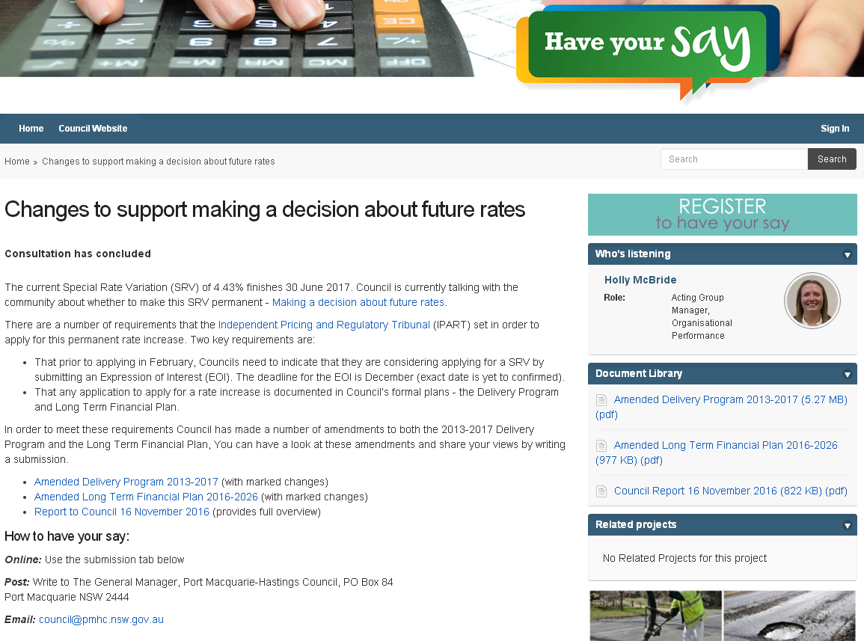

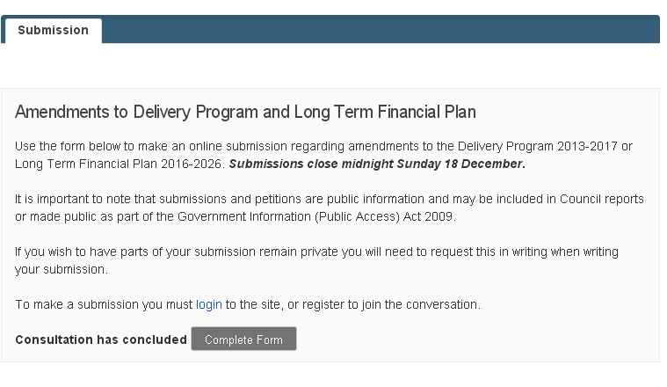

Five (5) submissions were received by Council during the exhibition period (attachment 12).

**1 February 2017** - Councillor review of submissions at a Councillor Briefing.

**15 February 2017** - Council adopted the amended 2013-2017 Delivery Program (attachment 2) and Long Term Financial Plan 2016-2026 (attachment 3).

|  |
| --- |
| ***09.06 Making a Decision About Future Rates*** |
| *RESOLVED: Intemann/Hawkins*  *That Council:*  *1. Adopt the amended 2013-2017 Delivery Program.*  *2. Adopt the amended Long Term Financial Plan 2016-2026.*  *3. Request the General Manager submit an application to the Independent Pricing and Regulatory Tribunal (IPART) under section 508(2) of the NSW Local Government Act 1993, for a permanent single year Special Rate Variation (SRV) of 3.89% in addition to the rate peg amount of 1.5%  (total 5.39%), noting that this is a continuation of the funding provided by the existing SRV which expires June 2017, for the purpose of maintaining and renewing Council’s road network.*  *carried: 8/1*  *For: Besseling, Alley, Cusato, Dixon, Hawkins, Intemann, Levido and Turner*  *Against: Griffiths* |

# Assessment criterion 5: Productivity improvements and cost containment strategies

*Criterion 5 in the Guidelines is:*

*The IP&R documents or the council’s application must explain the productivity improvements and cost containment strategies the council has realised in past years, and plans to realise over the proposed special variation period.*

*In this section, you must provide details of any productivity improvements and cost containment strategies that you have implemented during the last two years (or longer) and any plans for productivity improvements and cost containment over the duration of the proposed special variation.*

*These strategies, which may be capital or operational in nature, must be aimed at reducing costs and/or improving efficiency. Indicate if any initiatives are to increase revenue eg, user charges. Please include below whether the proposed initiatives (ie, cost savings) have been factored into the council’s Long Term Financial Plan.*

*Where possible, the council is to quantify in dollar terms the past and future productivity improvements and cost savings.*

*The council may also provide indicators of efficiency, either over time or in comparison to other relevant councils. We will make similar comparisons using various indicators and OLG data provided to us.*

**Supporting Attachments:**

* Attachment 3 Long Term Financial Plan.

In June 2015, Council was required to submit an improvement proposal to the NSW Office of Local Government as part of the NSW Government’s ‘Fit for the Future’ assessment of councils. At the June 2015 Council meeting, Council resolved the following in response to this submission:

|  |
| --- |
| ***09.09 Reform of Local Government - Fit for the Future Submission to the NSW Government*** |
| *RESOLVED: Besseling/Levido*  *That:*   1. *The content of the ‘Fit for the Future’ proposal identified as “Scenario 2C” be submitted in accordance with the requirements of IPART, prior to 30 June 2015.* 2. *Council acknowledges that the submission does not bind this Council or any future Council to the suggested rate increases contained therein.* 3. *Any future application for Special Rate Variations associated with the submission take into account the following:* 4. *The community’s capacity to pay any suggested rate increase.* 5. *Any further efficiencies identified in Council’s current Services Review.* 6. *The financial realisation of Council assets.* 7. *Federal and State Government funding equity improvements.* 8. *Feedback from the community.*   *carried: 7/1*  *For: Besseling, Cusato, Griffiths, Intemann, Levido, Sargeant and Turner*  *Against: Roberts* |

Taking into account the above Council resolution the following has been undertaken:

***Community’s capacity to pay***

* The rates and annual charges outstanding ratio is an indication of ratepayer’s ability to pay. Council performs well compared to benchmark in this ratio.

In 2015-16 Council achieved a rates and annual charges outstanding ratio of 5.34% for all of Council consolidated and 5.08% for general fund. This ratio has been steadily improving. The 2016 result exceeded the benchmark which applied until 2015 (6%), and was close to meeting the revised benchmark of 5%.

Prior to 2015/16, the benchmark was 6% for this ratio as prescribed by Local Government Managers Australia - now known as Local Government Professionals Australia. In 2015/16 a new lower benchmark was introduced by the Local Government Code of Accounting Practice. The benchmark for metropolitan areas is 5%, and the benchmark for rural areas is 10%. Council’s auditors have applied the metropolitan benchmark to Port Macquarie Hastings Council despite Council being in a regional area.

5.34% is a strong result for a regional area.

***Efficiencies and Financial Realisation of Council’s assets***

**Service Review Project**

Council commenced a detailed service review process in 2014. The overall objective of the service reviews being to review all Council services to ensure Council is operating at ‘best value’ taking into consideration long-term financial sustainability and meeting the needs of the community i.e. delivering agreed services at the agreed level and at best value.

The objectives of the Service Review Project are:

1. To better understand what the community wants and ensure that council’s businesses and services are aligned to corporate and community priorities;
2. To improve the quality of some or all services; and
3. To generate income or make savings.

Priority areas identified by Council in which the Service Review Project is focused are as follows:

1. Focus on economy and efficiency and also effective provision of services;
2. Engage and consult with a wide range of stakeholders throughout the review;
3. Respond to the needs and wants of both the current and future community;
4. Be transparent with all stakeholders about proposed outcomes; and
5. Set targets for quality and cost and benchmark/measure/report these against other organisations or standards.

The Service Review Project has been split into three phases:

***Phase 1: Service Summaries***

Service Summary methodology was endorsed by Council in May 2014 and delivered from June 2014 to February 2015. A service summary was created for each of Council’s 32 services providing a service view which included information relating to the objective of the service, service delivery including FTE information, income and expenditure, measures and benchmarking. Service Summary information was considered by Councillors in workshop in March 2015, facilitated by University of Technology Centre for Local Government (UTS:CLG). The following services were identified for alternate service delivery review:

* Bushland Management;
* Crematorium;
* Lifeguard Services;
* Small Plant; and
* Stores.

These services underwent review with the outcome presented to Council for formal consideration in May 2016 and since the following progress has been made and continues:

* Bushland Management service is retained at the current funding level with the same number of staff delivering this important service to the community;
* Crematorium review is to be finalised with newly elected Council;
* Lifeguard Services have been outsourced to optimise service delivery;
* Small Plant currently under review; and
* Council Store Operation resolved to continue the service and is undergoing a service review to identify efficiency opportunities.

***Phase 2: Service Levels***

Service Level methodology was endorsed by Council in August 2015 and delivered from August 2015 to June 2016. Phase 2 focused on Councils 20 external services, creating a Service Level Report for each service and consulting with the community about service level expectations. The Service Level Report includes information on community feedback, current service levels and opportunity for increase/decrease of service. Service Level information was presented to Councillors, including community feedback, in a workshop in March 2016, facilitated by University of Technology Centre for Local Government (UTS:CLG). The outcome of this workshop identified services to progress into phase 3 to identify opportunity for improvement.

***Phase 3: Business Improvement***

Business Improvement methodology was endorsed by Council in June 2016 and delivered from July 2016 ongoing. Phase 3 is progressing services for review as identified by the community and Councillors using an improvement methodology. It is expected improvements from this phase seen by council and the community will include:

* Financial savings;
* Productivity release;
* Improved quality;
* Easier processes for staff and/or customers; and
* Improved customer experience/satisfaction.

*PMHC Service Review Project Three Phase Methodology*

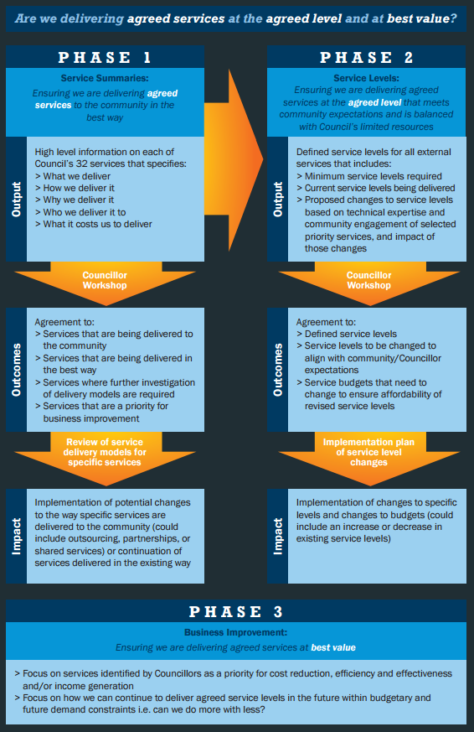

Service Review Project activities from 2015 to now have included:

* Defining 20 External Services split into 93 Service Categories, to describe the services from the perspective of the community;
* 20 Service Level Reports created describing the current service level, increase/decrease service level options and impacts;
* Your Voice our Community (YVOC) Engagement Program provided a snap shot point in time opinion from the community on whether we should keep doing, stop doing, do more or do less for the services Council currently provides;

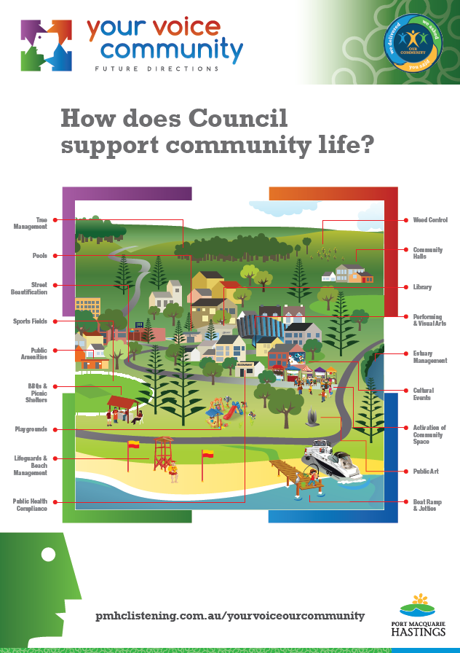

* 18 hours of community discussions;
* 1000+ service votes;
* 1 Civic Leaders Forum, 2 Community Forum’s and 7 Focus Groups to discuss service levels;
* PMHC Listening online forum used for community discussion and to capture feedback;
* 5 services reviewed for alternate service delivery;
* 2 Councillor briefings, 1 Councillor workshop and 2 Council reports; and
* Working directly with University of Technology Centre for Local Government (UTS:CLG) to facilitate Councillor and community discussion and support methodology creation.

Other efficiencies made by Council outside of the Service Review Project include:

* Council has been focused on its procurement approach and with the implementation of a procurement strategy, it is estimated this has resulted in savings in order of $1.3m per annum which are now embedded in our Long Term Financial Plan;
* Council has worked hard to contain staffing with very little movement in full time equivalent employees in the last few years (507 in 2015/16 compared to 490 in 2013/14) despite regional growth and improved service;
* Additionally Council has undertaken a program to ensure that annual leave is taken as appropriate. The number of annual leave hours accrued by staff in excess of 8 weeks[5] has more than halved since 2015. This results in a reduction in wages compared to what they would otherwise have been;
* Council has undertaken a review of its loan portfolio, and as a consequence has recently undertaken refinancing to take advantage of the current prevailing low interest rate environment. In total, this review will save Council in the order of $2.5m over the life of the loans. As a consequence Council has factored significant amounts of interest savings in the outer years in its long term plan; and
* Council continually reviews processes as part of its continuous improvement approach. Operational process improvements are realised across the business that provide financial savings, productivity release, improved quality, easier processes for staff and/or customers and improved customer experience/satisfaction. Examples include:
  + Campaigns to increase emailing of rates notices to save on paper and postage costs. Based on current email quantities savings to postage are in the order of $15k per annum which have been embedded into our long term forecast;
  + Review of rates payment options (estimated saving $60k per annum from payment channel charges); and
  + Review of user pay fees and charges ensuring charges for services are at an appropriate level.
* The property business unit is developing a property portfolio business plan, which amongst other things will consider possibilities to optimise the financial return from property assets; and
* Significant progress has been made in developing and maturing our asset management plans and these will form a key part of the 2017-2021 Resourcing Strategy.

*Federal and State Government funding*

* In 2016 a cost shifting report was presented to Council that identified $9.2m of cost shifting to Council from other levels of Government. Subsequently Council lobbied Members of Parliament for assistance in reducing the financial burden on our community. At the time of writing this report, there has been no reduction in the levels of cost shifting from other levels of government; and
* The newly elected Council have formed a Portfolio focused on maximising external grants and revenues.

*Feedback from the community*

* Council undertakes regular community engagement on how the community feels about our region, current Council services and community service level expectations. Recent community engagement, also sought feedback from the community on its willingness and capacity to pay the proposed SRV; and
* Feedback from the community is considered when making any decisions about service change and delivery.

Productivity improvements are included in the amended Long Term Financial Plan 2016-2016 (attachment 3 page 8).

# List of attachments

*The following is a list of the supporting documents to include with your application.*

*Some of these attachments will be mandatory to all special variation applications (eg, extracts from the Community Strategic Plan).*

*Other attachments will be required from some, but not all, councils. For example, extracts from the Asset Management Plan would be required from a council seeking approval of a special variation to fund infrastructure.*

*Councils should submit their application forms and attachments online through the Council Portal in the following order. Councils may number the attachments as they see fit.*

|  |  |
| --- | --- |
| Item | Included? |
| **Mandatory forms and Attachments** |  |
| Part A Section 508A and Section 508(2) Application form (Excel spreadsheet) |  |
| Part B Application form (Word document) – this document |  |
| **Attachment 1** Relevant extracts from the Community Strategic Plan |  |
| **Attachment 2** Delivery Program |  |
| **Attachment 3** Long Term Financial Plan with projected (General Fund) financial statements (Income, Cash Flow and Financial Position) **Attachment 3a** in Excel format |  |
| **Attachment 4** NSW Treasury Corporation report on financial sustainability |  |
| **Attachment 5\*** Media releases, public meeting notices, newspaper articles, fact sheets relating to the rate increase and proposed special variation |  |
| **Attachment 5\*** Community feedback (including surveys and results if applicable) |  |
| **Attachment 6** Hardship Policy |  |
| **Attachment 7** Resolution to apply for the proposed special variation |  |
| Certification (see Section 9) |  |
| **Other Attachments** |  |
| **Attachment 8** Relevant extracts from the Asset Management Plan |  |
| **Attachment 9** Past Instruments of Approval (if applicable) |  |
| **Attachment 10** Resolution to adopt the revised Community Strategic Plan (if necessary) and/or Delivery Program |  |
| ***Other (please specify)***  **Attachment 11** PMHC Engagement Strategy **Attachment 12** Submissions received by Council **Attachment 13** Pensioner Concession Rebates Policy  *Note: Attachment 5 is intentionally repeated as the one document, attachment 5, contains media and community feedback information. |  |
|  |  |

# Certification

**APPLICATION FOR A SPECIAL RATE VARIATION**

**To be completed by General Manager and Responsible Accounting Officer**

**Name of council: PORT MACQUARIE-HASTINGS COUNCIL**

We certify that to the best of our knowledge the information provided in this application is correct and complete.

**General Manager (name): Craig Swift-McNair**

**Signature and Date: XXXXXXX 16 February 2017**

**Responsible Accounting Officer (name): Robyn Wilson**

**Signature and Date: XXXXXXX 16 February 2017**

Once completed, please scan the signed certification and attach it as a public supporting document online via the Council Portal on IPART’s website.

1. See Planning Circular 10-025 dated 24 November 2010 at [www.planning.nsw.gov.au](http://www.planning.nsw.gov.au) and for the most recent Direction issued under section 94E of the *Environmental Planning and Assessment Act 1979*. See also Planning Circular PS 10-022 dated 16 September 2010.
2. <https://www.ipart.nsw.gov.au/Home/Industries/Local-Government/For-Councils/Apply-for-a-special-variation-or-minimum-rate-increase>
3. The relevant IP&R documents are the Community Strategic Plan, Delivery Program, Long Term Financial Plan and where applicable, the Asset Management Plan.
4. Office of Local Government (then Division of Local Government), *Integrated Planning and Reporting Manual for local government in NSW*, March 2013, pp 5-6.
5. 8 weeks is noted in the Local Government State Award 2014 as being a level of leave accrued, at which employers can work with employees to reduce leave.