|  |
| --- |
| Special Variation Application Form – Part B  For 2017-18  Issued December 2016 |
| Bellingen Shire Council  13/02/2017  Maxine Compton  Xxxxxxxxx  xxxxxxxxxxxxxxxxxx |

© Independent Pricing and Regulatory Tribunal of New South Wales 2016

This work is copyright. The *Copyright Act 1968* permits fair dealing for study, research, news reporting, criticism and review. Selected passages, tables or diagrams may be reproduced for such purposes provided acknowledgement of the source is included.

The Tribunal members for this review are:

Dr Peter J. Boxall AO, Chairman

Ms Catherine Jones

Mr Ed Willett

Inquiries regarding this document should be directed to a staff member:

Derek Francis (02) 9290 8421

Letitia Watson-Ley (02) 9290 8402

Independent Pricing and Regulatory Tribunal of New South Wales

PO Box K35, Haymarket Post Shop NSW 1240

Level 16, 2-24 Rawson Place, Sydney NSW 2000

T (02) 9290 8400 F (02) 9290 2061

[www.ipart.nsw.gov.au](http://www.ipart.nsw.gov.au/)

Contents

1 Introduction 4

1.1 Completing the application form 4

1.2 Notification and submission of the special variation application 5

2 Preliminaries 6

2.1 Focus on Integrated Planning and Reporting 6

2.2 Key purpose of special variation 11

2.3 Capital expenditure review 15

3 Assessment Criterion 1: Need for the variation 16

3.1 Case for special variation - community need 16

3.2 Financial sustainability 22

3.3 Financial indicators 26

3.4 Contribution plan costs above the cap 28

4 Assessment criterion 2: Community awareness and engagement 28

4.1 The consultation strategy 29

4.2 Feedback from the community consultations 34

5 Assessment criterion 3: Impact on ratepayers 41

5.1 Impact on rates 42

5.2 Consideration of affordability and the community’s capacity and willingness to pay 1

5.3 Addressing hardship 2

6 Assessment criterion 4: Public exhibition of relevant IP&R documents 5

7 Assessment criterion 5: Productivity improvements and cost containment strategies 11

8 List of attachments 17

9 Certification 19

# Introduction

IPART will assess each application against the criteria set out in the Office of Local Government’s (OLG) *Guidelines for the preparation of an application for a special variation to general income for 2017/2018* (the [Guidelines](http://www.olg.nsw.gov.au/sites/default/files/Guidelines%20for%20the%20Preparation%20of%20an%20Application%20for%20a%20Special%20Variation%20to%20General%20Income%20for%202017-2018.pdf)). Councils should refer to these Guidelines before completing this application form.

Each council must complete this Part B application form when applying for a special variation to general income either under section 508(2) or section 508A of the *Local Government Act 1993* (NSW).

In addition, councils must complete the Part B form with the Part A (spreadsheet) form for both section 508(2) or section 508A applications. The Guidelines also require the council to have resolved to apply for a special variation. You must attach a copy of the council’s resolution. IPART’s assessment of the application cannot commence without it.

If the proposed special variation includes increasing minimum rates above the statutory limit, or is to apply a higher rate of increase to an existing minimum rate than to its other rates, it is not necessary for the council to also complete the separate Minimum Rates application form. However, this must be clearly identified and addressed in the special variation application. In such circumstances, councils are encouraged to discuss their proposed application with IPART as soon as possible.

As outlined in the Guidelines, new councils created in 2016, or councils whose merger proposals are pending due to legal proceedings, will be ineligible for special variations for the 2017-18 rating year.

## Completing the application form

This form is structured to provide guidance on the information we consider is necessary for us to assess a special variation application. To complete the form, the council will need to respond to questions and insert text in the boxed area following each section or sub-section.

The amount of information that a council provides will be a matter of judgement for the council, but it should be sufficient for us to make an evidence-based assessment of the application. Generally, the extent of the evidence should reflect the size of the variation sought. More complex applications or requests for a high cumulative percentage increase should be supported by stronger, more extensive evidence.

Councils may submit additional supporting documents as attachments to the application (refer to section 8). These attachments should be clearly cross-referenced in Part B. We prefer to receive relevant extracts rather than complete publications, unless the complete publication is relevant to the criteria. If you provide complete documents when only an extract is relevant, we may ask you to resubmit the extract only. (You should provide details of how we can access the complete publication should this be necessary.)

We publish videos and fact sheets on how IPART assesses special variations and on the nature of community engagement for special variation applications. These will assist in preparing the application. The latest videos and fact sheets on these topics are available on [IPART’s website](https://www.ipart.nsw.gov.au/Home/Industries/Local-Government/For-Councils/Apply-for-a-special-variation-or-minimum-rate-increase).

We may ask for additional information to assist us in making our assessment. If this is necessary, we will contact the nominated council officer.

This application form consists of:

* Section 2 – Preliminaries
* Section 3 – Assessment criterion 1
* Section 4 – Assessment criterion 2
* Section 5 – Assessment criterion 3
* Section 6 – Assessment criterion 4
* Section 7 – Assessment criterion 5
* Section 8 – List of attachments
* Section 9 – Certification.

## Notification and submission of the special variation application

Notification of intention to apply

Councils intending to submit an application under either section 508(2) or section 508A should have notified us of their intention to apply, via the Council Portal, by Friday 16 December 2016.

**Any councils that did not notify but intend to apply for a special variation for 2017-18 should contact us as soon as possible.**

Online submission of applications

All councils intending to apply for a minimum rate increase must use the [Council Portal](https://www.ipart.nsw.gov.au/Home/Industries/Local-Government/For-Councils/Council-portal) on IPART’s website to register as an applicant council and to submit an application.

You are required to submit the application, via the Council Portal, by **Monday 13 February 2017.**

The [User Guide](http://www.ipart.nsw.gov.au/files/948b8fb1-2e6e-4647-b9d3-a10000a2552a/Local_Government_-_Council_Portal_User_Guide_-_November_2012.pdf) for the Portal will assist you with the registration and online submission process. If you experience difficulties please contact:

* Arsh Suri - [Arsh_Suri@ipart.nsw.gov.au](mailto:Arsh_Suri@ipart.nsw.gov.au) or 02 9113 7730
* Himali Ardestani - [Himali_Ardestani@ipart.nsw.gov.au](mailto:Himali_Ardestani@ipart.nsw.gov.au) or 02 9113 7710.

File size limits apply on the Council Portal to each part of the application. For this Part B application form the limit is 10MB. The limit for supporting documents is 50MB for public documents and 50MB for confidential documents. These file limits should be sufficient for your application. Please contact us if they are not.

We will post all applications (excluding confidential content) on the IPART website. Confidential content may include part of a document that discloses the personal identity or other personal information pertaining to a member of the public or whole documents such as a council working document and/or a document that includes commercial-in-confidence content. Councils should ensure that documents provided to IPART are redacted so that they do not expose confidential content.

Councils should also post their application on their own website for the community to access.

Hardcopy of application

We ask that councils also submit their application to us in hard copy (with a table of contents and appropriate cross referencing to supporting documents) to the following address by **Monday 13 February 2017**:

**Local Government Team**  
The Independent Pricing and Regulatory Tribunal  
PO Box K35

Haymarket Post Shop NSW 1240

or

Level 15, 2-24 Rawson Place, Sydney NSW 2000.

# Preliminaries

## Focus on Integrated Planning and Reporting

Councils must identify the need for a proposed special variation to their General Fund’s rates revenue as part of their Integrated Planning and Reporting (IP&R) process. The IP&R documents will need to be publicly exhibited and adopted by the council prior to it submitting its application to us. Also refer to section 6 for a more detailed explanation.

The key IP&R documents are the Community Strategic Plan, Delivery Program, Long Term Financial Plan and, where applicable, the Asset Management Plan. A council’s application may also include supplementary and/or background publications used within its IP&R processes. You should refer to these documents to support your application for a special variation where appropriate.

**Integrated Planning and Reporting**

Since 2010, Council has engaged with the community through its Integrated Planning and Reporting (IP&R) process and within that its community engagement framework. More than 160 community members participated in the development of the Community Strategic Plan (Community Vision). The requirement for greater financial sustainability and responsible decision making of the Council is expressed in a number of themes in the endorsed Community Strategic Plan – Shire of Bellingen 2030, Our Community Vision (see Attachment C). These include:

*‘We are a vibrant, prosperous and inclusive community supported by a strong, sustainable local economy’*

*‘We have services, infrastructure and development that connects, supports and strengthens our community for the future’*

*‘Council is open and transparent and provides leadership and advocacy on behalf of our community’*

Bellingen Shire Council is currently preparing its next round of IP&R documents to commence in the 2017/18 financial year. Further to this, and in preparation of this application to IPART for a special rate variation (SRV), Council has made minor amendments to current and specific IP&R documents to reflect the proposed changes that a SRV will yield. The key current exhibited (and adopted) IP&R documents that outline the proposed standard rate peg of 1.5% and additional 4.5% SRV (above the rate peg) include Council’s Long Term Financial Plan (LTFP) and Delivery Plan (DP).

Council commenced initial engagement activities in September 2016 with two Councillor asset management and asset stewardship workshops. These workshops provided the Council with the asset portfolio status and the proposed required future LTFP to address the high risk of failure items identified within the asset portfolio. One of which is the urgent need to resurface significant lengths of the sealed roads network.

The Councillor workshops took place prior to the Council considering and resolving at its December 2016 Ordinary Meeting to formally engage with the community on a SRV regarding the imperatives for investment in transport infrastructure, specifically, a priority sealed roads resurfacing program. Council resolved:

|  |
| --- |
| Minute 142/16  That Council:   1. Notify the NSW Independent Regulatory and Pricing Tribunal of its intention to lodge an application for a Special Rate Variation for the 2017/18 Financial Year. 2. Undertake the community engagement initiatives outlined within this report inclusive of amendments to Council’s Integrated Planning & Reporting documentation (Delivery Program and Long Term Financial Plan) to support the Special Rate Variation application 3. Place on public exhibition the Integrated Planning & Reporting documents that articulate the special rate variation for a minimum period of six (6) weeks from 15 December   For: Cr King, Cr Klipin, Cr Harrison, Cr Jenkins, Cr Fenton and Cr Wright-Turner. Against: Cr Carter |

(See Attachment J - MINUTES ORDINARY MEETING OF COUNCIL 14 DECEMBER 2016).

**Engagement**

The Bellingen Shire Council Community Engagement Strategy was adopted by Council at its meeting on 22 February 2012. This strategy is designed to outline the approach Bellingen Shire takes towards engaging with our community.

Having regards to the Community Engagement Strategy, it is considered that the actions/initiatives required to address the IPART application criteria are appropriately categorised as having a LEVEL 1 impact (high impact – Shire wide). To address the requirements of Council’s Community Engagement Strategy and the NSW Local Government Act 1993, Council has undertaken the following engagement activities regarding the proposed SRV:

* A letterbox drop to all ratepayers/residents
* ‘Drop in sessions’ in the three townships
  + Dorrigo Community Hall – 24 January 2017 (9am to 12 Noon)
  + Urunga Literary Hall – 24 January 2017 (2pm to 5pm)
  + Bellingen Memorial Hall – 25 January 2017 (3pm to 6pm)
* The public exhibition of IP&R documents and where and how they can be accessed including the opportunity to make a submission
* Online self-completion survey
* Newspaper advertisements across all Shire publications and Coffs Coast newspapers
* Media releases (distribution as above including radio stations)
* Fact sheets - available in hardcopy and online
* Water rates inserts
* Focus groups
* ‘Have your say’ online
* Question and answers
* Council SRV Online Information Centre

Council developed an online SRV Information Centre as a one stop shop containing all relevant documents, Council reports, fact sheets, financial statements and other information pertaining to the SRV. (See link - <http://www.bellingen.nsw.gov.au/council/community-engagement/special-rate-variation-information-centre>). As part of the public exhibition period, Council distributed hard copies of relevant documents to libraries and administration centres in the Bellingen Shire. Under advice from IPART, and given no changes were made, the Community Strategic Plan was not exhibited but is readily available to the public through Council’s website.

Due to the timing of the engagement process in terms of meeting IPART’s application deadline, Council extended the exhibition period to 47 days, more than six (6) weeks. This was to ensure residents/ratepayers were afforded the opportunity to engage with Council regarding a SRV, in the context of guidelines and timelines provided by the Office of Local Government (OLG). The public exhibition period occurred from 15 December 2016 until 31 January 2017. Council was also proactive in providing media releases, advertising and briefings throughout the engagement process. Council monitored feedback from media outlets, such as letters to the editor, as one way of identifying the level of community engagement with the process.

At the conclusion of the community engagement process, Council reviewed and considered community submissions and feedback (Refer to section 4.2). This information was provided to Council at an Extraordinary Meeting held on   
8 February 2017 wherein Council resolved to adopt the revised IP&R documents and submit an application for a SRV. Council resolution in the matter of 8   
February 2017 is as follows:

|  |
| --- |
| **MOVED (Cr Fenton/Cr Klipin)**  **That Council:**   1. Acknowledge the feedback received from the community during the community and public exhibition process. 2. Adopt the updated Long Term Financial Plan that includes the 6% Special Rate Variation 3. Adopt the updated Delivery Program that includes the 6% Special Rate Variation 4. Make application to the NSW Independent Regulatory and Pricing Tribunal for a single year permanent 6% Special Rate Variation, under S. 508(2) of the NSW Local Government Act 1993, for the 2017/18 Financial Year for the specific purpose of implementing and partly funding its sealed road resurfacing program, based on the contents of this report. 5. Express its concerns to the State and Federal government regarding the impact on our community, our roads and our bridges of non-rateable land, specifically national parks and state forests. 6. Make strong representations to the State and Federal Government in relation to payment of rates on land currently owned by the Crown, specifically State Forest and National Parks. 7. Make strong representations to both the State and Federal Government regarding the distribution of Financial Assistance Grants, seeking a revision of the principles imposed by the Federal Government with the overall objective of a revised method of distribution by the state based on need. 8. Make strong representations to relevant State and Federal government departments and local members of parliament in relation to income support to meet the essential needs (such as housing) of low income earners, such as pensioners.   **For: Cr King, Cr Klipin, Cr Harrison, Cr Fenton and Cr Wright-Turner.**  **Against: Cr Carter and Cr Jenkins.**    Meeting concluded 9.45am. |

**ASSET MANAGEMENT**

Local Government has a responsibility to ensure that assets under its management will function and meet the community needs and expectations on a long term basis, for both present and future generations. This custodian role includes the need to maintain the assets in a safe and serviceable condition and exercising a reasonable duty of care (Roads Asset Management Plan - 8.0 Life Cycle Management – see Attachment L).

Bellingen Shire Council manages over $0.5 Billion in assets of which its transport infrastructure forms a significant component. Council is responsible for maintaining, renewing and improving 598kms of roads valued at approximately $275M.

Council has embarked on the implementation of advanced asset management practices including a risk based maintenance management system and full technical analysis of its timber bridges and road pavements. These systems will drive modern best value for money decision making processes. This information has been used to develop the current LTFP.

The full condition assessment of the sealed road network has been completed. One of the most significant findings from these assessments is that the condition of the rural sealed road network is well below satisfactory. Currently the analysis has identified that $6.07M is required to be spent over the next 10 years to renew the rural roads sealed pavement surface and that an additional $1.96M is required for the same period for urban streets. This represents a total sealed pavement resurfacing renewal investment of $8.03M. The annual required investment into resurfacing is approximated at $800,000. (Refer to LTFP Attachment 19)

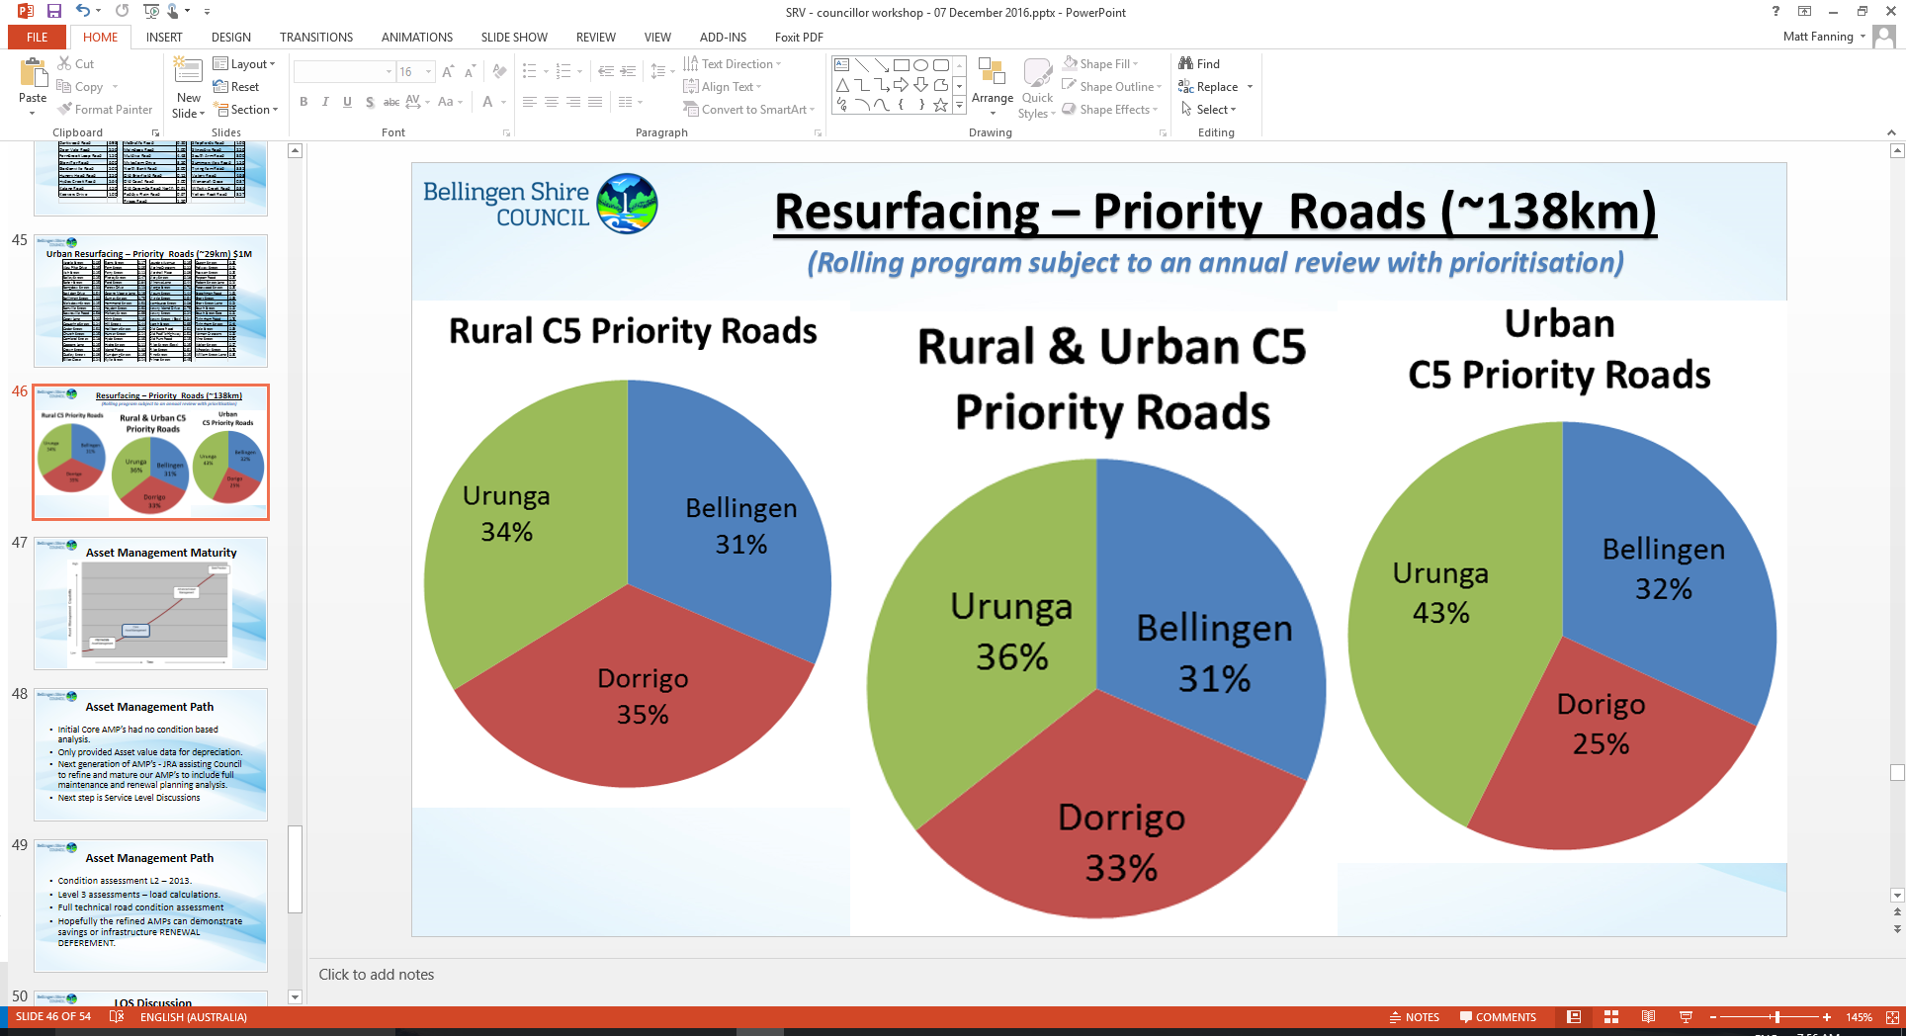

Revenue generated from a proposed SRV of 4.5% (not including the rate peg of 1.5%) for 2017/18 is approximately $310,000 and will be used to undertake a targeted road resurfacing program of works with a key focus on renewing condition 5 classified sealed road pavements, that is, those roads rated as very poor as first priority (refer to Attachment M). This is based on the following:

* Limited grant funding is available for resurfacing road renewal projects
* While extremely competitive, funding to support timber bridge works is available
* A regional initiative is underway with the intention of applying for funding to the Building Better Regions Fund for bridge infrastructure. For Bellingen, it is anticipated that this will involve 10 bridges valued at approximately $9M
* If work is not undertaken to resurface the road network as a priority, it is at risk of needing full reconstruction exponentially increasing the cost of works
* The proposed SRV for 2017/18 will enable the resurfacing program of works to be completed sooner than later minimising the risk of accelerated deterioration of the sealed road network

Without the SRV, the asset consumption is significantly greater than the rate of asset renewal. Whilst the SRV will not entirely address this issue, it affords Council the opportunity to manage asset depletion. In addition, it provides increased opportunity to seek external funding, e.g., through matching grants, and to continue to address the shortfall/backlog. Other internal cost saving measures that will continue to be undertaken over the coming financial years will also enable Council to divert more future funds to asset renewal. The LTFP includes a $300,000 cost saving for the 2017/18 financial year.

The required resurfacing renewal investment demonstrates that Council will have significantly lower opportunities to be financially sustainable in the longer term without the SRV. This is also supported by IPART in their original ‘Fit for the Future’ assessment that states, *“The council has limited options to improve its financial position and relies on the successful application for and adoption of a special rate variation from 2016-17 of 69% cumulative over 9 years (44% above the rate peg)”.*

While Council, over the last couple of years, has undertaken a series of reviews and assessments including significant improvements through cost containment strategies (refer to Section 7 of this application), the NSW Office of Local Government, in its reassessment of Council’s ‘Fit for the Future’ proposal in December 2016, stated that *Council was determined ‘Fit for the Future’. This determination is conditional on Council delivering on its planned strategies, one being the application of a 6% SRV over a 7 year basis.*

## Key purpose of special variation

At the highest level, indicate the key purpose(s) of the proposed special variation by marking one or more of the boxes below with an “x”.

|  |  |
| --- | --- |
| Maintain existing services |  |
| Enhance financial sustainability |  |
| Environmental services or works |  |
| Infrastructure maintenance / renewal |  |
| Reduce infrastructure backlogs |  |
| New infrastructure investment |  |
| Other (specify) |  |

You should summarise below the key aspects of the council’s application, including the purpose and the steps undertaken in reaching a decision to make an application.

Roads are vital transport infrastructure that connect and support our communities. Local government has been subject to rate pegging for 39 years and, as a consequence, the majority of councils in NSW are suffering from an infrastructure backlog, meaning that they have not been in a position to generate sufficient income to renew their infrastructure in a timely fashion.

The essence for a SRV is based on the need to address the backlog in transport infrastructure, specifically the sealed road network.

Bellingen Shire Council is responsible for maintaining, renewing and improving 598km roads valued at approximately $275M. From the most recent full comprehensive condition assessment undertaken of its transport infrastructure it has been determined that the Council needs to invest approximately $8 Million in sealed roads resurfacing over the next 10 years. This investment will address all current sealed road pavements with a condition score of 3 – (fair) to 5 - (very poor).

To quantify the investment quantum, the sealed roads network requires an investment of $6.07M to renew 202 km of rural sealed roads and an investment of $1.96M to renew 57 km of urban sealed roads. This total required investment will renew 76% of the rural sealed roads network and 55% of the urban sealed roads network. This can also be depicted as follows.

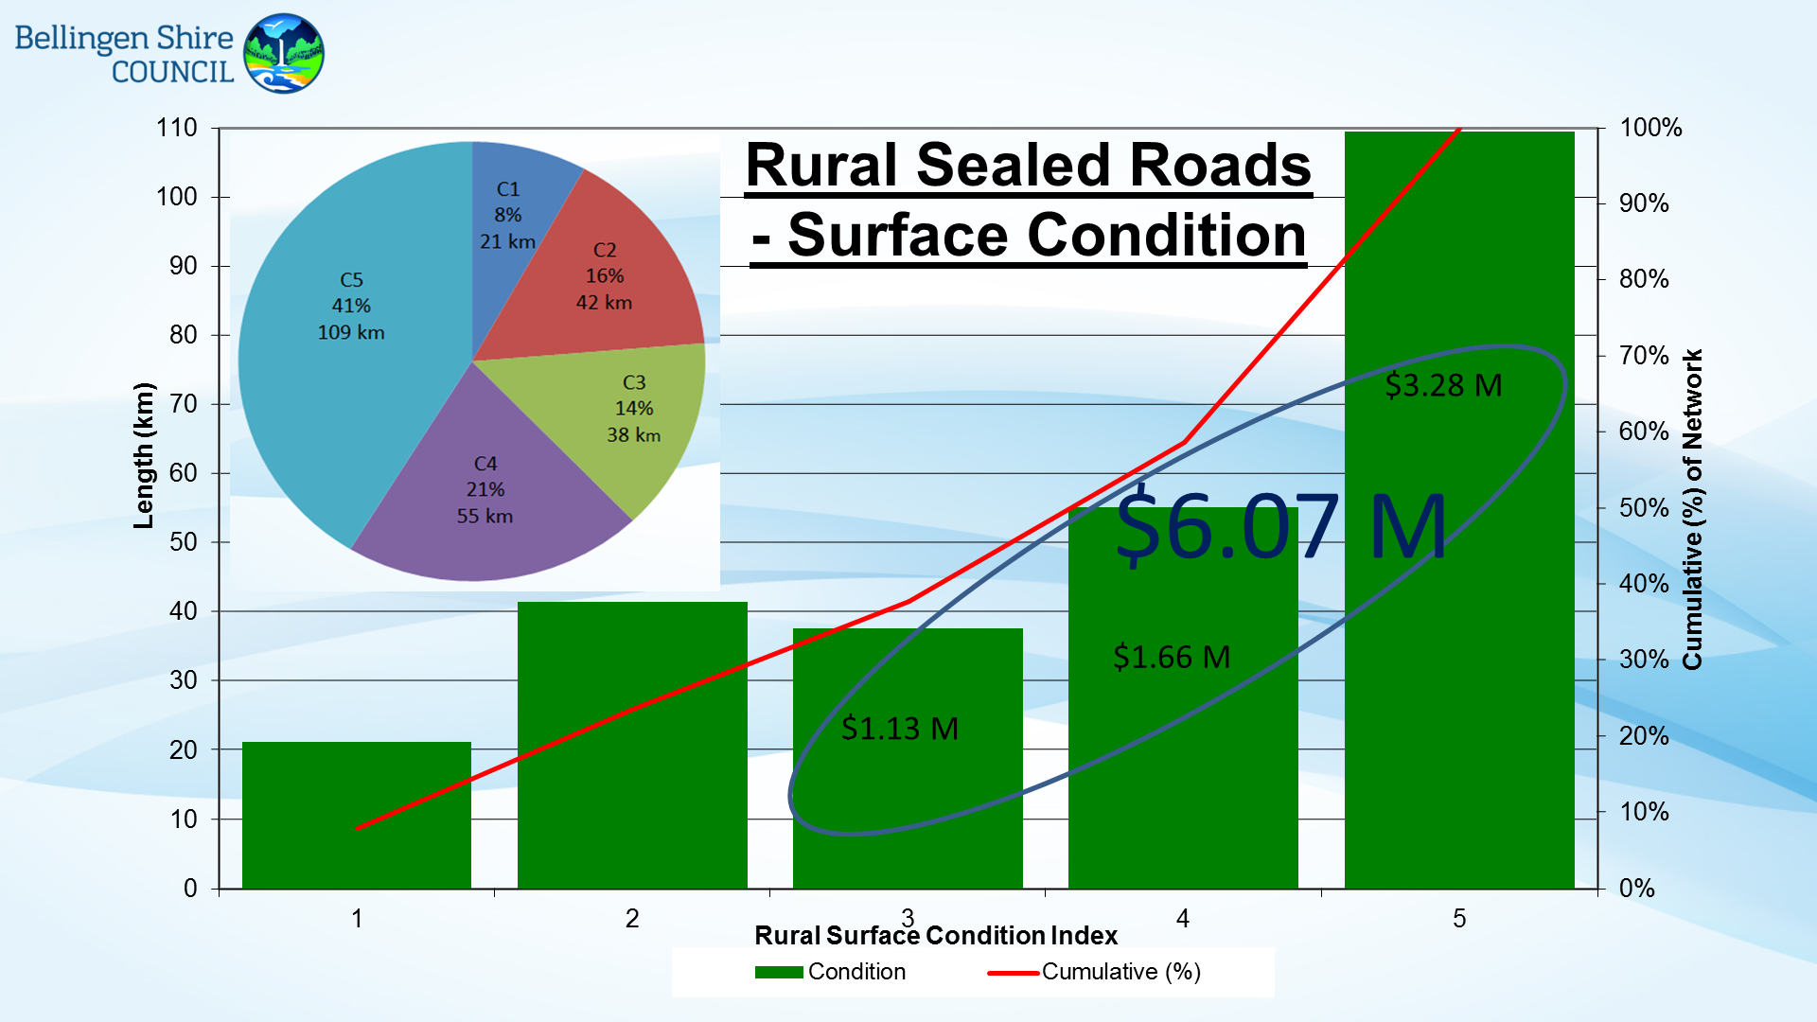

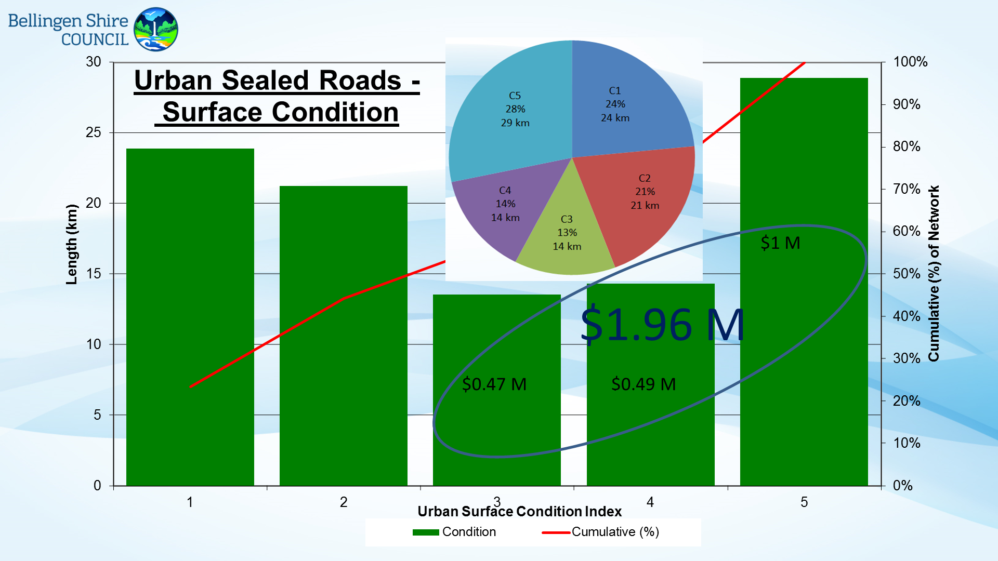

It should be noted that, as with all rolling capital works programs, priorities are reassessed annually as part of the annual budget process.

The Delivery Program (see Attachment D) captures the need for investment in road and bridge infrastructure in the section *What’s new about this version of the Delivery Program (page 4)* as the following excerpts shows:

|  |
| --- |
| *The first version of the Delivery Program for the 2012-2016 Council was originally adopted in June 2013. This revised Delivery Program is an update with an emphasis on addressing the backlog in relation to Transport (road and bridge) infrastructure. The backlog for roads and bridges stood at $12.9m at the end of 2012/13 and is on an upward trend. In addition Council is currently revising its Asset Management Plan for roads and bridges to better reflect the current conditions of our transport infrastructure. Bellingen Shire Council is not alone in this situation as councils across NSW face infrastructure backlogs. A Local Government Infrastructure Audit undertaken by the Division of Local Government estimated the size of the NSW backlog to be $7.4b in 2012.*  *In 2012 Council conducted a Community Satisfaction survey using a random fixed line telephone poll of 400 residents. Key findings from the survey were that the community rated road and bridge maintenance as areas of high importance and low satisfaction, and that were Council to receive a hypothetical unrestricted grant, the preferred option was to see it spent on road improvements.*  *Bellingen Shire manages over $0.5 Billion in assets of which its transport infrastructure forms a significant component. Council has embarked on the implementation of advanced asset management practices including a risk based maintenance management system and full technical analysis of its timber bridges and road pavements. These systems will drive modern best value for money decision making processes. This information has been used to develop the current LTFP.*  *The condition assessment of the sealed road network has just been completed. One of the most significant findings from these assessments is that the condition of the rural sealed road network is well below satisfactory. It has identified that $6.07M is required to be spent over the next 10 years to renew the rural roads sealed pavement surface and that an additional $1.96M is required for the same period for urban streets. This represents a total sealed pavement resurfacing renewal investment of $8.03M.*  *In addition to the sealed road network a number of other road improvement projects have been identified through staff assessment or via community feedback. These include road seal extension projects, drainage improvements, urban road improvement, and retaining wall replacements. As a consequence of the foregoing, a community engagement process commenced in September 2016 in relation to the imperative need for increased capital expenditure, specifically for investment in transport (road and bridge) infrastructure works, improving Council’s current financial position, and options for funding works through a special rate variation.*  ***Page 5 also states:***  *A community satisfaction survey was undertaken in September 2016, the results of which have been subject to briefings to both the 2012-16 and 2016-20 Councils. A consequent series of focus groups was undertaken which saw local asset infrastructure discussed as a focal point and in particular:*   * *The condition of local roads* * *The perceived lack of a well-publicised, long term infrastructure repair plan* * *Themes of discontent regarding the state of local roads* * *A perception of reactivity rather than proactivity around asset management* * *Many participants felt that improved roads and bridges were a huge priority* |

The Delivery Program details the proposed LTFP to address the roads and bridges infrastructure challenges - one of which is the resurfacing of the sealed road network. Council has provided as Attachment N a map of the Shire that outlines the proposed sealed roads resurfacing program of works. Refer also to Attachment M – the rural and urban condition 5 roads list.

Council’s need to invest in road infrastructure is also captured in the LTFP in the section 4. Revenue Forecasts under the heading of Special Rate Variation (page 14) as follows:

|  |
| --- |
| ***Section 4***  *Council continues to address its infrastructure priorities and intends to apply for a 6% SRV in 2017/18. The forecast income generated will allow Council to attend to urgent road resurfacing works that has been both assessed and prioritised. This will also allow a greater focus on the strategic management of its infrastructure while putting steps in place to ensure that any renewal requirements are addressed.*  *5.6. Asset Management*  *Infrastructure (assets) expenditure will progressively be mapped against maintenance and renewal programs recommended by respective asset management plans. In accordance with Council’s asset management review, asset maintenance has been increased by CPI with a strong focus on asset renewals as opposed to construction of new assets.*  *Subject to successful special rate variations and subsequent loan borrowings, assets should be maintained and renewed in accordance with the respective asset management plans and agreed condition intervention levels.*  *The 10 Year Asset Management Capital Works Program focuses on the renewal of Council’s infrastructure and effective management of Council’s plant and vehicles. The capital works listing in the annexures are based on a consolidated position (as per Attachment 19 [in the LTFP]). Council is currently integrating the full 10 year capital program into Council’s relevant Asset Management Plans.* |

**Council’s Financial Position**

In 2013, NSW Treasury Corporation provided a Financial Sustainability Rating (FSR) of moderate with a negative outlook. The LTFP provides a summary of the NSW Treasury Corporation Report on pages 7 - 8.

Whilst Council considers its short to medium position sound, the NSW Treasury Corporation report confirms that Council needs to reduce expenditure and/or increase revenue to ensure its long term financial sustainability. Council has made, and will continue to achieve, significant outcomes in terms of cost containment, efficiency and productivity savings. Details on cost containment are included in the DP in the section entitled *What will Council be doing to improve productivity?* (pages 8 - 10). These initiatives (outlined in pages 29-33 of the 8 February Extraordinary Council Meeting – refer to Attachment Q) are around detailed analysis and deep rooted change some of which has already been undertaken with other programs of work to continue. There is however an immediate imperative for investment in road infrastructure.

Securing a Special Rate Variation for investment in transport infrastructure will result in reduced whole of life costs by facilitating intervention at the appropriate points in the asset lifecycle. This will have the effect over the medium to long term of moving expenditure from reactive maintenance to proactive preventative asset management activities. Additional revenue raised, in excess of the rate peg of 1.5%, will go towards infrastructure renewal works, specifically, Council’s sealed roads resurfacing program. This along with other organisational sustainability strategies will assist Council to move towards generating necessary income to assist in the renewal of its infrastructure on an ongoing basis. This will further enable Council to continue to address its deficit and move to an improved position of financial and infrastructure sustainability.

Notwithstanding the foregoing, Council has seen a steady improvement in operating result over the past few years. This is due to a range of initiatives that Council has undertaken including, in more recent years, those commitments in its Fit for the Future (FFF) submission(s).

Importantly Councils overall operating result has improved from a deficit of $9M in 2014 to a deficit of $0.9M in 2016, a net decrease of $8.1M.

Significant achievements impacting the improvement in results have included:

* Special Rate Variation 2014
* Revaluation of Roads, Bridges, Footpaths and Drainage
* Derecognition of Rural Fire Service assets
* Review of fees and charges
* Achievement of Fit for the Future expenditure reduction commitments
* Staffing initiatives including monitoring staff overtime and leave liabilities
* Increase in Roads and Maritime Services state road works
* Shift in operational works to capital works
* Introduced a number of energy efficiency initiatives

## Capital expenditure review

You should complete this section if the council intends to undertake major capital projects that are required to comply with the OLG’s Capital Expenditure Guidelines, as outlined in OLG Circular 10-34. A capital expenditure review is required for projects that are not exempt and cost in excess of 10% of council’s annual ordinary rates revenue or $1 million (GST exclusive), whichever is the greater.

A capital expenditure review is a necessary part of a council’s capital budgeting process and should have been undertaken as part of the Integrated Planning and Reporting requirements in the preparation of the Community Strategic Plan and Resourcing Strategy.

|  |  |  |
| --- | --- | --- |
| Does the proposed special variation require council to do a capital expenditure review in accordance with OLG Circular to Councils, Circular No 10-34 dated 20 December 2010 | Yes | No |
| If *Yes*, has a review been done and submitted to OLG? | Yes | No |

# Assessment Criterion 1: Need for the variation

Criterion 1 in the OLG Guidelines is:

*The need for, and purpose of, a different revenue path for the council’s General Fund (as requested through the special variation) is clearly articulated and identified in the council’s IP&R documents, in particular its Delivery Program, Long Term Financial Plan and Asset Management Plan where appropriate. In establishing need for the special variation, the relevant IP&R documents should canvass alternatives to the rate rise. In demonstrating this need councils must indicate the financial impact in their Long Term Financial Plan applying the following two scenarios:*

* *Baseline scenario – General Fund revenue and expenditure forecasts which reflect the business as usual model, and exclude the special variation, and*
* *Special variation scenario – the result of implementing the special variation in full is shown and reflected in the General Fund revenue forecast with the additional expenditure levels intended to be funded by the special variation.*

*Evidence to establish this criterion could include evidence of community need /desire for service levels/projects and limited council resourcing alternatives.*

*Evidence could also include the assessment of the council’s financial sustainability conducted by the NSW Treasury Corporation.*

The response to this criterion should summarise the council’s case for the proposed special variation. It is necessary to show how the council has identified and considered its community’s needs, as well as alternative funding options (to a rates rise).

The criterion states that the need for the proposed special variation must be identified and clearly articulated in the council’s IP&R documents especially the Long Term Financial Plan and the Delivery Program, and, where appropriate, the Asset Management Plan. The purpose of the proposed special variation should also be consistent with the priorities of the Community Strategic Plan.

## Case for special variation - community need

Summarise and explain below:

* How the council identified and considered the community’s needs and desires in relation to matters such as levels of service delivery and asset maintenance and provision.
* How the decision to seek higher revenues above the rate peg was made and which other options were examined, such as changing expenditure priorities or using alternative modes of service delivery.
* Why the proposed special variation is the most appropriate option: for example, typically other options would include introducing new or higher user charges and/or an increase in council loan borrowings, or private public partnerships or joint ventures.
* How the proposed special variation impacts the Long Term Financial Plan forecasts for the General Fund and how this relates to the need the council identified. Our assessment will also consider the assumptions which underpin the council’s Long Term Financial Plan forecasts.

In addressing this criterion, you should include extracts from, or references to, the IP&R document(s) that demonstrate how the council meets this criterion.

**Need for a Special Rate Variation**

The community’s needs and desires in relation to service delivery and asset maintenance and provision relevant to the SRV application are clearly identified in the 2016 Customer Satisfaction Survey (see Attachment H) and Council’s recently completed condition assessments of the sealed road network.

These drivers provided the basis for recommendations to Council in December 2016 including further engagement with the community on the need to invest in transport infrastructure, specifically the sealed road network.

Section 2 of this application addresses the need for a SRV from an asset management perspective. Set out below is a detailed response in relation to community need and opinion.

**Satisfaction Survey**

The community satisfaction survey was a random and representative telephone survey of 400 local residents to measure their satisfaction with Council service levels. It was completed in late 2016. Relevant extracts are appended to this report. Residents were asked to contribute to a series of questions including:

* Satisfaction with and importance of key services and facilities
* Overall satisfaction with Council
* Contact with Council
* Council website
* Perception of safety
* Overnight visitors

The report highlighted the following:

* The highest mentioned priority for future Council resourcing was sealed roads at 41%
* Sealed roads was also highlighted as the greatest shortfall i.e. least satisfied
* In terms of their overall satisfaction with Council’s performance, 26% of respondents declared themselves satisfied against 36% dissatisfied and the balance neutral
* Among the eight facilities and services scoring less than or equal to the neutral ranking both unsealed and sealed roads as well as weed control scored poorly and a fraction higher than development applications and business development/new investment.

The following figure which is extracted from the survey results highlights the position of sealed roads as high importance but low satisfaction.



The following figure which is extracted from the survey results indicates that ‘everything is considered important’ based on the mean importance score of 2.83 (out of a possible 5).

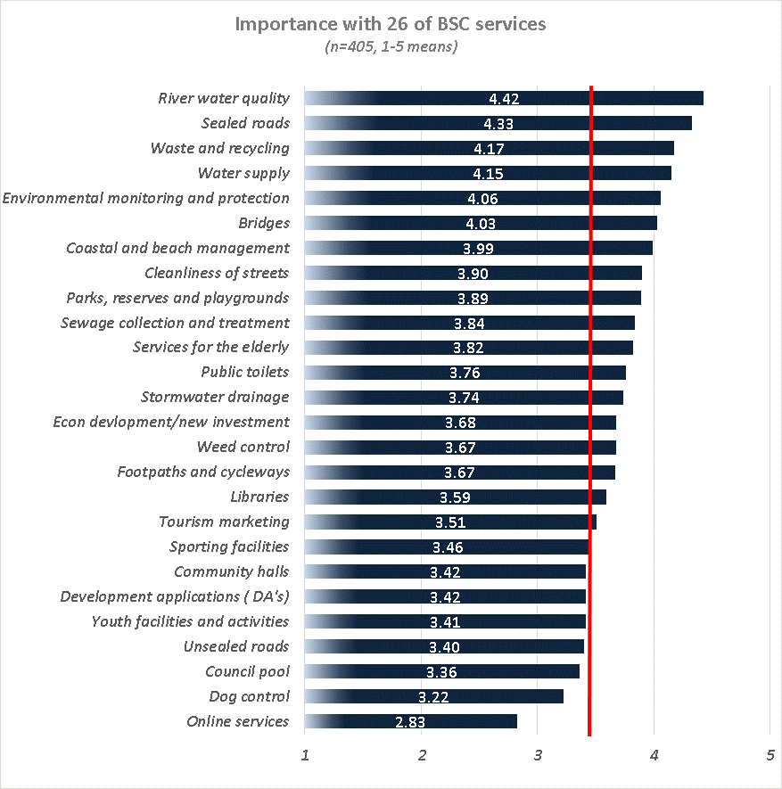

This demonstrates a community expectation that Council will continue to deliver a broad range of services to the community. This raises challenges around service delivery and the potential opportunity cost of the delivery of those services.

The following figure which is extracted from the survey results regarding rates and charges addresses the perceived cost to the community. 5% of respondents state that rates and charges are too high.

The following figure which is extracted from the survey results outlines satisfaction in terms of service provision.



The following figure which is extracted from the survey results outlines which three services are believed to be the most important in terms of allocating Council resources.

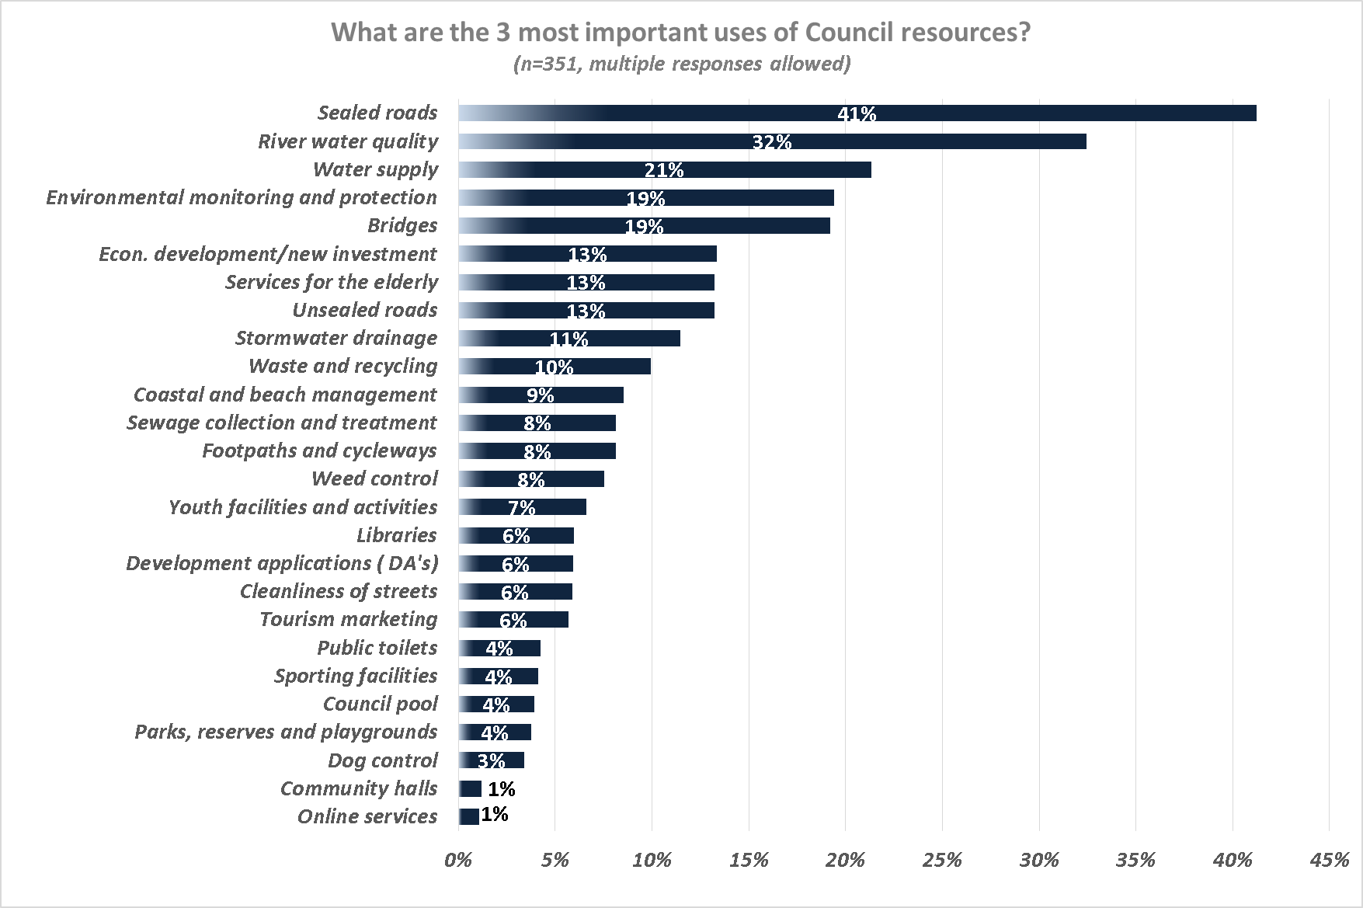

**Online Self-Completion Survey**

As a component of the engagement process, an online self-selecting survey was posted on the Council website and available for completion from the middle to the end of January 2017.

This opportunity for resident feedback was promoted as follows:

* Council's website
* Community drop in forums in Dorrigo, Bellingen and Urunga
* Letterbox drops
* Newspaper ads
* Media releases
* Fact sheets
* Council SRV Information centre
* Stakeholder forums

Both the December 2016 and February 2017 Council reports outlined community engagement, needs and priorities in relation to page 4 of the Delivery Program as follows:

|  |
| --- |
| *In 2012, Council conducted a Community Satisfaction survey using a random fixed line telephone poll of 400 residents. Key findings from the survey were that the community rated road and bridge maintenance as areas of high importance and low satisfaction, and were Council to receive a hypothetical unrestricted grant, the preferred option was to see it spent on road improvements.*  *Bellingen Shire manages over $0.5 Billion in assets of which its transport infrastructure forms a significant component.*  *Council has embarked on the implementation of advanced asset management practices including a risk based maintenance management system and full technical analysis of its timber bridges and road pavements. These systems will drive modern best value for money decision making processes. This information has been used to develop the current LTFP.*  *The condition assessment of the sealed road network has just been completed. One of the most significant findings from these assessments is that the condition of the rural sealed road network is well below satisfactory. It has identified that $6.07M is required to be spent over the next 10 years to renew the rural roads sealed pavement surface and that an additional $1.96M is required for the same period for urban streets. This represents a total sealed pavement resurfacing renewal investment of $8.03M.*  *In addition to the sealed road network a number of other road improvement projects have been identified through staff assessment or via community feedback. These include road seal extension projects, drainage improvements, urban road improvement, and retaining wall replacements. As a consequence of the foregoing, a community engagement process commenced in September 2016 in relation to the imperative need for increased capital expenditure, specifically for investment in transport (road and bridge) infrastructure works, improving Council’s current financial position, and options for funding works through a special rate variation.* |

Specifically, the Delivery Program provides background on the community’s needs on page 5 in the section *What’s new about this version of the Delivery program*, as follows:

|  |
| --- |
| *Engagement activities will continue until February 2017 and include community forums in each town as well as a forum with the business community, a web-based Special Rate Variation Information Centre, fact sheets, responses to community questions and submissions via fact sheets and FAQ’s, media releases, a resident mail-out and customer survey.*  *Two funding options for addressing the transport infrastructure renewal program will be canvassed during the phases one and two of the community engagement program:*   1. *The 1.5% state government determined rate peg increase* 2. *A 6% SRV increase (rate peg + 4.5%)*   *This report outlines a program of engagement with our residents to include:*   * *Community drop in forums in Dorrigo, Bellingen and Urunga* * *Mail out to all residents* * *Newspaper ads* * *Media releases* * *Fact sheets* * *Water notification inserts* * *Community newsletters* * *Council SRV Information Centre* * *Focus groups* * *Stakeholder forums* * *Documentation on public exhibition* * *Questions and Answers*   *Results of the 2013 survey confirm priorities identified in the 2012 Community Satisfaction survey, that is, that roads and bridges are important services with low satisfaction. The most recent survey indicates that sealed roads, unsealed roads, and bridges were the top three infrastructure areas deserving more funding and the least preferred areas for reduced funding.*  *Council has an adopted Community Engagement Strategy and Framework that forms the basis of the development of a specific community engagement plan for the SRV.*  *A community satisfaction survey was undertaken in September 2016, the results of which have been subject to briefings to both the 2012-16 and 2016-20 Councils. A consequent series of focus groups was undertaken which saw local asset infrastructure discussed as a focal point and in particular:*   * *The condition of local roads* * *The perceived lack of a well-publicised, long term infrastructure repair plan* * *Themes of discontent regarding the state of local roads* * *A perception of reactivity rather than proactivity around asset management* * *Many participants felt that improved roads and bridges were a huge priority* * *Council will continue with the community engagement program until February 2017.* |

**Cost containment productivity and efficiency measures**

Council, in resolving to support the option for a 6% SRV in December 2016, considered the following:

* The need and purpose of a SRV in relation to the infrastructure works required to be undertaken and current financial forecasts
* Community feedback and sentiment
* The community’s capacity to pay
* The impact on affected ratepayers
* The proposed Delivery Program and Long Term Financial Plan
* Productivity improvements
* Cost containment strategies

In considering the above, Council resolved to adopt two options for a General Rate Increase (1.5% rate peg and 6% SRV).

While the view of Council is that revenue from a SRV of 6% will assist Council to move towards generating necessary income to assist in the renewal of its infrastructure on an ongoing basis, it also acknowledges and has considered the view of the community in that Council should be looking to efficiencies and cost containment strategies to assist in funding the road infrastructure program. Council’s commitment to efficiencies and cost containment is outlined in Section 7, Criterion 5 of this application. Council will continue with its financial sustainability strategies to realise greater efficiencies and cost savings. Council’s adopted LTFP models a $300K operational cost reductions/savings commencing in 2017/18 and continued throughout the LTFP in order to improve Council’s infrastructure.

## Financial sustainability

The proposed special variation may be intended to improve the council’s underlying financial position for the General Fund, or to fund specific projects or programs of expenditure, or a combination of the two. We will consider evidence about the council’s current and future financial sustainability and the assumptions it has made in coming to a view on its financial sustainability.

You should explain below:

* The council’s understanding of its current state of financial sustainability, its long-term projections based on alternative scenarios and assumptions about revenue and expenditure.
* Any external assessment of the council’s financial sustainability (eg, by auditors, NSW Treasury Corporation). Indicate how such assessments of the council’s financial sustainability are relevant to supporting the decision to apply for a special variation.
* The council’s view of the impact of the proposed special variation on its financial sustainability.

**Financial Sustainability**

In 2013, the NSW Government engaged NSW Treasury Corp (TCorp) to undertake a financial capacity and sustainability review of all NSW councils. The review considered the councils’ financial performance against a range of benchmarks, looking at councils’ borrowing capacity and their financial sustainability. To be considered financially sustainable, councils had to show that they had sufficient revenue to deliver the level of services that the communities expect. The outcome was that each council was provided with a Financial Sustainability Rating (FSR) and financial outlook.

Bellingen Shire Council received a FSR rating of moderate and an outlook of negative. This meant that Council has adequate capacity to meet its financial commitments in the short to medium term, and acceptable capacity in the longer term. However, the negative rating means that Council’s financial position could deteriorate in the future unless it takes steps to improve its sustainability.

In its review, TCorp made the following observations of Bellingen Shire Council:

* *Council’s Unrestricted Current Ratio had been well above benchmark for the previous four years, indicating sufficient liquidity;*
* *BSC had operating deficits for the previous four years, and forecasted operating deficits into the future;*
* *High reliance on grants, not sustainable without grants;*
* *Forecast capital expenditure was insufficient to cover the cost of forecast asset renewals;*
* *No additional borrowing capacity in the short to medium term;*
* *A high number of flood events had negatively affected BSC’s operating expenses and ability to renew its assets;*
* *High infrastructure backlog with an increasing trend*.

For councils assigned with a negative outlook, TCorp provided some recommendations and areas of investigations to assist in improving the sustainability position. The recommendations include:

* *The need to source additional revenue, such as by a Special Rate Variation (SRV);*
* *For councils with sufficient borrowing capacity, to consider using debt funding to reduce infrastructure backlogs;*
* *Devising programs and strategies to contain costs and improve efficiencies;*
* *Further improvements in Asset Management Plans and integration into the Long Term Financial Plan;*
* *Increasing spending on maintenance and infrastructure renewal while balancing this with the need for capital expenditure on new assets.*

In response to the TCorp Review, Council has already undertaken a broad range of initiatives to address the issues, including:

* Successfully secured a Special Rate Variation in 2014 of which achievements include:
  + Contribution to road maintenance - $400,000
  + 1 major bridge and 1 culvert renewal - $660,000
  + 16km of shape correction/bitumen sealing - $630,000
  + 61km gravel resheeting/heavy formation grading - $300,000
  + Total investment - $1,990,000
* Reviewed user fees and charges
* Conducted several organisational reviews to improve organisational efficiency
* Ongoing review of assets and depreciation
* Ongoing reviews of services
* Established the Financial Sustainability Program Board (FSPB)
* Commenced shared services reviews with Nambucca and Kempsey Shire councils

These measures are variously factored into the IP&R documents and Fit for the Future initiatives.

**Service Reviews**

Bellingen Shire Council recognises the opportunities to increase efficiency and improve financial sustainability through shared services and alliancing and the opportunities that this process presents. Bellingen Shire Council is currently partnering with Nambucca Shire Council and Kempsey Shire Council in this regard, with the process underpinned by a MoU that has been endorsed by all three councils. In addition, it is anticipated that other regional initiatives previously undertaken within the Mid North Coast Region of Councils will continue. By way of example, a joint training initiative has resulted in savings across the region. For Bellingen, the saving was approximately $70,000. Further opportunities will also be pursued over time through participation in Joint Organisations.

The implementation of a service review program across Council is delivering enhanced efficiency and effectiveness, improved productivity, and identified savings. The outcomes are formally captured through Council’s Financial Sustainability Program Board which reports to the SRVIPP Committee.

An overview of the service review program is as follows.

Completed:

* Organisational structure - Financial Services, Operations, Environmental & Planning, Customer Service
* Weed management, swimming pools, bridge maintenance and repairs, roads maintenance, waste management, ranger services, fees and charges, library scanning (RFID) project, plant review, land rationalisation

Underway:

* IT hardware review
* Public conveniences
* Water/Sewer review
* Asset maintenance management system (Reflect)
* Building rationalisation
* Property Review

**Shared Services and Alliancing**

Council is also collaborating with Kempsey Shire Council regarding the replacement of its corporate IT system. The objective is to improve processes and information flow and importantly, to enable automation across a range of Council’s functions to further support the service review process.

A Signed a memorandum of understanding with Nambucca Shire Council and Kempsey Shire Council is in place to facilitate shared servicing and alliancing. This process is underway with the initial key review processes currently under active analysis.

Council has identified a range of initiatives that are forecast to deliver improved efficiencies and reduced costs. The MIDROC Shared Services KPMG report offers projections and opportunities of up to $2 million explicit to Bellingen Shire Council that our modelling has not specifically factored in. Notwithstanding that, as savings are realised, they will be operationalised through future long term financial plan documentation.

Each of the above measures has been factored into the LTFP.

**Fit for the Future Assessment**

Four years of discussion with the State Government has resulted in the local government reform process. This encapsulates a number of different undertakings including a series of reviews and, in particular, the Fit for the Future program in which Bellingen Council was assessed against the Fit for the Future ratios.

These ratios are underpinned by modelling which incorporates the generation of additional income above the rate peg. This was factored into the 2016/17 LTFP as well as the revised IP&R documents that were placed on public exhibition during December 2016 and January 2017. The proposed SRV is based on commitments within the IP&R documents and Council’s Fit for the Future reassessment which states that *Council was determined ‘Fit for the Future’. This determination is conditional on Council delivering on its planned strategies, one being the application of a 6% SRV over a 7 year basis.*

**Council’s Future Sustainability**

TCorp’s financial assessment and the Fit for the Future analysis articulates Council’s challenges in terms of having the required level of revenue to meet expenditure requirements into the future.

In order to be financially sustainable for the long term, Council continues to endeavour to balance its need to maximise its revenue with the principles of fairness and equity as outlined in the Community Strategic Plan, also known as the Community Vision. Refer to Section 3.3 Financial Indicators and Section 7 Productivity and Cost Containment.

The long term objective in terms of financial sustainability is for operating revenue to cover operating expenditure, including the cost of maintenance and renewal of its assets. This is the underlying premise of the Fit for the Future modelling as reflected in Council’s LTFP.

The current LTFP was prepared with the following objectives in mind:

* Maintaining a fair and equitable rating, fees and charges structure;
* Creating pricing structures that effectively address the economic cost of providing the service whilst not precluding community members access to essential services because of individual economic circumstances
* Allocating resources that achieves maximum result in meeting Community Vision goals and objectives;
* Achieving a strong asset management position;
* Long term financial sustainability;
* Moving towards achieving a minimum break even operating result in the ‘general fund’ by 2024

Council continues to address its infrastructure priorities and applying for a 6% SRV in 2017/18 is one step within Council’s overall financial strategy. The securing of a SRV will enable investment in transport infrastructure resulting in reduced whole of life costs by facilitating intervention in the asset lifecycle when necessary. This will have the effect over the medium to long term of moving expenditure from reactive maintenance to proactive preventative maintenance activities.

Council continues to make progress in improving its asset management processes and financial modelling, through the IP&R framework, to better understand future financial and infrastructure needs. Council will continue to engage with the community on service levels and acceptable infrastructure conditions.

Council’s LTFP is provided in Attachment E.

## Financial indicators

How will the proposed special variation affect the council’s key financial indicators (General Fund) over the 10-year planning period? Please provide, as an addendum to the Long Term Financial Plan, an analysis of council’s performance based on key indicators (current and forecast) which may include:

* Operating balance ratio excluding capital items (ie, net operating result before capital grants and contributions as percentage of operating revenue before capital grants and contributions).
* Unrestricted current ratio (the unrestricted current assets divided by unrestricted current liabilities).
* Rates and annual charges ratio (rates and annual charges divided by operating revenue).
* Debt service ratio (principal and interest debt service costs divided by operating revenue excluding capital grants and contributions).
* Broad liabilities ratio (total debt plus cost to clear infrastructure backlogs as per Special Schedule 7 divided by operating revenue).
* Asset renewal ratio (asset renewals expenditure divided by depreciation, amortisation and impairment expenses).

**Financial Indicators**

Council understands that if it is to achieve its ‘Fit for the Future’ commitments it must arrest the decline in the Shire’s $0.5 billion worth of assets and improve its financial capacity to fund infrastructure asset renewal and maintenance. Further to this, Council realises that, at a fundamental level, improving its financial sustainability into the future means ensuring its operating revenues cover operating expenditure over the long term.

As detailed in the financial indicators below, the Council achieves a financially responsible surplus operating balance by 2023/24. This result means operating revenues are forecast to sufficiently cover operating expenditure putting Council in a much stronger position to address infrastructure renewal and maintenance requirements.

As part of the LTFP, Council modelled two different scenarios. The scenarios tested as part of the modelling process are:

• Model 1 – Service Levels Maintained

• Model 2 – Service Levels Reduced

**Model 1 – Service Levels Maintained**

‘Model 1’ is the base model used and subsequently adopted by Council. This model assumes a permanent 6% per year SRV across all categories in years 2017/18 – 2023/24. The scenario also models a $300K operational cost reductions/savings (commencing 2017/18), continued throughout the LTFP in order to improve Council’s infrastructure.

**Model 2 – Service Levels Reduced**

The purpose of ‘Model 2’ is to model the impact on Council’s financial position if Council was not to include any new SRV over the life of LTFP, i.e. increase rates by the annual rate peg limit only. This model incorporates a permanent SRV that commenced in the 2014/15 financial year to fund road improvements and maintenance, as well as infrastructure programs. This scenario also models a $1.5M operational cost reductions/savings in 2016/17 continued throughout the LTFP in order to improve Council’s infrastructure.

Model 1 is the preferred model adopted by Council as part of its resubmission to the Office of Local Government in July 2016 in response to the Fit for the Future (FFF) program.

The proposed SRV has a positive impact on each of the key FFF ratios as evidenced in the table below, particularly the Operating Performance Ratio and the Asset Renewal Ratio. As the proposed SRV for 2017/18 is based on a larger strategy of returning Council to an operating surplus, the ratios shown in the table below include the future forecast SRV’s as per Model 1 above. Council will assess the need for future rate variations on a year by year basis taking into account growth in the number of rateable properties, other financial sustainability strategies (as outlined in its FFF submission) and importantly, the impact of the local government legislation reforms.

The proposed 6% SRV generates $310,752 (exclusive of the 1.5% rate peg) in the first year. This initial infrastructure investment will provide a small improvement to the Operating Performance Ratio of just over 1.5%. The Building and Infrastructure renewal ratio is also impacted, increasing the ratio by almost 6% in the first year.

The below table shows the forecast ratios for Council’s general fund and the audited 2015/16 results against the 7 FFF ratios:



The roll-on effect of the SRV, along with other financial sustainability strategies, will contribute to Council returning to an operating surplus with additional revenue able to be apportioned to the renewal of vital community infrastructure, in particular, the extensive sealed road network.

## Contribution plan costs above the cap

You should complete this section if the proposed special variation seeks funding for contributions plan costs above the development contributions cap. Otherwise, leave this section blank.

Please explain how the council has established the need for a special variation to meet the shortfall in development contributions.

For costs above the cap in contributions plans, a council must provide:[1]

* a copy of the council’s section 94 contributions plan
* a copy of the Minister for Planning’s response to IPART’s review and details of how the council has subsequently amended the contributions plan
* details of any other funding sources that the council is proposing to use, and
* any reference to the proposed contributions (which were previously to be funded by developers) in the council’s planning documents (eg, Long Term Financial Plan and Asset Management Plan AMP.

|  |
| --- |
| Not applicable |

# Assessment criterion 2: Community awareness and engagement

Criterion 2 in the Guidelines is:

*Evidence that the community is aware of the need for and extent of a rate rise. The Delivery Program and Long Term Financial Plan should clearly set out the extent of the General Fund rate rise under the special variation. The council’s community engagement strategy for the special variation must demonstrate an appropriate variety of engagement methods to ensure community awareness and input occur. IPART’s fact sheet includes guidance to councils on the community awareness and engagement criterion for special variations.*

Our fact sheet on the requirements for community awareness and engagement is available on the IPART website.[2]

In responding to this criterion, the council must provide evidence that:

* it has consulted and engaged the community about the proposed special variation using a variety of engagement methods and that the community is aware of the need for, and extent of, the requested rate increases
* it provided opportunities for input and gathered input/feedback from the community about the proposal, and
* the IP&R documents clearly set out the extent of the requested rate increases.

In assessing the evidence, we will consider how transparent the engagement with the community has been, especially in relation to explaining:

* the proposed cumulative special variation rate increases including the rate peg for each major rating category (in both percentage and dollar terms)
* the annual increase in rates that will result if the proposed special variation is approved in full (and not just the increase in daily or weekly terms)
* the size and impact of any expiring special variation (see Box 4.1 below for further detail), and
* the rate levels that would apply without the proposed special variation.

More information about how the council may engage the community is to be found in the Guidelines, the IP&R manual and our fact sheet.

|  |
| --- |
| Box 4.1 Where a council is renewing or replacing an expiring special variation |
| The council’s application should show how you have explained to its community:  There is a special variation due to expire at the end of the current financial year or during the period covered by the proposed special variation. This needs to include when the expiring special variation was originally approved, for what purpose and the percentage of (General Fund) general income originally approved.  The corresponding percentage of general income that the expiring special variation represents for the relevant year.  Whether the temporary expiring special variation is being replaced with another temporary or a permanent increase to the rate base.  The percentage value of any additional variation amount, above the rate peg, for which the council is applying through a special variation.  If the proposed special variation was not approved (ie, only the rate peg applies), the year-on-year change in rates would be lower, or that rates may fall.  The council also must attach, to its application to IPART, a copy of the Instrument of Approval that has been signed by the Minister or IPART Chairman. |
|  |

## The consultation strategy

The council is required to provide details of the consultation strategy undertaken, including the range of methods used to inform and engage with the community about the proposed special variation and to obtain community input and feedback. The engagement activities could include media releases, mail outs, focus groups, statistically valid random or opt-in surveys, online discussions, public meetings, newspaper advertisements and public exhibition of documents.

The council is to provide relevant extracts of the IP&R documents that explain the rate rises under the proposed special variation and attach relevant samples of the council’s consultation material.

**Consultation and Engagement Strategy**

The Bellingen Shire Council Community Engagement Strategy, as adopted by Council at its Meeting 22 February 2012, outlines the approach Council takes towards engaging with our community. To address the requirements of Council’s Community Engagement Strategy and to meet the IPART assessment criteria, Council has engaged with our residents through a number of avenues including:

* Community drop in forums in Dorrigo, Bellingen and Urunga
* Letterbox drops
* Newspaper ads
* Media releases
* Fact sheets
* Water rates inserts
* Council SRV Information Centre
* Focus groups
* Stakeholder forums
* Online self-completion survey
* Documentation on public exhibition
* Question and Answer

This strategy provides a framework for engagement and consultation activities undertaken for the purpose of informing and consulting with our community regarding the proposed SRV.

The objectives of this strategy are:

* To inform the community of Council’s intention to apply for SRV
* To provide information regarding the impact on the community through the different rating categories
* To provide information regarding what the revenue generated by the special rate variation will be used for
* To provide information to the community regarding documentation on public exhibition
* To inform the community on how they can engage with Council during the period of consultation, including making a submission

**IP&R Documentation – Consultation Strategy**

As part of the planning process, Council modelled two different scenarios in the LTFP (pages 9-10). The scenarios tested as part of the modelling process are:

* Model 1 – Service Levels Maintained
* Model 2 – Service Levels Reduced

**2.1 Model 1 – Service Levels Maintained**

‘Model 1’ is the base model used throughout the LTFP and assumes a permanent 6% per year special rate variation across all categories in years 2017/18 – 2023/24. The scenario also models a $300K operational cost reductions/savings (commencing 2017/18), continued throughout the LTFP in order to improve Council’s infrastructure.

**2.2 Model 2 – Service Levels Reduced**

The purpose of ‘Model 2’ is to model the impact on Council’s financial position if Council was not to include any new special variation over the life of LTFP, i.e. increase rates by the annual rate peg limit only. This model incorporates a permanent special variation that commenced in the 2014/15 financial year to fund road improvements and maintenance, as well as infrastructure programs. This scenario also models a $1.5M operational cost reductions/savings in 2016/17 continued throughout the LTFP in order to improve Council’s infrastructure.

Table 4.1: Forecast Rate Increases

|  |  |  |
| --- | --- | --- |
| 2016/17 | 2017/18 – 2023/24 | 2024/25 Onwards |
| 1.80% | 6.0% | 2.5% |

Council further outlines in its LTFP (pages 13-14) the revenue forecasts that include a SRV.

|  |
| --- |
| ***Special Rate Variation*** |
| *In 2014, Council successfully applied for a Special Rate Variation (SRV) of 9.5% in addition to the rate pegging limit of 2.3%. The SRV was implemented to address the priority works in Council’s infrastructure i.e. major renewal works of Council’s road and bridge infrastructure. The SRV was accompanied by a successful application for a Local Infrastructure Renewal Scheme (LIRS) grant which provides a 3% loan interest rate subsidy from the Office of Local Government. Accordingly, a bank loan for $4.85 million was taken out in May 2015 at a rate of 3.75%, the repayments for which are funded by the SRV and LIRS subsidy. These funds are now being utilised for a major upgrade of road infrastructure in the Bellingen Shire.* |
|  |
| *Council continues to address its infrastructure priorities and intends to apply for a 6% SRV in 2017/18. The forecast income generated will allow Council to attend to urgent road resurfacing works that has been both assessed and prioritised. This will also allow a greater focus on the strategic management of its infrastructure while putting steps in place to ensure that any renewal requirements are addressed.* |

The LTFP also provides the following summary outlining the additional revenue generated in 2017/18 from the proposed SRV:

|  |  |
| --- | --- |
| **Option** | **Revenue Generated** |
| 6% (rate peg + 4.5%*) | $413,023 |

*\*For 2017-18, the rate peg has been set at 1.5% based on the change in the Local Government Cost Index (LGCI) and a consideration of a productivity factor.*

The increase in rate revenue has been apportioned to the different Council rating categories in the table below. This shows the average annual dollar increase in rates for each of our rating categories.

**Table 1: Rating Categories – Average Annual Dollar Increase**

|  |  |  |  |  |
| --- | --- | --- | --- | --- |
| **Rate Category** | **Weekly Increase 1.50%** | **Annual Increase 1.50%** | **Weekly Increase 6.00%** | **Annual Increase 6.00%** |
| **Business** | $0.28 | $14.36 | $1.10 | $57.45 |
| **Business - Bellingen** | $0.36 | $18.82 | $1.45 | $75.26 |
| **Business - Dorrigo** | $0.23 | $12.10 | $0.93 | $48.42 |
| **Business - Urunga** | $0.47 | $24.26 | $1.87 | $97.04 |
| **Farmland** | $0.69 | $35.91 | $2.76 | $143.62 |
| **Residential** | $0.29 | $15.08 | $1.16 | $60.31 |
| **Residential - Bellingen** | $0.26 | $13.56 | $1.04 | $54.24 |
| **Residential - Dorrigo** | $0.23 | $11.77 | $0.91 | $47.06 |
| **Residential - Mylestom** | $0.30 | $15.78 | $1.21 | $63.11 |
| **Residential - Rural** | $0.41 | $21.24 | $1.63 | $84.95 |
| **Residential - Urunga** | $0.29 | $14.91 | $1.15 | $59.63 |
|  |  |  |  |  |

\****Disclaimer:*** *The above information is based on the current rating structure. Future financial years may be subject to changes in the rating categories and 3 yearly land revaluations.* ***Please also note:*** *These figures do not include the emergency services levy estimates forecast to be introduced by the NSW Government on 1 July 2017.*

In addition to the general rate, Council also applies water, sewer and domestic waste charges to properties that access those services. Table 2 provides an example of the projected pricing for 2017/18 for residential properties.

**Note: Water pricing comprises an availability charge and a user charge.**

**Table 2: Projected Nett Rates for General Residential Properties**

|  |  |  |  |  |  |  |
| --- | --- | --- | --- | --- | --- | --- |
| **Average Typical Residential Rate** | **Estimate 2017/18**  **1.50% Increase** | **Weekly Increase 1.50%** | **Annual Increase 1.50%** | **Estimate 2017/18**  **6.00% Increase** | **Weekly Increase 6.00%** | **Annual Increase 6.00%** |
| Residential Ordinary | $917.54 | $0.26 | $13.56 | $958.22 | $1.04 | $54.24 |
| Water & Sewer - Annual Charge | $1,056.00 | $0.60 | $31.00 | $1,056.00 | $0.60 | $31.00 |
| Domestic Waste | $658.00 | $0.37 | $19.00 | $658.00 | $0.37 | $19.00 |
| **Total** | **$2,631.54** | **$1.23** | **$63.56** | **$2,672.22** | **$2.01** | **$104.24** |

\****Disclaimer:*** *The above information is based on the current rating structure. Future financial years may be subject to changes in the rating categories and 3 yearly land revaluations.* ***Please also note:*** *These figures do not include the emergency services levy estimates forecast to be introduced by the NSW Government on 1 July 2017.*

Council’s DP also outlines its engagement strategy and SRV options (page 5)

|  |
| --- |
| *Engagement activities will continue until February 2017 and include community forums in each town as well as a forum with the business community, a web-based Special Rate Variation Information Centre, fact sheets, responses to community questions and submissions via fact sheets and FAQ’s, media releases, a resident mail-out and customer survey.*  *Two funding options for addressing the transport infrastructure renewal program will be canvassed during the phases one and two of the community engagement program:*   1. *The 1.5% state government determined rate peg increase* 2. *A 6% SRV increase (rate peg + 4.5%)*   *This report outlines a program of engagement with our residents to include:*   * *Community drop in forums in Dorrigo, Bellingen and Urunga* * *Mail out to all residents* * *Newspaper ads* * *Media releases* * *Fact sheets* * *Water notification inserts* * *Community newsletters* * *Council SRV Information Centre* * *Focus groups* * *Stakeholder forums* * *Documentation on public exhibition* * *Questions and Answers*   *Results of the 2013 survey confirm priorities identified in the 2012 Community Satisfaction survey, that is, that roads and bridges are important services with low satisfaction. The most recent survey indicates that sealed roads, unsealed roads, and bridges were the top three infrastructure areas deserving more funding and the least preferred areas for reduced funding.*  *Council has an adopted Community Engagement Strategy and Framework that forms the basis of the development of a specific community engagement plan for the SRV.*  *A community satisfaction survey was undertaken in September 2016, the results of which have been subject to briefings to both the 2012-16 and 2016-20 Councils. A consequent series of focus groups was undertaken which saw local asset infrastructure discussed as a focal point and in particular:*   * *The condition of local roads* * *The perceived lack of a well-publicised, long term infrastructure repair plan* * *Themes of discontent regarding the state of local roads* * *A perception of reactivity rather than proactivity around asset management* * *Many participants felt that improved roads and bridges were a huge priority*   *Council will continue with the community engagement program until February 2017.* |

Samples of Council’s consultation materials is included in Attachment G

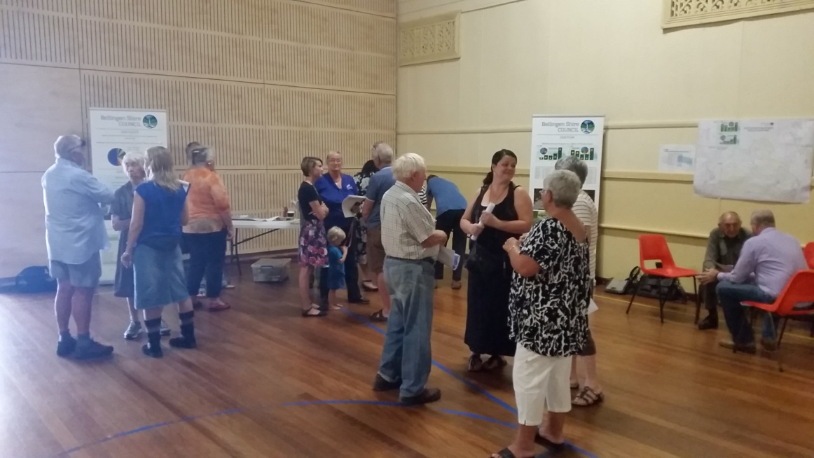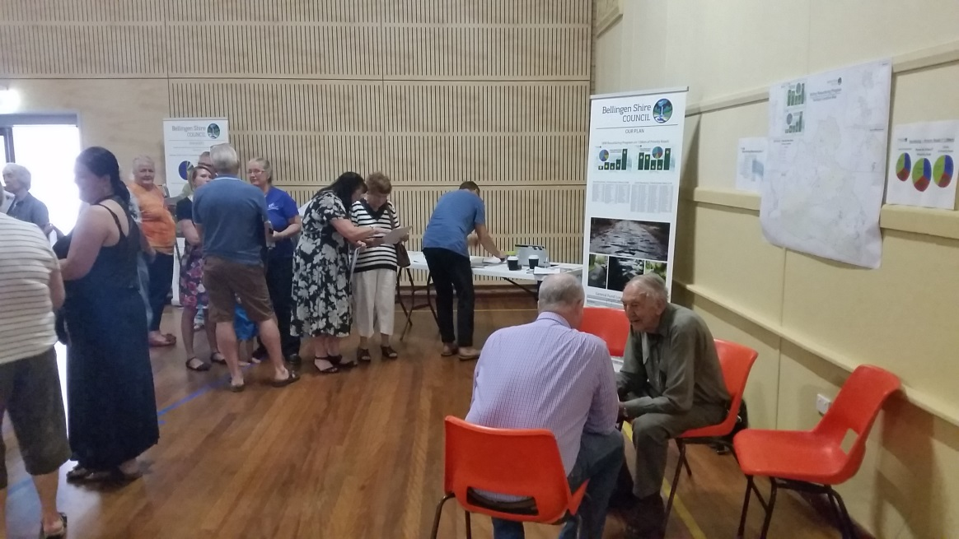

Photos of the Dorrigo community drop in sessions

## Feedback from the community consultations

Summarise the outcomes and feedback from the council’s community engagement activities. Outcomes could include the number of attendees at events and participants in online forums, as well as evidence of media reports and other indicators of public awareness of the council’s special variation intentions. Where applicable, provide evidence of responses to surveys, particularly the level of support for specific programs or projects, levels and types of services, investment in assets, as well as the options proposed for funding them by rate increases.

Where the council has received submissions from the community relevant to the proposed special variation, the application should set out the views expressed in those submissions. Please refer to Section 1.2 concerning how the council should handle confidential content in feedback received from the community. The council should also identify and document any action that it has taken, or will take, to address issues of common concern within the community.

**Community Engagement and Awareness**

The Bellingen Shire Council Community Engagement Strategy (Strategy), as adopted by Council at its Meeting on 22 February 2012, outlines the approach Council takes towards engaging with our community. The SRV engagement plan identifies specific community consultation activities as well as other communication initiatives for key stakeholders with the following objectives:

* To inform the community of Council’s intention to apply for SRV
* To provide information regarding the impact on the community through the different rating categories
* To provide information regarding what the revenue generated by the special rate variation will be used for
* To provide information to the community regarding documentation on public exhibition
* To inform the community on how they can engage with Council during the period of consultation, including making a submission

The key activities undertaken regarding the proposed SRV are as follows:

* Community drop in forums in Dorrigo, Bellingen and Urunga
* Letterbox drops
* Newspaper ads
* Media releases
* Fact sheets
* Water rates inserts
* Council SRV Information centre
* Focus groups
* Stakeholder forums
* Online self-completion survey
* Documentation on public exhibition
* Question and Answer

**Feedback**

Engagement was undertaken in three phases. Phases one and two included engagement with the community through the various mediums as outlined above. Phase three consisted of internal and some external engagement and predominantly focussed on receiving and acknowledging the information and feedback from phases one and two.

The following table outlines the three phases and activities undertaken in each.

| Engagement Activity | Phase 1 –  Dec 2016 | Phase 2 –  Jan 2017 | Phase 3 - Feb 2017 |
| --- | --- | --- | --- |
| Inform |  |  |  |
| Water rates pamphlet insert | x |  |  |
| Mail out to all residents |  | x |  |
| Notice/newspaper advertisement | x | x | x |
| Media Release/s | x | x | x |
| Community information sessions x 3 |  | x |  |
| Website SRV information page | x | x | x |
| Community newsletters |  |  | x |
| Mayor’s letter to residents |  |  | x |
| Consult |  |  |  |
| Online self-completion survey |  | x |  |
| Key stakeholder forums |  | x |  |
| Invite submissions | x | x |  |
| Public exhibition | x | x |  |

**Community Surveys**

The community’s needs and desires in relation to service delivery and asset maintenance and provision relevant to the SRV application are identified in the 2016 Customer Satisfaction Survey and Council’s recently completed condition assessments of the sealed road network.

These drivers provided the basis for recommendations to Council in December 2016 including further engagement with the community on the need to invest in transport infrastructure, specifically the sealed road network.

The community satisfaction survey was a random and representative telephone survey of 405 local residents to measure their satisfaction with Council service levels. It was completed in late 2016. Residents were asked to contribute to a series of questions including:

* Satisfaction with and importance of key services and facilities
* Overall satisfaction with Council
* Contact with Council
* Council website
* Perception of safety
* Overnight visitors

The report highlighted the following:

* The highest mentioned priority for future Council resourcing was sealed roads at 41%
* Sealed roads was also highlighted as the greatest shortfall i.e. least satisfied
* In terms of their overall satisfaction with Council’s performance, 26% of respondents declared themselves satisfied against 36% dissatisfied and the balance neutral
* Among the eight facilities and services scoring less than or equal to the neutral ranking, both unsealed and sealed roads as well as weed control scored poorly and a fraction higher than development applications and business development/new investment.

As outlined in Section 3: Need for the Variation, survey results highlight the following:

* The position of sealed roads is indicated as high importance but low satisfaction
* That ‘everything is considered important’
* Sealed roads are believed to be the most important in terms of allocating Council resources
* Only 5% of respondents state that rates and charges are too high

This demonstrates a community expectation that Council will continue to deliver a broad range of services to the community. This raises challenges around service delivery and the potential opportunity cost of the delivery of those services.

It is considered that the foregoing demonstrates the need for Council to continue to progress its plan to invest in its resurfacing program of work that a SRV will assist in realising. It also supports the need for Council and the community to consider a SRV as well as ongoing engagement around service provision priorities in the context of service cost and overall willingness to pay for such services.

As a component of the SRV engagement process and to further understand findings from the community survey, focus groups were carried out and an on line self-completion survey made available to residents.

**Self-Completion Survey**

As a component of the engagement process, an online self-selecting survey was posted on the Council website and available for completion from the middle to the end of January 2017.

This opportunity for resident feedback was promoted as follows:

* Council's website
* Community drop in forums in Dorrigo, Bellingen and Urunga
* Letterbox drops
* Newspaper ads
* Media releases
* Fact sheets
* Council SRV Information centre
* Stakeholder forums

43 responses were received (representing 0.7% of ratepayers) and the key findings are as follows:

1. Given the self-selecting (i.e. opt-in) nature of the online methodology and small sample size (n=43), the results of this survey are not considered to be representative of community opinion. Rather they should be viewed solely as the views of those who chose to take the time to complete the survey. Specifically, within these results, there is evidence of some disgruntled residents participating. This is highlighted by unusually high dissatisfaction ratings with Council overall, high levels of opposition to the proposed special rate variation, and comments questioning their general trust in Council.
2. All of the respondents were rate payers and represented a cross section of ages (63% were aged 50-69 years). The sample was over represented by rural property owners (42% rural, 29% urban, 26% mixed and 3% did not indicate) and males (54% male against 28% female, with 18% preferring not to state gender).
3. Residents participating in the online survey claimed to be well informed regarding the SRV with 95% saying they had read the SRV fact sheet and/or other information supplied by Council.
4. Satisfaction ratings with council’s services (mean rating):



1. Comparing these results to the equivalent results from the 400-person random sample survey conducted 2016, indicates similar average satisfaction scores for libraries (4.17 satisfaction mean in the 2016 survey), tourism services (3.07), and unsealed roads (2.38). However the online respondents were significantly less satisfied than the 2016 random sample in respect to the other equivalent services, and general satisfaction with Council
2. One in five (21%) of those completing the survey supported the proposed SRV, with 79% opposed.
3. Of those opposed to an SRV, 34 residents cited cost.
4. The remainder of those opposed cited other reasons which centered around their view of Council and use of ratepayer funds around cost savings, prioritisation of current expenditure, staffing, leadership, cost containment etc.
5. In terms of willingness to pay, if funds were specifically allocated to ongoing improvements to the local sealed road network, three in five respondents stated nothing. Of the remaining residents 14% were willing to contribute an additional $40 or less, and 12% said they would be prepared to pay between $41 and $80 per year.
6. Intention to attend the SRV drop-in sessions (running concurrently with the survey) were mixed, with two in five not planning to attend (38%), one in five unsure (19%) and the remaining two in five planning to attend one of the sessions.
7. Additional commentary included concerns regarding affordability, service delivery, guarantees regarding where the funds would be spent, staffing, work practices and dissatisfaction with management of road maintenance.

12 Other commentary included specific feedback regarding Darkwood road as follows:

‘Very happy to pay more rates to get better roads. Our road (Darkwood Rd) is disgraceful beyond Chrysalis School. Summervilles Road should be sealed for its entire length and it would be great to see improvements to the roads between Glennifer and Bonville’.

**Feedback to Documents on Exhibition**

Council invited submissions to the IP&R documents on exhibition during December 2016 and January 2017 and proactively sought to engage with the community during the consultation process.

The engagement process is outlined in detail in section 4.1 of this application. The issue was broadly promoted and involved:

* Community drop in forums in Dorrigo, Bellingen and Urunga
* Letterbox drops
* Newspaper ads
* Media releases
* Fact sheets
* Water rates inserts
* Council SRV Information Centre
* Focus groups
* Stakeholder forums
* Online self-completion survey
* Documentation on public exhibition

The community drop in sessions played an integral role in the consultation strategy and saw around 100 people attend. Council was particularly active in engaging with the community at the drop in sessions and was proactive in making sure as many community views, needs and expectations were recorded with feedback forms provided to, or completed for, participants. This was done in an endeavour to conduct genuine engagement with residents attending a session.

Council utilised a number of reference tools to ensure the community was provided with detailed information including:

* The proposed SRV
* How the revenue generated would be invested
* The cost relative to rating categories
* The specific program of work that would be undertaken including specific roads
* How the SRV would benefit the broader community.

The reference tools used included:

* Large banners
* Maps showing the road resurfacing program down to individual roads and priorities
* Factsheets
* Financial statements
* Feedback forms

Council also prepared key messages regarding comparisons with other and neighbouring councils that assisted in responding to questions raised at these sessions.

A register of submissions was developed and included feedback from all avenues of consultation including online, written, community drop in forums and Council’s email address.

98 submissions were received across all mediums and are broken down as follows:

* 19 - Formal
* 6 - Generalised responses
* 73 - Drop in sessions

Of the 98 SRV submissions received and registered, 73 were proactively sought by Councillors and staff during the face to face consultation at the community drop in sessions. Copies of the feedback received is provided in Attachments H.

Other unrelated concerns and issues raised were also recorded and will be addressed and responded to in accordance with Council’s Customer Service Management Policy and procedures.

It is considered that the submissions and feedback received whilst addressing issues affiliated with the proposed SRV do not warrant amendments to the IPR documents on exhibition. Further, it is also considered that the various issues raised have been addressed in the extensive documentation that has been produced and publicly available in the matter including previous reports to Council, SRV fact sheets, letterbox drops, newspaper ads, media releases, water rates inserts, Council SRV Information centre, detailed information provided at the drop in sessions, Council’s annual report and annual statements.

In the context of the foregoing, feedback from all submissions provided a number of views with respect to the proposed SRV.

Of the opposition submissions that were made regarding the SRV, many reflected factors outside of Council’s control, including:

* The need to rate National Parks and State Forests
* The NSW Government should support the cost for local roads and bridges
* Realistic (land) values set by Valuer General
* Historical issues from previous councils
* Financial assistance grants need to be increased
* Rate pegging

Comments were received regarding Council internal costs and administration including:

* The perception that there are too many staff compared to other councils
* Staff are paid too much
* Cutting Council jobs would free up more funds to go towards fixing roads and bridges
* The disparity between townships in terms of rate categories
* Mis-management of funds

Other comments generally included:

* The impact on pensioners as a result of the increase
* Too much money taken up in administration
* Other neighbouring council comparisons
* Council inefficiency

There were also neutral and positive responses for the proposed SRV including:

* Long term maintenance a priority for our roads
* Council’s roads and bridges need work
* Not unopposed to a rate rise
* No opinion at this stage
* Extra money going to roads and not on administration

Every opportunity to seek information and feedback from the community to ensure a complete picture is established when presenting information has been taken. Further to the above, other engagement outcomes, in summary, include:

* There are 6028 rateable properties within the Bellingen Local Government Area
* Council received 98 responses to the exhibition and engagement process. Of these, 19 were submissions and 6 were generalised comments. The balance was actively solicited by Council at the Drop in Sessions held in January in Dorrigo, Bellingen and Urunga
* There were 43 responses to the online survey.
* There were 84 hits on Council’s website in response to an article relating to the Drop in Sessions
* There were 142 hits on the Council’s website on the IP&R documents on exhibition
* There were 207 hits on the online SRV Information Centre
* There were 14 media articles published
* There were 13 advertisements including a letter from the Mayor to residents.
* There were 9 letters to the editor

Copies of feedback and consultation/engagement activities as part of the overall SRV engagement strategy are available in Attachments G and H.

# Assessment criterion 3: Impact on ratepayers

Criterion 3 in the Guidelines is:

*The impact on affected ratepayers must be reasonable, having regard to both the current rate levels, existing ratepayer base and the proposed purpose of the variation. The Delivery Program and Long Term Financial Plan should:*

* *clearly show the impact of any rises upon the community*
* *include the council’s consideration of the community’s capacity and willingness to pay rates and*
* *establish that the proposed rate increases are affordable having regard to the community’s capacity to pay.*

The impact of the council’s proposed special variation on ratepayers must be reasonable. To do this, we take into account current rate levels, the existing ratepayer base and the purpose of the proposed special variation. We also review how the council has assessed whether that the proposed rate rises are affordable having regard to the community’s capacity and willingness to pay.

## Impact on rates

Much of the quantitative information we need on the impact of the proposed special variation on rate levels will already be contained in Worksheet 5a and 5b of Part A of the application.

To assist us further, the application should set out the rating structure under the proposed special variation, and how this may differ from the current rating structure, or that which would apply if the special variation is not approved.

We recognise that a council may choose to apply an increase differentially among categories of ratepayers. If so, you should explain the rationale for applying the increase differentially among different categories and/or subcategories of ratepayers, and how this was communicated to the community. This will be relevant to our assessment of the reasonableness of the impact on ratepayers.

Councils should also indicate the impact of any other anticipated changes in the rating structure.

**Impact on the Rating Structure**

The proposed SRV is to be applied equally to all categories of the ordinary rate.  Council considers that, as the variation is intended to be utilised for transport infrastructure across the whole Local Government Area and will benefit all road users, the cost should be distributed proportionately to all ratepayers.

As outlined to Councillors at a briefing session on 24 January 2017, Bellingen has received a general re-valuation for the coming 2017/2018 financial year and has based revenue forecasts for the proposed SRV on the land values to take effect from 1 July 2017.  The re-valuation resulted in an overall average increase to rateable land values of 13%. The re-valuation has resulted in significant variations across the Shire with average increases of up to 34% in some segments to as low as 1% in other segments.

In adopting the most equitable structure that minimises the impact of these large fluctuations in land values and fairly attributing the 6% SRV across the Shire, Council will model a number of scenarios for consideration along with a formal public exhibition period prior to the adoption of the Operational Plan and Revenue Policy for 2017/18.

Council’s current rate structure comprises an ad valorem amount together with base amount in order to achieve an equitable distribution of rates and minimise excessive fluctuations.

Please refer to Part A of the application for further information on the impact of the proposed variation on the different rate categories and subcategories.

**Table 1: Rating Categories – Average Annual Dollar Increase**

|  |  |  |  |  |
| --- | --- | --- | --- | --- |
| **Rate Category** | **Weekly Increase 1.50%** | **Annual Increase 1.50%** | **Weekly Increase 6.00%** | **Annual Increase 6.00%** |
| **Business** | $0.28 | $14.36 | $1.10 | $57.45 |
| **Business - Bellingen** | $0.36 | $18.82 | $1.45 | $75.26 |
| **Business - Dorrigo** | $0.23 | $12.10 | $0.93 | $48.42 |
| **Business - Urunga** | $0.47 | $24.26 | $1.87 | $97.04 |
| **Farmland** | $0.69 | $35.91 | $2.76 | $143.62 |
| **Residential** | $0.29 | $15.08 | $1.16 | $60.31 |
| **Residential - Bellingen** | $0.26 | $13.56 | $1.04 | $54.24 |
| **Residential - Dorrigo** | $0.23 | $11.77 | $0.91 | $47.06 |
| **Residential - Mylestom** | $0.30 | $15.78 | $1.21 | $63.11 |
| **Residential - Rural** | $0.41 | $21.24 | $1.63 | $84.95 |
| **Residential - Urunga** | $0.29 | $14.91 | $1.15 | $59.63 |
|  |  |  |  |  |

\****Disclaimer:*** *The above information is based on the current rating structure. Future financial years may be subject to changes in the rating categories and 3 yearly land revaluations.* ***Please also note:*** *These figures do not include the emergency services levy estimates forecast to be introduced by the NSW Government on 1 July 2017.*

In addition to the general rate, Council also applies water, sewer and domestic waste charges to properties that access those services. Table 2 provides an example of the projected pricing for 2017/18 for residential properties.

**Note: Water pricing comprises an availability charge and a user charge.**

**Table 2: Projected Nett Rates for General Residential Properties**

|  |  |  |  |  |  |  |
| --- | --- | --- | --- | --- | --- | --- |
| **Average Typical Residential Rate** | **Estimate 2017/18**  **1.50% Increase** | **Weekly Increase 1.50%** | **Annual Increase 1.50%** | **Estimate 2017/18**  **6.00% Increase** | **Weekly Increase 6.00%** | **Annual Increase 6.00%** |
| Residential Ordinary | $917.54 | $0.26 | $13.56 | $958.22 | $1.04 | $54.24 |
| Water & Sewer - Annual Charge | $1,056.00 | $0.60 | $31.00 | $1,056.00 | $0.60 | $31.00 |
| Domestic Waste | $658.00 | $0.37 | $19.00 | $658.00 | $0.37 | $19.00 |
| **Total** | **$2,631.54** | **$1.23** | **$63.56** | **$2,672.22** | **$2.01** | **$104.24** |

\****Disclaimer:*** *The above information is based on the current rating structure. Future financial years may be subject to changes in the rating categories and 3 yearly land revaluations.* ***Please also note:*** *These figures do not include the emergency services levy estimates forecast to be introduced by the NSW Government on 1 July 2017.*

### Minimum Rates

The proposed special variation may affect ordinary rates, special rates and/or minimum rates.

As previously discussed, if the proposed special variation includes increasing minimum rates above the statutory limit, or is to apply a higher rate of increase to an existing minimum rate than to its other rates, it is not necessary for the council to also complete the separate Minimum Rates application form. However, this must be clearly identified and addressed in the special variation application.

|  |  |  |
| --- | --- | --- |
| Does the council have minimum Ordinary rates? | Yes | No |

If *Yes*, does the council propose to increase minimum Ordinary rates by:

The rate peg percentage

The special variation percentage

Another amount  Indicate this amount _____________

What will minimum Ordinary rates be after the proposed increase? _________

The council must explain how the proposed special variation will apply to the minimum rate of any ordinary and special rate, and any change to the proportion of ratepayers on the minimum rate for all relevant rating categories that will occur as a result.

You should also explain the types of ratepayers or properties currently paying minimum rates, and the rationale for the application of the special variation to minimum rate levels.

Not Applicable

## Consideration of affordability and the community’s capacity and willingness to pay

The council is required to provide evidence through its IP&R processes, and in its application, of how it assessed the community’s capacity and willingness to pay the proposed rate increases. This is to include an explanation of how the council established that the proposed rate rises are affordable for the community.

Evidence about capacity to pay could include a discussion of such indicators as SEIFA rankings, land values, average rates, disposable incomes, the outstanding rates ratio and rates as a proportion of household/business/farmland income and expenditure, and how these measures relate to those in comparable or neighbouring council areas.

As many of these measures are highly aggregated, it may also be useful to discuss other factors that could better explain the impact on ratepayers affected by the proposed rate increases, particularly if the impact varies across different categories of ratepayers.

We may also consider how the council’s hardship policy (see Section 5.3 below) might reduce the impact on socio-economically disadvantaged ratepayers.

**Community’s Capacity to Pay**

In consideration of making an application for a SRV, Council has considered the community’s capacity to pay based on the SEIFA Index of Advantage and Disadvantage, level of proposed increase and other cost indices. Given that many comparisons were made with neighbouring councils by respondents to the engagement process, the following information is provided.

Bellingen Shire’s SEIFA index, in comparison with some neighbouring councils, states Bellingen (950.1) has a higher capacity to pay compared to other like councils, e.g. Nambucca (900.0) that ranked higher in terms of their level of disadvantage. Kempsey also ranks higher with an Index of 879.7.

When comparing residential rates across neighbouring councils, Bellingen Shire ratepayers pay less on average. While each council uses different multiple rate categories, the following information outlines comparative differences across Bellingen, Nambucca, Coffs Harbour and Port Macquarie local government areas:

|  |  |  |  |  |
| --- | --- | --- | --- | --- |
|  | BELLINGEN | NAMBUCCA | COFFS HARBOUR | PORT MACQUARIE |
| Average Residential Rate | $903 (Bellingen township) | $912 (town) | $1,173 | $1,142 (defined as urban) |
| Average Business Rate | $1,254 (Bellingen CBD) | $2,265 (CBD) | $4,090 (non CBD) | $2,803 (defined urban) |

The above table also highlights that the comparative councils have higher business rates than Bellingen with Nambucca nearly twice as high and Coffs Harbour non CBD more than 3 times higher.

Further comparisons between the four councils indicate that farmland and sewer rates are higher but water is lower.

When comparing Bellingen Shire residential rates to Coffs Harbour, including 7 years of a 6% SRV, it should be noted that Bellingen Shire rates remain lower on average. It should be noted that this also does not include any future rate rises from Coffs Harbour.

The following table outlines the average general rates for both councils across a 10 year period inclusive of a 7 year 6% SRV for Bellingen.

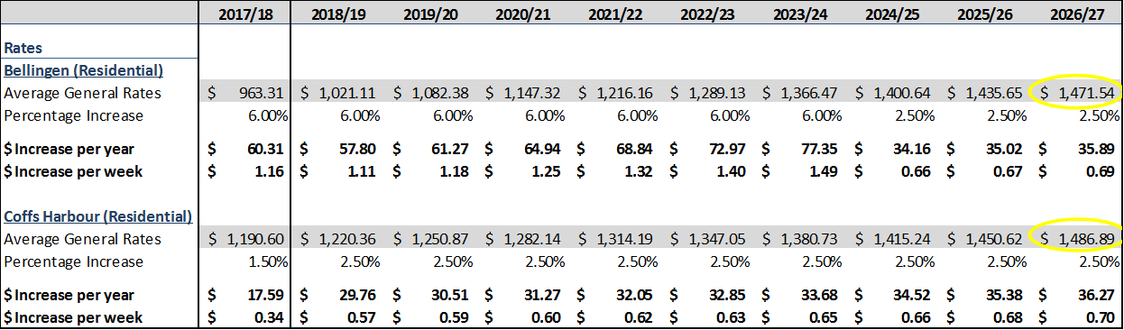

Council also considered the Bellingen Shire average weekly household income. The 2011 ABS Census Data states that 31.5% of Shire residents earn between $600 - $1,249 a week compared to the NSW Regional average of 27.1% and the Mid North Coast average of 30.8%.

Additional indicators, compared to neighbouring councils are as follows:

|  |  |  |  |
| --- | --- | --- | --- |
| **Data** | **Bellingen** | **Nambucca** | **Coffs Harbour** |
| **Unemployment** | **8%** | **13.3%** | **9.1%** |
| **Median Age** | **41** | **53** | **42** |
| **Owns home or in the process of being purchased** | **66.6%** | **58.7%** | **55.7%** |
| **Median mortgage repayment** | **$1,387 /mnth** | **$1,400 /mnth** | **$1,560 /mnth** |
| **Percentage of people renting** | **31.1%** | **35.7%** | **40.6%** |
| **Individual weekly income** | **$441** | **$371** | **$462** |

## Addressing hardship

In addition to the statutory requirement for pensioner rebates, most councils have a policy, formal or otherwise to address issues of hardship.

|  |  |  |
| --- | --- | --- |
| Does the council have a Hardship Policy? | Yes | No |
| If Yes, is an interest charge applied to late rate payments? | Yes | No |
| Does the council propose to introduce any measures to reduce the impact of the proposed special variation on specific groups in the community? | Yes | No |

You should attach a copy of the Hardship Policy and explain below who the potential beneficiaries are and how they are assisted.

Please provide details of any other measures addressing hardship to be adopted, or alternatively, explain why no measures are proposed.

The council is also to indicate whether the hardship policy or other measures are referenced in the council’s IP&R documents (with relevant page reference or extract provided).

Bellingen Council recognises that ratepayers may at times experience difficulty in paying rates and charges. Council has a Hardship Policy in place to provide assistance to ratepayers who are experiencing genuine difficulties with the payment of their rates and charges. The Hardship Policy (see Attachment I) was most recently adopted on 25 September 2013 and is reflected in Council’s IP&R Revenue Policy.

The NSW Local Government Act 1993 (LGA) gives Council the authority necessary to provide assistance to those ratepayers under the following sections of the LGA:

1. Section 564 of the LGA provides Council with the option to accept payment of rates and charges due and payable in accordance with an agreement made with BELLINGEN SHIRE COUNCIL – MINUTES – ORDINARY MEETING OF COUNCIL 25 SEPTEMBER, 2013 Page 14 of 75 the ratepayer and to write off or reduce interest accrued on rates and charges if the ratepayer complies with the agreement.
2. Section 567 of the LGA provides for Council to write off accrued interest on rates and charges payable by a ratepayer if, in Council’s opinion the reasons that the ratepayer was unable to pay the rates and charges when they became payable were beyond the ratepayer’s control, or that the ratepayer is unable to pay the accrued interest for reasons beyond that ratepayer’s control, or that the payment of the accrued interest would cause the ratepayer hardship.
3. Section 575 of the LGA provides for the granting of concession on rates and charges for eligible pensioners.
4. Section 601 of the LGA provides for ratepayers who incur a rate increase as a result of a revaluation of land to apply to Council for financial relief if the increase in the amount of rates payable will cause them substantial financial hardship.

The Hardship Policy requires ratepayers to be means tested and make an application for a formal payment arrangement. Once the payment arrangement has been finalised, Council may also remove any interest accrued should this contribute to any additional hardship.

As stated above, Council also provides concession on rates and charges for eligible pensioners. Bellingen Council has 24% of ratepayers that receive a pensioner concession on their rates. The following is an extract from Council’s Revenue Policy (page 5) that outlines the level of concession available to pensioners.

|  |
| --- |
| *Pensioner Rebates (Sec 575 NSW Local Government Act 1993)*  *Rebates are available to eligible pensioners who are solely or jointly liable for the payment of rates and charges. The pensioner must occupy the dwelling as their sole or principal place of living. The rebates are as follows:*   * *50% of the combined ordinary rates and domestic waste management charge up to a maximum rebate of $250.00.* * *50% of water charges up to a maximum rebate of $87.50.* * *50% of sewerage charges up to a maximum rebate of $87.50.*   *The pensioner rebate must be applied against the rate assessment or water billing account in the name of the ratepayer and not a Body Corporate or a Company, except where it is allowed by special agreement. The special agreement would cover circumstances such as where an applicant is the sole shareholder of the company that owns the property and the property is used as the applicants’ principal place of residence. The application must be approved by the General Manager.* |

# Assessment criterion 4: Public exhibition of relevant IP&R documents

Criterion 4 in the Guidelines is:

*The relevant IP&R documents must be exhibited (where required), approved and adopted by the council before the council applies to IPART for a special variation to its general revenue.*

Briefly outline the significant IP&R processes the council has undertaken to reach the decision to apply for a special variation. Include the details of and dates for key document revisions, public exhibition period(s) and the date(s) that the council adopted the relevant IP&R documents.[3]

You should also include extracts from council minutes as evidence that the documents were adopted.

The council is reminded that the Community Strategic Plan and Delivery Program (if amended), require public exhibition for at least 28 days prior to adoption. Amendments to the Long Term Financial Plan and Asset Management Plan do not require public exhibition.[4] However, it would be expected that the Long Term Financial Plan would be posted, in a prominent location, on the council’s website.

**Public Exhibition – IP&R Documents**

In consideration of making an application to IPART for a SRV to its general revenue, amendments were made to key IP&R documents. The following extracts outline these amendments reflective of the proposed SRV.

Specifically, the Delivery Program provides background on the community’s needs on pages 4 in the section *What’s new about this version of the Delivery program*, as follows:

|  |
| --- |
| *In 2012, Council conducted a Community Satisfaction survey using a random fixed line telephone poll of 400 residents. Key findings from the survey were that the community rated road and bridge maintenance as areas of high importance and low satisfaction, and were Council to receive a hypothetical unrestricted grant, the preferred option was to see it spent on road improvements.*  *Bellingen Shire manages over $0.5 Billion in assets of which its transport infrastructure forms a significant component.*  *Council has embarked on the implementation of advanced asset management practices including a risk based maintenance management system and full technical analysis of its timber bridges and road pavements. These systems will drive modern best value for money decision making processes. This information has been used to develop the current LTFP.*  *The condition assessment of the sealed road network has just been completed. One of the most significant findings from these assessments is that the condition of the rural sealed road network is well below satisfactory. It has identified that $6.07M is required to be spent over the next 10 years to renew the rural roads sealed pavement surface and that an additional $1.96M is required for the same period for urban streets. This represents a total sealed pavement resurfacing renewal investment of $8.03M.*  *In addition to the sealed road network a number other road improvement projects have been identified through staff assessment or via community feedback. These include road seal extension projects, drainage improvements, urban road improvement, and retaining wall replacements. As a consequence of the foregoing, a community engagement process commenced in September 2016 in relation to the imperative need for increased capital expenditure, specifically for investment in transport (road and bridge) infrastructure works, Council’s current financial position, and options for funding works through a special rate variation.* |

Additionally, the Delivery Program page 5 also states:

|  |
| --- |
| *Engagement activities will continue until February 2017 and include community forums in each town as well as a forum with the business community, a web-based Special Rate Variation Information Centre, fact sheets, responses to community questions and submissions via fact sheets and FAQ’s, media releases, a resident mail-out and customer survey.*  *Two funding options for addressing the transport infrastructure renewal program will be canvassed during the phases one and two of the community engagement program:*   1. *The 1.5% state government determined rate peg increase* 2. *A 6% SRV increase (rate peg + 4.5%)*   *This report outlines a program of engagement with our residents to include:*   * *Community drop in forums in Dorrigo, Bellingen and Urunga* * *Mail out to all residents* * *Newspaper ads* * *Media releases* * *Fact sheets* * *Water notification inserts* * *Community newsletters* * *Council SRV Information Centre* * *Focus groups* * *Stakeholder forums* * *Documentation on public exhibition* * *Questions and Answers*   *Results of the 2013 survey confirm priorities identified in the 2012 Community Satisfaction survey, that is, that roads and bridges are important services with low satisfaction. The most recent survey indicates that sealed roads, unsealed roads, and bridges were the top three infrastructure areas deserving more funding and the least preferred areas for reduced funding.*  *Council has an adopted Community Engagement Strategy and Framework that forms the basis of the development of a specific community engagement plan for the SRV.*  *A community satisfaction survey was undertaken in September 2016, the results of which have been subject to briefings to both the 2012-16 and 2016-20 Councils. A consequent series of focus groups was undertaken which saw local asset infrastructure discussed as a focal point and in particular:*   * *The condition of local roads* * *The perceived lack of a well-publicised, long term infrastructure repair plan* * *Themes of discontent regarding the state of local roads* * *A perception of reactivity rather than proactivity around asset management* * *Many participants felt that improved roads and bridges were a huge priority*   *Council will continue with the community engagement program until February 2017.* |

As part of the planning process, Council modelled two different scenarios in the LTFP (pages 9-10). The scenarios tested as part of the modelling process are:

|  |  |  |  |  |  |  |
| --- | --- | --- | --- | --- | --- | --- |
| * Model 1 – Service Levels Maintained * Model 2 – Service Levels Reduced   **2.1 Model 1 – Service Levels Maintained**  ‘Model 1’ is the base model used throughout the LTFP and assumes a permanent 6% per year special rate variation across all categories in years 2017/18 – 2023/24. The scenario also models a $300K operational cost reductions/savings (commencing 2017/18), continued throughout the LTFP in order to improve Council’s infrastructure.  **2.2 Model 2 – Service Levels Reduced**  The purpose of ‘Model 2’ is to model the impact on Council’s financial position if Council was not to include any new special variation over the life of LTFP, i.e. increase rates by the annual rate peg limit only. This model incorporates a permanent special variation that commenced in the 2014/15 financial year to fund road improvements and maintenance, as well as infrastructure programs. This scenario also models a $1.5M operational cost reductions/savings in 2016/17 continued throughout the LTFP in order to improve Council’s infrastructure.  Table 4.1: Forecast Rate Increases   |  |  |  | | --- | --- | --- | | 2016/17 | 2017/18 – 2023/24 | 2024/25 Onwards | | 1.80% | 6.0% | 2.5% | |

Council further outlines in its LTFP (pages 13-14) the revenue forecasts that include a SRV.

|  |  |  |  |  |  |  |  |  |  |  |  |  |  |  |  |  |  |  |  |  |  |  |  |  |  |  |  |  |  |  |  |  |  |  |  |  |  |  |  |  |  |  |  |
| --- | --- | --- | --- | --- | --- | --- | --- | --- | --- | --- | --- | --- | --- | --- | --- | --- | --- | --- | --- | --- | --- | --- | --- | --- | --- | --- | --- | --- | --- | --- | --- | --- | --- | --- | --- | --- | --- | --- | --- | --- | --- | --- | --- |
| The LTFP also provides the following summary outlining the additional revenue generated in 2017/18 from the proposed SRV:   |  |  | | --- | --- | | **Option** | **Revenue Generated** | | 6% (rate peg + 4.5%* | $413,023 |   *\*For 2017-18, the rate peg has been set at 1.5% based on the change in the Local Government Cost Index (LGCI) and a consideration of a productivity factor.*  The increase in rate revenue has been apportioned to the different Council rating categories in the table below. This shows the average annual dollar increase in rates for each of our rating categories.   |  |  |  | | --- | --- | --- | | **Rate Category** | **Weekly Increase 6.00%** | **Annual Increase 6.00%** | | Business | $1.10 | $57.45 | | Business - Bellingen | $1.45 | $75.26 | | Business – Dorrigo | $0.93 | $48.42 | | Business – Urunga | $1.87 | $97.04 | | Farmland | $2.76 | $143.62 | | Residential | $1.16 | $60.31 | | Residential - Bellingen | $1.04 | $54.24 | | Residential - Dorrigo | $0.91 | $47.06 | | Residential - Mylestom | $1.21 | $63.11 | | Residential - Rural | $1.63 | $84.95 | | Residential - Urunga | $1.15 | $59.63 | |  |  |  | |

\****Disclaimer:*** *The above information is based on the current rating structure. Future financial years may be subject to changes in the rating categories and 3 yearly land revaluations.* ***Please also note:*** *These figures do not include the emergency services levy estimates forecast to be introduced by the NSW Government on 1 July 2017.*

Council, in consideration of support for a 6% SRV in December 2016, considered the following:

* The need and purpose of a SRV in relation to the infrastructure works required to be undertaken and current financial forecasts
* Community feedback and sentiment
* The community’s capacity to pay
* The impact on affected ratepayers
* The proposed Delivery Program and Long Term Financial Plan
* Productivity improvements
* Cost containment strategies

Council, at its Ordinary December 2016 Meeting, resolved to place on public exhibition amended IP&R documents reflecting the proposed SRV including the LTFP and Delivery Plan. These documents were placed on exhibition for 47 days (more than 6 weeks). The exhibition period commenced on 15 December 2016 and closed on 31 January 2017. While the normal exhibition period requirement is 28 days, Council resolved to place the documents on exhibition for an additional 19 days to allow the community as much time as possible to engage with Council, particularly given the timeframe was over the Christmas and New Year period.

Council’s resolution of 14 December Meeting is as follows:

|  |
| --- |
| **Minute 142/16**  *That Council:*   1. *Notify the NSW Independent Regulatory and Pricing Tribunal of its intention to lodge an application for a Special Rate Variation for the 2017/18 Financial Year.* 2. *Undertake the community engagement initiatives outlined within this report inclusive of amendments to Council’s Integrated Planning & Reporting documentation (Delivery Program and Long Term Financial Plan) to support the Special Rate Variation application* 3. *Place on public exhibition the Integrated Planning & Reporting documents that articulate the special rate variation for a minimum period of six (6) weeks from 15 December*   *For: Cr King, Cr Klipin, Cr Harrison, Cr Jenkins, Cr Fenton and Cr WrightTurner. Against: Cr Carter* |

Council considered feedback received from the community from formal and informal submissions, community drop in sessions, the community satisfaction survey and other forms of engagement when deciding on whether to adopt a SRV for the 17/18 financial year (refer to section 7.4 of the Council report). In a report to the Extraordinary Meeting of Council on 8 February 2017, Council resolved to:

|  |
| --- |
| **MOVED (Cr Fenton/Cr Klipin)**  **That Council:**   1. Acknowledge the feedback received from the community during the community and public exhibition process. 2. Adopt the updated Long Term Financial Plan that includes the 6% Special Rate Variation 3. Adopt the updated Delivery Program that includes the 6% Special Rate Variation 4. Make application to the NSW Independent Regulatory and Pricing Tribunal for a single year permanent 6% Special Rate Variation, under S. 508(2) of the NSW Local Government Act 1993, for the 2017/18 Financial Year for the specific purpose of implementing and partly funding its sealed road resurfacing program, based on the contents of this report. 5. Express its concerns to the State and Federal government regarding the impact on our community, our roads and our bridges of non-rateable land, specifically national parks and state forests. 6. Make strong representations to the State and Federal Government in relation to payment of rates on land currently owned by the Crown, specifically State Forest and National Parks. 7. Make strong representations to both the State and Federal Government regarding the distribution of Financial Assistance Grants, seeking a revision of the principles imposed by the Federal Government with the overall objective of a revised method of distribution by the state based on need. 8. Make strong representations to relevant State and Federal government departments and local members of parliament in relation to income support to meet the essential needs (such as housing) of low income earners, such as pensioners.   **For: Cr King, Cr Klipin, Cr Harrison, Cr Fenton and Cr Wright-Turner.**  **Against: Cr Carter and Cr Jenkins.**    Meeting concluded 9.45am. |

# Assessment criterion 5: Productivity improvements and cost containment strategies

Criterion 5 in the Guidelines is:

*The IP&R documents or the council’s application must explain the productivity improvements and cost containment strategies the council has realised in past years, and plans to realise over the proposed special variation period.*

In this section, you must provide details of any productivity improvements and cost containment strategies that you have implemented during the last two years (or longer) and any plans for productivity improvements and cost containment over the duration of the proposed special variation.

These strategies, which may be capital or operational in nature, must be aimed at reducing costs and/or improving efficiency. Indicate if any initiatives are to increase revenue eg, user charges. Please include below whether the proposed initiatives (ie, cost savings) have been factored into the council’s Long Term Financial Plan.

Where possible, the council is to quantify in dollar terms the past and future productivity improvements and cost savings.

The council may also provide indicators of efficiency, either over time or in comparison to other relevant councils. We will make similar comparisons using various indicators and OLG data provided to us.

PRODUCTIVITY IMPROVEMENTS AND COST CONTAINMENT STRATEGIES

Council has worked extensively over the past few years to deliver a significant improvement in its operating result. This was reported to Council in conjunction with its 2015-16 Annual Report and subsequent 2016/17 report. The 2015/16 Financial Statement summary is provided at Attachment O. The result is due to a focus over the past five years on organisational reform, asset management and financial sustainability as well as Council’s Fit for the Future initiatives.

Council’s overall operating result has improved from a deficit of $9 million in 2014 to a deficit of $0.9 million in 2016. Council will continue to look for productivity improvements, efficiencies and cost containment strategies to assist in improving Council’s future financial sustainability.

**Organisational Review**

In accordance with the provisions of the NSW Local Government Act, Council must review their structure every 4 years and within 1 year of an election. Council undertook an extensive review of its structure in 2012. Work is again underway to review the organisational structure in the context of legislative requirements, but more importantly, to accommodate initiatives currently underway around financial sustainability, productivity and efficiency, service reviews, shared servicing alliancing, etc. This matter will be subject to briefings and reports to Council in quarters 2 and 3 of 2017.

**Governance Framework**

Community and Councillor engagement with regard to the 2014 SRV resulted in the development of a works enablement plan and a program identifying cost savings. Within the context of an overall governance framework, two programs were created:

* A Transport (Road and Bridge) Infrastructure Sustainability Program to implement the SRV rolling works program
* A Financial Sustainability Program to realise benefits from efficiency, productivity, and cost containment initiatives across Council

Both programs adopted a formal program management methodology with key processes for:

* Management Control
* Benefits Management
* Financial Management
* Stakeholder Engagement
* Risk Management
* Organisational Governance
* Resource Management

Council adopted a portfolio management approach to overseeing these and other programs through integration with, and enhancement of, Council’s existing IP&R Framework.

Currently all works emanating from the 2014 SRV are reported monthly. Notwithstanding that, Council will again put in place a governance arrangement to provide the necessary Council direction, oversight, and evaluation of the proposed 17/18 SRV works program. This will be subject to a future report to Council once the outcome of the SRV process is determined.

Noting the foregoing, the 10 year rolling LTFP in the Delivery Program will form the basis for the long term works program. The annual Operational Plan will incorporate detail on the shorter term works program.

The Delivery Program and Operational Plan have existing reporting periods and mechanisms that will facilitate reporting to Council and community without duplicating effort. The Operational Plan for works related to the proposed SRV will incorporate expanded data points for key performance indicators, goals (and progress), and milestones to satisfy the commitment to greater transparency and accountability.

Council is currently developing the next phase of the IP&R cycle and this will encompass SRV related works. This will be presented to Council for consideration prior to the commencement of the 2017/18 financial year.

**Financial Sustainability Program**

In November 2014, Council established the Financial Sustainability Program Board (FSPB) to develop a culture of efficiency, productivity as well as facilitating savings across the organisation by:

* Managing the Service Delivery Reform projects and assessing future options for service delivery reviews
* Initiating a shared servicing and alliancing program in partnership with Kempsey and Nambucca Shire Councils
* Managing projects related to enhanced funding (other than transport infrastructure), e.g. grant submissions, fees and charges review, land release
* Managing general savings and cost containment projects, e.g. property rationalisation and overdue rates recovery, employee oncost review

Since its inception, the FSPB has identified ongoing savings of over $400,000. These savings have enabled Council to redirect funds to transport infrastructure renewal projects.

In Council’s Fit for the Future re-submission, an operational saving of $300k was proposed in the Improvement Action Plan commencing in 2017/18. Council’s original Fit for the Future submissions proposed a $250k saving and this was realised through the implementation of:

* Review of print services
* Electricity consumption review
* Ranger services – shared alliance with Nambucca Council resulting in annual savings of $50,000
* Human resource initiatives:
  + Reduce Lost Time Injury (LTI) resulting in a reduction in Workers Compensation of 28% for the 14/15 financial year
  + Overtime management has seen a reduction of 23% in the last financial year
  + Leave Liability Reduction initiative resulting in an 8% reduction

**Other Financial Sustainability and Cost Containment Strategies include:**

**Bellingen Emissions Reduction Program (BERP)** – A recent investigation of the feasibility of installing Solar Photovoltaic (PV) systems on Council’s largest electricity consuming facilities has been undertaken as part of the Bellingen Emissions Reduction Program (BERP).

A total of 14 sites were assessed. Completing all installations would result in a total net cash benefit during the minimum 25 year effective operating period of $2,568,190. It is expected that installations will perform well beyond this period. The average annual net financial benefit over this time period is expected to be $102,640.

The financial savings, together with the savings already implemented, are anticipated to realise savings of around $200,000 per year, in addition to the environmental sustainability outcomes.

**Identification of Additional Income Streams**

A review of Council fees and charges was undertaken using best value principles of value for money, a consideration for community expectations and values, and a balance between affordability and accessibility of services. As part of the process, Council:

* Undertook training and workshops for managers and responsible officers in effective pricing
* Benchmarked fees and charges with other councils and service providers
* Improved the format of the Fees and Charges Policy to better align with the Community Vision
* Provided workshops and information packs for its Section 355 Committees

A further review of fees and charges with particular emphasis on understanding true costs and realising opportunities around facilities that are managed by Section 355 Committees is programmed for future years and on the back of work undertaken to date.

Council also undertook a review of the Section (S)355 committees and subsequent implementation of revised guidelines with committees taking on:

* More delegated responsibility for the direct costs of the facilities
* The care, control and management of the facilities under the legislation

Council has also been progressively increasing fees and charges within its control (i.e. those outside of the statutory fees and charges) to be more in line with the cost of providing the service.

In addition to this, Council’s FFF Action Plan outlines a range of additional initiatives around rating and land and property reviews. This work is underway and will be progressively reported to Council.

**Private Works**

Council currently undertakes private works as a commercial interest. Income generated as a result of private works assists Council’s overall financial performance. Private works undertaken by Council includes:

* Resident requests
* Road Maintenance Council Contract

**Asset Management** – Council is currently in the process of updating its core asset management plans. The next generation of asset management planning is currently being undertaken and will involve the full incorporation, analysis and modelling of the recently collected road and bridge condition data. This will better inform Council’s future infrastructure renewal programs and improve the maturity of the Long Term Financial Plans through any revised asset renewal profiles. This information will also prove invaluable for future grant applications.

**Cost Containment Programs** – existing and ongoing cost containment programs are already delivering savings to the organisation. These have been reported to Council quarterly since 2014 through the Special Rate Variation Implementation Planning and Policy Committee (SRVIPP).

**Service Reviews** – Council has, and will continue, to undertake reviews on its services. This has already delivered savings across the organisation including ranger services, finance, waste, water and waste water. These are further detailed elsewhere in this application.

**Shared Service Arrangements** – Council has existing shared service arrangements in place including waste services, libraries, ranger services and online learning systems. These are further detailed elsewhere in this application.

In summary, Council has committed to working with its neighbouring councils to evaluate the opportunities available from sharing services. Nambucca, Kempsey and Bellingen Shire councils have entered into a memorandum of understanding to guide the process and have agreed on a program of review that will operate over the next few years.

The initial focus is on putting in place a new corporate system designed to streamline and automate processes making customer service more efficient and effective. This process is significantly advanced and will be reported to Council in quarter 2 of 2017.

In addition, the three councils are actively reviewing their Information Technology and HR services to identify areas for process improvement, procedural gains and opportunities for sharing.

Moving into 2017-18, it is anticipated that the councils will review a broad range of services including procurement, financial management, human resource management, information technology etc.

**Review of Accounting Practices**

In 2014, Council undertook a major review of its finance section. This review identified a range of initiatives which are progressively being implemented including appointment of a Chief Financial Officer in order that Council could adopt a strategic approach to financial management. As part of the implementation of this approach, Council has implemented a review of its accounting practices including accounting treatments, management of grant funding etc.

**Greater Use of Electronic Communication Channels**

In 2015, Council implemented electronic rate notifications with the objective of improving productivity and customer service. To date this has realised a 17% take up rate and is anticipated to realise $100,000 in savings over the time horizon in the LTFP.

**The Mid North Coast Region of Councils (ROC)**, at a regional level, has undertaken extensive work to develop a strategic plan and establish sub-groups that work across councils around key focus areas such as roads and bridges, work health and safety, and information technology. It is envisaged that much of the work of the ROC will transition into the Joint Organisations.

**Joint Organisations** – Joint Organisations will be established in 2017 with objective of councils in the region working together around advocacy and collaboration.

**Growth Management Strategies** – Council is also future planning in terms of development with an additional 1,100 lots identified resulting in a potential rate revenue increase of $1.3M

**Financial Planning Policy**

Council’s adopted Financial Planning Policy sets the cost containment framework for the prudent management of Council’s finances and in particular incorporates the long term funding of Council’s Asset Management obligations.

The LTFP and Quarterly Budget Review Statement Guidelines released by the Division of Local Government (DLG) require councils to establish a suite of key performance indicators (KPIs) that monitor their financial performance and also measure their long term financial sustainability.

The LTFP Guidelines specifically state that “the indicators or measures will tie back to Council’s financial strategies and provide a framework against which to benchmark Council’s performance.”

The Guidelines also state “Performance measures need to be simple, measurable and understandable. To be effective, indicators need to:

* Measure those factors which define financial sustainability
* Be relatively few in number
* Be based on information that is readily available and reliable”

These KPIs are focused on Council’s short term financial position and include benchmarks which not only measure Council’s financial position but also Council’s financial performance, asset management performance and long term financial sustainability.

KPIs are continually reported in the annual financial statements and provided to the OLG as part of the standard reporting requirements.

While the majority of the above listed financial sustainability and cost containment strategies have been recognised as possible alternative revenue opportunities or efficiencies, not all been included in the LTFP financial indicators.

# List of attachments

The following is a list of the supporting documents to include with your application.

Some of these attachments will be mandatory to all special variation applications (eg, extracts from the Community Strategic Plan).

Other attachments will be required from some, but not all, councils. For example, extracts from the Asset Management Plan would be required from a council seeking approval of a special variation to fund infrastructure.

Councils should submit their application forms and attachments online through the Council Portal in the following order. Councils may number the attachments as they see fit.

|  |  |
| --- | --- |
| Item | Included? |
| **Mandatory forms and Attachments** |  |
| Part A Section 508A and Section 508(2) Application form (Excel spreadsheet) |  |
| Part B Application form (Word document) – this document |  |
| Relevant extracts from the Community Strategic Plan |  |
| Delivery Program |  |
| Long Term Financial Plan with projected (General Fund) financial statements (Income, Cash Flow and Financial Position) in Excel format |  |
| NSW Treasury Corporation report on financial sustainability |  |
| Media releases, public meeting notices, newspaper articles, fact sheets relating to the rate increase and proposed special variation |  |
| Community feedback (including surveys and results if applicable) |  |
| Hardship Policy |  |
| Resolution to apply for the proposed special variation |  |
| Certification (see Section 9) |  |
| **Other Attachments** |  |
| Relevant extracts from the Asset Management Plan |  |
| Past Instruments of Approval (if applicable) |  |
| Resolution to adopt the revised Community Strategic Plan (if necessary) and/or Delivery Program |  |
| Roads Resurfacing Program Priority List |  |
| Bellingen Shire Reseal Roads Map | X |
| 2015/16 Financial Statement Summary | X |
| FFF Improvement Action Plan | X |

# Certification

**APPLICATION FOR A SPECIAL RATE VARIATION**

**To be completed by General Manager and Responsible Accounting Officer**

Name of council: Bellingen Shire Council

We certify that to the best of our knowledge the information provided in this application is correct and complete.

General Manager (name): Liz Jeremy

Signature and Date:

Responsible Accounting Officer (name): Chris Hodge

Signature and Date:

Once completed, please scan the signed certification and attach it as a public supporting document online via the Council Portal on IPART’s website.

1. See Planning Circular 10-025 dated 24 November 2010 at [www.planning.nsw.gov.au](http://www.planning.nsw.gov.au) and for the most recent Direction issued under section 94E of the *Environmental Planning and Assessment Act 1979*. See also Planning Circular PS 10-022 dated 16 September 2010.
2. <https://www.ipart.nsw.gov.au/Home/Industries/Local-Government/For-Councils/Apply-for-a-special-variation-or-minimum-rate-increase>
3.
4.