|  |
| --- |
| Special Variation Application Form – Part B  For 2017-18  Issued December 2016 |
| Insert Name of Council: Lockhart Shire Council  Date Submitted to IPART: Friday 10 February 2017  Council Contact Person: Peter Veneris  Council Contact Phone: xxxxxxxxxx  Council Contact Email: xxxxxxxxxxxxxxxxxxx |

© Independent Pricing and Regulatory Tribunal of New South Wales 2016

This work is copyright. The *Copyright Act 1968* permits fair dealing for study, research, news reporting, criticism and review. Selected passages, tables or diagrams may be reproduced for such purposes provided acknowledgement of the source is included.

The Tribunal members for this review are:

Dr Peter J. Boxall AO, Chairman

Ms Catherine Jones

Mr Ed Willett

Inquiries regarding this document should be directed to a staff member:

Derek Francis (02) 9290 8421

Letitia Watson-Ley (02) 9290 8402

Independent Pricing and Regulatory Tribunal of New South Wales

PO Box K35, Haymarket Post Shop NSW 1240

Level 16, 2-24 Rawson Place, Sydney NSW 2000

T (02) 9290 8400 F (02) 9290 2061

[www.ipart.nsw.gov.au](http://www.ipart.nsw.gov.au/)

Contents

1 Introduction 1

1.1 Completing the application form 1

1.2 Notification and submission of the special variation application 2

2 Preliminaries 3

2.1 Focus on Integrated Planning and Reporting 3

2.2 Key purpose of special variation 4

2.3 Capital expenditure review 10

3 Assessment Criterion 1: Need for the variation 11

3.1 Case for special variation - community need 11

3.2 Financial sustainability 25

3.3 Financial indicators 32

3.4 Contribution plan costs above the cap 37

4 Assessment criterion 2: Community awareness and engagement 37

4.1 The consultation strategy 39

4.2 Feedback from the community consultations 41

5 Assessment criterion 3: Impact on ratepayers 44

5.1 Impact on rates 44

5.2 Consideration of affordability and the community’s capacity and willingness to pay 48

5.3 Addressing hardship 56

6 Assessment criterion 4: Public exhibition of relevant IP&R documents 57

7 Assessment criterion 5: Productivity improvements and cost containment strategies 58

8 List of attachments 61

9 Certification 64

# Introduction

IPART will assess each application against the criteria set out in the Office of Local Government’s (OLG) *Guidelines for the preparation of an application for a special variation to general income for 2017/2018* (the [Guidelines](http://www.olg.nsw.gov.au/sites/default/files/Guidelines%20for%20the%20Preparation%20of%20an%20Application%20for%20a%20Special%20Variation%20to%20General%20Income%20for%202017-2018.pdf)). Councils should refer to these Guidelines before completing this application form.

Each council must complete this Part B application form when applying for a special variation to general income either under section 508(2) or section 508A of the *Local Government Act 1993* (NSW).

In addition, councils must complete the Part B form with the Part A (spreadsheet) form for both section 508(2) or section 508A applications. The Guidelines also require the council to have resolved to apply for a special variation. You must attach a copy of the council’s resolution. IPART’s assessment of the application cannot commence without it.

If the proposed special variation includes increasing minimum rates above the statutory limit, or is to apply a higher rate of increase to an existing minimum rate than to its other rates, it is not necessary for the council to also complete the separate Minimum Rates application form. However, this must be clearly identified and addressed in the special variation application. In such circumstances, councils are encouraged to discuss their proposed application with IPART as soon as possible.

As outlined in the Guidelines, new councils created in 2016, or councils whose merger proposals are pending due to legal proceedings, will be ineligible for special variations for the 2017-18 rating year.

## Completing the application form

This form is structured to provide guidance on the information we consider is necessary for us to assess a special variation application. To complete the form, the council will need to respond to questions and insert text in the boxed area following each section or sub-section.

The amount of information that a council provides will be a matter of judgement for the council, but it should be sufficient for us to make an evidence-based assessment of the application. Generally, the extent of the evidence should reflect the size of the variation sought. More complex applications or requests for a high cumulative percentage increase should be supported by stronger, more extensive evidence.

Councils may submit additional supporting documents as attachments to the application (refer to section 8). These attachments should be clearly cross-referenced in Part B. We prefer to receive relevant extracts rather than complete publications, unless the complete publication is relevant to the criteria. If you provide complete documents when only an extract is relevant, we may ask you to resubmit the extract only. (You should provide details of how we can access the complete publication should this be necessary.)

We publish videos and fact sheets on how IPART assesses special variations and on the nature of community engagement for special variation applications. These will assist in preparing the application. The latest videos and fact sheets on these topics are available on [IPART’s website](https://www.ipart.nsw.gov.au/Home/Industries/Local-Government/For-Councils/Apply-for-a-special-variation-or-minimum-rate-increase).

We may ask for additional information to assist us in making our assessment. If this is necessary, we will contact the nominated council officer.

This application form consists of:

* Section 2 – Preliminaries
* Section 3 – Assessment criterion 1
* Section 4 – Assessment criterion 2
* Section 5 – Assessment criterion 3
* Section 6 – Assessment criterion 4
* Section 7 – Assessment criterion 5
* Section 8 – List of attachments
* Section 9 – Certification.

## Notification and submission of the special variation application

Notification of intention to apply

Councils intending to submit an application under either section 508(2) or section 508A should have notified us of their intention to apply, via the Council Portal, by Friday 16 December 2016.

**Any councils that did not notify but intend to apply for a special variation for 2017-18 should contact us as soon as possible.**

Online submission of applications

All councils intending to apply for a minimum rate increase must use the [Council Portal](https://www.ipart.nsw.gov.au/Home/Industries/Local-Government/For-Councils/Council-portal) on IPART’s website to register as an applicant council and to submit an application.

You are required to submit the application, via the Council Portal, by **Monday 13 February 2017.**

The [User Guide](http://www.ipart.nsw.gov.au/files/948b8fb1-2e6e-4647-b9d3-a10000a2552a/Local_Government_-_Council_Portal_User_Guide_-_November_2012.pdf) for the Portal will assist you with the registration and online submission process. If you experience difficulties please contact:

* Arsh Suri - [Arsh_Suri@ipart.nsw.gov.au](mailto:Arsh_Suri@ipart.nsw.gov.au) or 02 9113 7730
* Himali Ardestani - [Himali_Ardestani@ipart.nsw.gov.au](mailto:Himali_Ardestani@ipart.nsw.gov.au) or 02 9113 7710.

File size limits apply on the Council Portal to each part of the application. For this Part B application form the limit is 10MB. The limit for supporting documents is 50MB for public documents and 50MB for confidential documents. These file limits should be sufficient for your application. Please contact us if they are not.

We will post all applications (excluding confidential content) on the IPART website. Confidential content may include part of a document that discloses the personal identity or other personal information pertaining to a member of the public or whole documents such as a council working document and/or a document that includes commercial-in-confidence content. Councils should ensure that documents provided to IPART are redacted so that they do not expose confidential content.

Councils should also post their application on their own website for the community to access.

Hardcopy of application

We ask that councils also submit their application to us in hard copy (with a table of contents and appropriate cross referencing to supporting documents) to the following address by **Monday 13 February 2017**:

**Local Government Team**  
The Independent Pricing and Regulatory Tribunal  
PO Box K35

Haymarket Post Shop NSW 1240

or

Level 15, 2-24 Rawson Place, Sydney NSW 2000.

# Preliminaries

## Focus on Integrated Planning and Reporting

Councils must identify the need for a proposed special variation to their General Fund’s rates revenue as part of their Integrated Planning and Reporting (IP&R) process. The IP&R documents will need to be publicly exhibited and adopted by the council prior to it submitting its application to us. Also refer to section 6 for a more detailed explanation.

The key IP&R documents are the Community Strategic Plan, Delivery Program, Long Term Financial Plan and, where applicable, the Asset Management Plan. A council’s application may also include supplementary and/or background publications used within its IP&R processes. You should refer to these documents to support your application for a special variation where appropriate.

## Key purpose of special variation

At the highest level, indicate the key purpose(s) of the proposed special variation by marking one or more of the boxes below with an “x”.

|  |  |
| --- | --- |
| Maintain existing services |  |
| Enhance financial sustainability |  |
| Environmental services or works |  |
| Infrastructure maintenance / renewal |  |
| Reduce infrastructure backlogs |  |
| New infrastructure investment |  |
| Other (specify) |  |

You should summarise below the key aspects of the council’s application, including the purpose and the steps undertaken in reaching a decision to make an application.

**THE PURPOSE**

Lockhart Shire Council is seeking a S508A permanent Special Rate Variation (SRV) of 4.6% cumulative over 7 years to raise $1.749M which will increase Own Source Revenue (OSR) and be applied to the refurbishment of the Lockhart Swimming Pool and The Rock Swimming Pool, and flood mitigation and road restoration works. Council is seeking the SRV to remain permanently in the rate base to increase OSR to assist in funding current and future renewal of infrastructure, especially assets with intergenerational benefits to the community and assist in funding the borrowing costs for such renewal works.

These three projects have a total project cost of $8.030M. The Special Rate Variation, if approved, will generate $1.749M towards the project and will contribute as one source of funding for these projects, among a mix of Council Reserves, loan(s), and government grants.

The swimming pools at both Lockhart and The Rock are reaching end of life and require significant refurbishments to meet safety and operational obligations, as well as community levels of service. The pool works will address pool finishes, plant room, mechanical and chemical systems, pipework, and functional and aesthetic improvement to both facilities. The works will ensure the community has access to swimming facilities for another 50 years and will provide a safe and accessible facility for patrons.

Following the devastating floods of 2010 and 2012 Council has undertaken Flood Studies of both Lockhart and The Rock townships to understand the mitigation measures required to minimise flooding re-occurrence. Measures include improved drainage, levee banks, installation of early flood warning equipment, and voluntary purchase of properties in floodways through both towns. The NSW Office of Environment and Heritage will fund the construction works at 6:1 ratio. The implementation of flood mitigation will provide security and reassurance for the residents of Lockhart and The Rock in the event of more flooding.

After an unseasonal wet winter, and significant flooding events during 2016 the roads within Lockhart Shire have deteriorated, creating $2.4M of works to get the roads back to standard. Council was recently declared a natural disaster area and was allocated $1.4M of Natural Disaster Relief Assistance, leaving a $1M infrastructure renewal gap.

More information on the natural disaster declaration for Lockhart Shire can be found at <https://www.raa.nsw.gov.au/assistance/natural-disaster-relief/declarations>.

Lockhart Shire Council was recently deemed to be a financially Fit For the Future Council. To remain independent and sustainable into the future, Council must implement its Fit For the Future Council Improvement Action Plan (CIAP) and ensure it is continuing to achieve efficiencies in service delivery, as well as seeking ways to increase Own Source Revenue. The Special Rate Variation helps to meet this purpose.

Consistent with the CIAP, and in order to increase its Own Source Revenue, Council is seeking a Special Rate Variation to remain permanently in the rate base. The additional funds generated will initially be used to help fund the projects outlined above over the period of the Special Rate Variation and other community infrastructure going forward to be identified in consultation with the community and beyond the current Community Strategic Plan.

**FUNDING MODEL**

Overall project cost: $8.030M  
Includes: Swimming pools refurbishments: $4.2M  
 Road restoration: $1M  
 Flood mitigation works: $2.83M

A breakdown of the funding strategy is outlined below.

Council: $5.033M  
Includes: Reserves: $1.626M   
 Special Rate Variation: $1.749M  
 TCorp Loan: $1.658M

State Government $2.997M  
Includes: OEH Flood Grant Program: $1.997M  
 Building Better Regions Fund: $1M

The undertaking of the flood mitigation and swimming pool projects is dependent on Council receiving two fifths funding of the total project cost from the Federal and State Governments. Funding from the State Government is proposed to come from two grant funding sources: Office Environment and Heritage (OEH) Floodplain Management Program and the Federal Government’s Building Better Regions Fund Program.

Council submitted an application in the 2016/17 Floodplain Management Program for the flood mitigation projects seeking a first stage grant of $1M. Advice of Council’s successful application for the first $0.3M funding was received in November 2016. The balance of the initial $1M funding is on a reserves list waiting further advice from the Government. The remainder of the works under the flood mitigation program is to be constructed once the first stage is complete.

Council will be applying to the Federal Government 2016/17 round of the Building Better Regions Fund (BBRF) – Infrastructure Projects Stream seeking $1M in funding for the swimming pools refurbishment. The BBRF applications close on 28 February 2017, two weeks after Council’s SRV application is lodged with IPART. The outcome of the grant application is not expected to be known until June/July 2017, after IPART’s determination is announced in May 2017.

To meet Council’s contribution of $5.033M, additional rate income of $1.749M is required.

The table below shows the staging of project expenditure as reflected in the Long Term Financial Plan. (full LTFP detail can be found in Attachment 3).

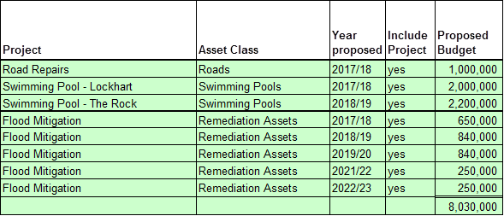

**STEPS UNDERTAKEN IN REACHING A DECISION TO MAKE AN APPLICATION**

The following provides the actions leading towards the decision of Council to apply for a special rate variation.

2005/06:

* Lockhart Swimming Pool reached the end of its useful asset life (based on a 50 to 60 year design life).

2012/13:

* Flood and Floodplain Risk Management Studies for Lockhart and The Rock commissioned.

2014/15:

* Final Flood and Floodplain Risk Management Studies for Lockhart and The Rock published.
* In February 2015, Council resolved on the motion of Crs Verdon and Day that Council:  
  *a) Undertake code compliance works, structural audit of Lockhart swimming pool balance tank, and electrical audit of both pools in 2015/16,  
  b) Gauge community support for continuing the operation of two Shire swimming pool complexes, and  
  c) Consider commencing capital injection in the 2016/17 budget, undertaking the Lockhart complex and then The Rock.*
* In March 2015, Council resolved on the motion of Crs Schirmer and Paterson that Council:  
  *a) Stand by its current position to remain independent and complete the Rural Council Template in the Fit For the Future, thus complying with the favoured option for Lockhart Shire Council by the Local Government Independent Review Panel;  
  b) Determine the method by which it will identify and detail the strategies to be adopted to complete the Rural Council Template;  
  c) Plan and carry out the appropriate community consultation and gain broad community support for Council’s decision to remain independent and for the strategy to be adopted by Council when completing the Rural Council Template;  
  d) Recognise the short time frame available to complete these tasks and accordingly apply the highest priority to their completion prior to the State Government’s deadline of 30 June 2015;  
  e) A councillor workshop be held on Monday, 23 March 2015 commencing at 5.00pm at the Council Chambers.*
* In June 2015, Council resolved on the motion of Crs Schirmer and Douglas that Council *note the report and endorse the submission on the Fit For the Future program to be submitted by 30 June 2015.*

2015/16:

* In February 2016, Council resolved on the motion of Crs Driscoll and Day that Council:  
  *a) Proceeds with installation in 2015/16 of early flood warning equipment for Lockhart and The Rock with Council contribution of $9,000 to be funded from Reserves;  
  b) Proceeds with negotiating in 2015/16 the Voluntary Purchase of properties in order of highest priority as determined by consultants final report, with Council contribution of $90,000 to be funded from Reserves;  
  c) Notes the other future costs associated with the overall flood mitigation works; and  
  d) Applies for funding under the 2016/17 Floodplain Management Program which is currently open to commence with the construction of flood mitigation infrastructure.*
* In June 2016, Council resolved on the motion of Crs Schirmer and Day that Council:  
  *a) Notes the information provided;  
  b) Adopts the final design of flood mitigation measures for both Lockhart and The Rock endorsed by respective Flood Study Committees; and   
  c) Continues to apply for funding in the future rounds for the construction of the designed flood mitigation measures and commence construction as soon as funding becomes available.*
* In June 2016, when considering the actions and targets set out in the Council Improvement Action Plan, Council resolved on the motion of Crs Verdon and Driscoll that *the information was noted and endorsed for the next Council to take forward as strategic actions.*
* In June 2016, Council resolved on the motion of Crs Driscoll and Verdon that Council:  
  *a) Undertakes second round of community consultation on Option 4 for continuing the operation of two Shire swimming pool complexes;  
  b) Subject to community consultation adopt Option 4 as its preferred option;  
  Include a mixture of grant funding, reserve funds and borrowing to commence upgrade the pools in 2016/17 and 2017/18; and  
  d) Adopt changes to proposed opening hours of the pools from 2016/17 swimming season, including changes to contractor payments, as detailed in the report.*

2016/17:

* In July 2016, Council resolved on the motion of Crs Schirmer and Verdon that Council *confirm its intent to apply for a special rate variation in the 2017/18 financial year to raise revenue to pay for future infrastructure.*
* In September 2016, when considering the Council Improvement Action Plan, Council resolved on the motion of Crs Verdon and Marston that Council *acknowledge and endorse the strategic actions embodied in this report as key performance requirements for the Council and they be included in revised Integrated Planning and Reporting documentation accordingly.*
* In September 2016, Council resolved on the motion of Crs Verdon and Marston that *community consultations for the review of the Community Strategic Plan be carried out in conjunction with community consultations for the proposed Special Rate Variation as follows:  
  - Pleasant Hills – Thursday, 20 October 2016 commencing at 6.00pm  
  - Osborne – Friday, 21 October 2016 commencing at 6.00pm  
  - The Rock – Tuesday, 25 October 2016 commencing at 6.00pm  
  - Lockhart – Wednesday, 26 October 2016 commencing at 6.00pm  
  - Yerong Creek – Thursday, 27 October 2016 commencing at 6.00pm*
* In November 2016, Council resolved on the motion of Crs Verdon and Day that Council *endorses the draft Community Strategic Plan Review documentation as amended and places it on public exhibition until Friday, 20 January 2017 and that community feedback be considered prior to it being resubmitted for adoption at the February 2017 Council Meeting.*
* In November 2016, Council resolved on the motion of Crs Verdon and Marston that Council *apply for a Special Rate Variation to commence in the 2017/18 financial year of 4.6% per annum inclusive of rate pegging cumulative for 10 years for the purpose of increasing Council’s own source revenue and to be applied to the provision of community infrastructure including flood mitigation works, road restoration and swimming pool refurbishments.*
* In December 2016, Council resolved on the motion of Crs Driscoll and Walker that Council:  
  *a) Continues undertaking detailed design and planning works for both Lockhart and The Rock pool upgrades to ensure project is shovel ready this year with works funded from Council reserves;  
  b) Continues engaging with respective pool Steering Committees to assist and provide guidance to Council;  
  c) Apply for funding of $1M for the pools under the current round of Building Better Regions Fund; and  
  d) Commence upgrade of the pools in 2016/17, 2017/18, and 2018/19 years subject to confirmation of grant funding, with project funding being combination of grant funding, third party contributions, loan and Council reserves.*
* In February 2017, Council resolved on the motion of Crs Rockliff and Walker that:  
  *a) Council apply for a Special Rate Variation (SRV) to commence in the 2017/18 financial year of 4.6% per annum inclusive of rate pegging cumulative for 7 financial years, to remain permanent in the rate base, for the purpose of increasing own source revenue and to be applied to the provision of community infrastructure including flood mitigation works, road restoration and swimming pool refurbishment; and  
  b) If the SRV is approved and the Building Better Regions Fund (BBRF) grant application is unsuccessful, Council will still proceed with a $4.2M upgrade of Lockhart and The Rock swimming pools;  
  c) If the SRV is not approved Council will proceed with a $2M repair only of Lockhart and The Rock swimming pools;  
  d) Council will only proceed with the flood mitigation works if Office of Environment and Heritage (OEH) funding is forthcoming.*

See Attachment 6 for the resolution to apply for the proposed special variation.

* In February 2017, Council resolved on the motion of Crs Rockliff and Walker that the Community Strategic Plan, Delivery Program, Long Term Financial Plan and Asset Management Plan as presented, be adopted subject to the SRV and base case scenario agreed to in the Workshop help prior to this meeting being incorporated into the documents.

See Attachment 10 for extracts of Council resolutions as outlined above.

## Capital expenditure review

You should complete this section if the council intends to undertake major capital projects that are required to comply with the OLG’s Capital Expenditure Guidelines, as outlined in OLG Circular 10-34. A capital expenditure review is required for projects that are not exempt and cost in excess of 10% of council’s annual ordinary rates revenue or $1 million (GST exclusive), whichever is the greater.

A capital expenditure review is a necessary part of a council’s capital budgeting process and should have been undertaken as part of the Integrated Planning and Reporting requirements in the preparation of the Community Strategic Plan and Resourcing Strategy.

|  |  |  |
| --- | --- | --- |
| Does the proposed special variation require council to do a capital expenditure review in accordance with OLG Circular to Councils, Circular No 10-34 dated 20 December 2010 | Yes | No |
| If *Yes*, has a review been done and submitted to OLG? | Yes | No |

# Assessment Criterion 1: Need for the variation

Criterion 1 in the OLG Guidelines is:

*The need for, and purpose of, a different revenue path for the council’s General Fund (as requested through the special variation) is clearly articulated and identified in the council’s IP&R documents, in particular its Delivery Program, Long Term Financial Plan and Asset Management Plan where appropriate. In establishing need for the special variation, the relevant IP&R documents should canvass alternatives to the rate rise. In demonstrating this need councils must indicate the financial impact in their Long Term Financial Plan applying the following two scenarios:*

* *Baseline scenario – General Fund revenue and expenditure forecasts which reflect the business as usual model, and exclude the special variation, and*
* *Special variation scenario – the result of implementing the special variation in full is shown and reflected in the General Fund revenue forecast with the additional expenditure levels intended to be funded by the special variation.*

*Evidence to establish this criterion could include evidence of community need /desire for service levels/projects and limited council resourcing alternatives.*

*Evidence could also include the assessment of the council’s financial sustainability conducted by the NSW Treasury Corporation.*

The response to this criterion should summarise the council’s case for the proposed special variation. It is necessary to show how the council has identified and considered its community’s needs, as well as alternative funding options (to a rates rise).

The criterion states that the need for the proposed special variation must be identified and clearly articulated in the council’s IP&R documents especially the Long Term Financial Plan and the Delivery Program, and, where appropriate, the Asset Management Plan. The purpose of the proposed special variation should also be consistent with the priorities of the Community Strategic Plan.

## Case for special variation - community need

Summarise and explain below:

* How the council identified and considered the community’s needs and desires in relation to matters such as levels of service delivery and asset maintenance and provision.
* How the decision to seek higher revenues above the rate peg was made and which other options were examined, such as changing expenditure priorities or using alternative modes of service delivery.
* Why the proposed special variation is the most appropriate option: for example, typically other options would include introducing new or higher user charges and/or an increase in council loan borrowings, or private public partnerships or joint ventures.
* How the proposed special variation impacts the Long Term Financial Plan forecasts for the General Fund and how this relates to the need the council identified. Our assessment will also consider the assumptions which underpin the council’s Long Term Financial Plan forecasts.

In addressing this criterion, you should include extracts from, or references to, the IP&R document(s) that demonstrate how the council meets this criterion.

**IDENTIFICATION AND CONSIDERATION OF THE COMMUNITY’S NEEDS AND DESIRES**

There has been strong community consultation relating to Lockhart Shire Council’s independence and sustainability, flood mitigation, roads and the swimming pools over recent years.

**Council independence and increasing own source revenue**

From 2014, when the Fit For the Future (FFF) process was announced, there has been significant consultation with the community regarding the sustainability of Lockhart Shire Council.

Council identified very early in the FFF program that it satisfied 6 of the 7 benchmarks and set about examining options by which it may work towards the Own Source Revenue (OSR) benchmark.

The only three options which were considered reasonable to pursue were:

* Increase rates
* Increase other revenue, ie. External contracting for works;
* A combination of the two.

After considering numerous different financial models including consideration of the ability to pay by ratepayers, Council planned for a series of five public meetings across the Shire as noted under.

Council informed the community of the FFF process and promoted opportunities to get involved by placing articles in Council’s community newsletter (distributed to all households), providing a dedicated FFF page on Council’s website, distributing media releases and placing advertisements in local newspapers, distributing posters with engagement session details, and creating a FFF booklet and distributing to all households. A copy of the information booklet is provided in Attachment 11.

At the five (5) community meetings, and during the engagement process, Council outlined the potential rate increases that residents could expect over the next ten years under the Special Rate Variation scenario. A total of 118 community members attended five (5) meetings, with 79% voting in favour of the Council Improvement Action Plan (CIAP) which included the intention to apply for a Special Rate Variation. It was also clearly communicated to meeting attendees that the additional rate income would be used to fund the swimming pools, flood mitigation and road renewal. A copy of the PowerPoint information presented at these meetings is provided in Attachment 12. Findings from the

Council adopted the Council Improvement Action Plan at its March 2015 Meeting as noted in section 2.2 of this application and the resolution is noted in Attachment 10.

Below is an extract from the Council Improvement Action Plan, of which more details are provided in Attachment 8.

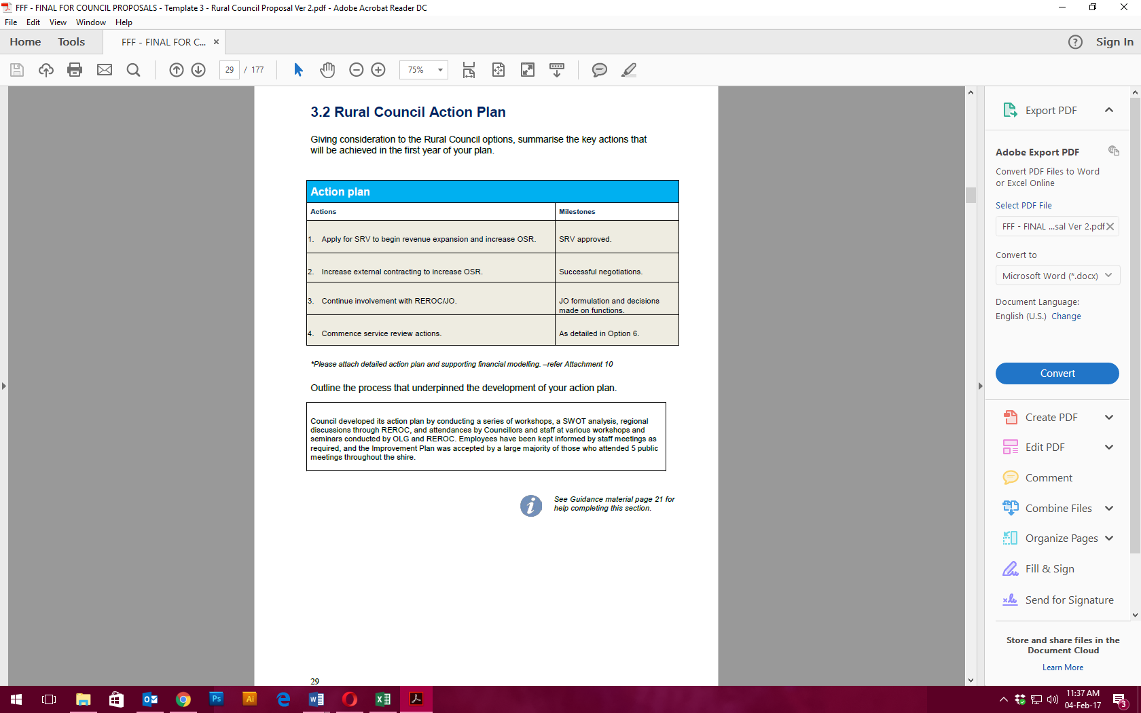  
Extract of the Fit For the Future Proposal outlining the Council Improvement Action Plan.

At it’s highest level, the community desires and aspires to remain independent as highlighted in the Community Vision 2027 on page 2 of the Community Strategic Plan. The Community Vision 2027 states, in part, “In 2027, we are: deeply connected to the land and proud of our independence…” Extract provided in Attachment 1.

Through the community engagement associated with the development of the Community Strategic Plan, the community collectively considered and identified a number of challenges, threats, opportunities and innovations that may affect the community’s long-term ability to achieve the Lockhart Shire Community Vision 2027. Noted on page 10 of the Community Strategic Plan (extract provided in Attachment 1) is evidence that the community is aware that not successfully implementing and achieving the outcomes of the CIAP is a significant threat to achieving the community’s vision to remain independent.

Further stated in the Community Strategic Plan on page 22 is a clear community objective that “Council is strong, sustainable and able to stand alone”, as evidenced in Attachment 1.

**Swimming pools**

The need for refurbishment works to the swimming pools has been discussed for more than a decade, starting before the Lockhart Swimming Pool reached the end of its economic asset life in 2006.

The need is noted on page 39 of Council’s Delivery Program as evidenced in the extract below, and in Attachment 2.

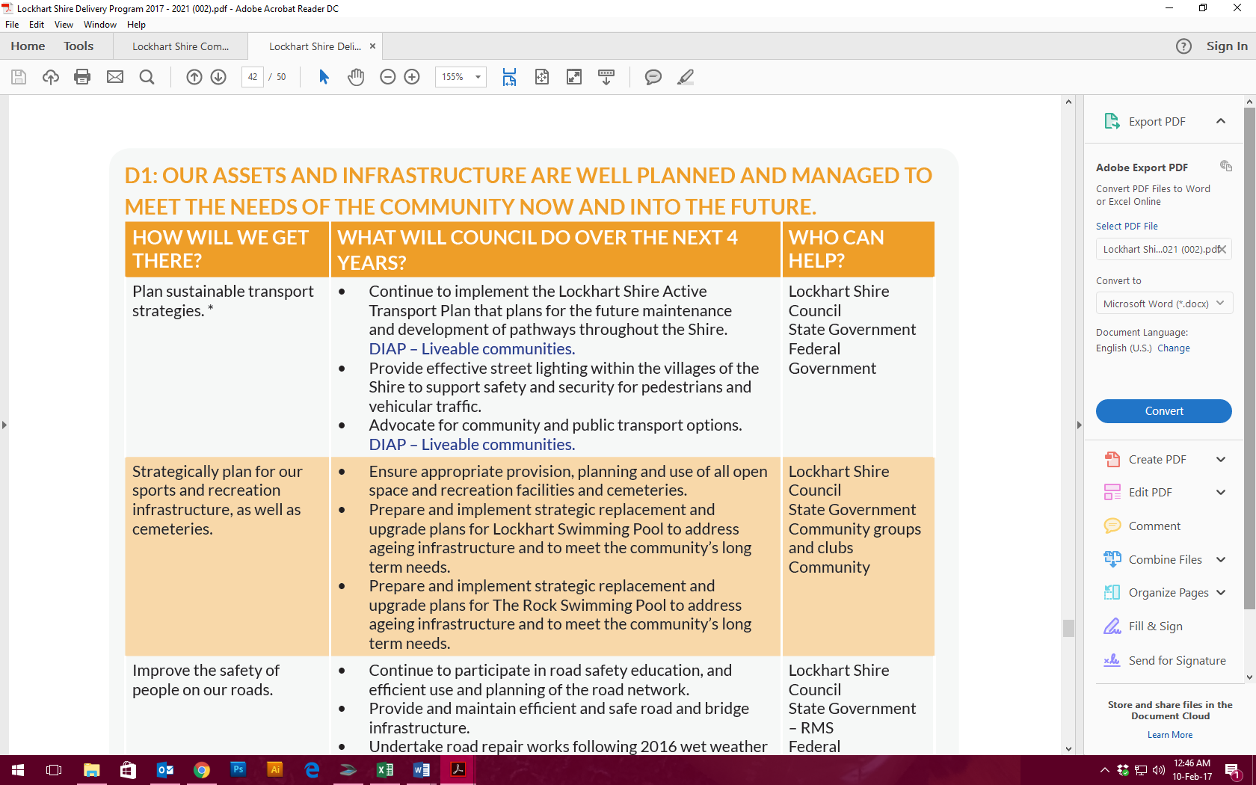  
Extract from page 39 of Council’s Delivery Program.

In December 2014 Council commissioned a condition report of both pools. The report found both pools are coming to the end of their economic life and in need of substantial capital injection. The major infrastructure shortfalls are the pool finishes, plant room, mechanical and chemical systems and pipework.

  
Extract from the Summary section on page 23 of the Pool Condition Report (see Attachment 13 for full details).

In March 2016, Council undertook design works and budget estimates, addressing infrastructure renewal and functional and aesthetic improvement to both facilities. A consultant was engaged to provide three options for consideration by Council and the Community.

Council consulted with the community during April 2016 to gauge comments on the proposal and to consider the three design options, costings and funding alternatives for the upgrades. Two public meetings were held, one each in Lockhart and The Rock, and Council also conducted a community survey. There were 22 people in attendance at the two meetings, and Council received 45 completed surveys and 9 letters of support.

The public feedback was considered and Option 4 was developed. In June 2016, Council resolved to undertake a second round of consultation, as outlined in section 2.2 of this application document. Two public meetings were held during June and July 2016 with 45 people attended two meetings. Subsequently, Steering Committees for both pools were established to assist and provide guidance on the detailed design of the respective pools.

Attachment 5f provides examples of the communication provided to the community in regards to the meetings, copy of survey, meeting attendances, presentation provided at meetings and questions presented by community members.

In addition to refurbishing the two swimming pools, the community desired an increase in opening hours at both pools. Aligned with its commitment to be responsive to the needs and expectations of the community, Council at its June 2016 meeting, as outlined in section 2.2 of this application document, resolved to adopt changes to proposed opening hours of the pools from 2016/17 swimming season. This equated to an additional 1,058 open hours across the 4 months the pools are open (38% increase). Solar heating included in the proposed swimming pool refurbishment could extend the swimming season by a further 6 – 8 weeks.

**Swimming pool background**

Both the Lockhart and The Rock swimming pools are at or nearing the end of their economic life. The Lockhart swimming pool was constructed in 1956 and is 61 years old. The Rock swimming pool was constructed in 1971 and is 46 years old. The typical design life for a swimming pool is 50 years.

The Lockhart Swimming Pool consists of an outdoor 33m long and 13m wide pool and a smaller 6m long and 13m wide children’s play pool. A new kiosk and amenities building has since been added to the facility.

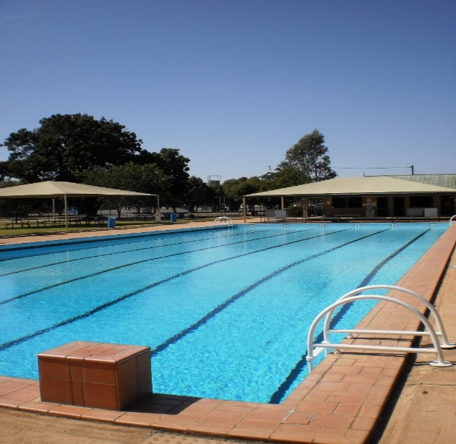  
Lockhart Swimming Pool

The Rock Swimming Pool consists of an outdoor 25m long and 9.2m wide pool and a smaller 6m long and 9.2m wide children’s play pool.

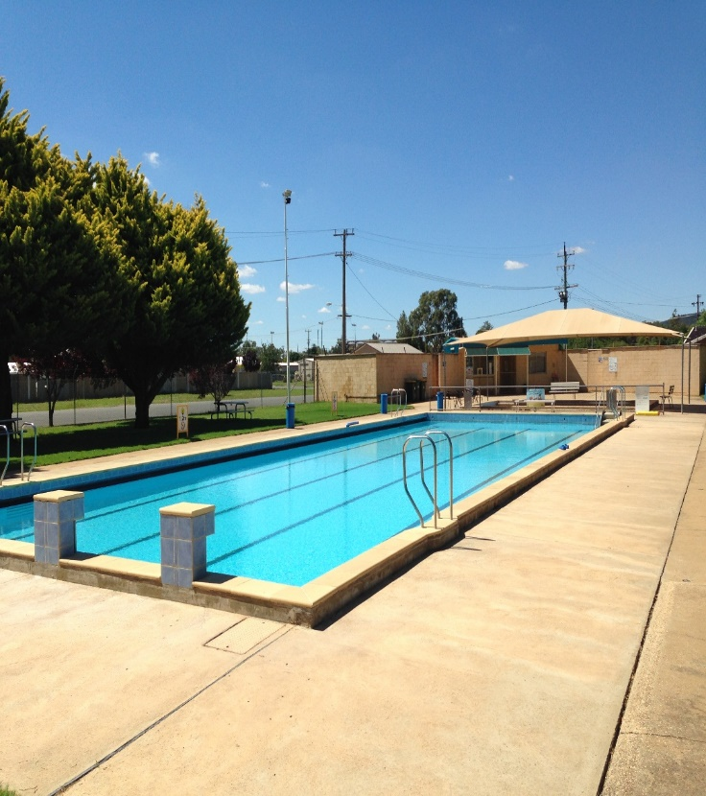  
The Rock Swimming Pool

The major infrastructure shortfalls at both pools consist of the pool finishes, plant room mechanical and chemical systems and pipe works, as detailed below:

* The Lockhart swimming pool finishes have reached the end of life and require renewal. The Rock swimming pool finishes are expected to require renewal within the next four (4) years. The pool finishes at both facilities are ‘tired’ and aged in appearance.
* The majority of the plantroom mechanical equipment is near the end of the serviceable life and required replacing.
* The chemical storage, preparation and dosing systems require upgrading in order to minimise WHS risks and improve operational performance.
* The majority of in ground and above ground cast iron pipework has reached the end of its life and it is expected that pipework may become problematic in the immediate to short term with possible breakages, reduction in flow capacity and or staining of the pool from corrosion deposits.

More information on Lockhart and The Rock swimming pool can be found at <http://www.lockhart.nsw.gov.au/residents-community/swimming-pool-complexes.aspx>.

**Integrated planning and reporting**

In September 2016, Council resolved to undertake community consultation for the review of the Community Strategic Plan and for the proposed Special Rate Variation. Five (5) community meetings, two (2) targeted meetings, and five (5) school sessions were held across the Shire during October and November 2016, and a month-long community survey was distributed. The community were invited to participate using several methods including advertisements in the Lockhart Community Newsletter, media releases, distribution of over 200 posters throughout the community, direct mail and email (invitations) and social media posts.

A total of 245 people from the community participated in the community engagement activities. This included 50 community members in attendance at the community and targeted meetings, 99 school children and 96 people completing the community survey.

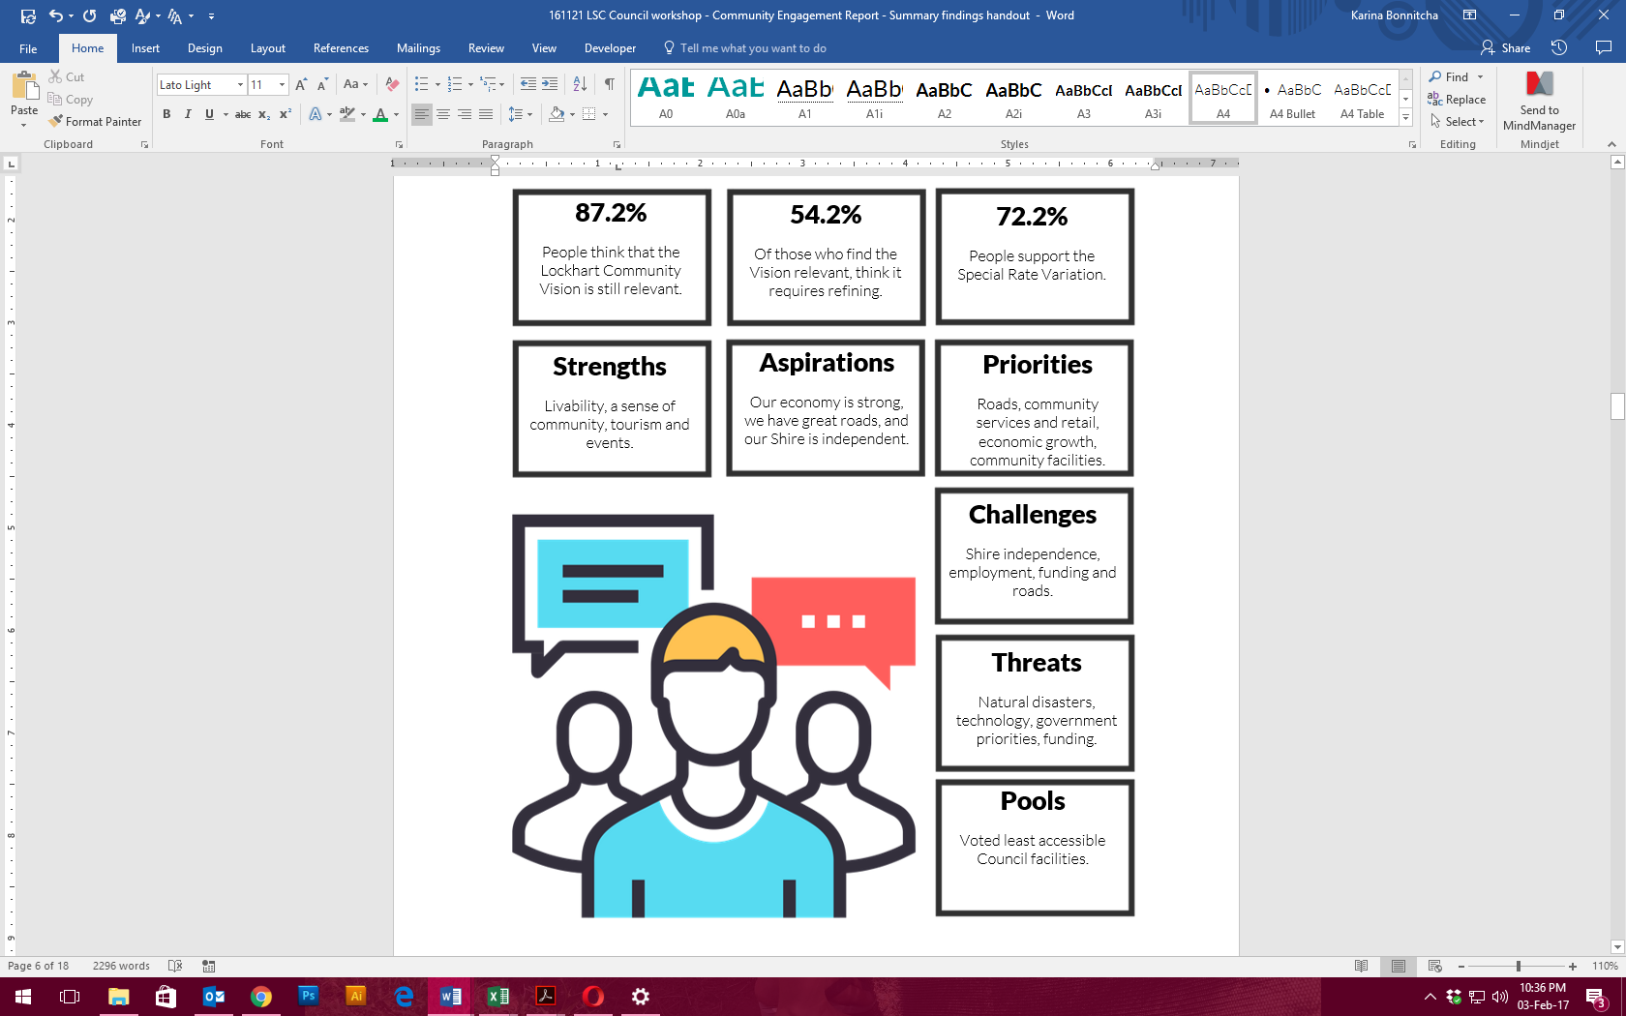  
Summary findings from the October/November 2016 community engagement

To understand the priorities of the community in relation to levels of service delivery and asset maintenance and provision, Council asked a number of questions of the community. Findings included:

* Key challenges facing the Shire include:   
  (1) Shire independence/amalgamation, (2) Employment, (3) Funding, (4) Roads, (5) Economic development and growth, (6) Flood repairs/management, (7) Population decline, (8) Major infrastructure, (9) Ageing population, and (10) Young people leaving the Shire.
* Aspirations of the community include:   
  (1) Our economy is strong, (2) We have reliable and safe roads, (3) Our Shire is independent, (4) We have a thriving tourism economy, (5) Our health services and aged care meet the needs of our community, (6) We have land available for business and residents, (7) We are proud of our community facilities, and (8) We have excellent flood management and drainage.
* The priorities of the community are:   
  (1) Roads, (2) Good community, sport and recreation facilities, (3) Our Shire is independent, (4) Economic growth, and (5) Council support of local infrastructure (water, sewer etc).
* When considering the accessibility of Council facilities:  
  The most accessible were: (1) Lockhart Shire Council offices, (2) Your local park, and (3) Your local aged care facility.   
  The least accessible were: (1) The Rock Swimming Pool, (2) Lockhart Swimming Pool, and (3) The Rock cemetery.
* The most accessible forms of getting information from council were:  
  (1) Council’s community newsletter, (2) Calls to customer service, and (3) Visits to customer service.

The community engagement report is provided in Attachment 5b.

**Roads**

After an unseasonal wet winter, and significant flooding events during 2016 the roads within Lockhart Shire have deteriorated, creating $2.4M of works to get the roads back to standard. Council was recently declared a natural disaster area and was allocated $1.4M of Natural Disaster Relief Assistance, leaving a $1M infrastructure renewal gap.

The state of the roads and the flooding that had recently occurred in 2016 (leading to a natural disaster declaration for the Shire) was and is an ongoing concern for the area. With agriculture being the leading industry for Lockhart Shire it is imperative to the farming industry to have roads that are maintained and safe for heavy vehicles and that can sustain high volumes of heavy traffic.

The main industry within Lockhart Shire is agriculture, with 97% of rateable land being farmland. It is vital to the Shire’s farmers that the roads are maintained and safe for heavy vehicle transport. As a predominantly grain growing region, a reliable and safe road network is essential in facilitating grain growers in transporting their product to market.

The community engagement undertaken for the Community Strategic Plan development and for the SRV during October and November 2016 showed that roads were a key challenge for the Shire. The community aspired to “have reliable and safe roads”, and roads were the community’s top priority.

Roads are the highest priority for our community. This is addressed on page 20 of the Community Strategic Plan where a strategy aims to *“Improve the safety of people on our roads”*. This is evidenced in Attachment 1.

**Flood mitigation**

Following the devastating floods of 2010 and 2012 Council has undertaken Flood Studies of both Lockhart and The Rock townships to understand the mitigation measures required to minimise flooding re-occurrence. Measures include improved drainage, levee banks, installation of early flood warning equipment, and voluntary purchase of properties in floodway through both towns. The NSW Office of Environment and Heritage will fund the construction works at 6:1 ratio. The implementation of flood mitigation will provide security and reassurance for the residents of Lockhart and The Rock in the event of more flooding.

The trauma of major flooding is still present in the psyche of the community and is evidenced by the community engagement findings in the community engagement report in Attachment 5b. Additionally, page 10 of the Community Strategic Plan as evidenced in Attachment 1, shows “natural disasters (floods….)” as a key challenge to achieving the Community Vision 2027. A strategy on page 20 of the Community Strategic Plan, evidenced in Attachment 1, aims to *“reduce the effects of flooding in our towns and villages”*.

**Flood history**

Brookong Creek at Lockhart has been subjected to numerous flood events since white settlement of the town. Significant flood events causing property inundation are known to have occurred in 1934, 1931, 1974 and 1939 (presented in order of magnitude). However, the March 2012 and October 2010 floods surpassed all previous flood events in terms of both magnitude and damage.

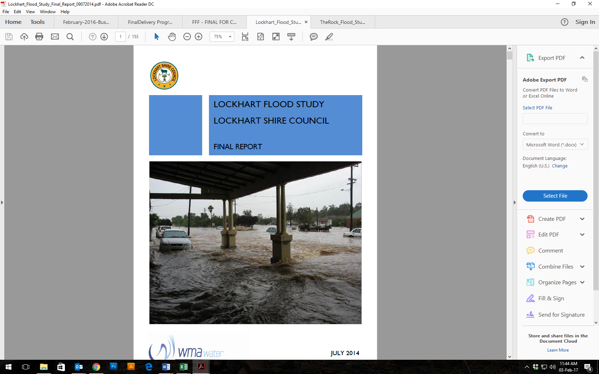  
Flooding at Lockhart, 2012

The Rock has flooded numerous times causing significant damage to low-lying areas of the community. Overtopping of Burkes Creek is a rare occurrence with most of the observed flooding problems being caused by overland flooding, especially runoff from Flowerpot Hill. The March 2012 and October 2010 floods surpassed all previous flood events in terms of both magnitude and damage, with the next most significant flood event in 1931. Other recorded flooding events in The Rock include January and February 2011, December 2010, March 2010, January 2000, December 1992, April 1989, December 1988, January 1974, March 1955, February 1939, January 1934, June 1931, February 1928, February 1927, 1912, and 1891. Burkes Creek is an ungauged stream, so no continuous, quantitative record of historic flood heights in available.

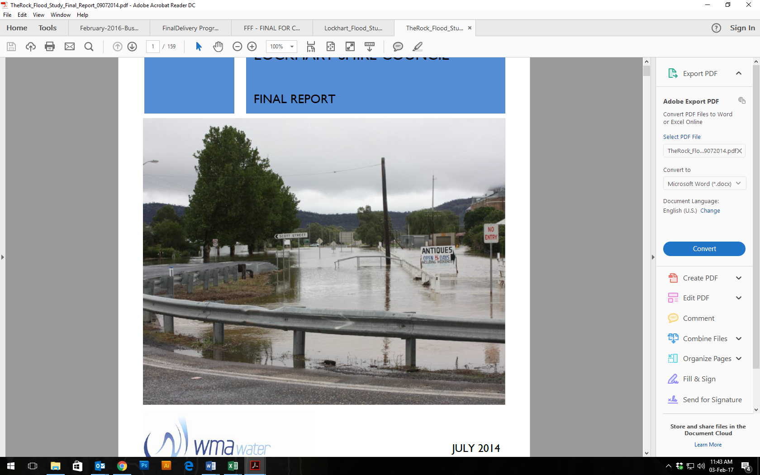  
Flooding at The Rock, 2012

More information on flooding studies in Lockhart Shire can be found at <http://www.lockhart.nsw.gov.au/environment/flood-study.aspx>.

**THE DECISION TO SEEK HIGHER REVENUES ABOVE THE RATE PEG AND OPTIONS EXPLORED**

Given that this project contains smaller project components, this question has been addressed by the project components of (a) increasing Own Source Revenue, (b) refurbishing swimming pools, (c) flood mitigation works, and (d) road renewal.

**Increasing Own Source Revenue**

Through the FFF process Council identified that it must increase its Own Source Revenue (OSR). The only three options which were considered reasonable to pursue were:

* Increase rates;
* Increase other revenue, ie. External contracting for works; and
* A combination of the two.

After considering numerous different financial models including consideration of the ability to pay by ratepayers, Council planned for a series of consultation activities across the Shire as noted earlier in this section. Together with the community, it was decided that remaining as a financially sustainable independent Rural Council was important enough to justify a potential special variation to rates.

External contracting was pursued as a new source of Own Source Revenue, and a potential expected revenue of $350,000 has been factored into the LTFP (Attachment 3).

**Refurbishing swimming pools**

There were three main options explored in relation to the Lockhart and The Rock swimming pools, which were:

* 1. Decrease or cease service provision;
* 2. Undertake immediate ‘patching’ works to extend the effective asset life by 10 to 15 years; and
* 3. Refurbish the pools.

All three options were explored with the community. There is strong community need to maintain current levels of service in relation to both swimming pools. The ‘patching’ works would not provide a strong cost-value benefit to Council and was not considered feasible to pursue.

Detail on levels of service are provided in Attachment 15.

**Flood mitigation works**

Following the largest floods on record in 2010 & 2012 Council commissioned, in conjunction with Office Environment & Heritage (OEH), Flood Studies of both Lockhart & The Rock. These studies determined the exact extent and how the flooding occurred. Following the Flood Studies, further studies were undertaken to develop Flood Risk Study & Management Plan which explored in fine detail measures that could be employed to mitigate the impact of flooding in Lockhart and The Rock. This process was completed in July 2014, thereafter detailed design works were undertaken of the recommended mitigation measures. Final designs we adopted by Council, following assessment by OEH and community consultation, in July 2016. These designs are the flood mitigation works that are to be constructed as part of this application.

**Road renewal**

Council’s road network suffered significant damage and deterioration following the wet winter/spring in 2016. During the minor flooding and wet conditions Council staff undertook patching works to minimise the effect of the inclement weather. Lockhart Shire Council assessed the damage and deterioration once conditions improved and was declared Natural Disaster LGA in mid-November 2016. Council undertook tender for heavy patching of damaged pavement and subsequently engaged a contractor to undertake works that is claimable under the natural disaster declaration. Council is now left with renewing the deteriorated pavements of the road network following the patching works and this is what forms part of this application.

**WHY THE SPECIAL VARIATION IS THE MOST APPROPRIATE OPTION?**

Council’s preferred option is based on SRV scenario 2 as it provides a responsible solution to enable the projects to proceed. While SRV Scenario 1 will still see the projects proceed, this model does place additional load on reserves and requires extra borrowings. The Baseline Scenario will only enable $2M to be spent on the two pools for another 10 to 15 years. The Baseline Scenario also will not provide the most efficient use of council resources as there will be more significant funds to be spent on the pools after the 10 to 15 years. Council does not have the financial resources available to complete such large capital projects by itself as is outlined in the base case scenario of the LTFP.

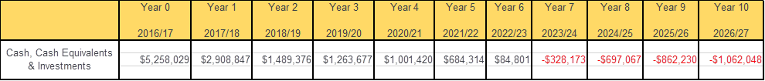

As part of Council’s FFF Improvement proposal, one of the key strategies was to maintain financial sustainability be seeking a Special Rate Variation. The proposed Special Rate Variation of 4.6% cumulative over 7 years to raise $1.749M will increase Own Source Revenue, and be applied to the refurbishment of the Lockhart and The Rock swimming pools, flood mitigation and road restoration works.

Council considered this to be the most appropriate option for the following reasons:

* Financial sustainability – the proposed increase will enable Council to address infrastructure renewal and to increase Own Source Revenue;
* Affordable – Council considered the affordability of a rate rise to the community and found the capacity and willingness to pay was evident in the community;
* Generational – the lifespan of the swimming pool assets will increase by further 50 years, allowing the community to have access to suitable facilities that can be paid for over the years; and
* Community aspirations – the community has clearly indicated a need for flood mitigation, road restoration and for the swimming pool projects to be completed, as documented in the adopted IP&R documentation.

If Council is not successful in obtaining the special rate variation, its ability to (a) fund the delivery of the infrastructure projects and (b) increase Own Source Revenue will be limited. This will impact the level of service that is offered to the community and what the community expect.

**IMPACTS ON THE LTFP FORECASTS FOR THE GENERAL FUND AND HOW THIS RELATED TO THE NEED**

The proposed special rate variation (SRV) has a positive impact on Council’s Own Source Revenue (OSR), raising OSR to 42.64% in Year 7. When Council’s OSR is coming from such a low base of 30.58%, the SRV impact on the LTFP is significant.

The cumulative dollar impact to Council’s Net Operating Result is Baseline $7.46M compared to SRV Scenario 2 of $9.9M for Years 1 to 7. While the primary objective of the SRV is to improve Council’s OSR ratio, the additional revenue enables Council to better fund the identified capital works on swimming pools, flood mitigation and roads.

## Financial sustainability

The proposed special variation may be intended to improve the council’s underlying financial position for the General Fund, or to fund specific projects or programs of expenditure, or a combination of the two. We will consider evidence about the council’s current and future financial sustainability and the assumptions it has made in coming to a view on its financial sustainability.

You should explain below:

* The council’s understanding of its current state of financial sustainability, its long-term projections based on alternative scenarios and assumptions about revenue and expenditure.
* Any external assessment of the council’s financial sustainability (eg, by auditors, NSW Treasury Corporation). Indicate how such assessments of the council’s financial sustainability are relevant to supporting the decision to apply for a special variation.
* The council’s view of the impact of the proposed special variation on its financial sustainability.

**COUNCIL’S UNDERSTANDING OF ITS CURRENT STATE OF FINANCIAL SUSTAINABILITY**

Lockhart Shire Council is very well financially managed. This is supported by achieving an average Operating Performance ratio of 18% over the four years 2013 to 2016.

Council’s Audited Financial Statements for year ending 30 June 2016 can be viewed at: <http://www.lockhart.nsw.gov.au/f.ashx/%24421238%24Lockhart-Shire-Council-Financial-Statements-2015-16.pdf>

While history has demonstrated that Lockhart Shire Council has had the scale and capacity to service the Shire while keeping rates affordable the Fit For the Future process highlighted that moving forward a low Own Source Revenue (OSR) may impact on Council’s financial sustainability in the future.

While Council is financially well managed, with the ageing infrastructure that local government manages, renewals to some of these intergenerational assets can require significant capital expenditure. The aim of the SRV is to increase OSR and for the current LTFP the additional income will go towards funding capital works on swimming pools, flood mitigation and roads. All these projects will benefit future generations, so Council in its view has taken a responsible approach to funding these works so current rate payers are not funding all the works now.

Council has considered other revenue options and its preferred option is based on SRV scenario 2 as it provides a responsible mix of funding sources, being reserves, loans, grants and SRV to enable the projects to proceed whilst at the same time meeting Council’s objective of increasing Own Source Revenue.

TCorp

Lockhart Shire Council

Financial Assessment, Sustainability and Benchmarking Report

21 March 2013

*Based on our review, Council is in a sound Sustainability position. Our key observations are:*

*• Council has been spending sufficient amounts on asset renewal and is forecasting above benchmark levels of capital expenditure in the long term. This will assist Council to improve or maintain its quality of assets and better enable the provision of services;*

*• Council’s use of excess cash reserves to increase capital expenditure will support Council’s long term Sustainability; and*

*• The long-term Sustainability of the Council is dependent on Council continuing to receive operating grants and contributions from both the State and Federal government to support its operations.*

*In respect of our Benchmarking analysis we have compared the Council’s key ratios with other councils in DLG Group 9. Our key observations are:*

*• Council’s financial flexibility was mixed with above benchmark and group average Operating Ratio and* ***below benchmark and group average Own Source Operating Revenue Ratio;***

*• Council’s liquidity position was sound with above group average Cash Expense Ratio and Unrestricted Current Ratio;*

*• Council’s debt servicing capacity was sound with above group average DSCR and Interest Cover Ratio; and*

*• Council generally outperformed the group average in terms of level of Infrastructure Backlog and Capital Expenditure. Council’s spending on maintenance of assets was on par with the group average. Council’s performance in terms of asset renewal was generally below the peer group.*

*Section 6 Conclusion and Recommendations*

*Based on our review of both the historic financial information and the 10-year financial forecast within Council’s long term financial plan we consider Council to be in a sound Sustainability position.*

*We base our recommendation on the following key points:*

* *Council reported surpluses each year over the review period and these are forecast to continue;*
* *Employee expense decreased over the review period;*
* *Council has had very strong levels of liquidity throughout the period as indicated by its Unrestricted Current Ratio being well above the benchmark;*
* *Council’s forecast capital expenditure will be sufficient to keep infrastructure assets in their current satisfactory condition;*
* *Council’s cash reserves will fund required levels of asset renewal in the long term; and*
* *Council has close to zero Infrastructure Backlog, although the AMP is to be reviewed and this may have some financial implications for Council.*

SRV Scenario 2 is the preferred option because it meets Council’s objective of increasing its Own Source Revenue and moves towards addressing the one FFF indicator which from TCorp’s Financial Assessment, Sustainability and Benchmarking Report (March 2013), Council was below the benchmark and group average for OLG Group 9 councils.

**EXTERNAL ASSESSMENT OF COUNCIL’S FINANCIAL SUSTAINABILITY**

Our Council has good reason to be positive about the future. Council met 6 of the 7 FFF benchmarks but other indicators are also strongly encouraging as detailed under:

* TCorp Financial Sustainability rating – current sound (top 20% of State), outlook neutral
* NSW Government LG Infrastructure Audit rating – moderate

The TCORP Lockhart Shire Council; Financial Assessment, Sustainability and Benchmarking Report dated 21 March 2013 stated:

*“Council is in a sound sustainability position…”*

*“The Own Source Operating Revenue Ratio has been well below the benchmark in all four years, reflecting Council’s dependence on grant revenue”.*

*“Roads are the largest part of the Infrastructure Backlog (94%)”.*

The TCORP Financial Assessment reported the following as specific risks to Council”

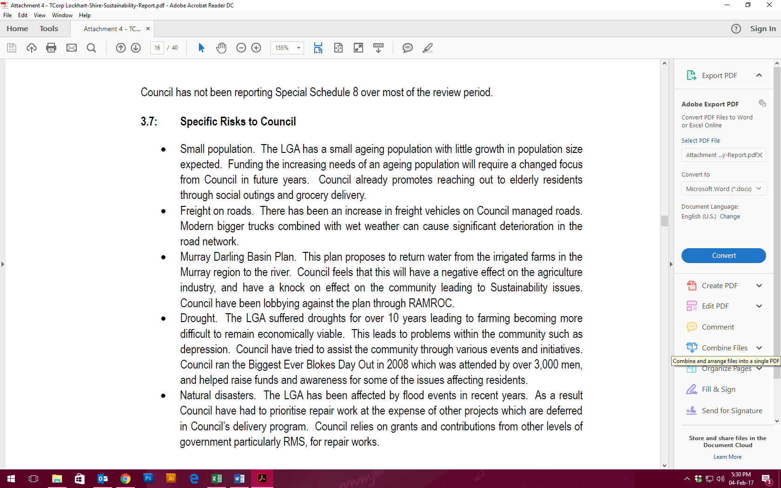  
Extract from TCorp’s Lockhart Shire Council; Financial Assessment, Sustainability and Benchmarking Report; 21 March 2013; page 16

The TCorp report highlighted “*Within the $7.7m in total cash balance, $2.8 was externally restricted, $4.5 was internally restricted and $0.5 was unrestricted*”.

Council’s 30 June 2016 Key Financial Indicators from Council’s audited financial statements were:

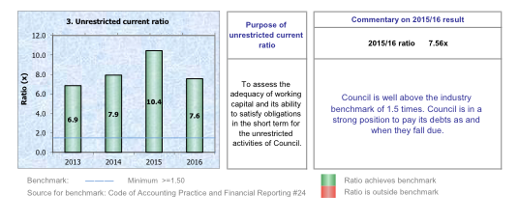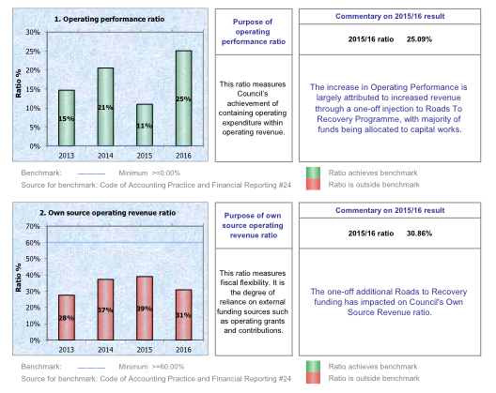

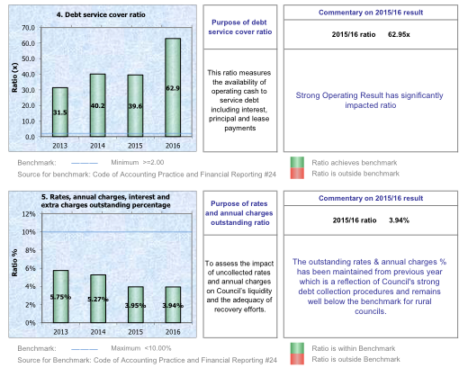

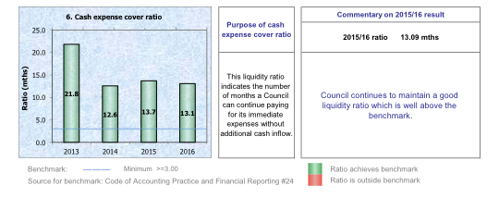

The Infrastructure Backlog ratio from TCORP assessment is following:



**COUNCIL’S VIEW OF THE IMPACT OF THE PROPOSED SPECIAL VARIATION ON ITS FINANCIAL SUSTAINABILITY**

Council views the Special Variation as necessary to its long term financial sustainability, enabling Council to increase its Own Source Revenue (OSR) and meet the needs of the community through delivery of community infrastructure. So much so that the SRV application is a key action in the Council Improvement Action Plan adopted by Council following the Fit For the Future process. The Actions contained in the CIAP have been incorporated into Council’s IP&R documents.

The proposed special rate variation (SRV) has a positive impact on Council’s Own Source Revenue (OSR), raising OSR to 42.64% in Year 7. The cumulative dollar impact to Council’s Net Operating Result is Baseline $7.46M compared to SRV Scenario 2 of $9.9M for Years 1 to 7. When Council’s OSR is coming from such a low base of 30.58%, the SRV impact on the LTFP is significant.

Consistent with the CIAP, and in order to increase its OSR, Council is seeking a SRV to remain permanently in the rate base. The additional funds generated will initially be used to help fund the projects identified in consultation with the community i.e. swimming pools, flood mitigation works and road restoration over the period of the SRV, and other community infrastructure going forward to be identified in consultation with the community beyond the current Community Strategic Plan.

The SRV remaining permanently in the rate base and the resulting increase in OSR will place Council in a more sustainable footing in the longer term. Council will be better placed to manage any unforeseen negative financial impacts such as reductions in grant funding, non-indexation of Financial Assistance Grants as occurred in recent years and the like. The positive impact of the SRV on Council’s financial sustainability compared to the Baseline Scenario is reinforced by the comparative financial indicators shown in Section 3.3, particularly the Operating ratio, Rates and Annual Charges ratio and Unrestricted Current ratio (longer term).

## Financial indicators

How will the proposed special variation affect the council’s key financial indicators (General Fund) over the 10-year planning period? Please provide, as an addendum to the Long Term Financial Plan, an analysis of council’s performance based on key indicators (current and forecast) which may include:

* Operating balance ratio excluding capital items (ie, net operating result before capital grants and contributions as percentage of operating revenue before capital grants and contributions).
* Unrestricted current ratio (the unrestricted current assets divided by unrestricted current liabilities).
* Rates and annual charges ratio (rates and annual charges divided by operating revenue).
* Debt service ratio (principal and interest debt service costs divided by operating revenue excluding capital grants and contributions).
* Broad liabilities ratio (total debt plus cost to clear infrastructure backlogs as per Special Schedule 7 divided by operating revenue).
* Asset renewal ratio (asset renewals expenditure divided by depreciation, amortisation and impairment expenses).

Council has undertaken detailed financial modelling based on three different scenarios:

• Baseline Scenario – This scenario is as Council resolved at its February 2017 meeting of works that would be undertaken even if unsuccessful for Special Variation. - Flood mitigation works subject to successful grant applications (Office of Environment & Heritage).

• SRV Scenario 1 – This scenario is based on a successful SRV application and no grant funding for the pools project. Flood mitigation works subject to successful grant applications (Office of Environment & Heritage).

• SRV Scenario 2 – This scenario is based on a successful SRV application and successful grant funding for the pools project (Building Better Regions Fund). Flood mitigation works subject to successful grant applications (Office of Environment & Heritage).

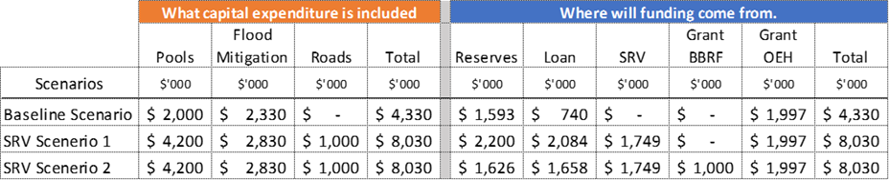

The following charts and commentary relates to Council’s General Fund only (excludes Sewer fund).

**OPERATING RATIO**

This ratio measures a Council’s ability to contain its operating expenditure within operating revenue. A target of breakeven is considered as a minimum. It is measured as the Net Operating Result over Operating Revenue.

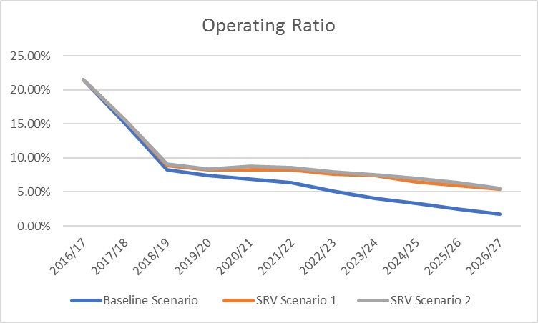

The operating ratio of Council is significantly better with SRV Scenarios 1 &2, due to the inclusion of the special rate variation funding. There is minimal difference SRV Scenarios 1 & 2, as only variance is SRV Scenario 2 has $1M grant for pools.

**RATES & ANNUAL CHARGES RATIO**

This ratio measures Council’s Rates & Annual Charges revenue as part of its operating revenue. This ratio outlines Council’s reliance on Rates & Annual charges revenue. It is measured as Rates & Annual Charges income over Operating Revenue.

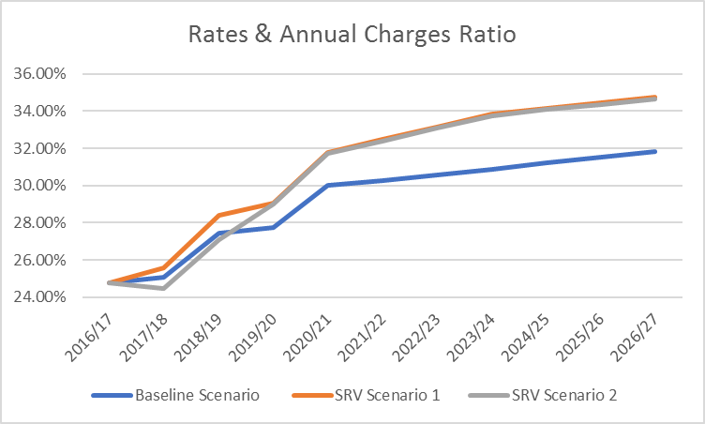

The Rates & Annual Charges ratio reflects Council’s reliance on its Rates & Annual Charges income. The increase in the ratio for SRV Scenario 1 & 2 is consistent with the increased rating income of the Special Rate Variation. Council is seeking the SRV to remain permanently in the rate base so the path of this ratio continues its upwards incline.

**ASSET RENEWAL RATIO**

This ratio measures Council’s intended expenditure on infrastructure asset renewals against total asset depreciation. It is measured as Asset Renewal Expenditure over Depreciation.

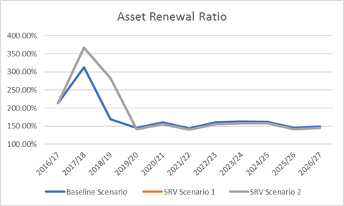

The spike in the initial years under SRV Scenarios 1 & 2 is indicative of the higher expenditure that is required to be funded in part by SRV.

**UNRESTRICTED CURRENT RATIO**

This ratio measures the adequacy of Council’s unrestricted working capital and its ability to meet short term obligations as they fall due. It is measured as Unrestricted Current Assets over Unrestricted Current Liabilities. NSW Treasury Corporation sets a minimum benchmark of 1.50.

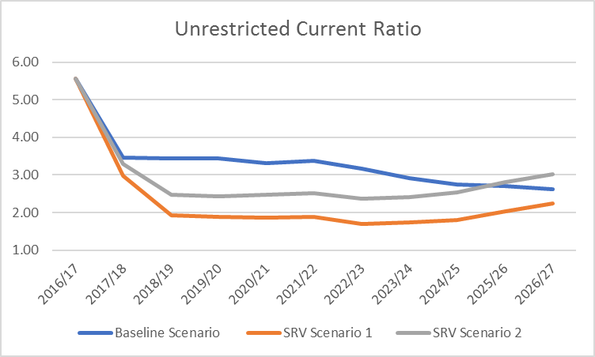

The differences for each scenario is reflective of the mix of funding projects in each scenario.

**DEBT SERVICE RATIO**

This ratio measures the portion of a Council’s operating revenue that is needed to cover its current principal and interest debt servicing costs. It is measured as Debt Servicing Costs over Operating Revenue.

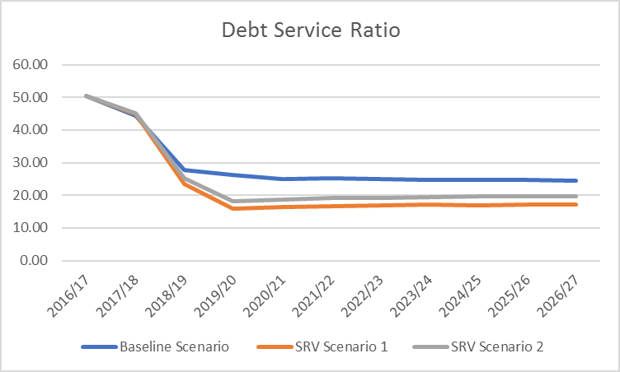

Ratios above are reflective of the amount of borrowings required for each scenario and each satisfies TCorp’s benchmark of 2 or greater.

**BROAD LIABILITIES RATIO**

This ratio measures a Council’s combined debt and infrastructure backlog as a percentage of operating revenue. This ratio outlines a Council’s ability to cover its debt and backlog liabilities if they were to fall due at once. It is measured as Total Debt & Infrastructure Backlog over Operating Revenue.

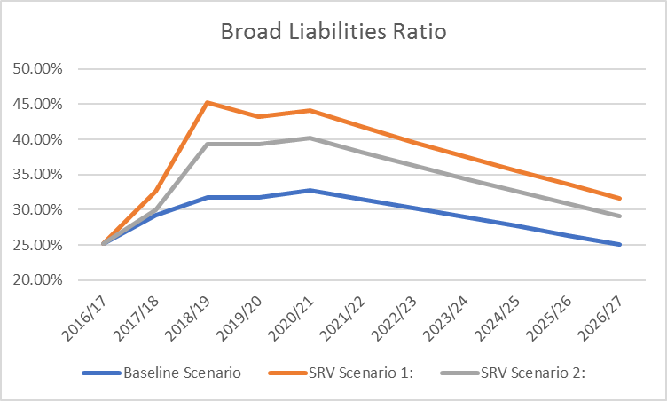

SRV Scenarios 1 & 2 are higher due to higher debt planned with each scenario.

## Contribution plan costs above the cap

You should complete this section if the proposed special variation seeks funding for contributions plan costs above the development contributions cap. Otherwise, leave this section blank.

Please explain how the council has established the need for a special variation to meet the shortfall in development contributions.

For costs above the cap in contributions plans, a council must provide:[1]

* a copy of the council’s section 94 contributions plan
* a copy of the Minister for Planning’s response to IPART’s review and details of how the council has subsequently amended the contributions plan
* details of any other funding sources that the council is proposing to use, and
* any reference to the proposed contributions (which were previously to be funded by developers) in the council’s planning documents (eg, Long Term Financial Plan and Asset Management Plan AMP.

|  |
| --- |
| N/A |

# Assessment criterion 2: Community awareness and engagement

Criterion 2 in the Guidelines is:

*Evidence that the community is aware of the need for and extent of a rate rise. The Delivery Program and Long Term Financial Plan should clearly set out the extent of the General Fund rate rise under the special variation. The council’s community engagement strategy for the special variation must demonstrate an appropriate variety of engagement methods to ensure community awareness and input occur. IPART’s fact sheet includes guidance to councils on the community awareness and engagement criterion for special variations.*

Our fact sheet on the requirements for community awareness and engagement is available on the IPART website.[2]

In responding to this criterion, the council must provide evidence that:

* it has consulted and engaged the community about the proposed special variation using a variety of engagement methods and that the community is aware of the need for, and extent of, the requested rate increases
* it provided opportunities for input and gathered input/feedback from the community about the proposal, and
* the IP&R documents clearly set out the extent of the requested rate increases.

In assessing the evidence, we will consider how transparent the engagement with the community has been, especially in relation to explaining:

* the proposed cumulative special variation rate increases including the rate peg for each major rating category (in both percentage and dollar terms)
* the annual increase in rates that will result if the proposed special variation is approved in full (and not just the increase in daily or weekly terms)
* the size and impact of any expiring special variation (see Box 4.1 below for further detail), and
* the rate levels that would apply without the proposed special variation.

More information about how the council may engage the community is to be found in the Guidelines, the IP&R manual and our fact sheet.

|  |
| --- |
| Box 4.1 Where a council is renewing or replacing an expiring special variation |
| The council’s application should show how you have explained to its community:  There is a special variation due to expire at the end of the current financial year or during the period covered by the proposed special variation. This needs to include when the expiring special variation was originally approved, for what purpose and the percentage of (General Fund) general income originally approved.  The corresponding percentage of general income that the expiring special variation represents for the relevant year.  Whether the temporary expiring special variation is being replaced with another temporary or a permanent increase to the rate base.  The percentage value of any additional variation amount, above the rate peg, for which the council is applying through a special variation.  If the proposed special variation was not approved (ie, only the rate peg applies), the year-on-year change in rates would be lower, or that rates may fall.  The council also must attach, to its application to IPART, a copy of the Instrument of Approval that has been signed by the Minister or IPART Chairman. |
|  |

## The consultation strategy

The council is required to provide details of the consultation strategy undertaken, including the range of methods used to inform and engage with the community about the proposed special variation and to obtain community input and feedback. The engagement activities could include media releases, mail outs, focus groups, statistically valid random or opt-in surveys, online discussions, public meetings, newspaper advertisements and public exhibition of documents.

The council is to provide relevant extracts of the IP&R documents that explain the rate rises under the proposed special variation and attach relevant samples of the council’s consultation material.

Lockhart Shire Council (LSC) implemented an extensive community engagement plan to ensure that residents and ratepayers were aware of Council’s intention of applying for a Special Rate Variation, the extent of the rate rise and how that would impact on the different rating categories. The Community Engagement Plan is provided in Attachment 5a.

LSC ensured that information was available to the community using a variety of different methods of communication including front page link on its website, fact sheet, media releases, news coverage in local media, online survey, LSC monthly newsletter, community forums and the IP&R documentation. Throughout the process residents were also encouraged to contact Council and Councillors at any time to provide feedback or ask any questions on the SRV.

Below is a summary of the number of quantifiable interaction with residents:

* 1500 households receive LSCs newsletter which included the Mayor’s report and advertisement of community meetings and SRV proposal (see note below);
* 36 residents attended the 5 community meetings;
* 1 phone call;
* 200 posters displayed throughout the Shire at prominent locations to advertise community meetings; and
* 96 people completed the online survey.

Further to the community engagement outlined above, specific engagement was held with the communities of Lockhart and The Rock between April and July 2016 to understand their levels of service and asset maintenance and provision views in relation to the township swimming pools. Below is a summary of the number of quantifiable interaction with residents:

* 22 people attended the two community meetings in April;
* 45 people completed surveys;
* 9 letters of support were received; and
* 45 people attended the two community meetings in June and July.

Lockhart Shire Council also consulted widely with the community through the Fit for the Future process where it was widely communicated that Council had intention of applying for a Special Rate Variation as part of the Council’s Improvement Action Plan’s action to increase Own Source Revenue. This included providing all households with an information booklet outlining the need for the SRV. This engagement also included using a variety of different platforms to communicate to the residents including FFF page on Council’s website, media releases, regular updates in the LSC monthly newsletters, newspaper adverts and community forums with presentations and handouts.

Below is a summary of the number of quantifiable interaction with residents:

* 1500 households received the Lockhart Shire Council monthly newsletter which included the information booklet on the Fit for the Future Improvement Plan outlining the Special Rate Variation intentions. See note below; and
* 118 residents attended the five (5) community meetings, which were held throughout the Shire to strategically cover each population centre.

The community forums on both occasions were valuable to the process as people were able to express their concerns and find out more about how the proposed increase to rates would impact them. Overall the consultation and engagement process found that the community understands and supports the need for a Special Rate Variation for LSC to remain financial sustainable and to upgrade and repair critical community infrastructure, as well as implement flood mitigation strategies.

NOTE: The Lockhart Shire Council community newsletter was chosen as a key communication tool due the results of the recent 2016 Community Satisfaction Survey which showed that 96% of respondents received their information about Council from the newsletter.

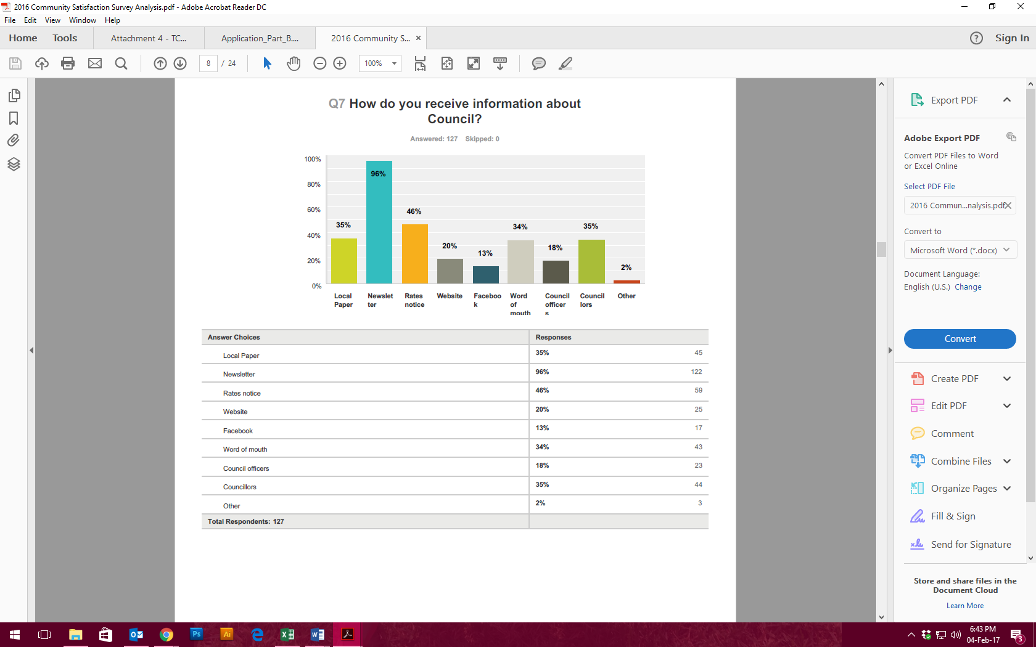  
Extract from page 8 of the 2016 Lockhart Shire Community Satisfaction Survey

Pages 4 and 5 of Council’s Delivery Program, located in Attachment 2, are of particular relevance as they explain the rate rises under the proposed special variation.

Attachments 5b, 5c, 5d, 5e, and 5f provide relevant examples of Council’s consultation materials, promotional materials, and consultation findings.

## Feedback from the community consultations

Summarise the outcomes and feedback from the council’s community engagement activities. Outcomes could include the number of attendees at events and participants in online forums, as well as evidence of media reports and other indicators of public awareness of the council’s special variation intentions. Where applicable, provide evidence of responses to surveys, particularly the level of support for specific programs or projects, levels and types of services, investment in assets, as well as the options proposed for funding them by rate increases.

Where the council has received submissions from the community relevant to the proposed special variation, the application should set out the views expressed in those submissions. Please refer to Section 1.2 concerning how the council should handle confidential content in feedback received from the community. The council should also identify and document any action that it has taken, or will take, to address issues of common concern within the community.

As outlined in the community engagement findings report in Attachment 5b, consultation has indicated support for the Special Rate Variation and the projects outlined as part of the SRV. The engagement for the Community Strategic Plan, Delivery Program, and related IP&R documents outlined the community’s need for Lockhart Shire Council to remain as a financially sustainable Council. Engagement also prioritised community infrastructure upgrades (roads and pools), as well as the need for flood mitigation works.

Those against the special rate variation felt that the farming community were already paying enough rates, and believed that the rating structure was unfair. A few suggested that any pool upgrades should be funded by those living in the townships and not rural residents outside of those township areas. Discussions in community meetings addressed these concerns and further explained how the rating system worked and why farmers believe they are paying the highest rates. In reality the ad valorem rate for farmland properties is lower than the ad valorem rate for all other categories of rateable land. However, as farmland properties are generally larger, have higher land values and make up the greatest proportion of rateable land (97%) in the Shire, they make the greatest contribution to Council’s revenue from ordinary rates. Currently farmland accounts for 93% of the Shire’s total land value and contribute 80% of the monetary value of rates collected.

**FIT FOR THE FUTURE**

The Fit For the Future (FFF) process was a significant issue in Lockhart between 2014 and 2016. Community members actively participated in the conversation on how Lockhart Shire Council would be able to remain as a financially sustainable Rural Council. Consultation materials shows the importance to Council and community of the Fit For the Future process with a dedicated booklet being developed to assist and guide the community through the process and the next steps forward. Attachment 5d and Attachment 5e provide evidence of promotional materials and consultation materials.

**COMMUNITY FORUM**

During the Fit for the Future process, in April 2015 Council hosted five (5) community meetings across the Shire, with 118 people attending those meetings at The Rock, Yerong Creek, Lockhart, Pleasant Hills and Osborne. Support for the Special Rate Variation was strong, with 79% of those attending voting in support.

In October 2016 Council hosted five (5) community meetings across the Shire to not only discuss the intention to apply for a Special Rate Variation but to also confirm community priorities for the Community Strategic Plan. Support for the Special Rate Variation was strong, with 72.2% of those attending voting in support.

The following themes and concerns emerged from the community meetings:

* Feeling of inequity of rates across the Shire, particularly the farming community;
* the cost of the swimming pools and who should be paying;
* the condition of the roads and the importance of maintenance and repair; and
* financial sustainability of the Council and remaining independent.

Council addressed each one of these concerns throughout the process by providing detailed information on the Special Rate Variation and how this would affect each major rating category (farming, residential and business). Council officers and Councillors also thoroughly explained the rating structure, ensuring people understood how value of land can impact on the distribution of the rate burden, particularly for those farming communities.

The cost of the swimming pools was discussed in detail and by utilising the SRV and loan borrowings, the funding of the pools would provide for inter-generational equity without the impact being too great on the immediate rate payers. Ongoing consultation with the community has continued with swimming pools and has been ongoing since early 2016.

Attachment 5f provides further evidence of the pool consultations and highlights the community’s desire to maintain their local swimming pools in Lockhart and The Rock.

The state of the roads and the flooding that had recently occurred in 2016 (leading to a natural disaster declaration for the Shire) was and is an ongoing concern for the area. With agriculture being the leading industry for Lockhart Shire it is imperative to the farming industry to have roads that are maintained and safe for heavy vehicles and that can sustain high volumes of heavy traffic.

It was communicated quite strongly in the meetings that the financial sustainability of Council and maintaining Council’s independence was important for the community. Members of the community value Lockhart Shire Council being a small and prosperous community with strong community connections and a Council that is supportive of the residents.

**ONLINE SURVEY**

The online survey was conducted in October/November 2016, with residents asked a range of questions around their community, services Council provide and the challenges for Lockhart Shire. 96 Surveys were completed by residents.

The following areas were identified as important for the community through the survey;

* Roads
* Shire independence
* Community facilities (including pools)
* Economic development (general)
* Health services and aged care

**MEDIA REPORTS AND NEWSLETTERS**

The media reports demonstrate the awareness of the community of the Special Rate Variation. The monthly newsletter which is delivered to 1500 households and community facilities/services has kept residents and the community informed of the Fit For the Future process, Councils Improvement Action Plan, Integrated Planning and Reporting, and the Special Rate Variation. Evidence of media coverage and promotional materials are provided in Attachment 5c and Attachment 5d respectively.

The community satisfaction survey indicates that 96% of respondent’s access information from the LSC monthly newsletter. This provides Council confidence that the community are well informed of the process. Copies of the newsletter are also provided online <http://www.lockhart.nsw.gov.au/council/shire-newsletters.aspx>

# Assessment criterion 3: Impact on ratepayers

Criterion 3 in the Guidelines is:

*The impact on affected ratepayers must be reasonable, having regard to both the current rate levels, existing ratepayer base and the proposed purpose of the variation. The Delivery Program and Long Term Financial Plan should:*

* *clearly show the impact of any rises upon the community*
* *include the council’s consideration of the community’s capacity and willingness to pay rates and*
* *establish that the proposed rate increases are affordable having regard to the community’s capacity to pay.*

The impact of the council’s proposed special variation on ratepayers must be reasonable. To do this, we take into account current rate levels, the existing ratepayer base and the purpose of the proposed special variation. We also review how the council has assessed whether that the proposed rate rises are affordable having regard to the community’s capacity and willingness to pay.

## Impact on rates

Much of the quantitative information we need on the impact of the proposed special variation on rate levels will already be contained in Worksheet 5a and 5b of Part A of the application.

To assist us further, the application should set out the rating structure under the proposed special variation, and how this may differ from the current rating structure, or that which would apply if the special variation is not approved.

We recognise that a council may choose to apply an increase differentially among categories of ratepayers. If so, you should explain the rationale for applying the increase differentially among different categories and/or subcategories of ratepayers, and how this was communicated to the community. This will be relevant to our assessment of the reasonableness of the impact on ratepayers.

Councils should also indicate the impact of any other anticipated changes in the rating structure.

The rating structure is not proposed to change in order to implement the proposed special rate variation. The existing rating categories will remain as per the 2016/17 structure. For those categories and sub-categories that have a Base Amount, these amounts are not proposed to change. The Ad Valorem for each category and sub-category will be the only variable that will change in the event of a successful SRV application. (refer to Part A for more detailed impact on each category and sub-category over the 7-year period of the SRV.

Additionally, the Emergency Services Property Levy (ESPL) will be added to the rates notice. Consideration has been given to clearly communicate with ratepayers when issuing the rate notices.

In conjunction with the NSW Treasury’s implementation plan for the ESPL, ratepayers will be notified of the classification of their land for ESPL purposes by 30 April 2017. This will provide an additional, and earlier opportunity, to explain the ESPL prior to the issue of the 2017/18 rate notices.

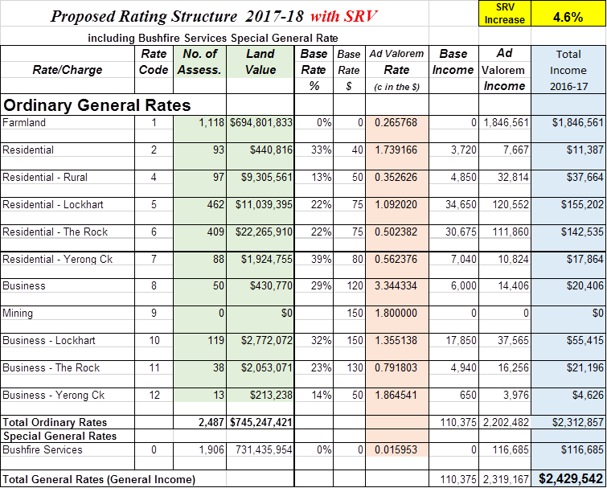

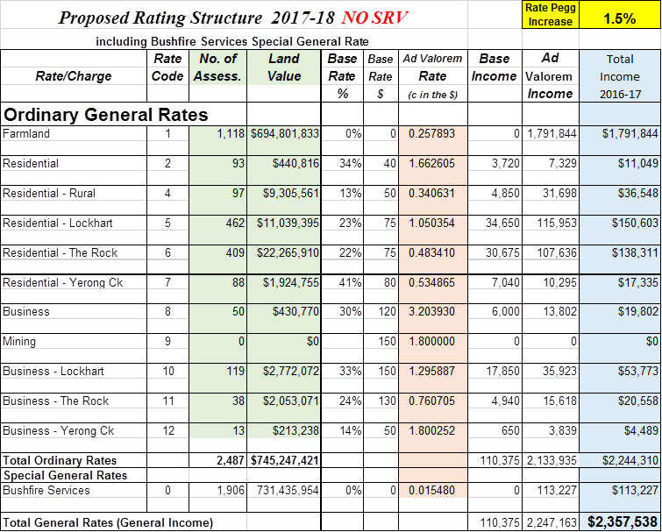

Council communicated the impact of the proposed special rate variation through various forms of information provided to the community. This information was provided as part of the community consultation at the community meetings, online fact sheet via the Council website, and fact sheet provided in the Lockhart Shire.

The information was also provided on page 4 of Council’s Delivery Program as per the extract below. More Delivery Program detail is provided in Attachment 2.

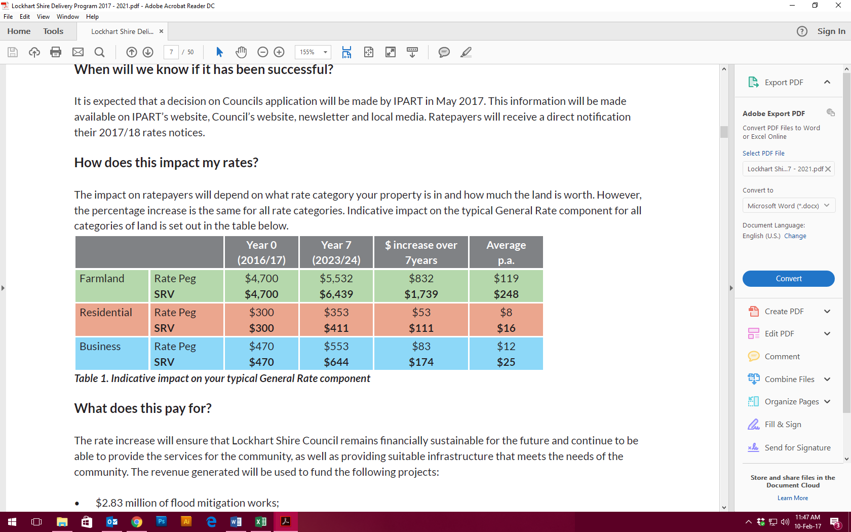  
Extract from page 4 of Council’s Delivery Program

### Minimum Rates

The proposed special variation may affect ordinary rates, special rates and/or minimum rates.

As previously discussed, if the proposed special variation includes increasing minimum rates above the statutory limit, or is to apply a higher rate of increase to an existing minimum rate than to its other rates, it is not necessary for the council to also complete the separate Minimum Rates application form. However, this must be clearly identified and addressed in the special variation application.

|  |  |  |
| --- | --- | --- |
| Does the council have minimum Ordinary rates? | Yes | No |

If *Yes*, does the council propose to increase minimum Ordinary rates by:

The rate peg percentage

The special variation percentage

Another amount  Indicate this amount _____________

What will minimum Ordinary rates be after the proposed increase? _________

The council must explain how the proposed special variation will apply to the minimum rate of any ordinary and special rate, and any change to the proportion of ratepayers on the minimum rate for all relevant rating categories that will occur as a result.

You should also explain the types of ratepayers or properties currently paying minimum rates, and the rationale for the application of the special variation to minimum rate levels.

N/A

## Consideration of affordability and the community’s capacity and willingness to pay

The council is required to provide evidence through its IP&R processes, and in its application, of how it assessed the community’s capacity and willingness to pay the proposed rate increases. This is to include an explanation of how the council established that the proposed rate rises are affordable for the community.

Evidence about capacity to pay could include a discussion of such indicators as SEIFA rankings, land values, average rates, disposable incomes, the outstanding rates ratio and rates as a proportion of household/business/farmland income and expenditure, and how these measures relate to those in comparable or neighbouring council areas.

As many of these measures are highly aggregated, it may also be useful to discuss other factors that could better explain the impact on ratepayers affected by the proposed rate increases, particularly if the impact varies across different categories of ratepayers.

We may also consider how the council’s hardship policy (see Section 5.3 below) might reduce the impact on socio-economically disadvantaged ratepayers.

Lockhart Shire Council has fully assessed the affordability of the proposed rate increase, as well as the community’s willingness and capacity to pay the increased rates.

**HOW THE COUNCIL ESTABLISHED THAT THE RATE RISE WAS AFFORDABLE**

Council’s current rates are very low compared to other similar Council areas. When compared to other Office of Local Government Group 9 Rural Councils (G9RC), Lockhart Shire’s residential rate for 2014/2015 was the third lowest at $259, compared to a G9RC average of $401. The average farmland rate was also the third lowest of the group at $1,563 compared to the G9RC average of $2,591. The average business assessment was $413 which was fourth lowest compared to other G9RCs.

To bring Lockhart Shire Council rates up to the G9RC average rate level, Council would need to increase its residential rates by 55%, farmland rates by 66% and business rates by 83%.

Compared to other G9RCs, Lockhart Shire Council has the 2nd lowest level of own source income, and 3rd highest reliance on grant income.

**Average Farmland Rates Comparison 2014/15**

The following table compares Lockhart’s average farmland rates for 2014/15 with other Group 9 Rural Councils:

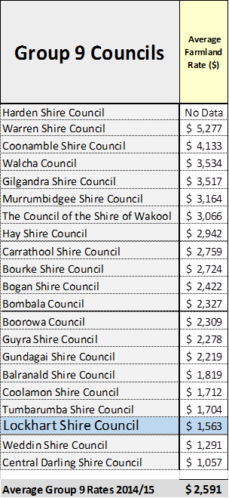  
Source: OLG – Time Series Data 2014/15

**Average Residential Rates Comparison 2014/15**

The following table compares Lockhart’s average residential rates for 2014/15 with other Group 9 Rural Councils:

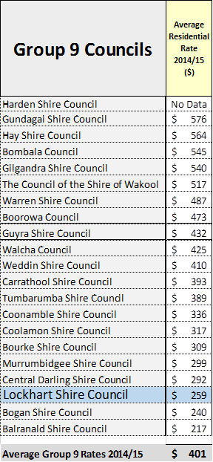  
Source: OLG – Time Series Data 2014/15

**Average Business Rates Comparison 2014/15**

The following table compares Lockhart’s average business rates for 2014/15 with other Group 9 Rural Councils:

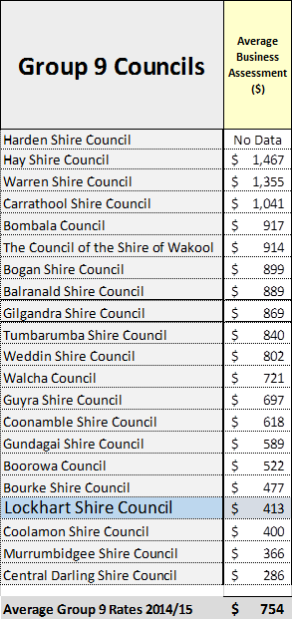  
Source: OLG – Time Series Data 2014/15

The SEIFA Index measures the relative level of socio-economic based on a range of Census characteristics.

Lockhart’s score ranks Council 102 in NSW by Local Government Area.

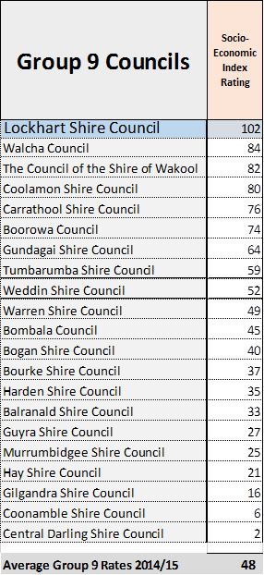   
Source: OLG – Time Series Data 2014/15

The summary OLG data for Group 9 Rural Councils is provided in Attachment 16.

**Community capacity to pay the increased rates**

Council’s outstanding rates ratio is significantly lower than other G9RCs at 3.95% compared to a group average of 9.85%.

Lockhart Shire’s SEIFA Index (Socio-Economic Indexes for Areas) of 999 is in the 68th percentile compared to other NSW Councils. ABS 2011 Census data shows that compared to Australia, Lockhart Shire residents have comparably higher levels of secondary and technical education. Lockhart residents aged 15 and over are more likely to be employed compared to the NSW and Australian percentages.

Lockhart residents have a much higher rate of outright home ownership at 48.1% compared to NSW at 33.2% and Australia at 32.1%. Lockhart Shire has almost half the percentage of rented dwellings at 16.5% compared to NSW at 30.1% and Australia at 29.6%. Both renters and home owners in Lockhart Shire are much less likely to be in mortgage or rental stress (where payments equate to 30% or greater of household income) compared to NSW and Australia.

Council has considered the potential for changes in the capacity of the community to pay rates at the SRV level over the period. Key considerations have been changes in demographics, economic development and growth, and funding sources.

Economic growth and increasing employment opportunities are two issues identified by Council in its SWOT analysis attached to its FFF Proposal. The Rock township has been identified as the urban area most likely to grow in future years due to closer proximity to Wagga Wagga, its recognition as a lifestyle alternative to living in a regional centre, and location on the Olympic Highway and the main southern rail line between Sydney and Melbourne. Council has taken steps to rezone land for industrial purposes, and examining the feasibility of sewerage extension. It is worth noting that any population growth expected in the northern end of the Shire will only negate overall population decline and result in neutral demographic changes.

Council proposes to increase its own sources revenue and one method proposed is an increased program of outsourcing labour and plant for external contracting works. Income for this method may result in minimal increases to own source revenue but will not impact Council’s reliance on rates over the SRV period. Additionally, any unforeseen decrease in grants or subsidies over the SRV period would impact reliance on rates although this is not assumed in the SRV period.

**COMMUNITY WILLINGNESS TO PAY THE INCREASED RATES**

Council consulted with the community over a period of 18 months to understand the community’s willingness to pay rates at the SRV level.

As part of the Fit For the Future process in April 2015, the community were informed of the improvement actions Council would have to implement to remain Fit For the Future as a sustainable independent Council. The key action that would impact ratepayers was an increase in rates through a Special Rate Variation to increase own source revenue. The community were actively consulted and involved in decision making, and 79% of the 118 people who attended the 5 community meetings voted in favour of supporting the Council Improvement Action Plan.

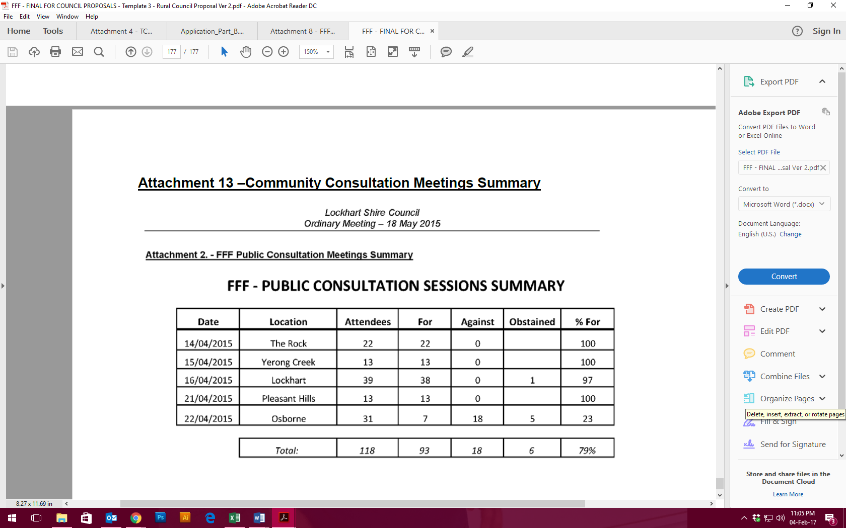  
Extract from Council’s Fit For the Future Proposal, outlining community involvement in the decision to increase own source revenue.

Additional community input was sought in October and November 2016 when Council implemented a community engagement plan to revise the Community Strategic Plan and gauge willingness of the community to apply for, and pay for, a Special Rate Variation. Five meetings were held across the Shire, with 72% of the 36 community attendees supporting the proposed rate variation. It is noted that attendance at these community meetings were low, and the vote count didn’t include council representatives at the meeting, or attendees of targeted and school sessions. Feedback from the community indicated that they felt that they had already addressed their support for the Special Rate Variation through earlier consultation (FFF April 2015).

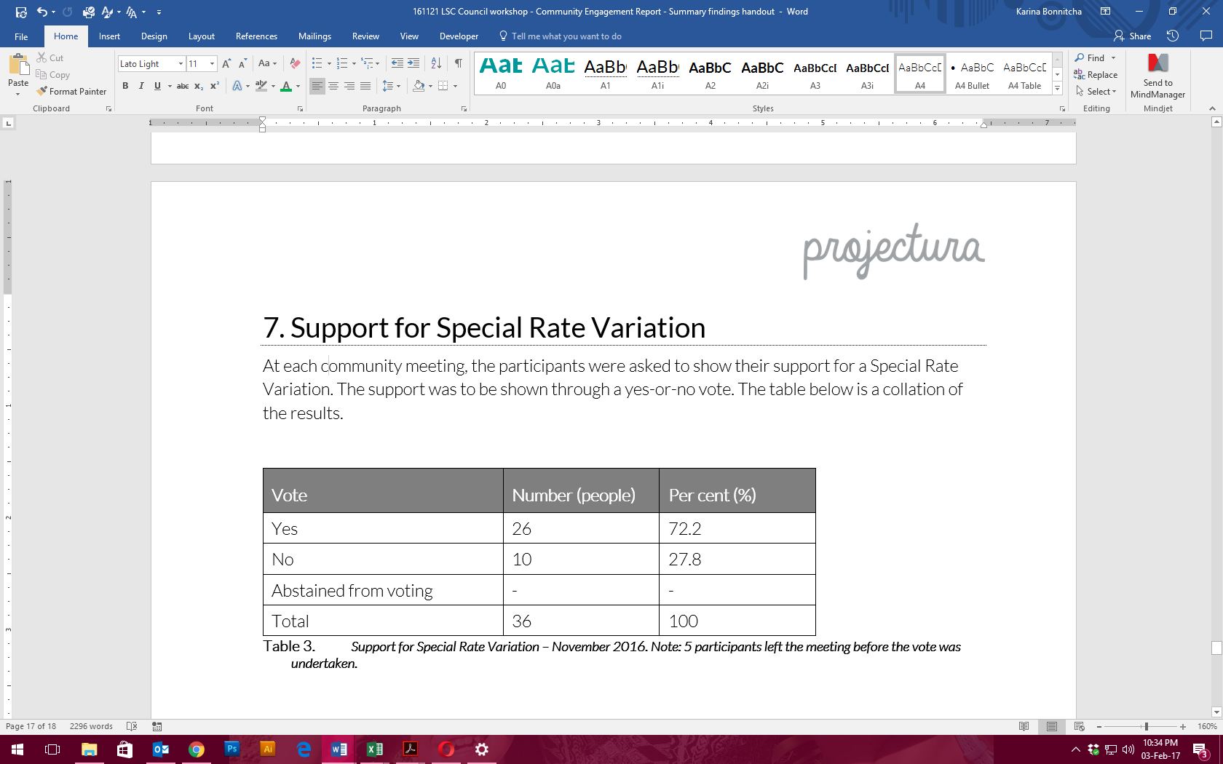  
Extract from IP&R/SRV Community Engagement Findings Report, Nov 2016

## Addressing hardship

In addition to the statutory requirement for pensioner rebates, most councils have a policy, formal or otherwise to address issues of hardship.

|  |  |  |
| --- | --- | --- |
| Does the council have a Hardship Policy? | Yes | No |
| If Yes, is an interest charge applied to late rate payments? | Yes | No |
| Does the council propose to introduce any measures to reduce the impact of the proposed special variation on specific groups in the community? | Yes | No |

You should attach a copy of the Hardship Policy and explain below who the potential beneficiaries are and how they are assisted.

Please provide details of any other measures addressing hardship to be adopted, or alternatively, explain why no measures are proposed.

The council is also to indicate whether the hardship policy or other measures are referenced in the council’s IP&R documents (with relevant page reference or extract provided).

Council’s approach to people suffering genuine financial hardship is addressed across two policies; its Pensioner Concession Policy and its Debt Recovery Procedures Policy, as outlined in Attachment 7a and Attachment 7b respectively.

**Potential beneficiaries**

The potential beneficiaries in the Debt Recovery Procedures Policy are ratepayers and debtors suffering genuine financial hardship, pensioners, and sundry debtors.

The prime beneficiaries in the Pensioner Concession Policy are eligible pensioners as defined by the Local Government Act 1993, and other people experiencing hardship in the Shire.

**How they are assisted?**

The Debt Recovery Procedures Policy states that where rates are outstanding, the ratepayer can work with Council Officers to arrange a mutual agreement when payment of rates would cause hardship.

The Pensioner Concession Policy states that eligible pensioners are able to apply for a concession to their rates. Applications are assessed and information is verified. The amount by which the rate and charges are reduced is determined by the ownership of the property. Once assessed, the applicant is notified in writing of Council’s decision.

Additional cases of hardship are considered on a case-by-case basis. Over the past four years, only one case of hardship has been presented to Council for consideration.

**Explain why no other measures addressing hardship will be adopted**

No other measures to address hardship will be adopted by Council, because: (1) the proposed rate increase is considered affordable by Council, and (2) Council’s existing hardship policy as outlined in the Debt Recovery Procedures Policy and the Pensioner Concession Policy addresses all hardship circumstances.

EXTRACT/PAGE REFERENCE - mention of Hardship Policy in LTFP

# Assessment criterion 4: Public exhibition of relevant IP&R documents

Criterion 4 in the Guidelines is:

*The relevant IP&R documents must be exhibited (where required), approved and adopted by the council before the council applies to IPART for a special variation to its general revenue.*

Briefly outline the significant IP&R processes the council has undertaken to reach the decision to apply for a special variation. Include the details of and dates for key document revisions, public exhibition period(s) and the date(s) that the council adopted the relevant IP&R documents.[3]

You should also include extracts from council minutes as evidence that the documents were adopted.

The council is reminded that the Community Strategic Plan and Delivery Program (if amended), require public exhibition for at least 28 days prior to adoption. Amendments to the Long Term Financial Plan and Asset Management Plan do not require public exhibition.[4] However, it would be expected that the Long Term Financial Plan would be posted, in a prominent location, on the council’s website.

The following outlines a history of the IP&R process to reach the decision to apply for a SRV:

* September 2016 - the new Council resolved to review the existing Community Strategic Plan with the community to ensure that its reflects the priorities, aspirations and challenges of the community. Council also reviewed the Council Improvement Action Plan and resolved to endorse the strategic actions and include them in the revised Integrated Planning and Reporting documentation accordingly.
* 1-31 October 2016 - Community engagement plan implemented. Included a community survey, five (5) community meetings, two (2) targeted sessions, and five (5) school sessions.
* 1-15 November 2016 – Preparation of IP&R documents.
* November 2016 - Council resolved to endorse the draft Community Strategic Plan documentation, place them on public exhibition until 20 January 2017, and consider any community feedback prior to them being resubmitted for adoption.
* 25 November 2016 – 20 January 2017 – Relevant IP&R documents on public exhibition. The documents on public exhibition included the Community Strategic Plan and the Delivery Program. An extended public exhibition period was allowed in acknowledgement of the Christmas/New Year holiday period. No public submissions were received.
* February 2017 - Council resolved to adopt the IP&R documentation.

Attachment 10 provides evidence of all the Council resolutions outlined above. Attachment 6 provides evidence of the resolution to apply for the proposed special variation.

# Assessment criterion 5: Productivity improvements and cost containment strategies

Criterion 5 in the Guidelines is:

*The IP&R documents or the council’s application must explain the productivity improvements and cost containment strategies the council has realised in past years, and plans to realise over the proposed special variation period.*

In this section, you must provide details of any productivity improvements and cost containment strategies that you have implemented during the last two years (or longer) and any plans for productivity improvements and cost containment over the duration of the proposed special variation.

These strategies, which may be capital or operational in nature, must be aimed at reducing costs and/or improving efficiency. Indicate if any initiatives are to increase revenue eg, user charges. Please include below whether the proposed initiatives (ie, cost savings) have been factored into the council’s Long Term Financial Plan.

Where possible, the council is to quantify in dollar terms the past and future productivity improvements and cost savings.

The council may also provide indicators of efficiency, either over time or in comparison to other relevant councils. We will make similar comparisons using various indicators and OLG data provided to us.

Lockhart Shire Council was determined as Fit For the Future (FFF) following the IPART assessment process undertaken. An integral part of Council’s 2015 FFF proposal was clearly demonstrating that Council has already implemented and will continue to implement operating efficiencies.

Council’s FFF improvement proposal outlined the following options (further details provided in Attachment 8.

* Option 1: Resource Sharing
* Option 2: Shared administration
* Option 3: Speciality services (N/A)
* Option 4: Streamlined governance
* Option 5: Streamlined planning, regulation and reporting
* Option 6: Service Review
* Option 7: Additional options identified by the Council (Special Rate Variation)

Lockhart Shire Council is committed to realising productivity improvements and cost containment strategies, with a focus on those highlighted in the Fit For the Future (FFF) Council Improvement Action Plan.

Detailed below are productivity improvements and cost containment strategies for the past two or more years, and for the proposed SRV period, which have been highlighted in Council’s Delivery Program (Attachment 2) and Long Term Financial Plan (Attachment 3).

**Past two years**

Over the last few years Council has achieved productivity efficiencies equating to over $1.36M per annum through resource sharing, streamlining governance, undertaking service reviews and purchasing additional plant. These productivity improvements and cost containment strategies are outlined in Council’s Delivery Program and Long Term Financial Plan.

**Term of the proposed SRV**

Council understands that it is critical to continue its commitment to the implementation of its Council Improvement Action Plan and maintain and improve its financial sustainability.

Over the term of the SRV, Council proposed a number of productivity improvements and cost containment strategies. These efficiencies should equate to savings of an additional $137K over the SRV period, plus one off savings of $405,000. These productivity improvements and cost containment strategies are outlined in Council’s Delivery Program and Long Term Financial Plan.

A summary of the identified productivity improvements and cost containment strategies was included on page 10 of the Delivery Program and provided in extract form below. The full list of productivity improvements and cost containment strategies are provided in Attachment 14.

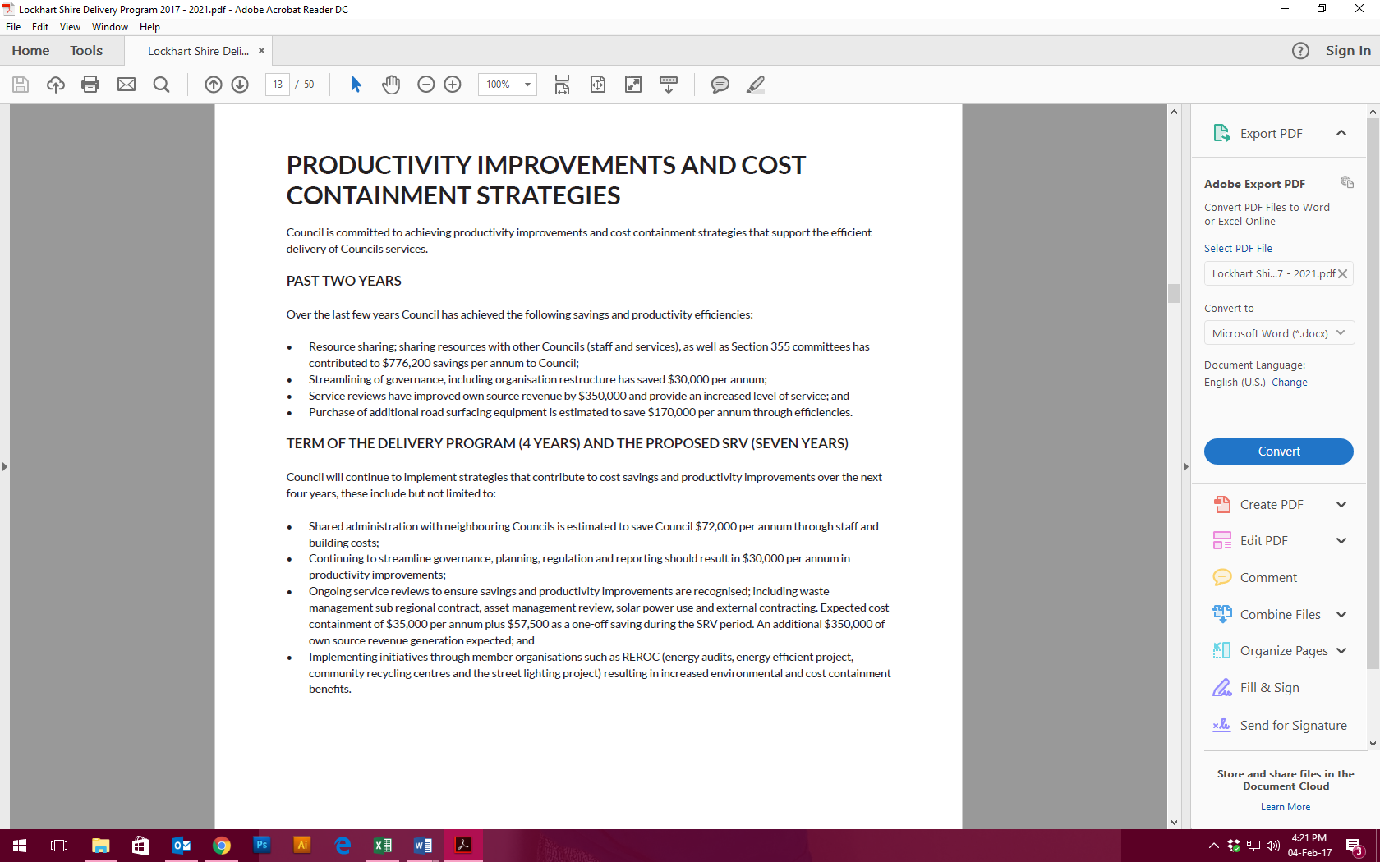  
Extract of the Delivery Program 2017-2021, page 10

# List of attachments

The following is a list of the supporting documents to include with your application.

Some of these attachments will be mandatory to all special variation applications (eg, extracts from the Community Strategic Plan).

Other attachments will be required from some, but not all, councils. For example, extracts from the Asset Management Plan would be required from a council seeking approval of a special variation to fund infrastructure.

Councils should submit their application forms and attachments online through the Council Portal in the following order. Councils may number the attachments as they see fit.

|  |  |
| --- | --- |
| Item | Included? |
| **Mandatory forms and Attachments** |  |
| Part A Section 508A and Section 508(2) Application form (Excel spreadsheet) |  |
| Part B Application form (Word document) – this document |  |
| Relevant extracts from the Community Strategic Plan |  |
| Delivery Program |  |
| Long Term Financial Plan with projected (General Fund) financial statements (Income, Cash Flow and Financial Position) in Excel format |  |
| NSW Treasury Corporation report on financial sustainability |  |
| Media releases, public meeting notices, newspaper articles, fact sheets relating to the rate increase and proposed special variation |  |
| Community feedback (including surveys and results if applicable) |  |
| Hardship Policy |  |
| Resolution to apply for the proposed special variation |  |
| Certification (see Section 9) |  |
| **Other Attachments** |  |
| Relevant extracts from the Asset Management Plan |  |
| Past Instruments of Approval (if applicable) |  |
| Resolution to adopt the revised Community Strategic Plan (if necessary) and/or Delivery Program |  |
| Other (please specify) |  |

|  |  |
| --- | --- |
| Item | Location |
| **Mandatory forms and Attachments** |  |
| Part A Section 508A and Section 508(2) Application form (Excel spreadsheet) | Part A |
| Part B Application form (Word document) – this document | Part B |
| Relevant extracts from the Community Strategic Plan | Attachment 1 |
| Delivery Program | Attachment 2 |
| Long Term Financial Plan with projected (General Fund) financial statements (Income, Cash Flow and Financial Position) in Excel format | Attachment 3a |
| NSW Treasury Corporation report on financial sustainability | Attachment 4 |
| Media releases, public meeting notices, newspaper articles, fact sheets relating to the rate increase and proposed special variation | Attachments 5c, 5d, 5e, 11 and 12 |
| Community feedback (including surveys and results if applicable) | Attachment 5b and 5f |
| Hardship Policy | Attachments 7 |
| Resolution to apply for the proposed special variation | Attachment 6 |
| Certification (see Section 9) | Attachment 9 |
| **Other Attachments** |  |
| Relevant extracts from the Asset Management Plan | Attachment 15 |
| Past Instruments of Approval (if applicable) | - |
| Resolution to adopt the revised Community Strategic Plan (if necessary) and/or Delivery Program, and other relevant minutes | Attachment 10 and 17 |
| Other (see below) | - |
| Long Term Financial Plan – pdf version | Attachment 3b |
| Community Engagement Plan | Attachment 5a |
| FFF Council Improvement Action Plan | Attachment 8 |
| Lockhart and The Rock Swimming Pools Assessment Report | Attachment 13 |
| Productivity improvements and cost containment strategies | Attachment 14 |
| Office of Local Government Group 9 Rural Councils comparable data | Attachment 16 |

# Certification

**APPLICATION FOR A SPECIAL RATE VARIATION**

**To be completed by General Manager and Responsible Accounting Officer**

Name of council: Lockhart Shire Council

We certify that to the best of our knowledge the information provided in this application is correct and complete.

General Manager (name): Peter Veneris

Signature and Date:

Responsible Accounting Officer (name): Craig Fletcher

Signature and Date:

Once completed, please scan the signed certification and attach it as a public supporting document online via the Council Portal on IPART’s website.

1. See Planning Circular 10-025 dated 24 November 2010 at [www.planning.nsw.gov.au](http://www.planning.nsw.gov.au) and for the most recent Direction issued under section 94E of the *Environmental Planning and Assessment Act 1979*. See also Planning Circular PS 10-022 dated 16 September 2010.
2. <https://www.ipart.nsw.gov.au/Home/Industries/Local-Government/For-Councils/Apply-for-a-special-variation-or-minimum-rate-increase>
3. The relevant IP&R documents are the Community Strategic Plan, Delivery Program, Long Term Financial Plan and where applicable, the Asset Management Plan.
4. Office of Local Government (then Division of Local Government), *Integrated Planning and Reporting Manual for local government in NSW*, March 2013, pp 5-6.