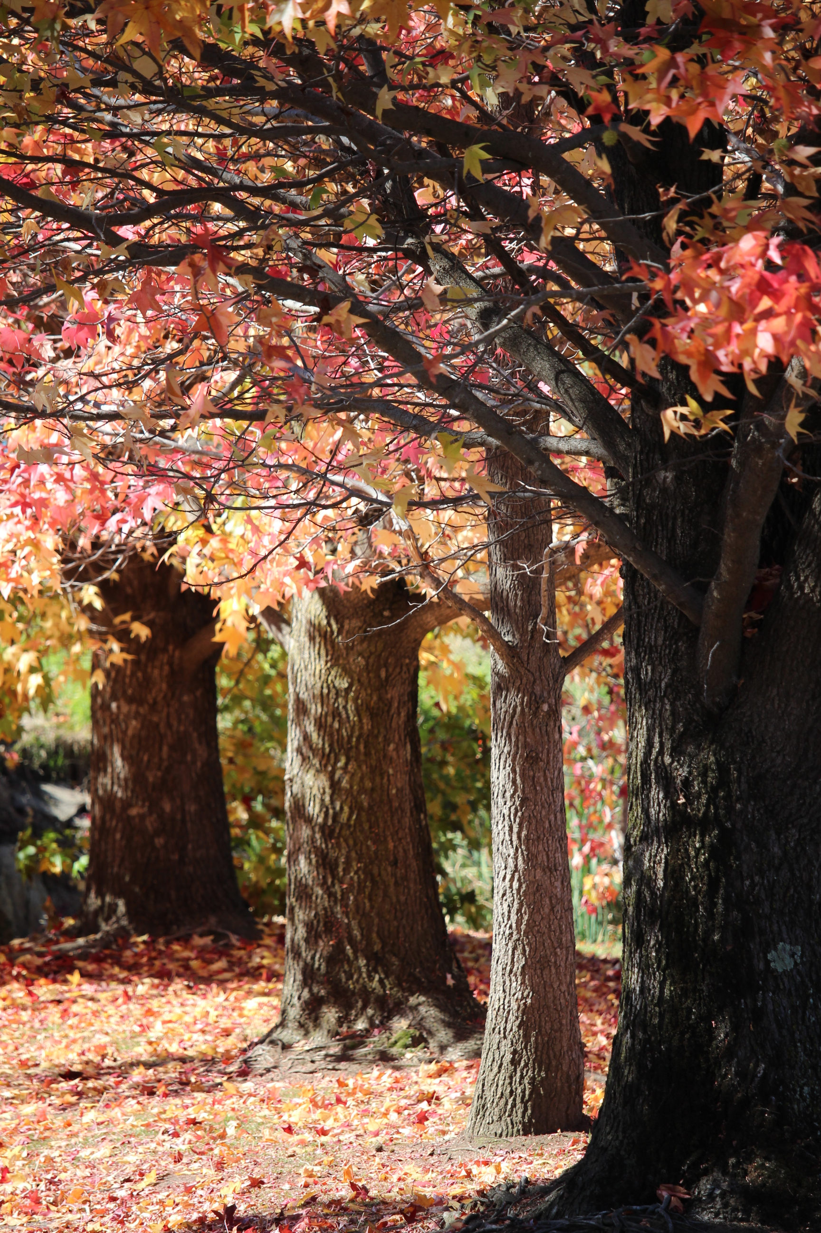

**Fit for the Future Program**

**Submission – 30 June 2015**

**URALLA SHIRE COUNCIL**

**Submission – 30 June 2015**

TABLE OF CONTENTS

EXECUTIVE SUMMARY 3

SCALE AND CAPACITY 5

ABOUT URALLA SHIRE COUNCIL 9

KEY CHALLENGES AND OPPORTUNITIES 11

PERFORMANCE AGAINST FIT FOR THE FUTURE BENCHMARKS (2011/12 - 2013/14) 13

IMPROVEMENT STRATEGIES – SUSTAINABILITY 20

IMPROVEMENT STRATEGIES – INFRASTRUCTURE & SERVICES 26

IMPROVEMENT STRATEGIES - EFFICIENCY 27

IMPROVEMENT ACTION PLAN 29

OTHER OPTIONS CONSIDERED 34

FORECAST PERFORMANCE AGAINST BENCHMARKS 36

IMPLEMENTATION OF THE IMPROVEMENT PROGRAM 38

WATER AND SEWERAGE UTILITY PERFORMANCE 39

ATTACHMENTS 40

# EXECUTIVE SUMMARY

The Independent Local Government Review Panels final report into revitalising NSW local government identified Uralla Shire Council as a Group D Council in its recommendations for non-metropolitan Councils. Group D is identified as *potential merger partners for Group B and C Councils*. More specifically Uralla Shire Council was recommended for a merger with Walcha Council who were identified in Group B.

In the time since a number of reports were completed that directly informed the Independent Local Government Review Panels findings, Uralla Shire Council has developed and implemented improvement strategies that have resulted in considerable progress being made in moving Council towards a more robust and sustainable organisation.

Accordingly the analysis undertaken on 2011/12 financial and infrastructure data by T-Corp and the Department of Local Government in their previous reports would have markedly different results if undertaken on Uralla Shire Councils financial and infrastructure results across the most recent three (3) financial years.

This is supported by the fact that **Uralla Shire Council currently meets 6 of the 7 Fit for the Future sustainability criteria** already **and will meet all 7 criteria by the 2016/17 financial year**.

As part of the Fit for the Future program Council undertook a rigorous community engagement program in-line with its Community Engagement Strategy and the public participation and social justice principles. The program was developed to firstly inform the community of what the program was about; to have frank discussions about Councils current sustainability position; to communicate the various options available (even more broadly than the panel’s recommendation); and ultimately to obtain the communities preferred options when developing Uralla Shire Councils strategies for the future.

Prior to the announcement of the Fit for the Future program in September, Council had already committed to a major project of rebuilding all of its Integrated Planning and Reporting documents in 2014/15 and resultantly Council was able to run this project directly in parallel with the fit for the future program.

The timing of this was extremely fortunate to inform robust discussion with the community as it allowed the community to be very well briefed about Councils current and projected future position, what opportunities were available to alter policy and/or service level settings, and what resourcing opportunities/consequences would be attached to any and all options.

The community engagement program culminated in a survey that was distributed to every mailing address in the shire along with a background information sheet. All data and the survey were also available for viewing and completion electronically via Council’s website.

The results of the survey were very conclusive, with the key themes as follows:

* Over 400 submissions were received from a population of 6300;
* 92% of respondents wanted Council to remain independent and not pursue a voluntary merger;
* Of the respondents who wanted Council to remain independent, 94% committed to some level of special rate variation to return Councils operating result before capital grants into surplus;
* Almost 70% of those respondents stated that a special variation of between 10 and 20 percent was acceptable to return Councils operating result before capital grants into surplus;
* A number of service areas were identified for review of their current service levels as a part of achieving the operating performance ratio benchmark.

The timing of the Integrated Planning and Reporting suite rebuild has also afforded Council the opportunity to construct new integrated strategic plans that commit Council and the community to a number of programs and policy positions that will see Council continue to increase its capacity and capability; move into a sustainable position in the short term and then continue to build on this position and the prosperity of our community in the mid and longer terms.

The headline improvement strategies identified by Uralla Shire Council include:

* The continuing implementation of Councils Organisation Development Strategy and related Action Plan to further build on Council organisation capacity and capability;
* The undertaking of major service reviews for a number of targeted service areas during the 2014/15 and 2015/16 financial years;
* The implementation of a rolling service review program to be undertaken on all service areas at least once during every four year cycle;
* The complete review of all Business Plans and strategies for Council’s commercial business undertakings;
* A further review of all of Council’s User Fees and Charges in 2015/16 to ensure that income is maximised as much as possible under a revised user pays philosophy;
* A further investigation of expanded opportunities for resource sharing or joint tendering with neighbouring and other regional Councils;
* The implementation of a number of systems to maximise automation and improve Council’s data collection and business intelligence capabilities;
* The ongoing implementation of Council’s Workforce Management Strategy and the targeted actions contained therein;
* The preparation for and submission of a special rate variation application in the 2015/16 financial year, to come into effect in 2016/17. This rate increase is currently estimated at 15% in Council’s Long Term Financial Plan, however, other efficiency programs being implemented in 2015/16 may see this figure reduced further by the time the final submission is completed.

Accordingly, Uralla Shire Councils submission to the fit for the future program is for Council to finalise the implementation of its on-going improvement strategies and to **remain as a proud, strong and independent Council.**

# SCALE AND CAPACITY

The Independent Local Government Review Panel’s recommendation for Uralla Shire Council was for a merger with Walcha Council, however, Walcha was also given the recommendation of becoming a Rural Council.

Uralla and Walcha councils have a strong working relationship and accordingly numerous meetings have taken place between Uralla and Walcha Councils since the announcement of the Fit for the Future program to specifically discuss the panel’s recommendation, the feasibility of such a move (social, economic and environmental), other opportunities to share resources and the views of our communities with regard to all such options.

Accordingly it was agreed very early on that both Councils should more broadly undertake investigation into all possible options for the respective Councils, (as the options are slightly different for each), and then utilise that information to inform and engage our respective communities in a factual, not emotional, discussion about what they see as the best option for the short and long term sustainability of their communities.

Following this Uralla Shire Council undertook an extensive analysis of the performance, position and sustainability of all four (4) Councils located within the broader New England region. The analysis took into consideration the results of all of the Councils against the Fit for the Future criteria from data taken from their respective annual financial statements, as well as a number of other identified key sustainability criteria.

Other key data comparisons that were utilised in the analysis included:

* Total cash and investments and unrestricted cash balances;
* Employee Leave Entitlement accrued and their degree of cash backing;
* Receivable amounts and outstanding collection percentages;
* Fair value and written down value of assets and % of asset remaining life;
* Financial analysis of the respective Water and Sewer operations.

This data was then utilised to run scenarios by combining the figures for every possible combination of council groupings within the New England area, including:

Uralla and Walcha; Uralla and Walcha and Armidale; Uralla and Walcha and Armidale and Guyra; Uralla and Armidale; Uralla and Guyra and Armidale.

Information was then also collated for all of the possible scenarios on:

* Combined population, combined area and combined scale;
* Estimates on economy of scale savings and formation costs;
* Expected positive and negative outcomes;
* Future representation and organisation structure;
* Relationship to regional organisations and Joint Organisations;
* State Seat boundaries and potential future boundary adjustments.

The findings of all of the analysis was then reported to Council and the community through an open report to the February Ordinary Council meeting. The Council then resolved to undertake a comprehensive engagement program utilising all of the collected information to inform the community prior to them completing a set survey in order to gauge the broad views of the entire community.

Following press releases, newsletter inserts, mail-outs to all residences, various web-content and community workshops Council received over 400 completed surveys. The response from the survey was **overwhelmingly (92%) in favour of Uralla Shire Council remaining independent and not pursuing a voluntary merger**.

At the same time Walcha Council had undertaken analysis of their own options and presented this to their community before undertaking a community survey of their own. Their survey showed that 84% of all respondents wished to remain independent and not pursue a voluntary merger and that they also preferred to take up the option of becoming a Rural Council.

Following the finalisation of these results **both Councils acknowledged that there was no community mandate or will to pursue a voluntary merger** between the two Councils.

Due to the fact that Uralla Shire Council currently meets 6 of the 7 Fit for the Future criteria and has strategies developed to meet the last outstanding ratio by 2016/17, Council and the community believe that this exemplifies that considerable capacity is already present.

In order to further illustrate the current and growing capacity of Uralla Shire Council, summary points have been detailed below against the assessment areas outlined by the independent review panel in their final report.

1. Robust revenue base and discretionary spending

* Council’s own source revenue ratio over the previous 3 year period has averaged 61.8%;
* Council makes allowance in its budget for an annual discretionary expenditure allocation;
* Council ran its largest ever capital works program in 2014/15 of almost $8 million;
* Councils 2015/16 capital works program totals $5 million and contains over $4 million is renewal and replacement projects plus over $500,000 on new sporting, recreation and community facilities.

1. High quality leadership and the ability to employ a wide range of skilled staff

* Council has an experienced and highly dedicated group of elected leaders who are well ingrained in the local community and in tune with the interests of the broad shire community;
* Council undertook a restructure of its senior executive staff in the previous 12 months and resultantly have now recruited a highly skilled, experienced and energetic senior executive to lead the organisation. Councils executive reverses the trend of NSW Local Government with its predominantly female make-up (60%) and an average age of 45;
* Key leadership members and their previous experience include:

Chief Financial Officer – previous education sector CEO and accounting firm partner;

Executive Infrastructure & Regulation – Engineer with over 30 years LG experience;

Executive Community & Culture – previous health sector CEO;

Executive Governance & Information – previous Federal Government Manager;

Executive Human Services – previous private sector Human Resources Manager;

Manager Planning & Regulation – Town Planner with over 20 years LG experience.

1. Advanced strategic planning and policy development skills

* Councils entire IP&R suite has been reconstructed in the previous 12 months;
* Major organisation development strategy has been developed and begun implementation in the previous 12 months;
* Strategic business plans for all of Councils services have been constructed for the first time in the previous 12 months;
* Considerable strategic planning and policy development skills reside in Councils senior management with vast experience in this regard from the Local Government, Federal Government, Health, Education and Private sectors.

1. Knowledge, creativity and innovation

* Uralla is the model in a pilot currently being finalised for the construction of an Australia first case study to become fully self-sustainable – or zero net energy. The Z-Net project is expected to be able to be used as a blue-print that can be rolled-out in other localities similar to what has been achieved in Germany.
* Uralla Council has an established Memorandum of Understanding for the provision of Community Care and Support services (delivered on behalf of the State and Federal governments) with two other Councils in the region which delivers considerable benefits and economies to all parties as well as giving the group a foot-print which covers the entire New England/North West region.
* Uralla Shire Council has a number of shared service delivery arrangements with other regional Councils, including Ranger and Regulatory services; a shared internal Audit Committee; Waste Collection and Recycling.
* Uralla Shire Council is a long standing member of Namoi Councils and is an associate member of the current pilot program for Joint Organisations of Councils.

1. Scope to undertake major projects and new functions

* Recent major project completion includes the $4.2 million replacement of the Emu Crossing Bridge and associated road realignment. This major construction project was delivered from design to completion, before time and on budget.
* Uralla Council runs a major Community Care and Support department, delivering service contracts into the regional community on behalf of the state and federal governments. In the past 12 months Council has picked up a number of new contracts referred to Council by the relevant agencies from other providers.

1. Resources to cope with complex and unexpected change

* Uralla Shire Council has undertaken major service delivery and organisational change over the last few years following the release of the independent panels report and the recruitment of a new General Manager. Accordingly Uralla Shire Council has recent experience in not only coping with unplanned change but has evolved and developed systems and approaches to be able to manage change and embrace the opportunities that it provides.
* By addressing all of the fit for the future criteria by 2016/17 Council will be in a position to continue to build resources to cope with unexpected change and deal with unavoidable business or political shocks as and when they arise.

1. Effective regional collaboration, advocacy and partnering with State and Federal Governments.

* Uralla Shire Council is a long standing member of Namoi Councils and is an associate member of the current pilot program for Joint Organisations of Councils.
* Uralla Shire Council played a leadership role in the recent establishment of the New England Organisation of Councils, utilising its experience as a member of Namoi Councils.
* Council is currently partnered with State and Federal Government on numerous projects, including; Zero Net Energy- pilot site, National Disability Scheme – system trial site, Emu Crossing Bridge construction, Electronic Housing Code and D/A’s online.

Council is also of the opinion that a merger of Uralla Shire Council, population 6300, and Walcha Council, population 3100, would not result in any meaningful change in scale with a combined population still below 10,000.

Other complications of such a merger include a political environment were the resultant merged entity would be split across two state electorates (Northern Tablelands and Tamworth) two health clusters and two local area commands.

However, even though both the Uralla and Walcha communities believe that a straight merger is not the best way forward we have made major steps in exploring opportunities to  further expand our sharing of services and joint contracting.

Since the release of the Fit for the Future program and as a benefit of our existing relationship we have now implemented a joint Ranger and Regulatory function and a shared independent audit and risk function to add to our already shared waste collection and recycling services.

Collaboration between the Councils to identify other resource sharing opportunities continues and milestones are outlined in the improvement plan section of this submission.

# ABOUT URALLA SHIRE COUNCIL

Uralla Shire Council is located in the beautiful New England Region with its enviable lifestyle choices, climate, quality of services and close proximity to major regional centres and the NSW North Coast. Uralla Shire Council covers an area of approximately 3,229.8km2 and has a rapidly growing population of 6,310.

Uralla is ideally located 10 minutes from a regional airport with two carriers flying direct to Sydney and is on the intersection of two major road freight and transport routes.

Uralla is also 20 minutes from the regional city of Armidale which contains the University of New England and an unparalleled range (outside of the metro area) of choice in education, including three private boarding schools. Uralla is also 50 minutes drive from the major regional city of Tamworth.

Uralla Shire Council is a large and diverse organisation employing over 150 staff and responsible for assets totalling over $300 million, 32 different services areas and a total annual budget of approximately $20 million.

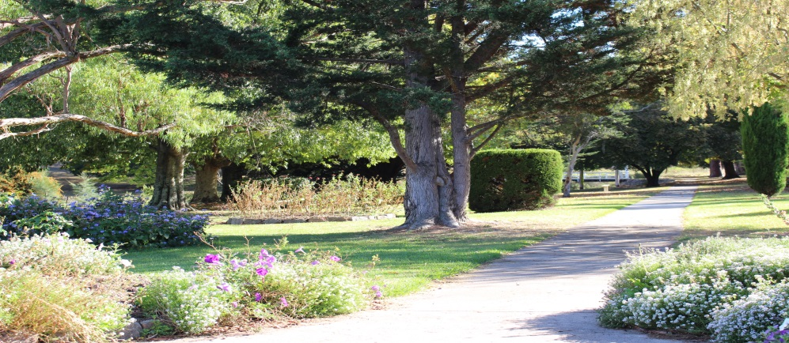

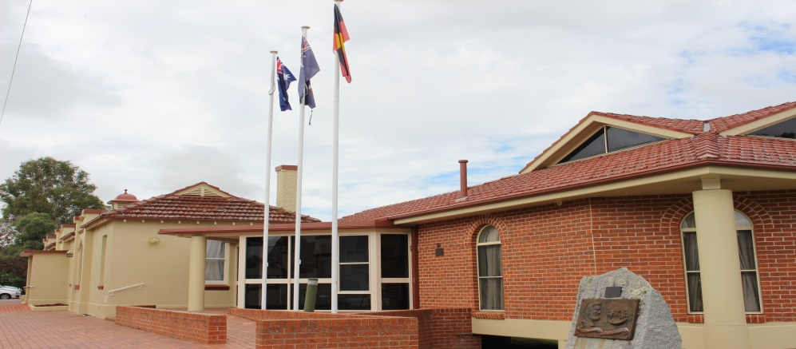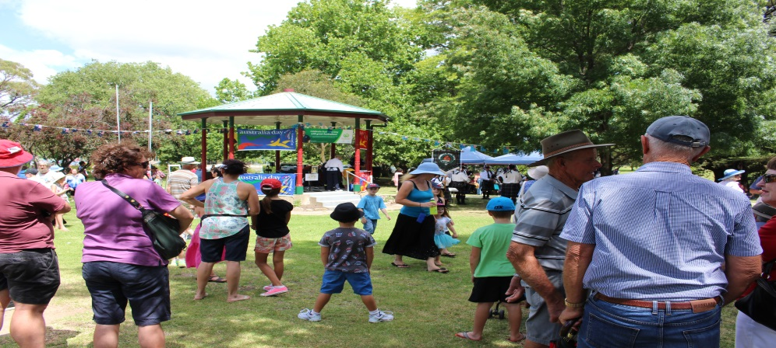

|  |  |  |
| --- | --- | --- |
| **OUR PEOPLE**  Five year population change (%)  Population aged 19 or less (%)  Population aged between 20 & 59 (%)  Population aged above 60 (%)  Aboriginal & Torres Strait Islanders (%)  Language Spoken Other than English (%)  Socio-Economic Index Rank (1 low. 152 high) | **LGA**  5.9  27.3  49.2  23.5  6.0  2.2  94 | **GROUP AVG**  1.7  25.9  47.4  26.7  7.9  2.6  n/a |
| **URALLA SHIRE COUNCIL**  Councillors (No.)  Population per Councillor (No.)  Equivalent Full Time Staff (EFT) (No.)  Residential Pensioner Rebates (%)  Population Density (residents per km2) | **LGA**  9  701  110  27  1.94 | **GROUP AVG**  9  835  108  25  1.8 |
| **OUR ECONOMY**  SALM Unemployment Rate (%)  Avg Taxable Income ($)  Avg Household Family Size (No.)  Largest Industry Employer  Active Businesses in LGA (No.) | **LGA**  5.1  34,090  3.0  Agriculture, Forestry  & Fishing  662 | **GROUP AVG**  5.5  34,729  2.9  Agriculture, Forestry  & Fishing  851 |
| **OUR PUBLIC FACILITIES**  Public Swimming Pool Complexes (No.)  Public Halls (No.)  Public Libraries (No.)  Open Public Space (ha)  Total Road Length (km)  Access to Internet at Home (%) | **LGA**  1  2  2  55  961.1  69.5 | **GROUP AVG**  2  7  2  151  1606.1  61.4 |
| **OUR RATES & CHAGES**  Avg Ordinary Residential Rate ($)  Avg Ordinary Business Rate ($)  Avg Ordinary Farmland Rate ($)  Typical Residential Water and Sewer Bill  (including usage) ($)  Avg Domestic Waste Charge ($)  Outstanding Rates & Annual Charges (%) | **LGA 2014/15**  672.23  618.68  3363.69  n/a  211.02  5.5 | **GROUP AVG 2012/13**  516.92  1,196.86  2,257.70  89,571.68  270.75  9.2 |

# KEY CHALLENGES AND OPPORTUNITIES

**Strengths**

1. Council’s current sustainability position – already achieving 6 of 7 FFTF benchmarks;
2. Rapidly growing population and residential land development – 5.9% growth rate;
3. Existing working relationships with other Councils from throughout the region – particularly strong relationship with Walcha and established service sharing already in place;
4. A committed Council prepared to make strong strategic decisions for the betterment of the broad community;
5. An established focus on capacity and capability building – ongoing implementation of Council’s Organisation Development Strategy and Action Plan;
6. Community satisfaction levels and support – detailed in community surveys;
7. A proven record of recent major project delivery - $4.2 million Emu Crossing bridge and major road realignment construction project in 2014/15;
8. A diversified organisation – various business undertakings allow Council to be able to get greater scale and distribute overheads across a broader base;
9. Robust and growing alternate sources of revenue – Large and diverse community support department with regional footprint;
10. A young population – a higher % of young and middle aged residents compared to regional NSW;
11. A skilled and experienced senior executive;
12. The ability to retain and attract skilled staff;
13. Strong socio-economic index for areas ranking – SEIFA ranking of 94 (1 low, 152 high);
14. Low average rate and annual charges levels – below Council grouping average;
15. Location and proximity to major freight and transport mediums;
16. Security of water supply;
17. Negligible infrastructure backlog –1.67% and declining;
18. Capacity to access funds when required- Low debt service ratio – 1.56%.

**Weaknesses**

1. General Fund Operating performance ratio (-6.6%);
2. Office of Local Government Infrastructure Audit 2011 identified Councils asset systems as weak;
3. Lack of an established regional organisation of Councils in the New England and the current absence of a robust sustainable regional centre;
4. Unrestricted cash reserves – reserves need to continue to be built;
5. Depth of specialist skilled staff resources – reliance on key positions and minimal coverage;
6. Availability and competition of specialist service providers.

**Opportunities**

1. Further economies of scope from service sharing and joint tendering;
2. Capacity for increased return from current commercial undertakings;
3. Continuing rapid population growth driven by lifestyle, location and affordability;
4. Local jobs growth in light industry – new industrial land development, cost effective and national highway frontage;
5. Well placed to take advantage of the new National Disability Scheme (NDS) – robust community support contracts have been extended and strategy to grow;
6. Growing the New England Group of Councils from its current infancy into a mature regional collaboration and advocacy vehicle;
7. Scope for dividends to be returned from Water and Sewer operations.

**Threats**

1. Removal of Water and/or Sewer operations from Councils management;
2. Failure to obtain modelled Special Rates Variation approval;
3. Failure to realise modelled cost reduction and profitability improvement programs.

# PERFORMANCE AGAINST FIT FOR THE FUTURE BENCHMARKS (2011/12 - 2013/14)

**Sustainability Benchmarks**



The operating performance benchmark is not currently met. All other FFTF criteria have continued to be met by utilising capital grants and reserves to ensure that infrastructure renewal and maintenance requirements are delivered. This is not a feasible long term approach and it is not sustainable to post any further operating deficits and accordingly a combination of efficiency programs; revenue maximisation; review of service levels; and an increase in rates have been modelled into Councils integrated strategic plans, supported by the community and are being implemented in 15/16 to rectify this ratio and return the General Fund operating result to surplus.





**Infrastructure and Service Management Benchmarks**







**Efficiency Benchmark**



# IMPROVEMENT STRATEGIES – SUSTAINABILITY













IMPROVEMENT STRATEGIES – INFRASTRUCTURE & SERVICES

# IMPROVEMENT STRATEGIES - EFFICIENCY





# IMPROVEMENT ACTION PLAN







**Development of the Action Plan**

Council’s improvement program and action plan were constructed internally by Council’s senior staff and reviewed and adopted by the full Council.

Council undertook community workshops and surveys as part of the engagement program associated with the FFTF program which identified clear themes on the community’s preferences for addressing Councils operating performance ratio improvement and other sustainability improvements more broadly. This engagement program and the data collected informed the approaches taken and actions identified in the development of this action plan.

The majority of actions in the plan were identified during the project to rebuild Council’s Integrated Planning and Reporting suite of documents conducted over the previous 12 months and resultantly integrates this improvement program with the recently adopted revised suite of strategic documents.

Council’s Organisation Development Strategy and Action Plan which were developed and begun implementation in the previous financial year also informed this action plan. The development strategy was developed through consultation with all of Councils business unit managers and feedback from staff.

A number of Council workshops have been conducted at regular intervals throughout the FFTF program and the development of Councils submission to inform and consult Councillors throughout the process. Council also conducts monthly briefing sessions for Councillors at which the FFTF program has been a standing agenda item since September.

A report was presented to the October 2014 Ordinary Meeting of Council detailing the Fit for the Future Program, analysing the implication to Council, the deliverables required and to ultimately adopt an approach to look at all available options in addressing the programs requirements.

Another report and major analysis was presented to the February Ordinary Council Meeting and a multi-point resolution was passed with regard to Councils continuing approach to the program and development of the draft submission and subsequent community engagement program to be conducted.

In late March and early April Council undertook a rigorous community engagement program with regard to the fit for the future program, including newsletter inserts, press releases, advertising, web content, a mail-out to all residential addresses, community workshops at Uralla and Bundarra and then a community survey, both on-line and paper based.

Headline results of the community workshops and community survey were published in the local newspaper, reported on regional television and provided in the resident’s monthly newsletter.

A further report was presented to the June Ordinary Council Meeting held on the 22nd of June which presented the final draft FFTF submission and was subsequently adopted by Council.

# OTHER OPTIONS CONSIDERED

Merger with Walcha Council

In accordance with the requirements of the Fit for the Future program Councils initial investigations surrounded discussions with Walcha Council to address the recommendation that was made by the Independent Local Government Review Panel for the two Councils to merge.

After two initial meetings between the Mayors and General Managers of the two Councils it was agreed that both Councils should more broadly undertake investigation into all possible options for their respective Councils, (as the options are slightly different for each), and then utilise that information to inform and engage our respective communities in a factual, not emotional, discussion about what they see as the best option for the short and long term sustainability of their communities.

Following this Uralla Shire Council undertook an extensive analysis of the performance, position and sustainability of all four (4) Councils located within the entire New England region. The analysis took into consideration the results of all of the Councils against the Fit for the Future criteria from data taken from their respective annual financial statements, as well as a number of other identified key sustainability criteria.

Other key data comparisons that were utilised in the analysis included:

* Total cash and investments and unrestricted cash balances;
* Employee Leave Entitlement accrued and their degree of cash backing;
* Receivable amounts and outstanding collection percentages;
* Fair value and written down value of assets and % of asset remaining life;
* Financial analysis of the respective Water and Sewer operations.

This data was then utilised to run scenarios by combining the figures for every possible combination of council groupings within the New England area, including:

Uralla and Walcha; Uralla, Walcha and Armidale; Uralla, Walcha, Armidale and Guyra; Uralla and Armidale; Uralla, Guyra and Armidale.

Information was then also collated for all of the possible scenarios on:

* Combined population, combined area and combined scale;
* Estimates on economy of scale savings and formation costs;
* Expected positive and negative outcomes;
* Future representation and organisation structure;
* Relationship to regional organisations and Joint Organisations;
* State seat boundaries and potential future boundary adjustments.

The findings of all of the analysis was then reported to Council and the community through an open report to the February Ordinary Council meeting (attached). The Council then resolved to undertake a comprehensive engagement program utilising all of the collected information to inform the community prior to them completing a set survey in order to gauge the broad views of the entire community.

Following press releases, newsletter inserts, mail-outs to all residences, various web-content and community workshops, Council received over 400 completed surveys. The response from the survey was overwhelmingly (92%) in favour of Uralla Shire Council remaining independent and not pursuing a voluntary merger.

At the same time Walcha Council had undertaken analysis of their own options and presented this to their community before undertaking a community survey of their own. Their survey showed that 84% of all respondents wished to remain independent and not pursue a voluntary merger and that they also preferred to take up the option of becoming a Rural Council.

Following the finalisation of these results **both Councils acknowledged that there was no community mandate or will to pursue a voluntary merger** between the two Councils.

However, even though both the Uralla and Walcha communities believed that a straight merger was not the best way forward it was decided to explore, and resultantly we have taken steps in exploring opportunities, to further expand our sharing of services and joint contracting.

As a benefit of our existing relationship we have now implemented a joint Ranger and Regulatory function and a shared Audit and Risk function to add to our already shared waste collection and recycling services.

Collaboration between the Councils to identify other resource sharing opportunities continues and milestones have been outlined in the improvement plan section of this submission.

Major Service reduction or discontinuation

The option to undertake major service reductions or discontinuation of a service/s was explored with the community during the FFTF community engagement program and a section of Councils community survey was dedicated to this issue.

Resultantly there was negligible support for this option, nor any consensus on a specific service area to be discontinued or altered considerably. In fact the considerable majority of survey respondents indicated that they would be prepared to pay an increase in rates of between 10% and 20% to assist in eliminating councils general fund deficit rather than majorly reduce or discontinue current services.

Accordingly, Council didn’t proceed with the option to discontinue or majorly reduce any services.

Council has utilised the survey responses to identify some service areas to be prioritised for targeted review in order to identify possible reduction in net cost without majorly impacting on service levels. These targeted reviews have been included in the FFTF Improvement Program and Action Plan.

# FORECAST PERFORMANCE AGAINST BENCHMARKS



**Position against FFTF Benchmarks at 2019/20 (3 year average results).**



# IMPLEMENTATION OF THE IMPROVEMENT PROGRAM

* Project Sponsor – Council
* Overall Project Manager – General Manager
* Action Delivery Managers – Executive Management Team

Council is responsible for allocating the appropriate resources to deliver Councils Improvement Program and Action Plan.

The General Manager will provide reporting on the progress in delivery of the Improvement Program to Council on a six monthly basis. The report will detail progress made against each of the Action Plan items.

A section of Councils Annual Report will also be dedicated to reporting on the progress made in implementing the Improvement Program during the completed financial year.

Councils Action Plan items will be incorporated into Councils Corporate Performance reporting suite and will be added as a standing agenda item in the Executive Business Paper on a monthly basis.

Each action plan item has been delegated to a member of the Executive Management Team as the responsible manager and the responsibility matrix is included in Councils Action Plan contained in this submission.

# WATER AND SEWERAGE UTILITY PERFORMANCE

Does your Council currently achieve the requirements of the NSW Government Best Practice Management of Water Supply and Sewerage framework?

NO

Which requirements are not met?

* Water Conservation – Demand Management Plan currently in draft, to be adopted in 2015/16
* Integrated Water Cycle Management – Plan programmed to be completed in 2015/16

Backlog amount – 2013/14

Water Supplies - $161,000

Sewerage Service - $157,000

Major Capital Works (>$1m) - 2016/17 – 2019/20

No projects over $1 million in this period.

Does your Council currently manage its water and sewerage operations on at least a break even basis?

YES

Improvement Strategies

1. Revision of Strategic Business Plans

Completion – 2015/16

Outcome - Revised data, modelling and asset programs.

1. Finalisation of Yield Study

Completion – 2015/16

Outcome – Improved data to underpin Strategic Business Plan modelling and asset programs

1. Adoption of Demand Management Plan

Completion – 2015/16

Outcome – Improved data to underpin Strategic Business Plan modelling and asset programs

1. Adoption of Integrated Water Cycle Management Plan

Completion – 2015/16

Outcome – Improved resource management

# ATTACHMENTS

Attachment A: **Community Strategic Plan 2025**

Attachment B: **Long Term Financial Plan 2025**

Attachment C: **Workforce Management Strategy 2019**

Attachment D: **Organisation Development Strategy**

Attachment E: **Organisation Development Action Plan**

Attachment F: **Community Engagement Strategy**

Attachment G: **Z-NET Blueprint Draft**

Attachment H: **Council Report FFTF – February 2015**

Attachment I: **Council Report FFTF – October 2014**

Attachment J: **USC Press Release – FFTF Community Engagement Program Results**

Attachment K: **CONFIDENTIAL – MOU – Ranger & Regulatory – Uralla Shire Council and Walcha Council**

Attachment L: **CONFIDENTIAL – MOU Community Support Services**

Attachment M: **CONFIDENTIAL – MOU Northern Alliance – Community Support Services**

Attachment N: **CONFIDENTIAL – Contract for Provision of Kerbside Waste Collection & Recycling Services**

|  |  |  |  |  |  |  |  |  |  |  |  |  |
| --- | --- | --- | --- | --- | --- | --- | --- | --- | --- | --- | --- | --- |
| Disclaimer Information  Copyright  Prepared By:  Version:   |  |  |  |  | | --- | --- | --- | --- | | **Version no.** | **Updated by:** | **Date:** | **Nature of changes** | | 1 | GM | 12 June 2015 | Initial Draft | |  |  |  |  | |