# Project Management Plan – Service Review Project

|  |  |
| --- | --- |
| **Project Name** | **Service Review Project** |
|  | **Name** |
| Project Manager | Simon Adcock |
| Internal Stakeholders | Excom |
| Program Managers |
| All Staff |
|  |
|  |
| External Stakeholders | Councillors, Community Groups, Local Residents, All Residents. |
| Primary Strategic Plan Link | Civic Leadership/Council Management |

## Background

### Service Reviews

We must as a Council become financially sustainable. There is no higher priority. No one underestimates just how hard this will be to achieve, but it is a path we must travel. We need to make a large number of very hard decisions about the allocation of resources.

Financial sustainability can be considered to be the interplay between four factors. These factors are:

* Revenue
* Service level
* Risk and
* Efficiency

Through well tried methods, this project will balance these factors to ensure Council’s financial sustainability.

## Project Methodology

Below is a pictorial representation of the components of the project.

The “Our House” diagram above gives a visual depiction of the interrelation of all the strands of the Organisational Development Strategy. At the very top is the service review. This splits into the Service Level Review and the Service Delivery Review.

The Service Level Review is the mechanism we will use to develop the 2017 to 2027 Imagine Lismore plans. It will involve extensive engagement with the community and Councillors. By understanding the consequences of changes to funding levels the community and Councillors will be able to make informed choices to find a balance between the level of service and the community’s willingness to pay.

Once we understand the community’s willingness to pay for levels of service we will outline how these services will be delivered over the next 10 years. This will become our Imagine Lismore 10 year plan. It will be supported by the; Workforce Plan which will outline the people, skill and attitudes that the Council will need to provide the required services; the Asset Management Plan which will outline how Council will create, maintain and dispose of the assets that support the services and the Long Term Financial Plan that will outline how Council will fund its service provision.

The Imagine Lismore 4 Year Plan and One Year Plan will follow from the 10 year Plan and outline how the 10 year Plan will be implemented over the following 4 and 1 year.

The Service Delivery Review looks at how we deliver service with the intension of making our service provision as productive and efficient as possible. The first part of this is an in depth review of each of the services, making improvement through business process management, implementing the ideas of frontline staff, customer needs analysis and systems thinking.

The second part of the Service Delivery Review is the Cultural Development Strategy. This is an organisational wide strategy that will improve the whole organisation’s capacity to meet the needs of the community. It consists of staff development, the improvement of internal communication and improving accountability through better performance management.

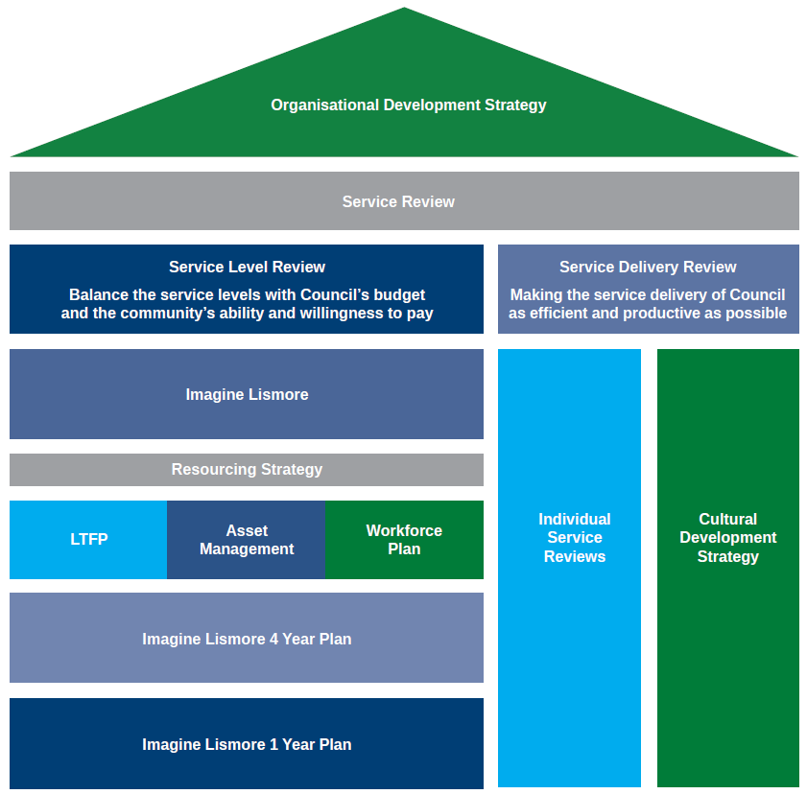

### Guiding Principles

The following are the guiding principles of the service review project. They will be used as a guide to all project decisions:

* The Service Review Project will review services to align with the key objectives of Imagine Lismore.
* The service review project is the primary mechanism to achieve the efficiency, effectiveness and productivity goals of Council.
* The project will fully understand and respond to the needs of both the current and future community.
* The project will engage and consult with a wide range of stakeholders throughout its lifecycle.
* The project will set targets for quality and cost and benchmark these against other organisations and standards
* The project will be transparent with all stakeholders about the proposed outcomes.
* The project will measure and report regularly.

## Scope Definition

Project Objective

The Service Review Project will, with full community, staff and Councillor involvement, balance revenue, service level, risk and efficiency to ensure financial sustainability. It will define the levels of service and revenue from July 2017 and define exactly what services are delivered to provide the best possible value for money for the community.

Project Outputs

The project will provide the following outputs

* A definition of Council services.
* A service matrix providing full details including, cost, standards, customer satisfaction, condition, function and capacity for all Council services.
* A service review schedule.
* Fully reviewed services.
* Imagine Lismore Plans including Resourcing Strategy for 2017-2021.
* Improved performance management
* Improved corporate communication
* A productive and efficient workforce
* A constructive corporate culture.

Project Outcomes

The project will provide the following outcomes:

* Ensure Council’s long term financial sustainability
* Improve the efficiency, effectiveness and productivity of all Council services.

## **Whole of Life Cost Benefit Analysis**

### Project Costs in addition to Recurrent Budget

The cost of this budget is $20,000 per year in incidental project costs, $40,000 per year in staff development costs and $80,000 per year in salaries. The total cost of the project is $140,000 per year.

### Project Benefits (Financial)

Through a combination of a rate increase, service reductions and efficiency and productivity gains this project will provide the financial benefit for Council to become financially sustainable.

## Project Schedule

|  |  |  |  |
| --- | --- | --- | --- |
| **Start Date** | **August 2014** | | |
| **Completion Date** | **September 2019** | | |
| **Major Milestones** | **Start Date** | **Finish Date** | **Output** |
| Project Management | Fri 22/08/14 | Thu 18/09/14 | Project Management Plan |
| Data Gathering | Fri 22/08/14 | Thu 30/04/15 | All service data gathered |
| **Service Level Review 1** |  |  |  |
| Funding Options | Fri 1/05/15 | Thu 10/10/16 | Funding Options ready for community consultation. |
| Imagine Lismore | Mon 24/10/16 | Fri 5/05/17 | Imagine Lismore Documentation Complete |
| **Service Delivery Review** |  |  |  |
| Prioritise Services | 1/05/2015 | 1/06/2015 | Service prioritised |
| Develop Benchmarks and KPIS | 1/05/2015 | 1/06/2015 | All services have benchmarks and KPIs |
| Complete the Service Review Schedule by Analysis, Developing Recommendations, Implementing Change | Fri 1/06/15 | Thu 14/09/19 | Service Review Completed |
| *Cultural Development Strategy* |  |  |  |
| Frontline Leaders Program 1 | 1/7/2014 | 30/6/2015 | Complete frontline leaders program |
| Frontline Leaders Program 2 | 1/7/2015 | 30/6/2016 | Complete frontline leaders program |
| General Staff Development Program 1 | 1/7/2015 | 30/6/2016 | Complete general staff development program. |
| General Staff Development Program 2 | 1/7/2016 | 30/6/2017 | Complete general staff development program. |
| Corporate Performance Management Plan | 1/7/2015 | 30/6/2017 | Accountability very clear across the organisation and linked to Imagine Lismore. |
| Corporate Communication Plan | 1/7/2015 | 30/6/2017 | Excellent corporate communication |

## Risk Management

|  |  |  |  |  |
| --- | --- | --- | --- | --- |
| **Risk** | **Impact** | **Probability** | **Risk Rating** | **Mitigation Strategy** |
| Lack of resources money, time, people | 3 | 2 | 4 | Smart project scheduling; clear Project Plan – well communicated so that people have notice and understand priorities; continued engagement with Steering Committee and Councillor Steering Group |
| Consultant availability | 2 | 2 | 3 | Get as much info from consultant as we can, when we meet to work towards self sufficiency; good communication & diary management; sharing of Project Plan with consultant so he understands our requirements |
| Keeping momentum going | 3 | 2 | 4 | Having Steering Committee on board so that there are a large number of energetic supporters so that we are not just ‘battling alone’; celebrating successes as we go; coffee! |
| Change of council | 2 | 3 | 4 | Clear communication strategy ensuring that everyone is clear on WIIFM; continued engagement with Steering Committee and Councillor Steering Group - keeping Steering Committee on board so that they can sell to the new councillors |
| Fit for future changes | 3 | 1 | 3 |  |
| Amalgamation | 3 | 3 | 5 | Project likely to be put on hold if this happens? |
| Community backlash to changes | 3 | 1 | 3 | Continued clear communication and good planning to pre-empt and overcome likely objections |
| Councillor backlash | 2 | 2 | 3 | Continued clear communication and good planning to pre-empt and overcome likely objections; continued engagement with Steering Committee and Councillor Steering Group; |
| Lack of support | 3 | 1 | 3 | Continued engagement with Steering Committee and Councillor Steering Group; one on one meetings with Councillor and Simon Adcock |
| Lack of clarity over deliverables | 3 | 1 | 3 | Regular reviews to manage expectations; everyone getting their issues and expectations out on the table; honesty and open-ness required from all |
| Unrealistic expectations | 3 | 3 | 5 | Regular reviews to manage expectations; everyone getting their issues and expectations out on the table; honesty and open-ness required from all |
| Seen as a ‘razor gang’ project | 3 | 2 | 4 | Continued clear communication about what this project is and isn’t and what is can and cannot deliver; honesty and open-ness required from all; getting stakeholder involved as much and as early as possible so that they have ownership |
| Failure of communications strategy | 3 | 1 | 3 | Review strategy; understand why its failing; make improvements; learn from mistakes and recommence communication |
| Lack of understanding of complex concepts | 2 | 2 | 3 | Jeff Roorda to assist in production of communication material? Examples from other councils to bring it all to life? Presentations from other councils eg Blue Mountains? |
| Burn out of project team | 3 | 1 | 3 | Involving others across the organisation who can become champions; succession planning to anticipate people leaving or getting burnt out |
| Loss of focus - scope creep | 3 | 1 | 3 | Clear & agreed Project Management Plan; sticking to the MS Project Plan; regular reminders to all about why we are doing this and what the ultimate end game is; developing the ability to say “no” and to stick to decisions and manage the various stakeholders |
| Changes in staff | 2 | 1 | 2 | Involving others across the organisation who can become champions; succession planning to anticipate people leaving or getting burnt out |
| Goal posts changing – alternative option arises | 3 | 2 | 4 | Clear & agreed Project Management Plan; sticking to the MS Project Plan; regular reminders to all about why we are doing this and what the ultimate end game is; developing the ability to say “no” and to stick to decisions and manage the various stakeholders |
| Community perception of council inefficiency | 1 | 3 | 3 | Communication that focuses on deliverables and how this project will increase efficiency |
| Risk that it is seen as a paper exercise; naval gazing | 1 | 3 | 3 | Jeff Roorda to assist in production of communication material? Examples from other councils to bring it all to life? Presentations from other councils eg Blue Mountains? |
| Unexpected negative impacts to budget | 2 | 3 | 4 | Open-ness; regular meetings to anticipate what might change; include Rino in the Steering Committee |
| Politicisation | 1 | 3 | 3 | Communication that focuses on deliverables and how this project will increase efficiency |
| Risk of union not being involved in Frontline Leaders Program – risk of misunderstanding & being quoted out of context |  |  |  | Take CC members who have not attended training through the content |

## Project Resources

The project will require the following staff resources, not including the implementation of the review schedule. The resourcing requirements for this step can’t be worked out until the previous actions have been completed.

|  |  |  |  |
| --- | --- | --- | --- |
| **Role** | **Tasks** | **Est. Total Work Time** | **When** |
| Manager of Corporate Services | Project Manager. | Entire Project | Entire Project |
| Business Excellence Facilitator | Project Officer | Entire Project | Entire Project |
| Corporate Compliance Officer | Service performance reporting  Service performance benchmarking  Providing assistance in the development of the service risk profile. |  |  |
| Service Owners (One owner for each of the services) | Service data collection and scenario costing and planning | 4 Weeks | Between October 2014 and March 2015. |
| Service Owners (One owner for each of the services) | Finalisation of Imagine Lismore Plans | 4 Weeks | Between February and April 2017 |
| Community Services Coordinator | Workshop facilitation.  Support and expertise for the community engagement. | 8 days | Place based forums and citizen’s juries in the engagement stage. |
| Partnering and Community Engagement Officer | Organising and conducting all community engagement work on the project | 1 year | July 2016 – June 2017 |
| People Services Coordinator | Creation of the Workforce Plan | 8 weeks | The WFP development will start early in 2017 and be completed by June of that year. |
| People Services Partner – Workforce Planning | Creation of the Workforce Plan | 12 weeks | The WFP development will start early in 2017 and be completed by June of that year. |
| Manager – Finance | Creation of the Long Term Financial Plan.  Assistance with development of the 4 Year Plan (Delivery Plan).  Creation of 1 Year Plan (Operational Plan). | 4 weeks | The LTFP will start early in 2017 and be completed by June of that year. |
| Principal Accountant/  Management Accountant | Service Costing. Assigning costs to each of the defined services | 2 Weeks | November 2014 |
| Principal Accountant | Creation of the Long Term Financial Plan.  Assistance with development of the 4 Year Plan (Delivery Plan).  Creation of 1 Year Plan (Operational Plan). | 16 weeks | The LTFP will start early in 2017 and be completed by June of that year. |
| Management Accountant | Creation of the Long Term Financial Plan.  Assistance with development of the 4 Year Plan (Delivery Plan).  Creation of 1 Year Plan (Operational Plan). | 16 weeks | The LTFP will start early in 2017 and be completed by June of that year. |

## Measuring Success

|  |  |  |
| --- | --- | --- |
| **Outcomes** | **Tangible Indicators of Success** | **How Will These Be Measured** |
| Ensure Council’s long term financial sustainability | All indicators published by the OLG for financial sustainability are met. | Through Council’s annual report |
| Improve the efficiency, effectiveness and productivity of all Council services. | Benchmarks for efficiency, effectiveness and productivity for each service are exceeded. The benchmarks will be developed during the Analysis stage of the project. | This will be reported annually. |

## Stakeholder Analysis/Communication Strategy

|  |  |  |  |
| --- | --- | --- | --- |
|  | Project Involvement | Needs – Of the project team | Communication/Engagement needs |
| Steering Committee | * Monthly steering committee meeting. * Ensure the accountability of the project. * Approve project management plan. * Approve change requests. | * Full understanding of the project. | * Monthly meeting. * Agenda and minutes. |
| Councillors | * Final approval for all service level, revenue and risk levels. * Community advocate for project. * Hold project accountable through the General Manager. * Provide advice on community attitudes. | * Full understanding of the project. * Complete faith in the information they have. * A complete understanding of the risks, costs and service levels for each service. | * Bi-Monthly meeting of the Value Management Councillor Advisory Group (See Appendix for ToR) * Regularly progress reports through city notes. |
| Excom | * First approval for service level, revenue and risk levels. * Internal advocacy for the project. * Resolve any resourcing conflicts. * Make Program Managers accountable for the service improvement in their area. | * Full understanding of the project. | * Regular updates through attendance of the steering committee. * Escalation from the project team of organisational problems. |
| Program Managers | * Primary responsibility and accountability for the service profiles. * Provision of expert advice on services. * Drive through service improvements. | * Full understanding of the requirements of the service review. * Support in finding collating the data. * Support in understanding risk. * Workshop facilitation | * Regular updates at the Program Managers meeting. * Regular, as required stakeholder meetings * One on one or small group meetings to provide support for data collect and risk. * Workshops as required. |
| Service Owners (Service owners may be Program Managers) | * Actual development of service profiles with the collection of data, development of revenue scenarios and creation of risk profiles. * Provision of expert advice on services. * Make improvements to service | * Full understanding of the requirements of the service review. * Support in finding and collating the data. * Support in understanding risk. * Workshop facilitation * Expertise in business process management and continuous improvement. | * Regular, as required stakeholder meetings * One on one or small group meetings to provide support for data collect and risk. * Workshops as required. * Training in business process management and continuous improvement. |
| Staff who work on services | * Provision of expert advice on services * Identify improvement opportunities * Provide advice on potential service modifications * Support the implementation of service improvements | * A broad understanding of the project. * Workshop facilitation for selected staff. * Expertise in business process management and continuous improvement for selected staff. | * One on one, or small group meetings to provide support for data collect and risk * Workshops as required. * Training in business process management and continuous improvement. |
| All staff | * Be advocates for the project | * Have a broad understanding of the project * Understand how they will be affected. | * Monthly newsletter * Updates on informer |
| Unions | * Bring staff concerns forward for consideration. * Provide advice on industrial relations. * Assist in dispute resolution | * Full understanding of the project. * Understand how staff will be affected. * Be fully aware about any specific issues relating to their members. | * Standing item on at the consultative meeting. * Access to project team as required. |
| The Media | * Report changes made by the project to the community. * Advocate for the project. | * Have a broad understanding of the project. * Understand how the community will be affected. * Be made aware of specific timelines and events. | * Regular media releases as required. * Journalist briefings. |
| Users of the services | * Provide advice on satisfaction with current service levels, revenue levels and risk. * Provide advice on future service levels, revenue levels and risk. | * A full knowledge of any changes to services. * An opportunity to have a say and have their views considered. | * Regularly updates in local matters * Revitalisation of the Imagine Lismore Facebook page and website. * Random telephone surveys * Randomly selected citizen’s juries and place based forums. |
| The general public | * Provide advice on future service levels, revenue levels and risk. | * A broad knowledge of the project | * Regularly updates in local matters * Revitalisation of the Imagine Lismore Facebook page and website. |
| Interest groups who have a stake in services | * Provide advice on particular areas of interest. | * A full knowledge of the changes in services that relate to their areas of interest. | * Briefings and workshops as required. |