**Report on Financial Sustainability**

**Shoalhaven City Council**

**General Fund**

**Authors**

Craig Milburn

Pam Gokgur

Contents

1. Introduction 3

2. Background statement/history 4

3. Guiding Principals 7

3.1 Organisational Vision 9

3.2 Mission Statement 9

3.3 Values 10

4. SWOT Analysis 11

4.1 Strengths 12

4.2 Weaknesses 12

4.3 Opportunities 12

4.4 Threats 13

5. Major Goals 13

5.1 Overall Objective – Financial sustainability 13

5.2 Increase Revenue 18

5.2.1 Rates Increase 18

5.2.2 Fees and Charges 21

5.2.3 Increases DA Fees and introduce value added services 22

5.3 Reduce Cost Structure – drive efficiency 22

5.3.1 Continuous Improvement 23

5.3.2 Outsourcing 23

5.3.3 Use of Technology 23

5.3.4 Procurement 24

5.3.5 Staff Changes and conditions of employment 24

5.3.6 Energy Management 24

5.4 Service Sustainability 25

5.5 Asset Utilisation 25

5.5.1 Only commit to Justified Renewal Projects 26

5.5.2 Selling off Under-utilised Assets 26

5.5.3 Asset Rationalisation/Optimisation 27

5.5.4 Pensioner Rates Deferral 28

5.6 Review Capacity to borrow 28

5.7 Cultural change 30

6. Risks 30

7. Evaluation 32

8. Recommendations 34

**Shoalhaven City Council**

**Report on Strategic Direction**

# Introduction

In October 2012 NSW Treasury Corporation presented a Financial Assessment and Benchmarking Report on Shoalhaven City Council. The analysis was based on historical performance, current financial position, and long term financial forecasts. Further to this it benchmarked Council against its peers using key ratios.

The review found that:

Council has been well managed over the review period based on the following observations:

* Whilst Council has incurred operating deficits (excluding grants and contributions for capital purposes), Council’s underlying operating result (measured using EBITDA) has improved from $40.3m in 2009 to $45.1m in 2011.
* Approximately 76% of the Council’s revenue base is derived from own sourced revenue (annual charges, and user charges and fees). They can rely upon these revenue streams on an ongoing basis for financial flexibility.
* The Council is facing pressure from rising employee costs, and material and contract costs above inflation but it has acknowledged the issue and is seeking to address this through expenditure review measures.

However the key observations from the review of the Council’s 10 year forecasts for its General Fund are:

* The forecast shows deficit positions excluding capital grants and contributions in all forecast years, *this already has factored in Transformation Program savings year on year.*
* The Council’s forecast liquidity position is starts to weaken from 2015 when the Unrestricted Current Ratio falls to 1.74:1, limiting available funding.
* Council’s level of fiscal flexibility, as indicated by its above benchmark Own Source Operating Revenue Ratio, is sound when excluding the impact of internal transactions.

In addition to this Council has reported $43.1m of Infrastructure Backlog in 2011 which represents 2.3% of its infrastructure asset value of $1,873m and this backlog is trending upwards, particularly in the roads asset category (77.9% of the backlog).

It should be recognised that the newly elected council in 2012 made a decision to increase rates and to also introduce an efficiency review. In response to this in February 2013 Blackadder Associates Pty Ltd prepared a report after an organisational structure and associated review, with an emphasis on savings and efficiencies and improvements to customer service. Council further sought direction on achieving financial sustainability. The review highlighted eight (8) areas for improvement:

* Alignment of Strategy to Operations
* Leadership
* Financial sustainability
* Asset Management
* Corporate Systems
* Project Management
* Organisational Culture
* Customer Service

More recently the Office of Local Government has released a roadmap for Stronger, Smarter Councils, where they have also announced funding for ensuring local government is Fit for the Future.

A Fit for the Future council should be:

* Sustainable
* Efficient
* Effectively manages infrastructure and delivers services for communities; and
* Has scale and capacity to engage effectively across community, industry and government.

Further to this the New Local Government Act will reflect that DP/OP guidelines will be amended to embed the principle of fiscal responsibility and improve financial and asset planning as part of IPR process from 2016.

The Office of Local Government see sustainable Councils as ones which:

* Saves money on bureaucracy and administration, freeing up funds for front-line services and community facilities
* Can contribute to projects and tackle issues that impact on its residents and extend beyond the council boundary:
* Has credibility and influence across councils, across government and with industry

This paper aims to expand on the Financial Sustainability theme by consolidating the above improvement areas and OLG direction into a strategic plan for Council in order to reduce the annual operating deficit and form a cohesive approach from all staff to be focused on this challenge.

# Background statement/history

From 1859, the demand for Local Government by residents of the widely scattered settlements within the Shoalhaven saw a number of Municipal areas declared.

On the 1st July, 1948 the Shoalhaven Shire Council was formed by amalgamating the following Councils:

* Nowra Municipal Council
* Berry Municipal Council
* South Shoalhaven Municipal Council
* Broughton Vale Municipal Council
* Cambewarra Shire Council
* Clyde Shire Council
* Ulladulla Municipal Council

Subsequent to this Shoalhaven City Council was proclaimed on 1st August, 1979.

The amalgamation of these widely scatter townships culminated in some of the current day issues encountered, with the geographic expanse of infrastructure assets, duplication of Council assets, multiple views on priorities resulting in competing priorities for where monies should be spent.

Over this time Council has encountered many changes in terms of

* complexity of operations,
* diversity of services provided,
* infrastructure requirements or expectations,
* expansion of development and requirements for services,
* demands from local communities for provision of facilities.

At the same time staffing levels have increased to support these requirements, systems have not kept up with the times and technologies are fast overtaking Council capabilities.

And now given the age of some of Councils assets, Council is in the unfortunate position that a significant infrastructure backlog is evident, and with each passing year continues to grow as Council does not have the funds to supports its maintenance.

The structure of Local Government Council hampers decision making with conflicting priorities between the elected Council (which is made up of the Mayor and 12 Councillors across 3 Wards) and Council administration, led by the General Manager, who is responsible for the day to day operations and ensuring that the decisions of the elected Council are implemented.

There are 4 Directorates reporting to the General Manager:

* Corporate and Community Services
* Planning and Development Services
* Assets and Works
* Shoalhaven Water

Currently Council employs approximately 751 staff across these directorates, with the split for indoor and outdoor staff being 380 indoor staff and 371 outdoor staff.

This report will focus on General Fund, therefore all subsequent information in this document will relate the financial sustainability of General Fund, in isolation from Shoalhaven Water.

The size and complexity of Council has led to institutional silos developing throughout the organisation, thereby adversely affecting communication and synergies for improvements.

Below is a snapshot of the Long Term Financial Plan for General Fund including Income Statement:



And Cashflow Statement:



Funding for the organisation comes from multiple sources as shown below:

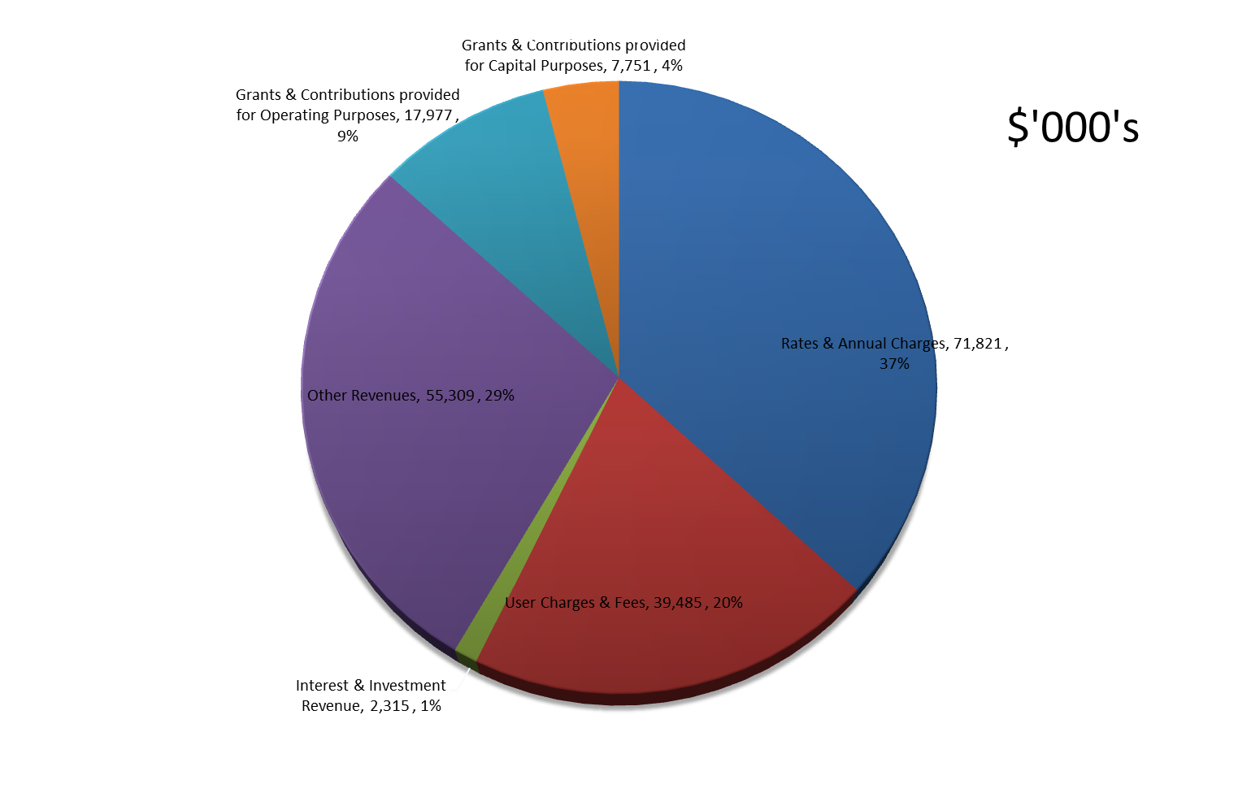

What can be seen from these figures is that council only captures 37% of its revenue in General Fund from rates and annual charges and a high proportion comes from user fees and charges as well as other revenue items such as fines, rental income, waste levy, etc. But the risk which is obvious from the above split is the reliance on Grant funding which is at 13% overall and equates to $25m in total. With increased cost shifting from Federal and State Governments to Local Government we could see this number diminish, placing more reliance on revenue Council can generate from services provided, given that our rates revenue is capped to a certain extent by IPART.

# 3. Guiding Principals

Council needs to be guided by the Integrated Planning and Reporting regime but also by a shared sense of urgency and a shared vision. It needs to break down bureaucratic walls and create some currency around processes, technology and work habits to be able to move towards a future state, in unison with the elected council, not in opposition to. It is of utmost importance that elected Councillors are educated on the current financial situation of Council, which should guide them in decision making with the best financial outcomes in mind. Councillors are responsible for strategic planning for the whole community and a sustainable future, along with determining the financial strategy and allocating resources for council through the budgeting process, so it is of utmost importance that each proposal for expenditure needs to be supported by a business case and needs to be justified and prioritised in order of the below criteria:

* Is it work required for statutory purposes
* Is it to address emergency situations
* Is it to eliminate hazards or eliminate risks
* Is it to meet contractual obligations
* Is it to perform necessary renovations or repairs (which will reduce ongoing operating expense)
* Is it to replace equipment
* Is it funded by state or federal government departments
* Is it a continuation of an existing project which cannot be deferred
* Is it to satisfy a community need or provide an improved level of customer service

If not and not funded then it is a desirable project for non-essential reasons and should be deferred until funds are in place to pursue.

This criteria needs to be in front of mind of staff and councillors when approving capital budgets and needs to be incorporated into our planning cycle.

In addition to this, additional work needs to be carried out to ensure that carryover funding is kept to a minimum, below are some core principles to consider when requesting capital funding:

At “budget bid” stage a “business case” is required, covering the following:

* A delivery program, identifying each phase of the project
* A detailed cost estimate for each phase of the project
* A cashflow forecast to reflect the delivery program, so funds are allocated to the appropriate year
* Anticipated lead times for the supply of critical components
* Project relationship to the Strategic Plan or Asset Management Plan
* Design development phase needs to be undertaken preceding the financial year to which they are scheduled to be delivered
* Whole of life costs, particularly recognising any increase in future years operational expenditures needs to be considered from the outset of a capital request.

A list of projects suitable for grant funding should be developed to a stage where the design documentation can be completed quickly once funding is received. These projects should have project risks identified and preliminary cost estimates and construction programs prepared.

The overall capital works program should be prepared in conjunction with the budget preparation and the following should be identified:

* The project custodian responsible for project delivery
* The extent of works scheduled in that Financial Year
* The resource requirements and whether external resources might be required
* The lead times and delivery risks

Monthly reviews should be instigated and program slippages identified and strategies developed to deliver the project on time.

## 3.1 Organisational Vision

The Vision is to “Make the Shoalhaven a great place to live, work, stay and play”. A shared vision is vital to achieve the outcomes desired. However the Vision needs to be able to be directly related to the work that employees are doing, otherwise it is not a shared vision. Further definition is required to ensure that Council staff are all working towards the same ultimate goal and that we can move away from the local government mentality, which slows progress and lets bureaucracy get in the way of progress.

A fully integrated suite of IP&R documents will help provide clarity to both the Councillors vision and the Council Strategy.

The IP&R planning cycle is shown below, and shows the integration of community engagement with the strategic plan and subsequent delivery program and operational plan for Council.



## 3.2 Mission Statement

Councils Mission is to “Enhance Shoalhaven’s strong communities, natural, rural and built environments and appropriate economic activities through strategic leadership, good management, community engagement and innovative use of resources”.

This mission statement should be driving how we behave as an organisation. The internal factors of strategic leadership, good management, community engagement and innovative use of resources have all been highlighted as part of the recent staff survey as areas which require attention. Action plans are currently being developed which should be related directly to the overarching Mission of Council.

The strategy map below tries to further drill down on Council Vision and incorporate the Business Plan, underlying philosophies and KPI’s to encapsulate what drives Council and what we are ultimately trying to achieve.

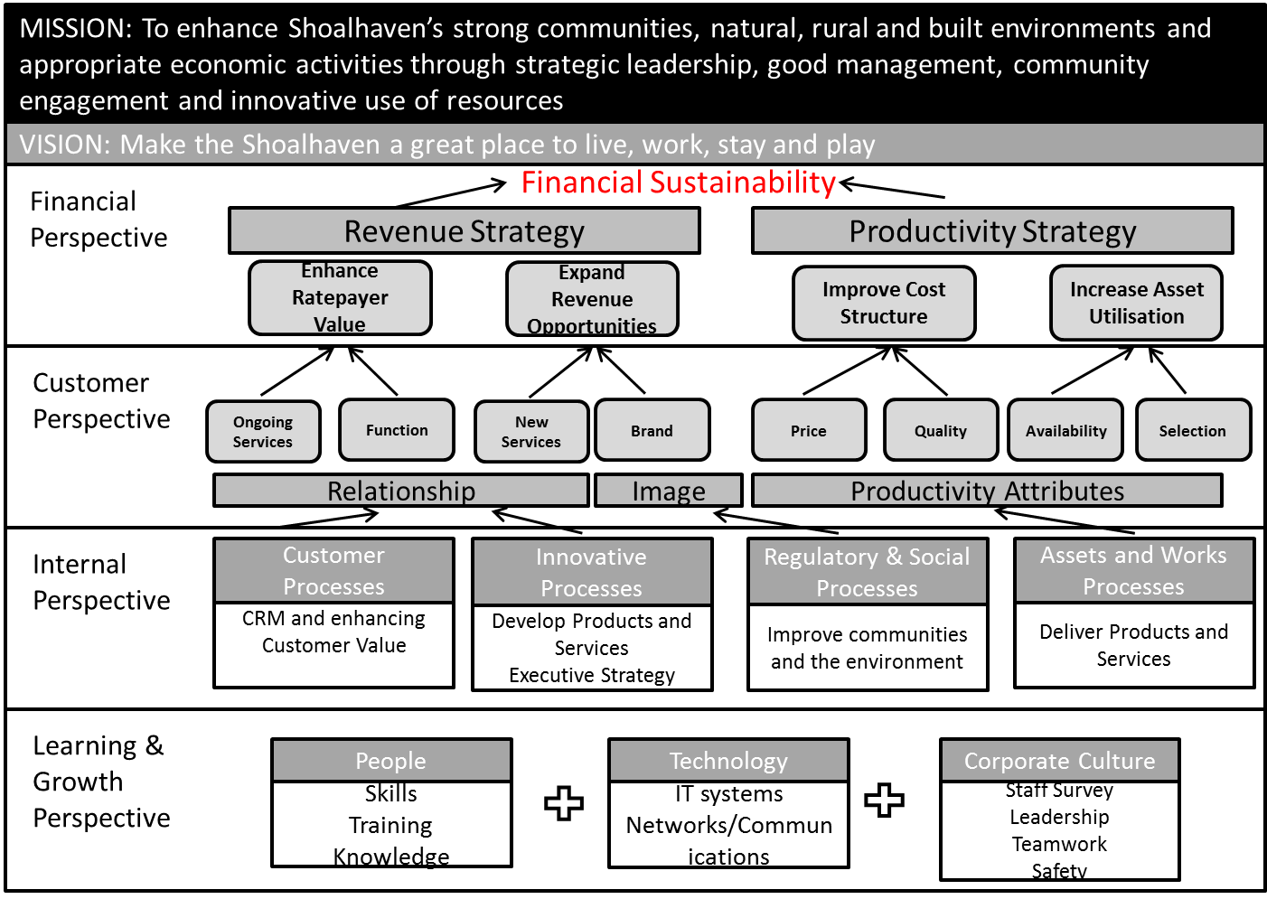

## 3.3 Values

Council’s four key workplace values are aimed at driving a culture and organisation that staff wish to work for. These are:

* How we work together
* How we behave at work
* The sort of workplace we aspire to
* The way we lead and manage work

Below is a snapshot of Council Workplace Values, which are critical to implementing any changes across the organisation. Some of the values are inherent in making changes within an organisation to deliver a far superior level of service to the community ie deliver best value service, best practice organisation, preferred employer, drive customer service, improving our use of technology, innovative and empowered. These values also align directly to the Strategic goals suggested further on in this paper.

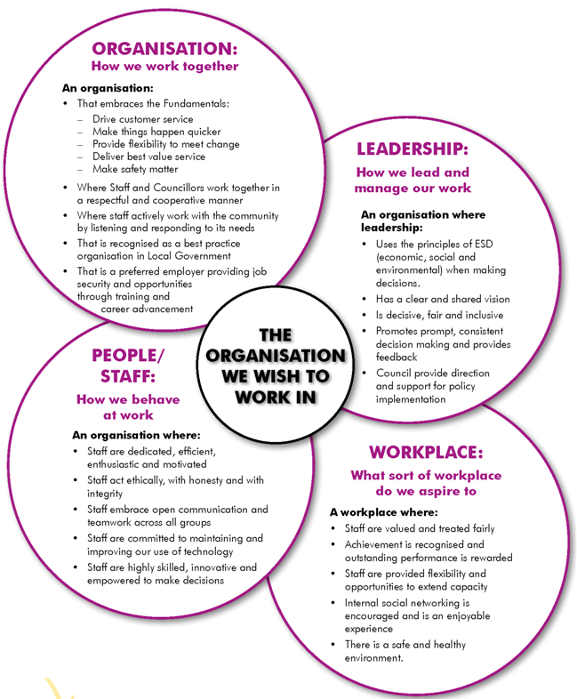

# 4. SWOT Analysis

In order to be able to implement a plan for moving forward we need to position ourselves now, what is the status quo and how do we move from the current situation to an improved position in the future?

Below is a summary of our strengths, weaknesses, opportunities and threats to help us arrive at a detailed plan to move forward.

## 4.1 Strengths

* We are a large Council and therefore have economies of Scale of which we can call on
* There are 55,000 ratepayers within the Council area
* Council has dedicated and long serving employees
* We are situated in a great location and a tourism destination
* We should see growth in future years, given the proximity to Sydney and improvements in the road network

## 4.2 Weaknesses

* We are forecasting a $10m operating deficits for a number of years over the next 10 years, ie $82.75m in total over this time
* Given the council size we have multiple duplicated assets across the council area – which need maintenance and renewal
* We have significantly greater lengths of road networks to maintain than other councils in our group
* We have a backlog of infrastructure work required to bring our assets up to the standard required and this is continuing to deteriorate year on year.
* There is an aging workforce, which results in risks from a workers compensation viewpoint, and a loss of knowledge on retirement
* There is an aging rate payer base, above group average which may drive higher pension deferrals in the future and less immediate income for Council and also drive infrastructure requirements in the community
* Higher levels of unemployment, 11.4% compared to 6.5% group average means less disposable income and less ability to pay for services
* Unfunded S94 and other liabilities, such as asbestos affected properties and gas remediation requirements?

## 4.3 Opportunities

* We have the capacity to borrow more to fund infrastructure works and new projects
* Borrowing rates may reduce in the future if Local Government NSW establishes a Pooled borrowing vehicle for NSW Councils.
* We have the opportunity to develop monthly KPI’s which will give us a better indication of how we are travelling in a more timely manner
* We are well into the implementation of Authority, which should bring technological improvements and efficiencies, along with the opportunity to utilise more e-commerce.
* Council amalgamations could lead to the bigger councils absorbing smaller councils
* We are in a better position to offer service provision to smaller councils
* With changes to transportability of people and the culture of using cars to attend social functions, shop, take children to school, etc, etc, we have the opportunity to rationalise some facilities to reduce costs.

## 4.4 Threats

* Further cost shifting from State and Federal Governments
* Further reductions in Grant Funding
* Increases in CPI risk increases to current cost structures
* Reductions in Australian Dollar would also further push costs up.
* Increasing unplanned reduction in services as assets fail over time in the future
* Reductions in Interest Rates resulting in decreased income from investments
* Council amalgamations may result in further complexities and an increased aging asset base, from inherited assets
* Dividends from Shoalhaven Water may not always be available given some of the significant expenditures required in future years.

# 5. Major Goals

## 5.1 Overall Objective – Financial sustainability

The current operating deficit is the driving force for this strategic plan, below is a snapshot of the General Fund LTFP over the next 10 years showing operating deficits each year for the next 10 years, with some years exceeding $10m. It should be noted that this is not a cash result but shows the effect of significant depreciation (a non cash item) as a result of asset revaluations in accordance with Accounting Standard AASB 13. When an asset is purchased it generally has a life of more than one year, so depreciation is a way of transferring a portion of the assets costs from the balance sheet to the profit and loss during each year of the assets life. It is a way of matching the cost of the asset to the revenue generated from that asset, over its useful life. Without depreciation the entire cost of the asset would need to be recognised or expensed at the time of the purchase, so it cannot be ignored in reviewing results.



Below is a chart showing the cumulative effect of the deficit operating mode, resulting in over $82.75m over the next 10 years.

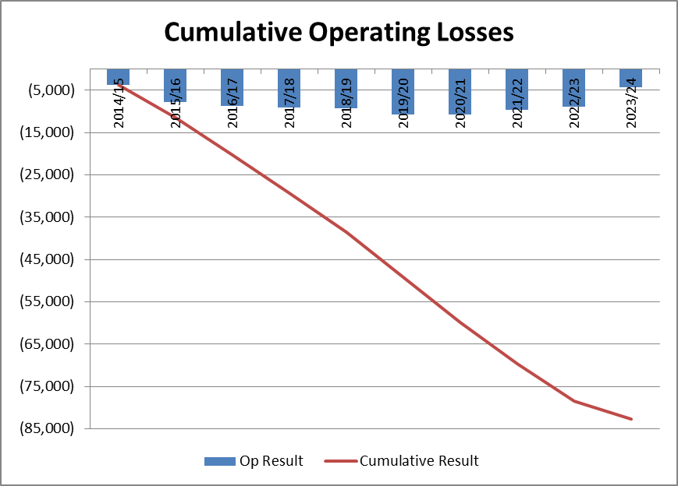

Further to this the Key Financial indicators show a number of areas of some concern, particularly the unrestricted current ratio which is deteriorating year on year, the aim is for this ratio to be greater than 1.5:1 for financial sustainability and we see it moving from over 2.23:1 in 2014/2015 to as low as 1.74:1 2017/2018. The other measure which highlights the gap in capital spending to depreciation is the Building Infrastructure Renewals Ratio which is well below the 100% target.



Loan Interest Coverage is averaging around 1.4% over the next 10 years, which is low in terms of the benchmark ratio of 5% of operating income, but it needs to be reiterated that unless Council can generate additional revenue or reduce its overall cost base this ratio does not give a clear picture of council capabilities.

Asset Sustainability Ratio or the capital expenditure ratio measures the extent to which Council are replacing assets compared with the rate at which we are depreciating or consuming them. See graph below showing this measure and the issues we start to encounter from 2015/2016 onwards, when this % is substantially less than 100%. The dollar impact of this shortfall is in the table below and further analysed in the graph below:



The cumulative shortfall of capital spend is shown below:

With changes to the Accounting treatment of valuation of assets, each year Council is required to make fair value adjustments to certain categories of assets. Below is a graph which shows historical asset values and the resultant depreciation increases in the subsequent years. This obviously has an impact on the overall operating result, which may further impact on our future results as assets are further increased in value and greater depreciation is required.

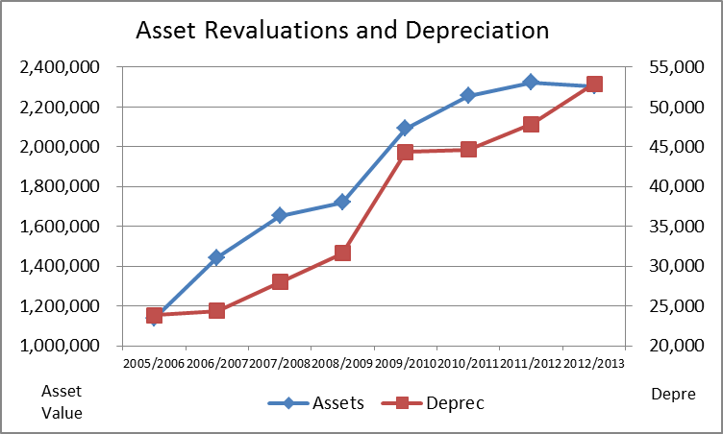

However if we are to also cover the annual shortfalls created from infrastructure funding deficits as well as cover the infrastructure backlog the graph for operating deficit looks like the one below:

The overarching objective is to reduce Councils overall deficit to a balanced operating plan and the subsequent objectives and recommendations will ultimately achieve financial sustainability within a 5 year timeframe.

There are a number of levers to pull with regard to achieving this goal, which are covered below in detail. It is important that Council see the urgency and importance to take the necessary action to address this issue. It is also important that the organisation take a long lens to this and put plans in place over a number of years, not just the next 1 – 2years.

In providing the required strategic leadership Council needs to take the community along this longer term journey to sustainability.

## 5.2 Increase Revenue

### 5.2.1 Rates Increase

Future rating strategies need to be considered in terms of anticipated growth in the city, future services and service levels, along with changes to Government Funding. The current proposal to introduce a Community Panel to review the rating structure will only be looking at overall allocation of rates within the current rating categories.

Further work will be required to assess the level of rating increase required in the future to assist with reducing the overall backlog of infrastructure requirements as well as enabling financial sustainability moving forward.

Any proposal for rate increases will also need to factor in growth estimates in the future, which will result in increased costs of servicing the growing community and additional stress on infrastructures already in place and in some instances additional infrastructure.

Further consideration needs to be factored in with regard to the demographics of the Shoalhaven, the education levels which are lower than National average, the level of unemployment at 13% in 2013.

On the flip side the location and lifestyle make the area a growth area in terms of population, with estimates that the population will exceed 130,000 by 2036 . There is a thriving defence industry, it is a regional manufacturing centre and a growing educational hub, and natural resources and tourism go hand in hand to increase the population movement.

It has been found through studies done by the SA Centre for Economic Studies that CPI is not an appropriate indicator to consider in relation to Council rates. Secondly, council rates are determined by more than average costs in a previous year. Local Government sets property rates in response to various factors including general price inflation affecting local government, policy decisions regarding changes in the level of services and community infrastructure provided to local communities, changes in demand for particular services and changes in financial support provided by other levels of government. It was found that a more reliable independent measure is the Local Government Pricing Index which was developed by the ABS on behalf of the South Australian Government Financial Management Group. This measure saw CPI running at 2.8% on average over the 10 year period to 2012/2013, compared to the LGPI running at 3.6% on average over the same period.

This needs to be considered when reviewing what a rate increase may look like. A further consideration is the comparison of residential rates of other councils within our Council Group, which further shows there is scope to increase rates by more than CPI and to still be under “like” councils rates. The Group Average for Ordinary Residential Rates is $978.15.

|  |  |  |  |  |  |
| --- | --- | --- | --- | --- | --- |
| Council 2012/2013 | Average Rates | Average Household Income # | Ratio | At 1.8% | Differential |
| Shoalhaven | $803.29 | $50,363 | 1.60% | $906.53 | $103.24 |
| Coffs Harbour | $837.67 | $54,077 | 1.55% | $973.39 | $135.72 |
| Maitland | $939.12 | $72,514 | 1.30% | $1,305.25 | $366.13 |
| Port Macquarie | $988.14 | $52,167 | 1.89% | $939.01 | -$49.13 |
| Lake Macquarie | $997.31 | $57,304 | 1.74% | $1,031.47 | $34.16 |
| Wollongong | $1077.96 | $65,926 | 1.64% | $1,186.67 | $108.71 |
| Tweed | $1167.26 | $51,220 | 2.28% | $921.96 | -$245.30 |

*# Source- ABS Household income*

This table shows a 45% difference between residential rates at Shoalhaven compared to those of Tweed Council. It also highlights that household income for the Shoalhaven is the lowest and that our rates as a percentage of household income are low compared to a number of councils. If we looked at an average of 1.8% as a guide, ie ratepayers capacity to pay we could argue that an increase of $103 per ratepayer is supportable and equates to an increase of approximately 13% in rates.

In addition to this, given the demographics of Shoalhaven City Council and the level of infrastructure in relation to the population in comparison terms, our level of rates should be above the average, given the higher number of pools, public halls, open space and road lengths to maintain. A special rate variation submission is fundamental to improving future sustainability. See table below for some of these comparative measures, which have significant impact on the overall expenditure required to maintain the infrastructure, which should warrant higher rates than some other councils with less infrastructure:

|  |  |  |
| --- | --- | --- |
| Your Public Facilities | LGA | Group Average |
| Public Pools | 12 | 11 |
| Public Halls | 27 | 24 |
| Open Public Space | 2029 | 1462 |
| Total Road length (km) | 1772.4 | 1193.0 |
| Road Length per ‘000 capita (metre) | 18.3 | 11.2 |
| Roads, Bridges and Footpath expenditure per capita ($) | 272.32 | 250.05 |

Further analysis was carried out on comparatives of Area of Council, income levels within Council and the rates being charged. The first chart below shows the relationship for Area Size and taxable income, which shows the bigger the council area the lower average taxable income and the second chart shows a comparison of average rates to the % of rates to taxable income. This shows the percentage for Shoalhaven at 2.2% of taxable income. The only Councils with a lower percentage than Shoalhaven are Newcastle and Maitland, but if you compare their land area in the first chart, plus the level of their average taxable income, they can probably afford to hold their rates at a lower overall percentage. The lower percentage also gives them higher overall rates than Shoalhaven given the level of Taxable income in their Council Areas.

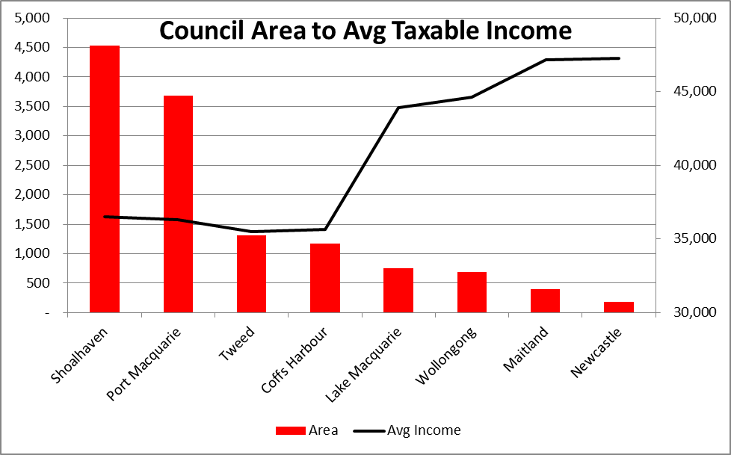

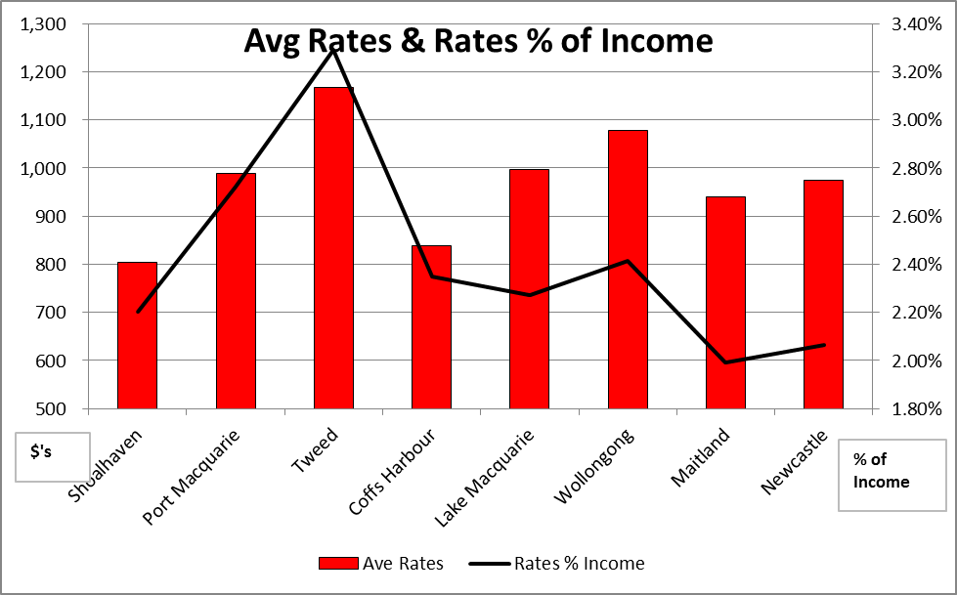

Below is a snapshot of comparatives of rates with a 5%, 10% and 15% increase in Shoalhaven Councils rates, which still shows lower rates relative to all other councils in our Group. This is also before Wollongong submitted and received approval from IPART for an increase in General Revenue and their minimum rate amounts of 6.23% in 2014/2015, 6.33% in 2015/2016 and 6.34% in 2016/2017, a total of 19% over the next 3 years. And also does not reflect increases to rates for Port Macquarie which were approved by IPART.

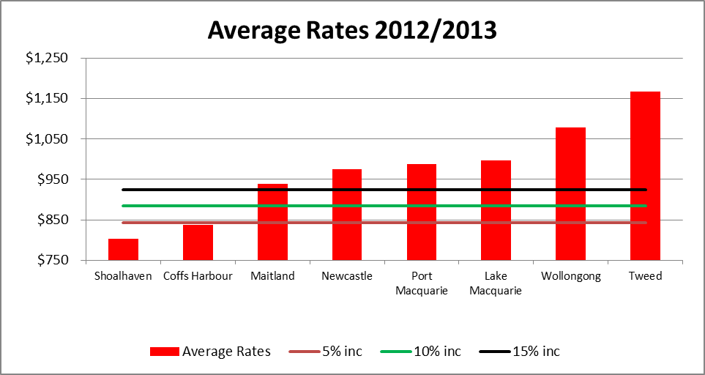

In terms of revenue these type increases would equate to the following in terms of total revenue dollars:



### 5.2.2 Fees and Charges

In addition to rates Council have the opportunity to review fees and charges, along with leases in an effort to increase the level of income generated from the delivery of services or hiring/leasing of properties. As part of fee setting the philosophy of user pay should be high on the agenda. The project team covering fees and charges are developing an actionable plan to address areas of improved revenue. Further to this the project team working on Leases is also developing a list of leases where increases might be introduced.

The number of Public Facilities obviously drives a certain cost structure and should be taken into consideration when reviewing increases to fees and charges, as well as rates.

A further consideration with the setting of fees and charges is how Council charge for the high influx of tourists around the summer period. We currently see approximately 2.5million tourist converging on the area within a short period of time and require infrastructure to cater for this influx. Given that tourists do not pay rates in the Council area and benefit from heavily subsidised fees and charges we need to look at a mechanism to capture some revenue from this influx, perhaps by setting higher fees and charges all year round and subsidising for rate payers through yearly passes, regular hirer rates etc, ie a discount for ratepayers

An additional way to bolster Council revenue is by promotion of these public facilities. If council can bundle up a marketing campaign to sell the benefits of these facilities, they could attract events or conferences to the area and increase Tourism but also increase the returns on Local Council infrastructure.

### 5.2.3 Increases DA Fees and introduce value added services

An increase to DA charges has the ability to increase Council revenue, but at the same time it can hamper growth in the city. There needs to be a balance between economic development and the amount of fees being charged and these charges will rise and fall with the inherent business cycle of economic activity. These fees are also regulated by state government, so are not as easily increased as desired. In order to increase DA fees outside this cycle Council would need to consider what else we have on offer to promote business and development in the area, ie by developing zoning policies that support business, by economic development and tourism working towards increasing tourism, investment etc.

In addition to this Council should look into the introduction of Value add services to the community, including but not limited to Bush Fire assessments, pre-purchase inspections etc. The issues of independence in DA approvals would certainly need to be covered off if a decision was made to go down this path.

## 5.3 Reduce Cost Structure – drive efficiency

There are a number of opportunities to improve the cost structure of Council.

### 5.3.1 Continuous Improvement

Fundamental to cost reductions is the introduction to the concept of Lean or continuous improvement. This is a philosophy which needs to be driven from the top of the organisation and filtered out to all levels within the organisation. This takes commitment and dollars in terms of training and allowing time for teams to hold meetings to review processes and look for efficiencies.

Value streams are a good tool to link all horizontal processes that run across vertical organisational silos and removing wasteful activity that adds no value for the customer. All staff would need their induction to include Lean and in-house learning programs would need to be introduced to educate staff to be able to work in projects teams. Lean is also about changing culture to one where staff feel empowered, equipped and supported to improve their work as part of their everyday job.

Major areas impacted by customer calls would be an ideal starting point for review, and this could be incorporated with the introduction of the Customer Service Centre. This would review outdated practices and better utilise technology to ultimately improve customer service and at the same time reduce costs. The introduction of e-commerce will further reduce workload, introduce a one stop shop for customers and reduce reliance on high staffing levels.

The culture of service, teamwork and continuous improvement, needs to be a journey that continues forever and becomes a way of working, it needs to be inherent in everything we do by way of quality systems, process mapping and re-engineering. The key point to make here is that a reduction in complexity will lead to reduced costs.

### 5.3.2 Outsourcing

A second opportunity for cost reduction is to review service levels of internally provided functions and look at outsourcing those which are not competitive with outside providers. Some of the areas being reviewed at present are the SEC, payroll, printing, audit, family day care to name a few of the TTF projects on the agenda. This process needs to benchmark the services provided against the cost of providing these services and determine where benefits would be gained from outsourcing.

As an alternative to outsourcing Council could increase revenue by setting up a shared service function and taking on work of other councils. This could lead to further economies of scale with reduced staffing requirements, particularly when system functionality is available to enable the best possible outcome for these processes.

### 5.3.3 Use of Technology

The improved use of technology will also assist in other areas of council, particularly in the finance area, where significant gains can be made by elimination of duplication and improvements in reporting and automation of processes. The implementation of Authority is instrumental in making these changes happen. The current systems rely heavily on individuals to hold things together and to understand the history of systems. This dependence on a few individuals leaves Council very vulnerable and does not allow for sharing of information, as people remain isolated from open and transparent information systems.

The integrated nature of an ERP system will help break down the silos in different work areas in council and should drive further reductions in staffing levels into the future, which should ultimately reduce costs.

The use of electronic commerce will further enhance customer service to the community and allow for self help portals which will drive further efficiencies. Considerable work is required to ensure the technology delivers as promised, so Council will need to commit dedicated resources to achieve the desired outcome.

### 5.3.4 Procurement

Another potential savings area is in procurement. Currently we spend $92m on our top 100 suppliers, if we could save .5% of this spend it equates to $458k. The current Southern Councils Group procurement team are looking at options for targeting savings and this should be driven more robustly to ensure savings are achieved, by prioritising big ticket items, such as motor vehicles, asphalt, energy etc.

### 5.3.5 Staff Changes and conditions of employment

The transformation task force team has been rolling out a restructure by Group or Section, with $2.8m in savings already achieved in salaries and wages, but this should continue to the next levels in the organisation, with the possibility of achieving a further $630k reduction Other programs to review staff conditions and the use of casuals and the payment of allowances and overtime are in process and should be advanced in order to achieve a further $500k in savings.

### 5.3.6 Energy Management

In line with the sustainability of operations, Council should also be considering the use of solar power to further reduce operating costs, particularly with regard to big energy use sites. Energy audits carried out in 2007 should be reviewed to see that the actions to reduce costs, energy consumption, green-house gas emissions and increasing management commitment have been responded to.

Monthly KPI’s should be introduced in line with the Strategic Plan, to measure performance, which will then aid in management and assist to drive improvements and cost savings.

Some KPI’s which could be introduced to monitor overall cost reductions are shown in the table below, these need to be in line with Performance Management targets and compared to the IRIS survey results to determine if they will drive the desired community outcomes:

|  |  |  |
| --- | --- | --- |
| Strategy | KPI | Target |
| Revenue – Enhance Ratepayer Value, ongoing Services | Operating Profit/No of Ratepayers | * 0 |
| Revenue – Enhance Ratepayer Value, Function | % uptake Formsport or BPAYview | * 10% |
| Revenue – Expand Revenue – New Services | Revenue Growth = increase in revenue/last years revenue as % | * 6% |
| Revenue – Expand Revenue – Brand – Shoalhaven area | Increase in economic activity | * 6.2% inc |
| Improve Cost Structure – Price | Procurement Savings | * $200k |
| Improve Cost Structure – Quality | Savings from Continuous Improvement efficiencies | * $200k |
| Improve Asset Utilisation – Availability | Percentage Preventative Maintenance/Total Maintenance Costs | * 80% |
| Improve Asset Utilisation – Selection | Life Cycle Costing completed on all new assets | * 80% |
| Customer Satisfaction | Community Satisfaction Rating | * 90% |
| Innovation – No. of new services | No. of New Services  No of DA’s and turnaround time | * 2 per annum * 1400 per annum   < 60 days |
| Improve Social Processes | Expenditure on community health and safety/Avg population | * $100 per capita |
| Deliver Products and Services | Reduction in Asset Backlog – Capex Expenditure/Depreciation | * 100% |
| Training | Avg Training Cost per FTE | * $750 per FTE |
| Cassi Implementation | Modules go live dates meet plan | Within plan and budget |
| Leadership Training | Managers Trained | * 80% |
| Health and Wellbeing of Staff – Safety | LTI | Hours Lost/Total hours worked as a % |

## 5.4 Service Sustainability

There should be a full review of the services Council provide and questions posed as to whether the service is broadly valued and does it align to the Long Term strategic direction of Council, is Local government the right organisation to be providing the services, what are the issues or risks with not providing the service and if Council does not provide the service, who will?

Where it is not possible to withdraw from provision of critical services, it might be prudent to review the level of support provided to some services and look at cutting the level of service if feasible. As an alternate to this a review of the delivery method may be possible, to look at other options for delivery eg are there some services we can deliver electronically as opposed to manually.

Other questions to ask are:

* Are there additional or new income producing opportunities?
* Is there unmet demand for the service, and if so how do we capture this demand?
* Is there an ability or willingness to pay for services we might be providing for free or at a subsidised rate at present?
* Are there growth areas where we are not providing services?
* Does the continuing delivery of services, maintenance or renewal works programs remain a sustainable option, supported by operations, works and projects?

## 5.5 Asset Utilisation

The utilisation of assets in an organisation is a critical component of return on investment, along with driving customer satisfaction in terms of reliability, cost and function. We know for Shoalhaven our assets are aging and our available funding is not sufficient to keep up with the current ongoing maintenance requirements, not to mention the backlog of infrastructure works required to bring our assets up to an acceptable level. This backlog is growing at a rate of approximately $4m per annum, and at this rate will be another $40m in 10 years time, bringing the total work required to $80m.

The decrease in CPI increase on Financial Assistance Grant Funding will lead to a further reduction in maintenance of $400k per year, which will impact considerably over the next 3 years totalling $1.2m.

The Graph below shows the current gap between revenue and expenses for the coming year, ie approximately $3.7m, if we add to this the run rate of backlog increase of $4m each year this becomes an $7.7m gap, and if we further add to this the catch up required for past years backlog this adds an additional $4m to expenses and widens the gap to $11.8m for the coming year. Obviously this number is totally unsustainable, and requires some drastic measures to turn things around.

### 5.5.1 Only commit to Justified Renewal Projects

Council needs to review opportunities to slow down this rate of deterioration, and one way to do this is to only commit capital to renewal projects which have a cost benefit, ie the cost of the investment is recouped from the savings made in maintenance and other operational costs to keep the asset in working mode.

When decisions are being made, with regard to investment in new capital items, a full life cycle costing should be prepared. This will ensure that the assets are not going to be an intergenerational burden on the community. Asset Management Planning needs to encapsulate all phases of life cycle costing and forecast these costs into the Long Term Financial Plan.

### 5.5.2 Selling off Under-utilised Assets

Another serious consideration is to review ownership of assets surplus to needs or costing Council money, ie where the rental income does not cover the costs if commercially leased. This would result in a reduction in operational expenditure ie less maintenance, less overheads and reduction in depreciation etc.

Further to this Council should look at selling off any land surplus to needs, once again this would reduce operating costs to maintain the land and is in line with Lean principles to reduce redundant assets and drive costs down.

There are approximately 9 properties earmarked for sale, where due diligence is still required. These properties have a combined land value of $1.475 in total, with differing rateability and potential for use.

### 5.5.3 Asset Rationalisation/Optimisation

In order to improve the Utilisation of assets, one needs to firstly look at the rationalisation of the existing asset base. When reviews are carried out on the profitability of assets and the return on assets employed, those with negative operating results and with negative returns on assets should be reviewed to see if there are other similar assets nearby which could cater for the current levels of demand. If this is the case there may be an opportunity to sell off duplicated facilities. If there are no other similar facilities nearby then we should look at increasing the use of the existing facility.

In the first instance we could look at promoting the facility to improve patronage. Secondly we should look at introducing new uses within the existing facility, this could be by introducing a gym to a pool complex or a café to a Library or a Visitor information centre to a Pool complex, similar to the arrangement at Ulladulla Civic Centre.

From financial analysis completed as part of the fees and charges TTF project team it was found that those facilities which were multi-use lost less money and had better returns on assets employed than those facilities with a single purpose.

An observation in this area is that Ulladulla Civic Centre operating budget did increase, but if like type facilities surrounding it were rationalised, the savings could more than offset this increase ie closing Milton library.

A further example of issues that can arise with the introduction of new or improved facilities is with the rebuilding of Nowra Pool. Whilst it will improve the pool facility at Nowra, it leaves less funds for maintenance or improvement of Bomaderry pool, it will require more funding for amenities, it will be an intergenerational burden on council and the legacy will exist for many years to come, where a consolidated approach to improvements to the Bomaderry Aquatic Centre may have been a much more financially viable option longer term.

Below is a list of principles which should be followed when reviewing our current Asset base and any plans for future developments:

The Asset must be:

* Fit for purpose – does it meet the needs of the service?
* Fit for use – is it in an acceptable condition?
* Fit for the future – will the asset meet future needs of the service?

**Core Principles**

* Is there a need for the asset, is the asset still providing a required service to the community. Is the service provision what the customers expect?
* Is there a more cost effective way to provide that service?
* If an asset is underutilised, then prior to any decisions to construct another similar asset, the potential for using the existing under-utilised asset, should be considered. What does demand forecasting look like?
* Where an asset is under-utilised or under-performing, an assessment must be made about continuing to fund the asset.
* Any rationalisations should be undertaken within the IPR framework that takes account of service delivery needs, corporate objectives, financial and budgetary constraints and the Council’s overall resource allocation objectives.
* Are there alternate methods of service delivery through other Council facilities, providers and levels of government or the private sector or regional opportunities.
* Are there disposal options including transfer for alternative use, rental, sale and/or leaseback, and demolition should be considered when reviewing acquisition plans.
* Does the asset have high operational costs with little income producing opportunity, if so a review of similar assets close by should be carried out before any further monies are sunk into the existing asset.

### 5.5.4 Pensioner Rates Deferral

Council currently has a policy which allows for Pensioners to defer payment of their rates and interest for a period of 17 years before Council will begin action to recover this debt. At present the total amount outstanding on Pensioner rates is approximately $3.3m including service charges, rates and interest components. By reviewing this policy and bringing payment terms in line with other rate payers Council could gain approximately $800k one off benefit in cash from new pensioner deferrals, along with a reduction in the overall outstanding of aged deferrals. This money could then be utilised within other Council activities.

## 5.6 Review Capacity to borrow

There is no right or wrong level of debt, but it must be able to be supported by the income Council generates and the cash flows which result.

Whilst it has historically been prudent to keep debt levels as low as possible, borrowing is a valid way to finance ongoing infrastructure requirements. Deferral of infrastructure replacement/ maintenance is often more detrimental to the long term capabilities of council then borrowing to finance such renewal or replacement spending. The spending may be justified now due to greater cost in the future of deferring this activity.

Generally however, a council with an operating deficit would find it difficult to justify the additional debt, unless there is a cost benefit of replacing assets over the cost of maintaining these assets.

Council is forecasting operating deficits for the next 10 years and we should never consider funding this deficit with debt, other means need to be sought out to raise the level of additional funding required. Council should only borrow to fund activities or developments which are core to council’s activities and agreed priorities. Each request for funding should be supported by a cost benefit analysis, showing whole of life cost of the investment.

The most recent loans drawn down were taken out with a 3 year variable rate, transferring to a fixed rate after this time, or with an option to refinance. This approach was taken to ensure flexibility in refinancing if the Office of Local Government arrive at a consolidated model for borrowing for Councils, assuming that any rates they derive would be lower than those which we can currently obtain on an individual basis.

A snapshot of our Debt Service Ratio for the next ten years is shown below:



As can be seen our debt service ratio is well below the guidelines set of between 10% and 20% however industry norms suggest that for non-growing Councils the debt service ratio should remain below 10%.

Given the fact that Council expenses are in excess of overall operating income by a considerable amount year on year, Council would find it difficult to justify taking out additional loans unless the interest repayments are less than the cost of maintaining the existing asset requiring renewal. Further to this the term of debt funding should never exceed the life of the asset it is used to fund.

The important consideration to address with further debt funding is full cost/benefit analysis to ensure that there are financial gains to be had by Council in borrowing additional funds.

Below is a list of core principles to follow when decisions are being made with regard to loan funding:

* NEVER borrow to fund operating deficits
* Only borrow to fund activities core to Councils agreed priorities (ie they must be in the Long Term Financial Plan) unless under circumstances of emergency
* Each funding request needs to be supported by full life cycle costing analysis
* Only fund to borrow if interest repayments are less than the cost of maintaining the existing asset requiring renewal
* The term of debt funding should never exceed the life of the asset it is used to fund
* The specific capital project should only be considered for loan funding, if it is to be beneficial to the majority of ratepayers.
* Debt servicing cost should not exceed 2% of annual general income.
* Loans should not be taken out over more than 20 years
* All loans should be taken out in accordance with relevant statutory requirements as contained in the Local Government Act (1993) and the Local Government (General) Regulations 2005.
* Three written quotes should always be sought or a loan tender called
* No borrowing from any source outside the Commonwealth of Australia nor in any currency other than Australian currency

## 5.7 Cultural change

An observation is that there is no sense of urgency within Council and this appears to be driven by the mindset that Legislation and bureaucracy slow things down. The other barriers to progress appear to be antiquated systems which rely heavily on human intervention on an individual basis, which gives great power to some individuals and excludes others from taking ownership.

Overall we know that most people come to work to do a good job, but the systems and processes in place do not allow for staff to do their best work.

Even though Council is a Local Government Authority and we are guided by legislation and at times bureaucracy we need to treat council like a business not a government agency, we need to get lean and keen.

In order to achieve “lean and keen” Council needs to make a cultural shift, from “this is the way we do things here” to “how can we do things better?” And what better time to do this than part of an organisation review, where the business is being restructured, where a new system is being implemented, where change is becoming the norm and at the same time demands for new services are increasing, with less staff to meet the demand.

This change needs to be driven from the top, with the four main principles being:

* Satisfy your customers – internal and external
* Continually improve through small steps – its evolutionary and ongoing
* Involve everyone in improvement – it will only work if everyone is on board
* Control processes through measurement and KPI’s- which are displayed for all

A cultural change such as this can save an organisation considerable time and money and improve customer service, but it needs investment in staffing, training and systems.

# 6. Risks

Council has considerable risks facing them into the future on top of the main financial risk of replacing and maintaining our current asset base to the level required. The following risk factors have been taken into consideration in our Long Term Financial Plan:

* Reduction in CPI on Financial Assistance Grant – with a negative financial impact of $1.2m over the next 3 years
* At present there are no proposed changes to the waste levy, so current rates are factored into the LTFP, but this may change in the future.

In addition to these risk factors which have been taken into consideration for future financial plans there are a number of areas where no changes have been considered:

* Increase in services such as Ulladulla Civic Centre, Nowra Pool, CCTV and other new assets and the long term financial burden from some of these
* Climate Change, will this have a positive or negative impact on our operating plans, will energy prices continue to increase, regardless of the repeal of the carbon tax, what will be the impact of waste energy and how can we harness this energy. What if we look at investing more in solar installations for energy, what will be the upfront capital cost and then ultimately the savings achieved if we go down this path.
* There is still some debate about indexation on the fuel excise and whether an annual increase will be re-introduced. If this is not the case it will have a small financial impact on Council of $3k per year based on last years usage rates. If the re-introduction does not go through this could mean a continual reduction year on year.
* For the majority of our financial forecasts we have continued to use a 3% increase year on year. This is not reflective of reality and does not review our cost structure year on year to understand if the increase is required or is adequate This CPI is used equally for income as well as expense. For the next budget year a zero based budget approach will be undertaken to go back to basics for budgeting, ensuring all expenditure is justified. For rates we have tended to see that increases approved by IPART have not been consistent with the CPI and for expenses we know that for some it is inadequate and for some it is over generous.
* Our approach to interest rates has been kept very deliberately conservative. But with the appointment of an investment advisor we are finding that by extending our deposit terms we are slowly improving the interest rates achieved. But the major risk in this area is that our returns are being eroded by the overall reduction in rates, which we are trying to abate for as long as possible. Alternately interest rates on borrowings are coming down but are always at the mercy of the Reserve bank and the major banks. The one positive on the horizon is that LGNSW are investigating the use of a Pooled borrowing vehicle which should see reductions in borrowing rates compared to rates we could achieve from the major banks. This is still in the very early stages for Local Government and has no impact on our financials at this stage. The impact of a .5% decrease in borrowing interest rates on a $10m loan is approximately $300k over a 10 year period.
* The impact on the AUD rate of a 15% reduction in exchange rate would mean that imported costs would increase and therefore drive increases in major commodities such as oil, asphalt etc. The assumption is that the AUD will remain at the existing level and this needs to be addressed with closer scrutiny of the impact.
* The level of restricted assets continues to increase thereby limiting funds available for General Council spend. Some of this funding is from Section 94 contributions where developers provide for future infrastructure as part of their Development consents. These contributions only cover the actual cost of the infrastructure, and not ongoing maintenance and renewal costs, so in the short term we see a positive income effect, but longer term we start seeing an ever increasing liability. In some instances where there has been a Section 94 contribution Council has a requirement to match that funding, this fund matching obviously has an impact on Councils cashflows and needs to be considered into the future plans of council, so timing and spend will need to be determined. To enable this Council needs a clear plan around infrastructure requirements. At present the total exposure to council is in the vicinity of $120m. Council is also currently undertaking a full review of social infrastructure requirements, in an effort to clearly define the requirements and to align this plan to the Section 94 monies currently held. This review may assist to bring into line funding requirements with available funding.
* Is there a risk/opportunity centred around structural reform for local government? There are a number of challenges facing local government and an ultimate aim of amalgamation should be to reduce the number of administrative units, encourage improve accountability and transparency and have a greater emphasis on core activities, thereby resulting in enhanced financial capability and increased resource sharing amongst councils.
* Unfunded liabilities also pose an additional threat on Councils future financial sustainability. Currently there are contingent liabilities in the following areas:
  + Gasworks remediation and subsequent costs in relation to this work - $395k is the current claim for acquisition of land at 76 Bridge Road, with additional remediation works yet to be assessed.
  + Asbestos issues at 180 properties with a cost to clean up estimated at $4.2m. This figure does not include asbestos removal at Shoalwater or Holiday Haven sites.
  + Leave entitlements provision where only 22% of the liability is funded by the reserve -with an overall difference of $20m still to be funded.
  + As mentioned above Section 94 contribution exposures could culminate in a council liability in the vicinity of $120m, currently we hold $19m for this purpose in restricted assets, therefore leaving $100m unfunded.

# 7. Evaluation

Reporting will play a major part in evaluating the success of this strategic direction. Council needs to put in place:

* Monthly financial reporting to show progress against plan
* Monthly KPI Indicators – showing progress against the major areas in the strategic plan
* The LTFP needs to be guided by the strategies put in place and the overarching programs Council is aiming to achieve.
* Returns on investments will continue to be reported monthly through the investment report.
* Reporting on restricted assets will continue as part of the Monthly investment report
* Reporting of actuals against targeted savings plans

Below is a graph showing the extent of savings targets required to start turning around the deficit position for Council. The most significant requirement to ensure that this is possible is a substantial increase in rates from 2016/2017, in the vicinity of 5% year on year for 3 years. Below the graph is a report showing the savings and revenue numbers required to achieve this outcome, with the assumptions on the left hand side of the table. These will need to be evaluated and reported monthly.

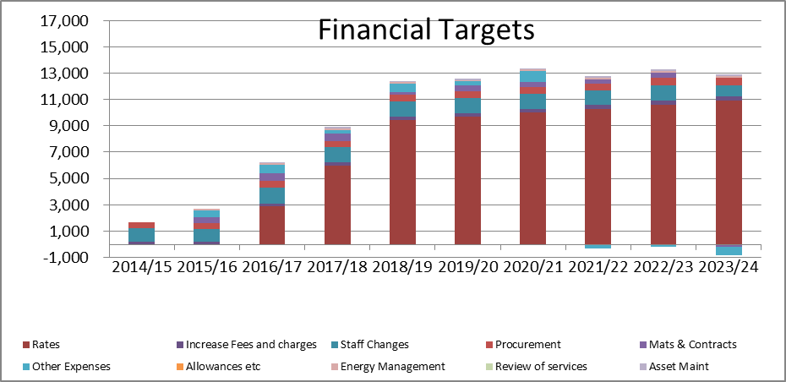



The chart below shows the movement from forecast deficit to the revised operating surplus as a result of the implementation of the above savings plan, this will need to be charted to ensure if actions are in alignment with our plans.

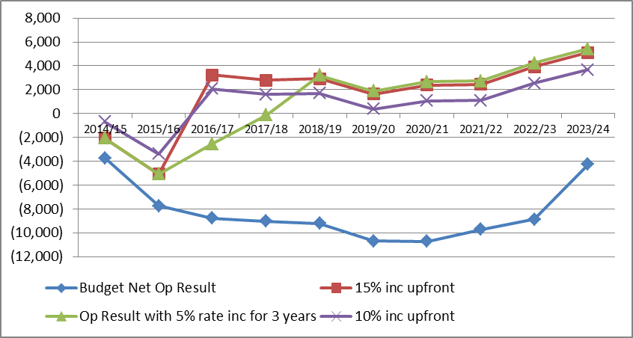

# 8. Recommendations

The following recommendations are proposed to ensure a way forward to a sustainable financial future for Council:

* Start Community dialogue around a rate increase during the next Council term
* Review fee structures including discounts to rate payers.
* Introduce continuous improvement principles throughout Council, including addressing the culture
* Outsourcing where practical and where it supports financial sustainability principles
* Optimisation of the use of technology to enable reengineered processes
* Introduce procurement savings targets
* Review conditions of employment eg spread of hours
* Investigate energy management initiatives
* Rationalise assets where possible – consolidate facilities, better utilisation of facilities and sell off of surplus assets
* Cut services to reduce costs
* Review Pensioner deferral scheme and improved debtor management