future-fund-report-cover-secondary-2

Muswellbrook Shire Council

Delivery Program

2017-21

Table of Contents

[A Message From the Mayor and General Manager 4](#_Toc470186548)

[Councillors of Muswellbrook Shire 6](#_Toc470186550)

[Snapshot of the Shire 7](#_Toc470186551)

[Integrated Planning and Reporting Framework 9](#_Toc470186571)

[Muswellbrook Shire Council Organisational Chart 10](#_Toc470186577)

[Delivery Program Structure 11](#_Toc470186578)

[1. Our Plan for Economic Prosperity 12](#_Toc470186579)

[2. Our Plan for Social Equity and Inclusion 15](#_Toc470186581)

[3. Our Plan for Environmental Sustainability 18](#_Toc470186583)

[4. Our Plan for Cultural Vitality 21](#_Toc470186585)

[5. Our Plan for Community Infrastructure 24](#_Toc470186587)

[6. Our Plan for Community Leadership 26](#_Toc470186588)

[Community Engagement Strategy and Outcomes 29](#_Toc470186592)

[Financial Position 29](#_Toc470186599)

[Special Rate Variation 32](#_Toc470186601)

[Budget Overview 35](#_Toc470186600)

A Message From the Mayor and General Manager

The Muswellbrook Shire Council Delivery Program 2017-21 is Council’s plan for the delivery of community services and infrastructure over the coming four years.

This Delivery Program reflects the broader goals set out in the Community Strategic Plan (CSP) 2017-2027 and outlines how we will deliver against the six priority areas stated, that is, our plan for:

* economic prosperity
* social equity and inclusion
* environmental sustainability
* cultural vitality
* community infrastructure, and
* community leadership.

The Delivery Program 2017 to 2021 has been developed to integrate with our CSP, the NSW Government’s Hunter Regional Plan 2036, the Hunter Regional Implementation Program 2016-2018 (both released in October 2016), the Shire Integrated Water Cycle Management Plan, Council’s Long Term Financial Plan and the commitments made in Council’s Fit for the Future Plan.

# Challenges and opportunities

Council has worked hard over these last few years to implement its Fit for the Future Improvement Plan with improved service delivery while costs have been contained. In July 2016 the community indicated a high level of satisfaction with the quality of the services delivered, with particular appreciation for improved amenity in the Shire’s parks, gardens, sporting fields, libraries, pools and the upgrades to the town centres of Muswellbrook, Denman and Sandy Hollow. As set out in the CSP, community feedback has indicated strong concern about job losses associated with the reversal in the long term economic projections for traded thermal coal. Undoubtedly, the recent closure of Drayton Coal in November 2016 and the planned closures of Muswellbrook Coal, Liddell Coal and Mangoola Coal will have a substantial impact on local employment. The community has seen a substantial increase in unemployment from 3.1%-12.4% between December 2012 and December 2015.

Nonetheless, the Shire’s largest thermal coal mines, Mt Arthur and Bengalla are relatively new and efficient operations, each operating within the first quartile of cost relative to global competitors, and will enjoy long futures even within a challenging international demand setting. Additionally, the new Mt Pleasant mine is widely regarded as the last high quality thermal coal asset in the Hunter.

The Shire has time in which to transition to a more diverse and sustainability economy – but transition we must.

Some years ago, the Hunter Research Foundation – Trade and Investment Upper Hunter Workforce Plan identified aged care, education, intensive agriculture, innovative and complex manufacturing, tourism and eco-tourism as being areas of focus in the diversification of the Hunter economy. Pleasingly, Council’s investments during the previous four year term in education – the Sam Adams residential student college, the Upper Hunter Conservatorium of Music, the Upper Hunter Tertiary Education Centre – together with private investment in approved and proposed preschool and child care developments, are working towards securing Muswellbrook as a centre of educational excellence to drive the upskilling of local residents and to drive further diversification in the local economy.

In 2016, Council developed a partnership with the University of Newcastle and, along with our existing relationship with Hunter TAFE, Council looks forward to expanding tertiary education opportunity within the Shire.

Aged care development is supported by the commencement of a $27m aged care and retirement living development, a $26.5m redevelopment of the Muswellbrook District Hospital together with the continued expansion of the community operated Merton Aged Care Village in Denman. Council will continue in this term to support development and expansion of the visitor economy and the quality of the tourism product.

This Delivery Program recognises that Council must concentrate its efforts on job creation, economic diversification and encouraging sustainable economic development within the Shire. Council’s commitment to continuous improvement and operational efficiency was recognised in 2015 by the Independent Pricing and Regulatory Tribunal’s (IPART) recommendation to the Office of Local Government that Council is Fit For The Future. Council recognises the need to continue to invest in efficiency and capacity within the organisation whilst we invest in significant regional major projects in ongoing consultation with the community. As part of this investment in continuous improvement, Council will implement a new $3 million Information Systems Strategy, which will be rolled out over the life of this Delivery Program, to upgrade customer service, data management and improve business processes.

This Delivery Program will progress the delivery of the new Muswellbrook and Denman Town Centre Strategies which are designed to improve the liveability of the town centres and facilitate economic development and retail investment. The formulation of new Development Control Plans (DCP) and a new Local Environmental Plan (LEP) for the Muswellbrook Shire will provide the basis, together with the new Hunter Regional Plan to consider future land use that will support sustainable economic growth and support the development of intensive agriculture in the Shire.

By this Delivery Plan, Council will also tackle community concerns for social inclusion – particularly in Muswellbrook South and we will develop and build new partnerships with our neighbouring councils, government and industry to tackle the issues in a more integrated way.

Council is pleased to commend the Delivery Plan to the community.

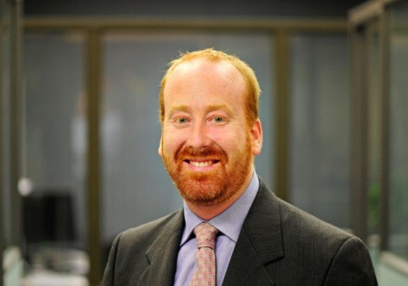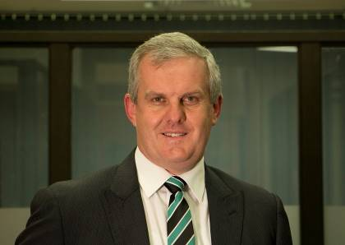

MARTIN RUSH STEVE MCDONALD

Mayor General Manager

Councillors of Muswellbrook Shire

Councillors were elected on 10 September 2016

#### C:\Users\colleenw\AppData\Local\Microsoft\Windows\INetCache\Content.Word\Cr-martin-rush.jpgMark-BowditchScott-Bailey

Cr Martin Rush Cr Scott Bailey Cr Mark Bowditch

Mayor

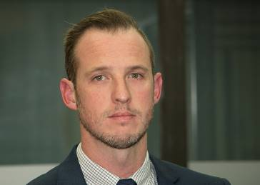[](http://muswellbrook.nsw.gov.au/index.php/home/council/mayor-councillors/435-council/mayor-and-councillors/413-janelle-risby)

Cr Janelle Eades Cr Jason Foy Cr Michelle Green

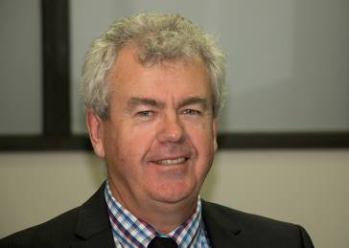

Cr Jacinta Ledlin Cr Graeme McNeil Cr Steve Reynolds

[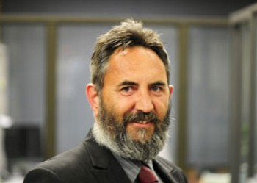](http://muswellbrook.nsw.gov.au/index.php/home/council/mayor-councillors/435-council/mayor-and-councillors/408-brett-woodruff)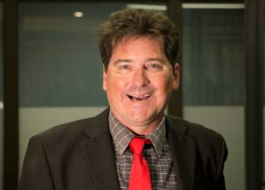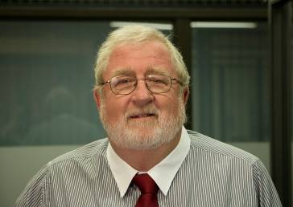

Cr Rod Scholes Cr Stephen Ward Cr Brett Woodruff

Snapshot of the Shire

Muswellbrook Shire is centrally located in the Upper Hunter Valley, approximately 130km north-west of Newcastle. By road, Muswellbrook is approximately three hours from Sydney, two hours from Tamworth and 90 minutes from Newcastle.

The Shire’s boundary is delineated by Lake Liddell to the east, Wollemi National Park to the west, Aberdeen to the north and Coricudgy State Forest to the south.

Muswellbrook Shire covers 3,402km², of which 1,455km (43%) is national park.

Approximately 17,209 people live in the Muswellbrook Shire Local Government Area (LGA), up around 4% from 2011. Most of this growth has been concentrated in the town of Muswellbrook. Council anticipates growth to continue in the short to medium term due to affordable housing and educational opportunities.

It is a welcoming community offering all the cultural, recreational, educational and community facilities that you would expect to find in a city.

Muswellbrook and Denman are the largest towns in the Shire along with a number of outlying rural communities including Sandy Hollow, Wybong, Baerami, Martindale, McCullys Gap, Widden and Muscle Creek.

The population of Muswellbrook Shire tends to be a younger community, with the median age of people being 34 years (2011 ABS Census), compared with 38 for NSW, and 37 for Australia.

Of this population 7.9% are aged 0-4 years (pre-school age) compared with NSW at 6.6%, while 22% are aged 5-19 years (school age/dependants) compared with NSW at 19%.

At the 2011 Census, the population was 51.7% male and 48.3% female.

To find out more about Muswellbrook Shire’s Community Profile visit:

[*www.communityprofile.com.au/muswellbrook*](http://www.communityprofile.com.au/muswellbrook)

# Economic Output

The total annual output in the Muswellbrook Shire LGA is estimated at $6.9 billion. Output data represents the gross revenue generated by businesses/organisations in each of the industry sectors.

# Mining

Coal mining commenced in Muswellbrook Shire in the late 1800s; initially underground mining and then, beginning in 1944, open cut mining.

The oldest mine is Muswellbrook Coal, which celebrated its centenary in 2006. The mining industry has recently experience external economic factors that have resulted in a review of operations, however, the industry remains the biggest employer in the Shire.

There are currently three large mining operations in the Shire, BHP Billiton’s Mount Arthur coal mine, New Hope Mining’s Bengalla, and Glencore’s Mangoola Coal mine are local employers who have also brought many new people and families to the Muswellbrook Shire. MACH Energy has commenced preliminary work on its Mt Pleasant project just north of Muswellbrook township.

# Power Generation

AGL Macquarie is Australia’s largest electricity producer; Liddell (which is earmarked to close in 2022) and Bayswater power stations currently employ around 600 people. They generate the equivalent of 40% of the State’s base-load electricity.

# Education

Muswellbrook is developing as a centre of educational excellence in the Upper Hunter. It is particularly well positioned for the efficient and effective provision of vocational training for existing and emerging industries.

In 2016 the Upper Hunter Tertiary Education Centre was opened, bringing the University of Newcastle to the Upper Hunter.  The Centre houses TAFE and the University of Newcastle, in partnership, contributing to the realisation of our goal for greater diversification over the life of the Community Strategic Plan and new Delivery Program. In addition, the recently opened and now operational Sam Adams College, a joint TAFE, Council and Federal Government initiative, is providing a 63 bed student accommodation facility for the Shire.

Council aims to grow tertiary education further with the implementation of the new Muswellbrook Town Centre Strategy, which will see Muswellbrook become a Regional Centre with high quality community services.

# **Thoroughbred Industry**

The equine industry origins in the Upper Hunter Valley date back over 150 years. This is a result of the Hunter Valley’s unique topography, soil, air, and water availability, making it an ideal location for the horse breeding industry.

Muswellbrook Shire is home to the largest critical mass of thoroughbred rearing in Australia, located in an arc from Widden Valley through Sandy Hollow to Jerry’s Plains. The equine industry is a significant employer alongside other agriculture including dairy, beef and cropping.

# **Viticulture Industry**

The Upper Hunter viticulture industry is small but internationally renowned for the quality and quantity of wine production and processing, and as a wine tourism destination.

The earliest evidence of grape growing in the Upper Hunter dates back to 1860 when vines were planted at the meeting of Wybong Creek and the Goulburn River. The wine from these grapes gained international recognition and acclaim and established a tradition and consumer expectation of quality that continues today.

# **Government Services**

A number of State Government Departments and Agencies have offices located in Muswellbrook Shire and have based regional and sub-regional operations to service the Upper Hunter; these including, Corrective Services, Juvenile Justice, Department of Human Services and the Area Command for NSW Police.

Muswellbrook District Hospital recently completed a significantly larger and more suitable emergency department and planning is currently nearing completion for stage two of development on the site.

Centrally located between the New England and Lower Hunter, Muswellbrook Shire holds an excellent geographical advantage in servicing the surrounding areas through these government agencies.

To find out more about Muswellbrook Shire’s Economic Profile visit:

[www.economicprofile.com.au/muswellbrook](http://www.economicprofile.com.au/muswellbrook)

Integrated Planning and Reporting Framework

The Integrated Planning and Reporting (IP&R) framework was established in 2009 by the New South Wales state government. This legislation requires all Councils to have the following plans developed in consultation with the community:

# **Community Strategic Plan (10 years)**

The Community Strategic Plan is an overview document that identifies the community’s main priorities and goals for the future. It aims to describe what the community wants to see and feel in and around their area. It is based on community consultation undertaken by Council and covers at least 10 years.

# **Delivery Program (4 years)**

#### The Delivery Program is the point of reference for all activities undertaken by the Council during its term of office. The Program details the goals Council prioritises to undertake over a four year period, working towards achieving certain strategies in the Community Strategic Plan.

# Operational Plan (Annual)

#### The Operational Plan directly addresses the goals outlined in the Delivery Program. It identifies the actions, programs and activities Council will undertake within the current financial year. The Operational Plan also allocates responsibility for each action, or set of actions, and identifies suitable performance measures for determining the effectiveness of the activities.

# Resourcing Strategy

The Resourcing Strategy demonstrates how Council will resource achievement of the Community Strategic Plan and Delivery Program. Council does not have full responsibility for implementing or resourcing all the community aspirations, State agencies, non-government organisations, community groups and individuals also have a role to play in delivering these outcomes. Council’s Long Term Financial Plan, Asset Management Plan and Workforce Management Plan have been developed to outline how Council intends to resource the actions identified in the Delivery Plan and objectives of the Community Strategic Plan.

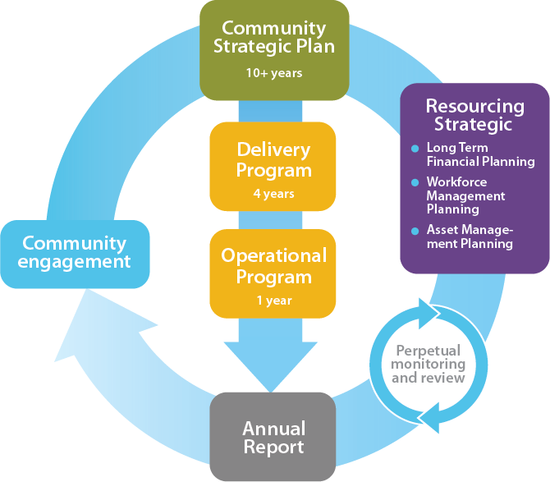

Muswellbrook Shire Council Organisational Chart

#### Council’s leadership team comprises the General Manager, the Director Planning, Community and Corporate Services, the Director Community Infrastructure Services and Executive Manager of Water & Waste.

#### The chart below shows the current organisational structure:

#### C:\Users\colleenw\AppData\Local\Microsoft\Windows\INetCache\Content.Outlook\RQBHLUIJ\Org-chart-20170202_01.png

Delivery Program Structure

#### The following sections of the Delivery Program provide details of each objective that Council will undertake in the next four years. It shows the link to the CSP and includes expected targets.

#### The CSP and Delivery Program were framed within the following model of community wellbeing and integrate with quadruple bottom line reporting and the IP&R Framework. Council’s Community Strategic Plan and Delivery Program respond to the six global megatrends identified by the CSIRO in 2010 to prepare Australia future challenges and assist with planning. The six megatrends address: 1) resource depletion (More from less); 2) reduced biodiversity and extinction (Going, going, gone?); 3) growth of the middle class in developing nations (The silk highway); 4) growing ageing populations in OECD countries (Forever young); 5) increasing connectivity and digital disruption (Virtually here); 6) growing demand for personalised services (Great expectations).

#### C:\Users\colleenw\AppData\Local\Microsoft\Windows\INetCache\Content.Outlook\RQBHLUIJ\community-wellbeing-graphic-for-comm-engagement-strategy-20161220.png

#### As noted above, Council’s priorities focus on:

#### Economic Prosperity

#### Social Equity and Inclusion

#### Environmental Sustainability

#### Cultural Vitality

Added to this are:

* + - 1. Community Infrastructure
      2. Community Leadership

Informing and underpinning these priorities and goals are Council’s:

* Community Engagement Strategy
* Asset Management and Asset Renewal Program
* Financial information, including budget and revenue
* Special rate initiatives

1. Our Plan for Economic Prosperity

##### Our plan for local economic prosperity is to continue our focus on supporting local jobs in the short term whilst facilitating the growth and development of innovative, sustainable and high value-add industries into the future.

#### We need to prepare our local economy for transition. In recent years, there has been a reversal in the long term projections for traded thermal coal and any many associated local job losses. The closure of Drayton Coal in November 2016, and the planned closures of a number of other mining operations, will have a substantial impact on local employment.

#### Nonetheless, the Shire’s largest thermal coal mines, Mt Arthur and Bengalla are relatively new and efficient operations, each operating within the first quartile of cost relative to global competitors, and will enjoy long futures even within a challenging international demand setting. Additionally, the new Mt Pleasant mine is widely regarded as the last high quality thermal coal asset in the Hunter.

#### For that reason, the Shire has time in which to transition to a more diverse and sustainable economy but it is important that we work towards that transition now. The volatility of the Shire’s thermal coal industry is not without very human consequences in terms of job losses and unemployment as well as housing affordability and investment certainty.

#### In arriving at this Delivery Program, Council has carefully considered the various local economic prosperity issues, along with global mega-trends as outlined in the following table:

|  |
| --- |
| Local **economic prosperity** issues |
| Structural decline or uncertainty in the thermal coal industry, associated job losses, and the need to diversify the Shire’s economic base |
| A rising middle class – particularly in south east Asia, and an associated growing demand for agricultural product |
| The growth of the knowledge, creativity, and digital economy and a reshaping labour market |
| The continued growth of the services sector and the concentration of services in Regional centres |
| A growing visitor economy |
| The movement from a linear to a circular economy 🞴 |

#### 🞴A **circular economy** is an alternative to a traditional linear economy (make, use, dispose) in which we keep resources in use for as long as possible, extract the maximum value from them whilst in use, then recover and regenerate products and materials at the end of each service life.

# [Related image](http://www.google.com.au/url?sa=i&rct=j&q=&esrc=s&source=images&cd=&cad=rja&uact=8&ved=0ahUKEwiC35-14PzRAhUIrJQKHZgZDicQjRwIBw&url=http://tracinggreen.uk/news-comment/new-puritans-and-the-circular-economy/&psig=AFQjCNHl_cK4kz7UJd9zcFwHTITXOv1C1A&ust=1486514524317217)Economic Prosperity

|  |  |  |
| --- | --- | --- |
| **Community Strategic Plan Goal** | **Delivery Program Objective** | **Target** |
| **IN PARTNERSHIP WITH:**   * Trade Unions * University of Newcastle * Hunter TAFE * Mining sector * Agriculture sector * AGL Macquarie * NSW Government * Federal Government * Hunter Development Corporation * Upper Hunter Shire Council * Hunter Councils * Muswellbrook Chamber of Commerce and Industry * Denman Chamber of Commerce | | |
| **GOAL ONE**  Support job growth | **1.1** Facilitate the expansion of and establishment of new industries and business | New growth achieved |
| **GOAL TWO**  Diversify the economy, facilitate the development of intensive agriculture and other growth industries, make the shire a more attractive place to invest and do business. | **2.1** Facilitate the diversification of the Shire’s economy and support growth of existing industry and business enterprise | Facilitation leads to the establishment of new industries and business enterprise which diversify our economic base and create employment opportunities. |
| **2.2** Work with the University of Newcastle on research and innovation in areas where the Upper Hunter has a competitive or comparative advantage | Research and innovation leads to the establishment of new industries. |
| **2.3** Review the Local Environmental Plan and Development Control Plan to improve investment certainty for industry | New planning instruments lead to greater industry investment in the Shire. |
| **2.4** Implement the Muswellbrook, Denman town centre masterplans and the Sandy Hollow Village Masterplan | Implement the first stage of the Muswellbrook town centre masterplan (Regional Convention and Performance Centre) and the Denman town revitalisation project, subject to Special Rate Variation. |
| **2.5** Develop agricultural industry opportunities in the Shire | Develop agricultural industry masterplan. |
| **GOAL THREE**  Facilitate greater access to higher education and participation in the knowledge and creativity economy | **3.1** Through the Future Fund invest in additional education infrastructure, in partnership with Hunter TAFE, the University of Newcastle and other providers | Additional education and creativity infrastructure constructed to support improved access to higher education and participation in the knowledge and creativity economy |
| **GOAL FOUR**  Develop Muswellbrook as a Regional Centre | **4.**1 Construct and maintain regionally significant infrastructure that facilitates regional service provision. | Increase in provision of regional service delivery. |

**How Muswellbrook’s Community Goals align with NSW Government Priorities and Plans:**

PREMIER’S PRIORITIES IN ACTION: Creating Jobs; improving education results.

STATE PRIORITIES: Strong budget and economy; encourage business investment; boosting apprenticeships; Improving Aboriginal education outcomes.

HUNTER REGIONAL PLAN 2036: to be the leading regional economy in Australia; enhance inter-regional linkages to support economic growth; transform the productivity of the Upper Hunter; greater housing choice and jobs; protect the economic functions of employment land; strengthen the economic self-determination of Aboriginal communities; develop advanced manufacturing, defence and aerospace hubs; promote innovative small business and growth in the service sectors; grow tourism in the industry; protect and enhance agricultural productivity; manage the ongoing use of natural resources; diversify and grow the energy sector.

2. Our Plan for Social Equity & Inclusion

##### Our plan for social equity and inclusion is to focus on supporting policies which promote social inclusion, participation in a range of employment and community events and activities, and better liveability services and facilities to help support families in work and older residents in retirement.

Most Shire residents are engaged, feel a sense of pride in their communities and feel safe and secure in their homes. However, there are still a number of indicators where the community is seeking more. Youth services, facilities and services for older people along with a desire for support for local communities are areas of priority.

Residents from across the Shire have access to a wide range of community and government agency services appropriate for their age and needs. Council works with health, welfare and educational organisations from the government and non-government sectors with the aim of improving outcomes for individuals and our community. This occurs through liaison, advisory support, assistance with premises and provision of opportunities for networking.

Council will continue to support the Aboriginal community and work in partnership with the Wanaruah Local Aboriginal Land Council to further the reconciliation process with local Aboriginal people.

In arriving at this Delivery Program, Council has carefully considered the various local social equity and inclusion issues, along with the external mega-trends outlined in the following table:

|  |
| --- |
| Local **social equity and inclusion** issues |
| An aging population and changing retirement patterns |
| Social disadvantage and social exclusion – particularly in Muswellbrook South |
| Early childhood education and social advantage indicia |
| Improving local liveability and amenity |
| Easily accessible venues to appreciate and participate in arts and culture |

# Social Equity & Inclusion

|  |  |  |
| --- | --- | --- |
| **Community Strategic Plan Goal** | **Delivery Program Objective** | **Target** |
| **IN PARTNERSHIP WITH:**   * Schools * Childcare providers * Shire Sports Clubs and User Groups * Muswellbrook Chamber of Commerce and Industry * Denman Chamber of Commerce * Social and community housing providers * NSW Government * Federal Government * Upper Hunter Community Services * Wanaruah Local Aboriginal Land Council * University of Newcastle * Hunter TAFE | | |
| **GOAL FIVE**  Continue to improve the affordability, liveability and amenity of the Shire’s communities | **5.1** Implement the outcomes of the Recreation Needs Study | The recommendations from the Recreation Needs Study are implemented |
| **5.2** Continue town centre revitalisation projects. | Revitalisation projects completed |
| **5.3** Facilitate investment in entertainment opportunities, particularly for young people. | New entertainment opportunities provided. |
| **5.4** Improve access to waterways | Greater appreciation and interaction by the community with our local rivers and creeks. |
| **5.5** Promote and facilitate increased participation in active and passive recreation activities | Increased participation in recreation activities |
| **5.6** Consider and deliver social inclusion principals across Council functions. | People with disability are continually included in improving the provision of accessible options across the Shire. |
| **5.7** Facilitate the provision of Affordable Housing opportunities through development application process as encouraged through the  Affordable Rental Housing SEPP 2009 | New Affordable Housing opportunities provided |
| **GOAL SIX**  Stabilise the tenancy turnover in the Shire’s social housing | **6.1** Continue partnership with Government and community housing services to reduce the turnover of tenants in the Shire’s social housing | Reduction in the turnover of tenants residing in social housing |

|  |  |  |
| --- | --- | --- |
| **GOAL SEVEN**  Build social inclusion and improve the delivery of social services | **7.1** Facilitate discussions with other levels of government to enhance the delivery of services to improve and promote social inclusion services | Improved social indicators across the Shire |
| **7.2** Facilitate and implement improved disability access and inclusion across the Shire | Disability access and inclusion improved to targeted facilities. |
| **GOAL EIGHT**  Retention and expansion of quality and affordable child care services. | **8.1** Facilitate investment in child care services across the Shire | Increased childcare, early childhood education and pre-school options. |
| **GOAL NINE**  Facilitate opportunities to expand seniors living. | **9.1** Facilitate investment in new seniors living facilities | Improved opportunities for seniors living within the Shire. |
| **9.2** Facilitate discussions with other levels of government to enhance the delivery of services to support older people to live in the Muswellbrook Shire | Improved services for older residents. |
| **GOAL TEN**  Further the process of reconciliation in the Shire | **10.1** Collaborate with local Aboriginal people on projects which enhance an appreciation for, and which develop the vitality of, Aboriginal culture. | Improved understanding and appreciation of the importance of the Aboriginal Community and their traditions and culture. |
| **10.2** Raise awareness of the local Aboriginal Community and an appreciation of their long traditions and culture. | Improved understanding and appreciation of the importance of the Aboriginal Community and their traditions and culture. |

**How Muswellbrook’s Community Goals align with NSW Government Priorities and Plans:**

PREMIER’S PRIORITIES IN ACTION: Reducing domestic violence; tackling childhood obesity; improving education results; protecting our kids; reduce youth homelessness; improving government services; creating jobs; building infrastructure; improving service levels in hospitals.

STATE PRIORITIES: Increasing housing supply; creating sustainable social housing; increasing cultural participation; improving Aboriginal education outcomes; reducing violent crime.

HUNTER REGIONAL PLAN 2036: Thriving Communities; create healthy built environments through good design; enhance access to recreational facilities and connect open spaces; revitalise existing communities; greater housing choice and jobs: promote housing diversity; deliver infrastructure to support growth and communities.

3. Our Plan for Environmental Sustainability

##### Our plan for environmental sustainability is to focus on the regeneration of mined land and urban riparian areas, increase our use of renewable energy and to monitor and manage our use of natural resources.

Muswellbrook Shire Council is committed to improve its environmental performance and to demonstrate good environmental practice. We are working towards a number of goals to reduce water and energy usage, improve waste management and promote awareness of environmental issues throughout the community.

Our sustainability goals are to:

* comply with the requirements of government legislation and regulations as applies to environmental sustainability
* reduce consumption of energy, water and consumables
* reduce waste to landfill and enhance our recycling system
* record energy usage and provide an annual estimate of carbon emissions
* incorporate sustainability measures into relevant business decisions
* promote environmental sustainability goals to staff, community and key stakeholders.

Council supports the Principles of Environmentally Sustainable Development as defined in the [*Protection of the Environment Administration Act 1991* (NSW)](http://www.legislation.nsw.gov.au/maintop/view/inforce/act+60+1991+cd+0+N):

* ***The precautionary principle*** - public and private decisions should be guided by careful evaluation to avoid serious or irreversible damage to the environment wherever practicable, and an assessment of the risk-weighted consequences of various options.
* ***Inter-generational equity***- the present generation should ensure that the health, diversity and productivity of the environment are maintained or enhanced for the benefit of future generations,
* ***Conservation of biological diversity and ecological integrity*** - conservation of biological diversity and ecological integrity should be a fundamental consideration in environmental planning and decision-making processes.
* ***Improved valuation, pricing and incentive mechanisms*** - environmental factors should be included in the valuation of assets and services for example, the polluter pays – those who generate pollution and waste should bear the cost of containment, avoidance or abatement.

These principles are implemented at the State level through a number of decision-making processes, including the regulation of pollution, and development assessment and approval regimes.

#### In arriving at this Delivery Program Council has carefully considered the various local environmental sustainability issues, along with the external mega-trends, as outlined in the following table:

|  |
| --- |
| Local **environmental sustainability** issues |
| Climate change |
| Loss/re-establishment/rehabilitation of native vegetation and vegetation connectivity |
| Poor riparian environments and poor public access to waterways |

# Environmental Sustainability

|  |  |  |
| --- | --- | --- |
| **Community Strategic Plan Goal** | **Delivery Program Objective** | **Target** |
| **IN PARTNERSHIP WITH:**   * University of Newcastle * Landcare groups * Muswellbrook Chamber of Commerce and Industry * Denman Chamber of Commerce * NSW Government * Federal Government * Hunter Councils * Upper Hunter Shire Council * Singleton Council * Upper Hunter Weeds Authority * Mining Industry * AGL Macquarie | | |
| **GOAL ELEVEN**  Higher quality final landforms with shallower voids and more emphasis on progressive rehabilitation with local workforce participation | **11.1** Work in partnership with industry and other levels of government to achieve improved rehabilitation outcomes for disused mining lands and ongoing employment for the local workforce. | Improvements in final landforms and void depths. |
| **GOAL TWELVE**  Enhance native vegetation connectivity across the Upper Hunter | **12.1** Support Landcare initiatives and programs to enhance native vegetation connectivity across the Upper Hunter. | Enhanced native vegetation connectivity across the Upper Hunter. |
| **GOAL THIRTEEN**  Our local rivers and creeks are enhanced, utilised and valued | **13.1** Adopt an Urban Riparian Masterplan and implement actions. | Healthier waterways and greater recreational use by the community. |
| **GOAL FOURTEEN**  Support initiatives which reduce the community’s impact on the environment | **14.1** Carry out actions under the Sustainability Plan as it relates to air quality, waste reuse and minimisation, electricity minimisation, Council’s Renewable Energy Target and food waste minimisation. | Actions carried out. |
| **14.2** Require all development proposals to avoid and mitigate against potential environmental impacts and facilitate improved environmental outcomes where possible | Development application process includes review of potential environmental impacts and mitigation requirements included in conditions. |

|  |  |  |
| --- | --- | --- |
| **GOAL FIFTEEN**  Support Federal and State initiatives to reduce the human impact on climate change | **15.1** Increase the proportion of the energy used by Council from renewable sources. | Council to meet a Renewable Energy Target of 40% by 2020. |
| **15.2** Increase the take up of energy used by the wider community from renewable sources. | The community to meet Renewable Energy Target commensurate with the NSW Government Renewable Energy Target. |

**How Muswellbrook’s Community Goals align with NSW Government Priorities and Plans:**

PREMIER’S PRIORITIES IN ACTION: Keeping our environment clean.

HUNTER REGIONAL PLAN 2036: A biodiversity-rich natural environment; protect and connect natural areas; sustain water quality and security; increase resilience to hazards and climate change.

NSW DRAFT CLIMATE CHANGE FUND STRATEGIC PLAN: NSW Aspirational objectives: achieve net-zero emissions of 2050; NSW is more resilient to a changing climate; lead by example to reduce emissions in government operations.

4. Our Plan for Cultural Vitality

##### Our plan for cultural vitality is to increase the variety, availability and access to the arts and cultural experiences.

Muswellbrook Shire aims to be a culturally rich and diverse Shire with communities that have strong identities and a shared sense of place. The communities of the Shire support and value the culture and traditions of local Aboriginal people and acknowledge their profound contribution to the land and communities of the Shire.

Council also places importance on the value of the arts and creative industries in all their forms as part of our everyday lives. Council recognises the value the arts provide to enrich our lived experience and supports:

* Providing opportunities for cultural participation across multiple dimensions;
* Systems and mechanisms that support and encourage cultural participation; and
* Opportunities for inclusive arts and cultural expression.

Council looks forward to encouraging growth in non-profit, public, and commercial arts-related organisations, retail arts venues (bookshops, cinemas, craft and art suppliers), venues with arts and cultural programming (parks, libraries, multicultural associations, societies, and centres), festivals and parades, arts-focused media outlets (print and electronic, including web-based venues) and art schools.

In arriving at this Delivery Program Council has carefully considered the various local cultural vitality issues, along with the external mega-trends, as outlined in the following table:

|  |
| --- |
| Local **cultural vitality** issues |
| A variety of opportunities for cultural participation |
| Opportunity to experience high quality national and international arts and culture |

# Cultural Vitality

|  |  |  |
| --- | --- | --- |
| **Community Strategic Plan Goal** | **Delivery Program Objective** | **Target** |
| **IN PARTNERSHIP WITH:**   * NSW Government * Federal Government * Arts Upper Hunter * Mining industry members * Creative industries sector * Muswellbrook Chamber of Commerce and Industry * Denman Chamber of Commerce | | |
| **GOAL SIXTEEN**  Conserve the Heritage and History of the Shire | **16.1** Support the conservation and restoration of the Shire’s heritage items. | New investment in heritage conservation and restoration made. |
| **16.2** Ensure sites or artifacts of aboriginal significance are protected where new development proposals are considered. | Development assessment includes assessment of the potential impact on aboriginal sites and artefacts and appropriate mitigation is applied as required. |
| **16.3** New investment in heritage conservation and restoration made. | Funding allocation for heritage conservation and restoration is available. |
| **GOAL SEVENTEEN**  Facilitate options to improve cultural activities in the Shire. | **17.1** Construct a Regional convention and performance space subject to a Special Rate Variation. | Construction completed. |
| **GOAL EIGHTEEN**  Facilitate cultural activities and events which engage the community and visitors, and which create a ‘sense of place’ and identity. | **18.1** Increase funding to the Blue Heeler Film Festival and the Bottoms Up beer and music festival with a view to engaging more locals and visitors. | Increased attendance and participation at a variety of festivals and events. |
| **18.2** Continue the provision of arts appreciated through the Muswellbrook Regional Arts Centre | A minimum of five exhibitions each year and the artist in residency completed. |
| **18.3** Continue the Public Art Program in the localities identified by Council | One piece of public art is placed each financial year for five years (commencing 16/17) |
| **18.4** Support Arts Upper Hunter as the peak organisation of Artist endeavour | Financial support is provided each year. |

**How Muswellbrook’s Community Goals align with NSW Government Priorities and Plans:**

PREMIER’S PRIORITIES IN ACTION: Creating jobs; building infrastructure.

STATE PRIORITIES: Improving Aboriginal education outcomes; increasing cultural participation.

HUNTER REGIONAL PLAN 2036: Transform the productivity of the Upper Hunter; grow tourism in the region; create healthy built environments through good design; enhance access to recreational facilities and connect open spaces; revitalise existing communities; deliver infrastructure to support growth and communities; strengthen the economic self-determination of Aboriginal communities.

5. Our Plan for Community Infrastructure

##### Our plan for community infrastructure is to expand on the infrastructure required for Muswellbrook to realise Regional Centre status, improve community facilities and improve accessibility to community facilities.

Council has made significant investments in community infrastructure in recent years and plans to continue to do so over the next four years of this Delivery Program. The value of community infrastructure for which Council is responsible is $795million.

The cost of operating, maintaining and renewing these assets, accounting for their depreciation and building new assets to meet the growing needs and aspirations of our community makes up around 85% of Council’s budget.

Council maintains 690.8 kilometres of roadway (596.6kms of which is sealed), 42.5km of footpaths, approximately 73 kms of stormwater drainage and over 1000 rural culverts, 45 carparks, 169kms of kerb and gutter and approximately $12.4 million worth of traffic safety and control devices.

Council as the local water utility provides water treatment and reticulated drinking water supply services to the urban areas of Muswellbrook, Denman and Sandy Hollow and sewerage reticulation and treatment to the urban areas of Muswellbrook and Denman. The fully regulated Hunter River provides a highly reliable source for Muswellbrook and Denman. Sandy Hollow relies for its water supply on the Goulburn River. Council provides domestic waste services for the townships and some limited rural roads along the truck travel routes. Council operates a three bin system; weekly mixed waste, fortnightly recycling and green waste services and operates a waste management centre in Muswellbrook and a transfer station in Denman.

Managing assets responsibly is critical to Councils financial sustainability. Councils focus is on the provision of best value, in terms of:

* performance - quality, functionality and capacity of assets
* sustainability - minimising the costs of providing assets over their life cycle
* risk (managed at an acceptable level) and resilience - ability to withstand shocks

#### In arriving at this Delivery Program Council has carefully considered the various local community infrastructure issues, along with the external mega-trends, as outlined in the following table:

|  |
| --- |
| Local **community infrastructure** issues |
| Integrated footpath and cycle ways |
| Improved accessibility to Council’s facilities |
| Maintain and expand infrastructure to support Muswellbrook achieve Regional Centre status |
| Ageing Water and Wastewater Infrastructure |

# Community Infrastructure

|  |  |  |
| --- | --- | --- |
| **Community Strategic Plan Goal** | **Delivery Program Objective** | **Target** |
| **in partnership with:**   * NSW Government * Hunter Development Corporation * Federal Government * Upper Hunter Water Alliance * Mining sector * Agriculture sector | | |
| **GOAL NINETEEN**  Our community’s infrastructure is planned well, is safe and reliable, and provides required levels of service. | **19.1** Improve and maintain civic precincts | Civic precincts and traffic safety devices and networks are well maintained and safe |
| **19.2** Maintain and continually improve asset management | Implement Councils asset management strategy. |
| **19.3** Facilitate investment in high quality community infrastructure necessary to a regional centre | High quality infrastructure is provided to support Muswellbrook as a regional centre. |
| **19.4** Maintain and continually improve community infrastructure across the Shire | Roads, footpath and cycleway networks, stormwater devices and kerb and guttering are well maintained, safe and meet relevant standards and the community’s service expectations. |
| **GOAL TWENTY**  A safe, secure and reliable water supply and sewerage services are provided to all residents that will ensure public health. | **20.1** Provide safe, secure, efficient and effective water, sewerage and waste services in compliance with regulatory requirements. | Council renews, upgrades and maintains Councils water and waste utilities and facilities to agreed standards and within regulatory requirements. |
| **GOAL TWENTY ONE**  The road, footpath and cycleway networks are integrated and allow for the safe movement of residents around the Shire. | **21.1** Maintain and continually improve the Shire’s footpath and cycleway networks to improve connectivity. | The Shire’s footpaths, cycleways and carparks are well planned, maintained, safe, assist community connectivity and meet the community’s service expectations. |

**How Muswellbrook’s Community Goals align with NSW Government Priorities and Plans:**

PREMIER’S PRIORITIES IN ACTION: Building infrastructure.

STATE PRIORITIES: Improving road travel reliability.

HUNTER REGIONAL PLAN 2036: Thriving communities: enhance access to recreational facilities and connect open spaces; Greater housing choice and jobs: deliver infrastructure to support growth and communities; A biodiversity-rich natural environment: sustain water quality and security.

6. Our Plan for Community Leadership

##### Our plan for community leadership is to improve the community’s participation in decision making and implement business improvement initiatives to improve service delivery.

**The Governing Body**

The Governing Body of the Council consists of 12 councillors elected for four years. The Chair of Muswellbrook Shire Council (the Mayor of Muswellbrook) and the Deputy Chair are elected by all councillors every two years.

**The Mayor and Councillors**

#### The Mayor holds a number of Council delegations and some statutory responsibilities to make determinations on behalf of the Governing Body of the Council between Council meetings. The Mayor is responsible to the Governing Body for the determinations he or she makes. The Governing Body has also provided certain delegations to Councillor Spokespersons for Council’s principal activities to speak on behalf of Council and make policy determinations between Council meetings with respect to those specific principal activities.

**Council’s Business Improvement Strategy**

Local governments across the state (and around the world) have recognised the need to improve service delivery and the way assets are managed to ensure they are financial sustainable, particularly as large portfolios of long-lived assets deteriorate with age and need renewal. Council’s Strategic Asset Management Plan, aligns with the Long Term Financial Plan and business improvement plans. Over this Delivery Program, Council will implement a new Information Services Strategic and Business Improvement Plan.

Key actions that will be undertaken across Council to improve delivery of all services over the next few years includes:

* *introduction of a new Information Services Strategy:* Council has applied technology in a number of areas, but the functionality of some systems is limited and most do not integrate (this is a barrier to improving management and planning, it also makes it difficult to keep data updated)
* *knowledge and data:* while Council has reasonable information on most asset classes (condition, expected service life, cost of renewal) there is a need to continue to refine this to improve confidence in reporting and to facilitate future planning
* *lifecycle management strategies:* the way assets are operated, maintained and renewed improves performance and resilience and reduces cost and risk (strategies are in place, but these need to be refined / optimised as well as modelled long term)
* *processes and documentation:* asset management can be technical and complex, but it must be simpler and clearer to facilitate community engagement, inform Council decision making and encourage active participation by relevant staff.

Council is also focused on ensuring the information it reports on its assets is auditable as auditing by the NSW Auditor General is due to commence in 2017.

#### In arriving at this Delivery Program Council has carefully considered the various local community leadership issues, along with global mega-trends, as outlined in the following table:

|  |
| --- |
| Local **community leadership** issues |
| Community consultation and participation in council planning |
| Workforce and asset management |
| Business Improvement |

# Community Leadership

|  |  |  |
| --- | --- | --- |
| **Community Strategic Plan Goal** | **Delivery Program Objective** | **Target** |
| **IN PARTNERSHIP WITH:**   * NSW Government * Federal Government * Hunter Councils * Trade unions | | |
| **GOAL TWENTY TWO**  Collaborative and responsive community leadership that meets the expectations and anticipates the needs of the community. | **22.1** Enhanced collaboration with Council’s community and stakeholders to ensure Council and its elected arm is best place to make decisions in the best interests of the community. | Heightened levels of community satisfaction with Council’s decision making processes and the maintenance of high standards of transparency and accountability. |
| **GOAL TWENTY THREE**  Genuine and well informed community participation in decision making. | **23.1** Utilise best practice models of community engagement to ensure decision making is meeting the expectations of the community. | Increased participation of residents and other key stakeholders in consultation and decision making processes. |
| **23.2** Enhance Council’s consultation and communication with the community to build awareness and understanding of Council’s activities and Community needs. | Greater awareness in the community of Council’s activities. |
| **GOAL TWENTY FOUR**  A Council that is well managed, efficient and properly resourced and that is responsive to its communities and stakeholders. | **24.1** Maintain a strong focus on financial discipline to enable Council to properly respond to the needs of the communities it serves. | Strong financial discipline maintained. Delivering approved programs complying with statutory obligations. |
| **24.2** Implement a comprehensive and targeted business improvement program | Improve information systems and business processes to provide responsive and customer focused service delivery |
| **GOAL TWENTY FIVE**  A sustainable council that is a best practice employer providing a safe, happy and productive workplace. | **25.1** Continue to prioritise safety and risk management initiatives, employee welfare initiatives and upgrades to Council’s works depot and waste management facility. | Initiatives and upgrades undertaken. |

**How Muswellbrook’s Community Goals align with NSW Government Priorities and Plans:**

PREMIER’S PRIORITIES IN ACTION: Improving government services; faster housing approvals; driving public sector diversity.

STATE PRIORITIES: Delivering strong budgets; Better Government digital services.

Community Engagement Strategy and Outcomes

#### As part of its 2015 Fit for the Future Plan, Council noted that it had sufficient resources to meet planned levels of service and the renewal of community infrastructure. It also noted, however, that:

The community engagement strategy articulates how Council will engage with the community to ensure that the Community Strategic Plan is developed in line with the community’s needs and reflects the community’s vision for the future of the Muswellbrook Shire.

Council’s Engagement Strategy aims to:

* To identify the community’s priorities and vision for the Muswellbrook Shire, its towns and villages over the next 10 years
* Develop a Delivery Program and Operational Plans to realise the community’s vision and priorities
* Test the relevance of the pillars and themes of the draft 2027 Community Strategic Plan

Our community engagement is guided by the following principles:

* Comply with ‘The council charter’ as per the NSW Local Government Act 1993 section 8
* Apply a deliberative democracy approach to community engagement
* Address social, environmental, economic and civic leadership issues in an integrated manner applying the 4 pillars of sustainability in the planning and reporting process.

NSW IP&R legislation requires a newly elected Council to endorse its new 10-year CSP within six months of the local government election. The Muswellbrook CSP 2027 needs to be endorsed by the elected Council no later than March 2017.

Council’s strategic planning documents sit within the IP&R framework as outlined previously.

Activities that have been undertaken in 2016-17 as part of our Community Engagement have included:

* **Media releases** - local radio and newspapers are kept informed about the range of opportunities to provide feedback and “have your say”
* **Council newsletter** - Council’s community newsletter keeps the community informed about our engagement process and how to get involved
* **Website feedback forum** - Council’s website includes information about Listening Post sites, post it walls and a portal to lodge submissions and ideas on various topics and issues of community significance
* **Listening Posts** - Council staff collect community feedback at Listening Posts; these are set up at shopping centres, schools and popular locations
* **Post it walls and boxes** - Post it walls and feedback boxes are provided at the libraries and swimming pools
* **Submissions** - local individuals and groups from across the Shire are invited to make submissions for the consideration and information of the Community Panel
* **Community Panel** - residents are randomly drawn from across the Shire to form a demographically representative panel. They regularly meet over a specific period to prepare recommendations for Council about their vision and priorities for the Muswellbrook area. Once the Community Panel process is complete the Panel will present their views to the Council.

The five characteristics of deliberative democracy that Council’s Community Panel will utilise are:

* Information - accurate and relevant data is made available to all participants
* Substantive balance - different positions are compared based on their supporting evidence
* Diversity - all major positions relevant to the matter are considered
* Conscientiousness - participants sincerely weigh all arguments
* Equal consideration - views are weighed based on evidence, not on who is advocating a particular view

Council has consulted with our community extensively. This has been done in relation to a number of specific projects, such as the Muswellbrook and Denman Town Centre Plans, but also in more general terms, such as our Listening Post interactions.

Financial Position

Over the last eight (6) years, Council has made a conscious and concerted effort to achieve ongoing improvements in its Operating Result and has been successful in reducing the General Fund operating result for the year before grants and contributions provided for capital purposes from a deficit of $3,090k in 2010/11 to a surplus of $3,342k for 2016/17. This has been achieved through a series of measures including:

* Financial and budgetary discipline in regard to expenditures.
* Careful investment in projects that have reduced ongoing operational costs
* Diversification of Council’s revenues, including investment in commercial properties that have allowed for the payment of an increasing and ongoing dividend.
* Increased revenues related to the expansion of mining activities in the Shire.

The achievement of a balanced budget, or even a small surplus is important for two major reasons. The first is that it allows for the continuation of services at their current levels without the need to unexpectedly increase revenues related to the provision of the services, that is, there is no need to unexpectedly increase fees and charges. The second is that it allows Council to replace and renew infrastructure and other community assets as they deteriorate. This ensures that the standard of this infrastructure is maintained over time. This prevents the accumulation of an “infrastructure backlog” or a catalogue of infrastructure items that Council does not have sufficient funds to be able to correct.

In addition to the achievement of a solid operating result, it should also be noted that the General Fund has a strong cash position, holding $19.402M in reserve fund and a low level of debt ($5.871M) that it can easily service with at its current revenue levels. This gives Council a degree of flexibility as it seeks to respond to the financial challenges that is faces.

As part of its 2015 *Fit for the Future* Plan, Council noted that it had sufficient resources to meet planned levels of service and the renewal of community infrastructure. However, Council now faces a situation of uncertainty in that there now exists a large degree of uncertainty in regard to revenues related to mining operations. This uncertainty arises from a series of threats as some mines reach the end of their approved or useful lives and opportunities as other mines open or expand their operations. If Council is to be able to maintain the strong financial situation that it has currently achieved and to be able to maintain services and infrastructure standards, it needs to be able to replace any revenues lost from this source. Similarly, in order to be able to properly plan for the provision of services and replacement and renewal of infrastructure, Council needs to be able to be confident in regard to the ongoing levels of revenue that it expects to receive over time.

Council also recognises that it needs to respond in regard to the local social and economic impacts that are currently arising in relation to the uncertainty facing the mining industry and this is why Council proposes a range of new programmes that are geared toward helping the community and the local economy adapt to these changes and to provide the Shire with a new base from which it can progress in the new economic realities that apply.

In order to be able to provide these new services, such as allocations towards job creation, the improvement of the local natural environment and the creation of new facilities such as those proposed in regard to performing arts and conventions, the aquatic centre and the central business district of Denman, Council will need to give serious consideration to all its possible revenue sources in regard to the funding of these proposals. These considerations could include the reallocation of funding away from other existing activities and services, review of the fees and charges levied on specific users of community facilities, the appropriate use of debt and cash reserves or the possible application for a Special Rate Variation aimed at raising enough revenue to allow for the provision of these new activities and facilities.

Council has prepared a budget based around the facilitation of the activities and targets outlined in this Delivery Program and a summary of these proposals, based on the scenario of the Special Rate Variation application being accepted and on the scenario of the application being refused are presented on the following pages. It should be noted that these figures and allocations will be subject to change on an annual basis as the needs, goals and targets of the organisation change and evolve.

Special Rate Variation

#### As part of its 2015 Fit for the Future Plan, Council noted that it had sufficient resources to meet planned levels of service and the renewal of community infrastructure. It also noted, however, that:

“Council would consider as an option, and in consultation with community, making application for a Special Rate Variation to fund any new infrastructure identified by the community.”

#### Since the last Community Strategic Plan and Fit for the Future Plan the issues, particularly the economic issues have become more acute. Council’s ability to address these issues has in part been met by the introduction of new programs for job creation, innovation and research and sustainability.

#### These programs, which have substantial priority, have largely been funded by further efficiencies achieved since the Fit for the Future process was introduced and additional revenues flowing from Council’s Future Fund. In order to drive the transition of the Shire into a regional centre (Goal 4 of the CSP), Council proposes a Special Rate Variation to fund three regionally significant projects: a Regional Convention and Performance Centre – a major component of the Muswellbrook Town Centre Plan, an expansion and upgrade to the Regional Aquatic Centre and the delivery of the Denman Town Centre revitalisation plan. These projects are also aligned with the priorities of this Plan together with the Premier’s Priorities in Action, State Priorities, Hunter Regional Plan 2036 and other State Government plans.

|  |  |
| --- | --- |
| **Regional Convention and Performance Centre** | |
| Premier’s Priorities in Action | Creating Jobs |
| Building Infrastructure |
| State Priorities | Encouraging Business Investment |
| Increasing cultural participation |
| Hunter Regional Plan 2036 | Transform the productivity of the Upper Hunter |
| Promote innovative small business and growth in the service sectors |
| Grow tourism in the region |
| Protect and enhance agricultural productivity |
| Enhance access to recreational facilities and connect open spaces |
| Revitalise existing communities |
| Deliver infrastructure to support growth and communities |
| Upper Hunter Economic Diversification Strategy | Encourage population to the region and develop knowledge intensive activity |
| Upper Hunter Workforce Plan | Implement initiatives to broaden the workforce  Attract higher education to Muswellbrook |

|  |  |
| --- | --- |
| **Muswellbrook Aquatic Centre (Stage III) Revitalisation Project** | |
| Premier’s Priorities in Action | Building Infrastructure |
| Tackling childhood obesity |
| State Priorities | Building Infrastructure |
| Hunter Regional Plan 2036 | Grow tourism in the region |
| Enhance access to recreational facilities and connect open spaces |
| Revitalise existing communities |
| Deliver infrastructure to support growth and communities |
| Upper Hunter Economic Diversification Strategy | Encourage population to the region and develop knowledge intensive activity |
| Upper Hunter Workforce Plan | Implement initiatives to broaden the workforce  Attract higher education to Muswellbrook |

|  |  |
| --- | --- |
| **Denman Town Centre Revitalisation** | |
| Premier’s Priorities in Action | Creating Jobs |
| Building Infrastructure |
| State Priorities | Encouraging Business Investment |
| Increasing cultural participation |
| Hunter Regional Plan 2036 | Transform the productivity of the Upper Hunter |
| Promote innovative small business and growth in the service sectors |
| Grow tourism in the region |
| Protect and enhance agricultural productivity |
| Enhance access to recreational facilities and connect open spaces |
| Revitalise existing communities |
| Deliver infrastructure to support growth and communities |
| Upper Hunter Economic Diversification Strategy | Encourage population to the region and develop knowledge intensive activity |
| Upper Hunter Workforce Plan | Implement initiatives to broaden the workforce  Attract higher education to Muswellbrook |

#### Each of the projects has been the subject of considerable interest from the community over a sustained period of time but could not be delivered within the current resourcing envelope which is fully committed to higher priority projects in job creation and diversification.

#### In light of the community’s desire to achieve the goals of this Plan as quickly as possible, Council proposes a Special Rate Variation accumulating over four years at 2.5 per cent each year to bring forward the three identified projects to completion within the period of the Delivery Program.

# **Scenario One – Consolidated - Financial Statements – 2019-28 LTFP**

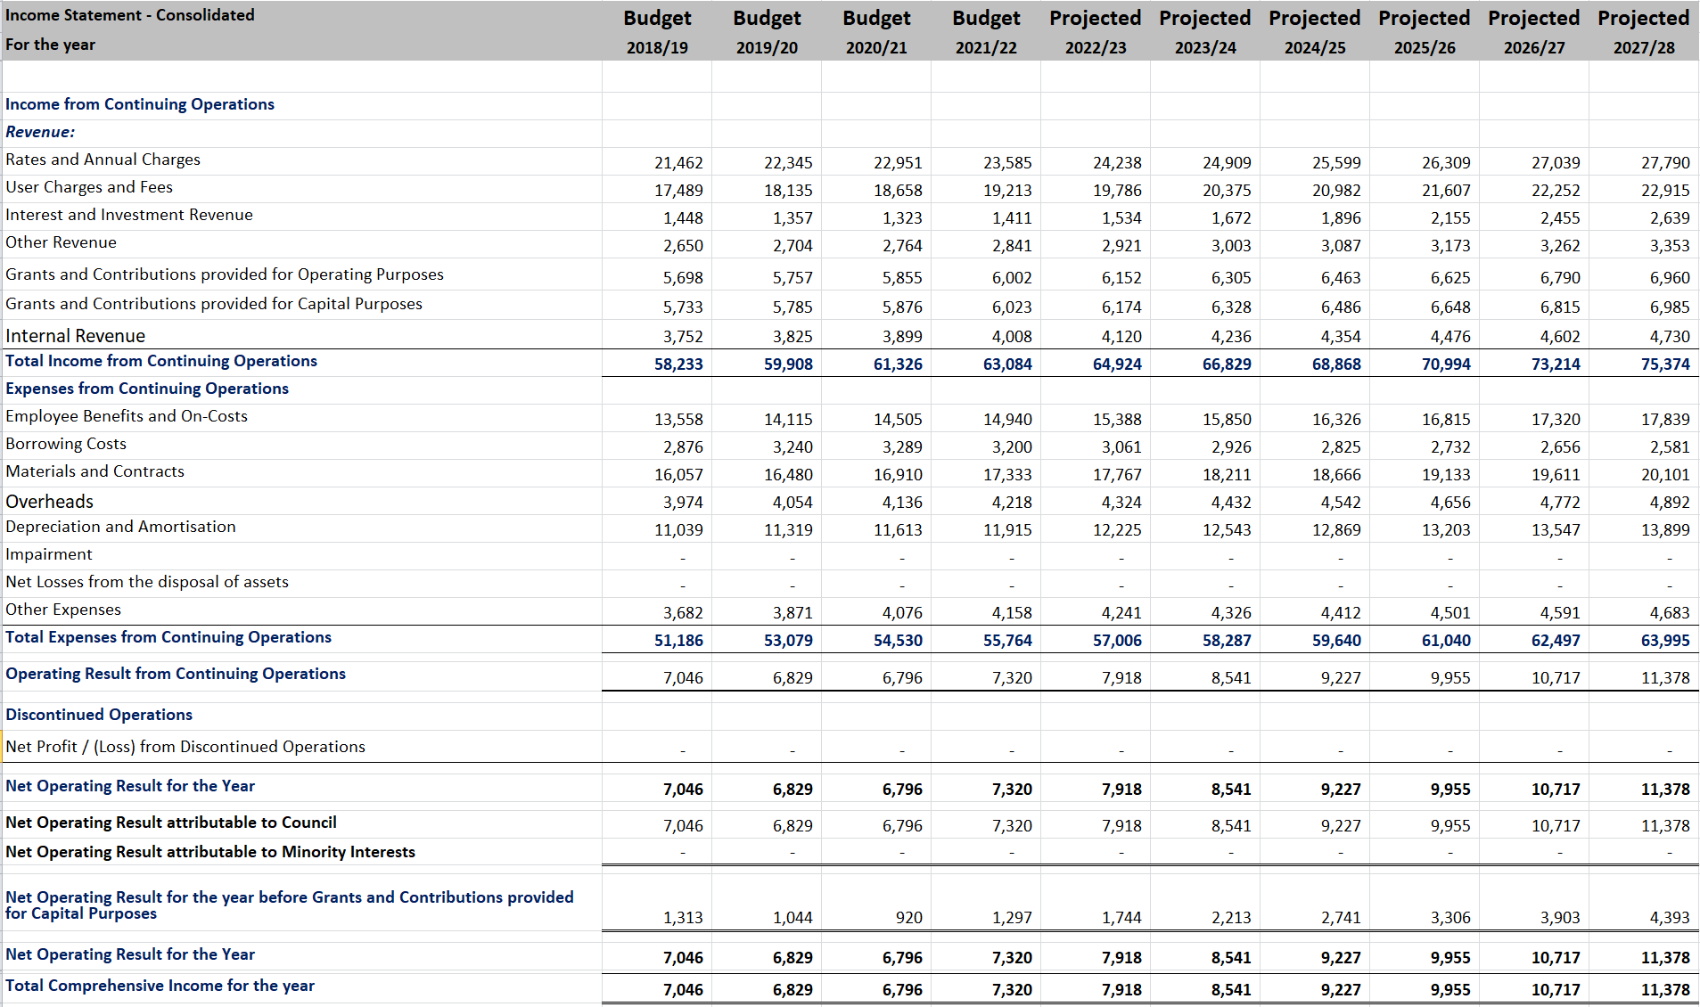

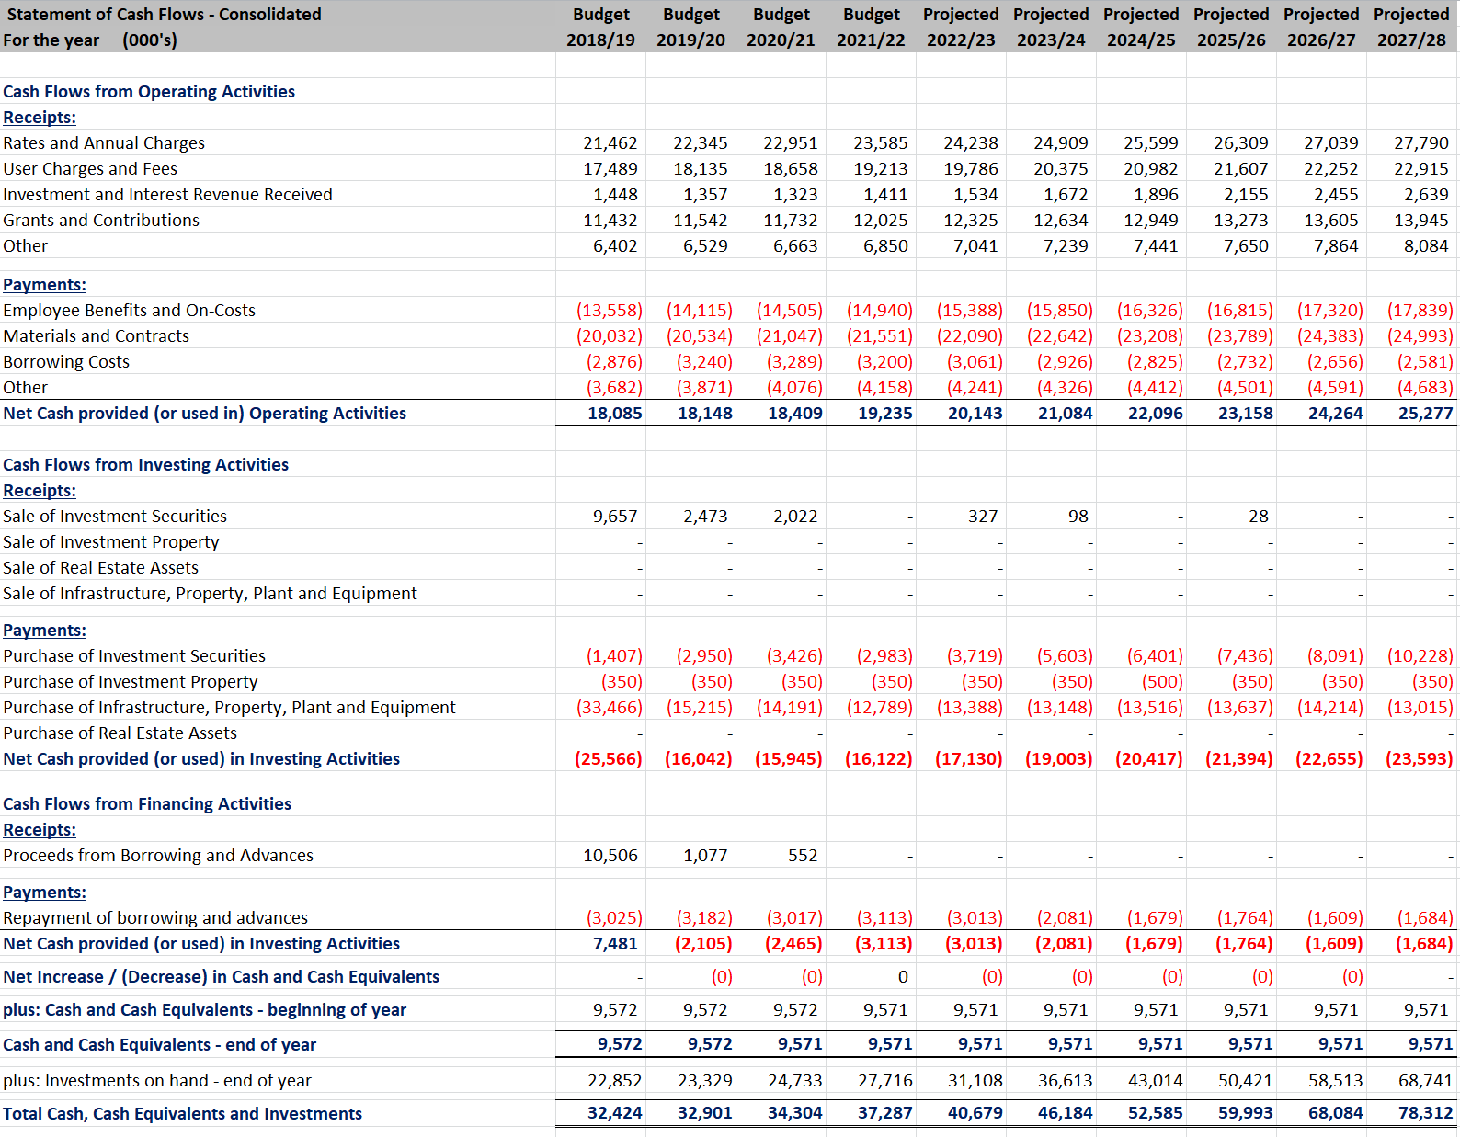

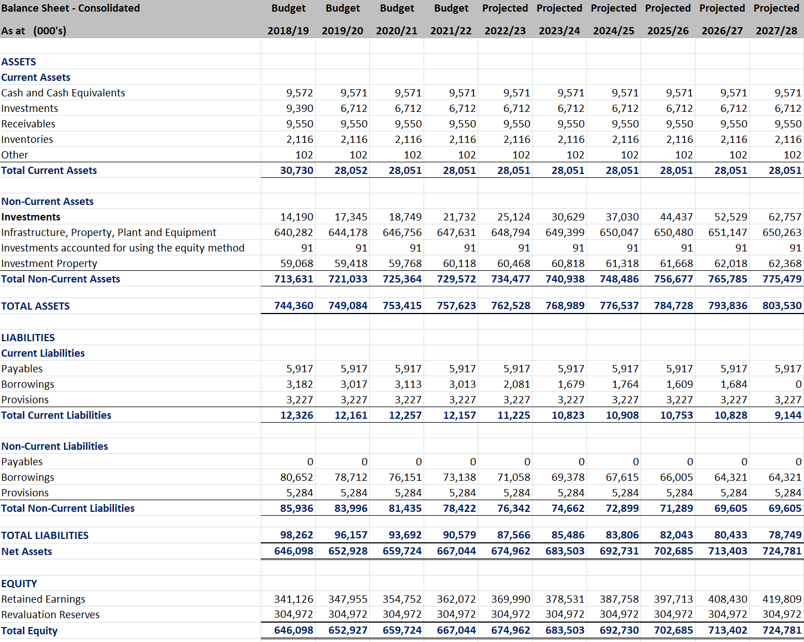

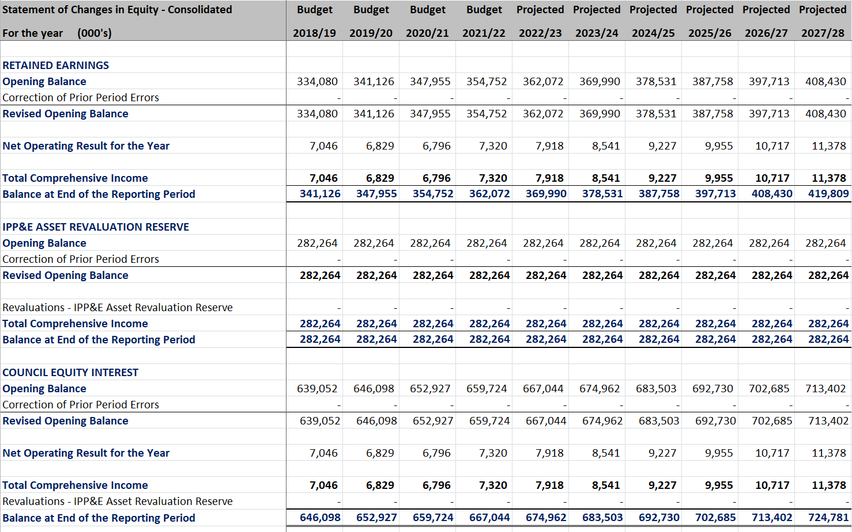

# **Scenario Two – Consolidated - Financial Statements – 2019-28 LTFP**

