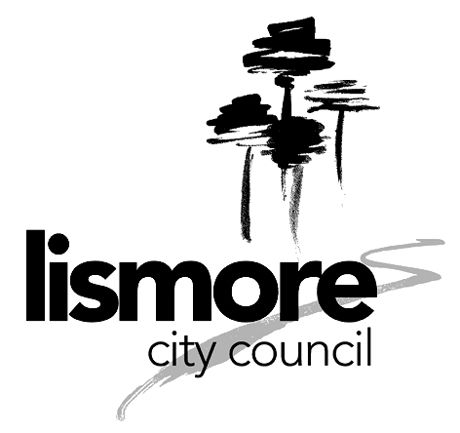 | POLICY MANUAL

POLICY NO: 1.5.12 | Financial Sustainability
OBJECTIVE: | To define financial sustainability and the fundamental financial sustainability objectives of the Long Term Financial Plan 2013-2023
COMMUNITY VISION/COUNCIL  SERVICE: | Imagine Lismore 4 Year Plan for Civic Leadership/Management – Activity 7
PROGRAM MANAGER: | Finance
COUNCIL AUTHORISED DATE:  11/2/14 | COUNCIL REVIEWED DATE:
STAFF VALIDATION DATE:

Financial Sustainability is defined as: Council’s financial ability to deliver acceptable, affordable and ongoing services to its community.

The fundamental financial sustainability objectives of the Long Term Financial Plan 2013-2023 are:

- Progressively achieve long term financial sustainability by generating at least a balanced annual result before capital grants and contributions by 2023
- Maintain a balanced annual budget from a "cash perspective", that is operations are fully funded
- Progressively increase asset maintenance and renewal funding in order to maintain current asset service levels and conditions
- Commit to identifying and implementing initiatives which reduce expenditure and/or increase income and therefore improves Council’s bottom line and/or its capacity to deliver services
- Eliminate borrowings as a funding source for asset renewal as opposed to major new projects where inter-generational equity issues justify borrowing
- Maintain debt service ratio within accepted industry benchmarks

This policy is to be reviewed annually with the Long Term Financial Plan and reported to Council.

