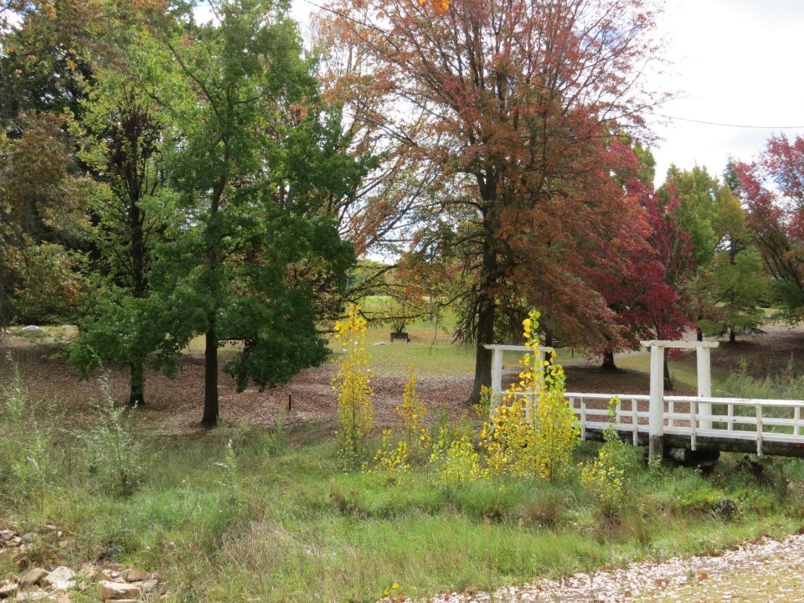

**The Forward Plan**

**Organisation Development Action Plan**

logo

**TABLE OF CONTENTS**

**1.** **BACKGROUND** 3

**2.** **ACTION PLAN** 4

**3.1** **Leadership and Direction** 4

**3.2** **Strategy and Planning** 4

**3.3** **Community Engagement and Communication** 5

**3.4** **Governance** 6

**3.5** **Financial Sustainability** 7

**3.6** **Asset Management and Infrastructure Sustainability** 7

**3.7** **Capable, Engaged and Challenged Staff** 8

**3.8** **Project Management** 8

**3.9** **Customer Service Excellence** 9

**3.10** **Performance Culture** 9

**3.11** **Innovation, Automation and Ideas** 10

**4.** **KEY** 10

**5.** **DELIVERY/RESPONSIBILITY** 11

**6.** **MONITORING AND REPORTING** 11

**7.** **REVIEW AND CLOSE** 11

**8.** **ACTION PLAN – BY DEPARTMENT** 12

**9.** **ACTION PLAN – CHRONOLOGICAL** 19

1. **BACKGROUND**

This **Action Plan** has been developed as the organisation’s primary change document and originated out of the strategic objectives established in *Our Pathway Forward*, Councils Organisation Development Strategy. This action plan provides the next level of detail in order to deliver this organisation advancement blueprint and provides the specific actions required to take the organisation forward.

The desired outcome of the strategy and this action plan is to transform the way Council currently operates so as to ensure that the organisation can achieve its fundamental goal of sustainability and establish the capacity and capability required to reliably deliver on *Our Community Plan* well into the future.

This plan is a ‘living’ document and it is expected that it will evolve during the implementation period. It will also be continually monitored, performance measured and reviewed.

This action plan sets out each of the key actions that are required to achieve the organisations desired strategic outcomes; the timeframes for the delivery of each; and the lead Department responsible for such.

The action plan has also been sorted in a number of different ways to assist end users, they are as follows:

* Primary – Actions sorted by Strategic **Objective**.
* Second – Actions sorted by responsible **Department**.
* Third – Actions sorted by **Target** delivery date.

1. **ACTION PLAN**

**3.1 Leadership and Direction**



**3.2 Strategy and Planning**



**3.3 Community Engagement and Communication**



**3.4 Governance**



**3.5 Financial Sustainability**



**3.6 Asset Management and Infrastructure Sustainability**



**3.7 Capable, Engaged and Challenged Staff**



**3.8 Project Management**



**3.9 Customer Service Excellence**



**3.10 Performance Culture**



**3.11 Innovation, Automation and Ideas**



**4. KEY**

**Division:**

1 – Finance & Governance;

2 – People, Information & Performance;

3 – Community & Culture;

4 – Infrastructure & Regulation.

**Department:**

FIN- Finance; GOV- Governance; HS- Human Services; INFO- Information; IT – Technology; PERF- Performance; COMM- Community Services; CULT- Culture;

INF- Infrastructure; PLAN- Town Planning; ECOM- Exec Communications; ALL- All Departments.

**5. DELIVERY/RESPONSIBILITY**

Each action from within this plan has been assigned to a Responsible Department, however, the majority of actions from within the plan require the input (either directly or indirectly) from any number of different officers for their successful completion. Accordingly the responsible Department will be accountable for undertaking the appropriate planning, consultation and management of each project; however, all staff required to provide input into the delivery of an action will remain responsible for their own performance.

**6. MONITORING AND REPORTING**

The progress of individual actions is to be monitored by the responsible lead department and reported to the Executive on a monthly basis. These progress reports are to be completed by the relevant department manager and forwarded to the Senior Executive & Communication Officer for inclusion in the Executive Business Paper.

Senior Executives will be responsible for monitoring the progress of all actions assigned to Departments from within their Division.

**7. REVIEW AND CLOSE**

Following completion of all of the actions from within this plan, a formal review and debrief will occur prior to the final close of the project. The review and debrief will address a number of issues with regard to the delivery of the identified strategic objectives, including:

* How successful the strategy and plan were at achieving the desired outcomes;
* What worked particularly well;
* What could have been done better; and
* Other lessons learnt.

All review notes and documents will then be registered into Councils records management system prior to close.

**8. ACTION PLAN – BY DEPARTMENT**

















**9. ACTION PLAN – CHRONOLOGICAL**









