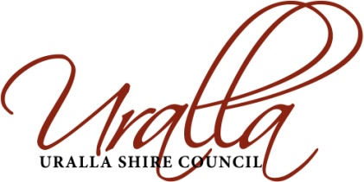 | REPORT TO COUNCIL

Department: | General Managers Office
Submitted by: | General Manager
Reference:
Subject: | Council position – Fit for the Future (FFTF) Program

LINKAGE TO INTEGRATED PLANNING AND REPORTING FRAMEWORK

Objective: Uralla leadership is visionary, compassionate, inclusive and promotes the needs of the community
Strategy: Advocate the needs of the Shire to State and Federal Government
Action: Address the requirements of the State Governments Fit for the Future Program

SUMMARY:

The purpose of this report is for Council to receive and give consideration to the results for Uralla Shire Council with regard to the Fit for the Future assessment criteria and to consider the analysis that has been undertaken of all of the other Councils located in the New England Region.

This should ultimately help to inform Councils decision making with regard to the approach to best represent the community of the Uralla Shire through the fit for the future process and final submission.

The desired outcome of this report is for Council to adopt a well informed position to take to the community for consultation, in order to obtain confirmation that Councils position is reflected of that of the broad community prior to the finalisation of Councils submission to the Office of Local Government.

BACKGROUND:

A Local Government Review Panel was established by the NSW Government in April 2012 tasked with the formulation of options for governance models, structures and boundary changes for NSW Local Government.

In April 2013 the panel released Future Directions for Local Government a draft consultation paper and then undertook public meetings at various locations throughout the state to discuss the recommendations.

In October 2013 the Review Panel released their final report, titled Revitalising Local Government, which contained 65 recommendations for change in NSW local government.

On the 10th of September 2014 the NSW Government announced its response to the recommendations of the Local Government Review Panel and Local Government Act Taskforce by way of the Fit for the Future (FFF) program. A web link was distributed to all Councillors that evening to access the information that had been released by the state government.

A workshop was conducted with Councillors on the 15th of September 2014 to further discuss the FFF program and what options, implications, challenges may arise from such.

A report was presented to the October 2014 Ordinary Meeting of Council detailing the Fit for the Future Program, analysing the implication to Council, the deliverables required and to ultimately adopt an initial position for the Council and a strategy to approach the programs requirements.

A Councillor workshop was conducted on the 16th of February 2015 to present the results of the analysis conducted regarding the FFTF criteria for Uralla Shire Council and for all other considerations relating to such.

REPORT:

On the 10th of September 2014 the NSW Government announced its new Fit for the Future program which now requires all Councils in NSW to assess their sustainability position and submit a FFTF proposal to the State Government by the 30th of June 2015. The submission is required to address how Councils meet a number of requirements that will have them identified as sustainable, or fit for the future.

In developing the requirements of the FFF program the government has used the findings and recommendations of the Local Government Review Panels recent work as the guide to move Councils to a more sustainable position.

Each Council is being asked to look at their current situation and consider the future needs of their community and the recommendations of the Review Panel. Councils are also to assess the current and future position against a set of established sustainability criteria which address financial management, service delivery, infrastructure management and scale of operations.

It should be noted that the Review Panels recommendations will be the assessment criteria for Councils to achieve the scale requirements required under the fit for the future program.

Under the FFTF program Councils are also required to investigate options with their neighbouring local government areas, particularly those with whom the Review Panel recommended mergers.

Considerable analysis has been undertaken over the last couple of months with regard to the performance and position of the Uralla Shire Council and all of the other Councils in the New England area, including; Armidale, Guyra and Walcha. The analysis has taken into consideration the results of all of the Councils against the fit for the future criteria from data taken from their respective Annual Financial Statements amongst a number of other identified key sustainability criteria.

Resultantly the fit for the future results for Uralla Shire Council are as follows:

As can be seen in the above table Council meets 6 of the 7 criteria currently, however, will need to meet all seven of the criteria if Council is to be any chance of arguing that the scale and capacity threshold criteria based on population is flawed. If Council is able to meet all of the 7 criteria associated with the program then this alone should proof that scale and capacity is present.

Therefore if Council is to pursue a submission to stand alone and not pursue a voluntary merger than Council will need to commit to increase its recurrent operating income, decrease its recurrent operating expenditure or a combination of both in an amount currently equivalent to $960,000 per annum.

This would require some level of special rate variation to be applied for and approved which is currently estimated to be equivalent to a 22% increase in rates and annual charges income. A special rates variation if applied for and approved couldn’t come into place until the 2016/17 financial year.

The fit for the future criteria results for all of the other Councils in the New England area are as follows:

# It should be noted that all of the last three financial years Annual Financial Statements for Armidale Dumaresq Council weren’t available and resultantly the real operating expenditure trend criteria was unable to be calculated.

As can be seen from the above table all of the other Councils in the New England region have more than one of the criteria that they don’t currently meet. Most importantly to note is that they all have considerably higher operating performance ratio deficits then that of Uralla Shire Council and they all have infrastructure backlogs, those of Walcha and Guyra Councils are particularly large.

This is of great concern to Uralla Council when considering any of the proposed mergers because it means that ratepayers of this shire would be worse off unless the increase to off-set the gap can be covered by economies of scale and efficiencies achieved through merger.

This is further considered in the following table which is an analysis to illustrate the combined deficits faced by all possible merger options for the New England area and their comparison against Uralla Shire alone. Economies of scale and efficiencies are not included in this next table but are brought into subsequent tables.

An exercise was then undertaken to identify and estimate the expected economies of scale benefits that would result from removal of management duplication, Councillor duplication, Licences and systems duplication etc. This figure was then taken away from the previously calculated combined deficits of each of the possible mergers to illustrate the deficit still remaining after the economies of scale benefits have been taken into consideration.

Additionally estimates were taken of the one-off costs to form-up and integrate all of the merger possibilities and then the amounts being offered as an incentive payment for merging Councils (one-off payment) were taken into calculations.

Some non-financial data was also collated to illustrate the approximate combined population, area and comparative scale of operations under each of the possible merger options.

The below tables reflect the summarised results from such:

Finally the analysis took into consideration other key liquidity, cash flow and infrastructure information not considered by the fit for the future criteria for all of the Councils General Fund operations but now also including the Water and Sewer Fund information.

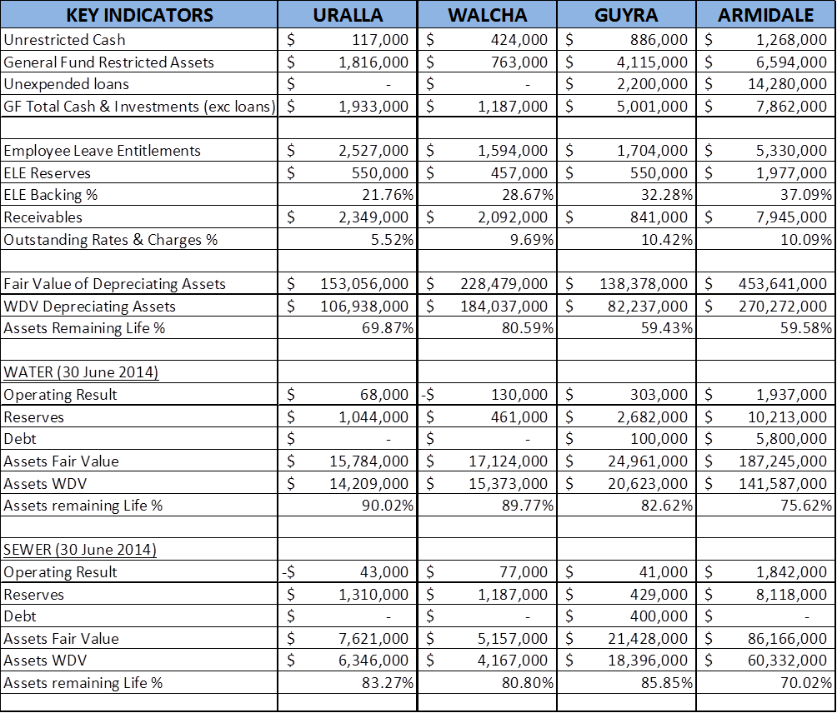

Below is a summary of the data that was then utilised to sum up the key considerations for each of the possible merger options holistically.

URALLA - WALCHA

URALLA - ARMIDALE

URALLA – ARMIDALE – GUYRA

URALLA – ARMIDALE – WALCHA

URALLA – ARMIDALE – GUYRA – WALCHA

The State Government and the Office of Local Government have stated that they do not intend to directly consult with the community on the Fit for the Future Program as they see it as a response to the Local Government Review Panels recommendations which were heavily consulted upon in the development of that report.

However, the Uralla Shire Council certainly has and will continue to make the community aware of the requirements of this program, developments and the implications of such.

Council will commence a community engagement program across the month of March culminating in a number of community forums in order to clearly inform the community and to gauge their opinions and preferences. Councillors will ultimately reflect the community’s priorities and interests in the final submission to the Office of Local Government.

The remaining overarching milestones of the FFTF program are as follows:

- June 2015 – Fit for the Future submissions due from Councils to expert review panel for assessment;
- September 2015 – Expert Review Panel makes recommendations directly to the Minister for Local Government;
- October 2015 – Councils begin to implement their roadmap or the Ministers alternate direction;
- September 2016 – Local Government elections; New Local Government Act; Regional JO’s commenced; any mergers completed.

COUNCIL IMPLICATIONS:

- Community Engagement/ Communication

Following the resolution from this report Council will commence a community engagement program across the month of March culminating in a number of community forums in order to clearly inform the community and to gauge their opinions and preferences. Councillors will ultimately reflect the community’s priorities and interests in the final submission to the Office of Local Government.

- Policy and Regulation

- NSW Local Government Act 1993;
- NSW Local Government (General) Regulations 2005; and
- NSW Government Fit for the Future Program.

- Financial (LTFP)

Financial analysis and the potential impacts are outlined throughout the report. Councils Long Term Financial Plan is currently being reconstructed and will model the identified recurrent revenue and expenses results to provide an operating surplus across the long term.

- Asset Management (AMS)

No changes recommended at this point

- Workforce (WMS)

No changes recommended at this point

- Legal and Risk Management

Considerable potential risk issues are outlined throughout the body of the report.

- Performance Measures

N/A

- Project Management

N/A

Damien Connor
General Manager

Prepared by staff member: | Damien Connor
Approved/Reviewed by Manager:  Department: | Damien Connor  General Managers Office
Attachments: | Nil

