Strategy map
Vision: Influencing positive impact and enabling Aboriginal-led outcomes in markets and services we regulate or influence.

Strategic Priority | Objective | How we achieve it | Action Areas
1. Empowering voices | Aboriginal peoples have a meaningful say and influence in decisions that impact them, these voices are centred and elevated through our processes. | - Our processes enable culturally appropriate avenues for Aboriginal perspectives, views and feedback.  - Aboriginal voices are centred through our decision-making processes, supporting self-determination and cultural expertise. | - Embedding engagement: Embed and implement IPART’s Aboriginal Engagement Framework across all business areas, including through project planning, implementation and evaluation.  - Centring perspectives: Develop procedures to elevate and centre Aboriginal engagement outcomes and perspectives of Aboriginal peoples, communities, and organisations within review and regulatory processes.  - Enhanced decision-making: Create and implement processes for Aboriginal outcomes and perspectives to be considered across Tribunal and Executive Leadership Team decision-making.
2. Enabling Aboriginal-led outcomes | Markets, programs and services that we have influence over positively impact the lives of Aboriginal peoples, communities and organisations, aligned with their needs and aspirations. | - We understand the impacts of our work from an Aboriginal perspective.  - We can articulate our levers for change and areas of influence in the context of Aboriginal priorities and aspirations.  - We understand what self-determination means in our regulatory context, evaluate equity considerations, and enhance Aboriginal regulatory inclusion.  - We develop Aboriginal targeted partnerships, programs, or business participation. | - Regulatory inclusion and impact: Identify and prioritise Aboriginal-led outcome areas by analysing impacts of our work from an Aboriginal perspective, understating how these intersect with our core regulatory and pricing functions.  - Regulatory influence: Update and review regulatory frameworks, support and compliance measures to drive and influence Aboriginal engagement and impact best practice within regulated entities.  - Ethical data practice: Develop an approach to how IPART handles and uses data regarding Aboriginal peoples, guided by Indigenous Data Sovereignty principles.
3. Building capabilities and workforce | IPART staff have strong awareness and knowledge of Aboriginal histories, cultures and contemporary contexts to inform how we engage and work alongside Aboriginal peoples. Our workforce reflects the communities we serve, and the skills required, supported by intentional employment approaches. | - Embed opportunities for on-going cultural capability development for all staff.  - Nurture a culturally safe and inclusive work environment.  - Develop Aboriginal employment opportunities and development pathways.  - Strong governance and accountability to deliver on the Strategy. | - Knowledge and capability: On-going Aboriginal cultural capability development, training and resources for staff based on evidence-based frameworks  - Employment and development: Develop Aboriginal recruitment, employment and development strategy/plan (including consideration of graduate opportunities, leadership development, mentoring, and secondment possibilities).  - Supportive and safe workplaces: Review and enhance workplace policies and practices to support a culturally safe workplace, and up-to-date anti-discrimination policy.

Alongside the 3 Strategic Priorities, IPART will continue our current on-going initiatives that support Aboriginal outcomes. This includes celebrating Aboriginal cultures and communities through key events and dates of significance, collaborating with other government agencies on Aboriginal outcomes, and support NSW Government Aboriginal procurement policies.

Aboriginal Outcomes and Impact Principles
 |  | 
Aboriginal rights and self-determination | Country, culture and community | Reciprocity: relationships and  sustained connections

Strategic priority logics

Strategic Priority 1: Empowering voices
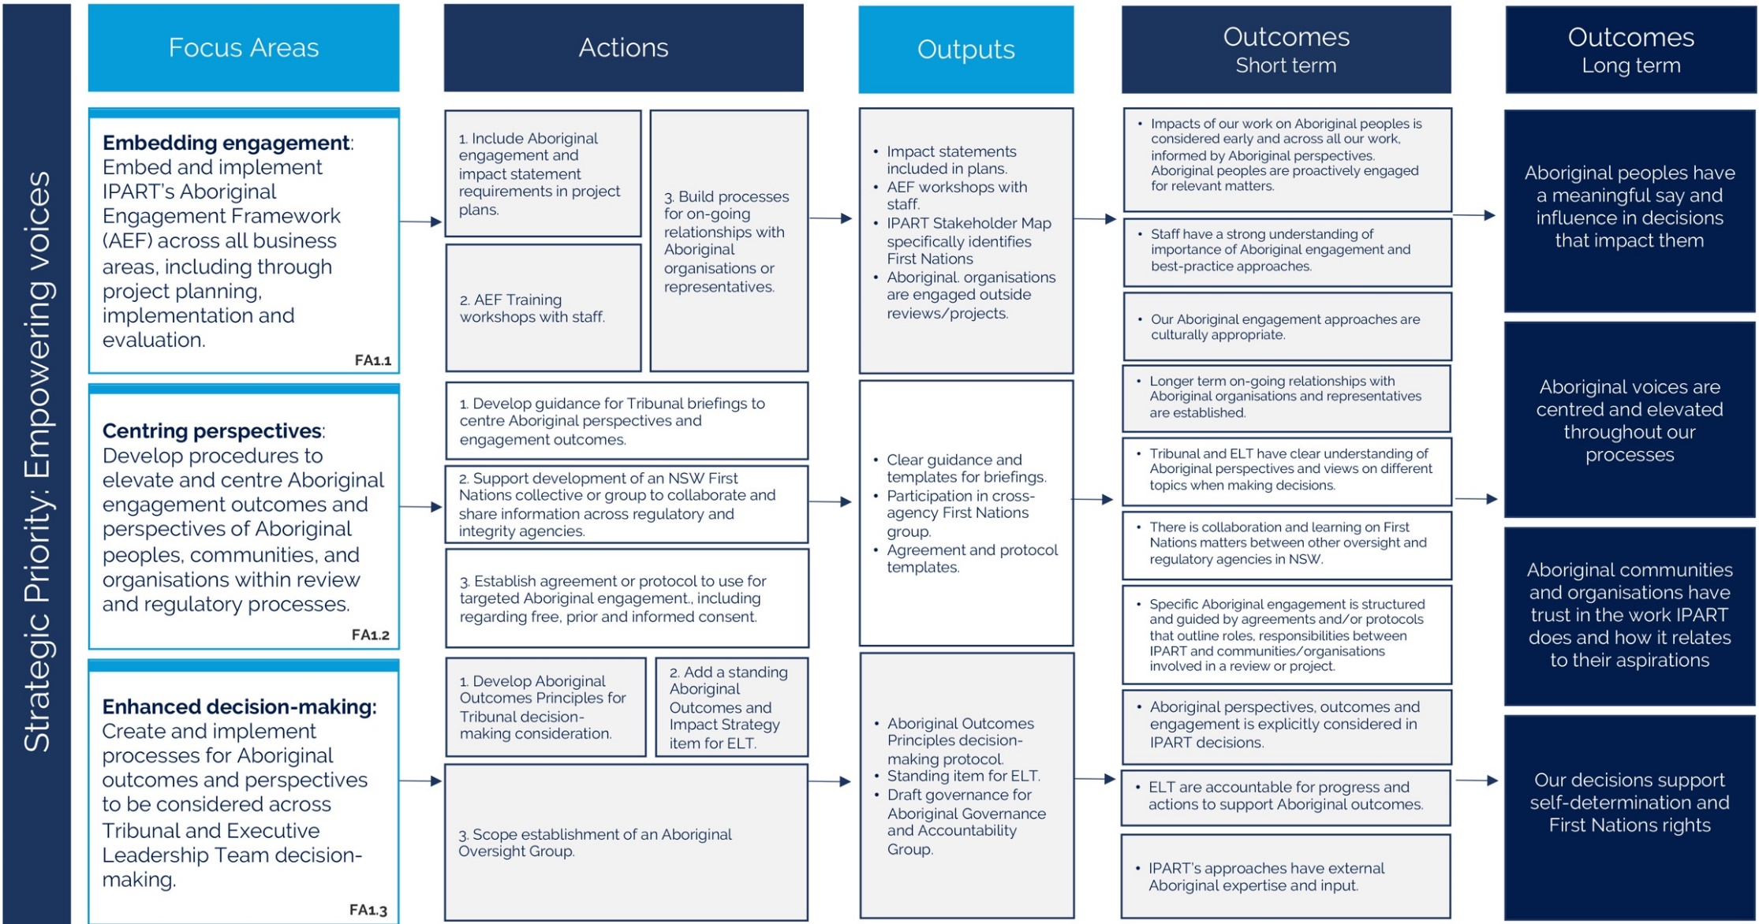

Strategic Priority 2: Enabling Aboriginal-led outcomes
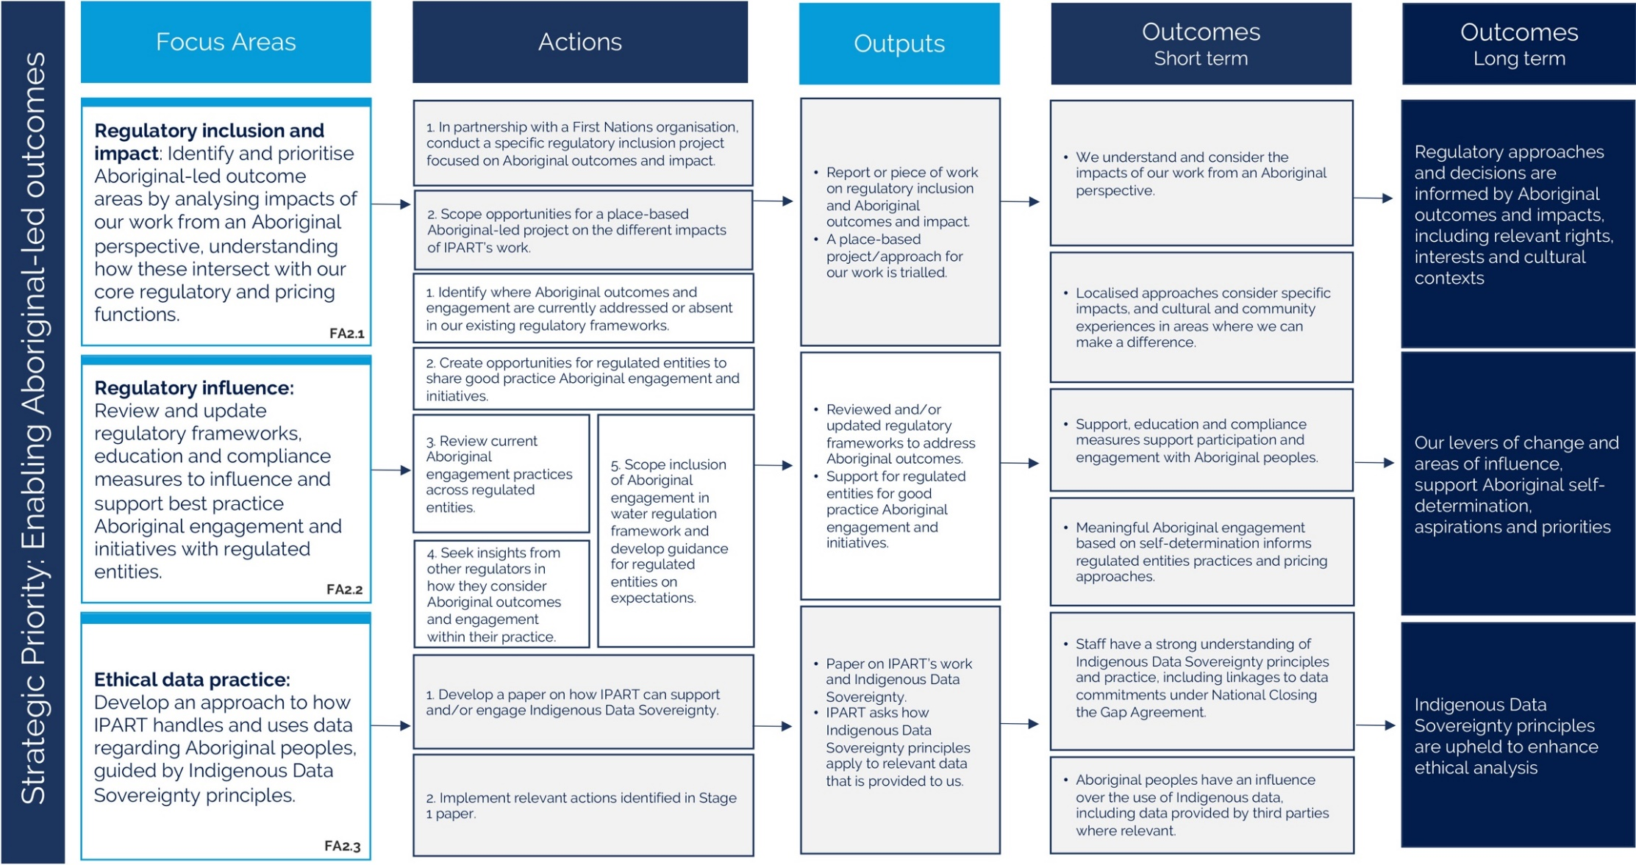

Focus area
Regulatory inclusion and impact: Identify and prioritise Aboriginal-led outcome areas by analysing impacts of our work from an Aboriginal perspective, understanding how these intersect with our core regulatory and pricing functions.

Actions
1. In partnership with a First Nations organisation, conduct a specific regulatory inclusion project focused on Aboriginal outcomes and impact.
2. Scope opportunities for a place-based Aboriginal-led project on the different impacts of IPART’s work.

Outputs
- Report or piece of work on regulatory inclusion and Aboriginal outcomes and impact
- A place-based project/approach for our work is trialled

Outcomes – short term
- We understand and consider the impacts of our work from an Aboriginal perspective.
- Localised approaches consider specific impacts, and cultural and community experiences in areas where we can make a difference.

Outcomes – long term
Regulatory approaches and decisions are informed by Aboriginal outcomes and impacts, including relevant rights, interests and cultural contexts.

Focus area
Regulatory influence: Review and update regulatory frameworks, education and compliance measures to influence and support best practice Aboriginal engagement and initiatives with regulated entities.

Actions
1. Identify where Aboriginal outcomes and engagement are currently addressed or absent in our existing regulatory frameworks.
2. Create opportunities for regulated entities to share good practice Aboriginal engagement and initiatives.
3. Review current Aboriginal engagement practices across regulated entities.
4. Seek insights from other regulators in how they consider Aboriginal outcomes and engagement within their practice.
5. Scope inclusion of Aboriginal engagement in water regulation framework and develop guidance for regulated entities on expectations

Outputs
- Reviewed and/or updated regulatory frameworks to address Aboriginal outcomes.
- Support for regulated entities for good practice Aboriginal engagement and initiatives.

Outcomes – short term
- Support, education and compliance measures support participation and engagement with Aboriginal peoples.
- Meaningful Aboriginal engagement based on self-determination informs regulated entities practices and pricing approaches.

Outcomes – long term
Our levers of change and areas of influence, support Aboriginal self-determination, aspirations and priorities.

Focus area
Ethical data practice: Develop an approach to how IPART handles and uses data regarding Aboriginal peoples, guided by Indigenous Data Sovereignty principles.

Actions
1. Develop a paper on how IPART can support and/or engage Indigenous Data Sovereignty.
2. Implement relevant actions identified in Stage 1 paper

Outputs
- Paper on IPART’s work and Indigenous Data Sovereignty.
- IPART asks how Indigenous Data Sovereignty principles apply to relevant data that is provided to us.

Outcomes – short term
- Staff have a strong understanding of Indigenous Data Sovereignty principles and practice, including linkages to data commitments under National Closing the Gap Agreement.
- Aboriginal peoples have an influence over the use of Indigenous data, including with data we a provided by third parties where relevant.

Outcomes – long term
Indigenous Data Sovereignty principles are upheld to enhance ethical analysis.

Strategic Priority 3: Building capabilities and workforce
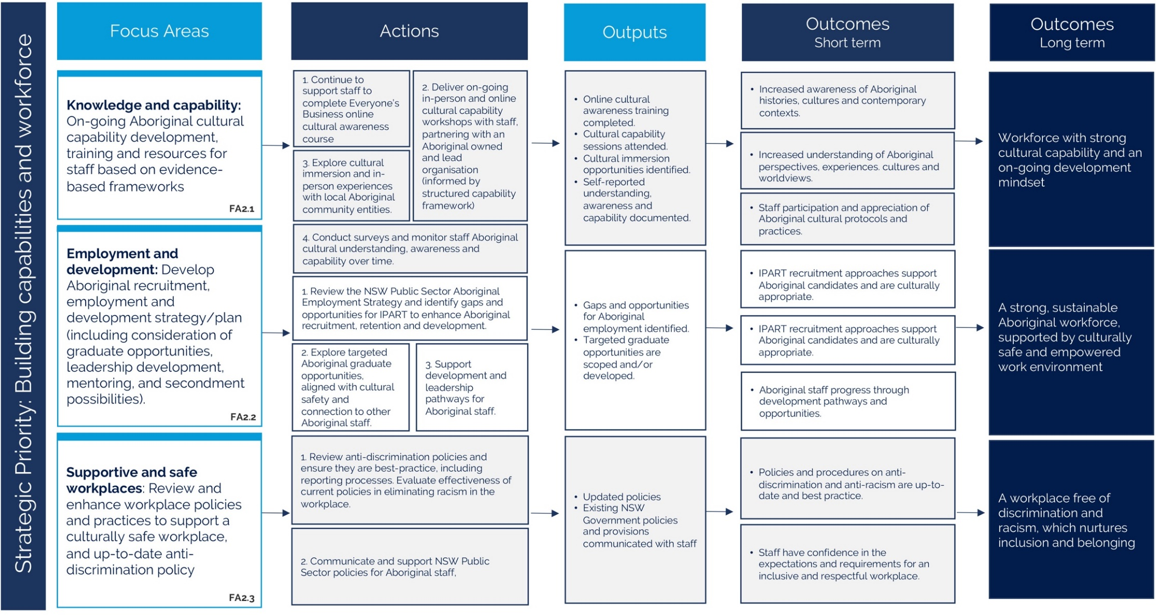

Focus area
Knowledge and capability: On-going Aboriginal cultural capability development, training and resources for staff based on evidence-based frameworks

Actions
1. Continue to support staff to complete Everyone’s Business online cultural awareness course
2. Deliver on-going in-person and online cultural capability workshops with staff, partnering with an Aboriginal owned and lead organisation (informed by structured capability framework)
3. Explore cultural immersion and in-person experiences with local Aboriginal community entities.
4. Conduct surveys and monitor staff Aboriginal cultural understanding, awareness and capability over time.

Outputs
- Online cultural awareness training completed.
- Cultural capability sessions attended.
- Cultural immersion opportunities identified.
- Self-reported understanding, awareness and capability documented.

Outcomes – short term
- Increased awareness of Aboriginal histories, cultures and contemporary contexts.
- Increased understanding of Aboriginal perspectives, experiences. cultures and worldviews.
- Staff participation and appreciation of Aboriginal cultural protocols and practices

Outcomes – long term

Focus area
Employment and development: Develop Aboriginal recruitment, employment and development strategy/plan (including consideration of graduate opportunities, leadership development, mentoring, and secondment possibilities).

Actions
1. Review the NSW Public Sector Aboriginal Employment Strategy and identify gaps and opportunities for IPART to enhance Aboriginal recruitment, retention and development.
2. Explore targeted Aboriginal graduate opportunities, aligned with cultural safety and connection to other Aboriginal staff.
3. Support development and leadership pathways for Aboriginal staff.

Outputs
- Gaps and opportunities for Aboriginal employment identified
- Targeted graduate opportunities are scoped and/or developed.

Outcomes – short term
- IPART recruitment approaches support Aboriginal candidates and are culturally appropriate.
- IPART recruitment approaches support Aboriginal candidates and are culturally appropriate.
- Aboriginal staff progress through development pathways and opportunities.
- Aboriginal staff progress through development pathways and opportunities

Outcomes – long term

Focus area
Supportive and safe workplaces: Review and enhance workplace policies and practices to support a culturally safe workplace, and up-to-date anti-discrimination policy

Actions
1. Review anti-discrimination policies and ensure they are best-practice, including reporting processes. Evaluate effectiveness of current policies in eliminating racism in the workplace.
2. Communicate and support NSW Public Sector policies for Aboriginal staff,

Outputs
- Updated policies
- Existing NSW Government policies and provisions communicated with staff

Outcomes – short term
- Policies and procedures on anti-discrimination and anti-racism are up-to-date and best practice.
- Staff have confidence in the expectations and requirements for an inclusive and respectful workplace.

Outcomes – long term
A workplace free of discrimination and racism, which nurtures inclusion and belonging.

