[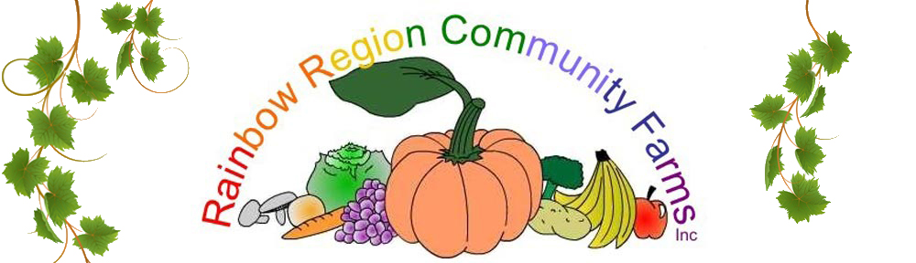](http://www.rrcf.org.au/)

**RAINBOW REGION COMMUNITY FARMS INC’s SUBMISSION TO THE INDEPENDENT PRICING AND REGULATORY TRIBUNAL RE THE SPECIAL RATE VARIATION (SRV) FOR THE LISMORE CITY COUNCIL’S BIODIVERSITY MANAGEMENT STRATEGY (BMS)**

**Rainbow Region Community Farms Inc (RRCF)** is a not-for-profit association, formed in 2006, and has the broad aim of promoting community gardens and related sustainability initiatives in and around Lismore in the Northern Rivers area of New South Wales, Australia.  At present our major activity is management and operation of the [**Lismore Community Garden**](http://www.rrcf.org.au/?page_id=7)**,** under a Deed of Licence from Lismore City Council.

The beginning of Lismore Community Garden 2009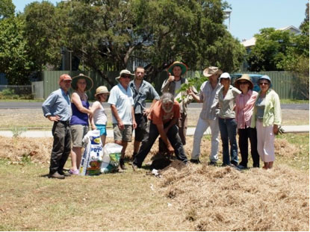

The overall aims of RRCF are to contribute to the community of Lismore in a number of ways.  By encouraging people to get involved in gardening activities, especially those involving edible produce, RRCF can help improve family nutrition through healthy eating, **facilitate environmental sustainability**, promote local health and fitness, provide education about a variety of gardening related topics through training projects and workshops, and help create employment and work experience opportunities.

**Background**

On 5 May 2015, Council adopted the *Biodiversity Management Strategy for the Lismore Local Government Area 2015–2035* (BMS). This strategy was developed in response to the community’s vision for Council to provide ‘environmental leadership’, as identified in the *Imagine Lismore 10 Year Plan*. RRCF has been a supporter of the BMS since the beginning of the proposal.

**Special Rate Variation to fund implementation of the Biodiversity Management Strategy**

Successful implementation of the BMS requires reliable, long-term funding. Council investigated a range of long-term funding sources and came to the conclusion that the only sustainable way was through a Special Rate Variation (SRV) to increase rates. Consequently, on 5 May 2015, Council resolved to apply to the NSW Independent Pricing and Regulatory Tribunal (IPART) for an SRV to fund implementation of the BMS.

**What are the impacts of the proposed rate increase?**

|  |  |  |
| --- | --- | --- |
| **Rating Category Average** | **Average increase (per year)** | **Average increase per week** |
| Farmland | $48 | 92c |
| Residential Rural | $30 | 57c |
| Residential Urban/village | $24 | 46c |

The average amount of annual rate pegging assumed at 2.5% will only marginally affect levy adding $1.20 annually to rural rates, 75c to rural residential rates and 60c to residential rates in the first year. There will of course be an annual increment for rate pegging. This financial year it is 1.8%

The Hunter Research Foundation conducted an in depth survey of 209 affected ratepayers. This was an independent stratified random survey.

66% of the respondents agreed or strongly agreed that the rate increase was affordable.

61% agreed or strongly agreed it was a reasonable price to pay.

**What will the Community Get for the Levy?**

Besides benefiting biodiversity, the community will get: cleaner roadsides; confidence that Council is undertaking best environmental management practice in its activities; recognition for your work and community achievements; assistance to landholders and community groups to manage pests and weeds; opportunities to gain knowledge; assistance to manage bushland and riversides on rural land; more opportunities to get involved through community events, workshops and field days; well-managed urban bushland reserves; and more recreational opportunities in the urban setting, such as walking tracks. These are all projects vigorously supported by Rainbow Region Community Farms.

**Debunking the criticisms**

Historically there have been 2 major criticisms of environmental initiatives and the BMS in particular by rural landowners:

1. That the BMS will increase regulation. ***The reality is that the BMS does not contain any additional regulation.***

***In time it may be able to reduce existing regulation through acceptance of incentives and education.***

2. That rural landowners will be asked to pay for the environmental aspirations of their city cousins.

***Under the BMS farmers will pay 20% of the revenue and get 71% of the expenditure. That is $3.5 million over 10 years. For the first time council will be able to offer rate reductions for environmental protection. There may be opportunities for landcare and green corp to do restoration work on properties.***

**Leverage**

There are often major opportunities created for grants and partnerships when a council takes a major initiative like the BMS. Already Council has received a grant of nearly $100,000 for an extension officer to work with farmers.

With the Federal government’s emphasis on direct action on climate change there is potential for profitable ‘carbon banking’ schemes to be developed with farmers.

**Relationship to RRCF and the Community Garden**

Longer term it is hoped that the Garden may be able to be involved with urban biodiversity projects. Volunteers involved in the garden have a wide range of skills and a strong commitment to biodiversity.

Yours sincerely,

Terry Lawrence

President Rainbow Region Community Farms Inc.