|  |
| --- |
| Special Variation Application Form – Part B  Council application for 2015/16 |
| Name of Council: Eurobodalla Shire Council  Date Submitted to IPART: 16 February 2015  Council Contact Person: Dr Catherine Dale  Council Contact Phone: (02) 4474 1308  Council Contact Email: [catherine.dale@eurocoast.nsw.gov.au](mailto:catherine.dale@eurocoast.nsw.gov.au) |

Contents

1 Introduction 1

2 Preliminaries 1

2.1 Focus on Integrated Planning and Reporting 1

2.2 Key purpose of special variation 4

2.3 Capital expenditure review 11

3 Assessment Criterion 1: Need for the variation 11

3.1 Case for special variation - community need 11

3.2 Financial sustainability 16

3.3 Financial indicators 20

3.4 Contribution plan costs above the cap 22

4 Assessment Criterion 2: Community awareness and engagement 23

4.1 The consultation strategy 24

4.2 Feedback from the community consultations 30

5 Assessment Criterion 3: Impact on ratepayers 40

5.1 Impact on rates 40

5.2 Consideration of affordability and the community’s capacity and

willingness to pay 42

5.3 Addressing hardship 46

6 Assessment Criterion 4: Public exhibition of relevant IP&R documents 47

7 Assessment Criterion 5: Productivity improvements and cost containment strategies 48

8 List of attachments 55

9 Certification 56

# Introduction

The management of community and transport infrastructure assets is a key issue facing Eurobodalla Shire Council. Like many NSW councils, Eurobodalla has a shortfall in the funds required to provide and maintain its existing facilities and assets as well as meet current and emerging community needs.

Eurobodalla's general rate has not increased more than the rate peg since 2006 and Council currently has a rates income which is 20% below the average rates of comparable Group 4 councils with residential and farmland rates being the fifth lowest of the group[1]. This situation presents challenges, identified in Council’s Integrated Planning and Reporting documents including the Long Term Financial Plan and Asset Management Plans, the principle of which is a substantial annual infrastructure renewal funding gap (identified at $4m in 2013/14 and growing over the ten year period of the long term financial plan).

To meet the needs of our community and address the challenges identified, Council has facilitated community participation through a range of consultations, assessed financial and infrastructure requirements, undertaken significant cost containment activities and service reviews. In response to these actions Council has developed a Special Rate Variation (SRV) proposal that is balanced, moderate and strengthens Council’s long term position on behalf of the community.

Council consulted and engaged the community on an 8% (including rate peg) special rate variation proposal. However, in response to the feedback received from the community via the various methods of consultation, Council resolved to apply to IPART for a 6.5% (including rate peg) special rate variation under section 508A of the Local Government Act over a 3 year period commencing 2015/16, to balance current requirements with intergenerational equity considerations.

# Preliminaries

## Focus on Integrated Planning and Reporting

Council’s financial sustainability challenge has been clearly highlighted during Integrate Planning & Reporting (IP&R) processes, initially commencing in 2010 during the development of our comprehensive Community Strategic Plan, and more recently following the election of a new Council in 2012 and the mandated review of the suite of planning documents.

During the extensive community consultation that took place to inform the development of IP&R documents, our community has indicated that they recognise the financial sustainability challenge we face; and clearly identified the services and infrastructure they need and expect both now, and in the future.

Development of the Community Strategic Plan, Delivery Program and Operational Plan has been informed and supported by the Resourcing Strategy (Long Term Financial Plan, Workforce Management Plan and Asset Management Strategy), as well as supporting strategies, such as the Recreation and Open Space Strategy, Pathways Strategy and the Disability Action Plan, all of which included consultation processes focused on infrastructure planning and rationalisation with a focus on improved service delivery and efficiency savings.

Council has embraced the opportunities offered by IP&R to genuinely engage the community in a vision for the future, foster greater awareness of Council’s services, ensure alignment of service planning and delivery with community needs and expectations, highlight the very real financial and asset challenges facing the organisation and finally, develop a solution to meet community expectations and move towards financial sustainability in the future.

A detailed summary of IP&R processes, engagement and key points is provided in Sections 4 and 6 of this application.

Eurobodalla’s SRV proposal

Under section 508A of the Local Government Act, Council is proposing a 6.5% special rate variation each year for three years including the IPART rate peg amount, which is assumed at 3%. After year three rates would increase by the IPART rate peg amount only.

The cumulative increase over the three years is 20.78% compared to 9.27% without the SRV. The SRV becomes a permanent part of the rate base after year three.

The estimated income generated from this increase is approximately $0.8 million, $1.7 million and $2.6 million at years one, two and three respectively.

The additional revenue will fund a community and transport infrastructure program to be delivered over four years costing $17.5 million, including approximately $0.9 million annually for ongoing renewals. The program will deliver:

* increased annual funding to help address the gap in funding for infrastructure renewal, particularly for short lived assets
* an enhanced capital works program that will stimulate economic and employment growth and development
* a capital renewal program for existing infrastructure in poor condition
* a capital program to upgrade existing infrastructure including funding for on-going ‘whole of life costs’
* in addition, the SRV will replace funds as a result of the flat lining of Federal Assistance Grants, a decision of the Federal Government June 2014.

To leverage the benefit for the community and minimise the impact on ratepayers, the financing strategy for the SRV includes:

* cash funding renewal of short lived infrastructure to address the annual infrastructure funding gap
* borrowings of $11.1 million to be repaid over 20 years to match the benefits and costs of long lived infrastructure to ratepayers
* utilise $2 million of Council’s cash reserves
* ensuring that the ‘whole of life costs’ of any new or upgraded assets are covered including maintenance, operations and depreciation costs.

The community and transport infrastructure package will provide:

*Transport infrastructure including*

* $1.0 million for Casey’s Beach Rock wall renewal.
* Approximately $5.9 million for reconstruction and sealing of a number of higher use gravel roads and renewal and upgrading of bridges and culverts.

*Community infrastructure*

* Approximately $3.1 million for upgrades and new infrastructure to sportsgrounds, local reserves, parks and associated amenities to increase year round use and capacity.
* $560,000 to improve local community halls and associated amenities to increase year round use.
* $50,000 additional recurrent funding for new pathways.
* $300,000 upgrade to Corrigan’s Beach Reserve Batehaven, Gundary Oval Moruya and Rotary Park Narooma to include playgrounds with special accessibility elements.

*Economic and tourism infrastructure*

* $1.25 million to upgrade Batemans Bay CBD to increase town centre vitality.
* $270,000 to upgrade Moruya Airport terminal building, car park and plane holding area to improve accessibility and user amenity.
* $350,000 for the provision of accessible toilets at high profile public sites.
* $300,000 for the provision of accessible viewing platforms and walks at high profile sites to improve visitor experiences and beach access.

The SRV would also fund project management costs of $750,000 to deliver the community and transport infrastructure package, and approximately $0.9 million of annual renewal funding to further address the infrastructure backlog.

**Initiatives supporting a SRV proposal**

The SRV is supported by a range of measures including:

* continuing the organisation service review program
* strategic land and asset sales
* the SRV implementation to be overseen by Council’s Audit Committee
* continuing to strive for improved efficiency and effectiveness
* optimising infrastructure provision and location through review and implementation of existing strategies
* in the medium term, after our legal commitments are met, transferring funds from capital works to renewals as loans for the proposed SRV works are paid down, ensuring all residual funding from the SRV is restricted and set aside for infrastructure renewal
* actively pursuing grants
* working within a regional context to facilitate shared services and procurement efficiencies.

## Key purpose of special rate variation

At the highest level, the key purpose of the SRV proposal is to:

* maintain existing services
* enhance financial sustainability
* infrastructure maintenance /renewal
* reduce infrastructure backlogs
* new infrastructure investment.

*Maintain existing services*

Council currently provides a similar suite of services to those of other councils and does so with a rate base that is 20% below the average of Group 4 councils.

Ongoing consultation with our community, as detailed in Section 4, has most recently shown that 89% of our community are very satisfied to somewhat satisfied with the level of service provided by Council, and 92% believe it is very important to somewhat important to improve community and transport infrastructure[2].

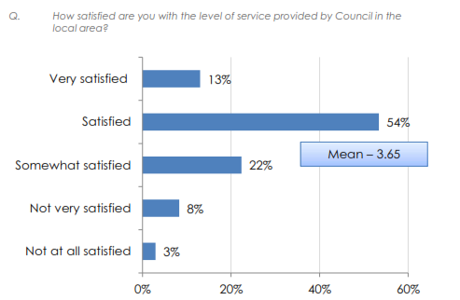

*Source: 2014 Micromex Survey (Attachment 6a)*

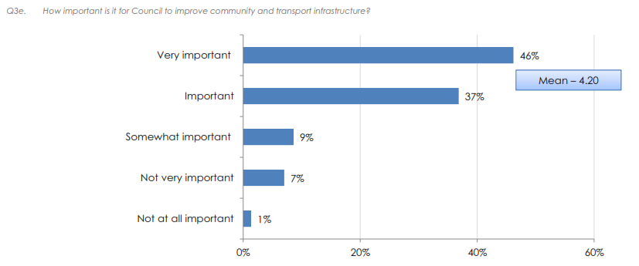

*Source: 2014 Micromex Survey (Attachment 6a)*

However, financial projections show that Council will be unable to continue to sustain the suite of services our community has stated they need at the standard they expect with the current rating income. The SRV proposal will assist in maintaining existing services.

*Enhance financial sustainability*

On behalf of the community, Council is responsible for ensuring that it is financially sustainable and able to generate sufficient funds to continue to deliver the services and infrastructure that meet our community’s needs and expectations.

As evident in the Long Term Financial Plan[3] base case, Council’s financial sustainability is at risk and Council will not be able to meet the needs of the community in the years ahead with its current level of rating income. This is reinforced by the independent assessment of Council’s financial sustainability as ‘moderate’ by NSW Treasury Corporation (TCorp)[4].

In addition, the recently introduced State Government’s Fit for Future program requires councils to measure performance against a series of key indicators to ensure long term financial sustainability. The SRV proposal will assist in moving towards meeting these indicators and subsequently enhance financial sustainability.

*Infrastructure maintenance/renewal and reduce infrastructure backlogs*

Council’s asset planning processes have highlighted an ongoing annual infrastructure funding gap ($4 million for the 2013/14 and growing) as well as a considerable backlog of infrastructure renewal, in the order of $78 million (as identified in Special Schedule 7 2013/14). If this issue is not addressed, the community will continue to experience a steady decline in the condition of its infrastructure over time, leading to reduced levels of service, reduced public safety, higher risks of infrastructure failure and higher maintenance and renewal costs.

The SRV proposal will assist in addressing the infrastructure funding gap as well as addressing immediate high risk backlog issues. This is vital in the short term to remove the infrastructure gap for short lived assets and address high risks to ensure the current level of service is sustained and the risks of failure is kept to acceptable levels.

Additionally, beyond the ten year horizon, the level of infrastructure renewal is expected to increase. As loans for new infrastructure are paid down, it is essential, and therefore proposed, that any funds becoming available from the proposed SRV, are restricted for infrastructure renewal in the long term. It is also vital that the rate component of the SRV be restricted from any new lots created so that the funds available for renewal increases with the increasing size of the infrastructure required to service that development.

*New infrastructure investment*

While the SRV proposal is primarily focused on addressing the infrastructure funding gap and backlog it also provides for investment in upgrading and provision of new infrastructure in line with Council’s revised Asset Management Plans (AMPs)[5] and community requests.

The proposed community and transport infrastructure package provides a select program of new works to help address community needs and expectations identified through the IP&R process and key Council strategies, and provide broad social and economic benefits.

The SRV financial model provides for the ongoing maintenance, operation and depreciation costs (i.e. whole of life costs). This will ensure that new works do not add to the current growing infrastructure gap or backlog.

**Decision making process**

Council has engaged with the community in relation to service delivery, financial sustainability and funding options since the development of the comprehensive Community Strategic Plan in 2010. The Resourcing Options Paper 2011[6] further articulated the issue of the infrastructure gap and backlog and presented a series of options:

1. No rate increase that would result in infrastructure assets to continue to deteriorate.
2. A moderate rate increase to allow maintenance of priority infrastructure
3. A larger increase to maintain infrastructure.

Any reduction in service delivery or level was not supported by the community throughout several consultation processes as outlined in Section 4.2. While a level of understanding and support for a rate rise existed during 2012 (62% of resident ratepayers and 68% of non-resident ratepayers supported a moderate rate increase), it was also indicated that ratepayers believed Council should review its own operations to achieve efficiencies prior to pursuing a SRV[7].

Since then, instead of increasing rates above the rate peg amount, Council has become more efficient and actively pursued alternative revenue sources such as:

* increased revenue from commercial operations
* strategic and prudent use of cash reserves
* strategic rationalisation of assets including land sales
* ongoing review and benchmarking of fees and charges
* grants to deliver services and improve infrastructure
* ongoing organisation service reviews
* strategic plans for business development
* energy efficiency initiatives
* technological improvements
* organisational restructures.

Cost containment and efficiency measures are detailed in Section 7.

Whilst considerable savings have been achieved through these measures, without further supplement to General Fund revenue through the SRV proposal Council will be unable to:

* meet community needs and expectations in relation to service delivery
* sustain ongoing infrastructure renewal costs
* address the infrastructure backlog
* achieve financial sustainability.

The following Council resolutions outline the decision making process to date[8]. The stepped process was employed to provide both community and councillors opportunity to provide feedback and input and influence the decision making process.

*22 July 2014: Development of SRV package and Community Engagement Strategy*

The Council report outlined issues concerning financial sustainability, engagement and cost containment efforts to date and recommended that Council commence the process of investigating a SRV to commence in the 2015/16 year.

**14/165 THAT:**

1. A list of priority community infrastructure projects be developed and reported to Council for consideration for a Special Rate Variation.

2. A detailed Community Engagement Strategy be prepared and submitted to Council for consideration.

*23 September 2014: Community awareness and engagement*

A package of community and transport infrastructure projects was prepared for consideration by Council and the community. The package was based on community needs and aspirations as stated in key IP&R documents and consultation, Disability Action Plan 2012-17, Recreation and Open Space Strategy 2010, Pathways Strategy 2010 and priorities identified in the Resourcing Strategy 2012-22. This was accompanied by a comprehensive phased engagement process to ensure community awareness of the SRV proposal.

**14/219 THAT:**

1. Council endorse the list of priority infrastructure projects attached (Attachment A) as the basis for a Special Rate Variation proposal for the purpose of community consultation.

2. Council endorse the Community Engagement Strategy (Attachment B).

3. Council receive a further report in early December to determine whether or not to notify Independent Pricing and Regulatory Tribunal (IPART) of Council’s intent to apply for a Special Rate Variation for the 2015/16 financial year.

4. Council write to the Office of Local Government to clarify the process for Council’s seeking a Special Rate Variation given the overlap of, and potential duplication of, the Fit for Future package assessment and submission.

5. The wording on the attached Appendix A be modified to clarify that the net proceeds from the sale of the old Tuross Hall are to be used as per Council’s resolution of 14/123

*9 December 2014: Draft Delivery Program 2013-17 and Long Term Financial Plan Exhibition*

Feedback on engagement activities, the package of community and transport infrastructure projects and the SRV proposal was provided. The economic, social and asset management benefits for progressing with the SRV proposal were outlined. Council’s obligation to meet the financial criteria set out in the NSW Government’s Fit for the Future package, which was released after Council commenced community consultation on the SRV proposal was also addressed.

**14/372 THAT Council:**

1. Receive and note the feedback and results of the community consultation.

2. Notify the Independent Pricing and Regulatory Tribunal of Council’s intention to apply for a special rate variation (SRV) to commence in 2015/16.

3. Endorse Council’s draft Long Term Financial Plan and revised Delivery Program 2013-2017 for the purpose of public exhibition for a minimum 28 days.

4. Receive a report back to the Ordinary Council meeting 10 February 2015 to consider any submissions received to the exhibition of the Long Term Financial Plan and revised Delivery Program 2013-2017, and determine whether or not to submit an application to the Independent Pricing and Regulatory Tribunal for a special rate variation to commence in 2015/16.

5. Notes the beneficial impact an SRV would have on the NSW Government’s Fit for the Future financial criteria and that Council will need to continue to identify and implement efficiency savings in addition to an SRV process.

6. Resolve that any residual funds, once the proposed package of works are delivered, and funds that become available once loans are repaid, are entirely allocated and internally restricted to infrastructure renewals.

7. Implement a communication plan to inform ratepayers and the wider community how a special rate variation would: contribute to Council’s financial sustainability, including assisting Council to move towards the NSW Government’s new Fit for the Future financial criteria; underpin a significant economic and employment stimulus to Eurobodalla including examining existing Infrastructure and assets to potentially utilise them in a more commercial manner (e.g. airport, surplus areas adjoining swimming pools and toilet blocks); assist Council in funding the renewal of its infrastructure assets into the future; and deliver social benefits to the community through provision of a broad range of community and transport infrastructure projects. The communication plan will include written advice to all ratepayers: media releases; digital newsletters, Facebook and Twitter and invite further feedback from the community.

8. Resolve that the Audit Committee monitor the implementation of the SRV to ensure that funds are directed to the agreed projects in the most cost effective manner and that the future revenue from the SRV be ‘ring-fenced’ to infrastructure renewal in perpetuity and report back Council on these issues on a six monthly basis.

9. Review its Rate and Debtors Hardship policy to assist any members of the community who may experience hardship as a result of a Special rate variation, by developing a range of strategies to address specific situations.

*10 February 2015: SRV Application*

Feedback on the exhibition of the Delivery Program 2013-17, Long Term Financial Plan and SRV proposal was provided and recommended that Council progress with an application to IPART for a SRV to commence in 2015/16.

While Council’s Community Engagement and Awareness program was centred on a SRV proposal of 8% (including rate peg), the final resolution of Council reflects key issues raised during the consultation period such as:

* + the level of community support for particular projects
  + the use of Council cash reserves and Council efficiencies
  + community willingness and capacity to pay

and supports a reduced SRV proposal of 6.5% (including rate peg).

**15/3 THAT Council:**

1. Receive and note the feedback and results of the public exhibition of the revised Delivery Program 2013-17 and Long Term Financial Plan 2015-25.
2. In response to community feedback, independent research undertaken and recent information regarding cost efficiencies, reduce the proposed Special Rate Variation (SRV) to 6.5% (including the rate peg amount) by:
   1. Removing from the proposed Special Rate Variation schedule of works, the multi-use community and exhibition space with meeting rooms at Moruya Library and the Captain Oldrey Park expansion;
   2. Note the savings arising from the contractor casual cost charge as outlined in the report;
   3. Reduce the rate revenue required by utilising $2 million of Council cash reserves which offset the loan funds required for the revised proposed schedule of works.
3. Make an application to the Independent Pricing and Regulatory Tribunal (IPART) under section 508A of the Local Government Act 1993 for a special variation to its general rate income of 6.5% per annum (including the rate peg amount) for a period of three years, commencing in 2015/16, with the increase to remain permanently in the rate base.
4. Adopt the revised Delivery Program 2013-17 and Long Term Financial Plan 2015-25 as amended in accordance with recommendation 2 above.
5. Investigate and report back to Council alternate funding options for the progression of the multi-use community and exhibition space with meeting rooms at Moruya Library, including libraries and cultural grant funding and philanthropic opportunities, noting the long term benefit that the project would generate for the community.
6. Investigate and report back to Council alternate funding options for the staged progression of the Captain Oldrey Park expansion including discussions with NSW Department of Sport and Recreation for grant funding, noting that this is a district facility.
7. Note the Council resolution of 9 December 2014 which outlines the role of the Audit Committee in monitoring the implementation of the proposed SRV and the restriction of funds as they become available to infrastructure renewals.
8. Prepare two Operational Plans for 2015/16 to reflect the base case scenario and special rate variation scenario of 6.5% (including the rate peg amount).

## Capital expenditure review

|  |  |  |
| --- | --- | --- |
| Does the proposed special variation require Council to do a capital expenditure review in accordance with OLG Circular to Councils, Circular No 10-34 dated 20 December 2010 | Yes | No X |
| If *Yes*, has a review been done and submitted to OLG? | Yes | No |

# Assessment Criterion 1: Need for the variation

## Case for special variation - community need

In 2010, in the lead up to the commencement of the IP&R process, Council highlighted to the community through the State of the Shire Report (2010)[9] that Council’s long term financial sustainability was at risk and that the service levels currently delivered by Council could not be sustained with existing levels of funding.

The implementation of the IP&R Framework enabled Council to have a conversation with the community about their vision for the Eurobodalla and their needs and expectations both now and into the future.  At the highest level, through the Community Strategic Plan: One Community (2013)[10] process, the community articulated the following objectives:

**1.3** Provide the right places, spaces and activities

**5.1**  Plan for and develop the right assets and Infrastructure

**5.3** Promote our community as the place to visit, live, work and invest

**8.3** Provide representative, responsive and accountable community governance.

To further explore and articulate community needs and expectations Council conducted a comprehensive engagement program as detailed in Section 4. This process engaged over 3,000 residents and ratepayers and involved numerous independently conducted, statistically reliable community surveys on Council performance, levels of service and willingness to pay. Throughout this process, the community clearly informed Council that:

* the standard of our community and transport infrastructure is a high priority issue
* there was a high importance but moderately low level of satisfaction with key Council infrastructure
* Council needed to implement plans and programs that provide for better infrastructure and facilities for the Eurobodalla
* they would not support a reduction in service levels
* they understood the financial challenges Council faced
* a moderate rate increase would be supported to improve local infrastructure and services.

The following figures are pages from the community surveys that support the above findings:

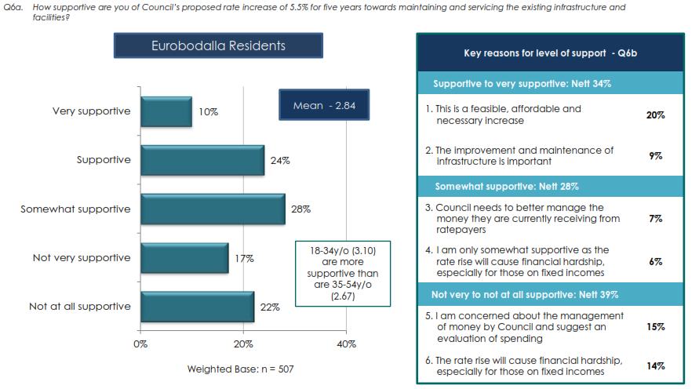

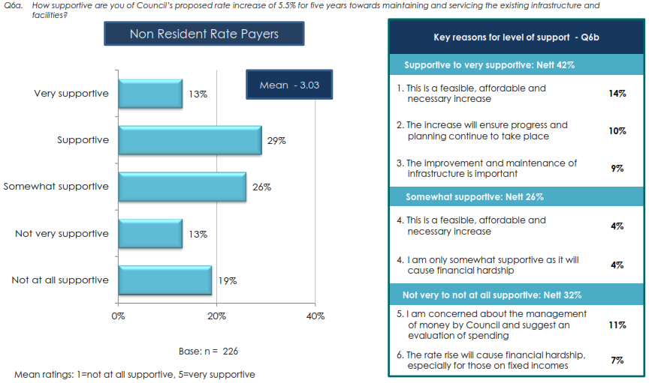

*Source: January 2012 Micromex Survey (Attachment 6a)*

In response to the community surveys conducted in 2012, supplementary community consultation and infrastructure planning was undertaken to identify specific community and transport infrastructure needs. These needs are reflected in the package of works included the SRV proposal. The following key Council strategies and plans included community consultations and were utilised to develop the SRV project list:

* Northern Area of Eurobodalla Traffic Study 2011
* Batemans Bay Traffic and Transport Study 2010
* Batemans Bay Parking Study 2011
* Moruya and Narooma Parking Study 2011
* Eurobodalla Pathways Strategy 2010
* Eurobodalla Road Safety Strategic Plan 2013-17
* Recreation and Open Space Strategy 2010
* Eurobodalla Disability Action Plan 2012-17
* Eurobodalla Social Plan 2010-15
* Situational Analysis and Cultural Infrastructure Report
* Libraries and Lifelong Learning Strategic Plan 2014-2018
* Developer contribution plans.

In the 2014 Micromex survey[11],transport infrastructure and community services and facilities were the predominate priorities raised by residents for the local area and 92% of residents stated that it was very important to somewhat important that Council improve community and transport infrastructure, as shown in the following graphs:

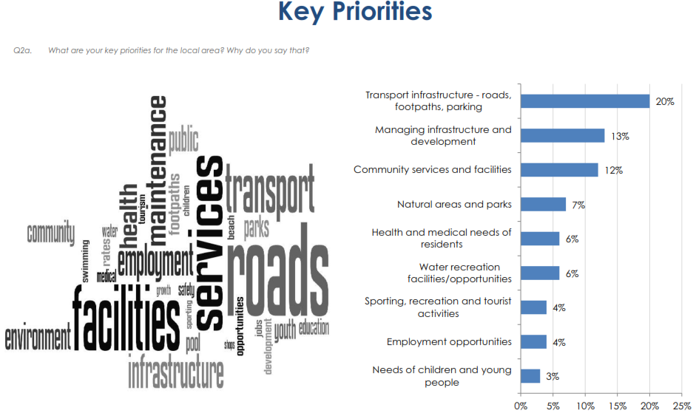

*Source: 2014 Micromex Survey (Attachment 6a)*

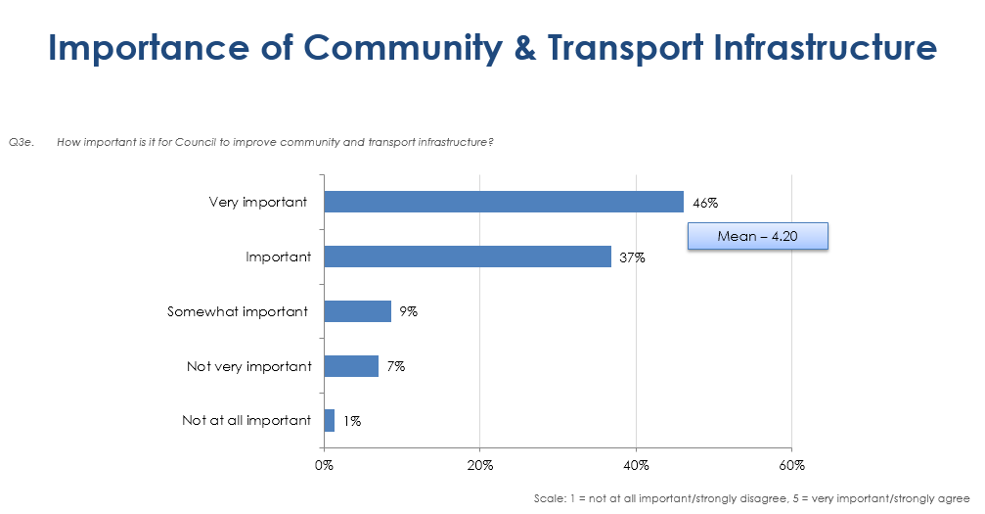

*Source: 2014 Micromex Survey (Attachment 6a)*

The package of community and transport infrastructure works was submitted to the community for review and comment during the consultation phase.

The results of Council’s various plans and strategies and community engagement activities have informed the revised Asset Management Plans (AMPs) for each major asset class. The AMPs summarise the works required to address infrastructure renewal, network deficiency and capacity issues over the next ten year period (based on whole of life analysis and sound risk management principles).

Council’s Long Term Financial Plan[12] identifies that without an increase in revenue Council will be unable to:

* meet community needs and expectations in relation to service delivery
* sustain ongoing infrastructure renewal costs
* address the infrastructure backlog
* achieve financial sustainability.

The TCorp assessment of Council’s financial sustainability as moderate[13], an infrastructure renewal ratio of 67%[14] for the General Fund compared to an Office of Local Government benchmark of 100%, an unfunded infrastructure renewal gap of approximately $4 million per year and the projected infrastructure backlog ratio of 9.8%[15] in the General fund reinforce this finding. In response to this, Council has implemented strategies, detailed in Section 5, to achieve efficiencies and drive productivity while striving to find alternative funding sources such as:

* strategic land and asset sales
* ongoing review and benchmarking of fees and charges
* grants to deliver services and improve infrastructure
* ongoing organisation service reviews
* strategic plans for business development
* energy efficiency initiatives
* technological improvements
* organisational restructures.

Council’s ongoing financial sustainability, infrastructure backlog and infrastructure gap remain at a significant level, despite implementing strategies to reduce cost, deliver efficiency and increase revenue. While Council will continue to implement these cost containment initiatives and actively seek new ways to operate more efficiently, these financial challenges are unable to be addressed without a significant increase to revenue through a SRV.

Council’s SRV proposal is balanced, moderate and reflects a strategy that will move Council towards long term financial sustainability. The SRV proposal will provide:

* increased annual funding to help address the gap in funding for infrastructure renewal, particularly for short lived assets
* an enhanced capital works program that will stimulate economic and employment growth and development
* a capital renewal program for existing infrastructure in poor condition
* a capital program to upgrade existing infrastructure including funding for ongoing ‘whole of life costs’
* replacement funds as a result of the flat lining of Federal Assistance Grants, a decision of the Federal Government June 2014.

The SRV proposal is a moderate increase. It provides a positive impact on Council’s LTFP results and therefore it is an essential step in the process of Council becoming fit for the future. To ensure long term financial sustainability, Council acknowledges that more work needs to be done. Council will continue to review and refine its service delivery model in consultation with the community in order to be fit for the future.

## Financial sustainability

The SRV proposal will support Council’s strategic imperative to become financially sustainable, assist Council to meet the Fit for the Future criteria, and address community expectations regarding community and transport infrastructure.

**Current state of financial sustainability**

Council’s current state of financial sustainability is similar to many other councils. The General Fund has significant operating deficits before capital revenues. This is because the net cost of services is not fully funded from general rates. In particular, the cost of maintaining infrastructure and adequate funding of renewals is a challenge. As a result, Council has needed to defer renewal works to balance its budgets resulting in infrastructure backlogs. Council is unable to adequately fund its current infrastructure assets without significant reduction in service levels, which is not supported by the community. It is also unable to fund an increase in infrastructure service levels as identified and requested through community consultation activities (refer Section 4.2).

*Table 1: General Fund Financial Performance*

|  |  |  |
| --- | --- | --- |
| Ratio | 2013/14 | OLG Benchmark |
| Operating Ratio | -4.8% | > 0% |
| Renewal Ratio | 67% | 100% |
| Infrastructure Backlog Ratio | 14.6% | < 2% over 3 years |

Special Schedule 7 in the 2013/14 the Annual Financial Statements also identifies a backlog of work estimated at $78.6M.

The Executive Summary of each Asset Management Plan summarise the funding challenges to address infrastructure renewal, network deficiency and capacity issues[16].

The Long Term Financial Plan[17] forecasts Council’s financial position over the next ten years under two different scenarios.

* Base case – business as usual (only the rate peg amount estimated at 3%).
* SRV case – general rate increase of 6.5% (including rate peg) per year cumulative for 3 years and thereafter on-going.

*Base Case*

The base case is a business as usual scenario which is described in more detail on page 12 of the LTFP and includes the long term financial projections for the Income Statement, Balance Sheet and Cash Flow Statement. The operating result before capital revenue projects deficits in the order of $4.5 - $5.5 million in today’s dollars, approximately 8 - 9% of total operating revenue.

*SRV Case*

The SRV is a proposed rate increase of 6.5% per year cumulative for 3 years and thereafter ongoing (including rate peg). The SRV will fund a community and transport infrastructure program that aims to increase spending on renewals and to provide upgraded infrastructure for community and economic benefit. The operating result before capital revenue projects deficits in the order of $4 - $5 million in today’s dollars, approximately 7% of total operating revenue.

Page 48 of the LTFP outlines the planning assumptions used in the development of the long term financial plans projections. The LTFP also includes the original 8% scenario which the community were consulted on.

**External assessment of Council’s finances**

In 2012 the New South Wales Treasury Corporation (TCorp) completed an assessment of all NSW Council’s financial sustainability and its findings support Council’s own assessment[18].

The report comments on the consolidated and general fund. The key findings in the report are:

* Council’s consolidated financial sustainability rating was assessed as ‘moderate’ and this means:
  + Council has adequate capacity to meet its financial commitments in the short to medium term and an acceptable capacity in the long term
  + while it has a record of reporting minor to moderate deficits they may also have recently reported a significant operating deficit
  + Council is likely to be able to address its operating deficits, manage unforseen financial shocks and any adverse changes in its business, with moderate revenue and/or expense adjustments. The expense adjustments are likely to result in a number of changes to the range of and/or quality of services offered
* Council’s financial capacity to manage core business risks is moderate.
* Council is underspending on asset renewal and maintenance and if this continues the backlog of infrastructure works will increase.
* Council’s general fund results adversely affect the consolidated results.
* The forecast highlights deficit positions in the general fund are expected in all ten years when capital grants and contributions are excluded. This indicates Council could face financial sustainability issues in the medium to long term.
* TCorp assessed Council’s consolidated outlook as ‘neutral’ and this means:
  + There are no known foreseeable events that would have a direct impact on the financial sustainability of the Council.
  + It may be possible for a rating upgrade or a downgrade to occur from a neutral outlook, if warranted by an event or circumstance.

It is important to note that the TCorp financial sustainability rating and outlook refers to the consolidated entity and not the General Fund by itself.

In summary, Council’s current financial performance of the consolidated position is relatively satisfactory due to the sound position of the Waste, Water and Sewer Funds. However, the financial sustainability and medium to long term outlook for the General Fund are not satisfactory and without change the Fit for the Future criteria will not be met. This supports Council’s case in applying for a SRV to partly address the significant operating deficits in the General Fund and thereby providing additional revenue to fund renewals and also to begin to address the infrastructure backlog.

Council’s external auditors, Pitcher Partners, also note the operating performance ratio is below the benchmark in its report on the conduct of the 2013-14 audit:

“*At - 3.11% this ratio is below the long-term benchmark of break-even set by NSW TCorp and the Office of Local Government”*

Although the auditor is referring to the consolidated result, the General Fund for the same period was -4.79%, well below the benchmark.

Council’s current financial strategy is in accord with the key recommendations from TCorp:

* source additional revenue to improve financial flexibility and to assist in reducing the Infrastructure Backlog
* take advantage of Council’s borrowing capacity and utilise debt to fund infrastructure to reduce the Infrastructure Backlog and improve intergenerational equity
* continue programs and strategies to contain rising costs and improve efficiencies
* increasing spend on maintenance and infrastructure renewal, balancing this with the need for capital expenditure on new assets.

**Impact of the SRV on Council’s financial sustainability**

The estimated income generated from the proposed SRV is approximately $0.8 million, $1.7 million and $2.6 million in years one, two and three respectively. The additional revenue will fund a community and transport infrastructure program to be delivered over four years costing $17.5 million.

To leverage the benefit for the community and minimise the impact on ratepayers, Council’s financial strategy for the SRV includes[19]:

* cash funding renewal of short lived infrastructure (less than 20 year life) to partly address the annual infrastructure funding gap
* borrowings of $11.1 million to be repaid over 20 years to match the benefits and costs of long lived infrastructure to ratepayers
* utilisation of Council’s cash reserves of $2 million
* ensuring that the ‘whole of life costs’ of any new or upgraded assets are covered including maintenance, operations and depreciation costs
* for high risk assets such as bridges, it is proposed to loan fund replacement works to allow them to be addressed with greater urgency and remove these from the backlog of existing works.

The strategies identified in the LTFP leverage the benefit additional rates revenue will have in reducing the infrastructure funding gap and backlog. Effective asset management planning is crucial to ensuring the ratepayers’ dollar go further to sustaining, and in select areas, improving infrastructure to meet current community need.

The LTFP shows that with the SRV in place there is favourable movement in reducing the annual infrastructure gap, and a similar impact on the infrastructure backlog ratio[20]. This compares to a continuing unfavourable movement without the SRV.

## Financial indicators

The following table presents the key indicators (including the 7 Fit for the Future indicators[21]) for Council’s General fund under both LTFP scenarios[22]:

*Table 2: Financial Indicators*

|  | 2013/14[23] | Base Case | SRV Case | OLG Benchmark |
| --- | --- | --- | --- | --- |
| *Financial Sustainability* | | | | |
| * Operating performance ratio[24] | -4.8% | -8.7% | -6.9% | > 0% |
| * Asset renewal ratio[25] | 67% | 39% | 48% | 100% |
| * Broad liabilities ratio[26] | 172% | 111% | 103% | < 60% |
| *Effective Infrastructure and Service management* | | | | |
| * Infrastructure backlog ratio | 14.6% | 13.4% | 11.9% | < 2% |
| * Asset maintenance ratio | 0.58 | 1 | 1 | 1 |
| * Debt service ratio[27] | 6.88% | 13% | 13% | < 20% |
| *Efficiency* | | | | |
| * Efficiency ratio | $1,700 | $1,648 | $1,672 | Improving |
| *Other* | | | | |
| * Unrestricted current ratio[28] | 2.85:1 | > 2 | >2 | > 1.5 |
| * Rates and annual charges ratio[29] | 71% | 75% | 76% | > 60% |

These indicators together with long term strategies to deliver infrastructure renewal, address network deficiencies and to meet increasing demands due to growth, will allow Council to meet its obligations under the Local Government Act 1993 - Council Charter, particularly taking account of the long term impact of its decisions and inter-generational equity.

The following outlines Council’s current position:

* **Operating performance ratio** – is a key measure of financially sustainability as it shows whether Council is able to generate sufficient funds to meet expenditure requirements for delivery of services and infrastructure. The SRV improves the 10 year average for the ratio from -8.7% to -6.9%, however this is still outside the benchmark of greater than 0%. Council will undertake further work to meet benchmark.
* **Asset renewal ratio** - provides an indication of whether asset renewals are matching the cost of asset deterioration i.e. depreciation. The community and transport program of $17.5 million over 4 years includes $9.6 million of expenditure on renewals with ongoing allocations dedicated to renewal programs in the future. The renewal ratio as a result improves by 9% to 48% over the next 10 years, however is still significantly short of the 100% benchmark target. To effectively manage our infrastructure, provide the level of service expected by our community and meet our legal obligations, Council must address condition, capacity and network deficiency issues. The asset management plans identify the priority renewal works, demand and risk management measures required over the next ten years. Beyond the ten year horizon, Council will need to reduce capital expenditure and redirect increased funding to renewal of ageing long lived assets (such as road pavements and bridges). Any additional income coming available as loan are paid down, or through increased growth will be directed to renewal of infrastructure.
* **Broad liabilities ratio** – is not an indicator in the effective infrastructure and service management in the Fit for the Future program and hence is not analysed in the LTFP however this ratio is considered as an important indicator of financial sustainability. Unsustainable councils average 187%, vulnerable councils 95% and sustainable councils 55%[30]. In the SRV scenario Council estimates a change from 172% in 2013/14 to 103% in 2024/25. This compares to the base case that is expected to be 111% by 2024/25. Hence the SRV improves broad liabilities ratio for Council’s General fund to a position closer to the benchmark within the 10 year planning period.
* **Infrastructure backlog ratio** - identifies whether Council is able to reduce the backlog and maintain it within acceptable levels. The ratio improves from 14.6% in 2013/14 to 13.4% in the base case and 11.9% in the SRV scenario by 2024/25. This is achieved by targeting high priority backlog works and addressing the infrastructure gap for short lived assets (useful life less than 20 years). This also reflect the targeted programs in Councils existing forward programs. Without the SRV however, it can be expected that the amount of unfunded renewal beyond the ten year horizon will increase, adversely impacting this ratio.
* **Asset maintenance ratio** - shows whether Council is fulfilling maintenance requirements or allowing some assets to degrade. Council’s current ratio meets the benchmark of 1. There is a need to ensure maintenance budgets grow in keeping with the growth in asset base. The focus of the asset management plans is to direct the majority of any additional funds toward renewal, which assists the renewal and backlog ratios. If adequate renewal is not achieved, there will be a significant increase in the required maintenance funding going forward.

The unrestricted current ratio, rates and annual charges ratio and debt service ratio are all expected to be within benchmark. Council’s management of its working capital to meet operational needs is sound, it utilises borrowings effectively to finance capital works and its revenue composition is predominantly rate based providing it with financial flexibility.

* **Unrestricted current ratio** - assesses Council’s liquidity position. Council’s position as at 30 June 2014 was 2.85:1. The use of $2 million cash to fund the SRV program will not adversely impact Council’s liquidity position. The ratio is expected to remain >2.
* **Rates and annual charges ratio** - assesses Council’s reliance on external sources of funding and hence its funding flexibility. For both scenarios the ratio is greater than the benchmark of 60%. Therefore Council has sound financial flexibility as it is not overly reliant on external sources of funding to deliver its core services. Council does however vigorously pursue grant funding to leverage its existing services.
* **Debt service ratio** – measures the availability of operating cash to service debt including interest, principal and lease payments. In the SRV case, the ratio approaches 20% (2016/17 to 2017/18) as the community and infrastructure package of $17.5 million over four years is highly leveraged with borrowings of $11.1 million. The SRV is designed to cover the loan commitments, so whilst Council’s borrowings have increased so has its capacity to repay. The use of debt to fund the community and infrastructure package is an effective way to ensure intergenerational equity by maintaining a more consistent condition of community and transport infrastructure and to provide a more stable pricing path. To fund the program directly through rates revenue would either require a deferment of works until enough funds are available or a very large increase in rates to raise $17.5 million in a short period of time. Both these options create inequity between current and future ratepayers.

The proposed SRV improves Council’s ability to meet the Fit for the Future criteria with four of the seven indicators being met. The operating performance, infrastructure backlog and renewal ratios are projected to improve with a SRV but still do not meet the benchmarks. The SRV proposal is a moderate approach and Council will continue to pursue additional strategies to assist to meet the benchmarks.

## Contribution plan costs above the cap

Council’s SRV proposal does not seek funding for contributions plan costs above the development contributions cap.

# Assessment criterion 2: Community awareness and engagement

Council has embraced the opportunities offered via the IP&R process to engage with the Eurobodalla community and non-resident ratepayers through a comprehensive, phased engagement program designed to:

* set the vision for Eurobodalla through the community strategic plan, our infrastructure strategies and asset management plans
* facilitate understanding of the very real financial and asset management challenges in meeting community needs and expectations
* align service delivery and financial planning to meet community needs
* develop a viable solution to work toward financial sustainability and provide inter-generational equity
* raise awareness of the extent and impact of the SRV proposal.

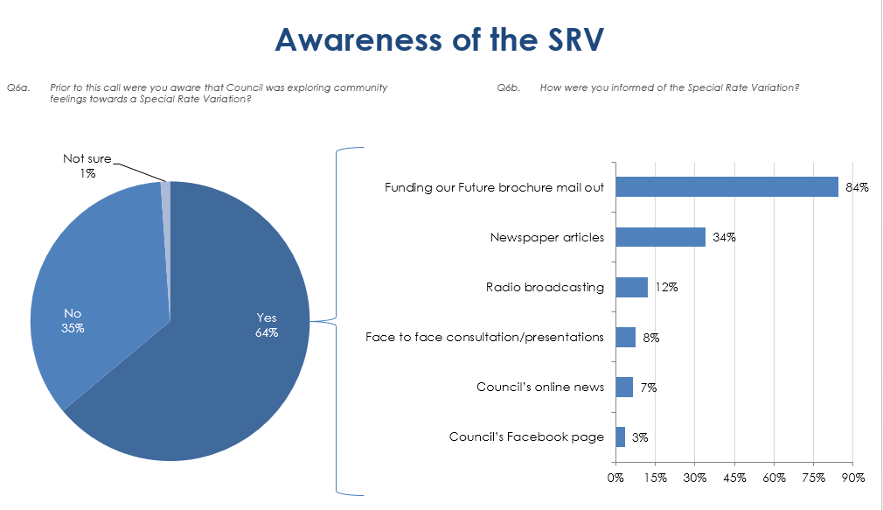

*Source: 2014 Micromex Survey (Attachment 6a)*

The program employed a range of methods which ensured a wide reach and extensive opportunity for feedback and input within our community. Details of the program are outlined below and in further detail in attachments as highlighted.

## The consultation strategy

**STAGE 1: ESTABLISHING NEED AND EXPLORING OPTIONS**

**Time Period:** August 2010 – June 2013

**Key Message:** *The long term financial sustainability of Council is at risk. Current income does not cover the cost of service delivery. We need to consider options such as service reduction, operating efficiencies or alternative revenue sources such as a rate increase.*

**Key Documents:** Eurobodalla 2030, State of the Shire Report 2010, Resourcing Options Paper 2011, Delivery Program Information Paper 2011-21, Resourcing Strategy 2012-22, Recreation and Open Space Strategy 2010, Disability Action Plan 2012-17 and Pathways Strategy 2010.

Council’s conversation with the community regarding future vision, long term financial sustainability and asset management challenges began in 2010 with the development of the first community strategic plan: Eurobodalla 2030.

This initial conversation was Council’s largest engagement initiative with over 3,000 community members and non-resident ratepayers involved. There was open and lengthy discussion about long term financing options, assets, service delivery and community expectations. There was also a range of methods to provide input into the planning process and feedback on potential solutions.

Outcomes from the engagement informed the development of Council’s first suite of IP&R documents which clearly identified a need for increased revenue in order to maintain assets and service levels to a level that meets community expectations in the future.

This early stage of consultation and engagement is outlined below and was an important step in identifying the need for a SRV. This informed the development of the package of community and transport infrastructure projects.

| **Method** | **Summary** | **Reach** |
| --- | --- | --- |
| **State of the Shire Report 2010 [31]** | * Long term financial sustainability of the Shire is at risk. * The service levels currently delivered by Council cannot be sustained with existing levels of funding. * Council income is largely dependent on Rates (51%) and has not kept pace with costs due to rate pegging. * Operating costs have increased above inflation, for example, the cost of resealing a road has risen 26% more than rate pegging in 5 years * Council is not spending enough on maintaining and renewing infrastructure * The infrastructure gap, or the amount not budgeted but required for essential maintenance and renewal of General Fund assets, is currently estimated at $4.5-5 million per annum. * As infrastructure ages, maintenance costs increase, service levels drop and risks to public safety increase. | Exhibited:  September 2010  Public Exhibition included static displays, media releases and web coverage. |
| **Community Strategic Plan – Eurobodalla 2030**  **(2011)[32]** | Comprehensive engagement strategy encompassing a broad range of engagement activities.   * Community reference group * Community vision survey * Statistically reliable survey of ratepayers * 15 focus groups * Community summit * 2 exhibition periods.   When the CSP was reported to Council it was accompanied by 3 financial scenarios to form the basis for the resourcing options paper and to be consulted on with the community. | Over 3,000 residents and ratepayers in total  Consult and development commenced: October 2010  Exhibited: July 2011 and November 2011  Adopted: April 2012 |
| **Resourcing Options Paper 2011[33] and Delivery Program information paper 2011-21[34]** | The Paper put forward three financial scenarios:  1: No rate increase – infrastructure continues to decline  2: Moderate rate increase – maintain priority infrastructure  3: Larger rate increase – maintain infrastructure and cater for growth  Scenario 1 was not modelled as it was not considered a viable option. It was outlined that if there was no increase in rates, infrastructure and services were unsustainable and services would need to be reduced to divert funds to priority infrastructure. This scenario was at odds with the direction advocated by the community via the Community Strategic Plan and therefore Council did not attempt to identify possible changes to levels of service or service rationalisation options to achieve a more sustainable budget.   * Statistically reliable community survey conducted on the options[35]. * Focus groups further explored the options. | Exhibited and consulted on: November 2011  Community SurveyJanuary 2012 (733 participants)  Focus Groups (17 participants) |
| **Delivery Program 2012-16 & Operational Plan 2012-13** | The Delivery Program outlined that financial sustainability remained one of Council’s greatest challenges and that in 2012‑2013 Council would again engage the community to determine service priorities and commence a thorough review of services based on this.  In preparation of these documents Council considered progressing an SRV application to meet community expectations and address financial challenges and determined that further engagement analysis was required. It was flagged with our community at this time that Council may still need to seek a rate increase through a special rate variation application to meet the community’s expectations for the long term and that this would be considered in the review or key IP&R documents following council elections in September 2012. | Exhibited:  May 2012  Adopted:  June 2012 |
| **Community Strategic Plan Review – One Community**  **(2013)[36]** | Review found aspirations of our community continued to be reflected in the plan, some minor changes including the rebranding of the plan**.**  Supported by statistically reliable community survey[37] to measure current community satisfaction and identify areas of community support for service level reductions. Outcomes from the survey were reflected in the CSP review and subsequent DP and OP and are detailed in Section 4.2. | Exhibited:  February - April 2013  Adopted:  June 2013  Community Survey (400 Participants) |
| **Resourcing Strategy 2013 – Asset Management** | Following council elections in 2012, continued engagement with the community occurred to develop the Asset Management Strategy and plans.  Focus groups to reviewcurrent levels of service and identify if there was any opportunity for service level reduction.  Outcomes from these focus groups are detailed in Section 4.2 of this application. | Focus groups February 2013  (28 participants) |
| **Delivery Program 2013-17 & Operational Plan 2013-14** | First Delivery Program and Operational Plan of new Council. Committed to continuing service reviews and developing a financial strategy to address infrastructure gap and backlog and become financially sustainable.  Development of the Plans included consideration and refinement of capital works programs. Select projects and programs were deferred at this time given budget constraints. | Exhibited: April 2013  Adopted: June 2013 |

**STAGE 2: SRV PROPOSAL AWARENESS AND INPUT**

**Time Period:** July 2014 – January 2015

**Key Message:** *As a result of ongoing conversations with the community Council has developed a financial strategy to meet community needs and expectations in service and asset provision and move towards becoming financially sustainable and Fit for the Future. The strategy included the original 8% SRV package of community and transport infrastructure projects supported by a range of measures including ongoing efficiency and cost containment by Council.*

**Key Documents:** Community Engagement Strategy 2014[38], Delivery Program including SRV 2013-17[39], Long Term Financial Plan 2015-25[40].

Council developed a Community Engagement Strategy for the SRV consultation process to ensure the community was well informed and able to provide feedback on the proposal in a range of ways.

The purpose of the strategy was to inform the community regarding the need, purpose and impact of the SRV proposal and to involve and consult a representative sample of the community about the SRV proposal.

Council communicated the extent and impact of the SRV proposal on all ratepayer categories showing individual annual and cumulative increases in both percentage and dollar terms. Proposed increases were also shown as a comparison to rate peg only amounts and neighbouring councils. It was clearly articulated that the SRV proposed increase to the general rate only; that figures were based on an estimated rate peg of 3%; and that increases shown were for an average rate. Ratepayers were advised this would vary based on individual cases and were invited to contact council to discuss the actual impact.

The strategy delivered activities across the first 3 levels in the International Association for Public Participation (IAP2) spectrum that are to inform, consult and involve and was a phased approach as outlined below.

**Phase 1: Inform and Involve (September – November 2014)**

Involved both broad and targeted provision of information and opportunity to provide feedback as outlined below.

| **Method** | **Summary** | **Reach** |
| --- | --- | --- |
| **Mail Out** | Funding Our Future Brochure[41] mailed out to all ratepayers. Provided information about the package of community and transport infrastructure projects and the extent and impact of the SRV proposal. It also detailed how community members could provide feedback. | 21,700 resident and non-resident ratepayers |
| **Community Survey** | Statistically valid community survey undertaken to determine awareness of and measure community support of the SRV proposal including the package of projects[42]. The survey also provided an avenue for feedback and measured current levels of satisfaction with Council services. The outcome of this survey is detailed in section 4.2 of this application. | 602 Participants |
| **Public Information sessions** | Council held four public information sessions in Moruya, Narooma, Batemans Bay and Tuross Head. Details of the sessions were widely publicised online and in local press and radio. Handouts detailing the SRV proposal were provided at all sessions. | Over 100 residents and ratepayers |
| **Telephone Feedback** | An SRV hotline was established with staff providing further information and assistance. | Over 70 calls received |
| **Council Website** | A dedicated web information hub was established linked from the front page of Council’s website and regularly updated with information[43]. | Total over both phases:  1,180 visits |
| **Information Stall** | An information stall was held at Moruya market to provide an opportunity for community members to ask questions of senior staff and Councillors about the SRV proposal. | Not measured |
| **Media** | Activities included coverage in Council’s regular Online Newsletter; five media releases and seven statements in response to media queries which formed the basis of a number of radio stories, interviews, newspaper articles and comments on social media and blogs; and commentary in two Mayor’s columns which are published in local newspapers and on Council’s website. A sample of key media coverage is provided in Attachment 5c. | Online news: over 3,000 subscribers |
| **Static Displays** | Information and copies of key documents and were available at council libraries and main administration centre for the duration of Phase 1. | Not measured |
| **Special Interest Groups** | The Mayor and staff met with a number of special interest community groups to address questions regarding the SRV proposal. | Not measured |

**Phase 2: Inform and Consult (December 2014 – January 2015)**

Involved the exhibition of an amended Delivery Program 2013-17 and Long Term Financial Plan 2015-25. The exhibition was promoted as outlined below:

|  |  |  |
| --- | --- | --- |
| **Method** | **Summary** | **Reach** |
| **Documents** | The revised Delivery Program 2013-17[44] and Long Term Financial Plan 2015-25[45] clearly articulated the SRV proposal in percentage and dollar terms and in comparison to base case. | Not measured |
| **Mail out** | Information flyer mailed out to all ratepayers[46]. Provided information on why council had made decision to progress SRV application, how it may affect ratepayers, where to find more information and how to provide feedback. | 21,700 resident and non-resident ratepayers |
| **Telephone Feedback** | The SRV hotline remained open during the second phase to provide further information and assistance. | Over 30 calls received |
| **Council Website** | The dedicated web information hub was continually updated through phase 2[47]. | Total over both phases: 1,180 visits |
| **Media** | Activities included coverage in Council’s regular Online Newsletter, media releases and response to media queries as required[48]. | Online news: over 3,000 subscribers |
| **Static Displays** | Information and copies of key documents and were available at council libraries and main administration centre for the duration of Phase 2. | Not measured |

**Media coverage**

Media coverage during stage 2 of community engagement regarding awareness and feedback on the SRV proposal was extensive and noteworthy. The coverage not instigated by Council shows a significant level of awareness of the SRV proposal within the community. Examples of print and web articles are provided in attachment 5c.

* Newspaper/Print:
  + 22 articles – 6 front page
  + Letter to the editor: 33 (September 2014 – January 2015)
  + Vox Pop: 3
  + Editor’s Column: 3
  + Mayor’s Column: 4.
* Web
* Articles: 29 (May 2014 – January 2015)
* Blog comments: 297 (average 10 comments per article; range 0-67).

## Feedback from the community consultations

**FEEDBACK STAGE 1: ESTABLISHING NEED AND EXPLORING OPTIONS**

**Time Period:** August 2010 – June 2013

Feedback highlighted that our community:

* wanted to at least maintain the current level of service provided in all major asset classes; some key areas were identified for improvement
* accepted there was a financial sustainability and infrastructure renewal/backlog challenge
* considered the provision and maintenance of infrastructure services was high to very high in importance, and the current level of satisfaction was moderately low to moderate
* considered there were significant gaps between service provision and satisfaction levels for transport and community infrastructure, and facilities for people with a disability
* would be willing to support a moderate rate increase to assist in maintaining the services and assets that were important to them
* was not supportive of an increase to pensioner rebates.

| **Method** | **Summary** |
| --- | --- |
| **Community Strategic Plan – Eurobodalla 2030**  **(2011)[49]** | Statistically reliable, independently conducted community survey[50].  Aim: to measure council performance, perceptions of service delivery and priorities for limited resource allocation.   * 87.3% of respondents gave a high rating to the standard of local roads and infrastructure as a high priority issue.     *Source: 2010 Iris Community Engagement Survey (Attachment XX)*   * Showed high importance and moderate to low satisfaction with:   + management of traffic congestion and road safety;   + management and provision of stormwater drainage;   + provision and maintenance of public toilets;   + unsealed roads and sealed roads; and   + provision of facilities and services for people with a disability.   These services were not meeting resident expectations at this point in time. |
| **Resourcing Options Paper (2011)[51] and Delivery Program information paper (2011-21)[52]** | Statistically reliable, independently conducted community survey[53].  Aim: to allow opportunity for ratepayers to provide feedback on two rate increase scenarios:   * Option 1 - 5.5% SRV each year for five years from 2013/14 (including rate pegging of 3%) raising an extra $3 million per annum by 2018. * Option 2 - 7% SRV each year for five years from 2013/14 (including rate pegging of 3%) raising an extra $5 million per annum by 2018.   The 5.5% increase option was the most acceptable, with 62% of residents and 68% of non-resident ratepayers indicating that they were supportive to somewhat supportive of this option. Those supportive believed that the SRV was affordable and needed in order to improve local infrastructure and services. Those not supportive had concerns about Council’s financial management, affordability and questioned the relevance of Council’s long-term resourcing strategies.   * 77% of resident ratepayers and 86% of non-resident ratepayers believed or considered it was important to somewhat important for Council to implement plans and programs that will provide better infrastructure and facilities for the Eurobodalla. * Transport renewal backlog was seen as the key priority maintenance program     *Source: January 2012 Micromex Survey (Attachment 6)*  Focus groups were also conducted to further explore rating options and the possibility of an additional pensioner rebate to assist in affordability. There was a low level of support for introduction of additional pensioner rebate at all focus groups. |
| **Community Strategic Plan Review – One Community**  **(2013)[54]** | Statistically reliable, independently conducted community survey[55].  Aim: measure current community satisfaction and identify areas of community support for service level reductions.   * Comparisons showed little change from 2010 results. * Showed moderate level of community support for service level reductions in specific areas. * Showed high importance and moderately low satisfaction with:   + provision and maintenance of sealed roads;   + unsealed roads and public toilets; and   + provision of youth services and facilities.     *Source: July 2012 Micromex Survey (Attachment 6a)* | |
| **Resourcing Strategy – Asset Management** | Independently facilitated focus groups.  Aim: to review current levels of service, identify if there was any opportunity for service level reduction and if residents would be willing to pay more for service levels to be maintained.   * More informed residents are willing to pay increased rates to maintain current service levels. * Key concern is that a reduction in service level does not impact on safety. * Transport: identified significant level of support for paying more in order to maintain service levels. Participants believed the majority of these assets were underperforming. * Recreation: moderate level of support for paying more in order to maintain service levels. * Marine: participants showed a moderate level of support for paying more to maintain car parks, boat ramps, wharves and rock walls. * Community buildings: 7 of 20 classes performing below acceptable standards. Moderate level of support for paying more to maintain current level of service. | |

**FEEDBACK STAGE 2: SRV PROPOSAL AWARENESS AND INPUT**

**Time Period:** July 2014 – January 2015

**Phase 1: Inform and Involve (September – November 2014)**

Feedback highlighted that:

* there was a high level of awareness of the SRV proposal (64% of residents aware)
* there was a high level of satisfaction with Council performance (82% very satisfied to somewhat satisfied) and current level of community and transport infrastructure provided by Council (81% very satisfied to somewhat satisfied)
* the community considered it was important that Council continued to improve community and transport infrastructure (92% very important to somewhat important)
* there was a level of concern about affordability of, and the need for the SRV proposal.

|  |  |
| --- | --- |
| **Method** | **Summary** |
| **Community Survey[56]** | Statistically reliable, independently conducted community survey to:   * To determine awareness of and measure community support for a SRV. * To provide an avenue for feedback for residents to express their views on the proposed SRV and a package of works. * Measure current levels of satisfaction with Council.   For this survey residents were asked to provide feedback on two rate increase scenarios:   * No rate increase above rate peg of 3% over 3 years * Rate increase of 5% above rate peg to 8% over 3 years.   A summary of the findings follows:   * 89% of residents were very satisfied to somewhat satisfied with the level of service and facilities provided by Council in the local area, which has increased from 85% in 2012. * Residents indicated they believed it is very important that Council continues to improve its community and transport infrastructure. * 82% of residents were satisfied or somewhat satisfied with Council’s performance. This result is significantly higher than the NSW Regional Benchmark. * 64% of residents were aware that Council was exploring community sentiment towards a rate variation; the majority of whom were informed by Council’s mail out. * Whilst the majority of residents surveyed did not support paying more when surveyed on the SRV, approximately 50% of residents were supportive or somewhat supportive. |
| **Submissions[57]** | In response to approximately 21,700 brochure mail outs[58] Council received 113 submissions (0.5%) by letter and email.   * 15 in support. * 2 giving conditional support. * 92 in opposition. * 4 requesting further information which was referred to relevant council officers and information provided. |

**Phase 2: Inform and Consult (December 2014 – January 2015)**

Feedback highlighted that:

* The community’s concern and capacity to pay an increase of 8% as proposed
* The level of support for particular projects was not consistent
* Council has capacity to utilise cash reserves

|  |  |
| --- | --- |
| **Method** | **Summary** |
| **Submissions[59]** | In response to approximately 21,700 information flyer mail outs[60] Council received 272 (1.3%) submissions by letter and email.   * 5 in support. * 1 giving conditional support. * 261 in opposition (139 form letter). * 5 requesting further information which was provided. |

**KEY ISSUES**

A number of key themes were raised during both phases of the engagement process. These issues and Council’s response are outlined below.

*Affordability*: Council’s residential and farmland rates are the 5th lowest in Group 4 (32 councils) and 38% of ratepayers are non-resident ratepayers. Eurobodalla does have a significant number of lower income earners and pensioners. Currently 21% of ratepayers receive a pensioner rebate, in line with the Group 4 average.

Whilst accepting that some individual ratepayers may find it challenging to adjust household budgets to accommodate rate increases, it is considered that there is a capacity to pay a higher level of rates within the broader community. This is evidenced by examination of levels of home ownership which is 44.6%; comparisons of rating with neighbouring and Group 4 councils which show Eurobodalla rates are 20% below the average; a review of Socio-Economic Indexes as published by the Australian Bureau of Statistics; Council’s own low level of outstanding rates (3.56%) and the low use of the existing Rates and Debtors Hardship policy by the community.

Council has reviewed its Rates and Debtors Hardship policy (see section 5.3) to ensure an appropriate and compassionate response to individual cases of hardship, tailoring individual arrangements as permissible under the Local Government Act, and providing appropriate assistance to any ratepayers experiencing hardship.

*Work within current capacity:* Council continues to improve productivity and contain costs to ensure we meet the expectations of the community as established in the Community Strategic Plan. This has been achieved through:

* structural changes
* work practice improvements and staff training
* energy efficiencies and the introduction of new technologies
* partnership initiatives and a program of service reviews.

However, despite making considerable savings via internal service reviews, securing grants and external funds to offset costs, and undertaking an external audit of Council’s depreciation model for infrastructure to identify savings, Council will not be able to meet the needs of the community in the years ahead with its current income.

*Financially responsible decision making*: A successful SRV application is an important step towards being able to meet the key financial criteria required in the NSW Government's new Fit for the Future reform program for local government. If Council does not increase rate income it will be required to significantly cut current service levels, including the maintenance and renewal of community and transport infrastructure and will not be able to access favourable loan facilities offered by State Government to Fit for the Future councils.

Increasing revenue through a modest SRV is proposed as a financially responsible way to:

* support economic growth by funding a $17.5 million package of community and transport infrastructure projects that the community has asked for
* deliver a broad range of social and economic benefits
* improve funding the increasing costs of infrastructure renewal and maintenance works on roads, bridges, sport and community facilities, playgrounds, pathways, and public toilets
* respond to the NSW Government’s new Fit for the Future financial criteria
* address the funding shortfall resulting from decreasing Federal Assistance Grants
* address the impact of the Independent Pricing and Regulatory Tribunal's rate pegging amount that has not kept up with inflation or the increasing cost of building and construction materials for several years.

To take a moderate step to address the financial sustainability of Council is an essential and responsible decision. Failure to do this will see the problems worsen, quality of infrastructure deteriorate, leading to negative economic impacts, increased costs to address the problem in the future, and inappropriately passing the cost on to future generations.

*Current level of service:* Several submissions (largely non-residents) suggested that as the current level of service was not meeting expectations they would not be willing to support a rate increase. Only through the SRV and continued improvement (as identified by the Organisation Service Reviews) will the current level of service be maintained.

Council has a considerable backlog of infrastructure renewal. If this issue is not addressed, our community will experience a steady decline in the condition of its infrastructure over time, leading to reduced levels of service, reduced public safety, higher risks of infrastructure failure and higher maintenance costs.

The proposed SRV would provide a significant pro-active measure toward addressing the infrastructure funding gap as well as addressing immediate high risk backlog issues.

The Community Research survey conducted by Micromex in July 2012[61] provided the following feedback about the importance and current level of satisfaction with a score out of 5 (5 being very important or very satisfied) on community and transport infrastructure.

*Table 3: Extract from July 2012 Micromex Survey*

| Service/facility | Importance | Satisfaction | Performance gap |
| --- | --- | --- | --- |
| Sealed roads | 4.55 | 2.88 | 1.67 |
| Public toilets | 4.49 | 3.01 | 1.48 |
| Unsealed roads | 4.12 | 2.70 | 1.42 |
| Traffic congestion | 4.17 | 3.0 | 1.17 |
| Road safety | 4.23 | 3.08 | 1.15 |
| Facilities for people with disabilities | 4.38 | 3.25 | 1.13 |
| Stormwater | 4.37 | 3.24 | 1.13 |
| Recreation facilities | 4.18 | 3.07 | 1.11 |
| Pathways | 4.38 | 3.3 | 1.08 |
| Parks/playgrounds | 4.36 | 3.44 | 1.02 |
| Boat ramps | 4.13 | 3.28 | 0.85 |
| Cultural facilities | 3.72 | 3.16 | 0.56 |
| Halls/centre | 3.78 | 3.22 | 0.56 |
| Sports grounds | 3.99 | 3.47 | 0.52 |

Overall these services were rated high to very high in importance by the community and moderately low to moderate in satisfaction level. The community indicated they wanted current service levels to be maintained or improved. If additional funding is not provided the levels of satisfaction will steadily decline with time as condition declines and demand increases (e.g. increased traffic congestion).

Council’s asset management plans identify specific targeted programs and projects to assist address the renewal of infrastructure and high priority backlog issues taking a long term view over the ten year financial period. For example, removing the infrastructure gap in resurfacing permits the backlog of works in this area to be significantly reduced over the ten year horizon. Also, loan funding of bridge renewal allows the removal of high risks from the infrastructure portfolio.

*Staffing levels:* There was suggestion that Council is overstaffed and expends too much on staff and therefore should reduce staffing levels rather than increase rates.

A benchmarking of employee costs as a percentage of total expenditure was conducted. This included 152 NSW councils and 31 Group 4 councils at a broad level to provide context. Key findings are outlined in detail in attachment 13d, and are summarised as follows:

* Over 70% of councils in New South Wales have higher employee costs, as a percentage of total expenditure, than Eurobodalla.
* Eurobodalla is below the state and Group 4 average for employee costs as a percentage of total expenditure (refer to section 7).

A number of councils outsource staffing via contractor and partnership arrangements. As such, the cost is not entirely visible in the employee cost component of the financial statements and therefore difficult to compare total employee numbers and costs between councils.

These findings support Council’s current staffing levels and any reduction in staffing levels would necessitate a reduction in service levels which is not supported by the community.

*Value for money – inequity of project distribution:* Some submissions suggested they could not see value for money in terms of the services or community and transport projects provided or used by them as individuals.

The package of community and transport infrastructure projects was developed based on broad and extensive community consultation that informed the development of key IP&R documents and council strategies as identified in section 3.1.

Rating is not a ‘fee for service’ but rather contributes to the overall functioning and amenity of the Eurobodalla and provides broad economic and social benefits to the community as a whole.

In the 2014 Micromex survey there was strong support for the projects included in the SRV package (ranging from 58% - 87% very supportive to somewhat supportive) with the exception of the Moruya library exhibition centre (44% somewhat to very supportive). The strongest support was for infrastructure renewal, sealing highly trafficked gravel roads, upgrading bridges and culverts and provision of accessible toilets (82% - 87% very supportive to somewhat supportive).

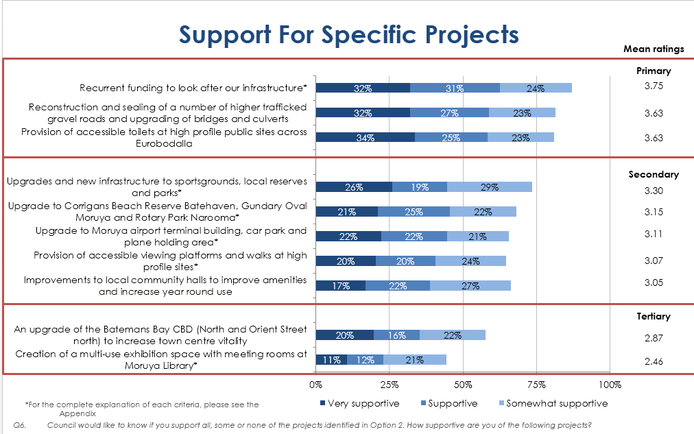

*Source: 2014 Micromex Survey*

*Alternative revenue sources:* Council’s long term financial plan and resourcing strategy explore alternatives for revenue and savings, and incorporate a range of non-rating revenue sources including:

* asset sales
* return of assets to the state
* public private partnerships
* increased fees and charges
* grants to deliver services and infrastructure

These alternatives are not sufficient to address the increasing gap between revenue and expenditure alone but will play a part in assisting to achieve financial sustainability. As such, the SRV proposal is part of a package to become financially sustainable.

*Amalgamation:* The Independent Local Government Review Panel did not recommend Eurobodalla Shire Council to merge with another council. The geographic length of the Eurobodalla (110km) does not lend itself to amalgamation nor would it assist in improving Council’s long term financial sustainability.

# Assessment criterion 3: Impact on ratepayers

At the 10 February 2015 meeting, Council considered the feedback received from the consultation on the original 8% SRV proposal. Taking into account the affordability issues raised by many ratepayers, Council resolved to reduce the SRV proposal to 6.5% to reduce the impact on the ratepayer.

## Impact on rates

Council’s SRV proposal is for a 6.5% increase (including rate peg) on the general rate only for residential, business and farmland categories for three years.

The specific impact of the SRV across the different rate categories is dependent upon a number of factors including land valuation. The Valuer General has recently issued new land valuations for 2015/16. The new valuations have been used to calculate the estimated rates levied should the SRV be approved. Significant variations between properties are indicative of the recent re-valuation. The rate structure has not been changed.

After applying the SRV to the July 2014 land value revaluation Council has maintained the same proportion of income from the base amount. The base charge will increase from $408 to $432 across the residential, business and farmland categories.

The following tables outline the dollar impact to the rate payer for years one, two and three plus the cumulative increase in dollar and percentage terms over three years for each rating category under each scenario (base and SRV):

**Residential** – *based 2014-15 average rate $817.82[62]*

|  |  |  |  |  |  |
| --- | --- | --- | --- | --- | --- |
|  | **2015-16** | **2016-17** | **2017-18** | **Cumulative $ increase** | **Cumulative % increase** |
| Base Case Scenario (3%) | $24.53 | $25.28 | $26.03 | $75.84 | 9.27% |
| SRV Scenario (6.5%) | $53.04 | $56.61 | $60.28 | $169.93 | 20.78% |
| *Difference* | *$28.51* | *$31.33* | *$34.25* | *$94.09* | *11.51%* |

**Business** *– based 2014-15 average rate $2,929.80[63]*

|  |  |  |  |  |  |
| --- | --- | --- | --- | --- | --- |
|  | **2015-16** | **2016-17** | **2017-18** | **Cumulative**  **$ increase** | **Cumulative**  **% increase** |
| Base Case Scenario (3%) | $87.59 | $90.83 | $93.25 | $271.67 | 9.27% |
| SRV Scenario (6.5%) | $189.60 | $202.86 | $215.84 | $608.30 | 20.78% |
| *Difference* | *$102.01* | *$112.03* | *$122.59* | *$336.63* | *11.51%* |

**Farmland** *– based 2014-15 average rate $1,272.14[64]*

|  |  |  |  |  |  |
| --- | --- | --- | --- | --- | --- |
|  | **2015/16** | **2016/17** | **2017/18** | **Cumulative $ increase** | **Cumulative % increase** |
| Base Case Scenario (3%) | $38.14 | $39.34 | $40.48 | $117.96 | 9.27% |
| SRV Scenario (6.5%) | $80.65 | $87.93 | $93.65 | $262.23 | 20.78% |
| *Difference* | *$42.51* | *$48.59* | *$53.17* | *$144.27* | *11.51%* |

Pages 11-13 of the revised Delivery Program 2013/17[65] provide a graphical interpretation of the impact to ratepayers of the proposed SRV.

There are no significant increases above CPI identified for water, sewer or waste charges for 2015/16. Therefore the following tables outline the impact of a 6.5% SRV plus 2.4% on charges on a 2015/16 ‘typical rate bill’ for each rating category:

|  |  |  |  |
| --- | --- | --- | --- |
| Residential | 2014/15 | 2015/16  Base Case (3% & 2.4% on charges) | 2015-16  SRV Case (6.5% & 2.4% on charges) |
| Estimated Rates ($) | $2,651.04 | $2,719.51 | $2,747.81 |
| Additional Cost |  | $68.47 | $96.77 |
| Overall % increase |  | 2.58% | 3.65% |

|  |  |  |  |
| --- | --- | --- | --- |
| Business | 2014/15 | 2015/16  Base Case (3% & 2.4% on charges) | 2015/16  SRV Case (6.5% & 2.4% on charges) |
| Estimated Rates ($) | $6,212.15 | $6,376.96 | $6,478.69 |
| Additional Cost |  | $164.81 | $266.54 |
| Overall % increase |  | 2.56% | 4.29% |

|  |  |  |  |
| --- | --- | --- | --- |
| Farmland | 2014/15 | 2015-16  Base Case (3% & 2.4% on charges) | 2015/16  SRV Case (6.5% & 2.4% on charges) |
| Estimated Rates ($) | $1,383.28 | $1,424.49 | $1,466.62 |
| Additional Cost |  | $41.21 | $83.34 |
| Overall % increase |  | 2.98% | 6.02% |

In addition, under the new Domestic Waste collection contract (in place since October 2012) the collection of garden organics changed from monthly to fortnightly and a new 240 litre bin was provided, resulting in an 8.8% decrease in the domestic waste collection charge under the new contract.

### Minimum Rates

|  |  |  |
| --- | --- | --- |
| Does the council have residential minimum rates? | Yes | No **X** |

## Consideration of affordability and the community’s capacity and willingness to pay

Council has assessed the community’s capacity to pay with regard to comparatively low residential rating base, the demography of the Local Government Area (LGA), pensioner rebates and the rate recovery ratio.

**Comparative Rates**

Council currently provides a similar suite of services to those of other councils. Council is 20% below the average of Group 4 councils resulting in having the 5th lowest residential and farmland rates in the group and lower than neighbouring councils[66]. The following graph shows Council’s average residential rates compared to Group 4 councils for the last seven years:

*Graph 1: Average Residential Rates (Source 2012/13 OLG Comparative Data)*

The graph below demonstrates how Eurobodalla 2012/13 rates compared to neighbouring councils.

*Graph 2: Average Ordinary Rates (Source 2012/13 OLG Comparative Data)*

**Demographic Factors**

The 2012/13 Local Government Comparative Data and 2011 Census was used to assess the community’s capacity to pay. The following tables details Eurobodalla’s comparison rates with Group 4 LGAs (comparative data) and Regional NSW (Census data).

In considering the demographic characteristics of the Eurobodalla LGA it must be noted that 38% of ratepayers are non-resident ratepayers (16% Canberra and 22% other areas) (2014).

*Table 4: Comparative Data (Source 2012/13 OLG)*

|  |  |  |
| --- | --- | --- |
| Data | Eurobodalla | Group 4 Average |
| SEIFA Index of Disadvantage | 955.8 | 964.9 |
| Average Taxable Income (2010) | $33,837 | $40,087 |
| Population aged < 19 | 21.9% | 26.1% |
| Population aged >20<59 | 42.4% | 49.6% |
| Population aged >60 | 35.7% | 24.2% |
| Pension Rebates | 21% | 21% |
| Unemployment Rate | 6.7% | 5.8% |
| Average Rates and Charges |  |  |
| Average Residential Rate | $736.77 | $878.05 |
| Average Business Rate | $2,746.32 | $3,168.15 |
| Average Farmland | $1,199.30 | $1,834.89 |
| Average Residential Water & Sewer bill | $1,330 | $1,188 |
| Average Domestic Waste Charge | $222.58 | $287.64 |

*Table 5: Census Data (Source 2011 Census)*

|  |  |  |
| --- | --- | --- |
| Data | Eurobodalla | Regional NSW |
| Individual Income % under $300 | 29.10% | 27.10% |
| Individual Income % over $600 | 31.30% | 38.50% |
| Household Weekly Income % under $300 | 7.10% | 6.30% |
| Household Weekly Income % over $600 | 56.30% | 62% |
| Home Owned (no mortgage) | 44.60% | 36.60% |

A SEIFA Index of Disadvantage (2011)[67] of 955.8 for Eurobodalla places the LGA slightly below the State (976.7) and Group 4 (964.9) average. However, an analysis of small areas within the LGA show several pockets of significant disadvantage (e.g. 460) impacting the average SEIFA rate for the LGA, even though the majority of small area results are much closer to the state average.

Eurobodalla’s population has greater than the Group 4 average of people aged over 60, however the number of pensioner rebates is in line with the group’s average of 21%.

The average rate bill for Eurobodalla is below Group 4 average when all rates and user charges are combined. For example, the rates notice for the average residential ordinary rate payer (including residential rate, water, sewer and domestic waste) is $2,289.35. The 2012/13 average for group 4 is $2,353.69. As mentioned previously in section 5.1, after the proposed 2.4% is applied to the other charges (i.e. water, sewer and waste) the overall impact of the 6.5% SRV on ordinary rates result in the following overall increase for each rating category:

* 3.65% for residential
* 4.29% for business, and
* 6.02% for farmland.

The Eurobodalla LGA has a higher percentage of individuals earning $300 per week or less, and fewer people earning $600 per week or more when compared to Regional NSW. However, Eurobodalla has a significantly higher percentage of people who own their home, when compared with Regional NSW, and the median weekly household income has risen by 24% between 2006 and 2011.

**Pensioner Rebates**

In addition to the Rates and Debtors Hardship Policy, pensioners receive a maximum $250 rebate on their ordinary rates. On average 21% of Eurobodalla ratepayers currently receive this rebate, in line with the Group 4 average.

During the 2011 Resourcing Strategy consultation the pensioner rebate level was discussed, with no meaningful support for an increase indicated by the community.

**Rates recovery ratio**

Council has a low level of outstanding rates and annual charges. In 2013/14 the ratio was 3.56%, which was below the average for NSW councils. Further, Council’s outstanding rates and charges ratio is stable and has remained low for a number of years, as the following graph highlights.

*Graph 3: Outstanding Rates and Charges Ratio*

Eurobodalla Shire Council has compared demographic data to other like LGAs (Group 4 LGAs) and regional NSW. After taking into account local economies, Council’s other current rates and charges are considered to be reasonable based on the Group 4 average.

**Willingness**

The 2012 Micromex survey indicated a 64% support of a modest 5.5% rate increase whilst more recently, the 2014 survey indicated that 50% of the community was very supportive to somewhat supportive of a SRV at 8% (original SRV proposal).

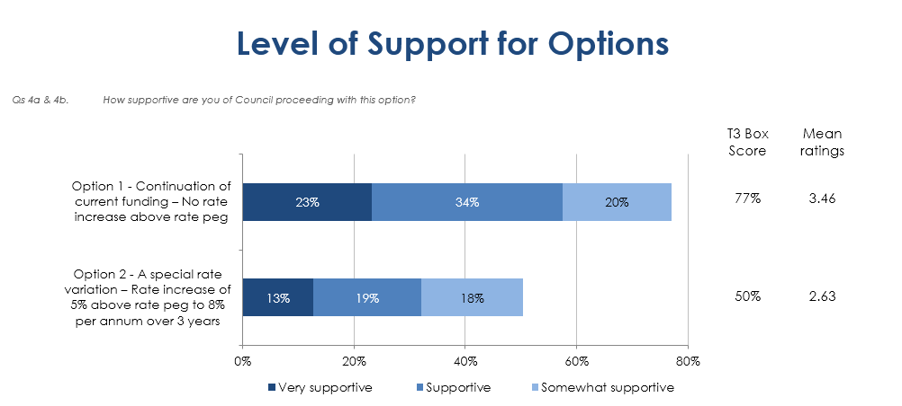

*Source: 2014 Micromex Survey*

This data supports Council’s assessment that overall the community has the capacity and willingness to pay the proposed rate increases.

## Addressing hardship

|  |  |  |
| --- | --- | --- |
| Does the council have a Hardship Policy? | Yes X | No |
| If Yes, is an interest charge applied to late rate payments? | Yes | No X |
| Does the council propose to introduce any measures to limit the impact of the proposed special variation on specific groups in the community? | Yes | No X |

Council’s Debtors and Hardship policy[68] provides the opportunity for relief from rates and charges to ratepayers experiencing genuine hardship. The policy refers to a ratepayer’s primary place of residence. Council will arrange weekly payments to ratepayers who request such assistance. In the case of ratepayers who apply under the policy, weekly payments incur no interest.

In considering a report to notify IPART of a Special Rate Variation at the Council meeting on 9 December 2014, Council added and approved the following recommendation:

*Review its Rate and Debtors Hardship policy to assist any members of the community who may experience hardship as a result of a Special rate variation, by developing a range of strategies to address specific situations.*

The review has identified that whilst the current policy is consistent with similar regional councils in its approach to genuine hardship, it highlighted the need to clarify the wording within the policy statement to clearly identify the circumstances where ratepayers may be assisted by the policy. The amended policy was endorsed by Council on 10 February 2015 and will now be exhibited for 28 days.

The Rate and Debtors Hardship policy is not specifically referred to in current IP&R documents. It is available on Council’s website and at all Council administration offices. There are currently no ratepayers utilising the Debtors and Hardship policy for rates.

Council has not proposed to introduce any measures to limit the impact of the proposed special variation to any specific group/s of ratepayers.

# Assessment criterion 4: Public exhibition of relevant IP&R documents

Council has met all legislative requirements since the introduction of IP&R. The following table includes the exhibition and adoption dates and minute numbers of the relevant IP&R documents. A copy of the minutes can be found in attachment 13c.

A summary of the IP&R processes, engagement and key points is outlined in Section 4 of this application.

| **Document** | | **Exhibition** | **Adoption** |
| --- | --- | --- | --- |
| **Community Strategic Plan – Eurobodalla 2030** | July 2011 – 11/185  November 2011 – 11/270 | | April 2012 – 12/98 |
| **Delivery Program 2012-16, Operational Plan 2012-13 & Resourcing Strategy** | May 2012 – FSM12/39 | | June 2012 – 12/155 |
| **Community Strategic Plan Review – One Community, Delivery Program 2013-17 & Operational Plan 2013-14** | April 2013 – 13/102 | | June 2013 – 13/144 |
| **Delivery Program 2013-17 & Operational Plan 2014-15** | May 2014 – 14/79 | | June 2014 – 14/140 |
| **Revised Delivery Program 2013-17 & Long Term Financial Plan 2015-25** | December 2014 – GMR14/037 | | February 2015 – 15/3 |

# Assessment criterion 5: Productivity improvements and cost containment strategies

Council is committed to improving productivity and containing costs, with actions taken to enhance the monitoring and management of productivity and costs, including the establishment of Council’s audit committee, an internal audit program and the external audit of Council’s depreciation model.

**Organisational Service Review**

Council commenced an ongoing service review program in 2013 to ensure the services delivered to the community remain relevant, meet needs and expectations, are efficient and innovative, and provide value for money. The 2013/14 Operation Plan identify 24 broad service areas, with service reviews prioritised based on a ‘Public Interest Test’. To date, three reviews have been presented to Council, with a further four near completion. Improvements achieved include:

* the redesign of library rosters, staff job descriptions and purchasing arrangements to improve cost effectiveness and service delivery
* the development and introduction of a new contract for the management of Council’s three swimming pools, with new KPIs in place
* the comprehensive review of the service model for delivery Visitor Information services, including a review of staffing and online technologies and mobile service options.

The detailed report to Council regarding the Service Review rationale and process framework is included in attachment 13f.

**Workforce Considerations**

A key goal of the Workforce Management Plan, addressed via the IP&R process by Council’s Organisational Development team, is to:

*Establish Council’s workforce requirements based on the commitments and objectives in the Community Strategic Plan with a particular focus on the four year Delivery Program*.[69]

In achieving this goal Council aims to balance workforce requirements with fiscal responsibility. As part of this process, Council has assessed staffing costs, as a percentage of total expenditure, against the state (152 councils) and Group 4 councils (32 councils) to determine how well Council compares. To ensure consistency, the income statement page from the 2012/13 annual reports of all NSW councils were utilised.

Eurobodalla staffing costs in 2012/13 were 31.7% of total expenditure. This places council below the state median (35.3%) and state average (35.2%) and in the lowest 30% in the state.

State Median 35.3

State Average 35.2

*Graph 4: Staff costs as a percentage - State comparison*

Eurobodalla staffing costs were also compared with Group 4 councils. At 31.7% council was below the Group 4 median (32.6%) and average (33.2%). The following graph illustrates

*Graph 5: Staff costs as a percentage - Group 4 comparison*

Further detailed analysis was conducted against four Group 4 councils that exhibit similar characteristics to Eurobodalla. This analysis included a review of financial data and interviews with each Council.

The following table details the total staff numbers in agreed categories. While Eurobodalla has the highest number of staff, it also has the lowest average employee costs at $65,267.

*Table 6: Staffing Levels Comparison*

|  |  |  |  |  |  |
| --- | --- | --- | --- | --- | --- |
| FTEs | Eurobodalla  Shire Council | Council A | Council B | Council C | Council D |
| Permanents (F/T & P/T) | 386 | 406 | 284 | 299 | 297 |
| Temps | 22 | 11 | 0 | 0 | 0 |
| Trainees/Apprentices | 26 | 39 | 0 | 15 | 0 |
| Casuals | 27 | 30 | 0 | 33 | 0 |
| TOTAL | **460** | **486** | **284** | **347** | **297** |
|  |  |  |  |  |  |
| Average Employee Costs ($) | **65,267** | **66,199** | **66,232** | **73,273** | **71,427** |

A detailed report in relation to Eurobodalla employee costs when compared to state and Group 4 councils is attachment 13d.

**Productivity Improvements and cost containment actions - Specific Examples**

The following summary provides an overview of key productivity improvements and cost containment actions, with specific examples outlined:

1. **Refined Procurement Practices**

* *Procurement* – throughthe use of the Local Government Procurement contract for small sites Council will receive an estimated energy cost reduction of 20% in electricity costs.
* Future saving of $140,000 via tendered contractor casuals from 2015/16 and efficiency improvements in the administration of internal Council casuals.

1. **Increased staff productivity, safety systems and skills development**

* *Improved Work Health and safety initiatives* – Council received a refund from its premium of approximately $250,000 plus a $53,000 bonus incentive as a result of a significant reduction in frequency and seriousness of incidents.
* *Learning and Development* – as a result of collaborative training initiatives (SEROC) Council received an $11,000 saving in training costs last year.

1. **Better use of sustainable practices and technology**

* Council has implemented a range of sustainable practices and embraced the use of smart technologies. A summary of actions taken is provided below:

*Table 7: Sustainable practices*

|  |  |
| --- | --- |
| Facility | Actions undertaken |
| Three swimming pools | * Installed pool blankets, shower timers, heat pump hot water systems, and solar pool water heaters. Completed 2009/10. * WaterSmart audits conducted. Leaks fixed, monitoring established, low flow fittings installed. Retrofitted energy efficient lights. Completed 2012 13. * Installed variable speed drives on water circulation pumps in 2013/14.   *Total estimated annual savings of over $100,000* |
| Moruya Administration building | * Energy efficient lighting upgrades, standby power management, solar hot water, air-con upgrade, 75kW solar power installed. Completed from 2011-2014.   *Total estimated annual savings of over $90,000.* |
| Street-lighting | * Replaced over 2,200 luminaires with energy efficient lights.   *Total estimated annual savings of $80,000.* |
| Various other buildings | * Energy efficient lighting retrofits, insulation, low flow water fittings, leak monitoring and alerts. * Solar hot water in 14 buildings. * 49kW of solar power across five other buildings.   *Total estimated annual savings of over $100,000* |

The 2012-17 Eurobodalla Greenhouse Action Plan (GAP) sets out the Council's response to the issue of climate change. This plan guides Council’s strategic approach to energy efficiency and renewable energy projects. It prioritises those actions with a short payback period, with the majority of actions having a payback period of less than four years.

Examples of energy savings are demonstrated in the graphs below:

*Graph 6: Energy Usage: Buildings*

Energy use has been contained significantly compared to a ‘business as usual’ 2.5% p.a. growth scenario (as shown above). If the energy efficiency and renewable energy projects (in the above Table) had not been completed energy costs to Council would be considerably higher (as shown in the Figure below). Electricity costs have risen at a rate far higher than CPI over the last five years, however Council has managed to contain these price increases to a degree.

*Graph 7: Energy Cost: Buildings*

Over recent years, Council has introduced a number of different software packages. The following list is an example of some of the new technologies that have assisted in productivity improvements and savings:

* ePlanning (Planning)
* Sky Trust (WHS)
* Pulse (IP&R software)
* New corporate website – increased traffic
* In-field technology – rolling out mobile management systems, higher technology solutions.

1. **Improved Corporate productivity**

* *Audit Committee* – introduced in 2009 and will oversee the implementation of the SRV proposal.
* *Finance* – a zero based budgeting approach was introduced in 2013/14 with a $218,000 annual saving identified.

1. **Regional Partnerships and Strategic Collaborations**

Council is a member of a number of regional organisations and has developed partnerships that contribute to improving service to our community. These include:

* South East Regional Organisation of Councils (SEROC)
* South East Resource Recovery Group (SERRG)
* Roads and Maritime Services (RMS)
* South East Australian Transport Strategy Inc. (SEATS)
* TAFE
* University of Wollongong
* South Coast Regional Tourism Organisation (SCRTO).

Council will continue to improve and review its services. For example, at the council meeting 9 December 2014 Council resolved:

*.. that Council will need to continue to identify and implement efficiency savings in addition to an SRV process.*

Examples of the above are detailed in the attached Delivery Program 2013-17[70] on page 6.

# List of attachments

|  |  |
| --- | --- |
| Item | Included |
| **Mandatory forms and Attachments** |  |
| Part A Section 508A and Section 508(2) Application form (Excel spreadsheet) |  |
| Part B Application form (Word document) – this document |  |
| Attachment 1: Relevant extracts from the Community Strategic Plan |  |
| Attachment 2: Delivery Program |  |
| Attachment 3: Long Term Financial Plan with projected (General Fund) financial statements (Income, Cash Flow and Financial Position) in Excel format   1. Narrative 2. Base case 3. SRV case |  |
| Attachment 4: TCorp report on financial sustainability |  |
| Attachment 5: Community Engagement Materials  a) Community Engagement Strategy  b) Media releases  c) Newspaper articles  d) Fact sheets – including website, brochures, flyers |  |
| Attachment 6: Community feedback   1. Community Survey reports 2. Submission summaries |  |
| Attachment 7: Hardship Policy |  |
| Attachment 8: Resolution to apply for the special variation |  |
| Attachment 9: Certification |  |
| **Other Attachments** |  |
| Attachment 10: Relevant extracts from the Asset Management Plan – executive summaries of relevant AMPs |  |
| Attachment 11: Past Instruments of Approval (if applicable) | N/A |
| Attachment 12: Resolution to adopt the revised Community Strategic Plan (if necessary) and/or Delivery Program |  |
| Attachment 13: Other (please specify)   1. 2010 State of the Shire Report 2. 2011 Resourcing Options Paper and Delivery Program Information Paper 3. Council reports supporting decision making process 4. Benchmarking Group 4 employee costs council report 5. 2013 Resourcing Strategy 6. Organisation Service Review 27 August 2013 Council report |  |

# Certification

**APPLICATION FOR A SPECIAL RATE VARIATION**

**To be completed by General Manager and Responsible Accounting Officer**

Name of council: Eurobodalla Shire Council

We certify that to the best of our knowledge the information provided in this application is correct and complete.

General Manager: Dr Catherine Dale

**Signature**  **Date:** 16 February 2015

Responsible Accounting Officer: Mr Anthony O’Reilly

**Signature** **Date:** 16 February 2015

1. As per the 2012-13 OLG Comparative Data
2. Attachment 6a: 2014 Micromex Survey
3. Attachment 3
4. Attachment 4
5. Attachment 10
6. Attachment 13b
7. Attachment 6a - 2012 Micromex survey
8. Attachment 13c
9. The State of Shire Report was prepared to inform community strategic plan development and provided information to the community about key social, environmental, economic and civic leadership issues and considerations such as the infrastructure gap and backlog. Attachment 13a
10. Attachment 1
11. Attachment 6
12. Attachment 3
13. TCorp’s rating refers to Council’s consolidated position, not the General fund. A “Moderate” financial sustainability rating indicates Council will not have sufficient funds to address their infrastructure backlog.
14. 2013-14 Building and Infrastructure asset renewal ratio, Annual Report 2013-14, pg. 14
15. See section 3.3
16. Attachment 10
17. Attachment 3
18. Attachment 4
19. Attachment 3
20. See section 3.3
21. The Fit for the Future indicators include operating performance, asset renewal, infrastructure backlog, asset maintenance, debt service, efficiency and rates and annual charges ratios.
22. Using 10 year averages for each scenario.
23. As per 2013-14 Annual Financial Statements
24. Net operating result before capital grants and contributions as percentage of operating revenue before capital grants and contributions
25. Asset renewals expenditure divided by depreciation, amortisation and impairment expenses
26. Total debt plus cost to clear infrastructure backlogs as per Special Schedule 7 divided by operating revenue. The broad liabilities ratio is also seen as another critical indicator of financial sustainability based on Professor Percy Allan AM presentation of the Latest Findings in NSW Council Sustainability (2008).
27. Principal and interest debt service costs divided by operating revenue excluding capital grants and contributions.
28. Unrestricted current assets divided by unrestricted current liabilities.
29. Rates and annual charges divided by operating revenue. Also called Own Source Revenue Ratio or Rate Coverage Ratio.
30. Professor Percy Allan AM presentation of the Latest Findings in NSW Council Sustainability (2008).
31. Attachment 13a
32. Attachment 1
33. Attachment 13b - The Resourcing Options Paper explored financial, people and asset needs for the next 10 years in order to assess council’s capacity to meet objectives of the Community Strategic Plan Eurobodalla 2030.
34. Attachment 13b - The Delivery Program Information Paper provided information on each of council services, income streams and importance and satisfaction.
35. Attachment 6a - January 2012 Survey
36. Attachment 1
37. Attachment 6a - July 2012 Survey
38. Attachment 5a
39. Attachment 2
40. Attachment 3
41. Attachment 5d
42. Attachment 6a - 2014 Micromex Survey
43. Attachment 5d
44. Attachment 2
45. Attachment 3
46. Attachment 5d
47. Attachment 5d
48. Attachment 5b
49. Attachment 1
50. Attachment 6a - 2010 Iris Community Engagement Survey
51. Attachment 13b
52. Attachment 13 b
53. Attachment 62 - January 2012 Micromex Survey
54. Attachment 1
55. Attachment 6a – July 2012 Micromex Survey
56. Attachment 6a - 2014 Micromex Survey
57. Attachment 6b
58. Attachment 5d
59. Attachment 6b
60. Attachment 5d
61. Attachment 6a -July 2012 Micromex Survey
62. Slightly different average rate compared to the exhibited Delivery Program 2013-17 as a result of the issue of supplementary land revaluations.
63. Slightly different average rate compared to the exhibited Delivery Program 2013-17 as a result of the issue of supplementary land revaluations.
64. Slightly different average rate compared to the exhibited Delivery Program 2013-17 as a result of the issue of supplementary land revaluations.
65. Attachment 2
66. As per 2012-13 OLG Comparative Data
67. The SEIFA Index of Disadvantage measures the relative level of socio-economic disadvantage based on a range of Census characteristics.
68. Attachment 7
69. Attachment 13e
70. Attachment 2