


Table of Contents

LIVERPOOL PLAINS SHIRE COUNCIL
Delivery Program
2014/15 to 2017/18

LIVERPOOL PLAINS SHIRE COUNCIL
Delivery Program
2012/13 to 2015/16

1. Community Strategic Plan Components 3
2. Corporate Planning Strategy 4
3. Community Vision & Mission Statements 5
4. The Need for a New Revenue path 6
5. Strategic Programs including budgets 11
1. Policy, Strategy and Finance 12
2. Environmental Services 17
3. Community Services 23
4. Economic Development……………..…………………………………………………………27
5. Technical Services 30
6. Capital Budgets 2014/15 -2017/18 34

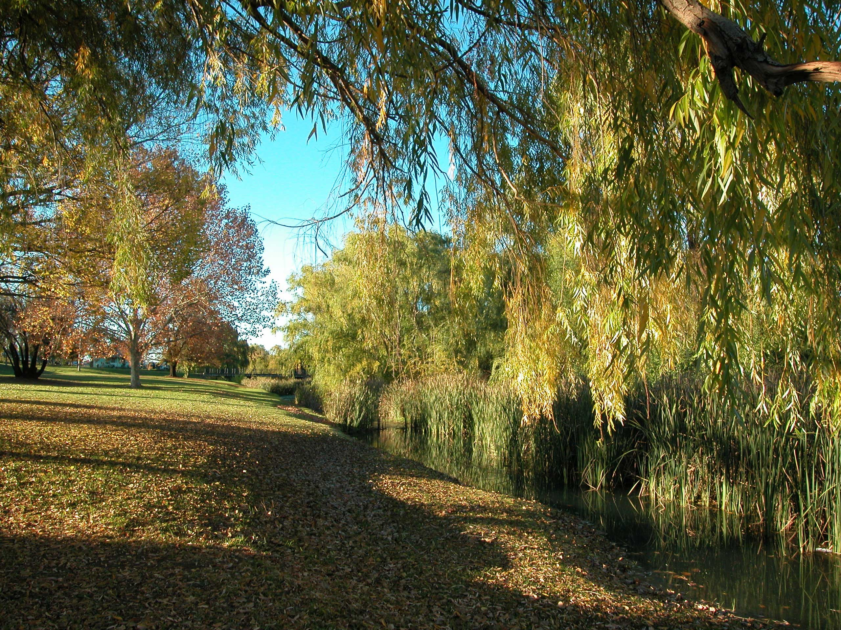

Community Strategic Plan Components
The Long Term Community Strategic Plan is the highest-level plan that a council will prepare. The Community Strategic Plan identifies the long-term aspirations our communities want to see delivered in the Shire. The Strategic Plan stretches over the next ten years, identifying the outcomes and long term strategic responses needed to achieve the agreed directions.
While council has a custodial role in initiating, preparing and maintaining the Community Strategic Plan on behalf of the community, it is not wholly responsible for its implementation. Other partners, such as State agencies and community groups may also be engaged in delivering the long-term objectives of the plan.
The Four-Year Delivery Program links the ‘planning’ in the long term Strategic Plan with the ‘implementing’ in the annual Operational Plan. It is the strategic document that guides the organisation’s work program over the Councillors’ four year term. The Delivery Program sets out clear priorities, ongoing activities and specific actions Council will undertake, within its responsibilities and capacity, towards achieving the communities’ outcomes.
The Annual Operational Plan is the ‘implementing’ part of Council’s key strategic documents, and outlines all of Council’s services. All services deliver a range of ongoing service activities, and may also identify specific tasks to be undertaken in the year ahead. Both ongoing activities and specific tasks contribute to the implementation of Council’s Delivery Program.
The Community Strategic Plan provides a vehicle for expressing long-term community aspirations. However, these will not be achieved without sufficient resources – time, money, assets and people – to actually carry them out. The Resourcing Strategy consists of three components:
- Long Term Financial Planning
- Workforce Management Planning
- Asset Management Planning
The Resourcing Strategy explains how the organisation will meet its obligations now and in the future, taking into account our workforce, our finances and our assets. The Resourcing Strategy enables us to deliver our services to the community in the most sustainable way.
The Community Engagement Strategy outlines how Council will engage with its communities and relevant stakeholders in developing and finalising the Community Strategic Plan. Over time it will be reviewed to outline how Council will ensure regular engagement and discussion with our communities about their needs and aspirations for the Shire.
At the end of the Council Term, Council must provide a detailed Report on how it achieved the priorities in the Delivery Program over its four year term.

Corporate Planning Strategy
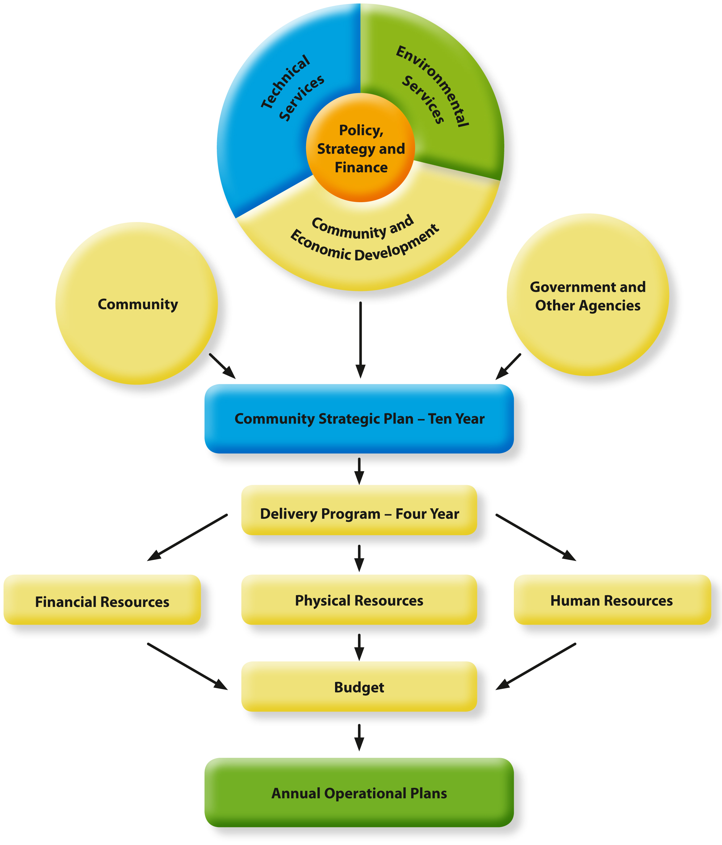

Community Vision and Mission Statements

Vision
That the Liverpool Plains Shire area achieves higher levels of growth and generates improved quality of life through expanded opportunities for economic and social development being realised within an environmentally and financially sustainable framework.


Mission
To achieve the vision through a proactive community focus delivering best value and practice services that are recognised by the community for their quality and positive impact on development.

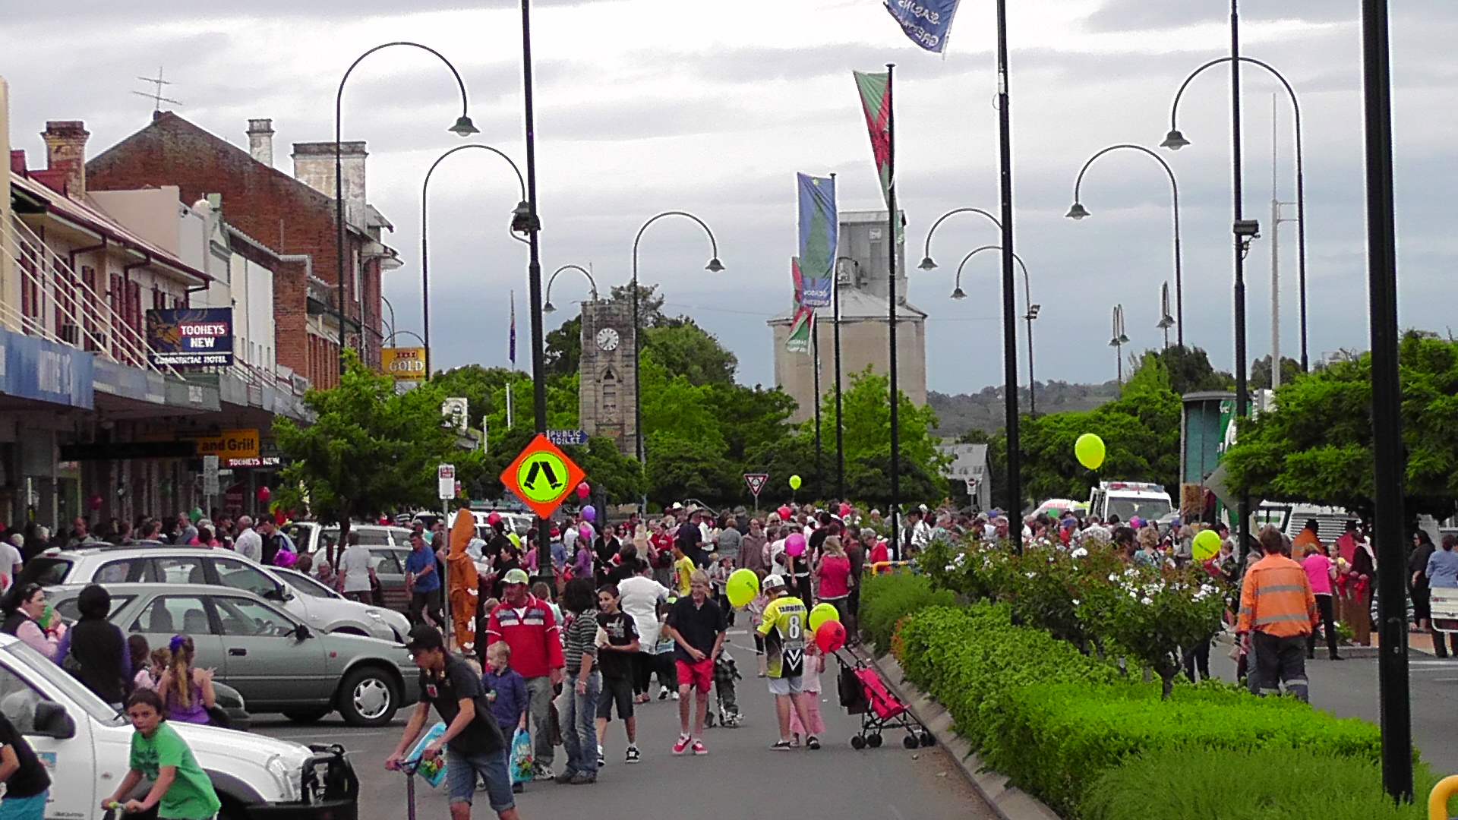

4. The Need for a New Revenue Path
Background
There have been a number of reviews of Local Government in recent years highlighting the financial problems of Local Government and the backlog of infrastructure works. The Independent Local Government Review Panel Report also highlights the need for Council’s to maximise their own source income and taxation revenue or risk being amalgamated with other councils. This has been difficult for Councils to do as rate pegging has been in force in NSW for decades and is not imposed on councils in any other Australian State.
At the same time the NSW Treasury Corp reviewed the last three years’ financial statements of all councils and determined that this Council was financially weak with a negative outlook. Community surveys over the last ten years all show that the number one priority of residents by far, is for improved roads throughout the shire.
Proposed Rate Increase
For these reasons, Council is proposing a permanent 12.5% rate increase effective from July 2014 and then ongoing. This 12.5% increase is comprised of the continuation of an expiring Special Rate Variation of 6.5% which ends in June 2014, a 2.3% rate pegging increase and a further 3.7% to be spent reducing Council’s road infrastructure backlog.
The increase will also assist Council in being financially sustainable in the longer term and reduce our chances of being amalgamated with neighbouring councils. The increase does not apply to water, sewer and waste charges.
However this increase is still not enough to ensure the future financial sustainability of Council and a further scenario of two more special rate variations of 13% each in 2016/17 and 2018/19 is detailed in the long term financial plan (Scenario 3). It is not being proposed at this time due to a review being undertaken of the redistribution of Federal Government financial assistance grants from metropolitan councils to rural/remote councils which do not have the same populations and revenue raising abilities as their city cousins. If this occurs Council may not need any further Special Rate Variations as proposed in Scenario 3, however the situation will be monitored over the next two years.
Council has consulted extensively with the community over this proposed increase including distributing a newsletter to all residents, conducting an independent community survey of 200 households, holding public meetings, consulting village development committees, media interviews and seeking comments on Council’s Facebook and Twitter. Results of this consultation are detailed in the Community Strategic Plan document.
Impacts of Decrease/Increase on Residents
Scenario 1 in the Long Term Financial Plan shows the impact of no special rate increase being sought. Rates would reduce by the 6.5% expiring Special Rate Variation and then increased by the allowable rate pegging figure of 2.3% - a corresponding reduction would also occur in road expenditure to offset the loss of rate income leading to a further expansion of the infrastructure backlog.
The impact of a 6.5% rate decrease and then a 2.3% rate peg increase in 2014/15, on the average rate in the main categories, is shown below:

4. The Need for a New Revenue Path Cont’d

CATEGORY | YEARLY DECREASE | WEEKLY DECREASE
Quirindi Business | $84 | $1.61
Werris Creek Business | $32 | $0.62
Village Business | $32 | $0.62
Quirindi Residential | $26 | $0.50
Werris Creek Residential | $19 | $0.37
Village Residential | $18 | $0.35
Rural Residential | $29 | $0.56
Farmland | $139 | $2.68

In Scenario 2 the impact of a 12.5% rate increase on the average rate in the main categories is shown below:
CATEGORY | YEARLY INCREASE | WEEKLY INCREASE
Quirindi Business | $261 | $5.03
Werris Creek Business | $99 | $1.90
Village Business | $100 | $1.94
Quirindi Residential | $82 | $1.57
Werris Creek Residential | $60 | $1.15
Village Residential | $57 | $1.09
Rural Residential | $90 | $1.74
Farmland | $436 | $8.39

As can be seen above in Scenario 2 the increases per week equate in most cases to the cost of a cup of coffee or less. The business and farmland rates are also tax deductible so the impact is even less in those categories. These increases are considered to be reasonable when looking at a resident’s capacity to pay, the benefits to be received through increased roadwork upgrades and the higher level of average residential rates imposed by neighbouring Councils.

4. The Need for a New Revenue Path Cont’d
For Scenario 3 the impact on average rates in 2018/19 – year 5 would be as follows:
CATEGORY | 5 YEAR NET INCREASE | WEEKLY INCREASE in Year 5
Quirindi Business | $1096 | $21.08
Werris Creek Business | $414 | $7.97
Village Business | $422 | $8.12
Quirindi Residential | $342 | $6.58
Werris Creek Residential | $251 | $4.83
Village Residential | $237 | $4.56
Rural Residential | $379 | $7.28
Farmland | $1,827 | $35.13

Scenario Assumptions
The Long Term Financial Plan presents three scenarios:
Scenario 1 – Base Case with no Special Rate Variation approved
This is the financial forecast based on the revised 2013/14 budget, indexed for forecast movements in the major income and expenditure areas for every year out to 2023/24.
The key assumptions are:
- Rates increased by 2.3% in 2014/2015 then by 3.0% p.a thereafter
- Rates income reduced in 2014/15 and onwards due to cessation of existing Special Rate Variation of 6.5%
- Fees, charges and other revenue increased by 3.0% p.a
- Investment Return = 4.0% p.a.
- Employee Costs increased by 3.0% p.a.
- Electricity, Insurance and Other Expenses increased by 3.0% p.a
- Materials & Contracts increased by 3.0%

The Base Case financial position places great strain on maintaining the current levels of service to ratepayers with Council going into deficit budgets due to the loss in rate income from the Special Rate Variation. This scenario does not address Council’s long term financial sustainability or the continued deterioration of Council’s infrastructure assets, with projections under Council’s Asset Management Plans of ongoing deterioration in asset levels, whereas Scenarios 2 and 3 attempt to address this.

4. The Need for a New Revenue Path Cont’d
Scenario 2 – Continuation of the existing special rate variation of 6.5% plus an additional 3.7% plus 2.3% rate pegging from 2014/15.
This is the financial forecast based on the revised 2013/2014 budget, indexed for forecast movements in the major income and expenditure areas for every year out to 2023/24.
The key assumptions are:
- Rates permanently increased by 12.5% in 2014/2015 (special rate variation of 10.2% plus rate pegging increase of 2.3%) then by 3.0% p.a from 2015/16 onwards
- Fees, charges and other revenue increased by 3.0% p.a.
- Investment Return = 4.0% p.a
- Employee Costs increased by 3.0% p.a.
- Electricity, Insurance and Other Expenses increased by 3.0% p.a.
- Materials & Contracts increased by 3.0% p.a.

Under this scenario, Council will continue working towards a surplus budget before capital grants & contributions, while maintaining much needed funding for capital infrastructure which will continue to slow the rate of deterioration of the asset network.

Scenario 3 – Total rates income has been increased to achieve the income necessary to raise the quality of all Council assets to a satisfactory standard and to fully fund depreciation expenses.
This is the financial forecast based on the revised 2013/2014 budget, indexed for forecast movements in the major income and expenditure areas for every year out to 2023/2024.
The key assumptions are:
- Rates increased by 12.5% in 2014/2015 (2.3% rate pegging increase plus 10.2% p.a special rate variation) then by 13.0% p.a from 2016/17 (3.0% rate pegging plus 10.0% special rate variation) then by another 13% from 2018/19 (3.0% rate pegging plus 10.0% special rate variation) and then by 3% onwards from 2019/20. All increases are permanent and are not for a fixed period.
- Fees, charges and other revenue increased by 3.0% p.a
- Investment Return = 4.0% p.a
- Employee Costs increased by 3.0% p.a
- Electricity, Insurance and Other Expenses increased by 3.0% p.a
- Materials & Contracts increased by 3.0% p.a

Under this scenario rates income has been increased over a 5 year period 52.4% to fund the additional expenditure required to bring all Council assets up to a satisfactory level, to fully fund the depreciation expense and to maintain service levels as requested by the community. %

4. The Need for a New Revenue Path Cont’d
Funds Raised To Be Spent on Capital Works
Scenario 2 excluding the rate peg increase will raise an additional $604,000 from year one and this will be spent on various capital works over the next four years as detailed in Section 6.

Past Improvements and Cost Containment Measures
Council has made a number of expenditure reductions in its 2013/14 Budget including making two full time positions redundant, not replacing council vehicles and reducing costs throughout departments to the tune of $325,000 which is equivalent to a 5 % rate increase. In addition, in October 2013, Council engaged the YMCA to operate the Quirindi Recreation Centre and two swimming pool complexes with the hope that it will in the future reduce running costs to be paid by Council.
Following a strategic examination of service levels over the next 18 months by management further cost savings of $471,000 were identified during the public exhibition period of this plan and subsequently adopted by Council at the Special Council Meeting held 5th February 2014. These savings included 3 redundancies and a further 4 positions lost through natural attrition among various other cost reductions and fee increases.
Other measures to reign in costs and generate further revenue include Council staff developing a suite of multi award winning Tr@ceR data management and property tracking programs which have been sold to numerous other Councils with the profits being utilised to upgrade the Administration Centre customer service areas, toilets and foyer thus saving ratepayers this cost.
Council is also looking at resource sharing with other organisations and councils to generate cost savings and has recently entered into a water and sewer alliance with other Namoi Councils. Council is a member of various organisation such as the Weight of Loads Roads Group, Northern Inland Weeds Advisory Council, Central Northern Libraries, North West Regional Community Care, Liverpool Ranges Rural Fire Service, New England North West Arts Group, Namoi Regional Waste Group, New England North West Tourism, Kamilaroi Highway Group, Local Government Procurement for the purchase of goods and services, etc, which all share costs and information and therefore reduce the cost burden on ratepayers .
Many volunteers are encouraged and assisted by Council to undertake parks and cemetery maintenance or work at the Royal Theatre, Australian Railway Museum, Visitor Information Centre, Libraries and Home and Community Care. This volunteer work saves ratepayers over $200,000 per annum.
Council’s Asset Management Plans are also being refined each year and it is anticipated further cost savings with regard to depreciation expense can be made along with the disposal of some unwanted land and building assets which will further reduce maintenance costs and depreciation expenses.

5. Strategic Programs
The Four-Year Delivery Program links the ‘planning’ in the Long Term Community Strategic Plan with the ‘implementing’ in the Annual Operation Plan, setting out clearly the actions and activities Council will be undertaking in a four year program to deliver, or work towards achieving, Council’s longer term strategic directions. The Delivery Program is important in making sure that all of Council’s services and programs remain focussed on delivering the agreed long-term outcomes for The Shire.
The following Programs are aligned with Council’s portfolio governance and committee systems and address four main themes:
- Social – a socially mixed community characterised by diversity of income, age, culture, housing tenure, etc and there are opportunities to move freely through life’s cycles without the need to relocate
- Environmental – ecologically balanced with impacts from human activity being accommodated without degradation to the environment
- Economic – diverse employment opportunities exist which underpin a quality of life matched with community prosperity expectations
- Governance – participative and open local government, strong leadership and stewardship and ensuring sound infrastructure with facilities and services matched to community needs.

The various strategies and actions within the programs are linked to Council’s Guiding Principles and to the State and Regional Plan Goals and Priorities. The State Plan can be found on the NSW Government website:
<www.nsw.gov.au/stateplan/pdf/Summary_complete.pdf>
See also the New England North West Regional Action Plan on that website.
For the Regional Development Australia Northern Inland Plan go to:
<www.rdani.org.au/our-region/regional-plan.php>
Council also consulted the NSW Government’s State of the Catchment Report 2010 for the Namoi and the Namoi 2030 Regional Resource Strategy.

Program 1: Policy, Strategy and Finance

Vision Statement
Participative and open local government for the Liverpool Plains Shire community and effective management and service delivery achieved by:
- Council exercising leadership
- Consulting with the community as necessary in the development of operational, social, environmental and economic policies
- Making open, fair and equitable decisions in the public interest
- Delivering and providing high quality services and facilities
- Monitoring and measuring Council financial performance.

Objectives
- To be satisfied that Council’s stewardship of the area is in the best public interest through leadership, care and responsibility, efficiency in service delivery and proper custody of public assets in conjunction with processes of consultation.
- To ensure the good management and governance of the Shire and the wellbeing of its residents and to develop and apply model policies for the effective delivery of core business activities.
- To observe the statutory requirements of the Local Government Act and other relevant legislation
Main Council Functions in this Program Area:
- Administration
- Policy Development
- Strategic Planning
- Finance and Audit
- Payroll/Human Resources
- Information Technology
- Roads and Maritime Services Agency
The Community’s Vision for this Program.
During the community engagement process leading to the development of the Community Strategic Plan, the community identified the following priority areas that Council should focus on over the next 10 years:
- Financial management and sustainability
- Opportunities to participate in council decision making
- Communication with the community.
Council will continue to undertake independent community surveys to analyse any trends in the responses from the community over time. This will enable Council to measure the effectiveness of the implementation of its strategies in the Community Strategic Plan.
In order to address the above issues and challenges Council has a number of strategies as detailed in the following tables.
STRATEGY 1.1 |  | Ensure residents have the opportunity to have a say on important issues
Actions 2014/15 - 2017/18 |  |  | Performance Measure | Timeline | Responsibility
1.1.1 | Periodically review community engagement strategy |  | Community engagement strategy reviewed  Percentage satisfaction in community survey | Annually  Bi-annually | MANEX, Council  MANEX
1.1.2 | Councillors to be available for community members to raise issues |  | No reasonable complaints from members of the public about access | Ongoing | Executive Assistant  Councillors
1.1.3 | Council to have a greater presence in outlying areas |  | At least two committee/council meetings held each year in other locations in the shire | Annually | Executive Assistant  Council

STRATEGY 1.2 |  | Foster and support community leadership and encourage innovation
Actions 2014/15 - 2017/18 |  |  | Performance Measure | Timeline | Responsibility
1.2.1 | Develop scholarships for young people to foster leadership. |  | Youth scholarships available and committee established. | Annually | Community Committee  Director Economic and Community Development
1.2.2 | Promote volunteering and develop partnerships with community leaders  Hold volunteer appreciation function |  | Volunteers sought for community purposes and supported by council.  Meetings held with community representative groups | Ongoing  Annually | Director Economic and Community Development  General Manager
1.2.3 | Improve the efficiency and transparency of council processes |  | Independent Internal Auditor engaged to review all council processes and report to Council | Annually | Internal Audit Committee
1.2.4 | Encourage staff to be innovative |  | Funds/efficiencies generated from staff innovation, eg Tr@ceR, quarry extraction | Ongoing | General Manager, staff

STRATEGY 1.3 |  | Advocate for an increase in the resources committed by the Federal and State Governments to Local Government and Liverpool Plains Shire Council in particular for infrastructure
Actions 2014/15 - 2017/18 |  |  | Performance Measure | Timeline | Responsibility
1.3.1 | Council will advocate strongly for improved funding to Local Government by lobbying Local Members of Parliament, and supporting Namoi Councils and LGSA proposals |  | Quantum of additional resources allocated to Council as a result of lobbying | Ongoing | Council

STRATEGY 1.4 |  | Seek Constitutional recognition of local government to enable direct funding from the Commonwealth
Actions 2014/15 - 2017/18 |  |  | Performance Measure | Timeline | Responsibility
1.41 | Council will actively support constitutional recognition of local government via media campaigns in conjunction with the ALGA |  | Local Government is recognised in the constitution after the next Referendum | To be confirmed | Council

STRATEGY 1.5 |  | Demonstrate accountability, good customer service, transparency and ethical conduct
Actions 2014/15 - 2017/18 |  |  | Performance Measure | Timeline | Responsibility
1.5.1 | Provide relevant staff training and offer competitive working conditions and remuneration |  | Council performance in these areas against benchmark in Annual Employee Survey | Ongoing | MANEX
1.5.2 | Ensure decision making processes are fair, open and equitable |  | Council recognised as a transparent, accountable and ethical organisation | Ongoing | Council, MANEX
1.5.3 | Ensure staff respond to all forms of customer requests in a timely manner |  | Level of satisfaction in community survey for customer service | Ongoing | MANEX

STRATEGY 1.6 |  | Increase the number of female councillors and management staff
Actions 2014/15 - 2017/18 |  |  | Performance Measure | Timeline | Responsibility
1.6.1 | Promote the need for greater gender equity on councils via media outlets, newsletters and community forums |  | Female staff and councillors as a percentage of total staff and councillors | Every four years for councillors; ongoing for staff | MANEX, Councillors

STRATEGY 1.7 |  | Explore options for an enhanced local government sector as detailed in the NSW Government’s Destination 2036 Action Plan
Actions 2014/15 - 2017/18 |  |  | Performance Measure | Timeline | Responsibility
1.7.1 | Discuss resource-sharing opportunities with Namoi Councils |  | Discussions held – opportunities developed | Ongoing | MANEX
1.7.2 | Contribute to Regional Action plans that link with the State Plan |  | Regional Plans contributed to | Ongoing | MANEX
1.7.3 | Determine relevance of other key activities in Action Plan |  | Other key activities in the Action Plan implemented where relevant | By 30th June 2015 | MANEX
STRATEGY 1.8 |  | Enhance the financial sustainability of Council
Actions 2014/15 - 2017/18 |  |  | Performance Measure | Timeline | Responsibility
1.8.1 | Develop long term financial plans that improve council’s financial position |  | LTFP developed and reviewed | Annually | Director Corporate Services, Council

General (Unattached) Income | 2014-2015 | 2015-2016 | 2016-2017 | 2017-2018
Operating Income | 10,227,894 | 10,534,730 | 10,850,780 | 11,226,290
Operating Expenses | 0 | 0 | 0 | 0
Capital Income | 0 | 0 | 0 | 0
Operating Result before Capital | 10,227,894 | 10,534,730 | 10,850,780 | 11,226,290
Capital Expenditure | 0 | 0 | 0 | 0
Transfer to Reserves | 0 | 0 | 0 | 0
Transfer from Reserves | 0 | 0 | 0 | 0
Net Result After Capital and Reserve Transfers | 10,227,894 | 10,534,730 | 10,850,780 | 11,226,290
Net Restricted Cash Asset Movement | 0 | 0 | 0 | 0
Principal Activity Net Result | 10,227,894 | 10,534,730 | 10,850,780 | 11,226,290

Governance | 2014-2015 | 2015-2016 | 2016-2017 | 2017-2018
Operating Income | 6,700 | 6,900 | 7,110 | 7,320
Operating Expenses | (442,680) | (456,000) | (519,740) | (483,890)
Capital Income | 0 | 0 | 0 | 0
Operating Result before Capital | (435,980) | (449,100) | (512,630) | (476,570)
Capital Expenditure | 0 | (14,000) | 0 | 0
Transfer to Reserves | 0 | 0 | 0 | 0
Transfer from Reserves | 0 | 0 | 0 | 0
Net Result After Capital and Reserve Transfers | (435,980) | (463,100) | (512,630) | (476,570)
Net Restricted Cash Asset Movement | 0 | 0 | 0 | 0
Principal Activity Net Result | (435,980) | (463,100) | (512,630) | (476,570)
General Manager's Office | 2014-2015 | 2015-2016 | 2016-2017 | 2017-2018
Operating Income | 78,200 | 90,550 | 93,270 | 106,070
Operating Expenses | (436,220) | (460,160) | (474,920) | (500,180)
Capital Income | 0 | 0 | 0 | 0
Operating Result before Capital | (358,020) | (369,610) | (381,650) | (394,110)
Capital Expenditure | 0 | 0 | 0 | (5,000)
Transfer to Reserves | 0 | 0 | 0 | 0
Transfer from Reserves | 0 | 1 | 2 | 3
Net Result After Capital and Reserve Transfers | (358,020) | (369,609) | (381,648) | (399,107)
Net Restricted Cash Asset Movement | 0 | 0 | 0 | 0
Principal Activity Net Result | (358,020) | (369,609) | (381,648) | (399,107)
Corporate Services | 2014-2015 | 2015-2016 | 2016-2017 | 2017-2018
Operating Income | 594,780 | 612,110 | 629,940 | 648,310
Operating Expenses | (2,266,799) | (2,334,729) | (2,403,797) | (2,488,106)
Capital Income | 40,000 | 0 | 0 | 0
Operating Result before Capital | (1,632,019) | (1,722,619) | (1,773,857) | (1,839,796)
Capital Expenditure | (81,500) | (100,000) | (80,500) | (98,500)
Transfer to Reserves | (34,780) | (35,830) | (46,900) | (38,010)
Transfer from Reserves | 0 | 70,000 | 10,000 | 30,000
Net Result After Capital and Reserve Transfers | (1,748,299) | (1,788,449) | (1,891,257) | (1,946,306)
Net Restricted Cash Asset Movement | 0 | 0 | 0 | 0
Principal Activity Net Result | (1,748,299) | (1,788,449) | (1,891,257) | (1,946,306)

Program 2: Environmental Services

Vision Statement
A quality environment for the community of Liverpool Plains Shire achieved by:
- Enhancing and protecting the social, environmental, economic, heritage and physical wellbeing of the community
- Contemporary land use planning and assessment
- Effective management and minimisation of waste collection and disposal.

Objectives
- To develop strategies that facilitates growth and guide Council toward ecological sustainability through responsible management of both the natural and built environments.
- To be recognised as a leader in environmental management.
Main Council Functions in this Program Area:
- Building and Development Control
- Law Enforcement
- Public Health
- Natural Resource Management
- Waste Management
- Emergency Services/Animal Control
- Land Development
- Heritage
The Community’s Vision for this Program.
During the community engagement process leading to the development of the Community Strategic Plan, the community identified the following priority areas that Council should focus on over the next 10 years:
- Aware of the environment and infrastructure impact of mining
- Environmental sustainability
- Housing Development
- Management of development
- Enforcing regulations and control over residential animals
- Waste services.

Council will continue to undertake independent community surveys to analyse any trends in the responses from the community over time. This will enable Council to measure the effectiveness of the implementation of its strategies in the Community Strategic Plan.
In order to address the above issues and challenges Council has a number of strategies as detailed in the following tables.

STRATEGY 2.1 |  | Support and develop programs which protect and enhance the Shire’s natural environment and ‘rural’ character
Actions 2014/15 - 2017/18 |  |  | Performance Measure | Timeline | Responsibility
2.1.1 | Undertake creek clearing projects. |  | Projects undertaken, health of rivers and creeks improved | Ongoing | Director Environmental Services
2.1.2 | Seek grant funding opportunities. |  | Grants received | Ongoing | Director Environmental Services
2.1.3 | Ensure LEP and DCP protects rural areas |  | LEP and DCP adequately protect the environment, rural character maintained | Ongoing | Director Environmental Services
2.1.4 | Undertake statutory functions in weed control |  | People made aware of new and emerging weeds | Ongoing | Director Environmental Services
STRATEGY 2.2 |  | Ensure that environmental and development standards satisfy community needs and aspirations
Actions 2014/15 - 2017/18 |  |  | Performance Measure | Timeline | Responsibility
2.2.1 | Council will review its LEP every 5 years |  | LEP reviewed | By 2015/16 | Director Environmental Services. Council
2.2.2 | The development control plan will be reviewed and implemented to provide guidance for the sustainable development of the Shire |  | DCP reviewed  Level of community satisfaction in surveys for management of development | Ongoing  Bi-annual | Director Environmental Services, Council
STRATEGY 2.3 |  | Assist in the provision of infrastructure and resources associated with the emergency services requirements of The Shire
Actions 2014/15 - 2017/18 |  |  | Performance Measure | Timeline | Responsibility
2.3.1 | Provision of funding and accommodation in annual operational plans for RFS, VRA and SES |  | Level of community satisfaction in surveys for emergency services compared to benchmark | Bi-annual | Director Environmental Services
2.3.2 | A comprehensive emergency management response and capacity Plan will be developed through the EMPlan |  | EMPlan developed and reviewed in conjunction with agencies such as NSW FB, NSW RFS, SES, VRA, Police and Department of Health. | By June 2014 and then ongoing | Director Environmental Services
STRATEGY 2.4 |  | Council uses its resources wisely to reduce its ecological footprint
Actions 2014/15 - 2017/18 |  |  | Performance Measure | Timeline | Responsibility
2.4.1 | Implement results of water, waste and energy audits from Namoi towards a sustainable future project when funding permits |  | Council’s ecological footprint is smaller. | Ongoing to 2015/16 | MANEX

STRATEGY 2.5 |  | Council will work for the retention, restoration and protection of the Shire’s heritage
Actions 2014/15 - 2017/18 |  |  | Performance Measure | Timeline | Responsibility
2.5.1 | Complete a community heritage plan |  | Heritage Plan completed | By June 2014 | Director Environmental Services

STRATEGY 2.6 |  | Ensure the importance of the black soil Liverpool Plains to agricultural production and wealth of the Shire, Region and State will be recognised
Actions 2014/15 - 2017/18 |  |  | Performance Measure | Timeline | Responsibility
2.6.1 | Advocate for protection of black soil plains and water aquifers from mining & gas extraction |  | Mining and gas approvals do not allow encroachment on the black soil plains  Aquifers Protected | Ongoing | Council

STRATEGY 2.7 |  | Ensure best practice principles are adopted for waste management and recycling
Actions 2014/15 - 2017/18 |  |  | Performance Measure | Timeline | Responsibility
2.7.1 | Provide waste resource services and facilities |  | Level of community satisfaction in surveys and compared to benchmarks | Bi-annual | Director Environmental Services
2.7.2 | Increase education to community on benefits of recycling. |  | Education program implemented  Waste to Art Program implemented | Ongoing  Annually | Director Environmental Services
2.7.3 | Develop a waste management strategy |  | Waste management strategy developed | By June 2014 | Director Environmental Services

Environmental | 2014-2015 | 2015-2016 | 2016-2017 | 2017-2018
Operating Income | 91,190 | 93,680 | 96,250 | 98,910
Operating Expenses | (678,430) | (718,030) | (773,080) | (742,830)
Capital Income | 34,200 | 35,300 | 36,400 | 37,500
Operating Result before Capital | (553,040) | (589,050) | (640,430) | (606,420)
Capital Expenditure | 0 | (2,500) | 0 | (5,000)
Transfer to Reserves | (34,200) | (35,300) | (36,400) | (37,500)
Transfer from Reserves | 0 | 0 | 0 | 0
Net Result After Capital and Reserve Transfers | (587,240) | (626,850) | (676,830) | (648,920)
Net Restricted Cash Asset Movement | 0 | 0 | 0 | 0
Principal Activity Net Result | (587,240) | (626,850) | (676,830) | (648,920)
Public Health | 2014-2015 | 2015-2016 | 2016-2017 | 2017-2018
Operating Income | 10,870 | 11,200 | 11,540 | 11,890
Operating Expenses | (23,082) | (23,542) | (24,022) | (24,502)
Capital Income | 0 | 0 | 0 | 0
Operating Result before Capital | (12,212) | (12,342) | (12,482) | (12,612)
Capital Expenditure | 0 | 0 | (10,000) | 0
Transfer to Reserves | 0 | 0 | 0 | 0
Transfer from Reserves | 0 | 0 | 0 | 0
Net Result After Capital and Reserve Transfers | (12,212) | (12,342) | (22,482) | (12,612)
Net Restricted Cash Asset Movement | 0 | 0 | 0 | 0
Principal Activity Net Result | (12,212) | (12,342) | (22,482) | (12,612)
Built Environment | 2014-2015 | 2015-2016 | 2016-2017 | 2017-2018
Operating Income | 58,800 | 60,560 | 62,380 | 64,260
Operating Expenses | (34,740) | (35,780) | (36,850) | (37,950)
Capital Income | 0 | 0 | 0 | 0
Operating Result before Capital | 24,060 | 24,780 | 25,530 | 26,310
Capital Expenditure | 0 | 0 | 0 | 0
Transfer to Reserves | 0 | 0 | 0 | 0
Transfer from Reserves | 0 | 0 | 0 | 0
Net Result After Capital and Reserve Transfers | 24,060 | 24,780 | 25,530 | 26,310
Net Restricted Cash Asset Movement | 0 | 0 | 0 | 0
Principal Activity Net Result | 24,060 | 24,780 | 25,530 | 26,310

Natural Resources | 2014-2015 | 2015-2016 | 2016-2017 | 2017-2018
Operating Income | 93,270 | 96,060 | 98,940 | 101,900
Operating Expenses | (220,580) | (227,440) | (234,780) | (240,040)
Capital Income | 0 | 6,000 | 0 | 0
Operating Result before Capital | (127,310) | (125,380) | (135,840) | (138,140)
Capital Expenditure | 0 | 6,000 | 0 | 0
Transfer to Reserves | 0 | 0 | 0 | 0
Transfer from Reserves | 0 | 0 | 0 | 0
Net Result After Capital and Reserve Transfers | (127,310) | (119,380) | (135,840) | (138,140)
Net Restricted Cash Asset Movement | 0 | 0 | 0 | 0
Principal Activity Net Result | (127,310) | (119,380) | (135,840) | (138,140)
Waste Management | 2014-2015 | 2015-2016 | 2016-2017 | 2017-2018
Operating Income | 1,323,100 | 1,362,770 | 1,403,670 | 1,445,780
Operating Expenses | (1,249,980) | (1,303,480) | (1,339,040) | (1,375,640)
Capital Income | 0 | 0 | 0 | 0
Operating Result before Capital | 73,120 | 59,290 | 64,630 | 70,140
Capital Expenditure | (110,000) | (110,000) | (70,000) | (610,000)
Transfer to Reserves | 0 | 0 | 0 | 0
Transfer from Reserves | 0 | 0 | 0 | 0
Net Result After Capital and Reserve Transfers | (36,880) | (50,710) | (5,370) | (539,860)
Net Restricted Cash Asset Movement | (101,770) | (108,100) | (154,640) | 378,620
Principal Activity Net Result | (138,650) | (158,810) | (160,010) | (161,240)
Emergency Services | 2014-2015 | 2015-2016 | 2016-2017 | 2017-2018
Operating Income | 374,900 | 386,150 | 397,730 | 409,660
Operating Expenses | (796,860) | (821,770) | (845,400) | (870,760)
Capital Income | 440,060 | 453,260 | 466,860 | 480,870
Operating Result before Capital | 18,100 | 17,640 | 19,190 | 19,770
Capital Expenditure | (440,060) | (468,260) | (466,860) | (480,870)
Transfer to Reserves | 0 | 0 | 0 | 0
Transfer from Reserves | 0 | 0 | 0 | 0
Net Result After Capital and Reserve Transfers | (421,960) | (450,620) | (447,670) | (461,100)
Net Restricted Cash Asset Movement | 0 | 0 | 0 | 0
Principal Activity Net Result | (421,960) | (450,620) | (447,670) | (461,100)

Animal Control | 2014-2015 | 2015-2016 | 2016-2017 | 2017-2018
Operating Income | 8,970 | 9,240 | 9,510 | 9,800
Operating Expenses | (92,170) | (94,940) | (97,790) | (100,730)
Capital Income | 0 | 0 | 0 | 0
Operating Result before Capital | (83,200) | (85,700) | (88,280) | (90,930)
Capital Expenditure | (140,000) | 0 | 0 | 0
Transfer to Reserves | 0 | 0 | 0 | 0
Transfer from Reserves | 92,000 | 0 | 0 | 0
Net Result After Capital and Reserve Transfers | (131,200) | (85,700) | (88,280) | (90,930)
Net Restricted Cash Asset Movement | 0 | 0 | 0 | 0
Principal Activity Net Result | (131,200) | (85,700) | (88,280) | (90,930)
Buildings | 2014-2015 | 2015-2016 | 2016-2017 | 2017-2018
Operating Income | 2,690 | 2,770 | 2,850 | 2,940
Operating Expenses | (281,010) | (286,780) | (292,260) | (298,510)
Capital Income | 0 | 0 | 0 | 0
Operating Result before Capital | (278,320) | (284,010) | (289,410) | (295,570)
Capital Expenditure | (19,500) | (21,200) | (10,300) | (20,000)
Transfer to Reserves | 0 | 0 | 0 | 0
Transfer from Reserves | 0 | 0 | 0 | 0
Net Result After Capital and Reserve Transfers | (297,820) | (305,210) | (299,710) | (315,570)
Net Restricted Cash Asset Movement | 0 | 0 | 0 | 0
Principal Activity Net Result | (297,820) | (305,210) | (299,710) | (315,570)

Program 3: Community Services

Vision Statement
A dynamic and inclusive community motivated and achieved by Council through:
- Engaging the community in activities and business of Council
- Advocating equity and access for all services
- Maximising lifestyle qualities for residents of Liverpool Plains Shire
- Establishing programs for future lifestyle and recreational pursuits

Objectives
- To provide a fair and equitable distribution of social and community services that are developed in consultation with the stakeholders and to act as facilitator in the provision of new and expanded services.
- To facilitate, support and provide opportunities for our community to participate in activities that will assist in maintaining and improving their health and wellbeing.
Main Council Functions in this Program Area:
- Libraries
- Aged Care
- Recreation Centres
- Royal Theatre, Museums and Arts
- Community Halls
- Sister City
- Child Care and Youth Services

The Community’s Vision for this Program.
During the community engagement process leading to the development of the Community Strategic Plan, the community identified the following priority areas that Council should focus on over the next 10 years:

- Aged Care
- Developing youth services and facilities
- Health Services
- Safety within the community
- Childcare Services

Council will continue to undertake independent community surveys to analyse any trends in the responses from the community over time. This will enable Council to measure the effectiveness of the implementation of its strategies in the Community Strategic Plan.
In order to address the above issues and challenges Council has a number of strategies as detailed in the following tables:
STRATEGY 3.1 |  | The community builds on its strengths and embraces its heritage and cultural diversity
Actions 2014/15 - 2017/18 |  |  | Performance Measure | Timeline | Responsibility
3.1.1 | Promote and support cultural festivals and events within the Shire. |  | Festivals, events and promotions are celebrated. | Annually | Director Economic and Community Development
STRATEGY 3.2 |  | The community has improved access to health services and facilities
Actions 2014/15 - 2017/18 |  |  | Performance Measure | Timeline | Responsibility
3.2.1 | Council will monitor and advocate for the provision of health services to ensure residents have access to quality services and facilities that meet community expectations. |  | Current health services are at least maintained and/or improved and new health services are introduced to meet local demand | Ongoing | Council, Director Economic and Community Development
3.2.2 | Continue with the provision of subsidies to attract new GP’s |  | Sufficient GP’s to meet demand | Ongoing | Council, Director Economic and Community Development
3.2.3 | Advocate better services for people with special needs. |  | Better services provided as a result of advocacy | Ongoing | Council
3.2.4 | Advocate services to address mental health issues |  | Better services provided as a result of advocacy | Ongoing | Council
STRATEGY 3.3 |  | The community has improved access to health services and facilities
Actions 2014/15 - 2017/18 |  |  | Performance Measure | Timeline | Responsibility
3.3.1 | Council will lobby the State Government to have a greater police presence in the Shire. |  | The number of police stationed in the Shire increased. | Ongoing | Council
3.3.2 | Council will continue to install CCTV cameras at strategic crime hot spots |  | CCTV cameras installed | As required | Director Corporate Services

STRATEGY 3.4 |  | Provide opportunities to facilitate utilisation of the skills and expertise of women in the community within the workforce
Actions 2014/15 - 2017/18 |  |  | Performance Measure | Timeline | Responsibility
3.4.1 | Provide adequate day care facilities through the Eastside CCC and the provision of assistance to pre-schools and play groups. |  | Number of women in the workforce as per the census statistics compared to last census. | Ongoing | Director Economic and Community Development

STRATEGY 3.5 |  | Improve the health and wellbeing of residents and ensure residents play an active role in the community
Actions 2014/15 - 2017/18 |  |  | Performance Measure | Timeline | Responsibility
3.5.1 | Encourage and develop vibrant and creative open space areas and public infrastructure for use by residents and youth in particular. |  | Increase in people being active and using recreational facilities  Level of satisfaction in the community survey for recreation facilities compared to benchmark | Ongoing  Bi-annual | Director Economic and Community Development

Cultural & Community | 2014-2015 | 2015-2016 | 2016-2017 | 2017-2018
Operating Income | 423,820 | 437,950 | 449,050 | 464,010
Operating Expenses | (1,136,667) | (1,174,882) | (1,202,892) | (1,243,542)
Capital Income | 0 | 100,000 | 0 | 0
Operating Result before Capital | (712,847) | (636,932) | (753,842) | (779,532)
Capital Expenditure | (5,000) | (108,000) | (7,500) | (12,000)
Transfer to Reserves | 0 | 0 | 0 | 0
Transfer from Reserves | 0 | 0 | 0 | 0
Net Result After Capital and Reserve Transfers | (717,847) | (744,932) | (761,342) | (791,532)
Net Restricted Cash Asset Movement | 0 | 0 | 0 | 0
Principal Activity Net Result | (717,847) | (744,932) | (761,342) | (791,532)
Youth & Children's Services | 2014-2015 | 2015-2016 | 2016-2017 | 2017-2018
Operating Income | 476,030 | 490,320 | 505,030 | 520,190
Operating Expenses | (532,066) | (548,356) | (565,706) | (583,066)
Capital Income | 0 | 0 | 0 | 0
Operating Result before Capital | (56,036) | (58,036) | (60,676) | (62,876)
Capital Expenditure | 0 | (10,000) | (3,000) | (10,000)
Transfer to Reserves | 0 | 0 | 0 | 0
Transfer from Reserves | 0 | 10,000 | 0 | 0
Net Result After Capital and Reserve Transfers | (56,036) | (58,036) | (63,676) | (72,876)
Net Restricted Cash Asset Movement | 0 | 0 | 0 | 0
Principal Activity Net Result | (56,036) | (58,036) | (63,676) | (72,876)

Museums | 2014-2015 | 2015-2016 | 2016-2017 | 2017-2018
Operating Income | 0 | 0 | 0 | 0
Operating Expenses | (6,850) | (7,060) | (7,270) | (7,490)
Capital Income | 0 | 0 | 0 | 0
Operating Result before Capital | (6,850) | (7,060) | (7,270) | (7,490)
Capital Expenditure | 0 | 0 | 0 | 0
Transfer to Reserves | 0 | 0 | 0 | 0
Transfer from Reserves | 0 | 0 | 0 | 0
Net Result After Capital and Reserve Transfers | (6,850) | (7,060) | (7,270) | (7,490)
Net Restricted Cash Asset Movement | 0 | 0 | 0 | 0
Principal Activity Net Result | (6,850) | (7,060) | (7,270) | (7,490)

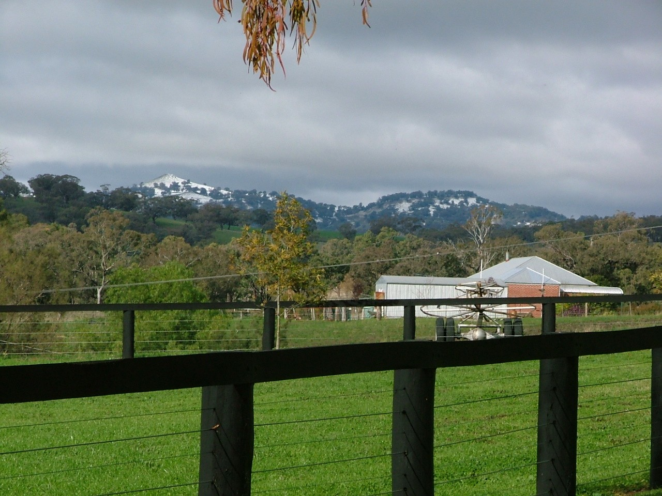

Program 4: Economic Development

Vision Statement
A dynamic and inclusive community motivated and achieved by Council through promoting the areas potential and advantage.

Objective
To maximise the tourism and economic development potential of the Shire and facilitate increased growth and sustained development.
Main Council Functions in this Program Area:
- Tourism
- Economic Development

The Community’s Vision for this Program.
During the community engagement process leading to the development of the Community Strategic Plan, the community identified the following priority areas that Council should focus on over the next 10 years:

- Local Employment Opportunities (12% community)
- Encourage local business (7% Community)
Council will continue to undertake independent community surveys to analyse any trends in the responses from the community over time. This will enable Council to measure the effectiveness of the implementation of its strategies in the Community Strategic Plan.
In order to address the above issues and challenges Council has a number of strategies as detailed in the following tables:

STRATEGY 4.1 |  | Increase tourism infrastructure and visitation to The Shire
Actions 2014/15 - 2017/18 |  |  | Performance Measure | Timeline | Responsibility
4.1.1 | Maintain local tourism committee and involvement with NENW Tourism, Inland Tourism and Kamilaroi Highway Promotion Committee and review tourism plan. |  | Level of satisfaction in the community survey with tourism services and facilities compared to benchmark. | Bi-annual | Director Economic and Community Development
4.1.2 | Implement strategies in the tourism plan. |  | Strategies implemented | Ongoing to 2016/17 | Director Economic and Community Development
STRATEGY 4.2 |  | Strengthen and grow the economic prospects of The Shire and create more sustainable job opportunities
Actions 2014/15 - 2017/18 |  |  | Performance Measure | Timeline | Responsibility
4.2.1 | Promote and market the area to attract businesses and new residents. |  | Increase in resident population as per ABS projections  Level of satisfaction in the community survey with economic development compared to benchmark | Annually  Bi-annual | Director Economic and Community Development
4.2.2 | Make industrial and commercial land available along with the provision of associated infrastructure |  | Net number of new businesses established in the Shire  Reduced number of vacant commercial premises in Quirindi and Werris Creek | Annually  Ongoing | Council, Private Sector  Director Economic and Community Development

Tourism & Economic | 2014-2015 | 2015-2016 | 2016-2017 | 2017-2018
Operating Income | 40,080 | 41,290 | 42,520 | 43,790
Operating Expenses | (462,805) | (473,390) | (488,550) | (501,040)
Capital Income | 0 | 0 | 0 | 50,000
Operating Result before Capital | (422,725) | (432,100) | (446,030) | (407,250)
Capital Expenditure | (35,900) | 0 | 0 | (50,000)
Transfer to Reserves | 0 | 0 | 0 | 0
Transfer from Reserves | 0 | 0 | 0 | 0
Net Result After Capital and Reserve Transfers | (458,625) | (432,100) | (446,030) | (457,250)
Net Restricted Cash Asset Movement | 0 | 0 | 0 | 0
Principal Activity Net Result | (458,625) | (432,100) | (446,030) | (457,250)

Program 5: Technical Services

Vision Statement
- The best value, best practice delivery of safe and convenient roads and ancillary facilities.
- The delivery of water and sewerage and other business enterprise services that are efficient and effective, produce a commercial return and are compliant with statutory obligations.

Objectives
- The provision, maintenance and enhancement of Transport and Drainage Infrastructure that minimises risk to the community, is environmentally friendly and financially sustainable.
- To ensure that Council’s business activities operate at no cost to Council and generate sufficient revenue to provide the appropriate level of services, taking into account community service obligations for each business unit.
- To provide safe, effective and resource efficient reticulated water supplies and environmentally responsible sewerage schemes in townships and villages within The Shire.
Main Council Functions in this Program Area:
- Main Council Functions in this Program Area
- Asset Management Planning
- Roads and Street Lighting
- Town Centres, Kerb and Gutter, Footpaths and Drainage
- Parks, Reserves, Sporting Fields and Showgrounds
- Plant Workshop
- Swimming Centres
- Water and Sewer
- Airport
- Cemeteries
- Gravel Quarries
The Community’s Vision for this Program.
During the community engagement process leading to the development of the Community Strategic Plan, the community identified the following priority areas that Council should focus on over the next 10 years:
- Road Maintenance
- Water supply
- Footpath and Bridge Maintenance
Council will continue to undertake independent community surveys to analyse any trends in the responses from the community over time. This will enable Council to measure the effectiveness of the implementation of its strategies in the Community Strategic Plan.
In order to address the above issues and challenges Council has a number of strategies as detailed in the following tables.

STRATEGY 5.1 |  |  | Maintain and develop a bicycle and/or footpath network that satisfies community needs
Actions 2014/15 - 2017/18 |  |  |  | Performance Measure | Timeline | Responsibility
5.1.1 | Undertake works as per the asset management plan and develop options for shared pathways in The Shire |  |  | Percentage of residents who express satisfaction in survey compared to benchmark | Bi- annual | Director Works
STRATEGY 5.2 |  |  | Maintain a road transport network that satisfies community needs
Actions 2014/15 - 2017/18 |  |  |  | Performance Measure | Timeline | Responsibility
5.2.1 | Undertake biannual road surveys and works as per management plan and funding limits. |  |  | Percentage of residents who express satisfaction in survey compared to benchmark | Bi-annual | Director Works
5.2.2 | Lobby for rail overpasses or by-passes at key road/rail interfaces to reduce delays |  |  | Overpasses/By-passes constructed | Ongoing | Council
STRATEGY 5.3 |  |  | Ensure bridges and drains are well maintained and satisfy community expectations
Actions 2014/15 - 2017/18 |  |  |  | Performance Measure | Timeline | Responsibility
5.3.1 | Undertake maintenance and new works as funding permits |  |  | Percentage of residents who express satisfaction in survey | Bi-annual | Director Works
STRATEGY 5.4 |  |  | Provide adequate and well maintained cemeteries, pools, parks, gardens, public toilets, showgrounds, playing fields and district facilities that are safe and developed to agreed standards
Actions 2014/15 - 2017/18 |  |  |  | Performance Measure | Timeline | Responsibility
5.4.1 | Undertake works as per Asset Management Plans and available funding ensuring that local parks, public open spaces, town centres, cemeteries, pools, showgrounds and playing fields continue to be enhanced to accommodate future need |  |  | Percentage of residents who express satisfaction in survey for pools, cemeteries, parks, showgrounds and playing fields compared to benchmarks where available | Bi-annual | Director Works
STRATEGY 5.5 |  |  | Pursue best practice management of Water Supply and Sewerage Systems including resource sharing with other Councils
Actions 2014/15 - 2017/18 |  |  |  | Performance Measure | Timeline | Responsibility
5.5.1 |  | Implement Best Practice Water Supply and Sewerage principles. |  | Achievement of 100% compliance with best practice principles excluding best practice pricing  Percentage of residents who express satisfaction in survey compared to benchmark | Ongoing to 2016/17  Bi-annual | Director Works
5.5.2 |  | Develop an alliance with Gunnedah Shire Council and/or Namoi Councils |  | Alliance implemented | By June 14 | MANEX/Council

Engineering Administration | 2014-2015 | 2015-2016 | 2016-2017 | 2017-2018
Operating Income | 0 | 0 | 0 | 0
Operating Expenses | 238,720 | 258,870 | 281,380 | 306,480
Capital Income | 0 | 0 | 0 | 0
Operating Result before Capital | 238,720 | 258,870 | 281,380 | 306,480
Capital Expenditure | 0 | 0 | (19,000) | (5,000)
Transfer to Reserves | (87,420) | (120,040) | (123,640) | (127,350)
Transfer from Reserves | 0 | 0 | 0 | 0
Net Result After Capital and Reserve Transfers | 151,300 | 138,830 | 138,740 | 174,130
Net Restricted Cash Asset Movement | 0 | 0 | 0 | 0
Principal Activity Net Result | 151,300 | 138,830 | 138,740 | 174,130
Depots | 2014-2015 | 2015-2016 | 2016-2017 | 2017-2018
Operating Income | 0 | 0 | 0 | 0
Operating Expenses | (171,670) | (168,180) | (171,490) | (174,900)
Capital Income | 0 | 0 | 0 | 0
Operating Result before Capital | (171,670) | (168,180) | (171,490) | (174,900)
Capital Expenditure | (122,900) | 0 | (3,000) | (15,000)
Transfer to Reserves | 0 | 0 | 0 | 0
Transfer from Reserves | 0 | 0 | 0 | 0
Net Result After Capital and Reserve Transfers | (294,570) | (168,180) | (174,490) | (189,900)
Net Restricted Cash Asset Movement | 0 | 0 | 0 | 0
Principal Activity Net Result | (294,570) | (168,180) | (174,490) | (189,900)

Engineering Plant | 2014-2015 | 2015-2016 | 2016-2017 | 2017-2018
Operating Income | 3,010,480 | 3,100,790 | 3,193,810 | 3,289,630
Operating Expenses | (2,175,900) | (2,220,180) | (2,265,790) | (2,354,760)
Capital Income | 1,188,420 | 940,440 | 1,255,860 | 835,700
Operating Result before Capital | 2,023,000 | 1,821,050 | 2,183,880 | 1,770,570
Capital Expenditure | (1,858,330) | (1,650,650) | (1,966,380) | (1,613,540)
Transfer to Reserves | (700,000) | (700,000) | (700,000) | (742,000)
Transfer from Reserves | 700,000 | 700,000 | 700,000 | 742,000
Net Result After Capital and Reserve Transfers | 164,670 | 170,400 | 217,500 | 157,030
Net Restricted Cash Asset Movement | 0 | 0 | 0 | 0
Principal Activity Net Result | 164,670 | 170,400 | 217,500 | 157,030
Parks & Reserves | 2014-2015 | 2015-2016 | 2016-2017 | 2017-2018
Operating Income | 472,873 | 487,059 | 501,669 | 516,725
Operating Expenses | (1,923,898) | (1,973,103) | (2,022,967) | (2,074,130)
Capital Income | 125,000 | 0 | 0 | 0
Operating Result before Capital | (1,326,025) | (1,486,044) | (1,521,298) | (1,557,405)
Capital Expenditure | (297,200) | (47,500) | (40,000) | (298,000)
Transfer to Reserves | (32,987) | (34,576) | (51,211) | (5,790)
Transfer from Reserves | 125,000 | 0 | 0 | 99,896
Net Result After Capital and Reserve Transfers | (1,531,212) | (1,568,120) | (1,612,509) | (1,761,299)
Net Restricted Cash Asset Movement | 0 | 0 | 0 | 0
Principal Activity Net Result | (1,531,212) | (1,568,120) | (1,612,509) | (1,761,299)
Works Maintenance & Construction | 2014-2015 | 2015-2016 | 2016-2017 | 2017-2018
Operating Income | 3,961,390 | 4,054,200 | 4,148,610 | 4,246,040
Operating Expenses | (8,283,383) | (8,365,540) | (8,480,610) | (8,608,740)
Capital Income | 667,387 | 300,000 | 318,000 | 250,000
Operating Result before Capital | (3,654,606) | (4,011,340) | (4,014,000) | (4,112,700)
Capital Expenditure | (4,353,360) | (4,130,210) | (4,210,140) | (4,336,060)
Transfer to Reserves | (60,000) | (60,000) | (60,000) | (60,000)
Transfer from Reserves | 0 | 0 | 0 | 45,000
Net Result After Capital and Reserve Transfers | (8,067,966) | (8,201,550) | (8,284,140) | (8,463,760)
Net Restricted Cash Asset Movement | 0 | 0 | 0 | 0
Principal Activity Net Result | (8,067,966) | (8,201,550) | (8,284,140) | (8,463,760)

Water Services | 2014-2015 | 2015-2016 | 2016-2017 | 2017-2018
Operating Income | 2,201,048 | 2,527,254 | 2,603,070 | 2,681,168
Operating Expenses | (2,294,672) | (2,338,598) | (2,518,302) | (2,702,575)
Capital Income | 34,950 | 5,536,000 | 5,537,080 | 38,190
Operating Result before Capital | (58,674) | 5,724,656 | 5,621,848 | 16,783
Capital Expenditure | (318,886) | (6,875,150) | (3,743,266) | (1,394,002)
Transfer to Reserves | 0 | 0 | 0 | 0
Transfer from Reserves | 0 | 0 | 0 | 0
Net Result After Capital and Reserve Transfers | (377,560) | (1,150,494) | 1,878,582 | (1,377,219)
Net Restricted Cash Asset Movement | (166,440) | 606,494 | (2,422,582) | 833,219
Principal Activity Net Result | (544,000) | (544,000) | (544,000) | (544,000)
Sewer Services | 2014-2015 | 2015-2016 | 2016-2017 | 2017-2018
Operating Income | 1,121,070 | 1,154,700 | 1,189,340 | 1,225,010
Operating Expenses | (935,900) | (957,860) | (962,720) | (985,570)
Capital Income | 0 | 0 | 0 | 0
Operating Result before Capital | 185,170 | 196,840 | 226,620 | 239,440
Capital Expenditure | (150,600) | (137,500) | (118,600) | (95,500)
Transfer to Reserves | 0 | 0 | 0 | 0
Transfer from Reserves | 0 | 0 | 0 | 0
Net Result After Capital and Reserve Transfers | 34,570 | 59,340 | 108,020 | 143,940
Net Restricted Cash Asset Movement | (205,570) | (230,340) | (279,020) | (314,940)
Principal Activity Net Result | (171,000) | (171,000) | (171,000) | (171,000)

Capital Budgets 2014/15 – 2017/18

See attached spreadsheets

