|  |
| --- |
| Special Variation Application Form – Part B  **For applications for 2014/15**  **Issued October 2013** |
| Randwick City Council  Date Submitted to IPART: 24 February 2014  Council Contact Person: Anne Warner  Council Contact Phone: 9399 0532  Council Contact Email: [anne.warner@randwick.nsw.gov.au](mailto:anne.warner@randwick.nsw.gov.au) |

© Independent Pricing and Regulatory Tribunal of New South Wales 2013

This work is copyright. The *Copyright Act 1968* permits fair dealing for study, research, news reporting, criticism and review. Selected passages, tables or diagrams may be reproduced for such purposes provided acknowledgement of the source is included.

The Tribunal members for this special variation assessment are:

Dr Peter J Boxall AO, Chairman

Mr Simon Draper, Part Time Member

Inquiries regarding this document should be directed to a staff member:

Dennis Mahoney (02) 9290 8494

Heather Dear (02) 9290 8481

Independent Pricing and Regulatory Tribunal of New South Wales

PO Box Q290, QVB Post Office NSW 1230

Level 8, 1 Market Street, Sydney NSW 2000

T (02) 9290 8400 F (02) 9290 2061

[www.ipart.nsw.gov.au](http://www.ipart.nsw.gov.au/)

Contents

1 Introduction 2

1.1 Completing the application form 2

1.2 Submitting the application 3

2 Focus on Integrated Planning and Reporting 4

3 Assessment criterion 1: Need for the variation 9

3.1 Community needs 11

3.2 Alternative funding options 18

3.3 State of financial sustainability 25

3.4 Capital expenditure review 29

4 Assessment criterion 2: Community awareness and engagement 30

4.1 The consultation strategy 31

4.2 Alternatives to the special variation 35

4.3 Feedback from the community consultations 39

4.4 Considering the impact on ratepayers 45

4.5 Considering the community’s capacity and willingness to pay 48

5 Assessment criterion 3: Impact on ratepayers 51

5.1 Impact on rates 51

5.2 Affordability and community capacity to pay 55

5.3 Other factors in considering reasonable impact 57

6 Assessment criterion 4: Assumptions in Delivery Program and LTFP 58

7 Assessment criterion 5: Productivity improvements and cost containment strategies 60

8 Other information 64

8.1 Previous Instruments of Approval 64

8.2 Reporting to your community 65

8.3 Council resolution to apply to IPART 67

9 Checklist of contents 68

10 Certification 69

# Introduction

Each council must complete this application form(Part B) in order to apply for a special variation to general income. The same Part B form is to be used for applications madeeither under section 508A or under section 508(2) of the *Local Government Act 1993*.

IPART assesses each application against the criteria set out in the Division of Local Government (DLG) *Guidelines for the preparation of an application for a special variation to general income for 2014/2015* (the Guidelines). Councils should refer to these guidelines before completing this application form. They are available at [www.dlg.nsw.gov.au](http://www.dlg.nsw.gov.au).

We also publish Fact Sheets on our role in local government rate setting and special variations and on the nature of community engagement for special variation applications. The latest Fact Sheets on these topics are dated September 2013. They are available on our website at [www.ipart.nsw.gov.au](http://www.ipart.nsw.gov.au).

Councils must complete thisPart B form with a relevant Part A form, also posted on our website. The relevant Part A form is either:

* *Section 508(2) Special Variation Application Form 2014/15 – Part A* for a single percentage variation under section 508(2) or
* *Section 508A Special Variation Application Form 2014/15 – Part A* for more than one percentage variation under section 508A.

The amount of information to be provided is a matter for judgement, but it should be sufficient for us to make an evidence-based assessment of the council’s application against each criterion. This form includes some questions that the application should address, and guidance on the information that we require. As a general rule, the higher the cumulative percentage increase requested, and the greater its complexity, the more detailed and extensive will be the information required.

## Completing the application form

To complete this Part B form, insert the council’s response in the boxes and the area which is highlighted, following each section or sub-section.

Councils may submit additional supporting documents as attachments to the application. The attachments should be clearly identified in Part B and cross-referenced. We prefer to receive relevant extracts rather than complete publications, unless the complete publication is relevant to the criteria. Please provide details of how we can access the complete publication should this be necessary.

We may ask for additional information to assist us in making our assessment. If this is necessary, we will contact the nominated council officer.

This application form consists of:

* Section 2 - Focus on Integrated Planning and Reporting
* Section 3 – Assessment criterion 1
* Section 4–Assessment criterion 2
* Section 5–Assessment criterion 3
* Section 6 – Assessment criterion 4
* Section 7–Assessment criterion 5
* Section 8 - Other information
* Section 9 – Checklist of contents
* Section 10– Certification.

## Submitting the application

IPART asks that all councils intending to apply for a special variation use the Council Portal on our website to register as an applicant council and to submit their application.

The Portal is at <http://www.ipart.nsw.gov.au/Home/Industries/Local_Govt>. A [User Guide](http://www.ipart.nsw.gov.au/files/948b8fb1-2e6e-4647-b9d3-a10000a2552a/Local_Government_-_Council_Portal_User_Guide_-_November_2012.pdf)for the Portal will assist you with the registration and online submission process.

Councils intending to submit an application should notify us of their intentionto apply by **cob Friday 13 December 2013.**

Councils should also submit their applications, both Part A and Part B and supporting documents, via the Portal. File size limits apply to each part of the application. For Part B the limit is 10MB. The limit for the supporting documents is 120MB in total, or 70MB for public documents and 50MB for confidential documents. These file limits should be sufficient for your application. Please contact us if they are not.

We also ask that councils also submit their application to us in hard copy (with a table of contents and appropriate cross referencing of attachments). Our address is:

Local Government Team  
Independent Pricing and Regulatory Tribunal  
PO Box Q290  
QVB Post Office NSW 1230

Level 17, 1 Market Street, Sydney NSW 2000.

We must receive your application via the Council Portal and in hard copy no later than **cob Monday 24 February 2014.**

We will post all applications (excluding confidential documents) on our website. Councils should also post their application on their own website for the community to read.

# Focus on Integrated Planning and Reporting

How a council considers and consults and engages on a special variation as part of its Integrated Planning and Reporting (IP&R) processes isfundamental to our assessment of the application for a special rate variation. Such a focus is clear from DLG’s September 2013 *Guidelines*.

The keyrelevant IP&R documents are the Community Strategic Plan, Delivery Program, Long Term Financial Plan and, where applicable, Asset Management Plan.

A council’s suite of IP&R documents may also include supplementary and/or background publications used within its IP&R processes. As appropriate, you should refer to these documents to support your application for a special variation.

Briefly outline how the council has incorporated the special variation into its IP&R processes. Include details of and dates for community consultation, key document revisions, exhibition period(s) and the date(s) that the council adopted the relevant IP&R documents.

**Summary of application**

This application made under *Section 508(A)of the Local Government Act 1993,* is for a one-off special increase in rates calculated at 6% of total rates income to be applied in the first year, 2014-2015 and maintained over five years to fund the environmental programs and expiring on 30 June 2019. This is in addition to the 3.59% special variation that is already approved for the extent of the 2013-2017 Delivery Program. The proposed SRV (environment levy) will replace the existing SRV (environment levy), also calculated at 6% of total rates income, that was first approved for five years in 2004 and then approved for continuation for another five years in 2009. This is due to expire on 30 June 2014.

In June 2013, the Independent Pricing and Regulatory Tribunal (IPART) approved a special rate variation for Randwick City Council to set its annual rate increase at 3.59% for the next four years (Delivery Program 2013 -17), enabling Council to raise rate income in alignment with Council's long term financial planning needs. Beyond 2017 Council's LTFP assumes that rates will continue to increase annually by 3.59%. The impact of this 3.59% SRV was identified in the information provided during the consultation.

In 2010 Randwick City Council had a 508A special variation approved for a three year period (2010-2013) to provide funding for the *Buildings for our Community* program. The total overall increase from this past levy is providing the revenue required to deliver facilities, programs and services at the agreed standards and to implement a seven year building program that is now in its fourth year.

**Focus on Integrated Planning and Reporting**

**COUNCIL RESPONSE**

Randwick City Council has a sound Integrated Planning and Reporting (IP& R) Framework in place as can be seen in the following **Diagram 1**.

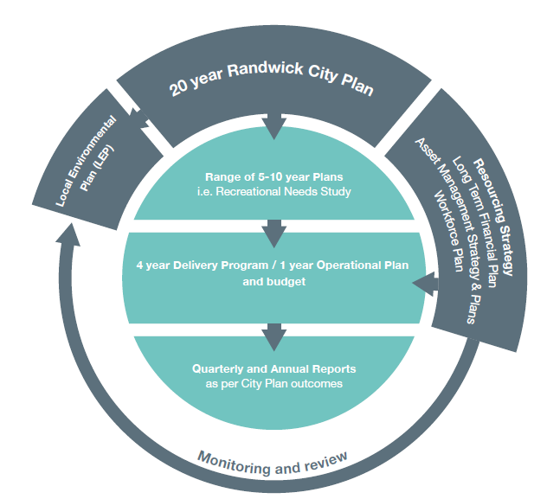

The key elements of this plan that underlie and support this application are:

* [Randwick City Plan 2012-2022](http://www.randwick.nsw.gov.au/library/scripts/objectifyMedia.aspx?file=pdf/300/26.pdf&siteID=1&str_title=FINAL%20Randwick%20City%20Plan%20WEB.pdf)
* Delivery Program 2013-17 / Operational Plan 2013-14 **Attachment A**
* Long Term Financial Plan 2013-14-2022-23 -provided as **Attachment B**
* [Asset Management Plan 2013-23](http://www.randwick.nsw.gov.au/library/scripts/objectifyMedia.aspx?file=pdf/300/30.pdf&siteID=1&str_title=FINAL%20Asset%20Management%20Strategy%20WEB.pdf),
* [Workforce Management Plan](http://www.randwick.nsw.gov.au/library/scripts/objectifyMedia.aspx?file=pdf/300/28.pdf&siteID=1&str_title=FINAL%20Workforce%20Plan%202012%20WEB.pdf),

A key outcome adopted by Randwick in its 20-year strategic City Plan is a healthy environment. Over the past decade, Council has been responding to this key outcome and the related community’s expectations through the implementation of the *Sustaining our City* initiative funded by an environment levy based on 6% of rates. The current levy is due to expire on 30 June 2014.

The *Sustaining our City* program focuses on fostering sustainable behavioural changes; protecting our bushland, open space and diversity; sustainably managing waste to maximise resource recovery; implementing a total water cycle management approach; improving energy conservation and efficiency and managing environmental risks and their impacts. Over the past decade, *Sustaining our City* initiatives have delivered very positive outcomes and clear benefits to the community.

Randwick City Council is proposing to seek a continuation of this 6% special variation to rates, the environment levy for another five years. In preparation for a possible continuation of the Sustaining our City initiative, Randwick prepared a five year environmental program (**Attachment C**) to enable continued and further implementation of its long-term strategy to protect, enhance and improve its natural environment for future generations.

**Attachment D** provides an extract from the Delivery Program 2013-17(pages 58-63) that outlines the strategies planned to deliver the outcome of *a healthy environment*. The funding for most of these activities would come from the environment levy.

**Table 2** provides an overview of the strategies and activities undertaken as part of the process of applying for the SRV and shows their relation to and integration into the overall Integrated Planning and Reporting (IP&R) processes.

**Table 2: Incorporation of Special Variation into IP & R processes**

|  |  |
| --- | --- |
| **DATE** | **ACTIVITY** |
| **Sept-Nov 2012** | Review of Randwick City Plan and commencement of preparation of new Delivery Program 2013-2017 |
| **Oct 2012** | Preparation of Randwick's 2012 State of the City report |
| **Oct 2012** | Preparation of Randwick's 2012 State of the Environment report (**Attachment E**) as part of State of City report (**Attachment H**) |
| **Nov 2012** | Council resolved to put draft Randwick City Plan 2012 and the draft Resourcing Strategy suite on public exhibition during December 2012 and January 2013 |
| **Feb 2013** | Council adopted the Randwick City Plan 2012 and the Resourcing Strategy suite that had been on public exhibition.  It also resolved to apply to IPART for a special variation to rates income of 3.59% per annum for each year of the four-year Delivery Program (2013-17), as per Model 3 of the LTFP; |
| **June 2013** | Council adopted the Operational Plan 2013-14 incorporating the Delivery program 2013-17. This document referred to the intention to In 2013-14, we will undertake Community engagement activities around the potential continuation of the Environment Levy 2014-19. **(Attachment F)** |
| **July 2013** | Preparation of a Community Engagement Strategy for the environment levy (**Attachment G**) |
| **27 August** | Council approved the community engagement process for the continuation of the environment levy (SRV ) (**Attachment I**) |
| **3 Dec. 2013** | Report to Planning Committee with summary of outcomes of community engagement. (**Attachment J**) |
| **3 Dec.2013** | Planning Committee resolved that the Council apply to IPART for a 6% SRV for 5 years to fund environment programs and projects (**Attachment K**) |
| **10 Dec 2013** | Council resolved to adopt updated LTFP that modelled the financial impact of the including and not including the environment levy |
| **Feb 24 2014** | Submission of application for SRV to IPART |

A review of the Randwick City Plan (Community Strategic Plan) and the Resourcing Strategy commenced in September 2012 and was informed by a comprehensive State of the City Report (**Attachment H**). The review incorporated relevant information, current issues and the feedback gained from 47 consultations undertaken during the previous two years into the draft Delivery Program 2013-17.

As part of the review, the resourcing requirements for the 2013-17 Delivery Program, addressing infrastructure, equipment, technology and staff were established. The Long Term Financial Plan calculations have determined the required rates as part of the Resourcing Strategy. This approach has been consistent with the *Guidelines for the preparation of an application for a special variation to general income* in that IP&R underpins decisions on revenue requirements.

The LTFP includes forecasts regarding the $51 million employee costs and $15.1 million employee leave entitlements liability reflecting the assumptions and strategies contained within the Workforce Plan. The financial impacts of issues such as an ageing workforce, which have been identified in the Workforce Plan, are addressed in the LTFP through management of the Employee Leave Entitlements reserve.

The State of the City report incorporating the State of the Environment (SoE) report was prepared in October and November 2012 in accordance with Section 428A of the *Local Government Act 1993* and in conjunction with the Integrated Planning and Reporting Guidelines as described under Section 406 of the same Act.

The objectives of Randwick’s 2012 Comprehensive SoE report (**Attachment E**) align directly with the seven environmental objectives (10a to 10g) adopted by Council within Outcome 10, *A Healthy Environment*, in Council’s 20-year City Plan. For each environmental objective the SoE established and reported on relevant environmental indicators and identified all major environmental impacts. This review was a very important part of the process for preparing future plans and identifying programs.

The draft Randwick City Plan 2012 and the draft Resourcing Strategy suite were presented at the November 2012 Council meeting where Council resolved to place the documents on public exhibition in December 2012 and January 2013.

Following consideration of submissions and the incorporation of subsequent changes the final documents were adopted at the February 2013 Council meeting. At the same time Council resolved to apply to IPART for a special variation to rates income of 3.59% per annum for each year of the four-year Delivery Program (2013-17), as per Model 3 of the LTFP.

In June 2013 Council adopted the recommended Operational Plan 2013-14 (**Attachment A)** and the recommended Annual Budget 2013-14. The Operational Plan on page 68 noted that the 2013-14 rating year is the fifth and final year of the current special increase to fund the Environment Levy and on page 73, that Council will undertake Community engagement activities round the potential continuation of the Environment Levy for 2014-19. The Council resolution to adopt these plans is provided in **Attachment F**.

In July and August a community engagement strategy was developed to guide Council in the community engagement process regarding the proposed continuation of the environment levy. (**Attachment G**)

In August 2013 Council approved the implementation of the community engagement process. **Attachment I** includes the report to Council and the resolution, noting that the continuation of this environment levy program forms an important element in achieving Council's long term environmental sustainability outcomes.

The community consultation and engagement process took place from September 2013 through to November 2013.

On 3 December a report to Council's Planning Committee (this Committee consists of all fifteen Councillors) sought approval to apply for continuation of the environment levy for 5 years from 2014 to 2019. This report (**Attachment J**) provided a summary of the outcomes of the community engagement process. At this Planning Committee meeting it was resolved that the Council apply to IPART for a 6% SRV to be applied in the first year and maintained for 5 years to fund environment programs and projects. The resolution is provided in **Attachment K**.

Council revised the LTFP in November 2013 and this was adopted by Council on 10 December 2013.

# Assessment criterion 1: Need for the variation

In the DLG Guidelines, criterion 1 is:

*The need for and purpose of a different revenue path (as requested through the special variation) is clearly articulated and identified through the council’s IP&R documents, including its Delivery Program and Long Term Financial Plan. Evidence for this criterion could include evidence of community need/desire for service levels/project and limited council resourcing alternatives and the Council’s financial sustainability conducted by the NSW Treasury Corporation. In demonstrating this need councils must indicate the financial impact in their Long Term Financial Plan applying the following two scenarios:*

* *Baseline scenario – revenue and expenditure forecasts which reflects the business as usual model, and exclude the special variation, and*
* *Special variation scenario – the result of approving the special variation in full is shown and reflected in the revenue forecast with the additional expenditure levels intended to be funded by the special variation.*

The response in this section should summarise the council’s case for the proposed special variation. It is necessary to show how the council has identified and considered its community’s needs, alternative funding options and the state of its financial sustainability.

The criterion states that all these aspects must be identified and articulated in the council’s IP&R documents.

At the highest level, please indicate the key purpose(s) of the special variation by marking one or more of the boxes below with an “x”.

Maintain existing services

Enhance financial sustainability

Environmental works X

Infrastructure maintenance / renewal

Reduce infrastructure backlogs

New infrastructure investment

Other (specify)

Summarise below the council’s need for the special variation. Comment on how the need is captured in the IP&R documents, especially the Long Term Financial Plan (LTFP) and the Delivery Program, and, where appropriate, the Asset Management Plan (AMP). Note that the LTFP is to include both a ‘baseline scenario’ and an ‘SV scenario’ as defined in the *Guidelines*.

**COUNCIL RESPONSE**

In summary the Randwick City community's need for the SRV (environment levy) is based on:

* The community's high level of satisfaction with existing service standards
* The community's strong support in the 2013 survey for continuing the environment programs
* Council's responsibilities for maintaining and protecting its natural environment
* The environment is considered to be an important issue by Randwick residents
* The expiration in June 2014 of the existing 6% environment levy would reduce the funds available to Council by approximately $4 million per year for the next five years ($3.8m. in the first year). This reduction means that Council would have to find alternate sources of funding if it is to continue to deliver the environmental programs that the community expects.

If the special variation seeks funding for contributions plan costs above the development contributions cap, refer to Box 3.1.[1]

|  |
| --- |
| Box 3.1 Special variations for development contributions plan costs above the developercap |
| For costs above the cap in contributions plans, a council mustprovide:  a copy of the council’s section 94 contributions plan  a copy of the Minister for Planning and Infrastructure’s response to IPART’s review and details of how the council has subsequently amended the contributions plan  details of any other funding sources that the council is proposing to seek to use  any reference to the proposed contributions (which were previously to be funded by developers) in the council’s planning documents (eg, LTFP and Asset Management Plans (AMP)  any necessary revisions to financial projections contained in the LTFP and AMP to reflect the special variation. |
|  |

If the special variation seeks funding for contributions plan costs above the development contributions cap, set out below:

* details explaining how the council has established the need for a special variation to meet the shortfall in development contributions, and
* how this is reflected in the council’s IP&R documents.

## Community needs

Indicate how the council has identified and considered the community’s needs and desires in relation to matters such as levels of service delivery and asset maintenance and provision in deciding to apply for a special variation. The application should include extracts from, or references to, the IP&R document(s) that demonstrate how the council meets this criterion.

**COUNCIL RESPONSE**

Council had engaged the community on a continuous basis over the previous five years as part of the Integrated Planning and Reporting process; through the preparation of the Comprehensive Local Environment Plan (LEP) that was adopted in 2013; regular “*Who Cares about the Environment?”* surveys; the biennial community satisfaction survey: and the *Your Say Randwick* website that give residents opportunities to participate in decisions that affect their lives and their environment including open space, waste survey, light rail and flood studies.

The consultation and engagement strategy for the 2012 City Plan review in addition to the strategies listed above used the additional input, feedback, community contributions and information gathered since 2006 through:

* input from Councillors
* social media
* Precinct committees
* economic development forums
* consultative and advisory committees
* regular consultation on annual operational plan and delivery program

It was through this broad range of consultative activities that community’s priorities and Council’s resourcing strategy were reviewed and confirmed leading to the update of the ten year Randwick City Plan in 2012 and the 2013-2017 Delivery Program that contained the services, major programs and initiatives that Council was committed to delivering from its regular budget.

**The Randwick City Plan** reflects the community's aspirations for the future including the wider and more complex aspirations over which Council has little or no control. It is based on the extensive research, input from the ongoing and well thought out community engagement processes that are in place and reflects the changes in community expectations as captured through biennial community surveys. It is also based on the knowledge that Council has about its community and the local area. It reflects *NSW 2012*, the ten year State Plan, the Metropolitan Plan for Sydney 2036 and other key relevant State and regional plans and integrates with key internal documents such as the new Local Environment Plan and Development Control Plans.

It has ten key outcomes and one of these is a ***Healthy environment*** where *the natural environment will be protected, enhanced and promoted for future generations*.

There are six directions for achieving this outcome including:

* 10a: Council's programs and partnerships foster sustainable behavioural changes and outcomes
* 10b: Policies and programs are developed and implemented in response to environmental risks and their potential impacts.
* 10c: Bushland, open spaces and biodiversity are protected and enhanced for future generations.
* 10d: Waste is managed sustainably to ensure highest level of resource recovery.
* 10e: A total water cycle management approach including water conservation, re-use and water quality improvements is adopted
* 10f: Energy conservation and efficiency programs are implemented.

The proposed program of works that will be carried out if the continuation of the environment levy is approved, support the achievement of not only the above directions but also other outcomes and directions in the Randwick City Plan as can be seen in **Table 4**. Full details on the proposed program of works are provided in **Attachment C**.

**Table 4: Relationship of new initiatives and projects to outcomes and directions in Randwick City plan**

|  |  |  |  |  |
| --- | --- | --- | --- | --- |
| **PROPOSED ACTIVITY** | **COST** | **PROJECT/ PROGRAM** | **CITY PLAN OUTCOME** | **CITY PLAN DIRECTION** |
| **Coastal Protection** | $6.85m | Coastal Walkway - completion of future stages including:   * Malabar Headland * Malabar to La Perouse * South Coogee to North Maroubra (design)   Interpretive signage project for our coastline  Installation of Gross Pollutant Traps | 5. Excellence in recreation & lifestyle opportunities  10. A Healthy environment | 5a. Maximise opportunities for residents & visitors to enjoy both active & passive open spaces uses  10e. Total water cycle management approach including water quality improvements is adopted |
| **Resource Conservation – Energy**  **Savings** | $4.6m | * Energy efficiency upgrades * Implementation of cogeneration technology * Renewable energy / solar panel installations * LED energy efficient streetlight program for Council’s parks * Implementation of a range of energy efficiency measures at Council sites | 10. A Healthy environment | 10f. Energy conservation & efficiency programs are implemented |
| **Resource Conservation – Water Savings** | $1.61 million | * Stormwater harvesting and irrigation works * Building / amenities upgrades | 10. A Healthy environment | 10e. Total water cycle management approach including water conservation, reuse & water quality improvements is adopted |
| **Resource Conservation – Reducing**  **greenhouse emissions** | $2.5 million | Cycle way implementation and pedestrian upgrades | 9. Integrated & accessible transport | 9a. Network of safe & convenient walking paths &cycleways |
| **Resource Conservation – Materials** | $0.55 million | Investigating new recycled materials and sustainable processes for road and footpath  Upgrades | 10. A Healthy environment | 10d Waste is managed sustainably to ensure highest level of resource recovery |
| **Biodiversity** | $1.8 million | * Dune protection & restoration * Expanding our ‘Green Corridor’, street and park planting and private land habitat planting * Native Haven advice and support for schools and households * Native plant & animal monitoring via Bushland programs | 10. A Healthy environment | 10c Bushland, open spaces and biodiversity are protected & enhanced for future generations |
| **Community Engagement and Education** | $2.46 million | * Sustainable workshops * Schools initiatives and programs * Marine and coastal programs * Eco-living Fair * Council Open Days and events * Community gardens * School food gardens | 10. A Healthy environment | 10a. Council's programs & partnerships foster sustainable changes & outcomes |

***Who Cares About the Environment* surveys**

In order to better understand the views of the community and associated actions on local environmental issues, Council has carried out regular surveys of it residents over the past decade. These surveys, “*Who Cares About the Environment”* and their results have contributed to the development of Council’s environmental and sustainability initiatives and projects.

The results of the most recent survey in 2011 confirm the environment is an important issue for residents. The only issues of greater concern are roads and traffic issues. The most important environmental issues identified in the survey include litter and illegal dumping of rubbish as well as beach and ocean pollution. In Randwick’s southern suburbs, residents’ concerns remains high over industrial emissions.

The Who Cares survey results also indicate the predominant environmental actions being taken by Randwick residents:

* 94% are reducing their energy consumption;
* 91% are re-using items for environmental reasons;
* 88% are reducing water consumption for environmental reasons;
* 83% are reducing the amount of food they throw out;
* 78% are avoiding the use of plastic bags;
* 68% are avoiding products with lots of packaging;
* 31% are composting or using a worm farm; and
* 44% are growing their own food.

The fact that the environment is an important issue for residents supports the need for the Council to continue with its environmental programs.

Many of Council’s sustainability programs and activities are focussed on helping the wider community take their own actions, often as small, incremental steps over time that nevertheless contribute to measurable and positive outcomes for the environment and individual households as these actions may save money and/or contribute to increased social well being. For instance, reducing car use results in less traffic on the roads and also delivers health and fitness benefits if individuals are cycling or walking.

The **2012 Community Satisfaction Survey** obtained the views of residents on Council services and programs and gathered information on what residents saw as the most important priorities over the next three years enabling Council’s forward planning to be in accordance with the community’s aspirations.

In August 2012 an independent research organisation carried out the survey with telephone interviews with 1000 residents representative of the Randwick community. As this was the fourth survey in a biennial series it enables trends to be identified and the cumulative information provided by the surveys assists councillors and Council management with future planning, establishing long term priorities and identifying key opportunities for improvements. The scope of this consultation provides Randwick Council with research findings that they can confidently assert reflect the attitudes of the broader community. The report on the 2012 survey is provided in **Attachment L**.

In summary the survey found that:

* Satisfaction with the performance of Council is high indicating that Council is maintaining its delivery levels.
* Dissatisfaction with the Council’s performance remains low at 8%
* Overall the community is happy with the levels of service provided and wants these service levels to continue
* There is a consistent positive trend in community satisfaction across the survey.
* Three services that showed a significant improvement in level of satisfaction in 2012 are:
  + - Festivals and events
    - Ocean pools
    - Protection of natural bushland

*Sustaining our City* activities and strategies would have contributed to the cleaner water at the beaches and hence the ocean pools and the increased and more effective protection of the natural bushland.

The high level of customer satisfaction supported the fact that the residents were satisfied with Council's services and programs and service delivery standards including the environmental programs. **Table 5** shows the improvement in satisfaction of the environmental programs over the years.

|  |  |  |  |  |
| --- | --- | --- | --- | --- |
| **Theme** | **2006 Satisfaction (%)** | **2008 Satisfaction (%)** | **2010 Satisfaction (%)** | **2012 Satisfaction (%)** |
| **Looking after our environment** | 40.33% | 52.37% | 58.0% | 58.33% |

From 2006, in the early years of the *Sustaining our City* program to 2012 there has been a significant increase of 18% in the level of satisfaction with the environmental programs and services.

For the past ten years the environment programs have been funded by the environment levy enabling the fast tracking of some major capital works such as the construction of the Coastal Walkway sections, the improvement of other open space assets, improved quality of water on beaches through construction of GPTs and stormwater harvesting and the saving of water, and energy and as a consequence costs for Council. There has also been investment and development of a number of ongoing facilities and services such as Barrett Place as a sustainability demonstration project and the Randwick Sustainability Hub. A result of these positive outcomes is that the expectations of the community have been raised in terms of both environmental progress and services. A summary of the achievements over the past four years is provided in **Attachment M**. The importance of the Coastal Walkway can be seen by the fact that it is ranked as number two of 274 attractions in Sydney, second only to Sydney Harbour, by TripAdvisor, the world’s largest travel website. It has also been rated 5 stars by almost 1300 reviewers.

The need for the environment levy is also driven by Council's responsibilities in caring for and managing its unique environment. Randwick City represents a fairly unique urban and coastal environment with a relatively high population within the 37 square kilometres of the local government area. The coastal boundaries include around 29 kilometres of beaches and foreshore along the Pacific Ocean and historic Botany Bay. Within these boundaries there are nine popular swimming beaches and 247 hectares of remnant bushland equivalent to around 6.5% of the local government area.

Randwick City is recognised for its abundance of open space and its rich biodiversity. Besides the Eastern Suburbs Banksia Scrub, which is the most significant plant community recognised across the Eastern suburbs, there are currently around 500 species of indigenous plants and 300 native fauna species, including frogs, reptiles, birds and mammals that have been recorded in Randwick. This represents 25 percent of all species indigenous to the Sydney Basin, which remains one of the main centres of plant diversity in Australia creating a significant responsibility for Randwick and its community.

Under the NSW Government’s *Threatened Species Conservation Act (1995)* and the Commonwealth’s *Environmental Protection and Biodiversity Conservation Act (1999)* Council is responsible for managing certain species as listed by an independent NSW Scientific Committee that include the endangered ecological community made up of Eastern Suburbs Banksia Scrub, Sunshine Wattle, Grey Headed Flying Fox and the Green and Golden Bell Frog. Randwick City has the largest remaining area of Eastern Suburbs Banksia Scrub (ESBS) and administers and implements the NSW Government’s Recovery Plans for these important species of flora and fauna.

Council is also required to implement *Threat Abatement Plans* under this legislative framework to minimise the damage caused by pest plants and animals including the very aggressive noxious weed, Bitou bush.

A number of Council programs also contribute to the strategic responses to Climate Change, including the energy saving initiatives and investments in renewable energy installations and water saving projects. Key responses to improve the ability of infrastructure to withstand the impacts of increased storm events and expected increases in rainfall is being addressed through the flood studies and the priority actions identified and implemented as a result.

In 2013 as part of the consultation strategy around the proposed levy Council surveyed its ratepayers and had a highly significant response with 6,960 surveys returned (13.8% of all ratepayers). In the survey, 6,639 residents (95.3% of all survey respondents) provided answers to the questions relating to the level of support for continuing the programs. The results, in **Table 6,** show the overall strong support for the continuation of the environmental programs.

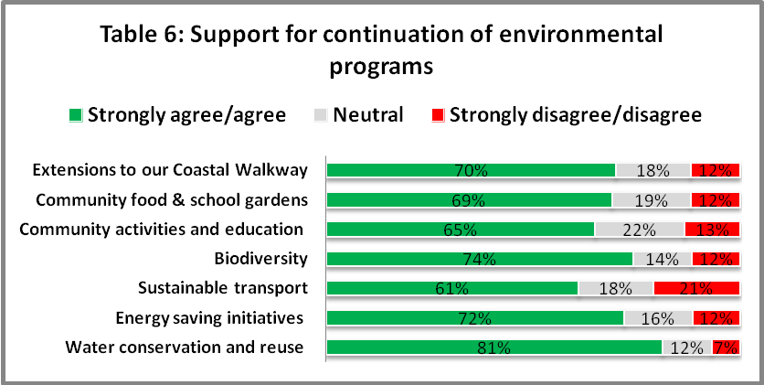

## Alternative funding options

Explainhow the decision to seek higher revenueswas made after other options such as changing expenditure priorities or using alternative modes of service delivery were examined. Also explain the range of alternative revenue/financing options you considered and why the special variation is the most appropriate option. For example, typically these options would include introducing new or higher user charges and increase council borrowing, but may include private public partnerships or joint ventures.

Provide extracts from, or references to, the IP&R document(s) which show how the council considered the alternatives.

**COUNCIL RESPONSE**

Randwick City Council receives the majority of its operating income from rates and annual charges as can be seen below in **Figure 7**. In 2012/13 its total operating income was $130,081,000.

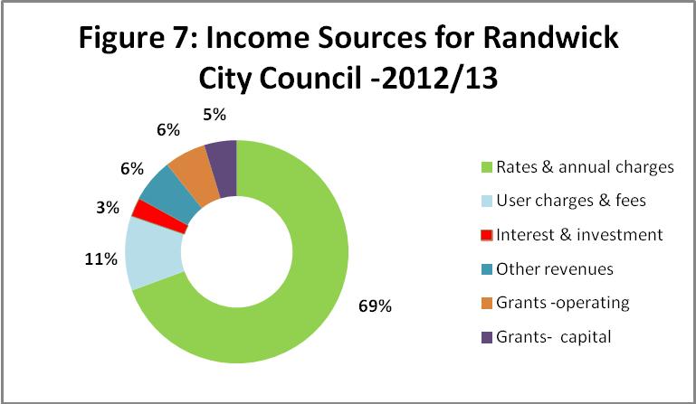

This high dependence on rates revenues creates challenges when considering other funding options for the environmental programs. However, despite this, the Council has considered a number of other options to fund the environmental program, *Sustaining our City* for the next five years. The impact of each of these options, as presented in the community engagement information, is detailed below.

|  |  |
| --- | --- |
| **OTHER OPTIONS** | **COMMENTARY** |
| **Increasing user fees and charges** | Many of the fees that Council charges, such as hall hire, are on a partial cost recovery basis to promote local social and economic activity. Other fees are set by the State Government and cannot be changed. The majority of the income coming from activities such as planning & building regulation, statutory fees and microfilm fees is cost recovery only and cannot produce any additional revenue.  It is not possible for the Council to raise the amount needed through increasing our general fees and charges |
| **Annual charges** | In 2012/13 Council received $27.339 million in annual charges consisting of Domestic Waste Management Charge ($26.123m) Stormwater Management Service Charge ($1.125m) and Section 611 Charges ($91,000). While this represents a significant proportion of Council's revenue the use of the funds from these charges is restricted to their specific purposes only. |
| **Reallocation of the existing operational budget** | Council’s current budget allocations reflect the community's priorities. If the budget is reallocated to fund some or all of the environmental programs there will be an impact on the quality of life enjoyed by the residents. Funding projects such as water re-use and water quality improvements means less money for street and beach cleaning, park mowing, maintenance of our roads and footpaths and/or library and community programs. |
| **Business as usual - complete the capital work with existing budgets** | Major upgrades and construction of sections of the Coastal Walkway require additional capital funding and would have to compete each year for scarce capital funds with road, footpath and building priorities. Without the additional funding through the environment levy, completion of the coastal walkway south of Malabar could take an additional 30 years. |
| **Interest & investment revenue** | The Council has a large investment portfolio that is subject to movements in interest rates. Investments are placed and managed in accordance with the Council’s adopted Investment Policy in compliance with the Local Government Act. As a custodian of the community’s funds, the Council ensures funds are invested with the same care, diligence and skill that a prudent person would exercise. |
| **Installation of parking meters** | Many councils receive substantial revenue from parking charges, for example in 2012 Waverley received $12.4 million in additional income from this source.  Randwick Council has considered this as an option and in 2005 Council undertook extensive consultation with our community on the matter of implementing parking meters in five areas. There was overwhelming rejection by the community of this proposal and Randwick Council continues to respect the community’s view in relation to the installation of parking meters. |
| **Grants and contributions** | The amounts of grants from State and Federal Governments are difficult to predict and are dependent on other levels of government. Development contributions are restricted in their usage and cannot be used to fund Council general operations. |
| **Loans** | The Council has been debt free since 2001 and has adopted a debt free strategy. Borrowing is not a sustainable funding alternative for the Council’s recurrent programs |

When the various alternative funding options listed above were considered it was considered that the most effective option for the Council to fund the planned environmental improvements and sustainability initiatives over the next five years is to apply to IPART for a special variation to rates. A 6% SRV (environmental levy) applied in the first year and maintained for five years will fund the environmental programs for the same period.

The Long Term Financial Plan (LTFP) provided in **Attachment B**, considers two models:

* **Model 1** assumes that the Environment Levy Special Variation Application has been approved and is included in the forecasts. It is assumed to continue through to the end of the LTFP.
* **Model 2** assumes that the Environment Levy Special Variation Application has been unsuccessful and has been excluded from all forecast in the LTFP. The *Sustaining our City* environmental programs will continue to operate using General Revenue.

The feedback received during the community consultation showed that there was a very high level of support for continuing the environmental programs and this has been taken into consideration in developing these two models that show the financial impact of including and not including the environment levy.

In Model 2 that does not include the environment levy, the *Sustaining our City* program will continue to operate using General Revenue with funds that would normally have been used on Capital Works. Reserve funds will be utilised to make up the shortfall.

The two financial models have been developed to demonstrate the impact of changes in the revenue assumptions.

There are two performance measures that are impacted by the removal of the Environment Levy in Model 2, these being the Operating Surplus Ratio and Infrastructure and Building Assets Renewal Ratio.

The Environment Levy contributes 0.17% to Council’s Operating Surplus Ratio. Although the removal of the Environment Levy reduces this ratio it is still forecasted to remain above the 1.00 benchmark for the duration of the plan. The Environment Levy funds various Capital Works projects most significantly the Coastal Walkway. The removal of these funds will require the Capital Works program to be reduced. This reduction in Capital Expenditure results in a reduction in the Infrastructure and Building Assets Renewal Ratio.

The Infrastructure and Building Assets Renewal Ratio compares the amount of capital expenditure on buildings and infrastructure assets to the level of their depreciation. With the removal of the Environment Levy the Infrastructure and Building Assets Renewal Ratio does not exceed the benchmark level of 100% until 2018 (Page 34 Attachment 1). The benchmark level of 100% is met one (1) year earlier with the inclusion of the Environment Levy (See Assessment Criterion 4).

The Open Space Asset Management Plan covers such assets as coastal open spaces and walkway, beaches, protection of natural bushland and ocean pools, many of which are critical elements in the environmental programs. The plan identifies the estimated maintenance and capital expenditures required to provide an agreed level of service to the community, that is, it identifies what needs to be done based on data including factors such the age and condition of each asset. These projected renewals may be compared to existing or planned expenditures to identify any gaps.

**Attachment N** includes two extracts from the Open Space Asset Management Plan. The first, page 27 shows a table comparing over a twenty year period the projected (what needs to be done), planned (based on existing or planned expenditure in the LTFP) and current renewal expenditure. This shows that for eighteen of these twenty years the planned expenditure greatly exceeds the projected expenditure.

While this high level of planned expenditure reflects the significant investments in the Coastal Walkway, Chifley Sports Field (involved remediation work in early stages) and the Heffron Park upgrade, the second extract, page 61, shows the strong sustainability ratios for both the 10 year and 20 year period.

The projected financial results within both models of the LTFP indicate the Council will continue to generate operating surpluses with strong growth in capital expenditure, maintaining its financially sustainable position with balanced budgets, sufficient unrestricted cash and available working capital, strong liquidity, sufficient cash reserves and a good debt collection ratio.

The exclusion of the environment levy funds, as illustrated in Model 1, does not have a significant impact on the financial results; however there will be an impact on the level of services provided should Council choose to maintain the activities contained within the Sustaining Our City program without raising the levy

The financial impact of each model is outlined below.

**Model 1: Inclusion of the Environment Levy**

In this model, the Council will continue to be financially sustainable, with a capacity to generate operating surpluses well into the future and fund capital and infrastructure programs. Under Model 1, all categories of assets would be maintained at a satisfactory standard and the Council would be able to sustain current service levels. **Graph 8** illustrates the sustainability outcomes when the environment levy is included in the projections.

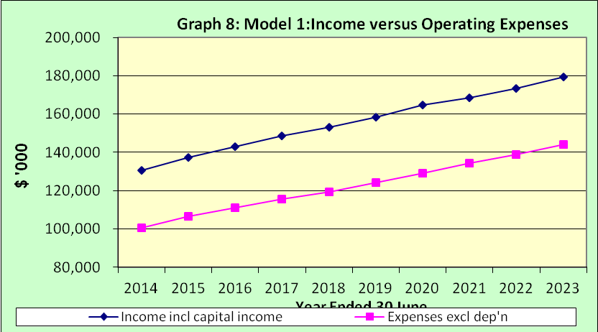

**Model 2: Exclusion of the Environment Levy**

In the Model, the Council will still continue to be financially sustainable, with a capacity to generate operating surpluses well into the future. The Council will still be able to fund capital and infrastructure programs; however these will be reduced by the amount normally funded from the Environment Levy Program. This will have an impact on the Council’s Infrastructure Assets as illustrated by the Renewal Ratios that are not as strong as they are under Model 1.

**Graph 9** shows the impact on financial sustainability of no environment levy.

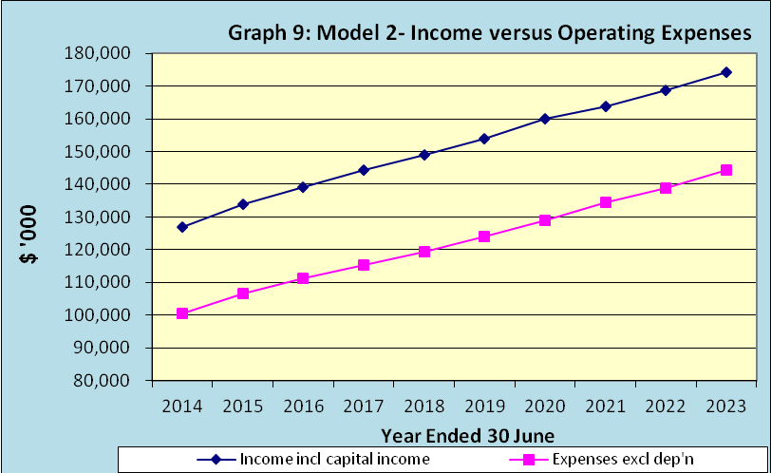

As can be seen above in **Graphs 8 and 9**, the projected income and expenditure over the next 10 years indicates the Council will retain the gap between income and operating expenses under each model.

In both Models 1 and 2 steady growth in capital expenditure will continue over the next 10 years in line with growth in revenue. The peaks in the **Graphs 10 and 11** below are due to cycles in plant replacement.

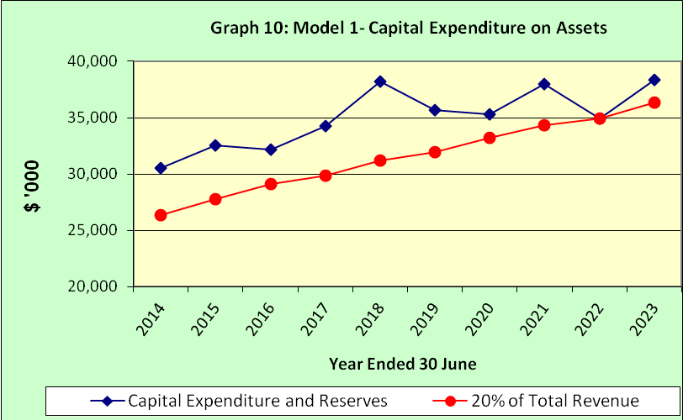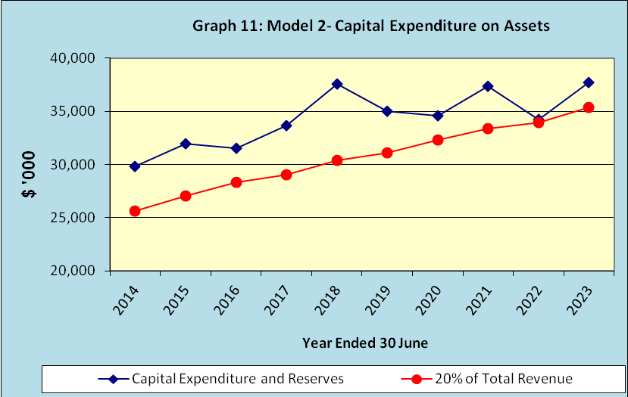

The LTFP, **Attachment B**, provides details on projected income and expenditure, detailed capital expenditure, balance sheet, reserve funds and cash flow statements for each model over **pages 30-37**.

## State of financial sustainability

The special variation may be intended to improve the council’s underlying financial position, or to fund specific projects or programs of expenditure, or a combination of the two. We will consider evidence about the council’s current and future financial sustainability.

The application should set out the council’s understanding of its current state of financial sustainability, as well as long-term projections based on alternative scenarios and assumptions about revenue and expenditure. Such evidence can be drawn from the LTFP and from any external assessment, eg by auditors or TCorp.

Explain the council’s view of its financial sustainability as it relates to the application for a special variation.

**COUNCIL RESPONSE**

“A local government will be financially sustainability over the long term when it is able to generate sufficient funds to provide the levels of service and infrastructure agreed with its community” (*Financial Sustainability of the NSW Local Government Sector*, TCorp).

Financial sustainability is one of the key issues facing local government. This is due to several contributing factors including cost shifting from other levels of government, increased and more complex expectations of local communities, ageing infrastructure and constraints on revenue growth. Financial sustainability in local government has been the topic of industry wide reviews and considerable public discussion in recent years.

Randwick Council has had a long term focus on achieving and maintaining financial sustainability whilst providing the levels of service and infrastructure agreed with its community. It has achieved this through developing and implementing a sound Integrated Planning and Reporting Framework including an effective resourcing strategy as well as implementing an ongoing process of review and improvement. It has also been prepared when required to make some hard decisions such as the 2004-05 restructure of the organisation that resulted in a reduction of 40 full time equivalent positions (7.5% of the existing workforce).

In October 2007, an independent review of Randwick Council’s financial position and long-term financial strategies was undertaken. This review concluded the Council’s financial position was within sustainability guidelines, with a capacity to generate operating surpluses and fund capital works and infrastructure programs well into the future. The Council's auditor, in the Audit Report of the 2012-13 Financial Reports, also assessed the Council's financial position and reported that, in his opinion, the overall financial position is sound.

The LTFP**, Attachment B**, enables the Council to better plan and understand long term financial requirements. This includes consideration of sustainability, service provision levels and the creation, upgrading and renewal of infrastructure. The LTFP is a key component of the Randwick City Council Resourcing Strategy. This Strategy underpins the Council's Integrated Planning and Reporting framework and demonstrates how the Randwick City Plan will be resourced over the next 10 years.

Financial modelling in the LTFP is based on the activities outlined in the City Plan and the Delivery Program and the requirements of the Asset Management Plans and Workforce Plan. This modelling has determined the level of special variation required and the timing of these variations.

The service levels, asset maintenance and renewal requirements outlined in the Asset Management Plan determine the capital expenditure and maintenance expenditure components of the LTFP. The objectives of the Asset Management Plans correlate with the LTFP objectives and measures regarding capital expenditure. In 2012-13 the Council spent $30.6 million on capital expenditure.

The LTFP is a dynamic document, updated twice each year on the adoption of the Budget and the completion of the annual Financial Reports. The LTFP changes as the needs, strategies and financial position of the Council change over time.

Randwick Council's LTFP has set the following objectives over the 10 year timeframe:

* Maintain the existing service levels to the community.
* Maintain a strong cash position.
* Maintain a balanced annual budget.
* Maintain a sufficient Employee Leave Entitlements Cash Reserve based on the age and entitlements of all staff in accordance with the Council’s Workforce Strategy.
* Capital expenditure on asset renewal, upgrades and extensions represents at least 20 per cent of the annual budget.
* The Council remains debt free.
* All adopted plans have a 10 year financial plan for incorporation into the LTFP.

The LTFP is based on clear and reasonable assumptions on forecasted growth in both income and expenditure over the next 10 years (see page 58 of this document).

Two financial models have been developed in the LTFP and the financial impact of each model in terms of sustainability is as follows.

**Model 1: Inclusion of the Environment Levy**

In this model, the Council will continue to be financially sustainable, with a capacity to generate operating surpluses well into the future and fund capital and infrastructure programs. All categories of assets would be maintained at a satisfactory standard and the Council would be able to sustain current service levels.

**Model 2: Exclusion of the Environment Levy**

In the Model, the Council will continue to be financially sustainable, with a capacity to generate operating surpluses well into the future. The Council will still be able to fund capital and infrastructure programs; however these will be reduced by the amount normally funded from the Environment Levy Program. This will have an impact on the renewal ratios for Council’s Infrastructure Assets.

In summary the Council will remain financially sustainable over the 10 year period under both Models 1 and 2 in terms of maintaining a balanced budget, sufficient unrestricted cash and available working capital, strong liquidity, sufficient cash reserves and a good debt collection ratio.

Explain how TCorp’s recent Report on the council’s financial sustainability is relevant in supporting the decision to apply for a special variation.

**COUNCIL RESPONSE**

In April 2013 NSW Treasury Corporation (TCorp) released its report on the Financial Sustainability of the New South Wales Local Government Sector. TCorp rated Randwick City Council’s Financial Sustainability (FSR) as ‘Sound’ and its Financial Outlook as ‘Neutral’. The Council has since received subsequent notification from TCorp that these ratings are trending ‘Strong’ and ‘Positive’ respectively.

The Report (**Attachment O**) concluded the Council has been well managed over the review period based on the following observations:

* Operating surpluses have been posted in each review year when capital grants and contributions are excluded
* Liquidity has remained sound as indicated by an Unrestricted Current Ratio above benchmark
* Council’s underlying operating performance, measured by EBITDA, has been on a positive trend between 2010 and 2012
* Council’s financial flexibility is good as indicated by an Own Source Operating Revenue Ratio being above benchmark in all four years

The TCorp Report concludes that, “From our review, Council appears to be in a sound position in terms of its long term sustainability”.

How will the special variation affect the council’s key financial indicators over the 10-year planning period? Key indicators may include:

* Operating balance ratio excluding capital items (ie, net operating result before capital as percentage of operating revenue before capital grants and contributions)
* Unrestricted current ratio (the unrestricted current assets divided by unrestricted current liabilities)
* Rates and annual charges ratio (rates and annual charges divided by operating revenue)
* Debt service ratio (net debt service cost divided by revenue from continuing operations)
* Broad liabilities ratio (total debt plus cost to clear infrastructure backlogs (Special Schedule 7) divided by operating revenue)
* Asset renewal ratio (asset renewals expenditure divided by depreciation, amortisation and impairment expenses).

**COUNCIL RESPONSE**

The LTFP provides detailed information on Council's key financial indicators including projected income and expenditure, detailed capital expenditure, balance sheet, reserve funds and cash flow statements for each model, that is, with the SRV and without it. These impacts, detailed in the LTFP and provided as **Attachment P** are summarised in **Table 12**.

**Table 12**: Impact of **Model 1**- including the Environment levy and **Model 2**- excluding the environment levy on key financial indicators from Year 1 - 5

|  |  |  |  |  |  |  |  |
| --- | --- | --- | --- | --- | --- | --- | --- |
| **INDICATOR** | **Target** | **Model** | **Yr 1** | **Yr 2** | **Yr 3** | **Yr 4** | **Yr 5** |
| **1. Balanced annual budget** | **>$0** | **1** | **√** | **√** | **√** | **√** | **√** |
| **2** | **√** | **√** | **√** | **√** | **√** |
| **2. Operating surplus ratio** | **>1** | **1** | **√** | **√** | **√** | **√** | **√** |
| **2** | **√** | **√** | **√** | **√** | **√** |
| **3. Unrestricted cash** | **>$1000** | **1** | **√** | **√** | **√** | **√** | **√** |
| **2** | **√** | **√** | **√** | **√** | **√** |
| **4 Unrestricted Current ratio - DLG ratio** | **>2** | **1** | **√** | **√** | **√** | **√** | **√** |
| **2** | **√** | **√** | **√** | **√** | **√** |
| **5. Unrestricted Current ratio -Working Capital ratio** | **>1** | **1** | **√** | **√** | **√** | **√** | **√** |
| **2** | **√** | **√** | **√** | **√** | **√** |
| **6. Rates & annual charges outstanding** | **<4%** | **1** | **√** | **√** | **√** | **√** | **√** |
| **2** | **√** | **√** | **√** | **√** | **√** |
| **7. Debt commitment ratio** | **0%** | **1** | **√** | **√** | **√** | **√** | **√** |
| **2** | **√** | **√** | **√** | **√** | **√** |
| **8. Employees Leave Entitlements Funding (%)** | **\*+** | **1** | **√** | **√** | **√** | **√** | **√** |
| **2** | **√** | **√** | **√** | **√** | **√** |
| **9. Infrastructure & Building Assets renewal ratio (%)** | **>100%** | **1** | x | x | x | **√** | **√** |
| **2** | x | x | x | x | **√** |
| **10. Buildings, infrastructure and open Space assets Renewal ratio (%)** | **>100%** | **1** | **√** | **√** | **√** | **√** | **√** |
| **2** | **√** | **√** | **√** | **√** | **√** |
| **11. Capital expenditure as a percentage of total expenditure ratio** | **>20%** | **1** | **√** | **√** | **√** | **√** | **√** |
| **2** | **√** | **√** | **√** | **√** | **√** |

* Determined through age profiling of staff

The above summary and comparison of performance shows that Model 1 (including SRV/environment levy) will over the long term deliver better outcomes for Randwick City with better results in relation to five of the eleven key financial indicators and the same result for five of the indicators.

## Capital expenditure review

Councils undertaking major capital projects are required to comply with the DLG’s Capital Expenditure Guidelines, as outlined in DLG Circular 10-34. A capital expenditure review is required for projects that are not exempt and cost in excess of 10% of council’s annual ordinary rates revenue or $1 million (GST exclusive), whichever is the greater. A capital expenditure review is a necessary part of a council’s capital budgeting process and as such should have been undertaken as part of the Integrated Planning and Reporting requirements in the preparation of the Community Strategic Plan and Resourcing Strategy.

|  |  |
| --- | --- |
| Does the proposed special variation require you to do a capital expenditure review in accordance with DLG Circular to Councils, Circular No 10-34 dated 20 December 2010? | Yes No X |
| If *Yes*, has a review been done and submitted to DLG? | Yes  No |

# Assessment criterion 2: Community awareness and engagement

In the DLG Guidelines, criterion 2 is:

*Evidence that the community is aware of the need for and extent of a rate rise. This must be clearly spelt out in IP&R documentation and the council must demonstrate an appropriate variety of engagement methods to ensure opportunity for community awareness/input. The IP&R documentation should canvas alternatives to a rate rise, the impact of any rises upon the community and the council’s consideration of the community’s capacity and willingness to pay rates. The relevant IP&R documents must be approved and adopted by the council before the council seeks IPART’s approval for a special variation to its general revenue.*

To meet this criterion, councils must provide evidence from the IP&R documents[2] that the council has:

* Consulted and engaged the community about the special variation using a variety of engagement methods and that the community is aware of the need for, and extent of, the requested rate increases
* considered and canvassed alternatives to the special variation
* provided opportunities for input and gathered input/feedback from the community about the proposal
* considered the impact of rate rises on the community
* considered the community’s capacity and willingness to pay.

In assessing the evidence, we will consider how transparent the engagement with the community has been, especially in relation to explaining:

* the proposed cumulative rate increases including the rate peg (including in both percentage and dollar terms)
* the annual increase in rates that will result if the special variation is approved in full (and not just the increase in daily or weekly terms)
* the size of any expiring special variation (see Box 4.1 below)
* alternative rate levels that would apply without the special variation
* proposed increases in any other council charges (eg, waste management, water and sewer), especially if these are likely to exceed the increase in the CPI.

|  |
| --- |
| Box 4.1 Where a council is renewing or replacing an expiring special variation |
| The council should have explained to its community:  that there is a special variation due to expire at the end of this financial year or during the period covered by the proposed special variation  that, if the special variation were not approved so that only the rate peg applied, the year-on-year change in rates would be lower, or that rates may fall  if applicable, that the expiring special variation is being continued (in full or in part), in the sense that it is being replaced with another that may be either temporary or permanent, or that the value is included in the percentage increase being requested in the following year. |
|  |

More information about how community engagement might best be approached may be found in the DLG *Guidelines*, the IP&R manual, and our Fact Sheet *Community Awareness and Engagement*, September 2013.

## The consultation strategy

Provide details of the consultation strategy undertaken, including the range of methods used to inform the community about the proposed special variation and to engage with the community and obtain community inputand feedback on it. The range of engagement activities could include media releases,mail outs, focus groups,random or opt-in surveys, online discussions, public meetings, newspaper advertisements and public exhibition of documents.

Please provide relevant extracts of the IP&R documents that explain the council’s engagement strategy and attach relevant samples of the council’s consultation material.

**COUNCIL RESPONSE**

The Community Engagement Strategy for the review of the Randwick City Plan was developed using:

* relevant planning and reporting legislation and guidelines, and
* the Council’s adopted [Community Consultation Principles and Consultation Planning Guide](http://randwick.nsw.gov.au/library/scripts/objectifyMedia.aspx?file=pdf/23/94.pdf&siteID=1&str_title=Community%20Consultation%20Principles%20and%20Planning%20Guide.pdf)

At the Ordinary Council meeting in August 2013 the Council approved the implementation of the community engagement process (**Attachment I**) noting that the continuation of this environment levy program forms an important element in achieving Council's long term environmental sustainability outcomes.

As agreed in the above resolution a specially designed consultation and communication strategy was implemented to engage the Randwick community on the proposal to continue our *Sustaining our City* program and possible funding options. This strategy, provided as **Attachment G**, was developed to meet the consultation level of “collaboration” as detailed in the DLG guidelines and to satisfy IPART submission requirements for special rate variation requests.

The consultative approach was transparent and well publicised. It sought to engage the wider local community as well as existing community and stakeholder groups. It made available accurate information and provided the opportunity for intensive in depth discussion of issues and options. It provided a variety of different formats to communicate and collect information on the proposal to continue the environmental levy and gave the whole community the choice of how they could participate and give feedback to the Council.

The consultation and engagement strategy acknowledged the diversity of the Randwick community by recognising that different people prefer to engage and give feedback in different ways. It was based on the Randwick City Council’s Community Consultation Principles and Consultation Planning Guide and had a key focus on ensuring that the ‘silent majority’ had access to the information and were directly encouraged to provide feedback.

In Randwick the 2011 Census data showed that 76% of households had internet connections and Council provided opportunities to read information, complete the survey and provide feedback online. However as not every household has internet access and not all members of the public feel comfortable interacting via a computer, a fact sheet and hard copy of the survey were provided to all ratepayers with a letter from the Mayor and a reply paid envelope to make it easier for responses to be returned to Council.

Information on the proposal was provided through:

* Council’s website
* Randwick eNews
* Information at Council’s customer service centre and libraries
* Mayor’s column, advertising and media coverage
* Two face-to-face community workshops
* An information package distribution to all ratepayers
* Community newsletter distributed to all households
* Online discussion
* Stall at our EcoLiving Fair.

Residents could engage in discussion of the issues and give feedback through:

* commenting on *Have* *Your Say*webpage
* attending as a randomly selected participants one of the two externally facilitated community workshops
* a survey distributed in hardcopy to all ratepayers and available online
* online web based discussion forum website
* letters and submissions
* social media
* face to face discussions or telephone calls with Council staff.

A summary of the key consultation activities are outlined in **Table 13** and this includes a brief description of the technique and when and where it was used. A copy of all information provided during the consultation is provided in **Attachment Q.**

**Table13: Key elements of consultation and engagement strategy**

|  |  |  |  |
| --- | --- | --- | --- |
| **CONSULTATIVE**  **STRATEGY** | **DATE** | **TARGET GROUP** | **FEATURES** |
| **Councillor briefings** | Aug. 2013  Ongoing | Elected representative | Briefing on 10 year initiative  Briefings were provided as required and/or requested |
| **All Stops to Randwick** | August 2013 | Council staff | Information provided at Sustainability stall at an all council staff workshop  480 staff participated |
| **Randwick Community News** | August  2013 | Randwick Community | 55,000 copies of Council’s newsletter were distributed to every household in August. This included a one page insert outlining recent projects and how residents could get more information and have their say. Included a link to *Have Your Say* Randwick. This is included in **Attachment Q** |
| **Randwick e news** | 18 Sept.  30 Oct.  6 Nov.  2013 | Online - Randwick community and other interested | The proposed environment levy was discussed with encouragement to respond, in three issues of regular enews. Copies provided in **Attachment R**  9,450 subscribers |
| **Information package** | August- November  2013 | Randwick community and other interested | **Provision of six key documents:**   1. Your rates and the Environment Levy 2. General income/funding options 3. Efficiency & productivity savings 4. Key achievements of the program   5. Proposed projects 2014-19  6. Fact Sheet  (Included in **Attachment Q**)  The package was available online and in all Council facilities such as customer service centre and libraries  There were 205 document downloaded |
| **Media** | Ongoing | Randwick community and other interested | Media releases, stories and commentary in local newspapers  Provided in **Attachment R** |
| **Survey** | October 2013 | Randwick ratepayers and residents | * On ***Have Your Say Randwick*** website * Included in letter to ratepayers with reply paid envelope. * Available in libraries etc   Total surveys returned **6,960**  Survey & results in **Attachment S** |
| **Have Your Say Randwick website** | 9 Sept. - 15 Nov. 2013 | Randwick community and other interested | Website with all documents and background material, and online survey. During this period there were:  - 1,432 unique site visits  -15,238 page views  Summary in **Attachment T** |
| **Social media** | Ongoing | Randwick community and other interested | Facebook followers- 4,172  Twitter (Mayor) - 1,023 followers  Council 256 followers  Summary of activity in **Attachment T** |
| **Stall at the Eco-living fair** | September 2013 | Randwick community and visitors | Information and survey available  Approx. 6,000 attended |
| **Vox pop made at the Eco-living fair** | September  2013 | Randwick community and visitors | Students interviewed visitors to fair as part of a school project involving them in environmental activities with their Council  [Link to video](http://yoursayrandwick.com.au/videos/23?project_id=33&client_id=1) |
| **Posters** | September - October 2013 |  | Posters for libraries, customer service centres and bus shelters  Included in **Attachment Q** |
| **Mayors letter to all ratepayers** | October  2013 | Randwick ratepayers | Letter from Mayor addressed to 55,000 ratepayers which provided a fact sheet and invited people to make comment via survey with a reply paid envelope included.  Letter and Fact sheet included in **Attachment Q** |
| **Community engagement workshops** | October | Randwick ratepayers- randomly selected | Two workshops held- 29th & 30th October  37 participants  Report provided In **Attachment U** |

The information given to the community outlined:

* that the current environment levy was due to expire in June 2014
* why the environment program should be able to continue
* proposed future projects and programs including costs
* the cost of the proposed special variation showing the cumulative impact
* financial impact of the preferred option with a range of examples based on different land values showed the varying impacts of the accumulated increase
* the compounding impact of the total increase shown in several tables.

Copies of all the information provided during the consultations are included in **Attachment Q**.

## Alternatives to the special variation

Indicate the range of alternatives to the requested special variation that the council considered and how you engaged your community about the various options.

**COUNCIL RESPONSE**

There were a number of possible alternatives to fund the environment programs and Randwick Council carefully considered these other revenue options, productivity improvements and cost containment measures prior to the decision to apply for the special variation.

During the consultation information on some of these other options was available in Information Sheet 2 (**Attachment Q**). Randwick sought to encourage the community to consider and provide feedback on the proposed options to fund the programs and contribute their own ideas to the discussion. The alternate funding suggestions from the community are outlined in **Table 14**.

**Table 14: Analysis of community suggested funding options**

|  |  |
| --- | --- |
| **OTHER FUNDING OPTIONS SUGGESTED** | **COMMENTARY** |
| **Existing budgets** | The Council's current budget allocations reflect the priorities identified by the community and if we were to reallocate budgets it would significantly impact on the services and programs and quality of life that you enjoy.  Reallocating budgets means that the roads will have more potholes; there may be reduced library opening hours; the beaches may be cleaned only three times a week rather than every day and parks will be mown less frequently. |
| **Council Reserves** | Randwick City Council did have in excess of $62 million cash and investments at the end of the 2012-13 financial year . However, the majority of these funds are restricted funds. This means that there is either legislation, primarily the *Local Government Act 1993* or a particular Council resolution restricting how those funds can be used  The restricted funds also include Section 94 contributions which are governed by the *Environmental Planning and Assessment Act 1979*. Section 94 contributions are payments made by Developers where the development will result in an increase in the demand for public amenities and public services. These funds must be used to satisfy that demand.  However there is opportunity to allocate less budget to Capital Works |
| **Applying a flat levy** | A flat levy is not permitted under the legislation.    A flat 'charge' bears no relationship with land value and rates are meant to be tied to value |
| **Savings achieved from environmental initiatives such as water conservation** | It may be possible in the future to identify savings achieved and reallocate them to the environment budget. This is an option that needs to be explored in more depth |
| **Increased support from State and Federal governments** | Council is currently feeling the impact of cost shifting from the State and Federal Governments and it is unlikely that there will be additional funding from this area. However whenever possible Council does apply for any grants and/or funding offered from other sources but in many cases this funding is tied and cannot be applied to another project. |
| **Department of Education and/or parents to fund anything to do with schools** | Project support of local school initiatives are aimed at fostering partnerships with local students, their families and community education networks. They tend to relate to local improvements usually outside the level of DET funding or support |
| **Projects such as coastal walkway to be funded from infrastructure/capital works budget** | This is possible but will mean that hard decisions will be made as to what other capital works program will not proceed. If the $6.85 million funding for the next 5 years for the coastal walkway is to be funded from capital works budget within the same timeframe then this money will be taken from the parks and recreation and roads and footpaths capital works program. |

**Benchmarking against peer councils**

Five metropolitan coastal councils, Sutherland, Waverley, Manly, Warringah and Pittwater make up the group against which Randwick can be benchmarked. These are all coastal metropolitan councils with responsibilities for regional beach facilities used by large numbers of non-resident visitors. The beach facilities include beaches, rock pools, surrounding parks, recreation reserves and gardens with each council devoting a significant budget to maintaining, cleaning and patrolling the beaches as well as managing the large crowds who visit and use the facilities and the subsequent impact on residents

As discussed previously in the application the Council is highly dependent on rate revenue. Rates and annual charges currently represent approximately 69% of total operating income.

In 2011/12 Randwick's total operating income of $124,129,000 provided a per capita operating income of $962. This $962 represents the funds per resident that Randwick had available for constructing new roads, community buildings and other assets, maintaining its roads, footpaths, buildings, beaches, parks and drainage and providing community services and events, beach lifeguard services, aquatic centres, environmental programs, library services and other programs.

However when the total operating incomes (includes rates & annual charges, user charges & fees, interest & investment, grants and other revenues) per capita available to each of the other coastal metropolitan councils are considered, it can be seen in **Figure 15**, that Randwick is well below the benchmark average, and by comparison, is clearly under-resourced. In fact, if Randwick had the same operational income per capita as the benchmark average ($1,252) it would have an additional $37.4 million to spend every year.

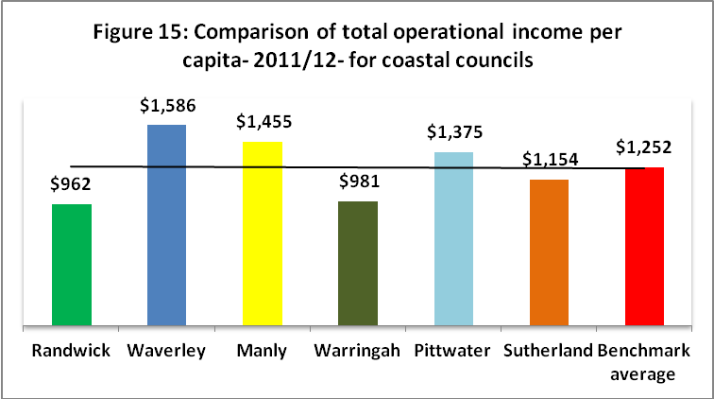

However, Randwick's lower operating income per capita does not impact on the delivery of its services and programs and it is significant that despite having much lower operating income per capita than all bar one of the other benchmark councils Randwick has:

* achieved the desired condition rating for its major asset classes, roads, footpaths and open space
* no debt and is financially sustainable
* delivers quality programs and services
* achieved a high level of satisfaction from its community
* demonstrated through the awards it has won and the recognition accorded to it by the industry that it is innovative, efficient and provides quality services and programs

These are all strong indicators of the efficiency and cost effectiveness of Randwick's service delivery.

In the information provided to the community during the consultation, Randwick Council outlined how other Councils paid for their environmental programs- providing some funding options to consider. These other options included:

* **Business rates and property rentals income:** Some metropolitan councils such as North Sydney, Parramatta, Willoughby and City of Sydney receive significant income from business rates, while others have substantial property portfolios.
* **Other charges:** Many councils receive substantial revenue from parking charges. In 2011-12 Waverley received $12.4 million ($195.68 per capita) in additional income from this source. In stark comparison, Randwick only received $522,000 ($4.05 per capita) as additional income from parking meters and parking stations.

**Other options for the community**

During the consultation Council said that if the community decided to reject the continuation of the special variation for another five years then the Council would need to make some hard decisions so that the budget continued to be balanced. Given the high value placed on many of the programs by the community it was recognised by Council that it would not be desirable to cut programs and therefore if some or all of the programs and projects were to continue then cuts may have to be made in other areas to fund these.

If the community wanted major capital environmental works such as the construction of the Coastal Walkway to continue then it was suggested that other planned capital programs would not be able to be delivered as planned and/or that it would take many more years to implement the environmental capital works.

It was also stated that not continuing with many of the Sustaining our City programs would also have some substantial implications for the environment.

## Feedback from the community consultations

Summarise the outcomes of, and feedback from, your community engagement activities. Such outcomes could include the number of attendees at events and participants in online forums, as well as evidence of media reports and other indicators of public awareness of the council’s intentions. Where applicable, provide evidence of responses to surveys, particularly the level of support for specific programs or projects, levels and types of services, investment in assets, as well as the options proposed for funding them by rate increases.

Where the council has received submissions from the community relevant to the special variation during the engagement process, the application should set out the views expressed in those submissions. It should also identify and document any action the council has taken, or will take, to address issues of common concern.

**COUNCIL RESPONSE**

Council used a variety of strategies to inform, consult with and seek feedback from the community on the proposed levy.

**1. Survey**

A short survey was prepared to ascertain:

* Awareness of sustainability programs undertaken since 2009
* Support for continuation of levy
* Support for continuation of environmental projects and programs.

The survey was included in a letter sent by the Mayor to all ratepayers in October 2013 and was also available on *Have Your Say Randwick* website.

A total of 6,960 surveys were completed and returned by the closing date with the majority being paper surveys. This is a very high response rate representing 13.8% of total ratepayers.

Of those who responded 86.3% live in Randwick and pay rates; 11% pay rates but live outside Randwick and 2.7% live in Randwick but do not pay rates.

The survey and a summary of the results are provided in **Attachment S**.

**Support for continuation of the environmental levy**

**Figure 16** shows that 51.9% of respondents supported the continuation of the environmental levy, compared with 10.4% who were unsure and 37.7% who did not want the levy to continue.

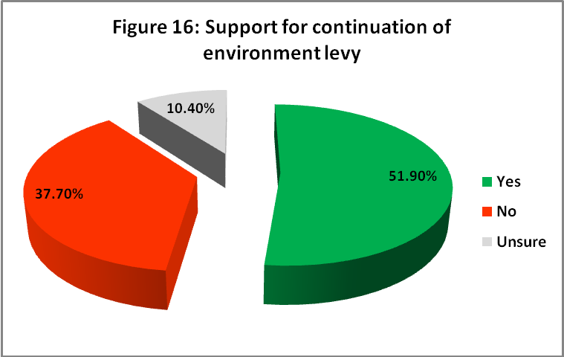

Of the 6,960 respondents, 1,575 (22.6%) commented on their choice of Yes, No or Unsure. The feedback varied considerably. It included comments on the proposed levy, general rates, environmental programs, capacity to pay, sources of funding and communication. There were also comments relating to other Council services and unmet needs as well as on non-Council related matters. All the feedback is valuable and will be shared with appropriate Council sections.

There were 2,622 respondents (37.7%) who did not support the continuation of the levy. When asked why they did not support it, 78.4% of this group stated they would prefer to save money on their rates with only 3.2% of the respondents who voted no, stating that environmental initiatives are not important to them. This result confirms previous findings that the environment is still an important issue for residents.

This result was reflected in the overall high level of support shown by respondents for the continuation of the programs and projects funded by the environmental levy. **Figure 17** below shows the level of support for the continuation of these programs and projects.

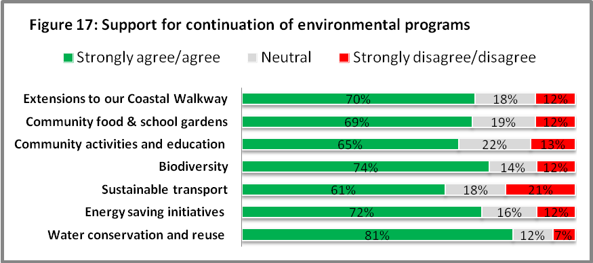

The above table shows that there was overall support for the continuation of the environmental programs with the strongest support for water conservation and reuse programs. Overall 95.3% of all respondents answered the questions related to continuing the programs so the opinions above include those who support continuation of the levy as well as those respondents who do not.

This high level of support for continuing the environmental programs was taken into consideration in the review of the LTFP in November 2013 that modelled the financial impact of including and not including the environment levy. Model 2 that does not include the environment levy assumed that the Sustaining our City program will continue to operate using General Revenue with funds that would normally have been used on Capital Works being used. Reserve funds will be utilised to make up the shortfall.

**Feedback in surveys**

An analysis of the comments provided by 22% of the respondents showed that there were many and varying suggestions to fund the levy including:

* using existing budgets
* using the operational savings achieved from environmental initiatives such as water conservation
* seeking increased support from State and Federal governments
* Department of Education and/or parents to fund anything to do with schools
* projects such as coastal walkway to be funded from infrastructure/capital works budget
* using Council reserves
* applying a flat levy of $75 or $100 per annum

Information has been provided on each of these options in pages 36-37 in this application.

**2. Community Workshops**

An external independent facilitator ran two community workshops as part of the broader consultation process. Thirty seven people participated in the workshops which were held on Tuesday 29 October and Wednesday 30 October. The participants were randomly selected by the researcher and were broadly representative of the demographic profile of Randwick LGA in terms of age, gender and suburb of residence to ensure a cross section of views in terms of environmental awareness, interest and attitude, However younger people were under-represented due largely to the fact that the focus was on ratepayers and young people tend to be renters rather than owners.

Participants were presented with information on the levy and funding implications as well as the environment programs funded by the levy.

Across both workshops there was general consensus that the highest priority environmental projects related to water savings, energy conservation and community activities and education.

As can be seen in **Figure 18**, 75% of the workshop participants supported the continuation of the environment levy, 17% were unsure and 8% did not support the levy.

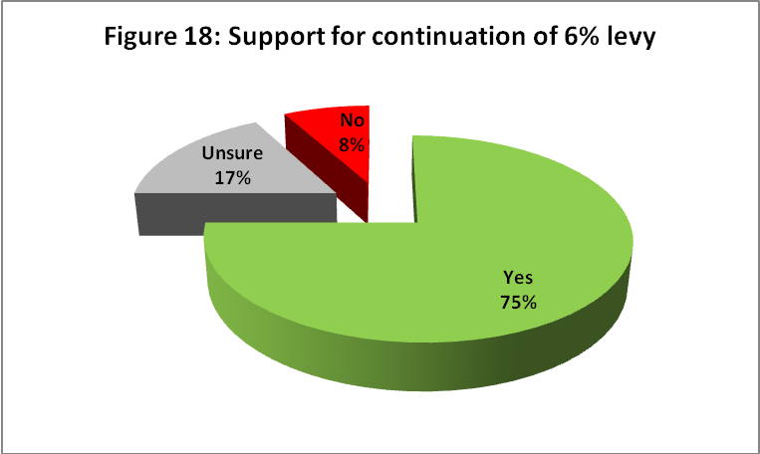

The workshops provided clear indication from people with a high level of environmental interest and awareness that Council should seek approval to extend the levy in order to continue delivering environmental programs.

Participants also provided strong feedback that Council needed to:

* Be more accountable and demonstrate transparency in terms of how levy funds were spent
* Communicate more actively to increase community awareness of the environmental projects and programs funded through the levy.

This reflects feedback provided by respondents to the survey.

Despite major efforts to identify people with a low level of concern for the environment, the workshop participants were underrepresented by people with a low level of environmental awareness. Accordingly, the workshops did not provide Council with any real insight into the views of people who are not actively interested in the environment. As such, it has been important to use other consultation activities to get community feedback from this group on the environmental levy.

A copy of the report from the workshops is provided in **Attachment U.**

**3. Council website**

There were 1,432 unique visits to the site with 15,238 page views during the period of consultation (9 September to 15 November). The most significant period for page views occurred after the Mayoral letter was sent out. A total of 264 documents, Information Sheets, were downloaded showing a strong interest in finding out more information.

**Attachment T** provides summary information on feedback activity on the website and social media.

## Considering the impact on ratepayers

Indicate how the council assessed the impact of the special variation on ratepayers, and where this was addressed within the community awareness and engagement processes. Where the impact will vary across different categories and/or sub-categories of ratepayers, the council should consider the circumstances of the various different groups.

**COUNCIL RESPONSE**

Council has assessed the impact of the special rate variation on ratepayers in two major ways:

* Within the community awareness and engagement process
* By undertaking a more broad review of the rating model in place and making representations for change to the State Government.

In its communication with the community Council provided clear, transparent and user-friendly information including tables that enabled ratepayers to easily assess how the levy might impact on them. The information addressed:

* the expiration in 2014 of the existing environment levy
* how much rates would increase by with the levy
* the impact of the proposed increase on the average ratepayer over the five year period
* the cumulative effect of the levy over the five year period
* the impact on rates if the levy is not continued
* quantified the environment levy component of the annual rates increase
* the projects and programs that would be funded by the proposed environment levy
* the benefits that the environment levy has delivered to residents, local businesses and business and residential ratepayers

This information was provided in the Information Sheets that were available on the website and in various Council locations. All information provided as part of the consultation is provided in **Attachment Q.**

The Fact Sheet that was posted out to all ratepayers with the letter to the Mayor and the survey contained a table showing the impact on the average ratepayer of continuing the levy.

**Other impacts of Randwick's rating model**

The Council’s rating policy is structured on an ‘ad valorem’ basis with two categories – residential and business. For each category, a minimum rate applies. This allows for a minimum to apply to a certain land value with ad valorem rating applying to all properties above this land level.

The environment levy special rate is an ad valorem rate calculated with no base or minimum rate component.   The ad valorem is multiplied by the land value of a property to calculate the levy amount.  The rate applies uniformly to both residential and business properties regardless of the use of the property.  If follows that properties with higher land values attract more environmental levy and properties with lesser land values attract a lesser amount.   The levy has been calculated this way for the past five years and will be re-applied this way in July 2014 if the special variation is approved.

The rating structure is reviewed annually to ensure equitable distribution among ratepayers. Any change to the rating structure does not equate to additional income to the Council but redistributes the rating liability of different property types.

The following **Graph 19** illustrates the existing rates distribution across Randwick City. The graph illustrates that while the majority of residential properties attract the minimum rate (predominately strata units) this group only pays 27 per cent of the Council’s total rates revenue. The capacity to pay principle that underpins the ‘ad valorem’ rating system results in properties with higher rateable land values attracting a higher rate.



The capacity to pay principle says that the higher the land value the greater the capacity to pay. However Randwick Council acknowledges in some cases this creates inequities as it ignores capital improvement. With high density urban areas and rates being determined on land value, the existing "Capacity to pay" principle fails to capture the capacity to pay of the ratepayers who own luxury apartments where the land value component may be significantly less than the land value component of a standalone property. This creates situations where some rate payers particularly in the older demographic groups may be asset rich but cash poor. There was concern expressed by some ratepayers during the consultation on this issue.

Council has tried to address these concerns in a number of ways including:

* providing range of strategies to assist ratepayers with difficulties in paying rates
* Making representations to the State Government to increase the pensioner rating concession which has not been changed since it was introduced in 1993.
* Making submissions to Local Government Acts Taskforce and the Local Government Independent Review panel regarding the need to create a more equitable rating model and make necessary changes to the legislation and the rating system.

There is a broad range of housing types across the City of Randwick and almost half of Randwick's ratepayers own strata units where the rateable land value is often significantly less than the overall average land value. As a result these ratepayers pay significantly less rates than that paid by the average ratepayer. The residential minimum properties represent half of the total number of properties but only a quarter of the total revenue. In 2012 the minimum rate threshold was a land value of $383,780.

For residential properties on the current minimum residential rate, the existing Environmental Special Rate ranges from as little as $4.80 per annum up to $54.75 per annum.

There are also many residents (approximately 9% of ratepayers) who live in properties where land value is in excess of $ 1 million. Yet even where the land valuation of a property is $1.1 million, the total environment levy component will be $157.21 per annum or $3.02 per week in the first year and over the next four years the annual increase due to the levy will not exceed $6.50 per year.

While the information and rating values provided focused on the 'average' ratepayer, with a land value of $589,500, it was possible for ratepayers to get a clear understanding of the potential impact as some tables provided information across a range of land values from $100,000 to $1.5 million.

*Information Sheet 1* in **Attachment Q** provided a full explanation of all information relating to the impact on rates.

## Considering the community’s capacity and willingness to pay

Indicate how the council has assessed the community’s capacity to pay for the rate increases being proposed, and also assessed its willingness to pay.

Evidence on capacity to pay could include a discussion of such indicators as SEIFA rankings, land values, average rates,disposable incomes,the outstanding rates ratio and rates as a proportion of household/business/farmland income and expenditure, and how these measures relate to those in comparable council areas. As many of these measures are highly aggregated, it may also be useful to discuss other factors that could better explain the impact on ratepayers affected by the proposed rate increases, particularly if the impact varies across different categories of ratepayers.

**COUNCIL RESPONSE**

There are a number of considerations when discussing affordability and the community capacity to pay, including:

* Land values across Randwick LGA
* Community profile
* SEIFA index
* Randwick's rates as they relate to other comparable councils
* The proposed levy will be replacing a similar existing levy

The Randwick LGA, as shown in **Table 20**, when compared with the rest of Australia has a well educated community with over a third of its workforce in professional occupations. Its median family weekly income is 39.5% higher than that of the median for all of Australia.

**Table 20: Profile of community demonstrating capacity to pay**

|  |  |  |
| --- | --- | --- |
|  | **Randwick LGA** | **Australia** |
| **Education- university or tertiary institution** | 31.4% | 14.3% |
| **Professional occupation** | 34.1% | 21.3% |
| **Median family weekly income** | $2,066 | $1,481 |
| **% Weekly Incomes> $2500 gross** | 26.5% | 17% |

Household income is one of the most important indicators of socio-economic status in Randwick City. The amount of income a household generates is linked to the number of workers in the household; the number who are unemployed or on other income support benefits; and the type of employment undertaken by the household members. As households vary in size, some areas have a greater number of dependents per income generated than others.

Generally, the areas with concentrations of high-income households have a larger number of people employed as professionals, managers and administrators. Households with two incomes are also more likely to feature among high income households.

The following **Figure 21** provides comparative information on the spread of high income households across Randwick LGA with comparisons to Greater Sydney, SSROC (Southern Sydney Regional Organisation of Councils) NSW and Australia.

|  |
| --- |
|  |

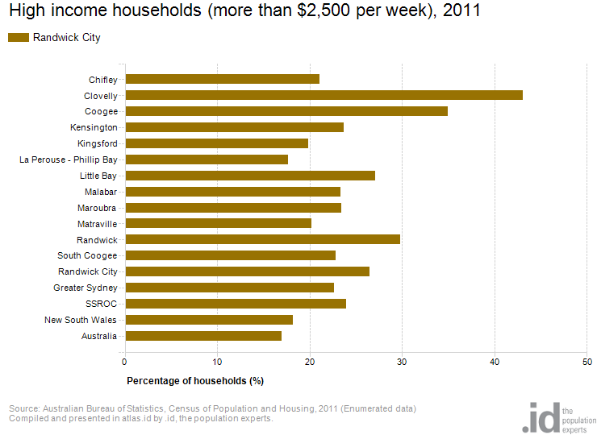

In 2011, 26.5% of Randwick City's total households were classed as high income compared to 22.6% in Greater Sydney. While Randwick City had a higher proportion of high income households, it is important to note that this varied across the City. Proportions ranged from a low of 17.6% in La Perouse - Phillip Bay to a high of 43.1% in Clovelly.

The large range of incomes is reflective of the City’s population mix. In the areas with a lower proportion of high income households there are high numbers of students (Kingsford) and significant public housing (Matraville & Chifley) with rate charges paid by Housing NSW.

The population mix is also reflective of Randwick City’s proximity to the Sydney CBD, good public transport, the attraction of its beaches and open space and the many places of education. These features ensure strong demand for property in the area and in turn generate both a willingness and capacity to pay rates levied by the Council.

**The Socio-Economic Index for Areas:**

The SEIFA index of Advantage and Disadvantage has "been constructed so that relatively disadvantaged areas have low index values while relatively advantaged areas have high values".

High scores on the Index of Relative Socio-Economic Advantage/Disadvantage occur when the area has many families with large houses, high incomes, low unemployment rates and professional occupations. Low scores on the index occur when the area has many low income families and people with little training and in unskilled occupations, as well as children in households with jobless parents. Unlike the index of disadvantage, a high score on this index indicates both a lack of disadvantage and a high level of advantage, based on these attributes.

For Statistical Areas Level 1 (SA1s) across Australia, the average (population weighted) SEIFA score on the index of disadvantage is 1,000. Therefore areas with an index above 1,000 are above the Australian average and so relatively less disadvantaged, while index figures below 1,000 indicate areas of relatively greater disadvantage when compared to the nation. **Table 22** below shows the index for each of Randwick's suburbs and it is significant to note that only one suburb, La Perouse-Phillip Bay (998.2) fell just below the Australian average (1000)

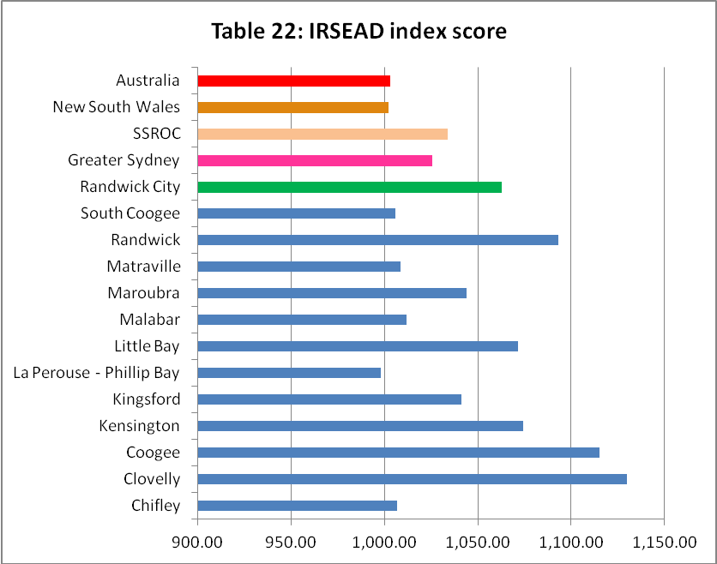

# Assessment criterion 3: Impact on ratepayers

In the DLG Guidelines, criterion 3 is:

*The impact on affected ratepayers must be reasonable, having regard to both the current rate levels, existing ratepayer base and the proposed purpose of the variation. Council’s IP&R process should also establish that the proposed rate increases are affordable having regard to the local community’s capacity to pay.*

We are required to assess whether the impact on ratepayers of the council’s proposed special variation is reasonable. To do this, we are required to take into account current rate levels, the existing ratepayer base and the purpose of the special variation. We must also assess whether the council’s IP&R process established that the community could afford the proposed rate rises.

## Impact on rates

Much of the quantitative information we need on the impact of the special variation on rate levels will already be contained in Worksheet 5 of Part A of the application.

To assist us further, the application should set out the rating structure under the proposed special variation, and how this differs from the current rating structure, which would apply if the special variation is not approved.

We recognise that a council may choose to apply an increase differentially among categories of ratepayers. However, you should explain the rationale for applying the increase differentially among different categories and/or subcategories of ratepayers, particularly in light of the purpose of the special variation. This will be relevant to our assessment of the reasonableness of the impact on ratepayers.

**COUNCIL RESPONSE**

Council has assessed the impact of the special rate variation on ratepayers within the community awareness and engagement process. Detailed information was provided on the impact of the proposed levy; on the impact if the levy is not continued and the environment levy component of the annual rates increase was clearly quantified.

The following provides an overview of the various impacts listed above. Note that the land value applicable to the average Randwick ratepayer in 2013/14 is $589,500. These three tables were provided to community in ***Information Sheet 1:*** *Important Information About Your Rates****.* (Attachment Q).**

***Note:*** *the rates figures provided to the community during consultation were accurate at that time. These figures have changed immaterially since the time of consultation and the preparation of Part A of this application. This is due to amendments to the Council’s land valuation register that have occurred routinely in the meantime.*

**Continuation of the existing environment levy**

Continuing the levy will not noticeably change the amount of rates paid by most residents, apart from the approved 3.59% annual increase, as the 6% environment levy has been in place since 2004. In 2014/15, if the levy is approved the total rates payable by the average ratepayer will only increase by **$40.41** or by 77 cents per week.

|  |  |  |  |  |  |  |
| --- | --- | --- | --- | --- | --- | --- |
| **Figure 23: Estimated total rates including 3.59% annual rates increase and environment levy** | | | | | | |
| **Land value** | **Current year** | **Year 1** | **Year 2**  **2015-16** | **Year 3**  **2016-17** | **Year 4**  **2017-18** | **Year 5**  **2018-19** |
| **2014-15** |
| **100,000** | 691.01 | 715.82 | 741.52 | 768.14 | 795.71 | 824.28 |
| **300,000** | 719.60 | 745.43 | 772.19 | 799.91 | 828.63 | 858.38 |
| **500,000** | 954.66 | 988.93 | 1,024.43 | 1,061.21 | 1,099.31 | 1,138.77 |
| **589,500** | 1,125.54 | 1,165.95 | 1,207.81 | 1,251.17 | 1,296.09 | 1,342.62 |
| **700,000** | 1,336.52 | 1,384.51 | 1,434.21 | 1,485.70 | 1,539.03 | 1,594.28 |
| **900,000** | 1,718.39 | 1,780.08 | 1,843.98 | 1,910.18 | 1,978.76 | 2,049.79 |
| **1,100,000** | 2,100.25 | 2,175.65 | 2,253.76 | 2,334.67 | 2, 418.48 | 2,505.30 |
| **1,500,000** | 2,863.98 | 2,966.80 | 3,073.30 | 3,183.64 | 2,297.93 | 3,416.32 |

The following Figure 24 shows the impact of the continuation of the levy on the 'average' ratepayer

|  |  |  |  |  |
| --- | --- | --- | --- | --- |
| **Figure 24: Continuation of the environment levy**  **Estimated impact on 'average' ratepayer** | | | | |
| **Levy year** | **Financial year** | **Rates ($) with 3.59% increase** | **Levy ($) with 3.59% increase** | **Total Rates ($) due** |
| **Now** | 2013-14 | 1,041.29 | 84.25 | 1,125.54 |
| **Year 1** | 2014-15 | 1,078.68 | 87.28 | 1,165.95 |
| **Year 2** | 2015-16 | 1,117.40 | 90.41 | 1,207.81 |
| **Year 3** | 2016-17 | 1,157.51 | 93.65 | 1,251.17 |
| **Year 4** | 2017-18 | 1,199.07 | 97.02 | 1,296.09 |
| **Year 5** | 2018-19 | 1,242.12 | 100.50 | 1,342.62 |
|  |  | **5,794.77** | **468.86** | **6,263.63** |

It can be seen in the above table that continuing the levy for the 'average' ratepayer means that:

* in 2013/14 with the existing levy in place plus the approved 3.59% increase the annual rates are **$1,125.54**
* in 2014/15 with the 6% environment levy approved and the 3.59% increase the annual rates will be **$1,165.95**
* the total rates will increase from 2013/14 to 2014/15 by **$40.41** a year
* in 2014/15 with the 6% environment levy approved and the annual 3.59% increase applied the annual rates will be **$1,342.62**
* in five years time the 'average' ratepayer will only be paying an additional $**100.50** in rates if the levy is approved. This is a small increase given the community's capacity to pay.
* the cumulative total additional rates paid over a five year period (2014-2019) by the average ratepayer will be **$468.86**.

**The impact on rates if the levy is not continued**

This impact can be seen in Figure 25 in **Information Sheet 1** where there would be a saving for this average ratepayer of $468.86 over the five years or an average of $98.73 per year.

|  |  |  |  |  |
| --- | --- | --- | --- | --- |
| **Figure 25: Removal of environment levy**  **Estimated impact on 'average' ratepayer** | | | | |
| Levy year | **Financial year** | **Rates ($) with 3.59% increase** | **Environment levy** | **Total Rates ($) due** |
| **Now** | 2013-14 | 1,041.29 | 84.25 | 1,125.54 |
| **Year 1** | 2014-15 | 1,078.68 | 0 | 1,078.68 |
| **Year 2** | 2015-16 | 1,117.40 | 0 | 1,117.40 |
| **Year 3** | 2016-17 | 1,157.51 | 0 | 1,157.51 |
| **Year 4** | 2017-18 | 1,199.07 | 0 | 1,199.07 |
| **Year 5** | 2018-19 | 1,242.12 | 0 | 1,242.12 |
|  |  | **5,794.77** | **0.00** | **5,794.77** |

The final table in **Information Sheet 1** showed if the environment levy is continued, the 6% levy will only be applied in year one and therefore in subsequent years the annual rates increase for the average ratepayer resulting directly from the environment levy ranges from **$3.13** to **$3.48** each year.

### Minimum Rates

The special variation may affect ordinary rates, special rates and minimum rates.

Does the council have minimum rates? YesX No

If *Yes*, explain how the proposed special variation will apply to the minimum rate of any ordinary and special rate, and any change to the proportion of ratepayers on the minimum rate for all relevant categories that will occur as a result.

So that we can assess the reasonableness of the impact on minimum ratepayers, briefly explain the types of ratepayers that are on minimum rates, and the rationale for the proposed impact of the special variation on minimum rate levels.

**COUNCIL RESPONSE**

Randwick City Council does have minimum rates for both residential and business rating categories.

The existing Environmental Special Rate is purely ad-valorem and applies to both residential and business properties equally with no minimums. Being a purely ad-valorem rate, the proposed Special Rate will have no impact on the proportion of ratepayers on the minimum rate.

If the proposed special variation is approved, the existing Environmental Special Rate will continue with the 2013-14 ad-valorem rate being indexed by our existing 3.59% Special Variation approval.

If the proposed special variation is not approved, the existing Environmental Special Rate will be removed and all properties including those on the minimum rate, will no longer incur the Environmental Special Rate.

For residential properties on the current minimum residential rate, the existing Environmental Special Rate ranges from as little as $4.80 per annum up to $54.75 per annum.

Randwick City Council has a wide variety of ratepayers on minimum rates. Close to half of our properties are units / apartments and a lot of these are subject to the minimum rate. Although many of these properties are at the more affordable end of housing within the Randwick LGA, we also have the situation of properties with purchase prices over $1 million that are subject to minimum rates due to the land value component being less than the threshold where minimum rates apply. For example, luxury beachfront units. There are very few freestanding homes on the minimum rate.

## Affordability and community capacity to pay

Show how your IP&R processes have established that the proposed rate rises are affordable for your community, and that affected ratepayers have the capacity to pay the higher rate levels. (Indicators considered in this context may be similar to those cited under criterion 2.)

**COUNCIL RESPONSE**

The Long Term Financial Plan (**Attachment B**, pages 6-9) provides information on the rating policy and the capacity for rating.

**Capacity for rating**

In reviewing and preparing the Resourcing Strategy as part of the IP&R process, Randwick Council has balanced the service needs of the community relative to their capacity and willingness to pay rates. In addition to community collaboration activities, the Council has assessed its rating policy and analysed the community’s median household income, socio-economic index and other relevant demographic factors.

As part of its focus on sustainability Council must be reassured that the proposed environment levy (SRV) is affordable and will only have a minimal impact on ratepayers.

Council acknowledges that while most of Randwick City enjoys a high socio-economic rating with the advantages that it brings, there is a mix of housing types with significant pockets of public housing in some suburbs and many students/renters around the University of NSW. However many in this group are not required to pay rates.

Land values are one of the key measures used by the Grants Commission to allocate the NSW Financial Assistance Grant to Local Government Area’s (LGA) across the state as it considers the land value of an LGA a reflection of the revenue raising capacity of a Council. Randwick City has one of the highest average land values in the state and as a result receives the lowest Financial Assistance Grant per capita in Australia. Properties with high land values are concentrated towards the north and coastal areas of the City and these areas also tend to have higher household incomes.

When considering affordability and the capacity to pay it is useful to compare what ratepayers in Randwick City pay in relation to ratepayers in other metropolitan coastal councils. Residents who live in beach suburbs enjoy natural facilities that are unique and very special. They attach a high value to living near the beach and generally expect to pay higher than average rates.

However Randwick ratepayers can enjoy the beaches and the proximity to major educational and health facilities and the CBD while paying one of the lowest average rate assessments for a metropolitan coastal community. **Figure 26** compares the average residential rates for 2013-14 for Randwick's benchmark group. It shows that Randwick's average residential rates ($1,041) are one of the lowest in the groups and it is well below the group average of $1,178.

**Figure 26 – Average Residential Rate 2013-14**

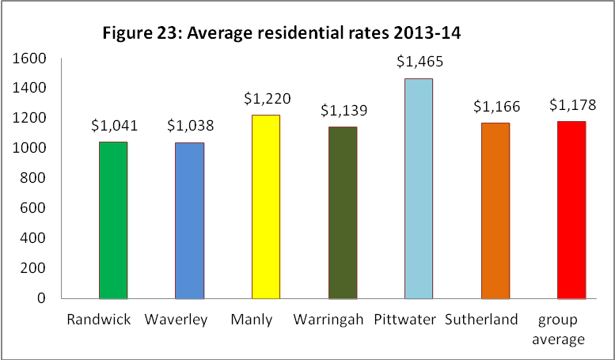

## Other factors in considering reasonable impact

In assessing whether the overall impact of the rate increases is reasonable we may use some of the same indicators that you cite in section 5.2 above. In general, we will consider indicators such as the local government area’s SEIFA index rankings, average income, and current rate levels as they relate to those in comparable councils. We may also consider how the council’s hardship policy might reduce the impact on ratepayers.

### Addressing hardship

In addition to the statutory requirement for pensioner rebates, most councils have a policy, formal or otherwise.

|  |  |
| --- | --- |
| Doe the council have a Hardship Policy? | Yes X No |
| If Yes, is it identified in the council’s IP&R documents? | Yes  No X |
| Please attach a copy of the Policy and explain who the potential beneficiaries are and how they are addressed. |  |
| Does the council propose to introduce any measures to limit the impact of the proposed special variation on various groups? | Yes No X |

Provide details of the measures to be adopted, or alternatively, explain why no measures are proposed.

**COUNCIL RESPONSE**

Randwick City Council currently has a number of policies and strategies in place to support ratepayers and limit the impact of the imposition of the special rates variation on them. This includes the:

* **Pensioner Concession Policy**: Currently there are 5,267 pensioners receiving the pensioner rating concession. This concession totals $1.32 million in 2013/14 with Council responsible for contributing 45% of total ($594,000). This distribution of the liability of the rebate has not changed since the mid 1990s.
* **Financial Hardship Policy** (**Attachment T**) This policy recognises that in exceptional circumstances/times that some ratepayers may encounter difficulties in paying their rates and charges. The Financial Hardship Policy aims to provide assistance to ratepayers experiencing genuine financial hardship with the payment of their rates. This will enable the preparation and implementation of a repayment plan and/or the writing off of interest due.
* **Pensioners Accruing Rates and Charges Policy** (**Attachment T**) – whereby aged pensioners may accrue rates and interest against their estate for payment when their property is eventually sold. This may benefit those pensioners who fall into the asset rich and cash poor group.
* **Debt Recovery Policy** prescribes that Council does not initiate court recovery actions against pensioners.

The preference is always to work with both pensioner and non-pensioner ratepayers at times when they may be facing financial difficulty. Randwick offers flexibility in establishing payment plans for all ratepayers. Pensioners can pre-arrange to make payments throughout the year at times that are convenient to them and at the end of the year Council will waive any interest accrued throughout the year so long as their current amount of rates has been paid in full.

Finally as this is a continuation of a current special variation and there is no additional impact on ratepayers it has not been considered necessary to introduce other measures in addition to those already in place.

# Assessment criterion 4: Assumptions in Delivery Program and LTFP

The DLG Guidelines state this criterion as follows:

*The proposed Delivery Program and Long Term Financial Plan must show evidence of realistic assumptions.*

Summarise below the key assumptions adopted by the council and indicate where they are set out in your Delivery Plan and LTFP. We will need to assess whether the assumptions are realistic. For your information, we will consider such matters as:

* the proposed scope and level of service delivery given the council’s financial outlook and the community’s priorities
* estimates of specific program or project costs
* projections of the various revenue and cost components.

To also assist us, identify any in-house feasibility work, industry benchmarks or independent reviews that have been used to develop assumptions in the Delivery Program and LTFP if these are not stated in those documents.

**COUNCIL RESPONSE**

The 2013-14 adopted budget and 2012-13 Financial Statements are the base years for the LTFP. The following key assumptions, detailed with range of other assumptions in pages 4-12 in the LTFP **(Attachment B**), have been used to forecast growth in both income and expenditure over the next 10 years.

**Population**

The LTFP is modelled on the Estimated Resident Population (ERP) which accounts for Australian resident absences on census night. According to the ABS, at 30 June 2011 Randwick City had an ERP of 137,757. Planning NSW has projected that the resident population will increase to 141,000 by 2021, representing an average annual growth rate of 0.2 per cent. The forecast population growth to 2021 is shown below in **Table 27**.

**Table 27: Population demographics and forecasts**

|  |  |
| --- | --- |
| **BRIEF STATISTICS** | **RANDWICK CITY** |
| Population June 2011* | 137,757 |
| Forecast population 2021 | 141,100 |
| Change between 2011 and 2021 | 3,343 |
| Average annual percentage change between 2011 and 2021 | 0.2% per annum |
| Total percentage change between 2011 and 2021 | 2.42% |

* Based on Estimated Resident population

**Inflation forecasts**

Inflation is based on the headline Consumer Price Index (CPI) published by the ABS and this headline CPI drives a number of revenue and expenditure items in the LTFP. Inflation forecasts shown below in **Table 28**, used over the term of the LTFP have been based upon predictions of growth in the Consumer Price Index (CPI) by the Deloitte Access Economics’ in their September 2013 forecasts.

**Table 28: Forecast CPI increases**

|  |  |  |  |  |  |  |  |  |  |
| --- | --- | --- | --- | --- | --- | --- | --- | --- | --- |
| **2014** | **2015** | **2016** | **2017** | **2018** | **2019** | **2020** | **2021** | **2022** | **2023** |
| 2.7% | 3% | 2.9% | 2.6% | 2.6% | 2.6% | 2.6% | 2.6% | 2.6% | 2.6% |

The Consumer Price Index (CPI) measures changes in the price of a fixed CPI alone, however, is not a sufficient measure of the rise in costs for a local government authority. A number of other assumptions and forecasts have been included in the LTFP models to provide a more accurate reflection of the movements in costs over a 10 year period.

**Interest Rate movements**

Interest Rate forecasts used over the term of the LTFP have been based upon Deliottes Access Economic predictions on the market rate for 90 bank bills. This is shown in the following **Table 29**

**Table 29: Forecast 90 day bank bill interest rates**

|  |  |  |  |  |  |  |  |  |  |
| --- | --- | --- | --- | --- | --- | --- | --- | --- | --- |
| **2014** | **2015** | **2016** | **2017** | **2018** | **2019** | **2020** | **2021** | **2022** | **2023** |
| **2.7%** | 3.7% | 4.6% | 4.7% | 4.6% | 4.6% | 5.2% | 5.2% | 5.1% | 5.1% |

**Revenue assumptions -****Capacity for rating**

In compiling the Resourcing Strategy, Randwick Council has balanced the service needs of the community relative to their capacity and willingness to pay rates. In addition to community collaboration activities, the Council has assessed its rating policy and analysed the community’s median household income and socio-economic index.

**Other key assumptions in the Long Term Financial Plan are that**:

* Existing services will run for the 10 year period (2013-23) at the same level of service
* The capital projects as detailed in the adopted Delivery Program 2013-17 will be implemented
* There will be expenditure as detailed for maintenance and upgrades on all asset programs for the life of the LTFP

# Assessment criterion 5: Productivity improvements and cost containment strategies

The DLG Guidelines state this criterion as follows:

*An explanation of the productivity improvements and cost containment strategies the council has realised in past years, and plans to realise over the proposed special variation period.*

In this section, provide details of any productivity improvements and cost containment strategies that you have implemented in the last 2 years (or longer) and any plans for productivity improvements and cost containment during the period of the special variation. These plans, capital or recurrent in nature, must be aimed at reducing costs. Please also indicate any initiatives to increase revenue eg, user charges. Identify how and where the proposed initiatives have been factored into the council’s resourcing strategy (eg, LTFP and AMP).

Where possible, quantify in dollar terms the past and future productivity improvements and savings.

You may also use indicators ofefficiency, either over time or in comparison to other relevant councils. We will make similar comparisons using various indicators and the DLG Group data provided to us.

**COUNCIL RESPONSE**

The Council adopts a strategic approach to achieving efficiency and productivity savings and is committed to continuing this work into the future. The identification and implementation of productivity improvements is an integral part of Council’s Long Term Financial Planning. **Table 30** below provides a summary of recent productivity initiatives that have delivered:

* recurrent savings
* increased revenue
* efficiency improvements
* improved customer focused services

**Table 30: Productivity Initiatives**

|  |  |  |
| --- | --- | --- |
| **INITIATIVES DELIVERING RECURRENT SAVINGS OR INCREASED REVENUE** | **INITIATIVES DELIVERING EFFICIENCY IMPROVEMENTS** | **INITIATIVES DELIVERING IMPROVEDCUSTOMER FOCUSED SERVICES** |
| New IT system resulted in cost savings of up to $1 million per annum  Southern Sydney Regional Organisation of Councils (SSROC) joint procurement venture resulted in approximate Randwick Council annual savings of $1.2m. (Estimated regional savings over 10 years of $105 million )  A review of fleet management extend the plant replacement schedule for passenger and light commercial vehicles to 3 years/60,000 kms. delivering savings of over $200,000 per annum  S94A *Development Contributions Plan* was reviewed and updated in 2012 and extended to Complying Development Applications providing additional revenue for community infrastructure  Diversification in the range of vehicles offered resulted in a decrease in average vehicle purchase price with savings of over $40,000 per annum  Implemented flexible leave arrangements such as cashing out annual leave and purchasing leave reducing leave balances by 9,000 hours with a $375,000 reduction in leave liability  Savings achieved under the SSROC Large Site Electricity contract equate to 6.5% or $100,000 per annum.  Improved management of sick and carer's leave absenteeism saw a productivity increase of over 350 work days in 12 months representing a saving of $131,000  Installation of in-house document scanning software has saved $39,000 per annum in scanning DAs and considerable staff time  The domestic waste garbage and recycling collection is saving $500,000 per annum saving  Annual water savings of 500 million litres saves $1 million annually  Completion of restoration of contaminated sites in 2019-20 will result in a 2% reduction in the domestic levy | Use of technology enables irrigation, water recycling and floodlights to be remotely controlled and monitored delivering more efficient water and electricity use  Redesigned the recruitment strategy to increase candidate numbers by 49% over 3 years and delivered a 66% reduction in recruitment costs through better branding and online focus  Improved and more tightly managed leases have resulted in lessees of all community buildings assuming responsibility for maintenance as detailed in their leases and licenses saving money for council.  Establishment of new environmental performance targets for new Council vehicles has realised a reduction in fuel consumption and CO₂ emissions from Council's fleet  Implemented an employee engagement program which increased employee productivity by 1.1% over 12 months   The introduction of an E tendering system has streamlined the issue and evaluation of tenders leading to a reduction in staff time allocated to assessing submissions  Strengthened relationships with Local Government Procurement and Procurement Australia has reduced the need to conduct tenders.  Participation in the PMMS Procurement Roadmap Program coordinated by SSROC has lead to an improved procurement process resulting in better planning, cost savings whilst ensuring probity and transparency  Introduction of Ezescan Indexing module has automated the process of registering various types of documents into Council's records management system. The time savings in registering some documents is around 90%; for other documents requiring meta data input there are time savings of about 50% to 70% | Provision of a range of online services including lodgement of development applications and BPoint for payment of rates (in 2011-12 $3.3 million of rates paid online  Range of innovative ways provided for the community to interact with Council such as Council website with 255,000 unique visits in 2012 (18% increase from 2011); myRandwick smartphone App; multi-lingual website; yourSayRandwick.com.au for community consultation;  Online Electronic Housing Code (EHC) was introduced in 2013 enabling property owners check whether approvals for proposed residential work is required. The system also allows 'fast-track' complying development to be lodged and progress tracked online  Dashboard iPad Software delivers live information to better inform councillors and senior management  The review of the Comprehensive DCP consolidated 29 existing DCPs and 9 policies into the one document, for easier and consistent guidance for applicants and the community  Heritage - background research statements on heritage items and conservation areas now on our web site as useful aid to people house buyers/sellers or renovators  Online waste forms available to report a missed collection, illegal dumping, lost/stolen bin and graffiti; and request a bin upgrade, or a clean-up booking  Ability for ratepayers to update their personal details online  Online mapping services and [interactive maps allows residents](http://mymaps.randwick.nsw.gov.au/interactiveMaps/)to access the latest updates on the Buildings for our Community Program, check wards and councillors and see waste collection timetable  A broader range of vehicles on offer, together with competitive employee contributions provides staff with choice of vehicle to best meet their individual needs and promotes Council as an Employer of Choice |

Over the past ten years Randwick has implemented a wide ranging reform program and has undertaken some comprehensive performance reviews including a peer group review to achieve efficiencies and cost savings, improved service delivery, increased sustainability, sound financial management and an integrated planning focus. This ongoing focus on review and performance improvement reflects Randwick’s need and intention to deliver better outcomes to its residents from a lower revenue and rate base.

**Level of staffing**

Another indicator of Randwick’s efficiency is its level of staffing. In 2004-05 there was a major reform and restructure of the organisation that resulted in a reduction of 40 FTE (full time equivalents). Since that time with the strong focus on improvement, productivity, service and efficiency many new services, such as public place officers, graffiti buster teams and environmental programs, have been introduced while some service standards have increased. For example, there has been an increase in the number of times beaches are cleaned, litter bins emptied, and parks mown. These improvements and new services have been provided with an overall increase of 20 FTEs which means the total FTE is still less than it was five years ago. The changes in the number of FTEs are shown in **Table 31**.

**Table 31: Changes in the number of FTE**

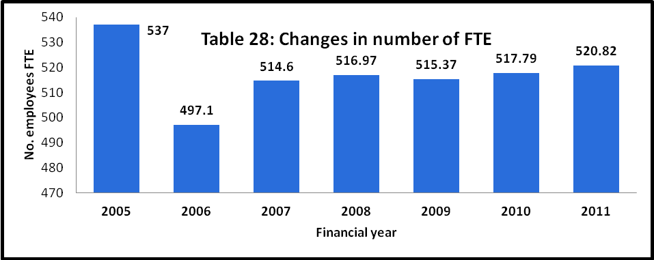

**Debt Recovery**

Randwick City Council has an excellent level of rates recovery as can be seen in **Table 32.** This is another indicator of its efficiency**.**

**Table 32: Outstanding rates & charges**

|  |  |  |
| --- | --- | --- |
|  | **Year** | **Outstanding rates & charges %** |
| **Randwick City Council** | 2008-08 | 2.92% |
| 2009-10 | 2.64% |
| 2010-11 | 2.22% |
| 2011-12 | 2.37% |
| **DLG benchmark for urban Councils** |  | <5% |
| **Average for urban councils** | 2011 | 4.9% |

# Other information

## Previous Instruments of Approval

If you have a special variation which is due to expire at the end of this financial year or during the period of the proposed special variation, when was it approved and what was its purpose?

Please attach a copy of the Instrument of Approval that has been signed by the Minister or IPART Chairman.

**COUNCIL RESPONSE**

There are two Instruments of Approval provided in **Attachment W**

* 2009 - 6 per cent SRV for environment levy- expiring 30 June 2014
* 2013 - 3.59% SRV for annual rate increase - expiring June 30 2017

## Reporting to your community

The *Guidelines* set out reporting mechanisms that show your accountability to your community. Please tell us how you will go about transparently reporting to the community on the proposed special variation, should it be approved. Also indicate the performance measures you will use to demonstrate how you have used the additional funds (above the rate peg) generated by the special variation.

**COUNCIL RESPONSE**

Randwick City Council will report to the community on:

* Progress on projects funded from the variation
* Outcomes achieved
* Key projects- timelines, variances etc

Council's structured assessment framework, part of the IP&R framework is the mechanism used to report on the implementation of the Delivery Program to the Council, the community, State Government and other organisations, agencies and key stakeholders. Progress, information and achievements against outcomes will be reported via:

* The four year Delivery program actions
* The one year Operational Plan actions
* Quarterly reports to council
* Annual Reports
* State of the Environment reports
* End of term review of the activities of Council

There will also be regular updates on specific activities and projects using Council's regular communication channels that include the quarterly Randwick Community News and the Randwick eNews.

The key assessment mechanism that is used to assess the performance of the implementation of the Randwick City Plan and programs and projects funded by the proposed environment levy is the Randwick City Plan Indicators Model (the Model). This Model, provided in **Attachment X**, was developed in 2010 to monitor and evaluate the state of the city in terms of the themes and directions set by the community in the Randwick City Plan.

The Model measures the outcomes of the actions taken by the Council, other organisations and the community as well as the impact of factors such as changes in the environment and economy and considers the level of control and influence that Council has on each indicator.

The Model contains 70 Indicators derived from a large number of sources and is designed to measure changes over time. In 2010 the most recent available data was used together with the available prior year’s data to establish a base line. The targets have been derived from a variety of sources including industry benchmarks, state government planning targets, Randwick Council planning targets and through consultation with the community and staff. There are a number of indicators that will measure achievement against the environmental outcomes including:

* Percentage of surveyed residents with a high degree of concern about the environment
* Biodiversity - percentage of open space land zoned for environmental protection
* Average daily number of cyclists counted on the Anzac Parade cycle route
* Community satisfaction with the construction of cycle ways
* Looking after our environment
* Solar energy generation exported back to Ausgrid network from small
* power systems within Randwick City per annum
* Net tonnes of greenhouse emission from the Councils operation
* Mains water consumed by the Council’s operations per day on average
* Mains water consumed by the Council’s operations per day on average -
* Energy (electricity and gas) consumed by the Council’s top 10 consuming sites per annum
* Household residential mains water consumption in Randwick City - per household per year
* Electricity consumed by residential properties in the Randwick City LGA - per household per year
* Water quality of beaches - percentage of beaches with a swimming suitability grade of good to very good
* Amount of residential waste diverted from landfill

Finally activities such as the annual Eco Living Fair and open days and demonstrations at Barrett Place (a sustainability demonstration project), Randwick Environment Centre and the depot will provide opportunities for the community to come and see what Council is doing and has achieved.

Council resolution to apply to IPART

## Council resolution to apply to IPART

The Guidelines require the council to have resolved to apply for a special variation. Please attach a copy of the council’s resolution to make a special variation application. Our assessment of the application cannot commence without it.

**COUNCIL RESPONSE**

Provided in **Attachment K**

# Checklist of contents

The following is a checklist of the supporting documents to include with your Part B application:

|  |  |
| --- | --- |
| **Item** | **Included?** |
| Relevant extracts from the Community Strategic Plan | X |
| Delivery Program | X |
| Long Term Financial Plan | X |
| Relevant extracts from the Asset Management Plan | X |
| TCorp report on financial sustainability | X |
| Contributions Plan documents (if applicable) |  |
| Media releases, public meeting notices, newspaper articles, fact sheets relating to the rate increase and special variation | X |
| Community feedback (including surveys and results if applicable) | X |
| Hardship Policy | X |
| Past Instruments of Approval (if applicable) | X |
| Resolution to apply for the special variation | X |
| Resolution to adopt the Delivery Program | X |

# Certification

**APPLICATION FOR A SPECIAL RATE VARIATION**

**To be completed by General Manager and Responsible Accounting Officer**

Name of council:

We certify that to the best of our knowledge the information provided in this application is correct and complete.

General Manager (name):

Signature and Date:

Responsible Accounting Officer (name):

Signature and Date:

Once completed, please scan the signed certification and attach it to the Part B form before submitting your application online via the Council Portal on our website.

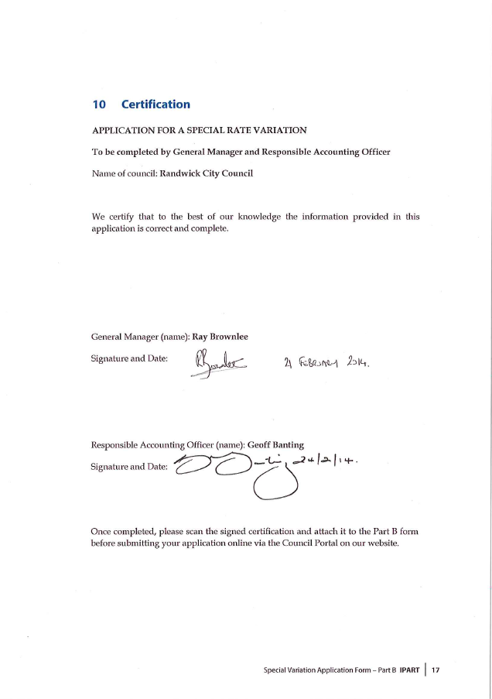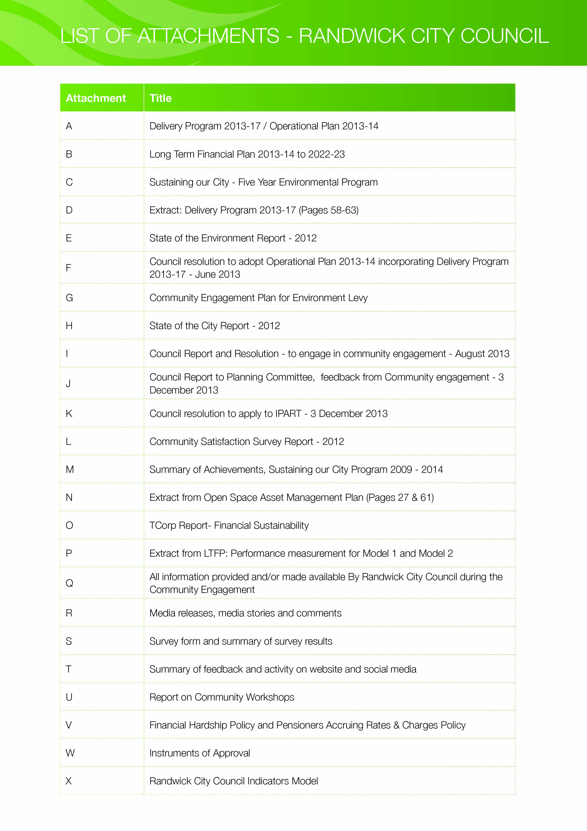

1. See Planning Circular 10-025 dated 24 November 2010 at [www.planning.nsw.gov.au](http://www.planning.nsw.gov.au)and for the most recent Direction issued under section 94E of the *Environmental Planning and Assessment Act 1979*. See also Planning Circular PS 10-022 dated 16 September 2010.
2. The relevant documents are the Community Strategic Plan, Delivery Program, Long Term Financial Plan and, where applicable, Asset Management Plan