|  |
| --- |
| T:\Chris\IPART\2016\Logos\IPART logo - trans.png |
|  |
| application for assessment  of a local infrastructure contributions plan  Insert name of council and contribution plan |
|  |
|  |

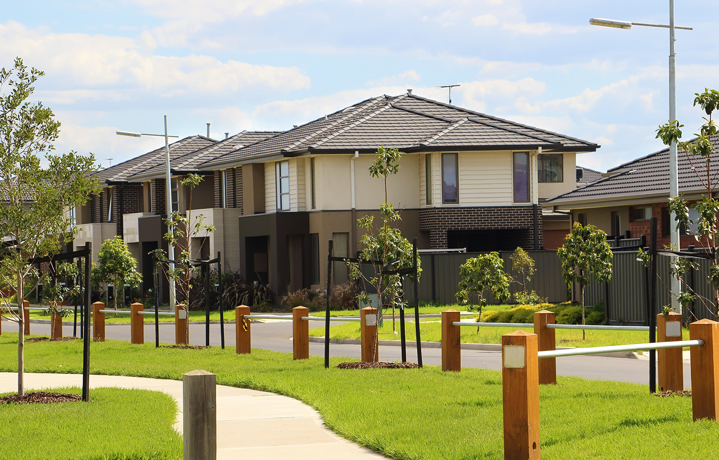

|  |  |
| --- | --- |
| Application Form  Local Government | February 2020 |

|  |
| --- |
| Contents  Instructions 1  Preliminary information 2  Assessment criteria 6  Quality assurance 16  Application checklist 17  Resources to assist councils 21  Example works schedule 23 |

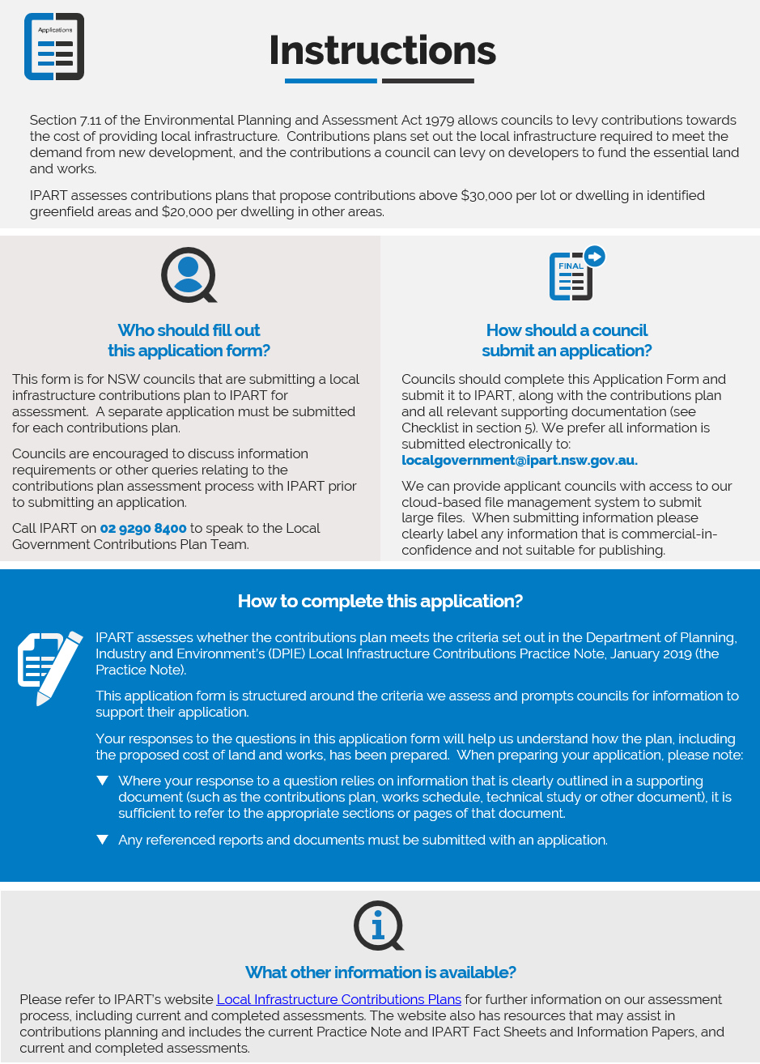

Preliminary information

#### Council information

|  |  |
| --- | --- |
| Council name | Click here to enter text. |
| Council contact details  (Provide more than one - include names, positions, phone numbers, and email addresses of council officers and/or consultant contacts) | Click here to enter text. |

#### Information about the plan

|  |  |
| --- | --- |
| What is the name of the plan? | Click here to enter text. |
| What is the name of the catchment (precinct or release area) covered by the plan?  * please specify any sub-catchments if applicable | Click here to enter text. |
| What is the base period of the plan? (e.g. June 2018) | Click here to enter text. |
| Which clause of the section 94E Ministerial Direction for Local Infrastructure Contributions (Ministerial Direction) applies to this plan (ie, clause 6, 6A, 6B or 6C)? | Click here to enter text. |
| What is the current maximum contribution amount (per lot or dwelling) for this plan under the Ministerial Direction? | Click here to enter text. |
| In the absence of any cap imposed by the Ministerial Direction, what are the indicative contribution amounts (per lot or dwelling) for each type of residential development in the catchment area? | Click here to enter text. |
| When was the plan publicly exhibited? And, how many submissions were received during exhibition? | Click here to enter text. |
| Has the council adopted the plan? If so, when was it adopted and when did it come into force? | Click here to enter text. |
| Who are the key stakeholders (e.g. Council, Department of Planning, Industry & Environment (DPIE), or developers) involved in planning for the area covered by the plan? | Click here to enter text. |
| Over what period will development in the catchment area of the plan occur? | Click here to enter text. |
| What planning instruments (SEPPs, LEPs, or DCPs) apply to land in the catchment area of the plan? | Click here to enter text. |
| Has the Minister referred this contributions plan to IPART for review?  If so, provide details. | Click here to enter text. |

For existing contributions plans where development has progressed

Councils only need to complete these questions for plans that have already been adopted and where development in the catchment area covered by the plan has progressed.

#### Information about existing plans

|  |
| --- |
| What proportion of the total projected development in the catchment area of the plan has been approved and/or constructed? |
| Click here to enter text. |
| Briefly explain if, and how the plan has been revised in response to any changes in the catchment area covered by the plan.  i.e. Has the council considered the impact of revised population estimates or dwelling yields, and how? |
| Click here to enter text. |

|  |  |
| --- | --- |
|  | Additional requirements  Please include the contributions register for the plan as an attachment to your application.  If costs in the plan are based on Works in Kind Agreements (WIKs) or Voluntary Planning Agreements (VPAs), please provide details in the works schedule of:   * The works items covered by the agreements * The total cost (land and works), including any indexation up to the base period of the plan * The name, date and applicable page numbers in the agreements |

|  |
| --- |
| Explain any other revisions to the plan such as updated costings, revised apportionment of costs, or amended delivery timeframes.  In addition to explaining any revisions below, please clearly identify any updated costings in the plan’s works schedule |
| Click here to enter text. |

For contributions plans previously reviewed by IPART

Councils only need to complete these questions for plans that IPART has previously reviewed.

#### Information about revisions to the plan

|  |
| --- |
| Why is the council submitting the revised plan for IPART’s review? |
| Click here to enter text. |
| Briefly explain how the plan has been revised in response to:   * Recommendations made in IPART’s assessment report on the previous version/s of the plan, and * Any directions from the Minister for Planning in relation to IPART’s assessment.   Please note any instances where a recommendation from the Minister for Planning has not been implemented/addressed. |
| Click here to enter text. |

Assessment criteria



We assess whether the land and works for transport infrastructure are consistent with the essential works list (EWL) in the Practice Note. Please refer to the latest version of the Practice Note for the latest EWL.

|  |
| --- |
| If the plan includes costs for land and/or works not on the EWL:   * List these items below, and * Indicate how their costs are to be met. |
| Click here to enter text. |

|  |
| --- |
| List the community services that will be provided on the land that is to be acquired for community services (eg, youth centre, library) and indicate the floor space area allocated to each.  Only land for community services is on the essential works list; works are not. However, we require details of the community services that are intended to be provided, so we can determine the proportion of the land costs that can be recovered through development contributions. |
| Click here to enter text. |



We assess whether there is nexus between the proposed land and works and the increased demand generated by development identified through the contributions plan. In assessing nexus we consider supporting evidence such as transport studies, traffic modelling or internal council analysis and reports that establish the need for the proposed land and works.

|  |
| --- |
| Explain the process used to determine the need for all land and works in the plan   * List any supporting studies relied on and explain any deviations from recommendations in those studies. Please also identify who commissioned the study (i.e. DPIE or council). * Show the link between the supporting studies and the land and works in the plan. This can be shown against each item in a separate table or in the plan’s works schedule (see Example Works Schedule in Section 7). |
| Transport land and works  Click here to enter text. |
| Stormwater land and management works  Click here to enter text. |
| Open space land and works (embellishments)  Click here to enter text. |
| Community services land  Click here to enter text. |
| Were any supporting studies prepared for the catchment area but not relied on? If yes, explain why they were not used. |
| Click here to enter text. |
| How has non-residential development been considered in determining the need for infrastructure in the plan? |
| Click here to enter text. |
| In determining the need for infrastructure in the plan, what consideration was given to:  Please separately address all questions below |
| * The existing population in the catchment area   Click here to enter text. |
| * Any existing or projected population outside the catchment area   Click here to enter text. |
| * The capacity of existing infrastructure in the catchment area, and/or   Click here to enter text. |
| * Any existing or proposed infrastructure outside the catchment area.   Click here to enter text. |



IPART must advise whether the proposed development contributions are based on a reasonable estimate of the cost of the proposed public amenities and public services. This includes how the base costs of land and each item of infrastructure are derived and the method used to calculate the contribution rates and escalate them over time.

|  |
| --- |
| Explain the process used to estimate costs for works for each infrastructure category.  Refer to matters such as:   * Use of consultant or QS estimates * Use of council costs * Use of benchmark costs * Any allowances included, such as professional fees and contingencies * Details of any indexation of cost estimates to the base period of the plan, including the index used   Show the link between the supporting cost sources and the land and works in the plan. This can be shows against each item in a separate table or in the plan’s works schedule (see Example Works Schedule in Section 7). |
| Transport works  Click here to enter text. |
| Stormwater management works  Click here to enter text. |
| Open space works (embellishments)  Click here to enter text. |
| Explain the process used to estimate the cost of plan preparation and administration. |
| Click here to enter text. |
| What, if any, land has the council already acquired to provide local infrastructure for development in the catchment area? How has the cost of this land been included in the plan?   * For land that the council has acquired in the plan, the works schedule should show: * Date of acquisition * Agreed market value * Any other acquisition costs * Indexation of the total acquisition cost to the base year of the plan. * For land that the council has agreed to acquire or have dedicated through a VPA, the work schedule should show: * Date of agreement * Agreed value * Indexation of the value to the base year of the plan. * For council-owned operational land, the works schedule should show: * Market value at the time the land was rezoned for public infrastructure * Indexation to the base year of the plan. |
| Click here to enter text. |
| Explain the process used to estimate the cost of land yet to be acquired by the council.   * Include details of any inclusions for other costs associated with a council’s land acquisitions, such as conveyancing, legal, survey and other costs payable to landowners under the *Land Acquisition (Just Terms Compensation) Act 1991* |
| Click here to enter text. |
| If contributions rates in the plan are calculated using an NPV model,   * Does the model use real or nominal values? * If the model uses nominal values, what indexation assumptions are applied to costs and revenue? * What discount rate does the model use, and why? |
| Click here to enter text. |
| What measures have been taken to minimise costs in the contributions plan (eg, adjustment to design or alternative engineering solutions)? |
| Click here to enter text. |
| Explain the method/s used to index the contributions rate for both land and works. |
| Click here to enter text. |



We assess whether the proposed public amenities and public services can be provided within a reasonable timeframe

|  |
| --- |
| How has the council determined the timing of infrastructure provision?  Provide details of the program for delivery of infrastructure in the contributions plan and explain its underlying rationale. |
| Click here to enter text. |



We assess whether the proposed development contribution is based on a reasonable apportionment of costs between existing and new demand. We also assess whether the apportionment of costs reflects the demand generated by different types and stages of development.

Apportionment is about ensuring the allocation of costs equitably between all those who will benefit from the infrastructure or create the need for it. While nexus is about establishing a relationship between the development and demand for infrastructure, apportionment is about quantifying the extent of the relationship.

|  |
| --- |
| How does the plan apportion costs?  Provide details of supporting calculations and explain how the apportionment takes into consideration demand arising from (as relevant):   * new and existing development in the catchment area * different stages of development * different sub-catchments * residential and non-residential development * different residential development densities * new and/or existing development outside the catchment area   Please provide additional information in this section is any development is exempt from paying contributions. |
| Transport land and works  Click here to enter text. |
| Stormwater management land and works  Click here to enter text. |
| Open space land and works (embellishments)  Click here to enter text. |
| Community services land  Click here to enter text. |
| Plan preparation and administration  Click here to enter text. |



We require evidence that the plan has been exhibited and publicised in accordance with the statutory requirements and that the council has considered submissions received during the exhibition period. The post-exhibition version of the plan should not differ so significantly from the exhibited version that it requires re-exhibition.

It is not necessary to include information about consultation in the contributions plan.

|  |
| --- |
| In developing the contributions plan, was any publicity and community liaison undertaken outside the mandatory exhibition period? |
| Click here to enter text. |
| How has the council taken into account submissions received on the draft plan placed on exhibition? |
| Click here to enter text. |
| Does the council intend to undertake any further publicity or community liaison? |
| Click here to enter text. |



IPART may take into consideration other matters relevant to our overall assessment of the contributions plan.

These matters may include compliance with the statutory requirements for making local infrastructure contribution plans and with the Practice Note, whether the plan uses up-to-date information, as well as issues of transparency and accountability in the council’s proposed arrangements for the levying and collection of contributions under the plan.

|  |
| --- |
| Is there any other information relating to the contributions plan which may assist us to assess it against this criterion? |
| Click here to enter text. |
| Is the council aware of possible changes to any underlying assumptions used in preparing the plan which may be relevant to our assessment?  Such matters could include:   * Revised population projections * Potential rezoning or changes to dwelling yields * Other changes to the applicable LEP, SEPP or DCP * Changes to NSW government policy for infrastructure delivery |
| Click here to enter text. |
| Please provide any other information which you consider would assist or expedite our assessment. |
| Click here to enter text. |

Quality assurance

We also request that council undertake a quality assurance (QA) check of the contributions plan before it is submitted to IPART for review.

The purpose of the council’s QA check is to identify and address any errors or inconsistencies within the work schedules and also between the contributions plan and relevant supporting information to ensure that the plan, as submitted, is accurate. This will reduce the risk of delay in our assessment and the need for recommendations for the council to correct errors.

#### Checklist for quality assurance of contributions plan and works schedule

|  |  |  |
| --- | --- | --- |
| Has the contributions plan been checked for | Yes | No |
| Typographical errors |  |  |
| Calculation errors (including checking infrastructure and land cost calculations) |  |  |
| Use of the most up-to-date data and information |  |  |

|  |
| --- |
| Explain the quality assurance process undertaken for the contributions plan prior to submitting it to IPART for review. |
| Click here to enter text. |

Application checklist

Please complete Checklist A to confirm the contributions plan contains all information requirements of the *Environmental Planning and Assessment Regulation 2000*.

Please complete Checklist B to ensure that all information necessary for IPART’s assessment is submitted.

Councils should also complete and provide IPART with spreadsheets that:

* Detail all infrastructure items included in the plan, with references to the studies (including the specific sections or page numbers), that support their inclusion in the plan as relevant
* Detail the cost of each infrastructure item (including source and date of costings, and any indexation of cost estimates)
* List the cost and area for all parcels of land required for infrastructure in the plan
* Detail the cost of any land that has already been acquired and land that the council is yet to acquire
* Show how the total cost of land and works for each infrastructure category (or subcategory) have been apportioned
* Show how the contributions rates in the plan have been calculated (including net present value modelling if this approach is used), and
* Show indicative contribution amounts for each type of residential dwelling.

IPART provides a Works Schedule template that councils can use to show information and calculate contribution rates (see Resources in section 6). For an example works schedule that shows the information listed above, see the Example Works Schedule in section 7 or the Works Schedule template on our website.

Checklist A – for the contributions plan

| Does the contributions plan: | Yes | No | Contributions plan  page reference(s) |
| --- | --- | --- | --- |
| Outline the purpose of the plan |  |  | - |
| Incorporate a map showing:   * Geographical catchment area of the contributions plan * Specific infrastructure to be provided under the plan (may include multiple maps) |  |  | - |
| Include details about how the need for land and works to support new development was determined |  |  | - |
| Include information about: |  |  |  |
| * Existing population in the catchment area |  |  | - |
| * Projected residential population and/or workforce |  |  | - |
| Include a schedule of the contributions rates (eg, $/ha, $/person, $/dwelling) |  |  | - |
| If using a Net Present Value (NPV) approach, including assumptions made in the modelling of costs and revenue |  |  | - |
| Include details of the anticipated rate of development in the catchment area and how this was determined |  |  | - |
| Include a program for infrastructure delivery and explain how it relates to the anticipated timing of development |  |  | - |
| Include a statement regarding potential revision of the scheduled timing for infrastructure delivery |  |  | - |
| The formulas used for determining the section 7.11 contributions for each infrastructure category |  |  | - |
| Explain how the proposed cost of works was derived (eg, quantity surveyor or other consultant advice, standard costs used by the council) |  |  | - |
| Explain how the proposed cost of land was derived |  |  | - |
| Include a works schedule that shows an estimate of the cost and the expected timing of infrastructure delivery |  |  | - |
| Include details of apportionment calculations |  |  | - |
| Explain how the contribution rates will be adjusted for inflation/ changes in costs |  |  | - |
| Outline the base period for costs in the plan (eg, June 2018) |  |  | - |
| Address the council’s position on the following policy matters: |  |  | - |
| * Provide details of accounting arrangements for contribution funds (eg, is pooling of funds permitted, will internal borrowings be used to deliver infrastructure projects |  |  | - |
| * Show how it will satisfy each condition requiring the payment of monetary contribution |  |  | - |
| * Consider the conditions that may be imposed under section 4.17 (6)(b) of the Act or section 97(1)(b) of the Local Government Act 1993. |  |  | - |

Checklist B – for the council’s application

Please complete the checklist below to ensure that all information necessary for IPART’s assessment is submitted.

|  | Yes | No | N/A |
| --- | --- | --- | --- |
| Works schedules and calculation of contribution rates |  |  |  |
| Spreadsheets must include a clear link between   * The listed infrastructure and the evidence which supports nexus |  |  |  |
| * The cost of land/infrastructure and the cost source. |  |  |  |
| Contributions plan |  |  |  |
| Version of contributions plan incorporating any post exhibition changes |  |  |  |
| Version of contributions plan publicly exhibited |  |  |  |
| Version of contributions plan previously submitted to IPART for review |  |  |  |
| Public consultation |  |  |  |
| Copy of all submissions to publicly exhibited contributions plan |  |  |  |
| Summary of submissions and council’s response |  |  |  |
| Technical studies and consultant documents |  |  |  |
| Land valuation report/s |  |  |  |
| Supporting studies for stormwater management infrastructure (eg, Flooding and Water Cycle Management report) |  |  |  |
| Supporting studies for transport infrastructure (eg, Traffic and Transport Assessment report) |  |  |  |
| Supporting studies for open space infrastructure (eg, Demographic and Social Infrastructure report) |  |  |  |
| Supporting studies for community services (eg, Demographic and Social Infrastructure report) |  |  |  |
| Maps and shape/spatial files |  |  |  |
| Plan catchment map/s |  |  |  |
| Final Indicative Layout Plan |  |  |  |
| Zoning map/s |  |  |  |
| Land acquisition map/s |  |  |  |
| Constrained land map/s (flooding and transmission lines) |  |  |  |
| Other documents |  |  |  |
| VPAs |  |  |  |
| Details of other funding agreements for state or local infrastructure in the area covered by the plan (including draft agreements) |  |  |  |
| Council business papers or meeting minutes related to the preparation of the contributions plan |  |  |  |
| Any other documents that you think could be useful in IPART’s assessment of the contributions plan |  |  |  |

Resources to assist councils

The following documents and resources are available to assist councils preparing a contributions plan.

Please refer to IPART’s website [**Local Infrastructure Contributions Plans**](https://www.ipart.nsw.gov.au/Home/Industries/Local-Government/Local-Infrastructure-Contributions-Plans) for further information on our assessment process.

|  |  |
| --- | --- |
| Policy Documents | Description |
| Section 94E Ministerial Direction for Local Infrastructure Contributions 2012, as amended (Ministerial Direction) | The Ministerial Direction sets out the role of IPART in reviewing local government contributions plans |
| Local Infrastructure Contributions Practice Note, January 2019 (the Practice Note) | Provides guidance to IPART and to assist councils to understand the role of IPART in the review of contributions plans. |
| Terms of Reference – Reviewable Contributions Plans – Environmental Planning and Assessment Act 1979, dated 14 November 2018 | IPART’s Terms of Reference for the review of local government contributions plans |

|  |  |
| --- | --- |
| Fact Sheets and Information Papers | Description |
| Fact Sheet – Contributions plan assessment | Explains why and how we assess contributions plans |
| Fact Sheet – Local Government discount rate | Every six months IPART publishes the local government discount rate |
| Fact Sheet – Inclusion of roads in contributions plans | Provides advice and guidance on the inclusion of roads in contributions plans |
| Information Paper – Contributions plan assessment: land costs | Sets out IPART’s approach to assessing land costs in contributions plans |
| Information Paper – Guidance for contributions plans: Local Infrastructure Benchmark Costs | Sets out IPART’s position on using our 2014 benchmark cost report |
| Information Paper – Indexation of contribution rates | Provides advice and guidance on the indexation of contribution rates |
| Technical Paper – Modelling local infrastructure contributions | A technical paper that outlines our recommended approach to calculating the discount rate and other aspects of modelling local infrastructure contributions using a net present value approach |

|  |  |
| --- | --- |
| Other documents | Description |
| IPART Works Schedule Template | An example works schedule that councils can use when developing a contributions plan  *We are currently revising our example works schedule and will update our website once it is complete.* |

Example works schedule

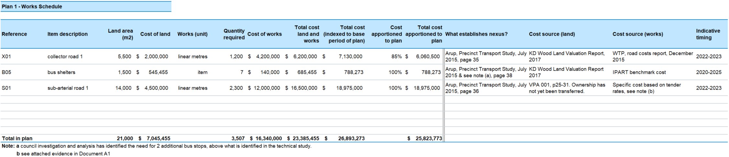

*We are currently revising our example works schedule and will update our website once it is complete.*